**Feasibility Report:**

**Microprocessor DSPIC30F4012**

**Author: Vũ Minh Phong**

# Overall of microprocessor DSPIC30F4012:

DSPIC30F4012 is a 28-pin micro processor published by MICROCHIP Technology Inc.

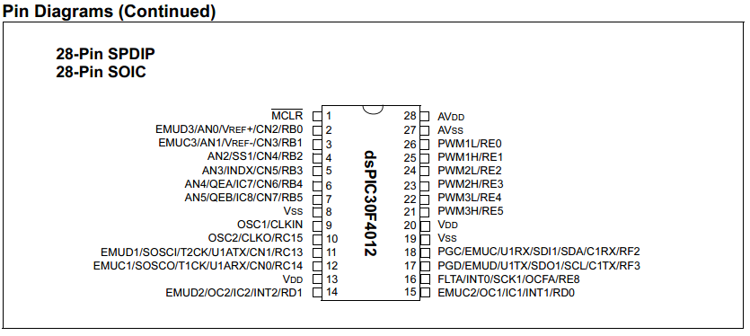

Features of DSPIC30F4012:

* 84 base instruction
* 24-bit wise instruction, 16-bit wise data path.
* 48kbytes on-chip Flash program space (16k instruction words)
* 2 Kbytes on-chip data RAM
* DC upto 40MHz external clock input
* 16x16 bit working register array.
* 16-bit compare /PWM output function.
* Five 16-bit timers.
* 6 PWM output channels.
* 3 duty cycle generators.
* 10-bit A/D with 6 input channels
* About half a size of PIC16f887.
* 1 UART channel
* 1 SPI channel + 1 I2C channel
* Operation voltage: 5V or 3.3V

# Why it is suitable for FUFO project:

Fufo project need a controller circuit which is capacible of the followings:

* Have 1 SPI or 1 I2C connection for 1 Gyroscope.
* Have 3 A/D pins connection for 1 Accelerometer.
* Have 1 UART connection for Bluetooth module at 9600 baud rate
* Have 4 PWM outputs for 4 ESC.
* As small, light and cheap as possible.

What DSPIC30F4012 provides:

* 1 SPI/I2C connection
* 6 A/D input pins
* 1 UART connection
* 6 PWM output pin (can work independently)
* Can either work at 3.3V or 5V
* Clock upto 40Mhz (4Mhz is good enough for 9600 baud rate)
* 16 bits register for PWM is precise enough.
* The size is about a half of PIC16f887 (small and light)
* Do not have to care about price since we have a sponsor (Mr. HungPD)
* Similar to other Microchip product in development. We donot have to learn too many new things.
* Can use MpLab IDE or CCS C IDE for development.