|  |  |
| --- | --- |
| **Logo_FPT_University_doc** | **MINISTRY OF EDUCATION AND TRAINING** |

|  |
| --- |
| **FPT UNIVERSITY** |
| Capstone Project Document |
| Drop It |
|  |
| |  |  | | --- | --- | | **Team 08** | | | **Group Members** | Lê Khôi Phong 2 60473  Đào Như Tùng 2 60408  Công Minh Hiếu 3  Nguyễn Thanh Tùng 4 60513  Đặng Quốc Duy 4 | | **Supervisor** | Lâm Hữu Khánh Phương | | **Ext Supervisor** | None | | **Capstone Project code** | DropIt | |
|  |

-Ho Chi Minh City, 08/2013-

Table of Contents

Table of Contents 2

1.1 Introduction 5

1.1.1 Project Information 5

1.1.2 Purpose 5

1.1.3 The People 5

1.1.4 Background 5

1.1.5 Problems 6

1.1.6 Our Proposal 6

1.1.7 Benefits 6

2.1 Problem Definition 7

2.1.1 Name of this Capstone Project 7

2.1.2 Problem Abstract 7

2.1.3 Project Overview 7

2.1.3.1 The Current System 7

2.1.3.2 The Proposed System 7

2.1.3.3 Boundaries of the System 8

2.1.3.4 Development Environment 8

2.2 Project Organization 9

2.2.1 Software Process Model 9

2.2.2 Roles and Responsibilities 9

2.2.3 Tools and Techniques 10

2.3 Project management Plan 10

2.3.1 Tasks 10

2.3.2 Task Sheet: Assignment and Timetable 12

2.4 Coding Convention 15

2.4.1 Naming Convention 15

2.4.2 Lengths 15

3.1 User Requirement Specification 16

3.1.1 Common Features 16

3.1.2 Authorized User 16

3.1.3 Admin 16

3.1.4 Guest 16

3.2 System Requirement Specification 17

3.2.1 External Interface Requirements 17

3.3.2.1 User Interfaces 17

3.2.1.2 Hardware Interfaces 17

3.2.1.3 Software Interfaces 17

3.2.1.4 Communications Protocol 17

3.2.2 System Features 18

3.2.2.1 Admin 19

3.2.2.2 Customer 54

3.2.2.3 Authorized User 72

3.2.2.4 Guest 78

3.2.2.5 Unauthorized User 82

3.2.2.6 Auto System 84

3.2.3 Software System Attributes 89

3.3.2.1 Reliability 89

3.2.3.2 Availability 89

3.2.3.3 Security 89

3.2.3.6 Maintainability 89

3.2.3.6 Portability 89

3.2.3.6 Performance 90

3.3 Entity Relationship Diagram 90

4.3 SOFTWARE DESIGN DESCRIPTION 90

4.3.1 Design Overview 90

4.3.2 System Architectural Design 91

4.3.2.2 Choice of System Architecture 92

4.3.2.2 Discussion of Alternative Designs 93

4.3.3 PACKAGE Diagram 94

4.3.4 Class Detailed Description 95

4.3.4.1 DropIt.Models Package 95

4.3.4.2 DropIt.Controllers Package 99

DropIt.Controllers 100

DropIt.Areas.Administration.Controllers 103

4.3.4.3 Class Diagram 107

4.3.5 Sequence Diagram 109

4.3.5.1 Get list ticket 109

4.3.5.2 Manage ticket 110

4.3.5.3 Manage transaction 111

4.3.5.4 Manage user 112

4.3.5.5 Create Event 113

4.3.6 Activity diagram 113

4.3.6.1 Create Ticket 113

4.3.6.2 Request Ticket 114

4.3.7 State Diagram 114

4.3.7.1 Ticket State Diagram 114

4.3.7.2 Event State Diagram 115

4.3.8 Database Design or Data Structures 116

4.3.8.1 CONCEPT Database diagram 116

4.3.8.2 Database diagram 117

4.3.8.3 Table 118

4.3.8.3.1 user table 118

4.3.8.3.2 ticket table 119

4.3.8.3.3 venue table 121

4.3.8.3.4 province table 121

4.3.8.3.5 event table 121

4.3.8.3.6 userfollowevent table 122

4.3.8.3.7 request table 123

4.3.8.3.8 ticketresponse table 123

4.3.8.3.9 categories table 123

4.3.8.3.10 setting 124

4.3.8.3.11 notification 124

## Introduction

### Project Information

* Project name: **Drop-It**
* Project code: **DIC2C**
* Product type: **Website**
* Timeline: **From 14 May 2013 To 14 Aug 2013**

### Purpose

This project is developed and registered as the capstone project for group number 8. The purpose is fulfilling the requirement from FPT University training program.

### The People

**Supervisor:**

|  |  |  |  |
| --- | --- | --- | --- |
| **Full name** | **Phone** | **E-Mail** | **Title** |
| Lâm Hữu Khánh Phương | 0915353001 | phuonglhk@fpt.edu.vn | Teacher |

**Team members:**

|  |  |  |  |  |  |
| --- | --- | --- | --- | --- | --- |
| **Student** | **Full name** | **Student code** | **Phone** | **E-Mail** | **Role in Group** |
| 1 | Lê Khôi Phong | 60473 | 0903045572 | phonglk60473@fpt.edu.vn | Leader |
| 2 | Đào Như Tùng | 60408 | 0909364008 | tungdn60408@fpt.edu.vn | Member |
| 3 | Công Minh Hiếu | 60535 | 0918125726 | hieucm60535@fpt.edu.vn | Member |
| 4 | Nguyễn Thanh Tùng | 60513 | 0934779004 | tungnt60513@fpt.edu.vn | Member |
| 5 | Đặng Quốc Duy | 00276 | 0943578179 | duydq00276@fpt.edu.vn | Member |

### Background

In addition to its economic growth, HCMC's cultural and artistic activities have been on the rise to form the habit of enjoying arts every night in the local residents. Together with technological demands and developments, a large number of online banking services for business transactions and ticket selling sprung up, making it more convenient for the buyers. However, whether the transactions are online or offline, there are always situations in which the ticket buyers cannot use the tickets and would have to find a way to resell the tickets to other people, often at a lower price. They can either advertise their tickets online or sell the tickets on the spot of the events.

### Problems

Most of online ticket selling businesses have these two common characteristics:

* Generality - Different types of tickets are sold and those tickets are not inclined towards any particular artistic activities.
* Most of them are B2C businesses, direct selling and are the distributors of programs to the end users.

Most of the Classified advertising websites are also general in nature and low in efficiency

Moreover, reliability and online security should be taken note of because those transactions are likely to have high risks.

### Our Proposal

DropIt is born with an aim to become a safe and convenient platform for users to resell their tickets. Although the market for second-hand tickets are smaller than that of first-hand tickets, second-hand tickets hold many potentials if DropIt can tap on to this and create a safe and anti-phish platforms.

Main Features:

* Allowing users to publish and advertise the tickets they want to resell
* Allowing users to buy second-hand tickets
* Holding money until buyer confirm that ticket is ok
* Keeping statistics and transaction records

### Benefits

* Sellers can have their tickets resold to the desired customers and are guaranteed to receive the money from the transaction.
* Buyers are able to buy their desired tickets, and only lose the money upon receiving the desired tickets.

## Software Project Management Plan (SPMP)

### 2.1 Problem Definition

#### 2.1.1 Name of this Capstone Project

Project Full name: **Drop It**

Project Code: **DIC2C**

#### 2.1.2 Problem Abstract

In addition to its economic growth, HCMC's cultural and artistic activities have been on the rise to form the habit of enjoying arts every night in the local residents. Together with technological demands and developments, a large number of online banking services for business transactions and ticket selling sprung up, making it more convenient for the buyers. However, whether the transactions are online or offline, there are always situations in which the ticket buyers cannot use the tickets and would have to find a way to resell the tickets to other people, often at a lower price. They can either advertise their tickets online or sell the tickets on the spot of the events.

#### 2.1.3 Project Overview

##### 2.1.3.1 The Current System

Most of online ticket selling businesses have these two common characteristics:

* Generality - Different types of tickets are sold and those tickets are not inclined towards any particular artistic activities.
* Most of them are B2C businesses, direct selling and are the distributors of programs to the end users.
* Most of the Classified advertising websites are also general in nature and low in efficiency
* Moreover, reliability and online security should be taken note of because those transactions are likely to have high risks.

##### 2.1.3.2 The Proposed System

DropIt is born with an aim to become a safe and convenient platform for users to resell their tickets. Although the market for second-hand tickets are smaller than that of first-hand tickets, second-hand tickets hold many potentials if DropIt can tap on to this and create a safe and anti-phish platforms.

Main Features:

* Allowing users to publish and advertise the tickets they want to resell
* Allowing users to buy second-hand tickets
* Holding money until buyer confirm that ticket is ok
* Keeping statistics and transaction records

##### 2.1.3.3 Boundaries of the System

The system under development of this Capstone Project will include:

* Based on web application
* Real payment is not included in this version
* Real event also is not included in this version

##### 2.1.3.4 Development Environment

Below is the list of hardware and software requirements needed for development environments:

**Hardware requirements:**

* Personal computers for developing with the minimum configuration: CPU Core 2 Duo 2.0GHz, 2GB of RAM, 30GB of hard disk, and internet.

**Software requirements:**

* Operating system: Windows 7
* Web Server: IIS
  + Microsoft Windows 7: operating system and platform for development
  + Microsoft SQL Server 2012 Express: used to create and manage the database for system
  + Assembla: used to control source code ,documents and task management project
  + IIS: web server
  + Idea Software Modeler: used to create models and diagrams
  + Microsoft Project 2010: used to manage process and work schedules.
  + Skype: used for communication and meeting
  + DBMS: Microsoft SQL Server 2012
* Source Control: Tortoise Subversion (SVN) and Assembla code server

### 2.2 Project Organization

#### 2.2.1 Software Process Model

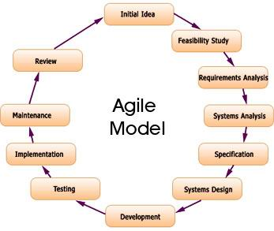

**Figure 2.2.1.1 - Agile Development Model**

All of the phases in the implemented modal are included in the scope of this project and are the responsibilities of the team.

#### 2.2.2 Roles and Responsibilities

|  |  |  |  |
| --- | --- | --- | --- |
| No | Full name | Role in Group | Responsibilities |
| 1 | Lam Huu Khanh Phuong | Supervisor | * Tracking & managing progress * Advising Idea & solutions * Suggesting & supporting in technologies |
| 2 | Le Khoi Phong | Team Leader | * Tracking & managing progress * Designing database * Creating coding framework * Analyzing requirements * Planning & scheduling * Coding * GUI Design * Testing * Writing documents & reports |
| 3 | Dao Nhu Tung | Team member | * Analyzing requirements * Coding * Writing documents * Testing |
| 4 | Cong Minh Hieu | Team member | * Analyzing requirements * Coding * Writing documents * Testing |
| 5 | Nguyen Thanh Tung | Team member | * Analyzing requirements * Coding * Writing documents * Testing |
| 6 | Dang Quoc Duy | Team member | * Analyzing requirements * Coding * Writing documents * Testing |

Table 1: Roles and Responsibilities

#### 2.2.3 Tools and Techniques

**Tools:**

* *Microsoft Visual Studio 2012*: Used to implement software modules.
* *Microsoft SQL server 2012 Express*: Used as the database of the system.
* *Microsoft Excel*: For the team leader to manage tasks of the members and the progress of the project.
* *Microsoft Project 2010*: for team tracking
* *TortoiseSVN*: Control Source code of the whole project.
* *VisualSVN*: extension for using subversion (SVN) inside Visual Studio.
* *Assembla:* SVN Repository
* *Idea Software Modeler:* Draw Diagram and Use case
* *moqups.com:* for prototyping
* *Google Chrome, Firefox*: Used to test the system

**Technologies:**

* ASP.NET MVC 4
* LINQ
* HTML 5, CSS 3, AJAX, jQuery, Knockoutjs, Lesscss, Bootstrap

### 2.3 Project management Plan

#### 2.3.1 Tasks

|  |  |
| --- | --- |
| **Scope Study and Technology** | |
| Description | General requirements analysis, technology & business process study |
| Deliverables | The feasibility report and decisions for the project |
| Resources Needed | 25 man-days |
| Dependencies and Constraints | N/A |
| Risks | * The project or the chosen technology is not feasible. * Team members don’t |
| **Documentation and review** | |
| Description | Create all the necessary documents for research and delivery |
| Deliverables | 1. Project Management Plan (PMP) 2. Software Requirements Specification (SRS) 3. Create Software Architecture Design (SAD) 4. Software Design Description (SDD) 5. Software Test Documentation (STD) 6. Software User’s Manual (SUM) |
| Resources Needed | FPT templates,  75 man-day |
| Dependencies and Constraints | Follow FPT templates |
| Risks | * Not follow FPT Templates * Team members lack experience in creating documents, * Bootle-Neck in review because lack of resources that have experience in review * Requirements are changing so quickly, CR appears |
| **GUI design and implementation** | |
| Description | Design user interface |
| Deliverables | Prototype (in HTML & PNG format) |
| Resources Needed | 25 man-days |
| Dependencies and Constraints | Web Application |
| Risks | * CR appears frequently * Lack of Desinger and HCI experience * Not all team members can design front-end (2/4 Members can design) |
| **Implementation** | |
| Description | Create the executable files |
| Deliverables | Solution (SLN) with all needed project files. |
| Resources Needed | Visual Studio 2012, .NET framework 4.5, Web browsers  200 man-days |
| Dependencies and Constraints | * All Teammembers should understand their module precisely * All Teammember have to experience the MVC4.0, and EF5 |
| Risks | * Team members don’t have experience with Technologies * Some function and modules are underestimate so can keep the deadline * Coding not follow conventions. |
| **Release and deployment** | |
| Description | Release the complete application and deploy it on the server |
| Deliverables | DropIt installation file and all the related documents (SUM) |
| Resources Needed | Installation package  10 man-days |
| Dependencies and Constraints | Meet the user requirements |
| Risks | * Can’t baseline and release on time |
| **Quality control** | |
| Description | Testing application’s performance and usability |
| Deliverables | STD |
| Resources Needed | QA, testers (team member),members), FPT template test case  75 man-days |
| Dependencies and Constraints | Follow FPT template test case |
| Risks | * Bug rate is very high * Some bugs can detect from Implementation by Perform UT not by IT * Test cases doesn’t meet the LOCs |
| **Human resource management** | |
| Description | Manage human resource, task assignments and member’s performances |
| Deliverables | Project Task List – Assignment Table sheet |
| Resources Needed | Project Task List |
| Dependencies and Constraints | N/A |
| Risks | * First time teamwork together * Communication Risk |

#### 2.3.2 Task Sheet: Assignment and Timetable

|  |  |  |  |  |
| --- | --- | --- | --- | --- |
| Task Name | Duration | Start | Finish | Resource Names |
| **Initiating** | **0.5 days** | **Fri 5/3/13** | **Fri 5/3/13** |  |
| **Planning** | **2 days** | **Sat 5/4/13** | **Tue 5/7/13** |  |
| Prepare project introduction | 1 day | Sat 5/4/13 | Sat 5/4/13 |  |
| Develop Software Management Plan | 2 days | Sun 5/5/13 | Mon 5/6/13 |  |
| Review Project Plan | 1 day | Tue 5/7/13 | Tue 5/7/13 |  |
| **Analyzing** | **7 days** | **Wed 5/8/13** | **Thu 5/16/13** |  |
| Define Problem | 2 days | Wed 5/8/13 | Thu 5/9/13 |  |
| Analyzing Ticket.st | 5 days | Fri 5/10/13 | Thu 5/16/13 |  |
| **Mockup & HTML** | **10 days** | **Fri 5/17/13** | **Thu 5/30/13** |  |
| Seller's functions mockup | 3 days | Fri 5/17/13 | Tue 5/21/13 | N.Tùng |
| Buyer's functions mockup | 3 days | Fri 5/17/13 | Tue 5/21/13 | Hiếu |
| User's function mockup | 3 days | Fri 5/17/13 | Tue 5/21/13 | T.Tùng |
| Seller's functions HTML | 7 days | Wed 5/22/13 | Thu 5/30/13 | N.Tùng,Phong |
| Buyer's functions HTML | 7 days | Wed 5/22/13 | Thu 5/30/13 | Hiếu,Phong |
| User's function HTML | 7 days | Wed 5/22/13 | Thu 5/30/13 | T.Tùng |
| **Design** | **11 days** | **Wed 5/22/13** | **Thu 6/6/13** |  |
| ERD Design | 0 days | Wed 5/22/13 | Wed 5/22/13 | N.Tùng |
| Database design | 7 days | Thu 5/23/13 | Fri 5/31/13 | Team |
| Graphic design | 11 days | Thu 5/23/13 | Thu 6/6/13 | Phong |
| **Coding** | **20 days** | **Mon 6/3/13** | **Fri 6/28/13** |  |
| **Buyer's functions** | **20 days** | Mon 6/3/13 | **Fri 6/28/13** | **Hiếu,Phong** |
| Create Basic Design (Architecture Design) | 6 days | Mon 6/3/13 | Mon 6/10/13 |  |
| Review Basic Design | 2 days | Mon 6/10/13 | Tue 6/11/13 |  |
| Create Detail Design | 4 days | Wed 6/12/13 | Mon 6/17/13 |  |
| Review Detail Design | 1 day | Tue 6/18/13 | Tue 6/18/13 |  |
| Coding | 5 days | Wed 6/19/13 | Tue 6/25/13 |  |
| Coding Review | 1 day | Wed 6/26/13 | Wed 6/26/13 |  |
| Unit Testing | 2 days | Thu 6/27/13 | Fri 6/28/13 |  |
| **Seller's functions** | **20 days** | **Mon 6/3/13** | **Fri 6/28/13** | **N.Tùng,Phong** |
| Create Basic Design (Architecture Design) | 6 days | Mon 6/3/13 | Mon 6/10/13 |  |
| Review Basic Design | 2 days | Mon 6/10/13 | Tue 6/11/13 |  |
| Create Detail Design | 4 days | Wed 6/12/13 | Mon 6/17/13 |  |
| Review Detail Design | 1 day | Tue 6/18/13 | Tue 6/18/13 |  |
| Coding | 5 days | Wed 6/19/13 | Tue 6/25/13 |  |
| Coding Review | 1 day | Wed 6/26/13 | Wed 6/26/13 |  |
| Unit Testing | 2 days | Thu 6/27/13 | Fri 6/28/13 |  |
| **User's functions** | **20 days** | **Mon 6/3/13** | **Fri 6/28/13** | **T.Tùng,Duy,Phong** |
| Create Basic Design (Architecture Design) | 6 days | Mon 6/3/13 | Mon 6/10/13 |  |
| Review Basic Design | 2 days | Mon 6/10/13 | Tue 6/11/13 |  |
| Create Detail Design | 4 days | Wed 6/12/13 | Mon 6/17/13 |  |
| Review Detail Design | 1 day | Tue 6/18/13 | Tue 6/18/13 |  |
| Coding | 5 days | Wed 6/19/13 | Tue 6/25/13 |  |
| Coding Review | 1 day | Wed 6/26/13 | Wed 6/26/13 |  |
| Unit Testing | 2 days | Thu 6/27/13 | Fri 6/28/13 |  |
| **Testing** | **30 days** | **Mon 7/1/13** | **Fri 8/9/13** | **Team** |
| Project Scope Studying | 5 days | Mon 7/1/13 | Fri 7/5/13 |  |
| Create Test View Point Document | 5 days | Sun 7/14/13 | Thu 7/18/13 |  |
| Review Test Viewpoint Document | 1 day | Fri 7/19/13 | Fri 7/19/13 |  |
| Create Integration Test Case Document | 7 days | Sat 7/20/13 | Mon 7/29/13 |  |
| Review Integration Test Case Document | 1 day | Tue 7/30/13 | Tue 7/30/13 |  |
| Perform Test | 7 days | Wed 7/31/13 | Thu 8/8/13 |  |
| Review Test Report | 1 day | Thu 8/8/13 | Thu 8/8/13 |  |
| Deliverable: Test Report | 0 days | Fri 8/9/13 | Fri 8/9/13 |  |
| Monitoring and Controlling | 57.04 days | Wed 5/22/13 | Fri 8/9/13 | Phong |

### 2.4 Coding Convention

#### 2.4.1 Naming Convention

* Do not use consecutive underscores in name.
* Do not use Hungarian style.

#### 2.4.2 Lengths

* Public name should not be longer than 32 characters or 7 words.
* Methods should contain no more than 100 lines of code (if it is, it must be divided into methods).
* Methods should contain no more than 7 levels of indentation (if it is, it must be divided into methods).
* A line of code should contain no more than 80 characters.

## Software Requirements Specifications (SRS)

### 3.1 User Requirement Specification

#### 3.1.1 Common Features

* Only authenticated users can access the system. Users can log in and log out using their own accounts.
* All guests or authorized users can view, sort, search event.
* Only authorized users, customer, and admin can use specific functions of the system.

#### 3.1.2 Customer

* Users can follow/unfollow event.
* User can view list of follow event.
* User can buy ticket accept their own tickets.
* Users can view transaction(buy and sell) history.
* User can request ticket on event, or they can response request if they have corresponding ticket.
* User can claim for transaction when received ticket got problem(in 5 days since received ticket).
* If user wants to sell a ticket, they have to provide their bank account, and must be approved by admin.
* User can post 1 ticket one time.
* For each sold ticket, website got 7% (can change in the future) on ticket price for website transaction fee.
* User can view other profile of rating.
* User can receive notification when they follow on something, particularly real – time notification.

#### 3.1.3 Admin

* Admin is responsible for managing category, event, user, transaction, venue, request, ticket, setting

#### 3.1.4 Guest

* They can only view, search, sort event and ticket but they cannot use authorized user functions

#### 3.1.5 System

* System can send notify message automatically.
* Sytem can check status of event and transaction after period of time.

#### 3.1.6 Authorized User

* An authorized user can change password and personal information.

### 3.2 System Requirement Specification

#### 3.2.1 External Interface Requirements

##### **3.2.1.1 User Interfaces**

* The design should be simple and user-friendly. Violet and dark will be 2 main colors of the website while charts may have more color to visually express data more effectively.
* The menu bar should be on the left and not take too much space of the screen. It consists of the list of main functions of the system that users can access.
* The design should be responsive. It means that the web components should be scaled according to a range of resolutions and devices to provide a consistent experience, no matter what.

##### **3.2.1.2 Hardware Interfaces**

* To access to the system, users only need any type of computer, tablet, or mobile phone with a fair internet connection.

##### **3.2.1.3 Software Interfaces**

* At the server side, the system should run on top of Windows 7, Windows Server 2012 or later versions of Windows Server. Besides, Microsoft .NET Framework 4.5 and MVC 4 should be installed on the server. The database management system use for SMDH is SQL Server 2012.
* At the client side, users can use any modern browser that supports JavaScript and HTML 5 to access to the system.

##### 3.2.1.4 Communications Protocol

HTTP is the protocol used for loading the web site in browsers.

#### 3.2.2 System Features

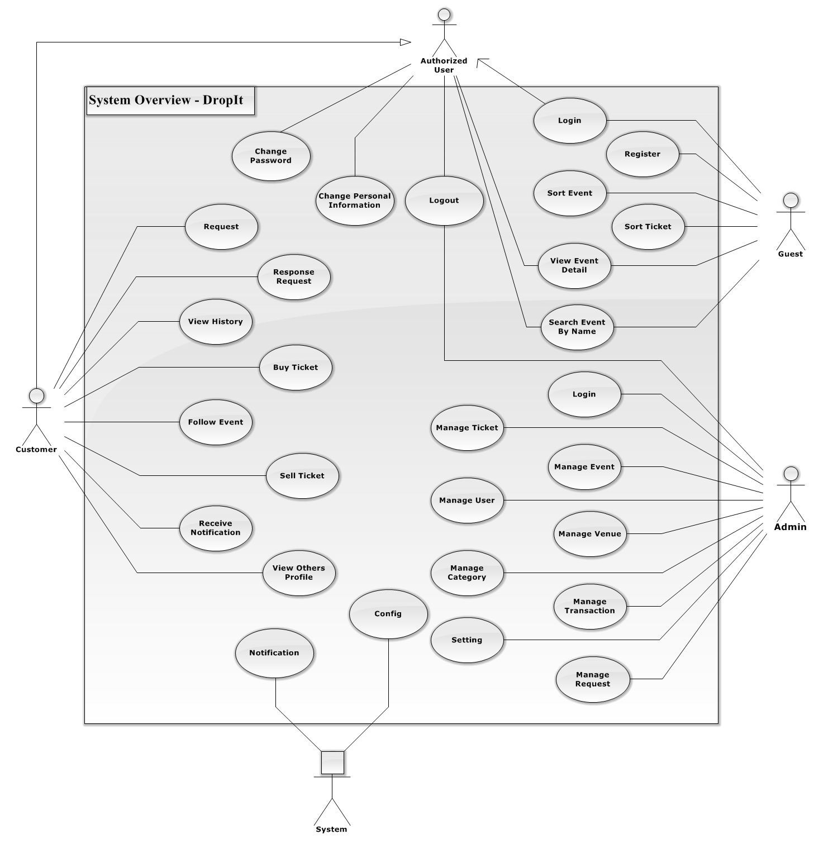

**Figure 3.2.2.1 - General Use Case Diagram**

##### **3.2.2.1 Admin**

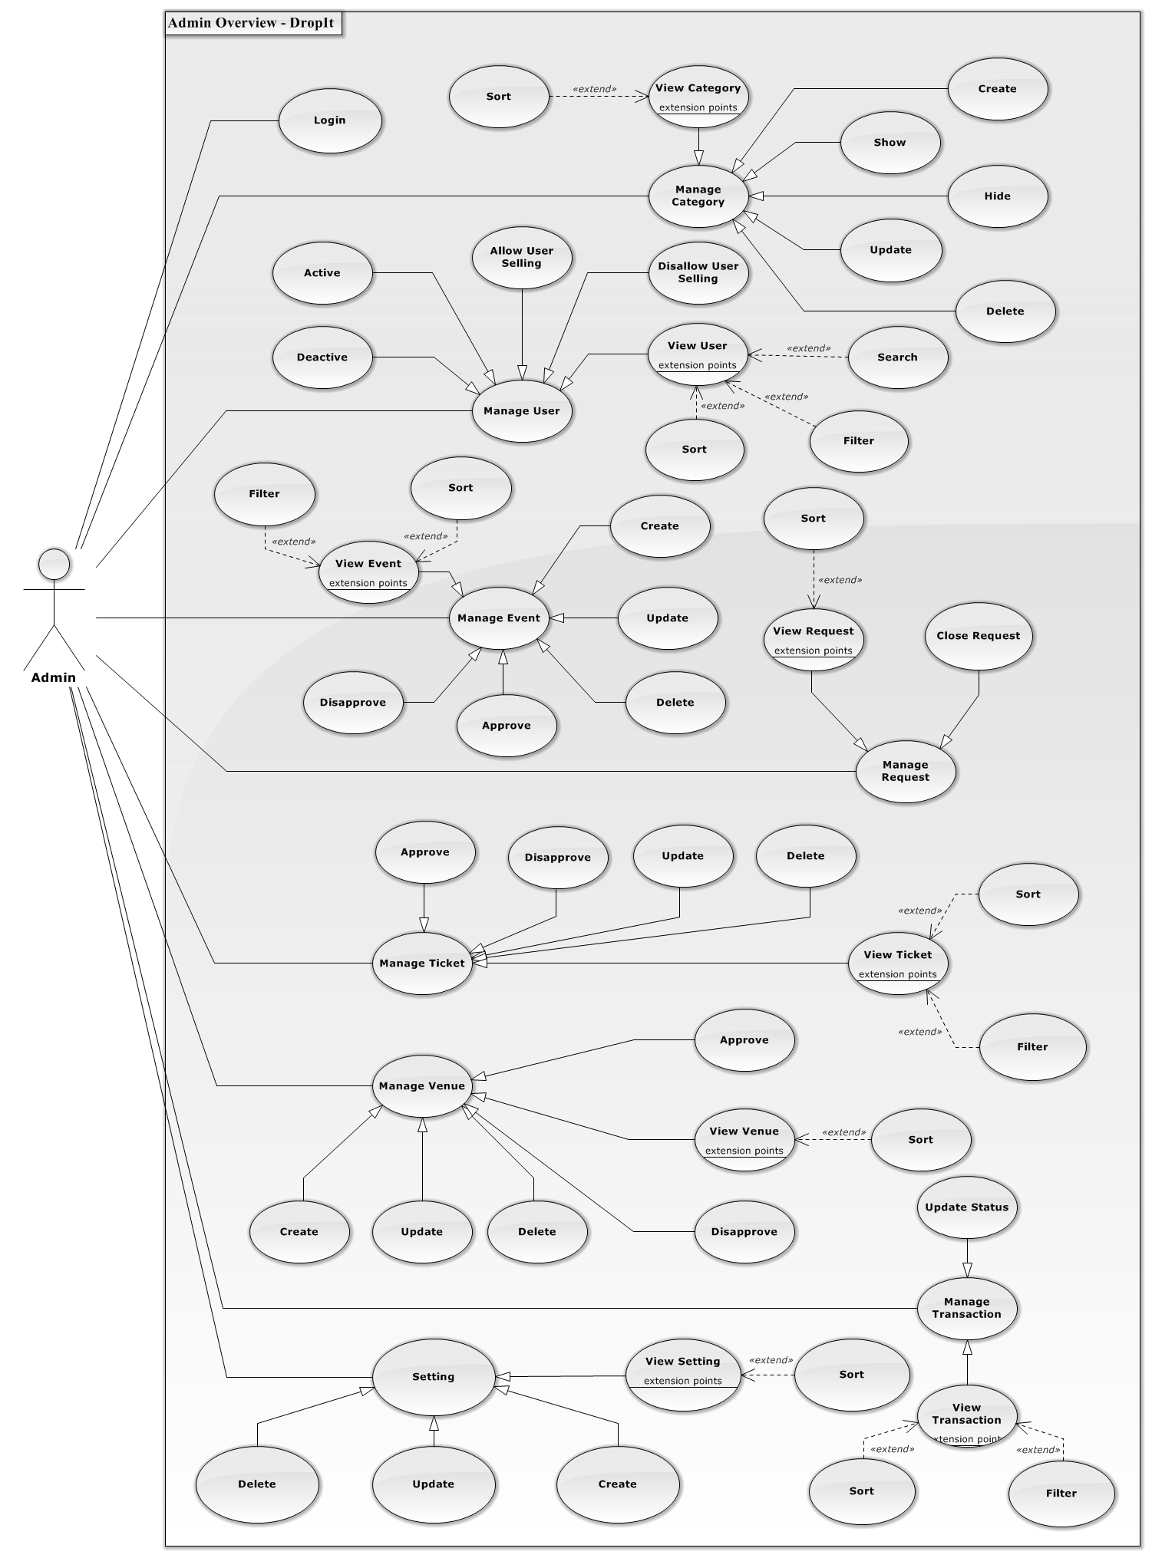

**Figure 3.2.2.1.1 - Admin Overview Diagram**

###### **3.2.2.1.1 Login**

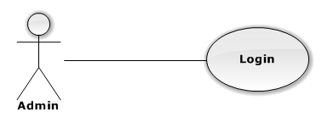

|  |  |  |  |
| --- | --- | --- | --- |
| USE CASE – LOGIN | | | |
| Use-case No. | UC01.01 | Use-case Version | 1.0 |
| Use-case Name | Login | | |
| Author | TungNT | | |
| Date | 06/01/2013 | Priority | Normal |
| **Actor:** Admin  **Summary:** This use case is about how Admin login to website  **Goal:** Login to Admin page successful  **Triggers:** N/A  **Pre-conditions:** N/A  **Post-conditions:** Admin is logged into the system successful  **Main Success Scenario:**   |  |  |  | | --- | --- | --- | | Step | Actor Action | System Response | | 1 | Go to [http://localhost:2065](http://localhost:2065/)/Account/AdminLogin | Navigate to Admin Login page | | 2 | Fill mandatory fields and click “Đăng nhập” button | Navigate to Admin homepage |   **Alternative Scenario:** N/A  **Exceptions:**   |  |  |  | | --- | --- | --- | | Step | Actor Action | System Response | | 1 | Same as Main Success Scenario | | | 2 | Dos not fill all required field | Display warning message to notify the missing field | | 2 | Enter invalid data (wrong password or wrong username) | Display warning message “Tên đăng nhập hoặc mật khẩu không đúng” |   **Relationships:**  N/A  **Business Rules:** N/A | | | |

###### **3.2.2.1.2 View Category**

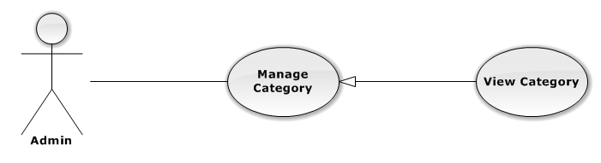

|  |  |  |  |
| --- | --- | --- | --- |
| USE CASE – VIEW CATEGORY | | | |
| Use-case No. | UC01.02 | Use-case Version | 1.0 |
| Use-case Name | View Category | | |
| Author | TungNT | | |
| Date | 06/01/2013 | Priority | Normal |
| **Actor:** Admin  **Summary:** This use case is about how admin view category  **Goal:** View category successful  **Triggers:** N/A  **Pre-conditions:** N/A  **Post-conditions:** N/A  **Main Success Scenario:**   |  |  |  | | --- | --- | --- | | Step | Actor Action | System Response | | 1 | Click on “Danh mục” tab | Navigate to Manage Category page | | 2 | Click “Hiển thị” tab | Display showed category list | | 3 | Click “Không hiển thị” tab | Display not showed category list |   **Alternative Scenario:**   |  |  |  | | --- | --- | --- | | Step | Actor Action | System Response | | 1 | Click on “Danh mục” tab | Navigate to Manage Category page | | 2 | Click “Hiển thị” tab or “Không hiển thị” tab | Display showed/hidden category list | | 3 | Click on “Tên danh mục” label | Display list of categories sort by category name |   **Exceptions:**  N/A  **Relationships:**  N/A  **Business Rules:** N/A | | | |

###### **3.2.2.1.3 Create Category**

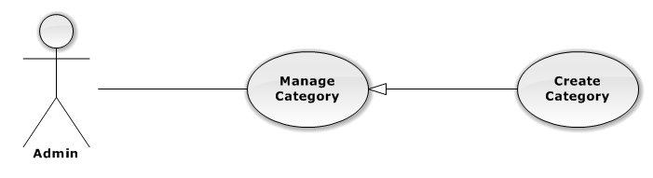

|  |  |  |  |
| --- | --- | --- | --- |
| USE CASE – CREATE CATEGORY | | | |
| Use-case No. | UC01.03 | Use-case Version | 1.0 |
| Use-case Name | Create Category | | |
| Author | TungNT | | |
| Date | 06/01/2013 | Priority | Normal |
| **Actor:** Admin  **Summary:** This use case is about how to create category  **Goal:** Create category successful  **Triggers:** N/A  **Pre-conditions:** N/A  **Post-conditions:** Category is created  **Main Success Scenario:**   |  |  |  | | --- | --- | --- | | Step | Actor Action | System Response | | 1 | Click on “Danh mục” tab | Navigate to Manage Category page | | 2 | Click “Tạo danh mục” button | Show create new category page | | 3 | Fill mandatory fields and click “Tạo mới” button | - Validate, check conflict and save data  - Navigate to Manage Category page |   **Alternative Scenario:**  N/A  **Exceptions:**   |  |  |  | | --- | --- | --- | | Step | Actor Action | System Response | | 1 | Same as Main Success Scenario | | | 2 | Same as Main Success Scenario | | | 3 | Does not fill all required field or enters invalid data | Display warning message to notify the missing field or invalid data |   **Relationships:**  N/A  **Business Rules:** N/A | | | |

###### **3.2.2.1.4 Update Category**

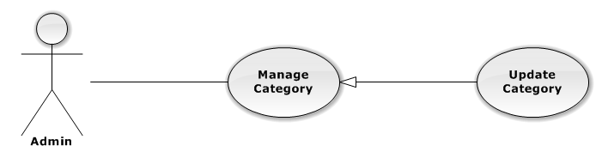

|  |  |  |  |
| --- | --- | --- | --- |
| USE CASE – UPDATE CATEGORY | | | |
| Use-case No. | UC01.04 | Use-case Version | 1.0 |
| Use-case Name | Update Category | | |
| Author | TungNT | | |
| Date | 06/01/2013 | Priority | Normal |
| **Actor:** Admin  **Summary:** This use case is about how to update category after created  **Goal:** Category is updated  **Triggers:** N/A  **Pre-conditions:** Category is already created  **Post-conditions:** Update category successful  **Main Success Scenario:**   |  |  |  | | --- | --- | --- | | Step | Actor Action | System Response | | 1 | Click on “Danh mục” tab | Navigate to Manage Category page | | 2 | Click on “Hiển thị” tab | Navigate to list of shown Category | | 3 | Click on a category | Show update category form | | 4 | Fill mandatory fields and click “Cập nhật” button | Does validation, checks conflict and save data  Navigate back to manage Category page |   **Alternative Scenario:**  N/A  **Exceptions:**   |  |  |  | | --- | --- | --- | | Step | Actor Action | System Response | | 1 | Same as Main Success Scenario | | | 2 | Same as Main Success Scenario | | | 3 | Same as Main Success Scenario | | | 4 | Does not fill all required field or enters invalid data | Display warning message to notify the missing field or invalid data |   **Relationships:**  N/A  **Business Rules:** N/A | | | |

###### **3.2.2.1.5 Delete Category**

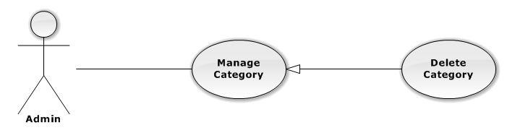

|  |  |  |  |
| --- | --- | --- | --- |
| USE CASE – DELETE CATEGORY | | | |
| Use-case No. | UC01.05 | Use-case Version | 1.0 |
| Use-case Name | Delete Category | | |
| Author | TungNT | | |
| Date | 06/01/2013 | Priority | Normal |
| **Actor:** Admin  **Summary:** This use case is about how to delete category after created  **Goal:** Category is deleted  **Triggers:** N/A  **Pre-conditions:** N/A  **Post-conditions:** Delete category successful  **Main Success Scenario:**   |  |  |  | | --- | --- | --- | | Step | Actor Action | System Response | | 1 | Click on “Danh mục” tab | Navigate to Manage Category page | | 2 | Choose Category and click “Xóa” button | Show confirm message | | 3 | Click “Yes” button | Selected category is deleted successfully |   **Alternative Scenario:**  N/A  **Exceptions:** N/A  **Relationships:**  N/A  **Business Rules:** N/A | | | |

###### **3.2.2.1.6 Hide Category**

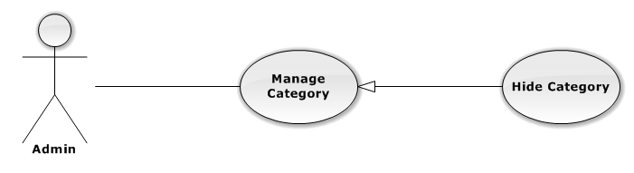

|  |  |  |  |
| --- | --- | --- | --- |
| USE CASE – HIDE CATEGORY | | | |
| Use-case No. | UC01.06 | Use-case Version | 1.0 |
| Use-case Name | Hide Category | | |
| Author | TungNT | | |
| Date | 06/01/2013 | Priority | Normal |
| **Actor:** Admin  **Summary:** This use case is about how to hide category after created  **Goal:** Category is hidden  **Triggers:** N/A  **Pre-conditions:** Category is shown  **Post-conditions:** Hide category successful  **Main Success Scenario:**   |  |  |  | | --- | --- | --- | | Step | Actor Action | System Response | | 1 | Click on “Danh mục” tab | Navigate to Manage Category page | | 2 | Choose Category in shown category and click “Ẩn” button | Selected category is hidden successfully |   **Alternative Scenario:**  N/A  **Exceptions:** N/A  **Relationships:**  N/A  **Business Rules:** N/A | | | |

###### **3.2.2.1.7 Show Category**

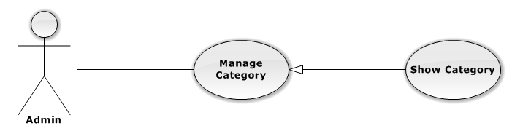

|  |  |  |  |
| --- | --- | --- | --- |
| USE CASE – SHOW CATEGORY | | | |
| Use-case No. | UC01.07 | Use-case Version | 1.0 |
| Use-case Name | Show Category | | |
| Author | TungNT | | |
| Date | 06/01/2013 | Priority | Normal |
| **Actor:** Admin  **Summary:** This use case is about how to show category after hidden  **Goal:** Category is shown  **Triggers:** N/A  **Pre-conditions:** Category is hidden  **Post-conditions:** Show category successful  **Main Success Scenario:**   |  |  |  | | --- | --- | --- | | Step | Actor Action | System Response | | 1 | Click on “Danh mục” tab | Navigate to Manage Category page | | 2 | Choose Category in hidden category and click “Hiện” button | Selected category is shown successfully |   **Alternative Scenario:**  N/A  **Exceptions:** N/A  **Relationships:**  N/A  **Business Rules:** N/A | | | |

###### **3.2.2.1.8 View User**

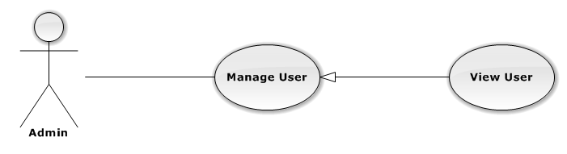

|  |  |  |  |
| --- | --- | --- | --- |
| USE CASE – VIEW USER | | | |
| Use-case No. | UC01.08 | Use-case Version | 1.0 |
| Use-case Name | View User | | |
| Author | TungNT | | |
| Date | 06/01/2013 | Priority | Normal |
| **Actor:** Admin  **Summary:** This use case is about admin view users  **Goal:** View users successful  **Triggers:** N/A  **Pre-conditions:** N/A  **Post-conditions:** N/A  **Main Success Scenario:**   |  |  |  | | --- | --- | --- | | Step | Actor Action | System Response | | 1 | Click on “Người dùng” tab | - Navigate to Manage User page  - Display list of users | | 2 | Click on a user | Display user information |   **Alternative Scenario:**   |  |  |  | | --- | --- | --- | | Step | Actor Action | System Response | | 1 | Click on “Người dùng” tab | - Navigate to Manage User page  - Display lst of users | | 2 | Input string want to search into  search box | Display information normally | | 3 | Click “Tìm kiếm” button or press  enter key | Display search user result in user field | | 4 | Click on “Username” label | Display list of users sort by user name |  |  |  |  | | --- | --- | --- | | Step | Actor Actin | System Response | | 1 | Click on “Người dùng” tab | - Navigate to Manage User page  - Display list of users | | 2 | Check on “Tất cả” box in “Kích  hoạt”field/ Check on “Tất cả” box in  “quyền đăng bán”field | Display list of all users | | 3 | Check on “Được kích hoạt” box in  “Kích hoạt”field or Check on “Được  bán” box in “quyền đăng bán”field | Display list of active users or Display list  of allowed selling users | | 4 | Check on “Không kích hoạt” box in  “Bộ lọc”field or Check on “Không  được bán” box in “quyền đăng  bán”field | Display list of deactive users or Display  list of disallowed selling users |   **Exceptions:** N/A  **Relationships:**  N/A  **Business Rules:** N/A | | | |

###### **3.2.2.1.9 Active User**

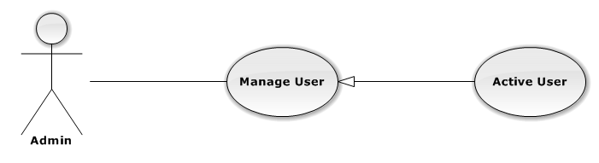

|  |  |  |  |
| --- | --- | --- | --- |
| USE CASE – ACTIVE USER | | | |
| Use-case No. | UC01.09 | Use-case Version | 1.0 |
| Use-case Name | Active User | | |
| Author | TungNT | | |
| Date | 06/01/2013 | Priority | Normal |
| **Actor:** Admin  **Summary:** This use case is about how to active a user  **Goal:** Active user successful  **Triggers:** N/A  **Pre-conditions:** User is deactivate  **Post-conditions:** User is activate  **Main Success Scenario:**   |  |  |  | | --- | --- | --- | | Step | Actor Action | System Response | | 1 | Click on “Người dùng” tab | Navigate to Manage User page | | 2 | Choose user want to active and check on “Kích hoạt” box | - Active user successful  - Display message active user success on top |   **Alternative Scenario:**  N/A  **Exceptions:** N/A  **Relationships:**  N/A  **Business Rules:** N/A | | | |

###### **3.2.2.1.10 Deactive User**

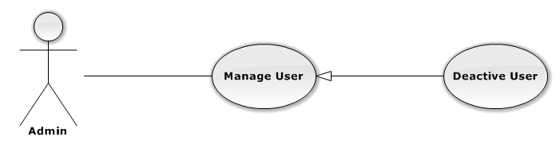

|  |  |  |  |
| --- | --- | --- | --- |
| USE CASE – DEACTIVE USER | | | |
| Use-case No. | UC01.10 | Use-case Version | 1.0 |
| Use-case Name | Deactive User | | |
| Author | TungNT | | |
| Date | 06/01/2013 | Priority | Normal |
| **Actor:** Admin  **Summary:** This use case is about how to deactive a user  **Goal:** Deactive user successful  **Triggers:** N/A  **Pre-conditions:** User is activate  **Post-conditions:** User is deactivate  **Main Success Scenario:**   |  |  |  | | --- | --- | --- | | Step | Actor Action | System Response | | 1 | Click on “User” button | Navigate to Manage User page | | 2 | Choose user want to deactive and uncheck “Kích hoạt” box | - Deactive user successful  - Display message active user success on top |   **Alternative Scenario:**  N/A  **Exceptions:** N/A  **Relationships:**  N/A  **Business Rules:** N/A | | | |

###### **3.2.2.1.11 Allow User Selling**

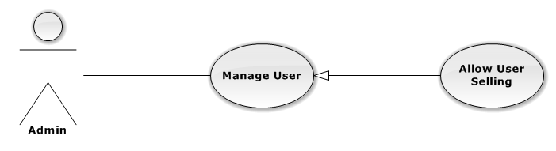

|  |  |  |  |
| --- | --- | --- | --- |
| USE CASE – ALLOW USER SELLING | | | |
| Use-case No. | UC01.11 | Use-case Version | 1.0 |
| Use-case Name | Allow User Selling | | |
| Author | TungNT | | |
| Date | 06/01/2013 | Priority | Normal |
| **Actor:** Admin  **Summary:** This use case is about how to allow user selling  **Goal:** Allow user selling successful  **Triggers:** N/A  **Pre-conditions:** User is disallowed to sell  **Post-conditions:** User is allowed to sell  **Main Success Scenario:**   |  |  |  | | --- | --- | --- | | Step | Actor Action | System Response | | 1 | Click on “User” button | Navigate to Manage User page | | 2 | Choose user want to allow selling and tickon “Được bán” checkbox | - Allow user selling successful  - Display message allow user selling success on top |   **Alternative Scenario:**  N/A  **Exceptions:** N/A  **Relationships:**  N/A  **Business Rules:** N/A | | | |

###### **3.2.2.1.12 Disallow User Selling**

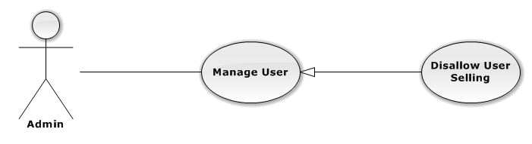

|  |  |  |  |
| --- | --- | --- | --- |
| USE CASE – DISALLOW USER SELLING | | | |
| Use-case No. | UC01.12 | Use-case Version | 1.0 |
| Use-case Name | Disallow User Selling | | |
| Author | TungNT | | |
| Date | 06/01/2013 | Priority | Normal |
| **Actor:** Admin  **Summary:** This use case is about how to disallow user selling  **Goal:** Disallow user selling successful  **Triggers:** N/A  **Pre-conditions:** User is allowed to sell  **Post-conditions:** User is disallowed to sell  **Main Success Scenario:**   |  |  |  | | --- | --- | --- | | Step | Actor Action | System Response | | 1 | Click on “User” button | Navigate to Manage User page | | 2 | Choose user want to allow selling tick on “Được bá” checkbox | - Allow user selling successful  - Display message disallow user selling success on top |   **Alternative Scenario:**  N/A  **Exceptions:** N/A  **Relationships:**  N/A  **Business Rules:** N/A | | | |

###### **3.2.2.1.13 View Event**

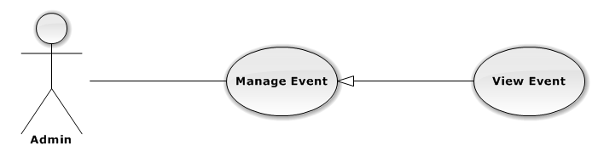

|  |  |  |  |
| --- | --- | --- | --- |
| USE CASE – VIEW EVENT | | | |
| Use-case No. | UC01.13 | Use-case Version | 1.0 |
| Use-case Name | View Event | | |
| Author | TungNT | | |
| Date | 06/01/2013 | Priority | Normal |
| **Actor:** Admin  **Summary:** This use case is about how admin view event  **Goal:** View event successful  **Triggers:** N/A  **Pre-conditions:** N/A  **Post-conditions:** Event is created  **Main Success Scenario:**   |  |  |  | | --- | --- | --- | | Step | Actor Action | System Response | | 1 | Click on “Sự kiện” tab | Navigate to Manage Event page | | 2 | Click “Chưa duyệt” tab | Display disapproved event list | | 3 | Click “Đã duyệt” tab | Display approved event list | | 4 | Click “Đang giao dịch” tab | Display on transaction event list | | 5 | Click “Quá ngày” tab | Display out of date event list |   **Alternative Scenario:**   |  |  |  | | --- | --- | --- | | Step | Actor Action | System Response | | 1 | Click on “Sự kiện” tab | Navigate to Manage Event page | | 2 | Click “Đã duyệt” tab | Display approved event list | | 3 | Select a venue in “Địa điểm” list or Select a category in “Danh mục” list | Display list of events include selected venue or Display list of events include selected category | | 4 | Click on “Tên sự kiện” label or  Click on “Ngày tổ chức” label | Display events sort by event name or Display events sort by hold date |   **Exceptions:** N/A  **Relationships:**  N/A  **Business Rules:** N/A | | | |

###### **3.2.2.1.14 Create Event**

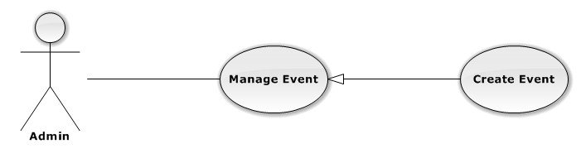

|  |  |  |  |
| --- | --- | --- | --- |
| USE CASE – CREATE EVENT | | | |
| Use-case No. | UC01.14 | Use-case Version | 1.0 |
| Use-case Name | Create Event | | |
| Author | TungNT | | |
| Date | 06/01/2013 | Priority | Normal |
| **Actor:** Admin  **Summary:** This use case is about how to create new event  **Goal:** Create event successful  **Triggers:** N/A  **Pre-conditions:** N/A  **Post-conditions:** Event is created  **Main Success Scenario:**   |  |  |  | | --- | --- | --- | | Step | Actor Action | System Response | | 1 | Click on “Sự kiện” tab | Navigate to Manage Event page | | 2 | Click “Tạo mới” buton | Navigate to Create Event page | | 3 | Fill mandatory fields and click “Tạo mới” button | - Does validation, check conflict and save data  - Navigate back to Event page |   **Alternative Scenario:**  N/A  **Exceptions:**   |  |  |  | | --- | --- | --- | | Step | Actor Action | System Response | | 1 | Same as Main Success Scenario | | | 2 | Same as Main Success Scenario | | | 3 | Does not fill all required field or enters invalid data | Display warning message to notify the missing field or invalid data |   **Relationships:**  N/A  **Business Rules:** N/A | | | |

###### **3.2.2.1.15 Update Event**

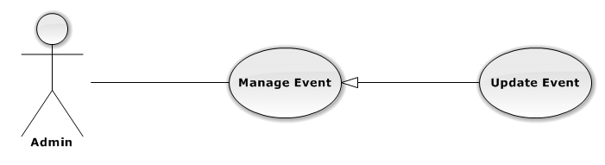

|  |  |  |  |
| --- | --- | --- | --- |
| USE CASE – UPDATE EVENT | | | |
| Use-case No. | UC01.15 | Use-case Version | 1.0 |
| Use-case Name | Update Event | | |
| Author | TungNT | | |
| Date | 06/01/2013 | Priority | Normal |
| **Actor:** Admin  **Summary:** This use case is about how to update event after created  **Goal:** Event is updated  **Triggers:** N/A  **Pre-conditions:** Event is already created  **Post-conditions:** Update event successful  **Main Success Scenario:**   |  |  |  | | --- | --- | --- | | Step | Actor Action | System Response | | 1 | Click on “Event” tab | Navigate to Manage Event page | | 2 | Click on an event | Show Update Event page | | 3 | Fill mandatory fields and click “Cập nhật” button | - Does validation, check conflict and save data  - Navigate back to Event page |   **Alternative Scenario:**  N/A  **Exceptions:**   |  |  |  | | --- | --- | --- | | Step | Actor Action | System Response | | 1 | Same as Main Success Scenario | | | 2 | Same as Main Success Scenario | | | 3 | Does not fill all required field or enters invalid data | Display warning message to notify the missing field or invalid data |   **Relationships:**  N/A  **Business Rules:** N/A | | | |

###### **3.2.2.1.16 Delete Event**

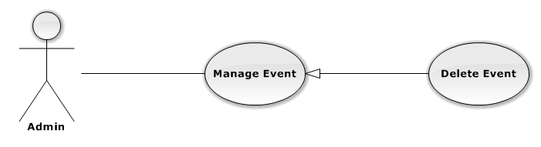

|  |  |  |  |
| --- | --- | --- | --- |
| USE CASE – DELETE EVENT | | | |
| Use-case No. | UC01.16 | Use-case Version | 1.0 |
| Use-case Name | Delete Event | | |
| Author | TungNT | | |
| Date | 06/01/2013 | Priority | Normal |
| **Actor:** Admin  **Summary:** This use case is about how to delete an event after created  **Goal:** Event is deleted  **Triggers:** N/A  **Pre-conditions:** Event is already disapproved or out date  **Post-conditions:** Delete event successful  **Main Success Scenario:**   |  |  |  | | --- | --- | --- | | Step | Actor Action | System Response | | 1 | Click on “Event” tab | Navigate to Manage Event page | | 2 | Click on “Chưa duyệt” tab or “Quá  ngày” tab | Show list of disapproved events | | 3 | Choose event and click “Xóa” button | Show confirm message | | 4 | Click “Yes” button | Selected event is deleted successfully |   **Alternative Scenario:**  N/A  **Exceptions:** N/A  **Relationships:**  N/A  **Business Rules:** N/A | | | |

###### **3.2.2.1.17 Approve Event**

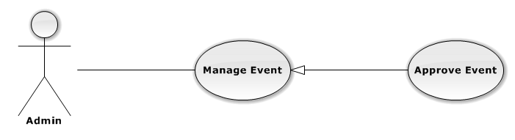

|  |  |  |  |
| --- | --- | --- | --- |
| USE CASE – APPROVE EVENT | | | |
| Use-case No. | UC01.17 | Use-case Version | 1.0 |
| Use-case Name | Approve Event | | |
| Author | TungNT | | |
| Date | 06/01/2013 | Priority | Normal |
| **Actor:** Admin  **Summary:** This use case is about how to approve an event after created  **Goal:** Event is approved  **Triggers:** N/A  **Pre-conditions:** Event is already disapproved  **Post-conditions:** Approved event successful  **Main Success Scenario:**   |  |  |  | | --- | --- | --- | | Step | Actor Action | System Response | | 1 | Click on “Event” tab | Navigate to Manage Event page | | 2 | Click on “Chưa duyệt” tab | Show list of disapproved events | | 3 | Choose event and click “Duyệt” button | Selected event is approved successful |   **Alternative Scenario:**  N/A  **Exceptions:** N/A  **Relationships:**  N/A  **Business Rules:** N/A | | | |

###### **3.2.2.1.18 Disapprove Event**

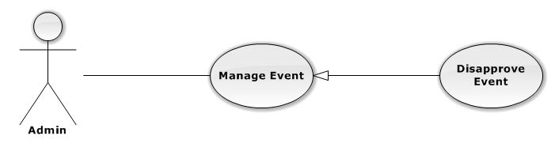

|  |  |  |  |
| --- | --- | --- | --- |
| USE CASE – DISAPPROVE EVENT | | | |
| Use-case No. | UC01.18 | Use-case Version | 1.0 |
| Use-case Name | Disapprove Event | | |
| Author | TungNT | | |
| Date | 06/01/2013 | Priority | Normal |
| **Actor:** Admin  **Summary:** This use case is about how to disapprove an event after created  **Goal:** Event is disapproved  **Triggers:** N/A  **Pre-conditions:** Event is already approved  **Post-conditions:** Disapproved event successful  **Main Success Scenario:**   |  |  |  | | --- | --- | --- | | Step | Actor Action | System Response | | 1 | Click on “Event” tab | Navigate to Manage Event page | | 2 | Click on “Đã duyệt” tab | Show list of approved events | | 3 | Choose event and click “Bỏ duyệt” button | Selected event is disapproved successully |   **Alternative Scenario:**  N/A  **Exceptions:** N/A  **Relationships:**  N/A  **Business Rules:** N/A | | | |

###### **3.2.2.1.19 View Request**

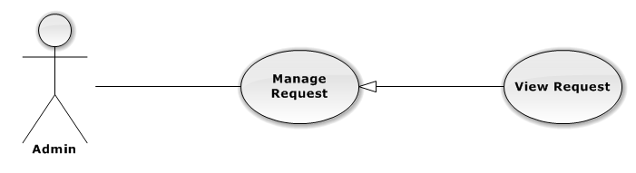

|  |  |  |  |
| --- | --- | --- | --- |
| USE CASE – VIEW REQUEST | | | |
| Use-case No. | UC01.19 | Use-case Version | 1.0 |
| Use-case Name | View Request | | |
| Author | TungNT | | |
| Date | 06/01/2013 | Priority | Normal |
| **Actor:** Admin  **Summary:** This use case is about how admin view request  **Goal:** Admin view request successful  **Triggers:** N/A  **Pre-conditions:** N/A  **Post-conditions:** N/A  **Main Success Scenario:**   |  |  |  | | --- | --- | --- | | Step | Actor Action | System Response | | 1 | Click on “Yêu cầu” tab | Navigate to Manage Request page |   **Alternative Scenario:**   |  |  |  | | --- | --- | --- | | Step | Actor Action | System Response | | 1 | Click on “Yêu cầu” tab | Navigate to Manage Request page | | 2 | Click on “Sự kiện” label or Click on  “Người đăng” label | Display requests sort by event name or  Display requests sort by user name |   **Exceptions:** N/A  **Relationships:**  N/A  **Business Rules:** N/A | | | |

###### **3.2.2.1.20 Close Request**

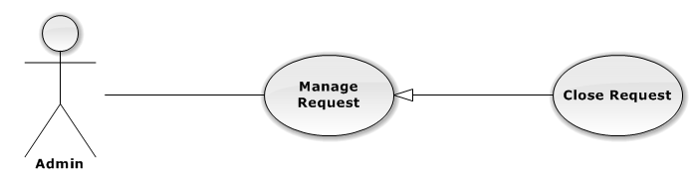

|  |  |  |  |
| --- | --- | --- | --- |
| USE CASE – CLOSE REQUEST | | | |
| Use-case No. | UC01.20 | Use-case Version | 1.0 |
| Use-case Name | Close Request | | |
| Author | TungNT | | |
| Date | 06/01/2013 | Priority | Normal |
| **Actor:** Admin  **Summary:** This use case is about how to close request after created  **Goal:** N/A  **Triggers:** N/A  **Pre-conditions:** Request is created  **Post-conditions:** Close request successful  **Main Success Scenario:**   |  |  |  | | --- | --- | --- | | Step | Actor Action | System Response | | 1 | Click on “Yêu cầu” tab | Navigate to Manage Request page | | 2 | Choose request want to close and click on “Đóng” button | Display confirm message | | 3 | Click on “Yes” button | Selected request is closed successful |   **Alternative Scenario:**  N/A  **Exceptions:** N/A  **Relationships:**  N/A  **Business Rules:** N/A | | | |

###### **3.2.2.1.21 View Ticket**

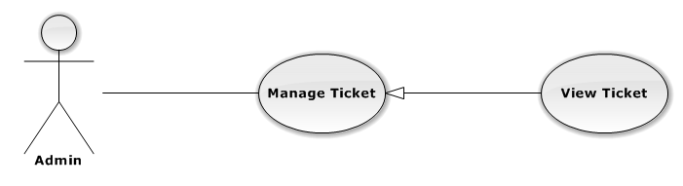

|  |  |  |  |
| --- | --- | --- | --- |
| USE CASE – VIEW TICKET | | | |
| Use-case No. | UC01.21 | Use-case Version | 1.0 |
| Use-case Name | View Ticket | | |
| Author | TungNT | | |
| Date | 06/01/2013 | Priority | Normal |
| **Actor:** Admin  **Summary:** This use case is about how admin view ticket  **Goal:** View ticket successful  **Triggers:** N/A  **Pre-conditions:** N/A  **Post-conditions:** N/A  **Main Success Scenario:**   |  |  |  | | --- | --- | --- | | Step | Actor Action | System Response | | 1 | Click on “Vé” tab | Navigate to Manage Ticket page | | 2 | Click on “Tạm hoãn” tab | Show list of disapproved ticket | | 3 | Click on “Sẵn Sàng” tab | Show list of approved ticket | | 4 | Click on “Người dùng duyệt” tab | Show list of waiting user-approve ticket | | 5 | Click on “Đang giao dịch” tab | Show list of on transaction ticket | | 6 | Click on “Chi tiết” button | - Navigate to edit ticket  - Display ticket details |   **Alternative Scenario:**   |  |  |  | | --- | --- | --- | | Step | Actor Action | System Response | | 1 | Click on “Vé” tab | Navigate to Manage ticket page | | 2 | Click on “Sẵn Sàng” tab | Show list of approved ticket | | 3 | Select an event in “Sự kiện” list or Select a seller in “Người bán” list | Display list of tickets include selected event or Display list of tickets include selected seller | | 4 | Click on “Tên sự kiện” label or  Click on “Ngày tổ chức” label | Sort ticket by Event name or Sort ticket by hold date |   **Exceptions:** N/A  **Relationships:**  N/A  **Business Rules:** N/A | | | |

###### **3.2.2.1.22 Approve Ticket**

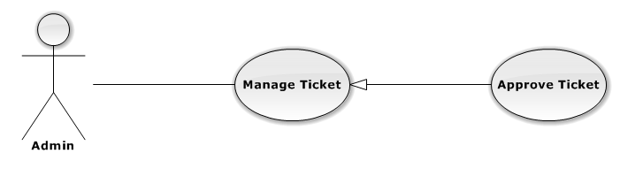

|  |  |  |  |
| --- | --- | --- | --- |
| USE CASE – APPROVE TICKET | | | |
| Use-case No. | UC01.22 | Use-case Version | 1.0 |
| Use-case Name | Approve Ticket | | |
| Author | TungNT | | |
| Date | 06/01/2013 | Priority | Normal |
| **Actor:** Admin  **Summary:** This use case is about how to approve ticket  **Goal:** Approve ticket successful  **Triggers:** N/A  **Pre-conditions:** Ticket is disapproved  **Post-conditions:** Ticket is approved  **Main Success Scenario:**   |  |  |  | | --- | --- | --- | | Step | Actor Action | System Response | | 1 | Click on “Vé” tab | Navigate to Manage Ticket page | | 2 | Click on “Tạm hoãn” tab | Show list of disapproved ticket | | 3 | Choose a ticket and click on “Duyệt” button | Approve ticket successful |   **Alternative Scenario:**  N/A  **Exceptions:** N/A  **Relationships:**  N/A  **Business Rules:** N/A | | | |

###### **3.2.2.1.23 Update Ticket**

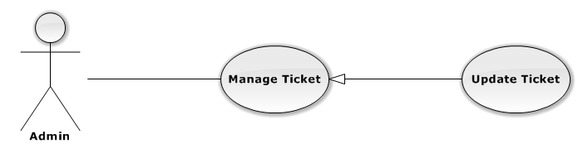

|  |  |  |  |
| --- | --- | --- | --- |
| USE CASE – UPDATE TICKET | | | |
| Use-case No. | UC01.23 | Use-case Version | 1.0 |
| Use-case Name | Update Ticket | | |
| Author | TungNT | | |
| Date | 06/01/2013 | Date | 07/31/2013 |
| **Actor:** Admin  **Summary:** This use case is about how to update ticket  **Goal:** Update ticket successful  **Triggers:** N/A  **Pre-conditions:** N/A  **Post-conditions:** Ticket is updated  **Main Success Scenario:**   |  |  |  | | --- | --- | --- | | Step | Actor Action | System Response | | 1 | Click on “Vé” tab | Navigate to Manage Ticket page | | 2 | Click “Chi tiết” buton | Show update ticket page | | 3 | Fill mandatory fields and click “Cập nhật” button | Does validation, check conflict and save data  Navigate back to Manage Ticket page |   **Alternative Scenario:**  N/A  **Exceptions:**   |  |  |  | | --- | --- | --- | | Step | Actor Action | System Response | | 1 | Same as Main Success Scenario | | | 2 | Same as Main Success Scenario | | | 3 | Does not fill all required field or enters invalid data | Display warning message to notify the missing field or invalid data |   **Relationships:**  N/A  **Business Rules:** N/A | | | |

###### **3.2.2.1.24 Disapprove Ticket**

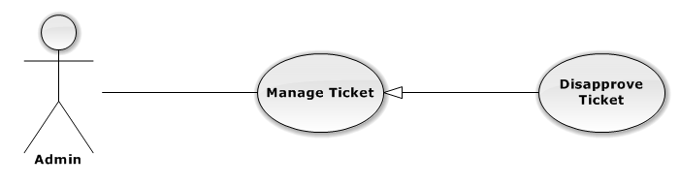

|  |  |  |  |
| --- | --- | --- | --- |
| USE CASE – DISAPPROVE TICKET | | | |
| Use-case No. | UC01.24 | Use-case Version | 1.0 |
| Use-case Name | Disapprove Ticket | | |
| Author | TungNT | | |
| Date | 06/01/2013 | Priority | Normal |
| **Actor:** Admin  **Summary:** This use case is about how to disapprove ticket  **Goal:** Disapprove ticket successful  **Triggers:** N/A  **Pre-conditions:** N/A  **Post-conditions:** Ticket is disapproved  **Main Success Scenario:**   |  |  |  | | --- | --- | --- | | Step | Actor Action | System Response | | 1 | Click on “Vé” tab | Navigate to Manage Ticket page | | 2 | Click on “Sẵn sàng” tab | Show list of approved ticket | | 3 | Choose a ticket and click on “Bỏ duyệt” button | Disapprove ticket successful |   **Alternative Scenario:**  N/A  **Exceptions:** N/A  **Relationships:**  N/A  **Business Rules:** N/A | | | |

###### **3.2.2.1.25 Delete Ticket**

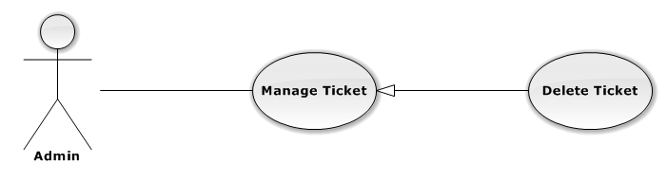

|  |  |  |  |
| --- | --- | --- | --- |
| USE CASE – DELETE TICKET | | | |
| Use-case No. | UC01.25 | Use-case Version | 1.0 |
| Use-case Name | Delete Ticket | | |
| Author | TungNT | | |
| Date | 06/01/2013 | Priority | Normal |
| **Actor:** Admin  **Summary:** This use case is about how to delete ticket  **Goal:** Delete ticket successful  **Triggers:** N/A  **Pre-conditions:** Ticket is disapproved and not on transaction  **Post-conditions:** Ticket is deleted  **Main Success Scenario:**   |  |  |  | | --- | --- | --- | | Step | Actor Action | System Response | | 1 | Click on “Vé” tab | Navigate to Manage Ticket page | | 2 | Click on “Tạm hoãn” tab | Show list of disapproved ticket | | 3 | Choose a ticket and click on “Xóa” button | Display confirm message | | 4 | Click “Yes” button | Delete ticket successful |   **Alternative Scenario:**  N/A  **Exceptions:** N/A  **Relationships:**  N/A  **Business Rules:** N/A | | | |

###### **3.2.2.1.26 View Venue**

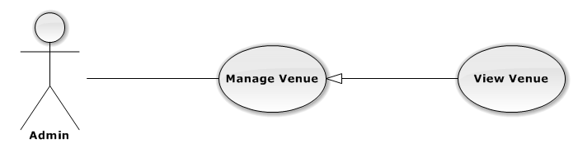

|  |  |  |  |
| --- | --- | --- | --- |
| USE CASE – VIEW VENUE | | | |
| Use-case No. | UC01.26 | Use-case Version | 1.0 |
| Use-case Name | View Venue | | |
| Author | TungNT | | |
| Date | 06/01/2013 | Priority | Normal |
| **Actor:** Admin  **Summary:** This use case is about how admin view venue  **Goal:** View venue successful  **Triggers:** N/A  **Pre-conditions:** N/A  **Post-conditions:** N/A  **Main Success Scenario:**   |  |  |  | | --- | --- | --- | | Step | Actor Action | System Response | | 1 | Click on “Địa điểm” tab | Navigate to Manage Venue page | | 2 | Click on “Chưa duyệt” tab | Display disapproved venue list | | 3 | Click on “Đã duyệt” tab | Display approved venue list | | 4 | Move mouse to a venue | Display hover about venue information |   **Alternative Scenario:**   |  |  |  | | --- | --- | --- | | Step | Actor Action | System Response | | 1 | Click on “Địa điểm” tab | Navigate to Manage Venue page | | 2 | Click on “Đã duyệt” tab or “Chưa duyệt” tab | Show list of approved or disapprove venue | | 3 | Click on “Tên địa điểm” label | Display list of venues sort by venue name |   **Exceptions:** N/A  **Relationships:**  N/A  **Business Rules:** N/A | | | |

###### **3.2.2.1.27 Create Venue**

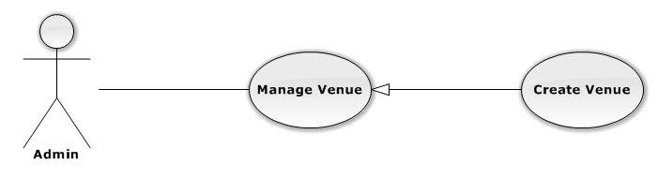

|  |  |  |  |
| --- | --- | --- | --- |
| USE CASE – CREATE VENUE | | | |
| Use-case No. | UC01.27 | Use-case Version | 1.0 |
| Use-case Name | Create Venue | | |
| Author | TungNT | | |
| Date | 06/01/2013 | Priority | Normal |
| **Actor:** Admin  **Summary:** This use case is about how to create venue  **Goal:** Create venue successful  **Triggers:** N/A  **Pre-conditions:** N/A  **Post-conditions:** Venue is created  **Main Success Scenario:**   |  |  |  | | --- | --- | --- | | Step | Actor Action | System Response | | 1 | Click on “Địa điểm” tab | Navigate to Manage Venue page | | 2 | Click on “Tạo địa điểm” button | Navigate to create new venue page | | 3 | Fill mandatory fields and click “Tạo mới” button | - Does validation, check conflict and save data  - Navigate back to Manage Venue page |   **Alternative Scenario:**  N/A  **Exceptions:**   |  |  |  | | --- | --- | --- | | Step | Actor Action | System Response | | 1 | Same as Main Success Scenario | | | 2 | Same as Main Success Scenario | | | 3 | Does not fill all required field or enters invalid data | Display warning message to notify the missing field or invalid data |   **Relationships:**  N/A  **Business Rules:** N/A | | | |

###### **3.2.2.1.28 Update Venue**

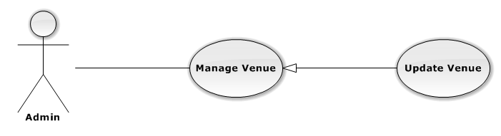

|  |  |  |  |
| --- | --- | --- | --- |
| USE CASE – UPDATE VENUE | | | |
| Use-case No. | UC01.28 | Use-case Version | 1.0 |
| Use-case Name | Update Venue | | |
| Author | TungNT | | |
| Date | 06/01/2013 | Priority | Normal |
| **Actor:** Admin  **Summary:** This use case is about how to update venue  **Goal:** Update venue successful  **Triggers:** N/A  **Pre-conditions:** Venue is not in transaction  **Post-conditions:** Venue is updated  **Main Success Scenario:**   |  |  |  | | --- | --- | --- | | Step | Actor Action | System Response | | 1 | Click on “Địa điểm” tab | Navigate to Manage Venue page | | 2 | Click on a venue | Navigate to Update Venue page | | 3 | Fill mandatory fields and click “OK” button | Does validation, check conflict and save data  Navigate back to Venue page |   **Alternative Scenario:**  N/A  **Exceptions:**   |  |  |  | | --- | --- | --- | | Step | Actor Action | System Response | | 1 | Same as Main Success Scenario | | | 2 | Click on a venue is in transaction | Display warning message that venue is in transaction, cannot edit | | 3 | Does not fill all required field or enters invalid data | Display warning message to notify the missing field or invalid data |   **Relationships:**  N/A  **Business Rules:** N/A | | | |

###### **3.2.2.1.29 Delete Venue**

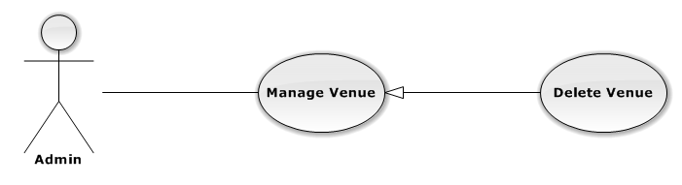

|  |  |  |  |
| --- | --- | --- | --- |
| USE CASE – DELETE VENUE | | | |
| Use-case No. | UC01.29 | Use-case Version | 1.0 |
| Use-case Name | Delete Venue | | |
| Author | TungNT | | |
| Date | 06/01/2013 | Priority | Normal |
| **Actor:** Admin  **Summary:** This use case is about how to delete venue after disapproved  **Goal:** Venue is deleted  **Triggers:** N/A  **Pre-conditions:** Venue is already disapproved  **Post-conditions:** Delete venue successful  **Main Success Scenario:**   |  |  |  | | --- | --- | --- | | Step | Actor Action | System Response | | 1 | Click on “Địa điểm” tab | Navigate to Venue page | | 2 | Click on “Chưa duyệt” tab | Show list of disapproved venues | | 3 | Choose venue want to delete and click on “Xóa” button | Show confirm message | | 4 | Click “Yes” button | Selected venue is deleted successful |   **Alternative Scenario:**  N/A  **Exceptions:** N/A  **Relationships:**  N/A  **Business Rules:** N/A | | | |

###### **3.2.2.1.30 Approve Venue**

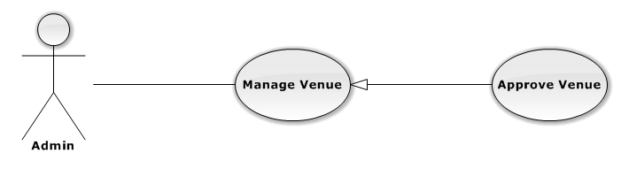

|  |  |  |  |
| --- | --- | --- | --- |
| USE CASE – APPROVE VENUE | | | |
| Use-case No. | UC01.30 | Use-case Version | 1.0 |
| Use-case Name | Approve Venue | | |
| Author | TungNT | | |
| Date | 06/01/2013 | Priority | Normal |
| **Actor:** Admin  **Summary:** This use case is about how to approve venue  **Goal:** Venue is approved  **Triggers:** N/A  **Pre-conditions:** Venue is already disapproved  **Post-conditions:** Approve venue successful  **Main Success Scenario:**   |  |  |  | | --- | --- | --- | | Step | Actor Action | System Response | | 1 | Click on “Đị điểm” tab | Navigate to Venue page | | 2 | Click on “Chưa duyệt” tab | Show list of disapproved venues | | 3 | Choose venue want to approve and click on “Duyệt” button | Approve selected venue successful |   **Alternative Scenario:**  N/A  **Exceptions:** N/A  **Relationships:**  N/A  **Business Rules:** N/A | | | |

###### **3.2.2.1.31 Disapprove Venue**

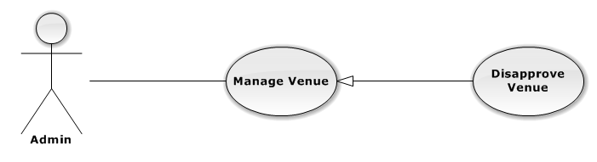

|  |  |  |  |
| --- | --- | --- | --- |
| USE CASE – DISAPPROVE VENUE | | | |
| Use-case No. | UC01.31 | Use-case Version | 1.0 |
| Use-case Name | Disapprove Venue | | |
| Author | TungNT | | |
| Date | 06/01/2013 | Priority | Normal |
| **Actor:** Admin  **Summary:** This use case is about how to disapprove venue  **Goal:** Venue is approved  **Triggers:** N/A  **Pre-conditions:** Venue is already approved  **Post-conditions:** Disapprove venue successful  **Main Success Scenario:**   |  |  |  | | --- | --- | --- | | Step | Actor Action | System Response | | 1 | Click on “Địa điểm” tab | Navigate to Venue page | | 2 | Click on “Đã duyệt” tab | Show list of approved venues | | 3 | Choose venue want to disapprove and click on “Bỏ duyệt” button | Disapprove selected venue successful |   **Alternative Scenario:**  N/A  **Exceptions:** N/A  **Relationships:**  N/A  **Business Rules:** N/A | | | |

###### **3.2.2.1.32 View Transaction**

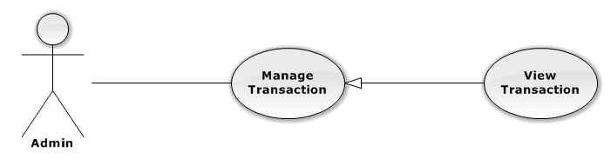

|  |  |  |  |
| --- | --- | --- | --- |
| USE CASE – VIEW TRANSACTION | | | |
| Use-case No. | UC01.32 | Use-case Version | 1.0 |
| Use-case Name | View Transaction | | |
| Author | TungNT | | |
| Date | 06/01/2013 | Priority | Normal |
| **Actor:** Admin  **Summary:** This use case is about how admin view transaction  **Goal:** View transaction successful  **Triggers:** N/A  **Pre-conditions:** N/A  **Post-conditions:** N/A  **Main Success Scenario:**   |  |  |  | | --- | --- | --- | | Step | Actor Action | System Response | | 1 | Click on “Giao dịch” tab | Navigate to Manage Transation page | | 2 | Click on a “Đã thanh toán” tab | Display paid transaction list | | 3 | Click on a “Giao hàng” tab | Display delivering transaction list | | 4 | Click on a “Đã nhận hàng” tab | Display received transaction list | | 5 | Click on a “Bị khiếu nại” tab | Display claimed transaction list | | 6 | Click on a “Đến hạn chuyển khoản” tab | Display need money transferred transaction list |   **Alternative Scenario:**   |  |  |  | | --- | --- | --- | | Step | Actor Actin | System Response | | 1 | Click on “Giao dịch” tab | Navigate to Manage Venue page | | 2 | Click on a “Đã thanh toán” tab | Display paid transaction list | | 3 | Select an event in “Sự kiện” list or Select a seller in “Người bán” list or Select a buyer in “Người mua” list | Display list of transactions include selected event or Display list of transactions include selected seller or Display list of transactions include selected buyer |   **Exceptions:** N/A  **Relationships:**  N/A  **Business Rules:** N/A | | | |

###### **3.2.2.1.33 Update Transaction Status**

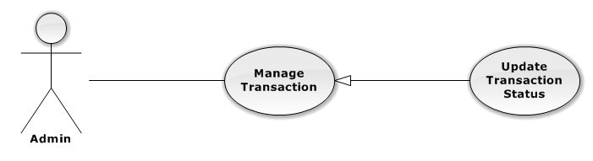

|  |  |  |  |
| --- | --- | --- | --- |
| USE CASE – UPDATE TRANSACTION STATUS | | | |
| Use-case No. | UC01.33 | Use-case Version | 1.0 |
| Use-case Name | Update Transaction Status | | |
| Author | TungNT | | |
| Date | 06/01/2013 | Priority | Normal |
| **Actor:** Admin  **Summary:** This use case is about how to update transaction  **Goal:** Update transaction successful  **Triggers:** N/A  **Pre-conditions:** N/A  **Post-conditions:** Transaction is updated  **Main Success Scenario:**   |  |  |  | | --- | --- | --- | | Step | Actor Action | System Response | | 1 | Click on “Giao dịch” tab | Navigate to Manage Transation page | | 2 | Click on a “Đã thanh toán” tab | Display paid transaction list | | 3 | Choose a transaction and click “Giao hàng” button | - Transaction disappeared  - Transaction status changed to delivering | | 4 | Click on a “Giao hàng” tab | Show delivering transaction list | | 5 | Choose a transaction and click “Nhận hàng” button | - Transaction disappeared  - Transaction status changed to received | | 6 | Click on a “Đã nhận hàng” tab | Display received transaction list |   **Alternative Scenario:**  N/A  **Exceptions:** N/A  **Relationships:**  N/A  **Business Rules:** N/A | | | |

###### **3.2.2.1.34 View Setting**

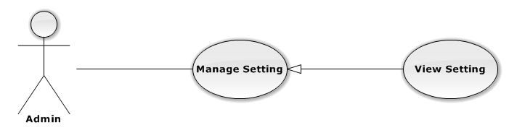

|  |  |  |  |
| --- | --- | --- | --- |
| USE CASE – VIEW SETTING | | | |
| Use-case No. | UC01.34 | Use-case Version | 1.0 |
| Use-case Name | View Setting | | |
| Author | TungNT | | |
| Date | 06/01/2013 | Priority | Normal |
| **Actor:** Admin  **Summary:** This use case is about how admin view setting  **Goal:** View setting successful  **Triggers:** N/A  **Pre-conditions:** N/A  **Post-conditions:** N/A  **Main Success Scenario:**   |  |  |  | | --- | --- | --- | | Step | Actor Action | System Response | | 1 | Click on “Tùy chỉnh” tab | - Navigate to Manage Setting page  - Display list of settings |   **Alternative Scenario:**   |  |  |  | | --- | --- | --- | | Step | Actor Action | System Response | | 1 | Click on “Tùy chỉnh” tab | - Navigate to Manage Setting page | | 2 | Click on “Tên thiết lập” label or Click  on “Giá trị” label | Display list settings sort by setting name  or Display list settings sort by setting  value |   **Exceptions:** N/A  **Relationships:**  N/A  **Business Rules:** N/A | | | |

###### **3.2.2.1.35 Create Setting**

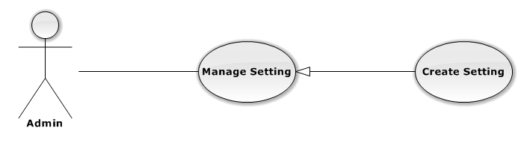

|  |  |  |  |
| --- | --- | --- | --- |
| USE CASE – CREATE SETTING | | | |
| Use-case No. | UC01.35 | Use-case Version | 1.0 |
| Use-case Name | Create Setting | | |
| Author | TungNT | | |
| Date | 06/01/2013 | Priority | Normal |
| **Actor:** Admin  **Summary:** This use case is about how to create setting  **Goal:** Create setting successful  **Triggers:** N/A  **Pre-conditions:** N/A  **Post-conditions:** N/A  **Main Success Scenario:**   |  |  |  | | --- | --- | --- | | Step | Actor Action | System Response | | 1 | Click on “Tùy chỉnh” tab | - Navigate to Manage Setting page | | 2 | Input all mandatory field | Input information normally | | 3 | Click on “Thêm” button | Setting is created successful |   **Alternative Scenario:**  N/A  **Exceptions:**   |  |  |  | | --- | --- | --- | | Step | Actor Action | System Rsponse | | 1 | Same as Main Success Scenario | | | 2 | Does not fill all required field | Input information normally | | 3 | Click on “Thêm” button | Display warning message to notify  missing fields |   **Relationships:**  N/A  **Business Rules:** N/A | | | |

###### **3.2.2.1.36 Update Setting**

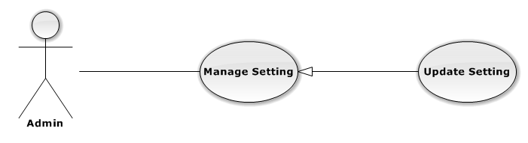

|  |  |  |  |
| --- | --- | --- | --- |
| USE CASE – UPDATE SETTING | | | |
| Use-case No. | UC01.36 | Use-case Version | 1.0 |
| Use-case Name | Update Setting | | |
| Author | TungNT | | |
| Date | 06/01/2013 | Priority | Normal |
| **Actor:** Admin  **Summary:** This use case is about how to update setting  **Goal:** Update setting successful  **Triggers:** N/A  **Pre-conditions:** N/A  **Post-conditions:** N/A  **Main Success Scenario:**   |  |  |  | | --- | --- | --- | | Step | Actor Action | System Response | | 1 | Click on “Tùy chỉnh” tab | - Navigate to Manage Setting page  - Display list of settings | | 2 | Choose a setting and click on “Sửa”  button | Display update field | | 3 | Input all mandatory field | Input information normally | | 4 | Click “Lưu” button | Update setting successful |   **Alternative Scenario:**  N/A  **Exceptions:**   |  |  |  | | --- | --- | --- | | Step | Actor Action | System Response | | 1 | Same as Main Success Scenario | | | 2 | Same as Main Success Scenario | | | 3 | Does not fill all required field | Input information normally | | 4 | Click on “Lưu” button | Display warning message to notify  the missing field |   **Relationships:**  N/A  **Business Rules:** N/A | | | |

###### **3.2.2.1.37 Delete Setting**

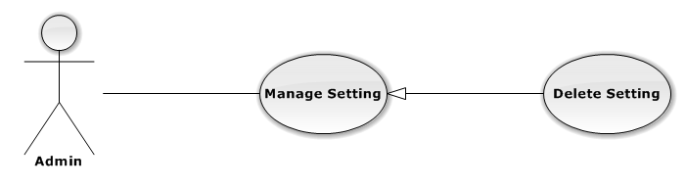

|  |  |  |  |
| --- | --- | --- | --- |
| USE CASE – DELETE SETTING | | | |
| Use-case No. | UC01.37 | Use-case Version | 1.0 |
| Use-case Name | Delete Setting | | |
| Author | TungNT | | |
| Date | 06/01/2013 | Priority | Normal |
| **Actor:** Admin  **Summary:** This use case is about how to delete setting  **Goal:** Delete setting successful  **Triggers:** N/A  **Pre-conditions:** N/A  **Post-conditions:** N/A  **Main Success Scenario:**   |  |  |  | | --- | --- | --- | | Step | Actor Action | System Response | | 1 | Click on “Tùy chỉnh” tab | - Navigate to Manage Setting page  - Display list of settings | | 2 | Choose a setting and click on “Xóa”  button | Display confirm message | | 3 | Click “Yes” button | Delete setting successful |   **Alternative Scenario:**  N/A  **Exceptions:** N/A  **Relationships:**  N/A  **Business Rules:** N/A | | | |

##### **3.2.2.2 Customer**

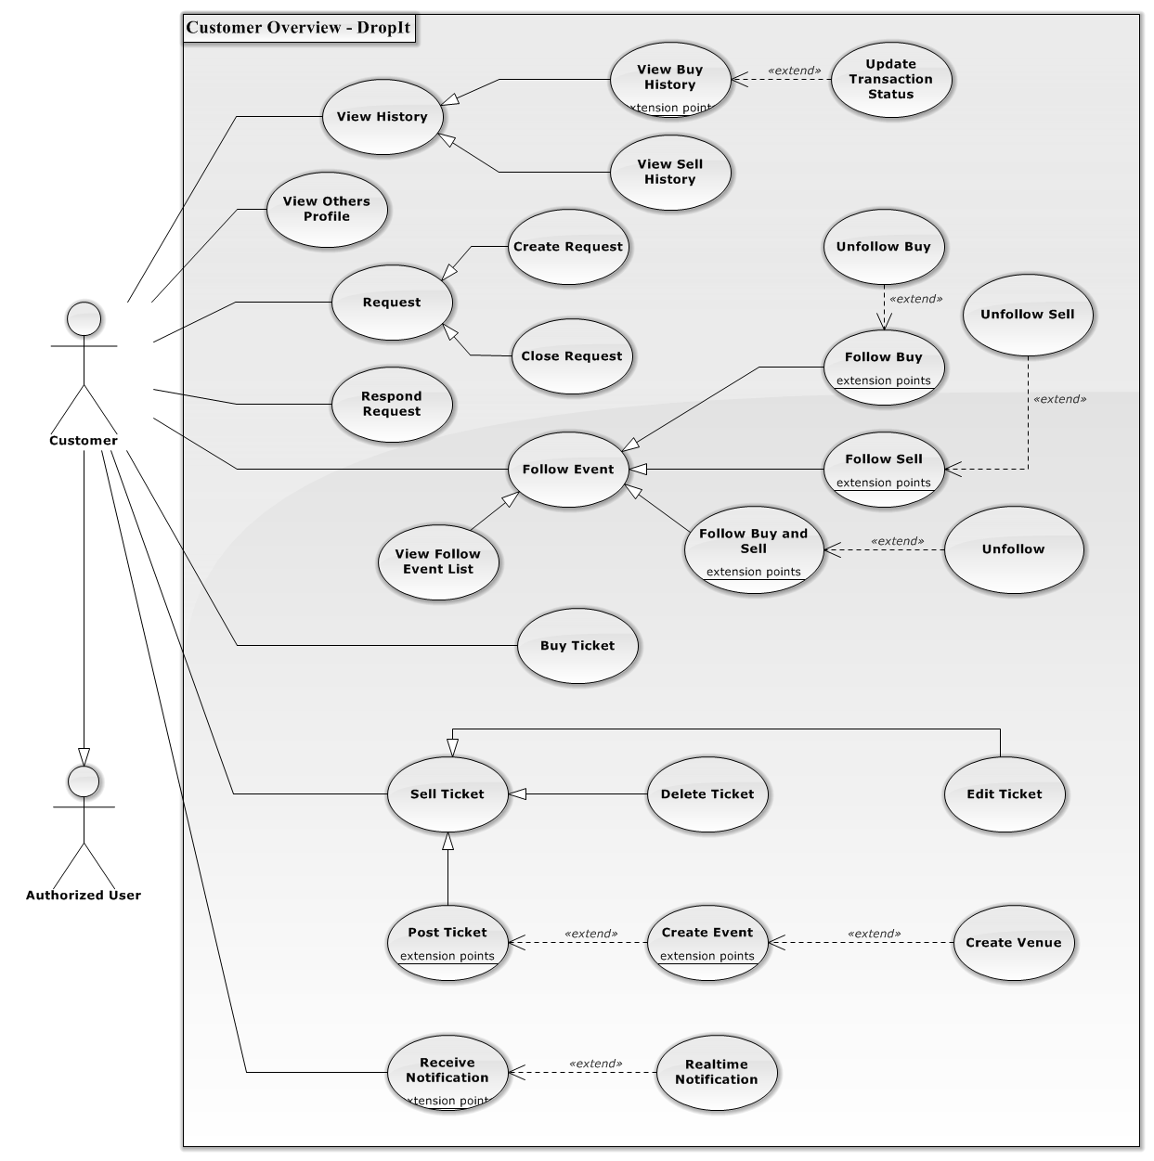

**Figure 3.2.2.2.1 – Customer Overview Diagram**

###### **3.2.2.2.1 View Buy History**

**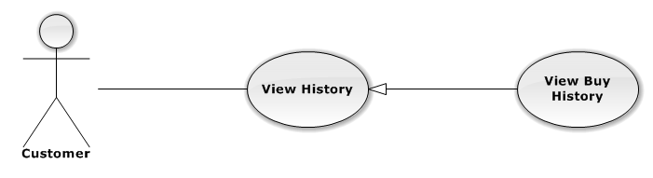**

|  |  |  |  |  |
| --- | --- | --- | --- | --- |
| USE CASE – VIEW BUY HISTORY | | | | |
| Use-case No. | UC02.01 | Use-case Version | | 1.0 |
| Use-case Name | View Buy History | | | |
| Author | DuyDQ | | | |
| Date | 06/01/2013 | Priority | Normal | |
| **Actor:** Customer  **Summary:** This use case is about how to view buy history  **Goal:** Customer can view buy history successful  **Triggers:** N/A  **Pre-conditions:**  Customer has logged into system  **Post-conditions:** View buy history successful  **Main Success Scenario:**   |  |  |  | | --- | --- | --- | | Step | Actor Action | System Response | | 1 | Click on “Mua vé” tab | Navigate to Buy Ticket page | | 2 | Click on “Lịch sử giao dịch” link | Navigate to Buy History page |   **Alternative Scenario:** N/A  **Exceptions:** N/A  **Relationships:**  N/A  **Business Rules:** N/A | | | | |

###### **3.2.2.2.2 Update Transaction Status**

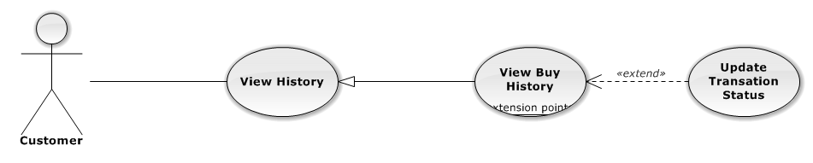

|  |  |  |  |  |
| --- | --- | --- | --- | --- |
| USE CASE – UPDATE TRANSACTION STATUS | | | | |
| Use-case No. | UC02.2 | Use-case Version | | 1.0 |
| Use-case Name | Update Transaction Status | | | |
| Author | DuyDQ | | | |
| Date | 06/01/2013 | Priority | Normal | |
| **Actor:** Customer  **Summary:** This use case is about how to update status of transaction  **Goal:** Customer can change status transaction successful  **Triggers:** N/A  **Pre-conditions:**  Customer has logged into the system  **Post-conditions:** N/A  **Main Success Scenario:**   |  |  |  | | --- | --- | --- | | Step | Actor Action | System Response | | 1 | Click on “Mua vé” tab and click on “lịch sử giao dịch” link at the left side | Navigate to Buy History page | | 2 | Click on “Đã giao” tab | Display list of delivered tickets | | 3 | Choose a ticket and click “Đã nhận hàng” button | Transaction status change to received | | 4 | Click on “Đã nhận” tab | Display list of received tickets | | 5 | Choose a ticket and click “Khiếu nại” button | Transaction status change to reported |   **Alternative Scenario:** N/A  **Exceptions:** N/A  **Relationships:**  N/A  **Business Rules:** N/A | | | | |

###### **3.2.2.2.3 View Sell History**

**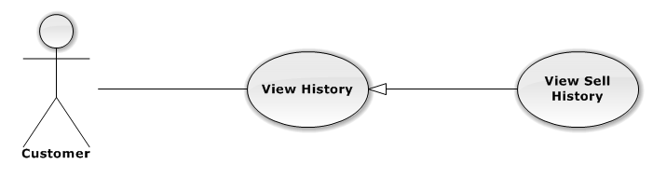**

|  |  |  |  |  |
| --- | --- | --- | --- | --- |
| USE CASE – VIEW SELL HISTORY | | | | |
| Use-case No. | UC02.03 | Use-case Version | | 1.0 |
| Use-case Name | View Sell History | | | |
| Author | DuyDQ | | | |
| Date | 06/01/2013 | Priority | Normal | |
| **Actor:** Customer  **Summary:** This use case is about how to view sell history  **Goal:** Customer can view sell history successful  **Triggers:** N/A  **Pre-conditions:**  Customer has logged into system  **Post-conditions:** View sell history successful  **Main Success Scenario:**   |  |  |  | | --- | --- | --- | | Step | Actor Action | System Response | | 1 | Click on “Bán vé” tab | Navigate to Sell ticket page | | 2 | Click on “Quản lí giao dịch” link | Navigate to Sell history page |   **Alternative Scenario:** N/A  **Exceptions:** N/A  **Relationships:**  N/A  **Business Rules:** N/A | | | | |

###### **3.2.2.2.4 Create Request**

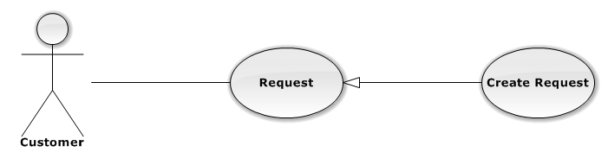

|  |  |  |  |  |
| --- | --- | --- | --- | --- |
| USE CASE – CREATE REQUEST | | | | |
| Use-case No. | UC02.04 | Use-case Version | | 1.0 |
| Use-case Name | Create Request | | | |
| Author | DuyDQ | | | |
| Date | 06/01/2013 | Priority | Normal | |
| **Actor:** Customer  **Summary:** This use case is about how to create request  **Goal:** Customer can create new request successful  **Triggers:** N/A  **Pre-conditions:**  Customer has logged into system  **Post-conditions:** Create request successful  **Main Success Scenario:**   |  |  |  | | --- | --- | --- | | Step | Actor Action | System Response | | 1 | Click on “Mua vé” tab | Navigate to Buy ticket page | | 2 | Click on “Đăng rao mua” link | Navigate to Create request page | | 3 | Fill mandatory fields and click “Đăng yêu cầu” button | Navigate to Home page |   **Alternative Scenario:** N/A  **Exceptions:**   |  |  |  | | --- | --- | --- | | Step | Actor Action | System Response | | 1 | Same as Main Success Scenario | | | 2 | Same as Main Success Scenario | 1 | | 3 | Does not fill all required field or enters invalid data | Display warning message to notify the missing field or invalid data |   **Relationships:**  N/A  **Business Rules:** N/A | | | | |

###### **3.2.2.2.5 Close Request**

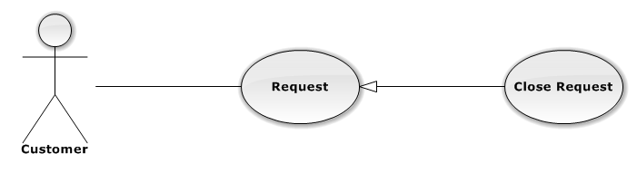

|  |  |  |  |  |
| --- | --- | --- | --- | --- |
| USE CASE – CLOSE REQUEST | | | | |
| Use-case No. | UC02.05 | Use-case Version | | 1.0 |
| Use-case Name | Close Request | | | |
| Author | DuyDQ | | | |
| Date | 06/01/2013 | Priority | Normal | |
| **Actor:** Customer  **Summary:** This use case is about how to close request  **Goal:** Customer can close request successful  **Triggers:** N/A  **Pre-conditions:**  Customer has logged into system  **Post-conditions:** Close request successful  **Main Success Scenario:**   |  |  |  | | --- | --- | --- | | Step | Actor Action | System Response | | 1 | Click on “Mua vé” tab | Navigate to Buy ticket page | | 2 | Click on “Quản lí rao mua” link | Navigate to Request page | | 3 | Choose a request and click “Đóng” button | Display confirm message | | 4 | Click on “OK” button | Close request successful |   **Alternative Scenario:** N/A  **Exceptions:** N/A  **Relationships:**  N/A  **Business Rules:** N/A | | | | |

###### **3.2.2.2.6 Respond Request**

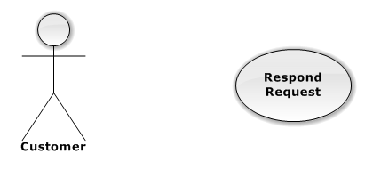

|  |  |  |  |  |
| --- | --- | --- | --- | --- |
| USE CASE –RESPOND REQUEST | | | | |
| Use-case No. | UC02.06 | Use-case Version | | 1.0 |
| Use-case Name | Respond Request | | | |
| Author | DuyDQ | | | |
| Date | 06/01/2013 | Priority | Normal | |
| **Actor:** Customer  **Summary:** This use case is about how to respond request  **Goal:** Customer can response request successful  **Triggers:** N/A  **Pre-conditions:**  Customer has logged into system  **Post-conditions:** Respond request successful  **Main Success Scenario:**   |  |  |  | | --- | --- | --- | | Step | Actor Action | System Response | | 1 | Click on “Bán vé” tab | Navigate to Sell ticket page | | 2 | Click on “Danh sách rao mua” link | Navigate to Request page | | 3 | Choose a request and click on “Phản hồi” button | Navigate to response page | | 4 | Choose a request and check “Phản hồi vé này” box and click “Phản hồi các vé trên” button | Respond request successful |   **Alternative Scenario:** N/A  **Exceptions:** N/A  **Relationships:**  N/A  **Business Rules:** N/A | | | | |

###### **3.2.2.2.7 Follow Buy**

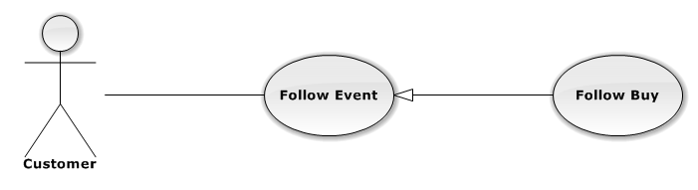

|  |  |  |  |  |
| --- | --- | --- | --- | --- |
| USE CASE – FOLLOW BUY | | | | |
| Use-case No. | UC02.07 | Use-case Version | | 1.0 |
| Use-case Name | Follow Buy | | | |
| Author | DuyDQ | | | |
| Date | 06/01/2013 | Priority | Normal | |
| **Actor:** Customer  **Summary:** This use case is about how to follow buy an event  **Goal:** Customer can follow buy event successful  **Triggers:** N/A  **Pre-conditions:**  Customer has logged into system  **Post-conditions:** Follow buy event successful  **Main Success Scenario:**   |  |  |  | | --- | --- | --- | | Step | Actor Action | System Response | | 1 | Click on an event | Navigate to Event page | | 2 | Click on dropdown button next to “Theo dõi” button | Display follow dropdown list | | 3 | Click on “Theo dõi mua” button | “Theo dõi” button turns into “Bỏ theo dõi mua” button |   **Alternative Scenario:** N/A  **Exceptions:** N/A  **Relationships:**  N/A  **Business Rules:** N/A | | | | |

###### **3.2.2.2.8 Unfollow Buy**

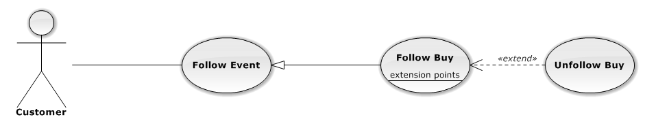

|  |  |  |  |  |
| --- | --- | --- | --- | --- |
| USE CASE – UNFOLLOW BUY | | | | |
| Use-case No. | UC02.08 | Use-case Version | | 1.0 |
| Use-case Name | Unfollow Buy | | | |
| Author | DuyDQ | | | |
| Date | 06/01/2013 | Priority | Normal | |
| **Actor:** Customer  **Summary:** This use case is about how to unfollow buy an event  **Goal:** Customer can unfollow buy event successful  **Triggers:** N/A  **Pre-conditions:**  Customer has already follow-buy event  **Post-conditions:** Unfollow buy event successful  **Main Success Scenario:**   |  |  |  | | --- | --- | --- | | Step | Actor Action | System Response | | 1 | Click on an event has been buy-followed | Navigate to Event page | | 2 | Click on “Bỏ theo dõi mua” button | “Bỏ theo dõi mua” button turns into “Theo dõi” button |   **Alternative Scenario:** N/A  **Exceptions:** N/A  **Relationships:**  N/A  **Business Rules:** N/A | | | | |

###### **3.2.2.2.9 Follow Sell**

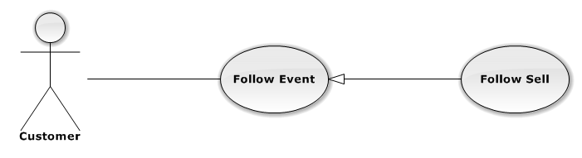

|  |  |  |  |  |
| --- | --- | --- | --- | --- |
| USE CASE – FOLLOW SELL | | | | |
| Use-case No. | UC02.09 | Use-case Version | | 1.0 |
| Use-case Name | Follow Sell | | | |
| Author | DuyDQ | | | |
| Date | 06/01/2013 | Priority | Normal | |
| **Actor:** Customer  **Summary:** This use case is about how to follow sell an event  **Goal:** Customer can follow sell event successful  **Triggers:** N/A  **Pre-conditions:**  Customer has logged into system  **Post-conditions:** Follow sell event successful  **Main Success Scenario:**   |  |  |  | | --- | --- | --- | | Step | Actor Action | System Response | | 1 | Click on an event | Navigate to Event page | | 2 | Click on dropdown button next to “Theo dõi” button | Display follow dropdown list | | 3 | Click on “Theo dõi bán” button | “Theo dõi” button turns into “Bỏ theo dõi bán” button |   **Alternative Scenario:** N/A  **Exceptions:** N/A  **Relationships:**  N/A  **Business Rules:** N/A | | | | |

###### **3.2.2.2.10 Unfollow Sell**

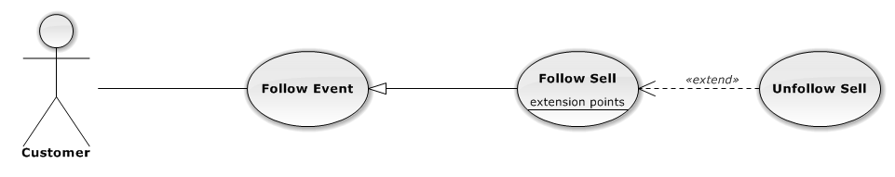

|  |  |  |  |  |
| --- | --- | --- | --- | --- |
| USE CASE – UNFOLLOW SELL | | | | |
| Use-case No. | UC02.10 | Use-case Version | | 1.0 |
| Use-case Name | Unfollow Sell | | | |
| Author | DuyDQ | | | |
| Date | 06/01/2013 | Priority | Normal | |
| **Actor:** Customer  **Summary:** This use case is about how to unfollow sell an event  **Goal:** Customer can unfollow sell event successful  **Triggers:** N/A  **Pre-conditions:**  Customer has already follow-sell event  **Post-conditions:** Unfollow sell event successful  **Main Success Scenario:**   |  |  |  | | --- | --- | --- | | Step | Actor Action | System Response | | 1 | Click on an event has been sell-followed | Navigate to Event page | | 2 | Click on “Bỏ theo dõi bán” button | “Bỏ theo dõi bán” button turns into “Theo dõi” button |   **Alternative Scenario:** N/A  **Exceptions:** N/A  **Relationships:**  N/A  **Business Rules:** N/A | | | | |

###### **3.2.2.2.11 Follow Buy and Sell**

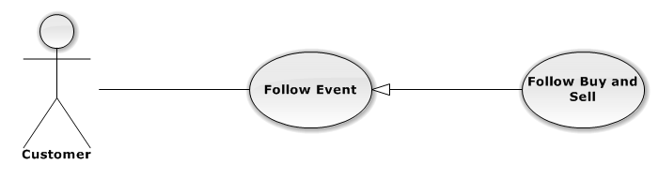

|  |  |  |  |  |
| --- | --- | --- | --- | --- |
| USE CASE – FOLLOW BUY AND SELL | | | | |
| Use-case No. | UC02.011 | Use-case Version | | 1.0 |
| Use-case Name | Follow Buy and Sell | | | |
| Author | DuyDQ | | | |
| Date | 06/01/2013 | Priority | Normal | |
| **Actor:** Customer  **Summary:** This use case is about how to follow buy-and-sell an event  **Goal:** Customer can follow buy-and-sell event successful  **Triggers:** N/A  **Pre-conditions:**  Customer has logged into system  **Post-conditions:** Follow buy and sell event successful  **Main Success Scenario:**   |  |  |  | | --- | --- | --- | | Step | Actor Action | System Response | | 1 | Click on an event | Navigate to Event page | | 2 | Click on “Theo dõi” button | “Theo dõi” button turns into “Bỏ theo dõi” button |   **Alternative Scenario:** N/A  **Exceptions:** N/A  **Relationships:**  N/A  **Business Rules:** N/A | | | | |

###### **3.2.2.2.12 Unfollow Buy and Sell**

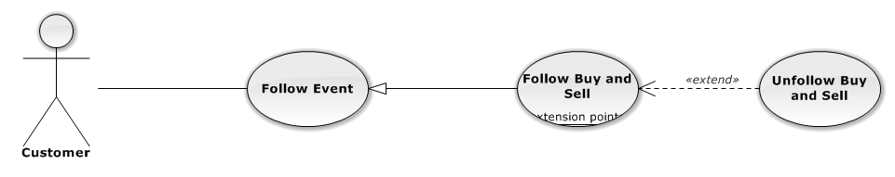

|  |  |  |  |  |
| --- | --- | --- | --- | --- |
| USE CASE – UNFOLLOW BUY-AND-SELL | | | | |
| Use-case No. | UC02.12 | Use-case Version | | 1.0 |
| Use-case Name | Unfollow Buy and Sell | | | |
| Author | DuyDQ | | | |
| Date | 06/01/2013 | Priority | Normal | |
| **Actor:** Customer  **Summary:** This use case is about how to unfollow buy-and-sell an event  **Goal:** Customer can unfollow buy-and-sell event successful  **Triggers:** N/A  **Pre-conditions:**  Customer has already follow-buy-and-sell event  **Post-conditions:** Unfollow buy-and-sell event successful  **Main Success Scenario:**   |  |  |  | | --- | --- | --- | | Step | Actor Action | System Response | | 1 | Click on an event has been buy-followed | Navigate to Event page | | 2 | Click on “Bỏ theo dõi” button | “Bỏ theo dõi” button turns into “Theo dõi” button |   **Alternative Scenario:** N/A  **Exceptions:** N/A  **Relationships:**  N/A  **Business Rules:** N/A | | | | |

###### **3.2.2.2.13 View Follow Event List**

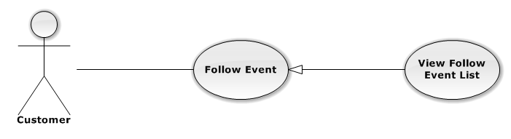

|  |  |  |  |  |
| --- | --- | --- | --- | --- |
| USE CASE – VIEW FOLLOW EVENT LIST | | | | |
| Use-case No. | UC02.13 | Use-case Version | | 1.0 |
| Use-case Name | View Follow Event List | | | |
| Author | DuyDQ | | | |
| Date | 06/01/2013 | Priority | Normal | |
| **Actor:** Customer  **Summary:** This use case is about how to view list of follow events  **Goal:** Customer can view list of follow events successful  **Triggers:** N/A  **Pre-conditions:**  Customer has logged into system  **Post-conditions:** View list of follow events successful  **Main Success Scenario:**   |  |  |  | | --- | --- | --- | | Step | Actor Action | System Response | | 1 | Click on “Bán vé” or “Mua vé” tab | Navigate to corresponding page | | 2 | Click on “Danh sách theo dõi” link | Navigate to List follow event page |   **Alternative Scenario:** N/A  **Exceptions:** N/A  **Relationships:**  N/A  **Business Rules:** N/A | | | | |

###### **3.2.2.2.13 Buy Ticket**

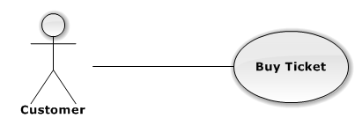

|  |  |  |  |  |
| --- | --- | --- | --- | --- |
| USE CASE – BUY TICKET | | | | |
| Use-case No. | UC02.13 | Use-case Version | | 1.0 |
| Use-case Name | Buy Ticket | | | |
| Author | DuyDQ | | | |
| Date | 06/01/2013 | Priority | Normal | |
| **Actor:** Customer  **Summary:** This use case is about how to buy a ticket  **Goal:** Customer can buy ticket successful  **Triggers:** N/A  **Pre-conditions:**  Customer has logged into system  **Post-conditions:** N/A  **Main Success Scenario:**   |  |  |  | | --- | --- | --- | | Step | Actor Action | System Response | | 1 | Click on an event | Navigate to Event page | | 2 | Choose a ticket and click on “Đặt vé” button | Navigate to Buy Ticket page | | 3 | Click on “Xác nhận” button | Navigate to PayPal page | | 4 | Complete transaction on Paypal | Navigate to Buy Success page |   **Alternative Scenario:** N/A  **Exceptions:** N/A  **Relationships:**  N/A  **Business Rules:** N/A | | | | |

###### **3.2.2.2.14 Post Ticket**

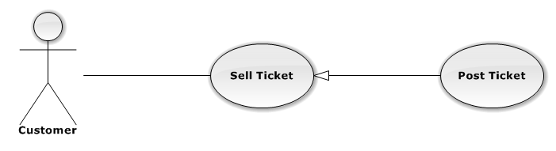

|  |  |  |  |  |
| --- | --- | --- | --- | --- |
| USE CASE – POST TICKET | | | | |
| Use-case No. | UC02.14 | Use-case Version | | 1.0 |
| Use-case Name | Post Ticket | | | |
| Author | DuyDQ | | | |
| Date | 06/01/2013 | Priority | Normal | |
| **Actor:** Customer  **Summary:** This use case is about how to post a ticket  **Goal:** Customer can post ticket successful  **Triggers:** N/A  **Pre-conditions:**  Customer has logged into system  **Post-conditions:** Ticket is posted successful  **Main Success Scenario:**   |  |  |  | | --- | --- | --- | | Step | Actor Action | System Response | | 1 | Click on “Bán vé” tab | Navigate to Sell ticket page | | 2 | Click “Bán vé” link | Navigate to Create ticket page | | 3 | Fill mandatory fields and click “Đăng vé” button | - Does validation, check conflict and save data  - Navigate back to Home page |   **Alternative Scenario:** N/A  **Exceptions:**   |  |  |  | | --- | --- | --- | | Step | Actor Action | System Response | | 1 | Same as Main Success Scenario | | | 2 | Same as Main Success Scenario | | | 3 | Does not fill all required field or enters invalid data | Display warning message to notify the missing field or invalid data |   **Relationships:**  N/A  **Business Rules:** N/A | | | | |

###### **3.2.2.2.15 Edit Posted Ticket**

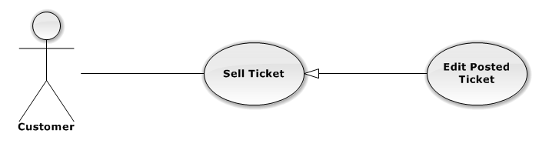

|  |  |  |  |  |
| --- | --- | --- | --- | --- |
| USE CASE – EDIT POSTED TICKET | | | | |
| Use-case No. | UC02.15 | Use-case Version | | 1.0 |
| Use-case Name | Edit Posted Ticket | | | |
| Author | DuyDQ | | | |
| Date | 06/01/2013 | Priority | Normal | |
| **Actor:** Customer  **Summary:** This use case is about how to edit posted ticket information  **Goal:** Customer can edit ticket information successful  **Triggers:** N/A  **Pre-conditions:**  Ticket want to edit is not in transaction  **Post-conditions:** Ticket is updated successful  **Main Success Scenario:**   |  |  |  | | --- | --- | --- | | Step | Actor Action | System Response | | 1 | Click on “Bán vé” tab | Navigate to Sell ticket page | | 2 | Click on “Danh sách rao bán” link | Navigate to List posted ticket page | | 3 | Click on a posted ticket | Display ticket information | | 4 | Click on “Chỉnh sửa” button | Navigate to Edit ticket page | | 5 | Fill mandatory fields and click “Cập nhật” button | - Does validation, check conflict and save data  - Navigate back to Home page |   **Alternative Scenario:** N/A  **Exceptions:**   |  |  |  | | --- | --- | --- | | Stp | Actor Action | ystem Response | | 1 | Same as Main Success Scenario | | | 2 | Same as Main Success Scenario | | | 3 | Same as Main Success Scenario | | | 4 | Same as Main Success Scenario | | | 5 | Does not fill all required field or enters invalid data | Display warning message to notify the missing field or invalid data |   **Relationships:**  N/A  **Business Rules:** N/A | | | | |

###### **3.2.2.2.16 Delete Posted Ticket**

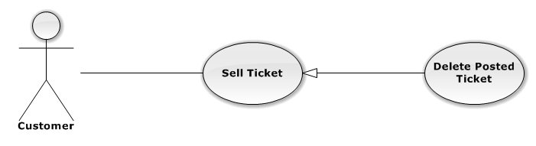

|  |  |  |  |  |
| --- | --- | --- | --- | --- |
| USE CASE – DELETE POST TICKET | | | | |
| Use-case No. | UC02.16 | Use-case Version | | 1.0 |
| Use-case Name | Delete Posted Ticket | | | |
| Author | DuyDQ | | | |
| Date | 06/01/2013 | Priority | Normal | |
| **Actor:** Customer  **Summary:** This use case is about how to delete a posted ticket  **Goal:** Customer can delete a posted ticket successful  **Triggers:** N/A  **Pre-conditions:**  Ticket want to delete is not in any transaction  **Post-conditions:** Ticket is deleted successful  **Main Success Scenario:**   |  |  |  | | --- | --- | --- | | Step | Actor Action | System Response | | 1 | Click on “Bán vé” tab | Navigate to Sell ticket page | | 2 | Click on “Danh sách rao bán” link | Navigate to List posted ticket page | | 3 | Click on a posted ticket | Display ticket information | | 4 | Click on “Xóa” button | Show confirm message | | 5 | Click “Yes” button | Ticket is deleted successful |   **Alternative Scenario:** N/A  **Exceptions:** N/A  **Relationships:**  N/A  **Business Rules:** N/A | | | | |

###### **3.2.2.2.17 Receive Notification**

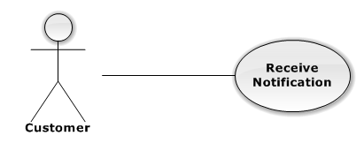

|  |  |  |  |  |
| --- | --- | --- | --- | --- |
| USE CASE – RECEIVE NOTIFICATION | | | | |
| Use-case No. | UC02.17 | Use-case Version | | 1.0 |
| Use-case Name | Receive Notification | | | |
| Author | PhongLK | | | |
| Date | 06/01/2013 | Priority | Normal | |
| **Actor:** Customer  **Summary:** This use case is about how to receive notification  **Goal:** Customer can receive notification successful  **Triggers:** N/A  **Pre-conditions:**  Customer has followed an event  **Post-conditions:** N/A  **Main Success Scenario:**   |  |  |  | | --- | --- | --- | | Step | Actor Action | System Response | | 1 | Login system with another user and post a ticket | Post ticket successful | | 2 | Login with user has followed event | - Navigate to home page with username on top right  - There’s notification about posted ticket in followed event | | 3 | Login system with another user and request ticket | Request ticket successful | | 4 | Login with user has followed event | - Navigate to home page with username on top right  - There’s notification about request ticket in followed event |   **Alternative Scenario:** N/A  **Exceptions:** N/A  **Relationships:**  N/A  **Business Rules:** N/A | | | | |

###### **3.2.2.2.18 Receive Real-time Notification**

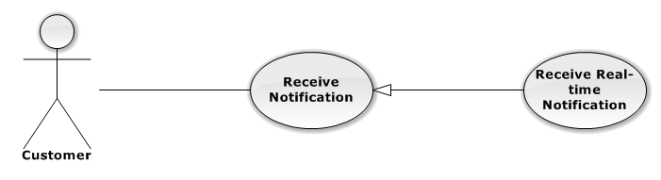

|  |  |  |  |  |
| --- | --- | --- | --- | --- |
| USE CASE – RECEIVE REAL-TIME NOTIFICATION | | | | |
| Use-case No. | UC02.18 | Use-case Version | | 1.0 |
| Use-case Name | Receive Real-time Notification | | | |
| Author | DuyDQ | | | |
| Date | 06/01/2013 | Priority | Normal | |
| **Actor:** Customer  **Summary:** This use case is about how user receive real-time notification  **Goal:** Customer can receive real-time notification successful  **Triggers:** N/A  **Pre-conditions:**  Customer has followed an event  **Post-conditions:** N/A  **Main Success Scenario:**   |  |  |  | | --- | --- | --- | | Step | Actor Action | System Response | | 1 | Open two browser and login with two account, one has followed event | Navigate to home page with username on top right | | 2 | Post ticket in event that remain user has followed | - Posted ticket successful  - There’s real-time notification about posted ticket in followed event at bottom left | | 3 | Click on real-time notification | Navigate to posted ticket | | 4 | Request ticket in event that remain user has followed | - Requested ticket successful  - There’s real-time notification about posted ticket in followed event at bottom left | | 5 | Click on real-time notification | Navigate to request page |   **Alternative Scenario:** N/A  **Exceptions:** N/A  **Relationships:**  N/A  **Business Rules:** N/A | | | | |

###### **3.2.2.2.19 View Others Profile**

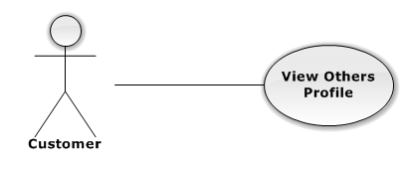

|  |  |  |  |  |
| --- | --- | --- | --- | --- |
| USE CASE – VIEW OTHERS PROFILE | | | | |
| Use-case No. | UC02.19 | Use-case Version | | 1.0 |
| Use-case Name | View Others Profile | | | |
| Author | HieuCM | | | |
| Date | 06/01/2013 | Priority | Normal | |
| **Actor:** Customer  **Summary:** This use case is about how user views others profile  **Goal:** Customer can views others profile about history transaction  **Triggers:** N/A  **Pre-conditions:**  Customer has logged in to system  **Post-conditions:** N/A  **Main Success Scenario:**   |  |  |  | | --- | --- | --- | | Step | Actor Action | System Response | | 1 | Click on ticket “Details “ | Navigate to details page of ticket | | 2 | Click on username of customer want to know profile transaction | Navigate to customer profile page. List all transaction in history and truth rating |   **Alternative Scenario:** N/A  **Exceptions:** N/A  **Relationships:**  N/A  **Business Rules:** N/A | | | | |

##### **3.2.2.3 Authorized User**

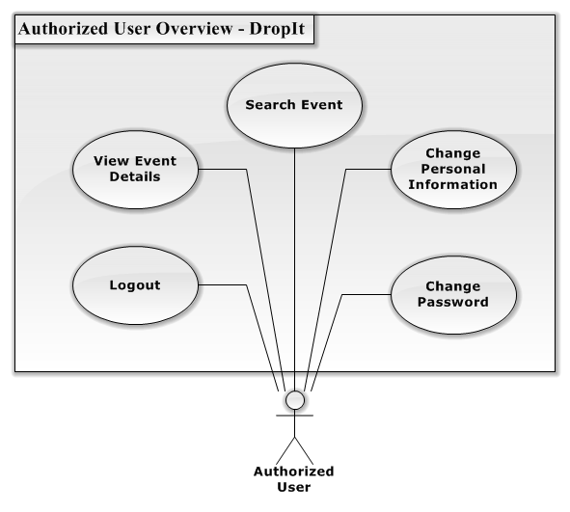

**Figure 3.2.2.3.1 – Authorized User Overview Diagram**

###### **3.2.2.3.1 Change Personal Information**

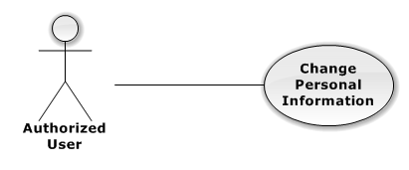

|  |  |  |  |  |
| --- | --- | --- | --- | --- |
| USE CASE – CHANGE PERSONAL INFORMATION | | | | |
| Use-case No. | UC03.01 | Use-case Version | | 1.0 |
| Use-case Name | Change Personal Information | | | |
| Author | DuyDQ | | | |
| Date | 06/01/2013 | Priority | Normal | |
| **Actor:** Customer, Authorized User  **Summary:** This use case is about how user change personal information  **Goal:** User can change personal information successful  **Triggers:** N/A  **Pre-conditions:**  User has logged into system  **Post-conditions:** User’s information is changed successful  **Main Success Scenario:**   |  |  |  | | --- | --- | --- | | Step | Actor Action | System Response | | 1 | Click on “Bán vé” or “Mua vé” tab | Navigate to corresponding page | | 2 | Click on “Thông tin tài khoản” link | Navigate to User information page | | 3 | Fill mandatory fields and click “Xác nhận” button | - Does validation, check conflict and save data  - Navigate back to Home page |   **Alternative Scenario:** N/A  **Exceptions:**   |  |  |  | | --- | --- | --- | | Step | Actor ction | Systm Response | | 1 | Same as Main Success Scenario | | | 2 | Same as Main Success Scenario | | | 3 | Does not fill all required field or enters invalid data | Display warning message to notify the missing field or invalid data |   **Relationships:**  N/A  **Business Rules:** N/A | | | | |

###### **3.2.2.3.2 Change Password**

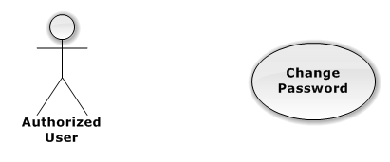

|  |  |  |  |  |
| --- | --- | --- | --- | --- |
| USE CASE – CHANGE PASSWORD | | | | |
| Use-case No. | UC03.02 | Use-case Version | | 1.0 |
| Use-case Name | Change Password | | | |
| Author | DuyDQ | | | |
| Date | 06/01/2013 | Priority | Normal | |
| **Actor:** Customer, Authorized User  **Summary:** This use case is about how user change password  **Goal:** User can change password successful  **Triggers:** N/A  **Pre-conditions:**  User has logged into system  **Post-conditions:** User’s password is changed successful  **Main Success Scenario:**   |  |  |  | | --- | --- | --- | | Step | Actor Action | System Response | | 1 | Click on user name at the top right | Navigate to change password page | | 2 | Fill mandatory fields and click “Xác nhận” button | - Does validation, check conflict and save data  - Navigate to change password page with success message at top of page |   **Alternative Scenario:** N/A  **Exceptions:**   |  |  |  | | --- | --- | --- | | Step | Actor Action | System Response | | 1 | Same as Main Success Scenario | | | 2 | Same a Main Success Scenario | | | 3 | Does not fill all required field or enters invalid data | Display warning message to notify the missing field or invalid data |   **Relationships:**  N/A  **Business Rules:** N/A | | | | |

###### **3.2.2.3.3 View Event Detail** C:\Users\duydq00276\Desktop\usecase\GuestOverview\ViewEventDetail.png

|  |  |  |  |  |
| --- | --- | --- | --- | --- |
| USE CASE – VIEW EVENT DETAIL | | | | |
| Use-case No. | UC03.03 | Use-case Version | | 1.0 |
| Use-case Name | View Event Detail | | | |
| Author | DuyDQ | | | |
| Date | 01/06/2013 | Priority | Normal | |
| **Actor:** Guest, Admin, User, Authorized User, Unauthorized User  **Summary:** This use case is about how actor views event detail  **Goal:** Actor can view event detail successful  **Triggers:** N/A  **Pre-conditions:** N/A  **Post-conditions:** N/A  **Main Success Scenario:**   |  |  |  | | --- | --- | --- | | Step | Actor Action | System Response | | 1 | Click on an event | Navigate to Event page |   **Alternative Scenario:** N/A  **Exceptions:** N/A  **Relationships:**  N/A  **Business Rules:** N/A | | | | |

###### **3.2.2.3.4 Search Event by Name**

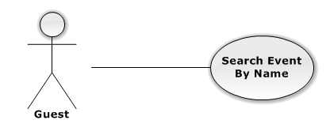

|  |  |  |  |  |
| --- | --- | --- | --- | --- |
| USE CASE – SEARCH EVENT BY NAME | | | | |
| Use-case No. | UC03.04 | Use-case Version | | 1.0 |
| Use-case Name | Search Event by Name | | | |
| Author | DuyDQ | | | |
| Date | 01/06/2013 | Priority | Normal | |
| **Actor:** Admin, User, Authorized User, Guest, Unauthorized User  **Summary:** This use case is about how actor search event by name  **Goal:** Actor can search event successful  **Triggers:** N/A  **Pre-conditions:** N/A  **Post-conditions:** N/A  **Main Success Scenario:**   |  |  |  | | --- | --- | --- | | Step | Actor Action | System Response | | 1 | Input information want to find in text box | Make suggestion when actor input more than 1 character | | 2 | Click on search label or press Enter key | Navigate to search result page |   **Alternative Scenario:** N/A  **Exceptions:** N/A  **Relationships:**  N/A  **Business Rules:** N/A | | | | |

###### **3.2.2.3.5 Logout**

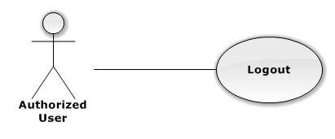

|  |  |  |  |  |
| --- | --- | --- | --- | --- |
| USE CASE – LOGOUT | | | | |
| Use-case No. | UC03.05 | Use-case Version | | 1.0 |
| Use-case Name | Logout | | | |
| Author | DuyDQ | | | |
| Date | 01/06/2013 | Priority | Normal | |
| **Actor:** Customer, Authorized User, Admin  **Summary:** This use case is about how to logout of the system  **Goal:** Logout from system successful  **Triggers:** N/A  **Pre-conditions:** Actor has logged into system  **Post-conditions:** Logout successful  **Main Success Scenario:**   |  |  |  | | --- | --- | --- | | Step | Actor Action | System Response | | 1 | Click on the “Đăng Xuất” button at the top right | - Remove user’s session  - Navigate to Home page |   **Alternative Scenario:** N/A  **Exceptions:** N/A  **Relationships:**  N/A  **Business Rules:** N/A | | | | |

##### **3.2.2.4 Guest**

**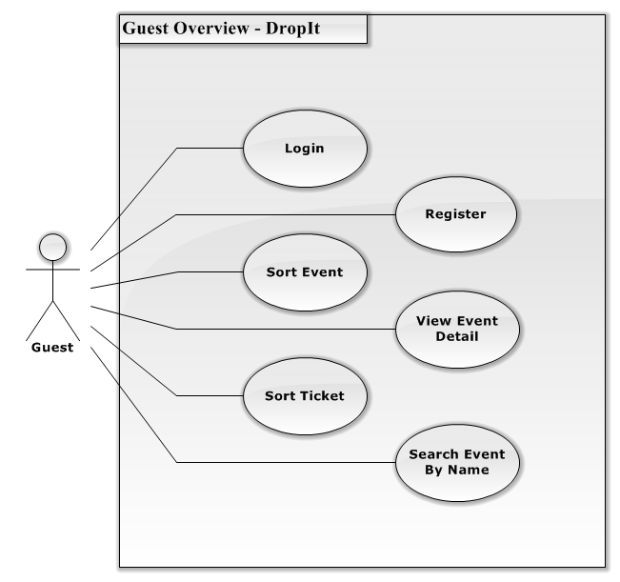**

Figure 3.2.2.4.1 – Guest Overview Diagram

###### **3.2.2.4.1 Login**

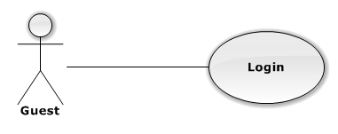

|  |  |  |  |  |
| --- | --- | --- | --- | --- |
| USE CASE – LOGIN | | | | |
| Use-case No. | UC04.01 | Use-case Version | | 1.0 |
| Use-case Name | Login | | | |
| Author | DuyDQ | | | |
| Date | 01/06/2013 | Priority | Normal | |
| **Actor:** Customer, Authorized User, Guest  **Summary:** This use case is about how actor login to website  **Goal:** Login to system successful  **Triggers:** N/A  **Pre-conditions:** No user has logged into system when access to home page  **Post-conditions:** Actor logged into the system successful  **Main Success Scenario:**   |  |  |  | | --- | --- | --- | | Step | Actor Action | System Response | | 1 | Click on “Đăng nhập” button | Navigate to login page | | 2 | Fill mandatory fields and click “Đăng nhập” button | Navigate to Home page with username at the top right |   **Alternative Scenario:** N/A  **Exceptions:**   |  |  |  | | --- | --- | --- | | Step | Actor Action | System Response | | 1 | Same as Main Succes Scenario | | | 2 | Does not fill all required field | Display warning message to notify the missing field | | 2 | Enter invalid data (wrong password or wrong username) | Display warning message “Tên đăng nhập hoặc mật khẩu không đúng” |   **Relationships:**  N/A  **Business Rules:** N/A | | | | |

###### **3.2.2.4.2 Register**

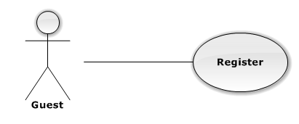

|  |  |  |  |  |
| --- | --- | --- | --- | --- |
| USE CASE – REGISTER | | | | |
| Use-case No. | UC04.02 | Use-case Version | | 1.0 |
| Use-case Name | Register | | | |
| Author | DuyDQ | | | |
| Date | 01/06/2013 | Priority | Normal | |
| **Actor:** Guest  **Summary:** This use case is about how guest register to website  **Goal:** Register successful  **Triggers:** N/A  **Pre-conditions:** Register with username not existed in database  **Post-conditions:** User is registered successful  **Main Success Scenario:**   |  |  |  | | --- | --- | --- | | Step | Actor Action | System Response | | 1 | Click on “Đăng kí thành viên” button | Navigate to register page | | 2 | Fill mandatory fields and click “Đăng ký” button | Navigate to Home page with username at the top right |   **Alternative Scenario:** N/A  **Exceptions:**   |  |  |  | | --- | --- | --- | | Step | Actor Action | System Response | | 1 | Same as Main Success Scenario | | | 2 | Does not fill all required field | Display warning message to notify the missing field | | 2 | Enter invalid data (wrong confirm password or register with username existed in database) | Display warning message to notify in each field |   **Relationships:**  N/A  **Business Rules:** N/A | | | | |

###### **3.2.2.4.3 View Event Detail**

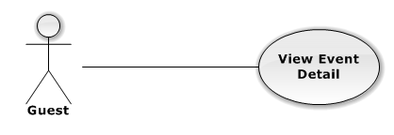

|  |  |  |  |  |
| --- | --- | --- | --- | --- |
| USE CASE – VIEW EVENT DETAIL | | | | |
| Use-case No. | UC04.03 | Use-case Version | | 1.0 |
| Use-case Name | View Event Detail | | | |
| Author | DuyDQ | | | |
| Date | 01/06/2013 | Priority | Normal | |
| **Actor:** Customer, Authorized User, Guest  **Summary:** This use case is about how actor views event detail  **Goal:** Actor can view event detail successful  **Triggers:** N/A  **Pre-conditions:** N/A  **Post-conditions:** N/A  **Main Success Scenario:**   |  |  |  | | --- | --- | --- | | Step | Actor Action | System Response | | 1 | Click on an event | Navigate to Event page |   **Alternative Scenario:** N/A  **Exceptions:** N/A  **Relationships:**  N/A  **Business Rules:** N/A | | | | |

###### **3.2.2.4.4 Search Event by Name**



|  |  |  |  |  |
| --- | --- | --- | --- | --- |
| USE CASE – SEARCH EVENT BY NAME | | | | |
| Use-case No. | UC04.04 | Use-case Version | | 1.0 |
| Use-case Name | Search Event by Name | | | |
| Author | DuyDQ | | | |
| Date | 01/06/2013 | Priority | Normal | |
| **Actor:** Customer, Authorized User, Guest  **Summary:** This use case is about how actor search event by name  **Goal:** Actor can search event successful  **Triggers:** N/A  **Pre-conditions:** N/A  **Post-conditions:** N/A  **Main Success Scenario:**   |  |  |  | | --- | --- | --- | | Step | Actor Action | System Response | | 1 | Input information want to find in text box | Make suggestion when actor input more than 1 character | | 2 | Click on search label or press Enter key | Navigate to search result page |   **Alternative Scenario:** N/A  **Exceptions:** N/A  **Relationships:**  N/A  **Business Rules:** N/A | | | | |

###### **3.2.2.4.5 Sort Ticket**

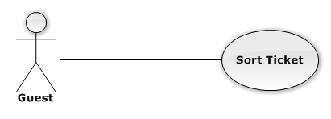

|  |  |  |  |  |
| --- | --- | --- | --- | --- |
| USE CASE – SORT TICKET | | | | |
| Use-case No. | UC04.05 | Use-case Version | | 1.0 |
| Use-case Name | Sort ticket by price | | | |
| Author | DuyDQ | | | |
| Date | 01/06/2013 | Priority | Normal | |
| **Actor:** Customer, Authorized User, Guest  **Summary:** This use case is about how actor sort ticket by price  **Goal:** Actor can sort ticket successful  **Triggers:** N/A  **Pre-conditions:** N/A  **Post-conditions:** N/A  **Main Success Scenario:**   |  |  |  | | --- | --- | --- | | Step | Actor Action | System Response | | 1 | Click on an event | - Navigate to Event page  - If there are tickets in this event, they are sorted by low to high price in ticket field | | 2 | Click on dropdown list “Giá từ thấp đến cao” and select “Giá từ cao đến thấp” | Tickets are sorted by high to low price in ticket field |   **Alternative Scenario:** N/A  **Exceptions:** N/A  **Relationships:**  N/A  **Business Rules:** N/A | | | | |

###### **3.2.2.4.6 Sort Event**

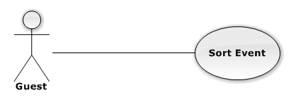

|  |  |  |  |  |
| --- | --- | --- | --- | --- |
| USE CASE – SORT EVENT | | | | |
| Use-case No. | UC04.06 | Use-case Version | | 1.0 |
| Use-case Name | Search Event by Name | | | |
| Author | DuyDQ | | | |
| Date | 01/06/2013 | Priority | Normal | |
| **Actor:** Customer, Authorized User, Guest  **Summary:** This use case is about how actor sort event  **Goal:** Actor can sort event successful  **Triggers:** N/A  **Pre-conditions:** N/A  **Post-conditions:** N/A  **Main Success Scenario:**   |  |  |  | | --- | --- | --- | | Step | Actor Action | System Response | | 1 | Go to homepage | - Navigate to homepage  - Events are sorted by top event (sorted by event has the most tickets) | | 2 | Click on “Top Các Sự Kiện” dropdown list, select “Được mua vé” option | Events are sorted by sold tickets (sorted by event has the most sold tickets) | | 2 | Click on “Top Các Sự Kiện” dropdown list, select “Có nhiều yêu cầu” option | Events are sorted by requests (sorted by event has the most requests) |   **Alternative Scenario:** N/A  **Exceptions:** N/A  **Relationships:**  N/A  **Business Rules:** N/A | | | | |

##### **3.2.2.5 Auto System**

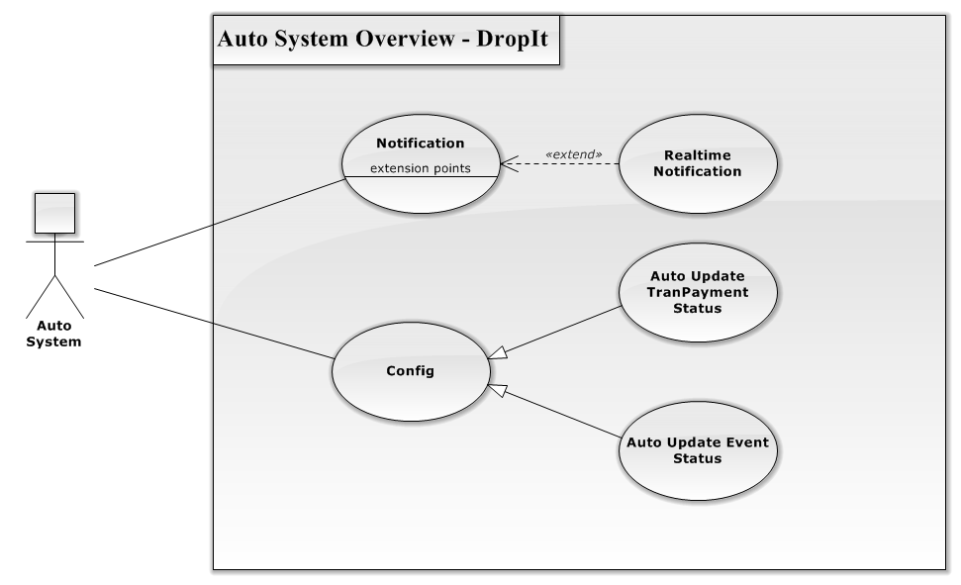

Figure 3.2.2.5.1 – Auto System Overview Diagram

###### **3.2.2.5.1 Notification**

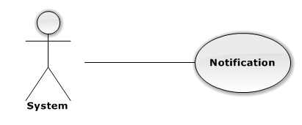

|  |  |  |  |  |
| --- | --- | --- | --- | --- |
| USE CASE – NOTIFICATION | | | | |
| Use-case No. | UC05.01 | Use-case Version | | 1.0 |
| Use-case Name | Notification | | | |
| Author | PhongLK | | | |
| Date | 01/06/2013 | Priority | Normal | |
| **Actor:** System  **Summary:** This use case is about how system notifies customer which their followed  **Goal:** Show event that customer followed has something new  **Triggers:** N/A  **Pre-conditions:** Customer follows event and another customer requests or creates ticket  **Post-conditions:**  **Main Success Scenario:**   |  |  |  | | --- | --- | --- | | Step | Actor Action | System Response | | 1 | Click “Theo dõi” button on event details | Change text button to “Bỏ theo dõi” | | 2 | When someone creates or requests this event ticket | Show the event in notification bar |   **Alternative Scenario:** N/A  **Exceptions:**  **Relationships:**  N/A  **Business Rules:** N/A | | | | |

###### **3.2.2.5.2 Real-Time Notification**

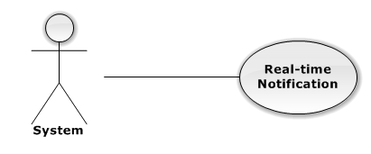

|  |  |  |  |  |
| --- | --- | --- | --- | --- |
| USE CASE – REAL-TIME NOTIFICATION | | | | |
| Use-case No. | UC05.02 | Use-case Version | | 1.0 |
| Use-case Name | Notification | | | |
| Author | PhongLK | | | |
| Date | 01/06/2013 | Priority | Normal | |
| **Actor:** System  **Summary:** This use case is about how system push real – time notification to customer  **Goal:** Real-time notification works normally when customer online  **Triggers:** N/A  **Pre-conditions:** Customer has logged into system  **Post-conditions:**  **Main Success Scenario:**   |  |  |  | | --- | --- | --- | | Step | Actor Action | System Response | | 1 | Click “Theo dõi” button on event details | Change text button to “Bỏ theo dõi” | | 2 | When someone creates or requests this event ticket | Show the event notification popup in left bottom website |   **Alternative Scenario:** N/A  **Exceptions:**  **Relationships:**  N/A  **Business Rules:** N/A | | | | |

###### **3.2.2.5.3 Auto Update TranPayment Status**

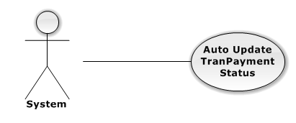

|  |  |  |  |  |
| --- | --- | --- | --- | --- |
| USE CASE – AUTO UPDATE TRANPAYMENT STATUS | | | | |
| Use-case No. | UC05.03 | Use-case Version | | 1.0 |
| Use-case Name | Notification | | | |
| Author | TungDN | | | |
| Date | 01/06/2013 | Priority | Normal | |
| **Actor:** System  **Summary:** This use case is about how the system auto change TranPaymentStatus when deadline comes.  **Goal:** The TranPaymentStatus change to “Transferred” after 5 days from TranShipDate was created  **Triggers:** N/A  **Pre-conditions:** TranShipDate was created  **Post-conditions:**  **Main Success Scenario:**   |  |  |  | | --- | --- | --- | | Step | Actor Action | System Response | | 1 | Select TranShipDate not null | Return all records that have TranShipDate | | 2 | Check TranShipDate with today | Return all records that have TranShipDate more than 5 days old | | 3 | Auto change TranPaymentStatus | Change TranPaymentStatus to “Transferred” |   **Alternative Scenario:** N/A  **Exceptions:**  **Relationships:**  N/A  **Business Rules:** N/A | | | | |

###### **3.2.2.5.4 Auto Update Event Status**

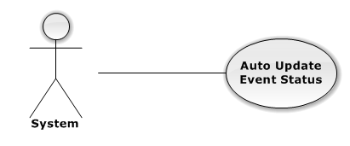

|  |  |  |  |  |
| --- | --- | --- | --- | --- |
| USE CASE – AUTO UPDATE EVENT STATUS | | | | |
| Use-case No. | UC05.04 | Use-case Version | | 1.0 |
| Use-case Name | Notification | | | |
| Author | PhongLK | | | |
| Date | 01/06/2013 | Priority | Normal | |
| **Actor:** System  **Summary:** This use case is about how to change status of event after over hold date  **Goal:** The status of event become “OutDate”  **Triggers:** N/A  **Pre-conditions:** The event was approved  **Post-conditions:**  **Main Success Scenario:**   |  |  |  | | --- | --- | --- | | Step | Actor Action | System Response | | 1 | Select all event has status not equal “Delete”and “OutDate” and not over hold date | Return all records of event that suitable | | 2 | Change event status to “OutDate” | Event status becomes “OutDate” |   **Alternative Scenario:** N/A  **Exceptions:**  **Relationships:**  N/A  **Business Rules:** N/A | | | | |

#### 3.2.3 Software System Attributes



##### **3.2.3.1 Reliability**

* The database can be backed up easily and recovered if necessary.
* The system should never crash or hang, except for the cause from an operating system or network error.
* Mean Time Between Failures (MTBF): The acceptable failure is once a year. The failure should not be because of the database, or else the data may be lost and cannot be recovered.
* Mean Time To Repair (MTTR): When the failure occurs, it should take as little time as possible to repair. The acceptable mean time for a particular failure must be less than 8 hours.
* Maximum Bugs or Defect Rate: 05 bugs / KLOC

##### **3.2.3.2 Availability**

* The uptime percentage should be at least 99.95%.
* The acceptable time for maintenance or backup should not be more than 8 hours per month.
* When the system goes in under-maintenance, the website should display a message to inform that.

##### **3.2.3.3 Security**

* Only users with proper account can access certain information of the system. All the information of users must not be available for anyone or software that is not part of the system. User password is also encrypted and not available to the system administrators.

##### **3.2.3.4 Maintainability**

* The code must follow C#.NET coding and naming convention.
* There should be comments in code files that explain the functions of each code segment.
* All the errors should be logged, which supports bug fixing and maintenance.

##### **3.2.3.5 Portability**

System can run best with the requirements:

* Hardware: Pentium IV, Ram 512 or above
* Network: ADSL or above
* Environment: Window 7
* Browser: Chrome 27

##### **3.2.3.6 Performance**

* Load time

### 3.3 Entity Relationship Diagram

**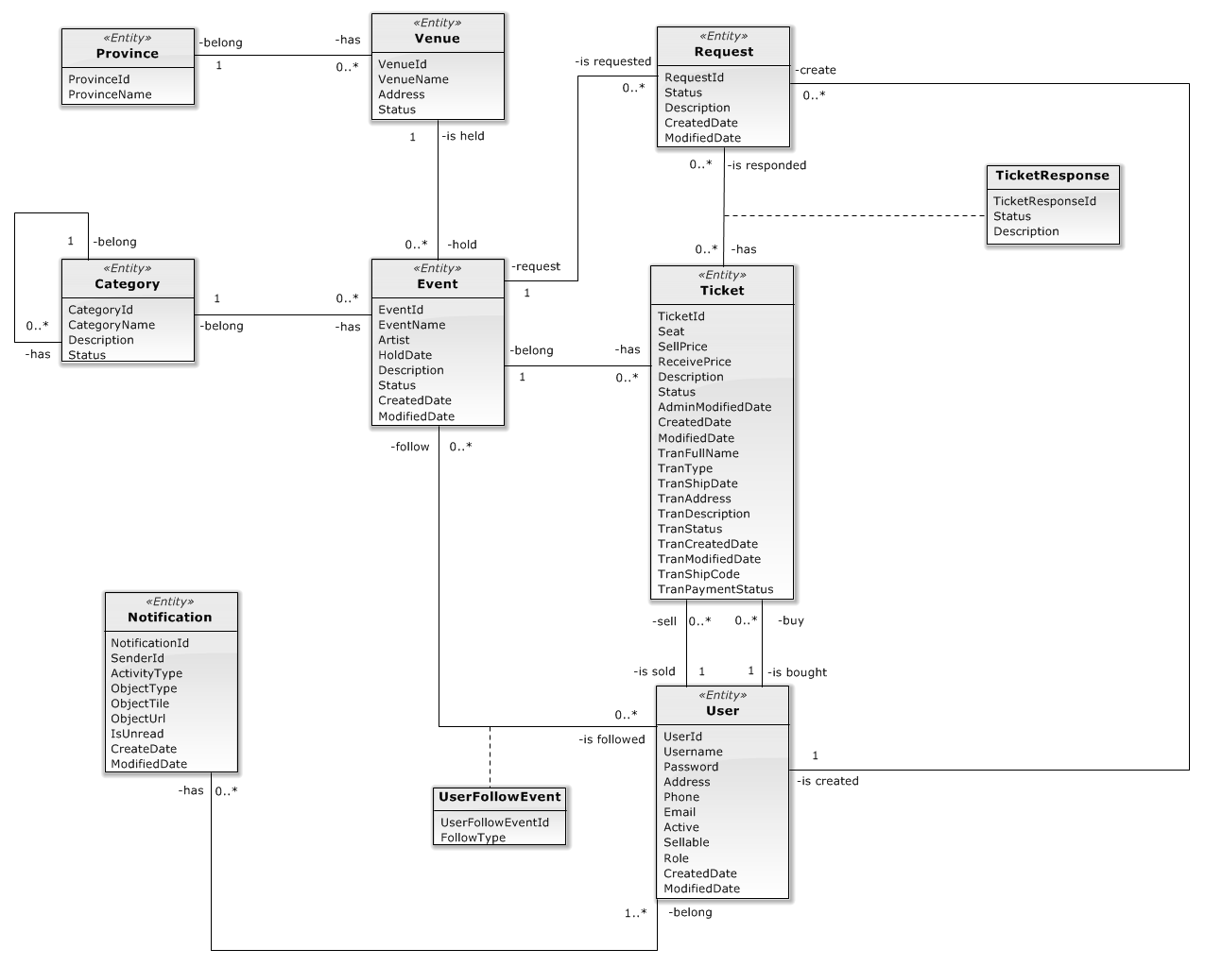**

**Figure 3.3.1 Entity Relationship Diagram**

## SOFTWARE DESIGN DESCRIPTION

### Design Overview

SDD document objective is providing for project’s stakeholders multi specific views of TWS website like:

* System Architectural design which describes the planned model of system, the initial design process of identifying sub-systems and establishing a framework for sub-system control and communication.
* Component design which describes all system’s component (class, interface…) together with relationships between them. It also explains clearly their purposes, methods within each component and detailed algorithms, pseudo code to implement them.
* Class diagram describes the structure of a system by showing the system's classes, their attributes, operations (or methods), and the relationships among the classes.
* Sequence diagram design which shows how system processes operate and in what order. A sequence diagram shows object interactions arranged in time sequence. It depicts the objects and classes involved in the scenario and the sequence of messages exchanged between the objects needed to carry out the functionality of the scenario.
* User interface design which describes all screens’ interface; each screen includes which types of input, output element and used by what action. It makes the user's interaction as simple and efficient as possible, in terms of accomplishing user goals.
* Database design is the process of producing a detailed [data model](http://en.wikipedia.org/wiki/Data_model) of a [database](http://en.wikipedia.org/wiki/Database). Database design section shows and explains the physical model of system database which includes all tables and their relationship.

### System Architectural Design

#### Choice of System Architecture

**Figure** **4.2.1.1 System Architecture**

ASP.NET MVC 4 is a framework for building scalable, standards-based web applications using well-established design patterns and the power of ASP.NET and the .NET Framework. MVC stands for model-view-controller. MVC is a pattern for developing applications that are well architected and easy to maintain. MVC-based applications contain:

* Views are template files that your application uses for dynamically generating HTML responses.
* Models are classes that represent the data of the application and that use validation logic to enforce business rules for that data.
* Controllers are classes that handle incoming requests to the application, retrieve model data, and then specify view templates that return a response to the client.

#### Discussion of Alternative Designs

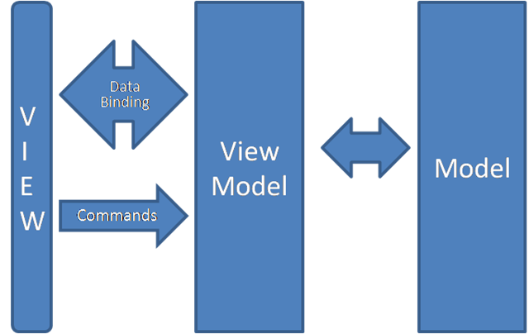

**Figure 4.2.2.1 – Alternative Designs**

MVP model also has three components like MVC mode, but Controller component is replaced by Presenter component which receives call from View component, interacts with Model component and bring changes back to the View.

In MVP model business logic section may be included directly in View or Presenter which can cause ambiguity and difficulty for implementation and testing.

### Package Diagram

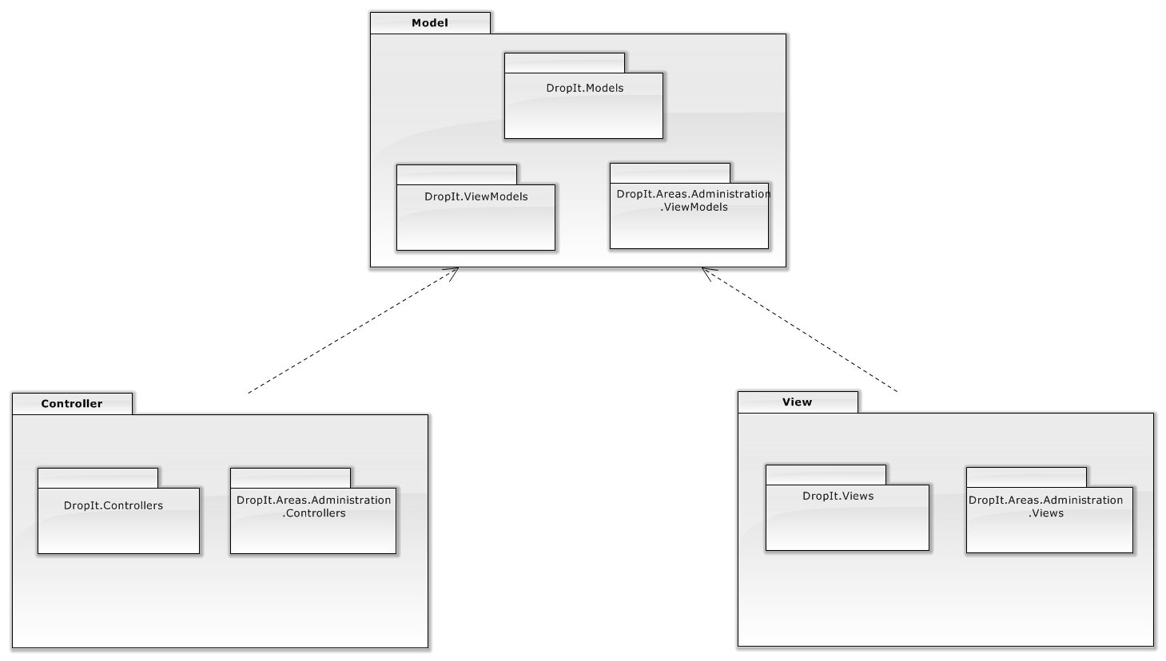

**Figure 4.1.3.1 – General Package Diagram**

### Class Detailed Description

#### DropIt.Models Package

##### **4.4.1.1 Class Diagram**

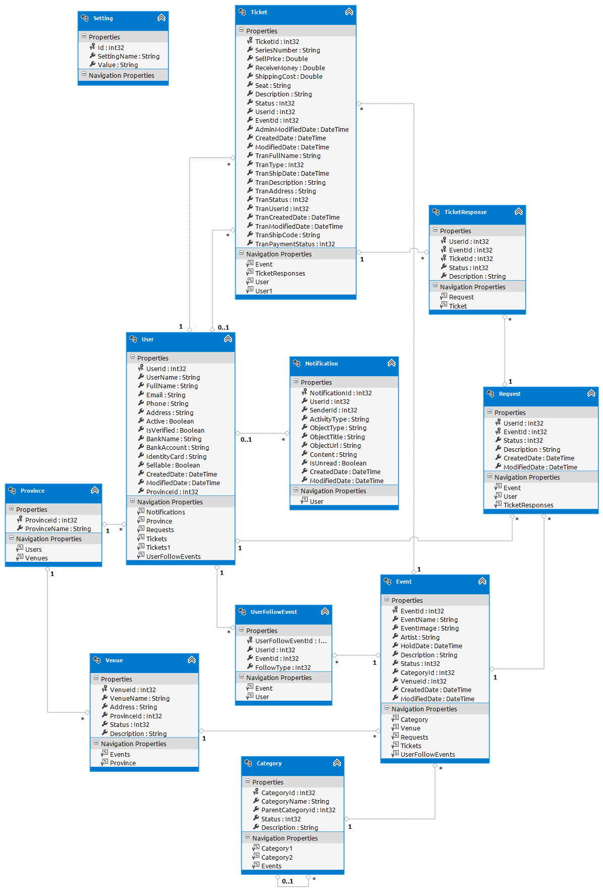

**Figure 4.4.1.1.1 – Class diagram**

##### **4.4.1.2 Class Diagram Explanation**

***Province Class***

1. *Attributes*

|  |  |  |
| --- | --- | --- |
| Parameter/Return | Type | Description |
| ProvinceId | int | Unique ID of each City |
| ProvinceName | string | Name of Province |

***Category Class***

1. *Attributes*

|  |  |  |
| --- | --- | --- |
| Name | Type | Description |
| CategoryId | int | Unique ID of each Category |
| CategoryName | string | Name of each Category |
| ParentCategoryId | int | Unique ID of each ParentCategory |
| Status | int | Status of Category |
| Description | string | Description of Category |

***Event Class***

1. *Attributes*

|  |  |  |
| --- | --- | --- |
| Name | Type | Description |
| EventId | int | Unique ID of each Event |
| EventName | string | Name of Event |
| EventImage | string | Image of Event |
| Artist | string | Name of Artist |
| HoldDate | datetime | Date event is hold |
| Description | string | Description of Event |
| Status | int | Status of Event |
| CategoryId | int | Unique ID of each Category |
| VenueId | int | Unique ID of each Venue |
| CreatedDate | datetime | Date event is created |
| ModifiedDate | datetime | Date event is modified |

***Notification Class***

1. *Attributes*

|  |  |  |
| --- | --- | --- |
| Name | Type | Description |
| NotificationId | int | Unique ID of each Notification |
| UserId | int | ID of received User |
| SenderId | int | ID of object occurs notification |
| ActivityType | string | Type of each Notify Activity |
| ObjectType | string | Type of object occurs notification |
| ObjectTitle | string | Title of each object occurs notification |
| ObjectUrl | string | Url of Notification |
| Content | string | Content of Notification |
| IsUnread | bool | Notification is read or not |
| CreatedDate | datetime | Time Notification is created |
| ModifiedDate | datetime | Time Notification is modified |

***Request Class***

1. *Attributes*

|  |  |  |
| --- | --- | --- |
| Name | Type | Description |
| UserId | int | Unique ID of each User |
| EventId | int | Unique ID of each Event |
| Status | int | Status of Request |
| Description | string | Description of Request |
| CreatedDate | datetime | Time Request is created |
| ModifiedDate | datetime | Time Request is modified |

***Setting Class***

1. *Attributes*

|  |  |  |
| --- | --- | --- |
| Name | Type | Description |
| Id | int | Unique ID of each Setting |
| SettingName | string | Name of each Setting |
| Value | string | Value of each Setting |

***Ticket Class***

1. *Attributes*

|  |  |  |
| --- | --- | --- |
| Name | Type | Description |
| TicketId | int | Unique ID of each Ticket |
| SeriesNumber | string | Series Number of each Ticket |
| SellPrice | float | Price of each Ticket |
| ReceiveMoney | float | Money user receives when Ticket is sold |
| ShippingCost | float | Cost of shipping Ticket |
| Seat | string | Seat location of Ticket |
| Description | string | Description of Ticket |
| Status | int | Status of Ticket |
| UserId | int | Unique ID of each User |
| EventId | int | Unique ID of each Event |
| AdminModifiedDate | datetime | Time Admin modified Ticket |
| CreatedDate | datetime | Time Ticket is created |
| ModifiedDate | datetime | Time User modified Ticket |
| TranFullName | string | Name of Ticket Buyer |
| TranDescription | string | Description of Transaction |
| TranAddress | string | Address of Ticket Buyer |
| TranStatus | int | Status of Transaction |
| TranUserId | int | Unique ID of Buyer |
| TranCreatedDate | datetime | Time Transaction is created |
| TranModifiedDate | datetime | Time Transaction is modified |
| TranShipCode | string | Code of shipping Transaction |
| TranPaymentStatus | int | Status of Transaction payment |

***TicketResponse Class***

1. *Attributes*

|  |  |  |
| --- | --- | --- |
| Name | Type | Description |
| UserId | int | Unique ID of each User |
| EventId | int | Unique ID of each Event |
| TicketId | int | Unique ID of each Ticket |
| Description | string | Description of Ticket Response |
| Status | int | Status of Category |

***User Class***

1. *Attributes*

|  |  |  |
| --- | --- | --- |
| Name | Type | Description |
| UserId | int | Unique ID of each User |
| UserName | string | Name of User |
| FullName | string | Full name of User |
| Email | string | Email of User |
| Phone | string | Phone of User |
| Address | string | Address of User |
| Active | bool | Active status of User |
| IsVerified | bool | Verified status of User |
| BankName | string | Bank name of User |
| BankAccount | string | Bank account of User |
| IdentityCard | string | Identity card of User |
| Sellable | bool | Sellable status of User |
| CreatedDate | datetime | Time user registered |
| ModifiedDate | datetime | Time User modified information |
| ProvinceId | int | Unique ID of each Province |

***UserFollowEvent Class***

1. *Attributes*

|  |  |  |
| --- | --- | --- |
| Name | Type | Description |
| UserFollowEventId | int | Unique ID of each follow Event |
| UserId | int | Unique ID of each User |
| EventId | int | Unique ID of each Event |
| FollowType | int | Follow type of follow Event |

***Venue Class***

1. *Attributes*

|  |  |  |
| --- | --- | --- |
| Name | Type | Description |
| VenueId | int | Unique ID of each |
| VenueName | string | Name of Venue |
| Address | string | Address of Venue |
| ProvinceId | int | Unique ID of each Province |
| Status | int | Status of Venue |
| Description | string | Description of Venue |

#### DropIt.Controllers Package

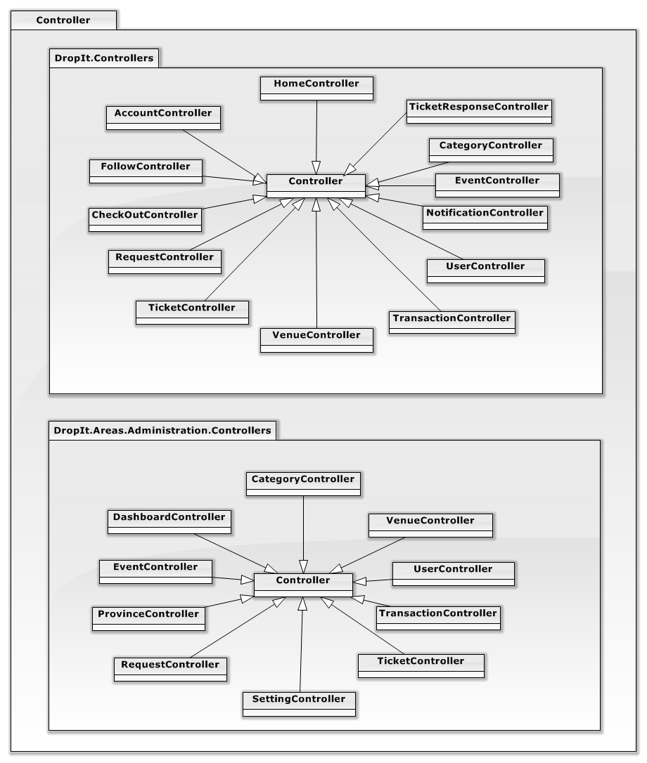

**Figure 4.4.2.1 – Controller Package**

##### **4.4.2.1 DropIt.Controllers**

*AccountController*

|  |  |  |
| --- | --- | --- |
| Method | Return type | Description |
| Login(LoginModel model, string returnUrl) | ActionResult | Allow user to login to system |
| ActionResult LogOff() | ActionResult | Allow user to logout from system |
| Register() | ActionResult | Display page for register |
| Register(RegisterModel model) | ActionResult | Allow user to create new account |
| Manage(ManageMessageId? message) | ActionResult | Display page for change password |
| Manage(LocalPasswordModel model) | ActionResult | Allow user to change password |

*CategoryController*

|  |  |  |
| --- | --- | --- |
| Method | Return type | Description |
| Details(int id = 0) | ActionResult | Display category details base on CategoryId |
| Create() | ActionResult | Display page for create category |
| getAll() | JsonResult | Get all category |

*CheckOutController*

|  |  |  |
| --- | --- | --- |
| Method | Return type | Description |
| Checkout(int Id) | ActionResult | Checkout ticket |
| Success() | ActionResult | Display checkout success page |

*EventController*

|  |  |  |
| --- | --- | --- |
| Method | Return type | Description |
| Index(int PageSize = 10, int StartIndex = 0,int CategoryId = -1) | ActionResult | Paging for event |
| Details(int id = 0) | ActionResult | Display event detail base on EventId |
| getInfo(int EventId) | JsonResult | Get event information |
| Image(int Id) | ActionResult | Return event image |
| Count() | JsonResult | Return all records of event |

*FollowController*

|  |  |  |
| --- | --- | --- |
| Method | Return type | Description |
| Event(int Id,int FollowType) | JsonResult | Allow user follow event |
| Events() | ActionResult | List all follow events |

*HomeController*

|  |  |  |
| --- | --- | --- |
| Method | Return type | Description |
| Index() | ActionResult | Display Homepage |
| BuyIndex() | ActionResult | Display Buy Index page |
| SellIndex() | ActionResult | Display Sell Index page |
| Search(string query, string sortBy = "relevant", int PageSize = 10, int StartIndex = 0) | ActionResult | Allow user to search event by name |
| SearchAjax(string searchText) | JsonResult | Suggestion on searching |
| About() | ActionResult | Display About page |
| Contact() | ActionResult | Display Contact Us page |
| GuideForNew() | ActionResult | Display Guide for New User page |

*NotificationController*

|  |  |  |
| --- | --- | --- |
| Method | Return type | Description |
| ReadAll(int FollowType = -1) | JsonResult | To mark all notifications are read |
| List(int FollowType = 2,String Object="\*",Nullable<Boolean> IsUnread = null,int jTStartIndex = 0,int FromId = 0,int jtPageSize = 10,String jtSorting = "CreatedDate DESC") | JsonResult | List notification |

*RequestController*

|  |  |  |
| --- | --- | --- |
| Method | Return type | Description |
| Index() | ActionResult | Display Request Ticket page |
| Details(int EventId) | ActionResult | Display ticket request details base on RequestId |
| Close(Request Request, int UserId, int EventId) | JsonResult | Allow user to close ticket request |

*TicketController*

|  |  |  |
| --- | --- | --- |
| Method | Return type | Description |
| Create() | ActionResult | Display page for create ticket |
| Create(PostTicket ticket) | ActionResult | Allow user to create new ticket |
| Buy(int Id) | ActionResult | Display page for buy ticket |
| Buy(BuyTicket buyTicket) | ActionResult | Allow user to buy ticket |
| RequestTicket(int EventId = 0) | ActionResult | Display page for request ticket |
| RequestTicket(RequestTicket ticket) | ActionResult | Allow user to create request ticket |
| Count() | JsonResult | Return all records of ticket |
| Approve(int id = 0) | ActionResult | Display page for approve ticket |
| Approve(Ticket ticket) | ActionResult | Allow user to approve ticket |
| Edit(int id=0) | ActionResult | Display page for edit ticket |
| Edit(Ticket ticket) | ActionResult | Allow user to edit ticket |
| Manage() | ActionResult | Display Manage Ticket page |
| Delete(int Id) | ActionResult | Allow user to delete ticket |
| Details (int id=0) | ActionResult | Allow user to view ticket details base on TicketId |

*TicketResponseController*

|  |  |  |
| --- | --- | --- |
| Method | Return type | Description |
| Index() | ActionResult | Display Request Ticket page |
| Create() | ActionResult | Display Response Ticket page |
| Response(CreateResponses data) | ActionResult | Allow user to respond ticket request |
| List() | ActionResult | Display list of responded ticket |

*TransactionController*

|  |  |  |
| --- | --- | --- |
| Method | Return type | Description |
| HistoryBuy() | ActionResult | Display Buy History page |
| HistorySell() | ActionResult | Display Sell History page |
| Receive(int Id) | ActionResult | Display Receive History page |
| Reported(int Id) | ActionResult | Display Claimed History page |
| Count(int id) | JsonResult | Return all records of transaction |

*UserController*

|  |  |  |
| --- | --- | --- |
| Method | Return type | Description |
| Edit(int id = 0) | ActionResult | Display Change Personal Information page |
| Edit(UserViewModel user) | ActionResult | Allow user to change personal information |

*VenueController*

|  |  |  |
| --- | --- | --- |
| Method | Return type | Description |
| getInfo(int VenueId) | JsonResult | Get venue information |

##### **4.4.2.2 DropIt.Areas.Administration.Controllers**

*CategoryController*

|  |  |  |
| --- | --- | --- |
| Method | Return type | Description |
| Index(int CategoryStatus = 0) | ActionResult | Display Manage Category Index page |
| List(int jtStartIndex = -1, int jtPageSize = 0, string jtSorting = "CategoryName ASC", int CategoryStatus = -1) | JsonResult | Paging for category |
| Create() | ActionResult | Display Create Category page |
| Create(Category Category) | JsonResult | Allow admin to create new category |
| Edit(int Id) | ActionResult | Display Edit Category page |
| Edit(Category Category) | JsonResult | Allow admin to edit category |
| Active(int Id) | JsonResult | Active category base on CategoryId |
| Deactive(int Id) | JsonResult | Deactive category base on CategoryId |
| Delete(int Id) | JsonResult | Delete category base on CategoryId |

*DashboardController*

|  |  |  |
| --- | --- | --- |
| Method | Return type | Description |
|  |  |  |
|  |  |  |

*EventController*

|  |  |  |
| --- | --- | --- |
| Method | Return type | Description |
| Index(int EventStatus = 0) | ActionResult | Display Manage Event Index page |
| List(int jtStartIndex = -1, int jtPageSize = 0, string jtSorting = "HoldDate ASC", int EventStatus = -1) | JsonResult | Paging for event |
| Create() | ActionResult | Display Create Event page |
| Create(Event Event, HttpPostedFileBase EventImage) | JsonResult | Allow admin to create new event |
| Edit(int Id) | ActionResult | Display Edit Event page |
| Edit(Event Event, HttpPostedFileBase EventImage) | JsonResult | Allow admin to edit event |
| getInfo(int EventId) | JsonResult | Get event information |
| Approve(int Id) | JsonResult | Approve event base on EventId |
| Disapprove(int Id) | JsonResult | Disapprove event base on EventId |
| Delete(int Id) | JsonResult | Delete event base on EventId |

*ProvinceController*

|  |  |  |
| --- | --- | --- |
| Method | Return type | Description |
| Index() | ActionResult | Display Manage Province Index page |
| List(int jtStartIndex = -1, int jtPageSize = 0, string jtSorting = null) | JsonResult | Paging for province |
| Create(Province province) | JsonResult | Allow admin to create new province |
| Update(Province province) | JsonResult | Allow admin to update province |
| Delete(int ProvinceId) | JsonResult | Allow admin to delete province |

*RequestController*

|  |  |  |
| --- | --- | --- |
| Method | Return type | Description |
| Index(int RequestStatus = 0) | ActionResult | Display Manage Request Index page |
| List(int jtStartIndex = -1, int jtPageSize = 0, string jtSorting = null, int RequestStatus = -1) | JsonResult | Paging for request |
| Close(int UserId, int EventId) | JsonResult | Allow admin to close request |

*SettingController*

|  |  |  |
| --- | --- | --- |
| Method | Return type | Description |
| Index() | ActionResult | Display Manage Setting Index page |
| List() | ActionResult | Return list of settings |
| List(int jtStartIndex = -1, int jtPageSize = 0, string jtSorting = null) | JsonResult | Paging for setting |
| Create(SettingViewModel setting) | JsonResult | Allow admin create new setting |
| Delete(int Id) | JsonResult | Allow admin delete setting |
| Edit(Setting setting) | JsonResult | Allow admin update setting |

*TicketController*

|  |  |  |
| --- | --- | --- |
| Method | Return type | Description |
| Index(int TicketStatus = 0) | ActionResult | Display Manage Ticket Index page |
| List(int jtStartIndex = -1, int jtPageSize = 0, string jtSorting = null, int TicketStatus = -1) | JsonResult | Paging for ticket |
| Approve(int Id) | JsonResult | Allow admin to approve ticket |
| Disapprove(int Id) | JsonResult | Allow admin to disapprove ticket |
| Delete(int Id) | JsonResult | Allow admin to delete ticket |
| Edit(int Id) | ActionResult | Display Update Ticket page |
| Edit(Ticket Ticket) | JsonResult | Allow admin to update ticket |

*TransactionController*

|  |  |  |
| --- | --- | --- |
| Method | Return type | Description |
| Index(int TranStatus = (int)Statuses.Transaction.Paid, int TranPaymentStatus = 0) | ActionResult | Display Manage Transaction Index page |
| List(int jtStartIndex = -1, int jtPageSize = 0, string jtSorting = null, int TranStatus = -1, int TranPaymentStatus = -1) | JsonResult | Paging for transaction |
| Delivered(int Id, string TranShipCode) | JsonResult | Allow admin to update transaction status to delivered |
| Paid(int Id) | JsonResult | Allow admin to update transaction status to paid |
| Done(int Id) | JsonResult | Allow admin to update transaction status to done |
| Received(int Id) | JsonResult | Allow admin to update transaction status to received |
| Canceled(int Id) | JsonResult | Allow admin to update transaction status to received canceled |

*UserController*

|  |  |  |
| --- | --- | --- |
| Method | Return type | Description |
| Index() | ActionResult | Display Manage User Index page |
| List(int jtStartIndex = -1, int jtPageSize = 0, string jtSorting = null,int isActive = -1,int isSellable =-1,String UserName = "") | JsonResult | Paging for user |
| UpdateActive(int UserId, bool Active) | JsonResult | Active user base on UserId |
| UpdateSellable(int UserId, bool Sellable) | JsonResult | Allow user selling base on UserId |

*VenueController*

|  |  |  |
| --- | --- | --- |
| Method | Return type | Description |
| Index(int VenueStatus = 0) | ActionResult | Display Manage Venue Index page |
| List(int jtStartIndex = -1, int jtPageSize = 0, string jtSorting = null, int VenueStatus = -1) | JsonResult | Paging for venue |
| Create() | ActionResult | Display Create Venue page |
| Create(Venue Venue) | JsonResult | Allow admin to create new venue |
| Approve(int Id) | JsonResult | Allow admin approve venue |
| Disapprove(int Id) | JsonResult | Allow admin disapprove venue |
| Edit(int Id) | ActionResult | Display Update Venue page |
| Edit(Venue Venue) | JsonResult | Allow admin to update venue |
| Delete(int Id) | JsonResult | Allow admin to delete venue |

### Sequence Diagram

#### Get list ticket

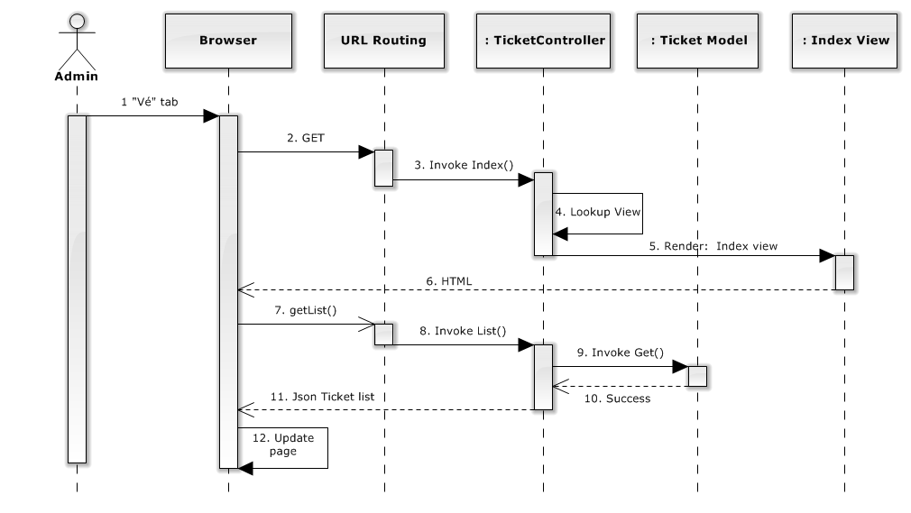

**Figure 4.5.1.1 – Get list ticket sequence diagram**

#### Edit Ticket

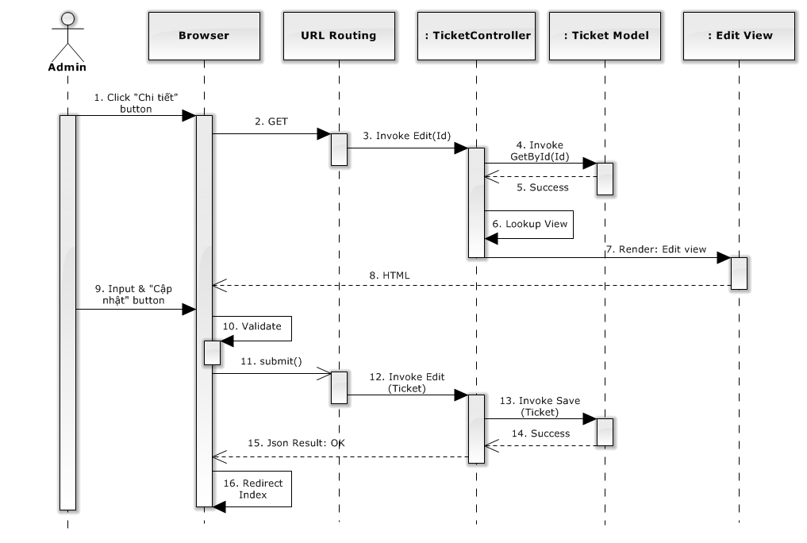

**Figure 4.5.2.1 – Edit ticket sequence diagram**

#### Delete Ticket

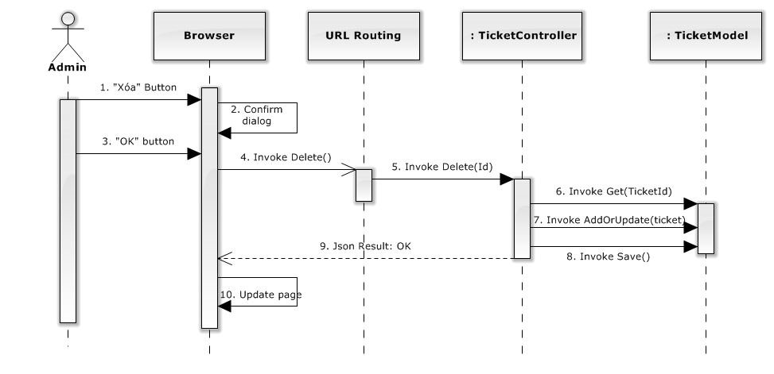

**Figure 4.5.3.1 – Delete ticket sequence diagram**

#### Approve Ticket

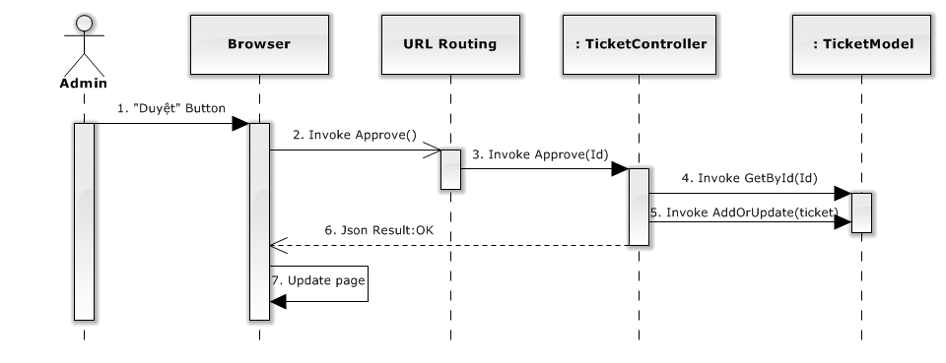

**Figure 4.5.4.1 –Approve ticket sequence diagram**

#### Delivered Transaction

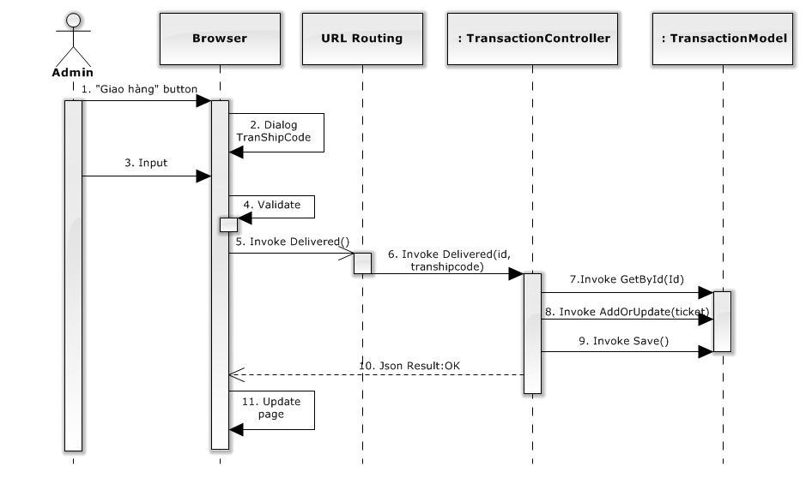

**Figure 4.5.5.1 – Delivered transaction sequence diagram**

#### Received Transaction

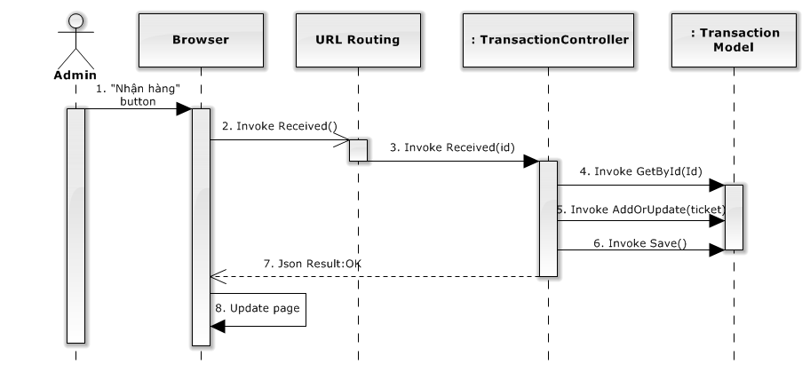

**Figure 4.5.6.1 – Received transaction sequence diagram**

#### Create Event

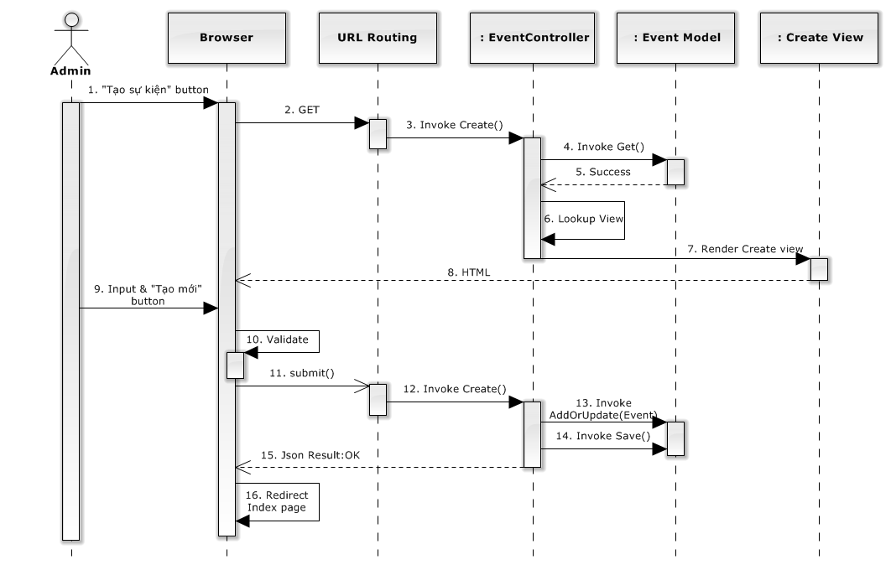

**Figure 4.5.7.1 – Create Event sequence diagram**

#### Active User

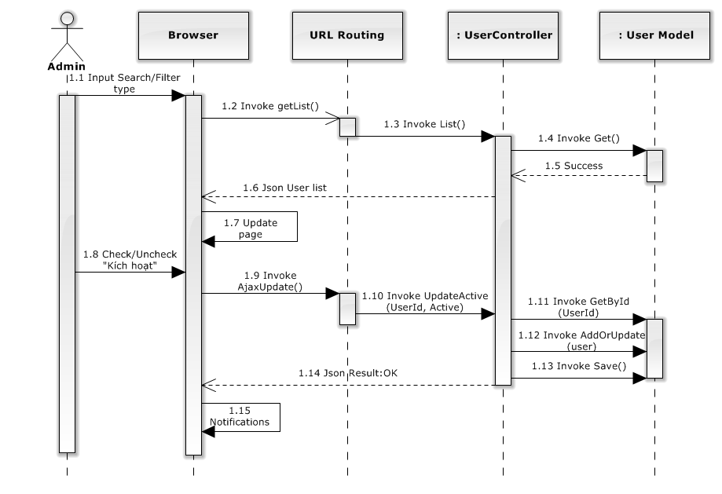

**Figure 4.5.8.1 – Active User sequence diagram**

### Activity diagram

#### Create Ticket

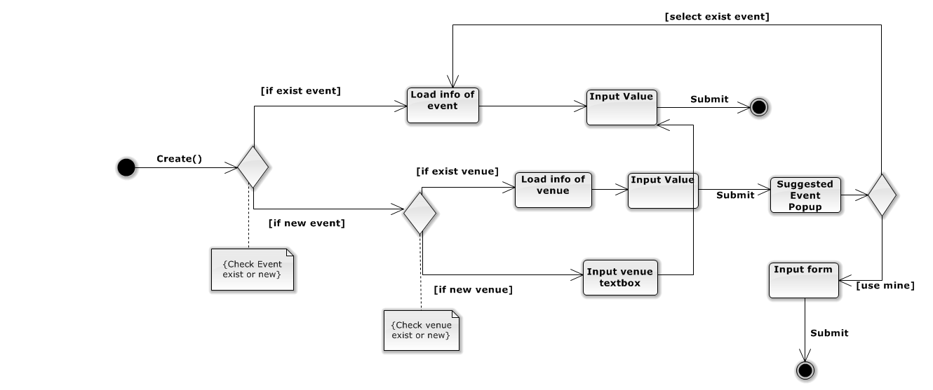

**Figure 4.6.1.1 – Create ticket activity diagram**

#### Request Ticket

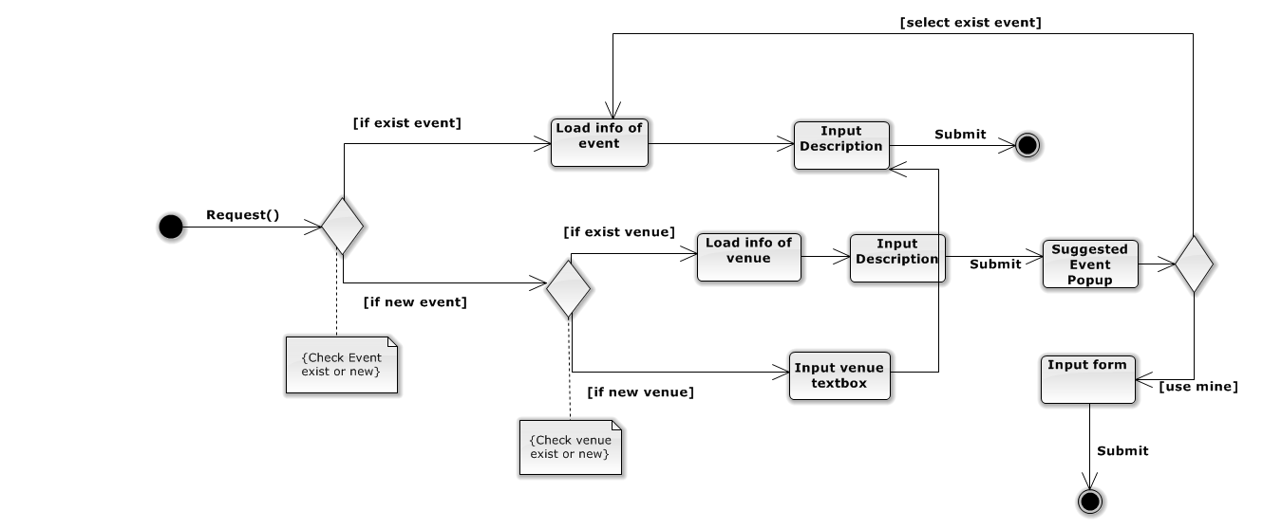

**Figure 4.6.2.1 –Request ticket activity diagram**

### State Diagram

#### Ticket State Diagram

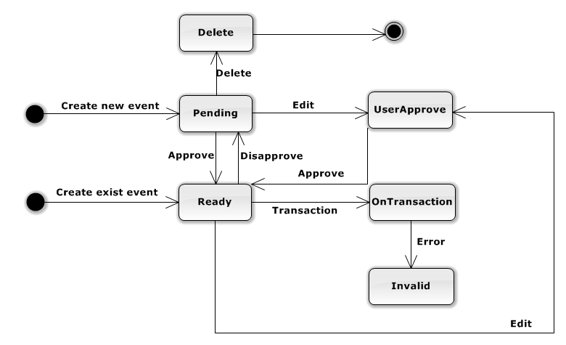

**Figure 4.7.1.1 – Ticket State Diagram**

**States Description:**

Delete: The ticket is not presented to user and admin.

Pending: The ticket can’t transact and present in user site.

UserApprove: The ticket was waiting for user approve when Admin edited information of ticket event.

OnTransaction: The ticket is transacting, user can’t buy or edit it.

Ready: The ticket is available for buying now.

Invalid: The ticket has some error on delivery to buyer.

#### Event State Diagram

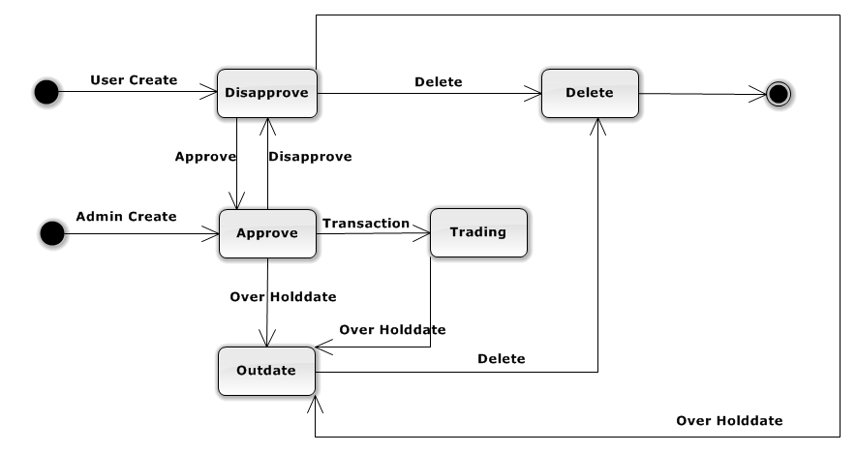

**Figure 4.7.2.1 – Event State Diagram**

**States Description:**

Disapprove: The event does not present in user site.

Delete: The event is not presented to user and admin.

Approve: The event presents in user site.

Trading: The event has ticket is transacted.

OutDate: The event is out of date.

### Algorithm Suggestion Event

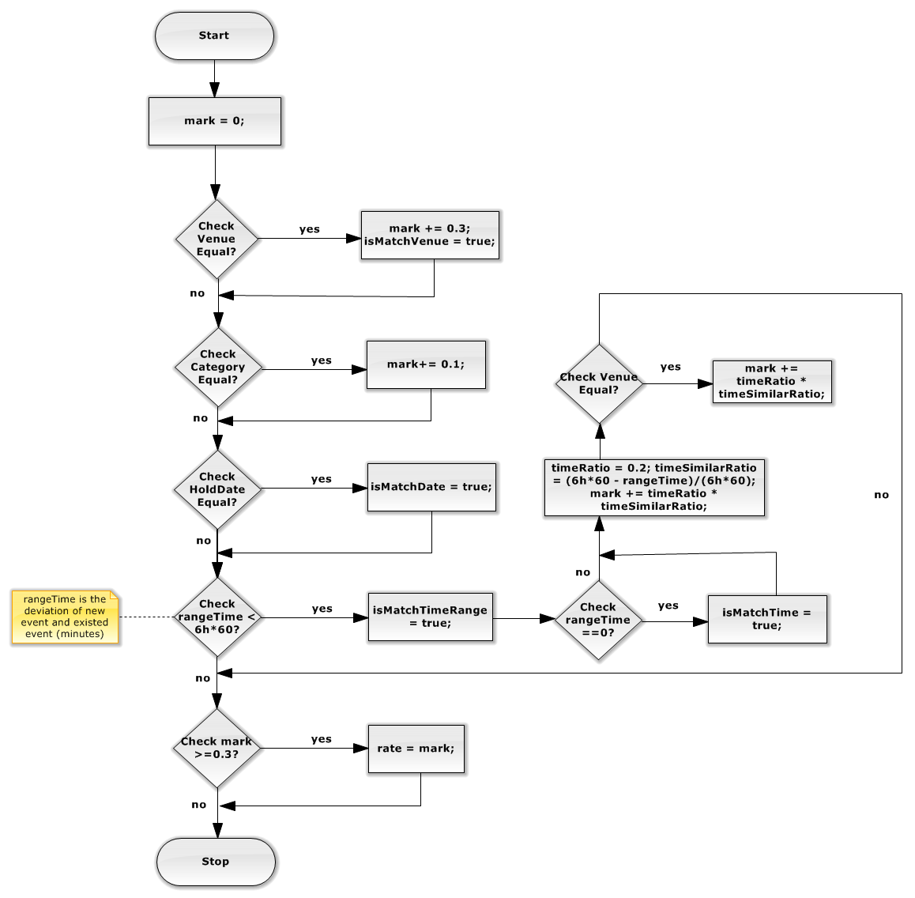

**Figure 4.8.1 – Algorithm Suggestion Event**

### Database Design or Data Structures

#### Database diagram

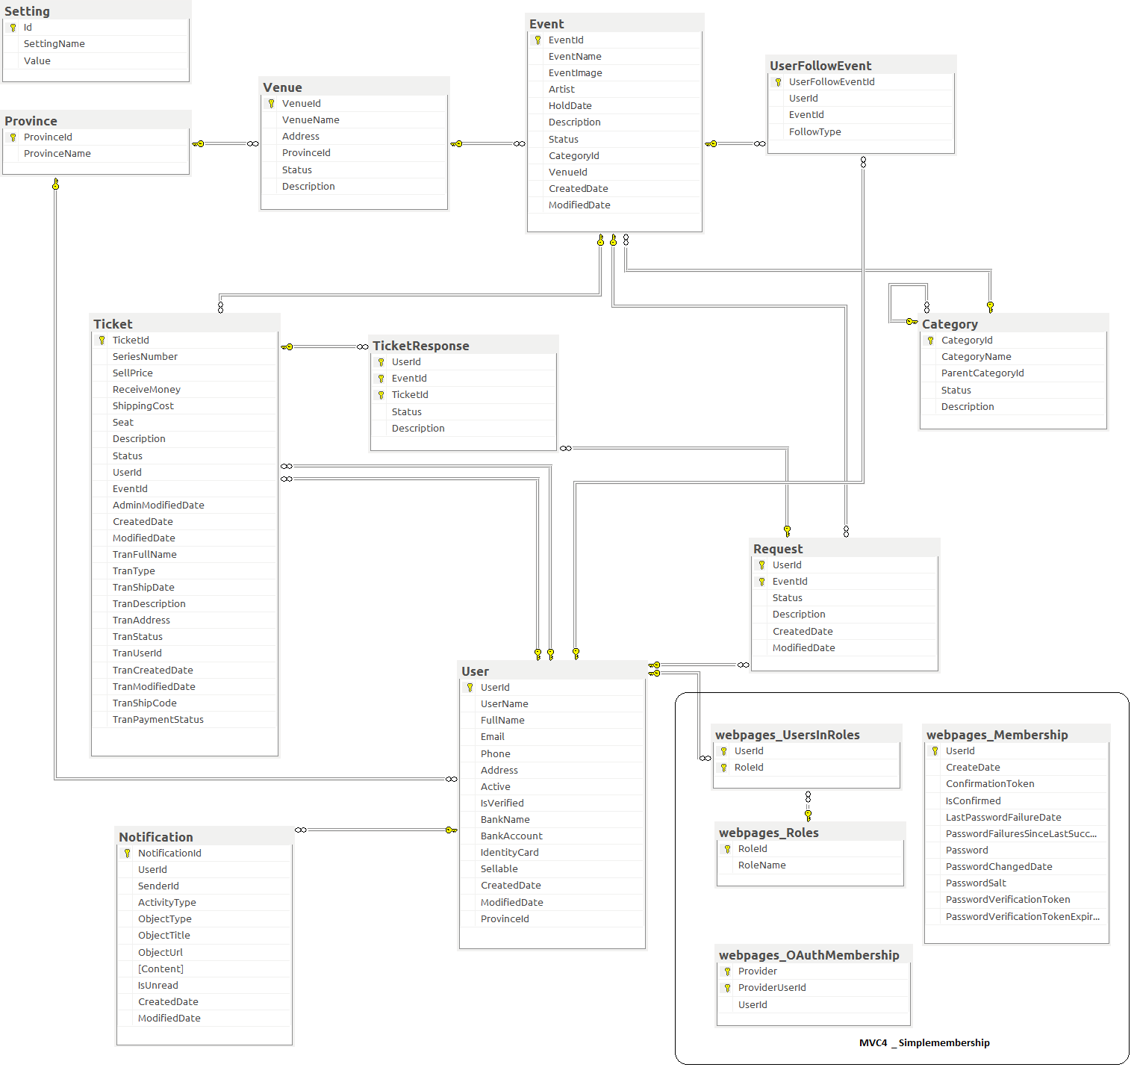

**Figure 4.9.1.1 Database Diagram**

#### Table

|  |  |
| --- | --- |
| **Table Name** | **Description** |
| User | Store detail of user |
| Ticket | Store feedback response content |
| Venue | Store detail of venue |
| Event | Store detail of event |
| UserFollowEvent | Store detail of follow |
| Request | Store detail of request |
| TicketResponse | Store detail of response |
| Category | Store detail of category |
| Province | Store detail of province |
| Setting | Store detail of setting |
| Notification | Store detail of notification |

##### **4.9.2.1 User table**

|  |  |  |  |  |  |
| --- | --- | --- | --- | --- | --- |
| Data Member Name | Description | Type | Mandatory | Unique? | Primary / Foreign key |
| UserId | This is unique id for user | int | Yes | Yes | PK |
| UserName | This is name for login | nvarchar(50) | Yes | Yes |  |
| FullName | This is name for payment | nvarchar(50) | No | No |  |
| Email | This is email of user | nvarchar(50) | Yes | No |  |
| Phone | This is phone number of user | nvarchar(50) | Yes | No |  |
| Address | This is address of user | nvarchar(MAX) | Yes | No |  |
| Active | This is status when user registers | bit | Yes | No |  |
| IsVerified | User is verified by admin | bit | Yes | No |  |
| BankName | This is name of bank for transaction | nvarchar(50) | No | No |  |
| BankAccount | This is user account name | nvarchar(50) | No | No |  |
| IdentityCard | This is user identity card | Nvarchar(10) | No | No |  |
| Sellable | This is status for user can sell or not | bit | Yes | No |  |
| CreatedDate | This is date when user creates an account | datetime | No | No |  |
| ModifiedDate | This is date when user changes personal information | datetime | No | No |  |
| ProvinceId | This is province when user registers | int | Yes | No | FK |

##### **4.9.2.2 Ticket table**

|  |  |  |  |  |  |
| --- | --- | --- | --- | --- | --- |
| Data Member Name | Description | Type | Mandatory | Unique? | Primary / Foreign key |
| TicketId | This is unique id for ticket | int | Yes | Yes | PK |
| SeriesNumber | This is series number on ticket | nvarchar(50) | No | No |  |
| SellPrice | This is money that user want to sell a ticket | float | Yes | No |  |
| ReceiveMoney | This is money user receives after tax | float | Yes | No |  |
| ShippingCost | This is ticket shipping cost to buyer | float | No | No |  |
| Seat | This is number of seat in ticket | nvarchar(MAX) | No | No |  |
| Description | This is ticket description details | nvarchar(MAX) | No | No |  |
| Status | This is status of ticket: Pending, Ready, Delete, UserApprove, OnTransaction, Invalid | int | Yes | No |  |
| UserId | This is id of user posted ticket | int | Yes | No | FK |
| EventId | This is id of event in this ticket | int | Yes | No | FK |
| AdminModifiedDate | This is date ticket is modified by admin | datetime | No | No |  |
| CreatedDate | This is date ticket is created | datetime | No | No |  |
| ModifiedDate | This is date ticket is modified by user | datetime | No | No |  |
| TranFullName | This is name of buyer | nvarchar(50) | No | No |  |
| TranType | This is transaction type user choose for payment | Int | No | No |  |
| TranShipDate | This is date buyer receive ticket | datetime | No | No |  |
| TranDescription | This is transaction description details | nvarchar(MAX) | No | No |  |
| TranAddress | This is address of buyer | nvarchar(MAX) | No | No |  |
| TranStatus | This is status for transaction: Unpaid, Paid, Delivered, Received, Reported, Canceled | int | No | No |  |
| TranUserId | This is id of buyer | int | No | No | FK |
| TranCreatedDate | This is date transaction is created | datetime | No | No |  |
| TranModifiedDate | This is date transaction is modified | datetime | No | No |  |
| TranShipCode | This is code of shipping | nvarchar(50) | No | No |  |
| TranPaymentStatus | This is status of transaction to determine admin to pay for user or not | int | No | No |  |

##### **4.9.2.3 Venue table**

|  |  |  |  |  |  |
| --- | --- | --- | --- | --- | --- |
| Data Member Name | Description | Type | Mandatory | Unique? | Primary / Foreign key |
| VenueId | This is unique id of the venue | int | Yes | Yes | PK |
| VenueName | This is name of venue | nvarchar(50) | Yes | No |  |
| Address | This is address of venue | nvarchar(MAX) | Yes | No |  |
| ProvinceId | This is id of province | int | Yes | No | FK |
| Status | This is status of venue: Approve, disapprove, delete | int | Yes | No |  |
| Description | This is venue description details | nvarchar(MAX) | No | No |  |

##### **4.9.2.4 Province table**

|  |  |  |  |  |  |
| --- | --- | --- | --- | --- | --- |
| Data Member Name | Description | Type | Mandatory | Unique? | Primary / Foreign key |
| ProvinceId | This is unique id for each province | int | Yes | Yes | PK |
| ProvinceName | This is province’s name | nvarchar(50) | Yes | No |  |

##### **4.9.2.5 Event table**

|  |  |  |  |  |  |
| --- | --- | --- | --- | --- | --- |
| Data Member Name | Description | Type | Mandatory | Unique? | Primary / Foreign key |
| EventId | This is unique id for each event | int | Yes | Yes | PK |
| EventName | This is name of event | nvarchar(50) | Yes | No |  |
| EventImage | This is image for each event | nvarchar(MAX) | No | No |  |
| Artist | The event usually have artist, this is name of artist | nvarchar(50) | No | No |  |
| HoldDate | This is date when event is hold | datetime | Yes | No |  |
| Description | This is description for event | nvarchar(MAX) | No | No |  |
| Status | Status of event: Approve, disapprove, delete, trading, outdate | int | Yes | No |  |
| CategoryId | This is id for category | int | Yes | No | FK |
| VenueId | This is id for venue | int | Yes | No | FK |
| CreatedDate | The date event is created | datetime | No | No |  |
| ModifiedDate | The date event is modified | datetime | No | No |  |

##### **4.9.2.6 UserFollowEvent table**

|  |  |  |  |  |  |
| --- | --- | --- | --- | --- | --- |
| Data Member Name | Description | Type | Mandatory | Unique? | Primary / Foreign key |
| FollowEventId | This is unique id for each follow event | int | Yes | Yes | PK |
| UserId | This is unique id for each user, the user to follow event | int | Yes | No | FK |
| EventId | This is unique id for each event, the event was follow by user | int | Yes | No | FK |
| FollowType | This is unique id for each follow event | int | Yes | No |  |

##### **4.9.2.7 Request table**

|  |  |  |  |  |  |
| --- | --- | --- | --- | --- | --- |
| Data Member Name | Description | Type | Mandatory | Unique? | Primary / Foreign key |
| UserId | This is user’s id, the user create this request | int | Yes | No | PK, FK |
| EventId | This is id for each event, the event was request by user | int | Yes | No | PK, FK |
| Status | This is status of request: Open, close | int | Yes | No |  |
| Description | This is description for request | nvarchar(MAX) | No | No |  |
| CreatedDate | The date create this request | datetime | No | No |  |
| ModifiedDate | The date modified request. | datetime | No | No |  |

##### **4.8.2.8 TicketResponse table**

|  |  |  |  |  |  |
| --- | --- | --- | --- | --- | --- |
| Data Member Name | Description | Type | Mandatory | Unique? | Primary / Foreign key |
| UserId | This is user’s id, the user response for ticket | int | Yes | No | PK, FK |
| EventId | This is event’s id | int | Yes | No | PK, FK |
| TicketId | This is ticket’s id, the ticket have response. | int | Yes | No | PK,FK |
| Status | This is status of ticket response: Appear, delete | int | Yes | No |  |
| Description | This is description for response. | nvarchar(MAX) | No | No |  |

##### **4.9.2.9 Category table**

|  |  |  |  |  |  |
| --- | --- | --- | --- | --- | --- |
| Data Member Name | Description | Type | Mandatory | Unique? | Primary / Foreign key |
| CategoryId | This is unique id for each category. | int | Yes | Yes | PK |
| CategoryName | This is name of category. | nvarchar(50) | Yes | No |  |
| ParentCategoryId | This is id for each parent category | int | No | No | FK |
| Status | This is status of category: Active, deactive, delete | int | Yes | No |  |
| Description | This is description for category | nvarchar(MAX) | No | No |  |

##### **4.9.2.10 Setting table**

|  |  |  |  |  |  |
| --- | --- | --- | --- | --- | --- |
| Data Member Name | Description | Type | Mandatory | Unique? | Primary/ Foreign key |
| Id | This is unique id for each setting | int | Yes | Yes | PK |
| SettingName | This is name of setting | nvarchar(50) | Yes | No |  |
| Value | This is value of setting | nvarchar(50) | Yes | No |  |

##### **4.9.2.11 Notification table**

|  |  |  |  |  |  |
| --- | --- | --- | --- | --- | --- |
| Data Member Name | Description | Type | Mandatory | Unique? | Primary / Foreign key |
| NotificationId | This is unique id for each notification | int | Yes | Yes | PK |
| UserId | This is id for each user | int | Yes | No | FK |
| SenderId | This is id of object occurs notification | int | Yes | No |  |
| ActivityType | This is type of notification | nvarchar(50) | Yes | No |  |
| ObjectType | This is type of object occurs notification | nvarchar(50) | No | No |  |
| ObjectTitle | This is title of object occurs notification | nvarchar(250) | No | No |  |
| ObjectUrl | This is Url of notification | nvarchar(MAX) | No | No |  |
| Content | This is content of notification | nvarchar(MAX) | No | No |  |
| IsUnread | To know notification is read or not | bit | Yes | No |  |
| CreatedDate | This is date notification is created | datetime | No | No |  |
| ModifiedDate | This is date notification is modified | datetime | No | No |  |

## Software Test Documentation (STD)

### Introduction

#### System Overview

* This document describes plan and methodologies used in testing stage, an important step for grading the quality of product before packaging it. Testing group would plan, manage and execute the process of testing. Testers must execute and pass all test cases and technical details of system features.
* The testing group is also the coding group of Drop It. The system is developed based on MVC architect. Drop It is an e commerce website for trading ticket between buyer and seller.

#### Test Approach

* Test approach defines goal and scope of system testing, overall strategy to be adopted, activities to be completed, general resources required, methods and processes to be used for testing. It also describes activities, dependencies and effort required to conduct system testing.
* The goal of testing is finding out remaining bugs, telling developing team about those bugs, and they will fix it before releasing. All members would participate in testing the system.
* The process of testing stage includes Unit Testing, Component Testing, Integration Testing and System Testing levels. Unit Testing uses white box method, while the other levels uses black box. However, this document only includes features which are in System Testing. There is at least one time to do Systems Testing by outside people who are not member of the developing team. The testing team and outside people do all testing work before the project manager executes the final test.

### Test Plan

#### Feature to be tested

##### **<Admin> Active user**

Test if admin can active user

##### **<Admin> Deactive user**

Test if admin can deactive user

##### **<Admin> Filter user**

Test if admin can filter user

##### **<Admin> Search user**

Test if admin can search user

##### **<Admin> Allow user selling**

Test if admin can allow user selling ticket

##### **<Admin> Disallow user selling**

Test if admin can disallow user selling ticket

##### **<Admin> Update ticket**

Test if admin can update ticket

##### **<Admin> Delete ticket**

Test if admin can delete ticket

##### **<Admin> Approve ticket**

Test if admin can approve ticket

##### **<Admin> Disapprove ticket**

Test admin if can disapprove ticket

##### **<Admin> Create event**

Test if admin can create event

##### **<Admin> Update event**

Test if admin can update event

##### **<Admin> Delete event**

Test if admin can delete event

##### **<Admin> Approve event**

Test if admin can approve event

##### **<Admin> Disapprove event**

Test if admin can disapprove event

##### **<Admin> Create venue**

Test if admin can create venue

##### **<Admin> Update venue**

Test if admin can update venue

##### **<Admin> Approve venue**

Test if admin can approve venue

##### **<Admin> Disapprove venue**

Test if admin can disapprove venue

##### **<Admin> Delete venue**

Test if admin can delete venue

##### **<Admin> Create category**

Test if admin can create category

##### **<Admin> Update category**

Test if admin can update category

##### **<Admin> Delete category**

Test if admin can delete category

##### **<Admin> Show category**

Test if admin can show hidden category

##### **<Admin> Hide category**

Test if admin can hide category

##### **<Admin> Close request**

Test if admin can close request

##### **<Admin> Update transaction status**

Test if admin can update transaction status

##### **<Admin> Create setting**

Test if admin can create setting

##### **<Admin> Update setting**

Test if admin can update setting

##### **<Admin> Delete setting**

Test if admin can delete setting

##### **<Guest> Register**

Test if guest can register new account

##### **<Guest> Login**

Test if guest can login

##### **<User> Buy ticket**

Test if user can buy ticket

##### **<User> Post ticket**

Test if user can post ticket

##### **<User> Edit posted ticket**

Test if user can edit posted ticket

##### **<User> View ticket details**

Test if user can view posted ticket details

##### **<User> Delete posted ticket**

Test if user can delete posted ticket

##### **<User> Request ticket**

Test if user can request ticket

##### **<User> Response ticket**

Test if user can respond ticket

##### **<User> View ticket request**

Test if user can view ticket request

##### **<User> Close ticket request**

Test if user can close ticket request

##### **<User> View buy history**

Test if user can view buy history

##### **<User> View sell history**

Test if user can view sell history

##### **<User> Follow/Unfollow buy event**

Test if user can follow or unfollow buy event

##### **<User> Follow/Unfollow sell event**

Test if user can follow or unfollow sell event

##### **<User> Follow/Unfollow buy and sell event**

Test if user can follow or unfollow buy and sell event

##### **<User> View follow event list**

Test if user can view list of follow event

##### **<User> View notification**

Test if user can view notification

##### **<User> Change password**

Test if user can change password

##### **<User> Change personal information**

Test if user can change personal information

##### **<User> View ticket request list**

Test if user can view list of request ticket

##### **<Guest/User> Search event by name**

Test if user or guest can search event by event name

##### **<Guest/User> View event details**

Test if user or guest can view event details

##### **<User> Logout**

Test if user can log out

#### Feature not to be tested

**Server:**

- Hardware: Intel Core i5 2.30 GHz, 4 G RAM, 500G HDD

- OS: Win 7 Profession

- DBMS: Microsoft SQL Server compact 2012

- Web server: Internet information service 7

**Client:**

- Hardware: Intel Core i5 2.30 GHz, 4 G RAM, 500G HDD

- OS: Win 7 Profession

- Brower: Google Chrome version 28

#### Testing Tools and Environment

### Test Case

#### Admin Test Case



##### **<Admin> Active user**

|  |  |  |  |  |  |  |  |
| --- | --- | --- | --- | --- | --- | --- | --- |
| ID | Test Case Description | Test Case Procedure | Expected Result | Result | Test date | Tester | Note |
| [AU-1] | Active user successful | 1. Click on “Người dùng” tab in Administration page  2. Choose a deactive user and check on “Kích hoạt” box | 1. Navigate to manage user page normally  2. Display message active user successful | Pass |  |  |  |

##### **<Admin> Filter user**

|  |  |  |  |  |  |  |  |
| --- | --- | --- | --- | --- | --- | --- | --- |
| ID | Test Case Description | Test Case Procedure | Expected Result | Result | Test date | Tester | Note |
| [FU-1] | Filter user successful | 1. Click on “Người dùng” tab in Administration page  2. Check on “Được kích hoạt” checkbox  3. Check on “Không kích hoạt” checkbox  4. Check on “Được bán” checkbox  5. Check on “Không được bán” checkbox | 1. Navigate to manage user page normally  2. Display list active user  3. Display list deactive user  4. Display list salable user  5. Display list unsalable user | Pass |  |  |  |

##### **<Admin> Search user**

|  |  |  |  |  |  |  |  |
| --- | --- | --- | --- | --- | --- | --- | --- |
| ID | Test Case Description | Test Case Procedure | Expected Result | Result | Test date | Tester | Note |
| [SU-1] | Search user successful | 1. Click on “Người dùng” tab in Administration page  2. Fill user name want to search into search box  3. Click on “Tìm kiếm” button or press enter key | 1. Navigate to manage user page normally  2. Display information normally  3. Display search result | Pass |  |  |  |

##### **<Admin> Deactive user**

|  |  |  |  |  |  |  |  |
| --- | --- | --- | --- | --- | --- | --- | --- |
| ID | Test Case Description | Test Case Procedure | Expected Result | Result | Test date | Tester | Note |
| [DAU-1] | Deactive user successful | 1. Click on “Người dùng” tab in Administration page  2. Choose an active user and uncheck “Kích hoạt” box | 1. Navigate to manage user page normally  2. Display message deactive user successful | Pass |  |  |  |

##### **<Admin> Allow user selling**

|  |  |  |  |  |  |  |  |
| --- | --- | --- | --- | --- | --- | --- | --- |
| ID | Test Case Description | Test Case Procedure | Expected Result | Result | Test date | Tester | Note |
| [AUS-1] | Allow user selling successful | 1. Click on “Người dùng” tab in Administration page  2. Choose a disallow selling user and check “Được bán” box | 1. Navigate to manage user page normally  2. Display message allow user selling successful | Pass |  |  |  |

##### **<Admin> Disallow user selling**

|  |  |  |  |  |  |  |  |
| --- | --- | --- | --- | --- | --- | --- | --- |
| ID | Test Case Description | Test Case Procedure | Expected Result | Result | Test date | Tester | Note |
| [DUS-1] | Disallow user selling successful | 1. Click on “Người dùng” tab in Administration page  2. Choose an allow selling user and uncheck “Được bán” box | 1. Navigate to manage user page normally  2. Display message disallow user selling successful | Pass |  |  |  |

##### **<Admin> Update ticket**

|  |  |  |  |  |  |  |  |
| --- | --- | --- | --- | --- | --- | --- | --- |
| ID | Test Case Description | Test Case Procedure | Expected Result | Result | Test date | Tester | Note |
| [UT-1] | Test display update ticket page | 1. Click on “Vé” tab in Administration page  2. Click on “Sẵn sang” tab  3. Choose a ticket and click “Chi tiết” button | 1. Navigate to manage ticket page normally  2. Display list of ticket normally  3. Navigate to edit ticket details page, content include:  - Title and input:  + “Mã số vé”  + “Giá bán”  + “Ghế ngồi”  + “Sự kiện”  + “Ngày diễn ra”  + “Địa điểm”  + “Chú thích”  - Button  + “Cập nhật”  + “Hủy” | Pass |  |  |  |
| [UT-2] | Test update ticket successful | 1. Click on “Vé” tab in Administration page  2. Click on “Sẵn sang” tab  3. Choose a ticket and click “Chi tiết” button  4. Select another event in “Sự kiện” field  5. Fill “Khán đài B” in “Chú thích” field  6. Click on “Cập nhật” button | 1. Navigate to manage ticket page normally  2. Display list of ticket normally  3. Navigate to edit ticket details page  4. Input normally  5. Input normally  6. Navigate to ticket page | Pass |  |  |  |
| [UT-3] | Test cancel update ticket | 1. Click on “Vé” tab in Administration page  2. Click on “Sẵn sang” tab  3. Choose a ticket and click “Chi tiết” button  4. Click on “Hủy” button | 1. Navigate to manage ticket page normally  2. Display list of ticket normally  3. Navigate to edit ticket details page  4. Navigate to manage ticket page | Pass |  |  |  |

##### **<Admin> Delete ticket**

|  |  |  |  |  |  |  |  |
| --- | --- | --- | --- | --- | --- | --- | --- |
| ID | Test Case Description | Test Case Procedure | Expected Result | Result | Test date | Tester | Note |
| [DT-1] | Test delete ticket successful | 1. Click on “Vé” tab in Administration page  2. Click on “Tạm hoãn” tab  3. Choose a ticket and click “Xóa” button | 1. Navigate to manage ticket page normally  2. Display disapproved ticket normally  3. Display message delete ticket successful | Pass |  |  |  |

##### **<Admin> Approve ticket**

|  |  |  |  |  |  |  |  |
| --- | --- | --- | --- | --- | --- | --- | --- |
| ID | Test Case Description | Test Case Procedure | Expected Result | Result | Test date | Tester | Note |
| [AT-1] | Test approve ticket successful | 1. Click on “Vé” tab in Administration page  2. Click on “Tạm hoãn” tab  3. Choose a ticket and click “Duyệt” button | 1. Navigate to manage ticket page normally  2. Display disapproved ticket normally  3. Display message approve ticket successful | Pass |  |  |  |

##### **<Admin> Disapprove ticket**

|  |  |  |  |  |  |  |  |
| --- | --- | --- | --- | --- | --- | --- | --- |
| ID | Test Case Description | Test Case Procedure | Expected Result | Result | Test date | Tester | Note |
| [DAT-1] | Test disapprove ticket successful | 1. Click on “Vé” tab in Administration page  2. Click on “Sẵn sàng” tab  3. Choose a ticket and click “Bỏ duyệt” button | 1. Navigate to manage ticket page normally  2. Display approved tickets normally  3. Display message disapprove ticket successful | Pass |  |  |  |

##### **<Admin> Create event**

|  |  |  |  |  |  |  |  |
| --- | --- | --- | --- | --- | --- | --- | --- |
| ID | Test Case Description | Test Case Procedure | Expected Result | Result | Test date | Tester | Note |
| [CE-1] | Test display create event page | 1. Click on “Sự kiện” tab in Administration page  2. Click on “Tạo sự kiện” button | 1. Navigate to manage event page successful  2. Navigate to create event page, content include:  - Title and input:  + “Tên sự kiện”  + “Danh mục”  + “Ngày diễn ra”  + “Nghệ sĩ tham gia”  + “Địa điểm”  + “Hình đại diện cho sự kiện”  + “Chú thích”  - Button  + “Tạo mới”  + “Hủy” | Pass |  |  |  |
| [CE-2] | Test create event successful | 1. Input "sự kiện mới” in “Tên sự kiện” field  2. Select “Giải Trí” in “Danh mục” field  3. Input “07/23/2013 08:00 PM” in “Ngày diễn ra” field  4. Input “Nhiều nghệ sỹ” in “Nghệ sĩ tham gia” field  5. Select “Phòng Trà We” in “Địa điểm” field  6. Upload an image in “Hình đại diện cho sự kiện” field  7. Input “Test tạo sự kiện” in “Chú thích” field  8. Click on “Tạo mới” button | 1. Input normally  2. Input normally  3. Input normally  4. Input normally  5. Input normally  6. Input normally  7. Input normally  8. Navigate to manage event page | Pass |  |  |  |
| [CE-3] | Test create event validation | 1. Leave “Tên sự kiện” field blank  2. Click on “Tạo mới” button | 1. Input normally  2. Display message “Cần phải điền tên sự kiện” at “Tên sự kiện” field | Pass |  |  |  |
| [CE-4] | Test create event validation | 1. Input "sự kiện mới” in “Tên sự kiện” field  2. Select “Giải Trí” in “Danh mục” field  3. Input “07/23/2000 08:00 PM” in “Ngày diễn ra” field | 1. Input normally  2. Display message “Cần phải điền ngày diễn ra sau ngày sự kiện được tạo” at “Ngày diễn ra” field | Pass |  |  |  |
| [CE-5] | Test cancel create event | 1. Click on “Sự kiện” tab in Administration page  2. Click on “Tạo sự kiện” button  3. Click on “Hủy” button | 1. Navigate to manage event page successful  2. Navigate to create event page  3. Navigate to manage event page | Pass |  |  |  |

##### **<Admin> Update event**

|  |  |  |  |  |  |  |  |
| --- | --- | --- | --- | --- | --- | --- | --- |
| ID | Test Case Description | Test Case Procedure | Expected Result | Result | Test date | Tester | Note |
| [UE-1] | Test display update event page | 1. Click on “Sự kiện” tab in Administration page  2. Click on “Đã duyệt” tab  3. Click on “[Đêm nhạc Nữ danh ca Ý Lan](http://localhost:2065/Administration/Event/Edit/11?Id=11)” link | 1. Navigate to manage event page successful  2. Navigate to approved ticket page  3. Navigate to edit event page, content include:  - Title and input:  + “Tên sự kiện”  + “Danh mục”  + “Ngày diễn ra”  + “Nghệ sĩ tham gia”  + “Địa điểm”  + “Hình đại diện cho sự kiện”  + “Chú thích”  - Button  + “Cập nhật”  + “Hủy” | Pass |  |  |  |
| [UE-2] | Test update event successful | 1. Input "sửa sự kiện” in “Tên sự kiện” field  2. Select “Giải Trí” in “Danh mục” field  3. Input “07/23/2013 08:00 PM” in “Ngày diễn ra” field  4. Input “Nhiều nghệ sỹ” in “Nghệ sĩ tham gia” field  5. Select “Phòng Trà We” in “Địa điểm” field  6. Upload an image in “Hình đại diện cho sự kiện” field  7. Input “Test sửa sự kiện” in “Chú thích” field  8. Click on “Cập nhật” button | 1. Input normally  2. Input normally  3. Input normally  4. Input normally  5. Input normally  6. Input normally  7. Input normally  8. Navigate to manage event page | Pass |  |  |  |
| [UE-3] | Test update event validation | 1. Leave “Tên sự kiện” field blank  2. Click on “Cập nhật” button | 1. Input normally  2. Display message “Cần phải điền tên sự kiện” at “Tên sự kiện” field | Pass |  |  |  |
| [UE-4] | Test update event validation | 1. Input "sự kiện mới” in “Tên sự kiện” field  2. Select “Giải Trí” in “Danh mục” field  3. Input “07/23/2000 08:00 PM” in “Ngày diễn ra” field | 1. Input normally  2. Display message “Cần phải điền ngày diễn ra sau ngày sự kiện được tạo” at “Ngày diễn ra” field | Pass |  |  |  |
| [UE-5] | Test cancel update event | 1. Click on “Sự kiện” tab in Administration page  2. Click on “Đã duyệt” tab  3. Click on “[Đêm nhạc Nữ danh ca Ý Lan](http://localhost:2065/Administration/Event/Edit/11?Id=11)” link  4. Click on “Hủy” button | 1. Navigate to manage event page successful  2. Navigate to approved ticket page  3. Navigate to edit event page  4. Navigate to manage event page | Pass |  |  |  |

##### **<Admin> Delete event**

|  |  |  |  |  |  |  |  |
| --- | --- | --- | --- | --- | --- | --- | --- |
| ID | Test Case Description | Test Case Procedure | Expected Result | Result | Test date | Tester | Note |
| [DE-1] | Test delete event successful | 1. Click on “Sự kiện” tab in Administration page  2. Click on “Chưa duyệt” tab  3. Choose a ticket and click “Xóa” button | 1. Navigate to manage event page normally  2. Display disapproved event normally  3. Display message delete event success | Pass |  |  |  |

##### **<Admin> Approve event**

|  |  |  |  |  |  |  |  |
| --- | --- | --- | --- | --- | --- | --- | --- |
| ID | Test Case Description | Test Case Procedure | Expected Result | Result | Test date | Tester | Note |
| [AE-1] | Test approve event successful | 1. Click on “Sự kiện” tab in Administration page  2. Click on “Chưa duyệt” tab  3. Choose a ticket and click “Duyệt” button | 1. Navigate to manage event page normally  2. Display disapproved event normally  3. Display message approve event success | Pass |  |  |  |

##### **<Admin> Disapprove event**

|  |  |  |  |  |  |  |  |
| --- | --- | --- | --- | --- | --- | --- | --- |
| ID | Test Case Description | Test Case Procedure | Expected Result | Result | Test date | Tester | Note |
| [DE-1] | Test disapprove event successful | 1. Click on “Sự kiện” tab in Administration page  2. Click on “Đã duyệt” tab  3. Choose a ticket and click “Bỏ duyệt” button | 1. Navigate to manage event page normally  2. Display approved event normally  3. Display message disapprove event success | Pass |  |  |  |

##### **<Admin> Create venue**

|  |  |  |  |  |  |  |  |
| --- | --- | --- | --- | --- | --- | --- | --- |
| ID | Test Case Description | Test Case Procedure | Expected Result | Result | Test date | Tester | Note |
| [CV-1] | Test display create venue page | 1. Click on “Địa điểm” tab in Administration page  2. Click on “Tạo địa điểm” button | 1. Navigate to manage venue page successful  2. Navigate to create venue page, content include:  - Title and input:  + “Tên địa điểm”  + “Địa chỉ”  + “Tỉnh/Thành phố”  + “Chú thích”  - Button  + “Tạo mới”  + “Hủy” | Pass |  |  |  |
| [CV-2] | Test create venue successful | 1. Input "địa điểm mới” in “Tên địa điểm” field  2. Input “1 Quang Trung Gò Vấp” in “Địa chỉ” field  3.Select “TP HCM” in “Tỉnh/Thành phố” field  4. Input “Test tạo địa điểm” in “Chú thích” field  5. Click on “Tạo mới” button | 1. Input normally  2. Input normally  3. Input normally  4. Input normally  5. Navigate to manage venue page | Pass |  |  |  |
| [CV-3] | Test create venue validation | 1. Leave “Tên địa điểm” field blank  2. Click on “Tạo mới” button | 1. Input normally  2. Display message “Cần phải điền tên địa điểm” at “Tên địa điểm” field | Pass |  |  |  |
| [CV-4] | Test create venue validation | 1. Input "địa điểm mới” in “Tên địa điểm” field  2. Leave “Địa chỉ” field blank  3. Click on “Tạo mới” button | 1. Input normally  2. Display message “Cần phải điền địa chỉ” at “Địa chỉ” field | Pass |  |  |  |
| [CV-5] | Test cancel create venue | 1. Click on “Địa điểm” tab in Administration page  2. Click on “Tạo địa điểm” button  3. Click on “Hủy” button | 1. Navigate to manage venue page successful  2. Navigate to create venue page  3. Navigate to manage venue page | Pass |  |  |  |

##### **<Admin> Update venue**

|  |  |  |  |  |  |  |  |
| --- | --- | --- | --- | --- | --- | --- | --- |
| ID | Test Case Description | Test Case Procedure | Expected Result | Result | Test date | Tester | Note |
| [UV-1] | Test display update venue page | 1. Click on “Địa điểm” tab in Administration page  2. Click on a venue link | 1. Navigate to manage venue page successful  2. Navigate to edit venue page, content include:  - Title and input:  + “Tên địa điểm”  + “Địa chỉ”  + “Tỉnh/Thành phố”  + “Chú thích”  - Button  + “Cập nhật”  + “Hủy” | Pass |  |  |  |
| [UV-2] | Test update venue successful | 1. Input "địa điểm mới sửa” in “Tên địa điểm” field  2. Input “1A Quang Trung Gò Vấp” in “Địa chỉ” field  3.Select “TP HCM” in “Tỉnh/Thành phố” field  4. Input “Test chỉnh sửa địa điểm” in “Chú thích” field  5. Click on “Cập nhật” button | 1. Input normally  2. Input normally  3. Input normally  4. Input normally  5. Navigate to manage venue page | Pass |  |  |  |
| [UV-3] | Test update venue validation | 1. Leave “Tên địa điểm” field blank  2. Click on “Cập nhật” button | 1. Input normally  2. Display message “Cần phải điền tên địa điểm” at “Tên địa điểm” field | Pass |  |  |  |
| [UV-4] | Test create venue validation | 1. Leave “Địa chỉ” field blank  2. Click on “Cập nhật” button | 1. Input normally  2. Display message “Cần phải điền địa chỉ” at “Địa chỉ” field | Pass |  |  |  |
| [UV-5] | Test cancel update venue | 1. Click on “Địa điểm” tab in Administration page  2. Click on a venue link  3. Click on “Hủy” button | 1. Navigate to manage venue page successful  2. Navigate to edit venue page,  3. Navigate to manage venue page | Pass |  |  |  |

##### **<Admin> Approve venue**

|  |  |  |  |  |  |  |  |
| --- | --- | --- | --- | --- | --- | --- | --- |
| ID | Test Case Description | Test Case Procedure | Expected Result | Result | Test date | Tester | Note |
| [AV-1] | Test approve venue successful | 1. Click on “Địa điểm” tab in Administration page  2. Click on “Chưa duyệt” tab  3. Choose a venue and click “Duyệt” button | 1. Navigate to manage venue page normally  2. Display disapproved venue normally  3. Display message approve venue success | Pass |  |  |  |

##### **<Admin> Disapprove venue**

|  |  |  |  |  |  |  |  |
| --- | --- | --- | --- | --- | --- | --- | --- |
| ID | Test Case Description | Test Case Procedure | Expected Result | Result | Test date | Tester | Note |
| [DAV-1] | Test disapprove venue successful | 1. Click on “Địa điểm” tab in Administration page  2. Click on “Đã duyệt” tab  3. Choose a venue and click “Bỏ duyệt” button | 1. Navigate to manage venue page normally  2. Display approved venue normally  3. Display message disapprove venue success | Pass |  |  |  |

##### **<Admin> Delete venue**

|  |  |  |  |  |  |  |  |
| --- | --- | --- | --- | --- | --- | --- | --- |
| ID | Test Case Description | Test Case Procedure | Expected Result | Result | Test date | Tester | Note |
| [DV-1] | Test delete venue successful | 1. Click on “Địa điểm” tab in Administration page  2. Click on “Chưa duyệt” tab  3. Choose a venue and click “Xóa” button | 1. Navigate to manage venue page normally  2. Display disapproved venue normally  3. Display message delete venue success | Pass |  |  |  |

##### **<Admin> Create category**

|  |  |  |  |  |  |  |  |
| --- | --- | --- | --- | --- | --- | --- | --- |
| ID | Test Case Description | Test Case Procedure | Expected Result | Result | Test date | Tester | Note |
| [CC-1] | Test display create category page | 1. Click on “Danh mục” tab in Administration page  2. Click on “Tạo danh mục” button | 1. Navigate to manage category page normally  2. Navigate to create category page, content include:  - Title and input:  + “Tên danh mục”  + “Danh mục cha”  + “Chú thích”  - Button  + “Tạo mới”  + “Hủy” | Pass |  |  |  |
| [CC-2] | Test create category successful | 1. Input "danh mục mới” in “Tên danh muc” field  2.Select “Giải trí” in “Danh mục cha” field  3. Input “Test tạo danh mục” in “Chú thích” field  4. Click on “Tạo mới” button | 1. Input normally  2. Input normally  3. Input normally  4. Navigate to manage category page normally | Pass |  |  |  |
| [CC-3] | Test create venue validation | 1. Leave “Tên danh muc” field blank  2. Click on “Tạo mới” button | 1. Input normally  2. Display message “Cần phải điền tên danh muc” at “Tên danh muc” field | Pass |  |  |  |
| [CC-4] | Test cancel create category | 1. Click on “Danh mục” tab in Administration page  2. Click on “Tạo danh mục” button  3. Click on “Hủy” button | 1. Navigate to manage category page normally  2. Navigate to create category page  3. Navigate to manage category page | Pass |  |  |  |

##### **<Admin> Update category**

|  |  |  |  |  |  |  |  |
| --- | --- | --- | --- | --- | --- | --- | --- |
| ID | Test Case Description | Test Case Procedure | Expected Result | Result | Test date | Tester | Note |
| [UC-1] | Test display update category page | 1. Click on “Danh mục” tab in Administration page  2. Click on a category link | 1. Navigate to manage category page successful  2. Navigate to edit category page, content include:  - Title and input:  + “Tên danh mục”  + “Danh mục cha”  + “Chú thích”  - Button  + “Cập nhật”  + “Hủy” | Pass |  |  |  |
| [UC-2] | Test update category successful | 1. Input “danh mục mới sửa” in “Tên danh muc” field  2.Select “Giải trí” in “Danh mục cha” field  3. Input “Test sửa danh mục” in “Chú thích” field  4. Click on “Cập nhật” button | 1. Input normally  2. Input normally  3. Input normally  4. Navigate to manage category page | Pass |  |  |  |
| [UC-3] | Test update category validation | 1. Leave “Tên danh muc” field blank  2. Click on “Tạo mới” button | 1. Input normally  2. Display message “Cần phải điền tên danh muc” at “Tên danh muc” field | Pass |  |  |  |
| [UC-4] | Test cancel update category | 1. Click on “Danh mục” tab in Administration page  2. Click on a category link  3. Click on “Hủy” button | 1. Navigate to manage category page normally  2. Navigate to edit category page  3. Navigate to manage category page | Pass |  |  |  |

##### **<Admin> Delete category**

|  |  |  |  |  |  |  |  |
| --- | --- | --- | --- | --- | --- | --- | --- |
| ID | Test Case Description | Test Case Procedure | Expected Result | Result | Test date | Tester | Note |
| [DC-1] | Test delete category successful | 1. Click on “Danh mục” tab in Administration page  2. Click on “Hiện” or “Không hiện” tab  3. Choose a category and click “Xóa” button | 1. Navigate to manage venue page normally  2. Display list of categories normally  3. Display message delete category successful | Pass |  |  |  |

##### **<Admin> Show category**

|  |  |  |  |  |  |  |  |
| --- | --- | --- | --- | --- | --- | --- | --- |
| ID | Test Case Description | Test Case Procedure | Expected Result | Result | Test date | Tester | Note |
| [SC-1] | Test show category successful | 1. Click on “Danh mục” tab in Administration page  2. Click on “Không hiện” tab  3. Choose a category and click “Hiện” button | 1. Navigate to manage venue page normally  2. Display list of hidden categories normally  3. Display message show category successful | Pass |  |  |  |

##### **<Admin> Hide category**

|  |  |  |  |  |  |  |  |
| --- | --- | --- | --- | --- | --- | --- | --- |
| ID | Test Case Description | Test Case Procedure | Expected Result | Result | Test date | Tester | Note |
| [HC-1] | Test hide category successful | 1. Click on “Danh mục” tab in Administration page  2. Click on “Hiện” tab  3. Choose a category and click “Ẩn” button | 1. Navigate to manage venue page normally  2. Display list of showed categories normally  3. Display message hide category successful | Pass |  |  |  |

##### **<Admin> Close request**

|  |  |  |  |  |  |  |  |
| --- | --- | --- | --- | --- | --- | --- | --- |
| ID | Test Case Description | Test Case Procedure | Expected Result | Result | Test date | Tester | Note |
| [CR-1] | Test hide category successful | 1. Click on “Yêu cầu” tab in Administration page  2. Choose a request and click “Đóng” button  3. Click “Yes” button | 1. Navigate to manage request page normally  2. Display confirm message normally  3. Display message close request successful | Pass |  |  |  |

##### **<Admin> Update transaction status**

|  |  |  |  |  |  |  |  |
| --- | --- | --- | --- | --- | --- | --- | --- |
| ID | Test Case Description | Test Case Procedure | Expected Result | Result | Test date | Tester | Note |
| [UTS-1] | Test change status to delivering success | 1. Click on “Giao dịch” tab in Administration page  2. Click on “Đã thanh toán” tab  3. Click on “Giao hàng” button | 1. Navigate to manage transaction page normally  2. Navigate to paid transaction normally  3. Display message change transaction status success | Pass |  |  |  |
| [UTS-2] | Test change status to delivering success | 1. Click on “Giao dịch” tab in Administration page  2. Click on “Giao hàng” tab  3. Click on “Nhận hàng” button | 1. Navigate to manage transaction page normally  2. Display delivering transaction normally  3. Display message change transaction status success | Pass |  |  |  |
| [UTS-3] | Test view received transaction list | 1. Click on “Giao dịch” tab in Administration page  2. Click on “Đã nhận hàng” tab | 1. Navigate to manage transaction page normally  2. Display received transaction successful | Pass |  |  |  |

##### **<Admin> Create setting**

|  |  |  |  |  |  |  |  |
| --- | --- | --- | --- | --- | --- | --- | --- |
| ID | Test Case Description | Test Case Procedure | Expected Result | Result | Test date | Tester | Note |
| [CS-1] | Test create setting successful | 1. Click on “Tùy chỉnh” tab in Administration page  2. Input “Tên test” in “Tên thiết lập” field  3. Input “test value” in “Giá trị” field  4. Click on “Thêm” button | 1. Navigate to manage setting page normally  2. Input normally  3. Input normally  4. Display new added setting in setting page | Pass |  |  |  |
| [CS-2] | Test create setting validate | 1. Click on “Tùy chỉnh” tab in Administration page  2. Leave “Tên thiết lập” field blank | 1. Navigate to manage setting page normally  2. Display message “Cần phải điền tên thiết lập” at “Tên thiết lập” field | Pass |  |  |  |
| [CS-3] | Test create setting validate | 1. Click on “Tùy chỉnh” tab in Administration page  2. Leave “Giá trị” field blank | 1. Navigate to manage setting page normally  2. Display message “Cần phải điền giá trị” at “Giá trị” field | Pass |  |  |  |

##### **<Admin> Update setting**

|  |  |  |  |  |  |  |  |
| --- | --- | --- | --- | --- | --- | --- | --- |
| ID | Test Case Description | Test Case Procedure | Expected Result | Result | Test date | Tester | Note |
| [US-1] | Test update setting successful | 1. Click on “Tùy chỉnh” tab in Administration page  2. Choose a setting and click “Sửa” button  3. Input “Tên test” in “Tên thiết lập” field  4. Input “test value” in “Giá trị” field  5. Click on “Thêm” button | 1. Navigate to manage setting page normally  2. Display update setting form  3. Input normally  4. Input normally  5. Display new added setting in setting page | Pass |  |  |  |
| [US-2] | Test create setting validate | 1. Click on “Tùy chỉnh” tab in Administration page  2. Choose a setting and click “Sửa” button  3. Leave “Tên thiết lập” field blank  4. Click on “Lưu” button | 1. Navigate to manage setting page normally  2. Display update setting form  4. Display message “Cần phải điền tên thiết lập” at “Tên thiết lập” field | Pass |  |  |  |
| [US-3] | Test create setting validate | 1. Click on “Tùy chỉnh” tab in Administration page  2. Choose a setting and click “Sửa” button  3. Leave “Giá trị” field blank  4. Click on “Lưu” button | 1. Navigate to manage setting page successful  2. Display update setting form  4. Display message “Cần phải điền giá trị” at “Giá trị” field | Pass |  |  |  |

##### **<Admin> Delete setting**

|  |  |  |  |  |  |  |  |
| --- | --- | --- | --- | --- | --- | --- | --- |
| ID | Test Case Description | Test Case Procedure | Expected Result | Result | Test date | Tester | Note |
| [CS-1] | Test delete setting successful | 1. Click on “Tùy chỉnh” tab in Administration page  2. Choose a setting and click “Xóa” button  3. Click “Yes” button | 1. Navigate to manage setting page normally  2. Display confirm message  3. Delete setting successful | Pass |  |  |  |

#### User/Guest Test Case

##### **<Guest> Register**

|  |  |  |  |  |  |  |  |
| --- | --- | --- | --- | --- | --- | --- | --- |
| ID | Test Case Description | Test Case Procedure | Expected Result | Result | Test date | Tester | Note |
| [GR-1] | Register successful incase: Fill in all necessary fields | 1. Click on “Đăng kí thành viên” button  2. Fill in all necessary fields  3. Click on “Đăng ký” button | 1. Navigate to register page normally  2. Input information displayed normally  3. Saved new user to database | Pass |  |  |  |
| [GR-2] | Register unsuccessful incase: required fields is blank | 1. Click on “Đăng kí thành viên” button  2. Enter valid data to all field except required field  3. Click on “Đăng ký” button | 1. Navigate to register page normally  2. Input information displayed normally  3. Show error message on all required fields | Pass |  |  |  |
| [GR-3] | Register unsuccessful incase: all fields is blank | 1. Click on “Đăng kí thành viên” button  2. Click on “Đăng ký” button | 1. Navigate to register page normally  2. Show error message on all required fields | Pass |  |  |  |
| [GR-4] | Register unsuccessful incase: input username existed in database | 1. Click on “Đăng kí thành viên” button  2. Input username existed in database  3. Click on “Đăng ký” button | 1. Navigate to register page normally  2. Input information displayed normally  3. Display message “Tên tài khoản đã tồn tại” | Pass |  |  |  |
| [GR-5] | Register unsuccessful incase: input invalid data | 1. Click on “Đăng kí thành viên” button  2. Input invalid data : username length, password length, phone number length, special characters at user name, email  3. Click on “Đăng ký” button | 1. Navigate to register page normally  2. Input information displayed normally  3. Show error message in username, email, phone number, password | Pass |  |  |  |

##### **<Guest> Login**

|  |  |  |  |  |  |  |  |
| --- | --- | --- | --- | --- | --- | --- | --- |
| ID | Test Case Description | Test Case Procedure | Expected Result | Result | Test date | Tester | Note |
| [GL-1] | Login successful incase: Fill in all necessary fields | 1. Click on “Đăng nhập” button  2. Enter valid data to all fields in login page  3.Click on “Đăng nhập” button | 1. Navigate to login page normally  2. Input information displayed normally  3. Navigate to homepage with user name at the top right | Pass |  |  |  |
| [GL-2] | Login unsuccessful incase: required fields is blank | 1. Click on “Đăng nhập” button  2. Click on “Đăng nhập” button | 1. Navigate to login page normally  2. Display message in username and password field | Pass |  |  |  |
| [GL-3] | Login unsuccessful incase: input wrong user | 1. Click on “Đăng nhập” button  2. Input username and password not existed in database  3. Click on “Đăng nhập” button | 1. Navigate to login page normally  2. Input information displayed normally  3. Display message “Tên đăng nhập hoặc mật khẩu không đúng” | Pass |  |  |  |
| [GL-4] | Login unsuccessful incase: input wrong password | 1. Click on “Đăng nhập” button  2. Input username with wrong password  3. Click on “Đăng nhập” button | 1. Navigate to login page normally  2. Input information displayed normally  3. Display message “Tên đăng nhập hoặc mật khẩu không đúng” | Pass |  |  |  |
| [GL-5] | Login unsuccessful incase: user field is blank | 1. Click on “Đăng nhập” button  2. Input password to “Mật Khẩu” field  3. Click on “Đăng nhập” button | 1. Navigate to login page normally  2. Input information displayed normally  3. Display message “Bạn phải nhập Tên Tài Khoản” | Pass |  |  |  |
| [GL-6] | Login unsuccessful incase: password field is blank | 1. Click on “Đăng nhập” button  2. Input username to “Tên Tài Khoản” field  3. Click on “Đăng nhập” button | 1. Navigate to login page normally  2. Input information displayed normally  3. Display message “Bạn phải nhập Mật Khẩu” | Pass |  |  |  |

##### **<User> Buy ticket**

|  |  |  |  |  |  |  |  |
| --- | --- | --- | --- | --- | --- | --- | --- |
| ID | Test Case Description | Test Case Procedure | Expected Result | Result | Test date | Tester | Note |
| [BT-1] | Buy ticket successful | 1. Click on an event  2. Click “Đặt vé” button  3. Click “Xác nhận” button  4. Finish transaction in PayPal Page | 1. Navigate to event details page normally  2. Navigate to buy ticket page normally  3. Navigate to PayPal page normally  4. Navigate to success transaction page normally | Pass |  |  |  |

##### **<User> Post ticket**

|  |  |  |  |  |  |  |  |
| --- | --- | --- | --- | --- | --- | --- | --- |
| ID | Test Case Description | Test Case Procedure | Expected Result | Result | Test date | Tester | Note |
| [PT-1] | Test post ticket button function | 1. Click on “Đăng bán vé” button in homepage  2. Back to homepage  3. Click on “Bán vé” tab  4. Click on “Bán vé” link in “Bán vé” field | 1. Navigate to create ticket page normally  2. Navigate to homepage  3. Navigate to sell ticket page normally  4. Navigate to create ticket page normally | Pass |  |  |  |
| [PT -2] | Test display post ticket page | 1. Click on “Đăng bán vé” button in homepage | 1. Navigate to create ticket page normally, content include:  - Field:  + “Thông tin sự kiên”  - Title and input:  + “Mã vé”  + “Chỗ ngồi”  + “Miêu tả”  + “Giá muốn bán”  + “Số tiền nhận được sau khi trừ thuế (7%)”  - Button  + “Đăng vé”  + “Hủy bỏ”  - Check box:  + “Tôi đồng ý với các điều khoản sử dụng” | Pass |  |  |  |
| [PT -3] | Test post ticket successful | 1. Click on “Đăng bán vé” button in homepage  2. Fill in all necessary information  3. Click on “Đăng vé” button | 1. Navigate to create ticket page normally  2. Input information displayed normally  3. Navigate to homepage | Pass |  |  |  |
| [PT -4] | Test create ticket validation | 1. Click on “Đăng bán vé” button in homepage  2. Fill in information except required field  3. Click on “Đăng vé” button | 1. Navigate to create ticket page normally  2. Input information displayed normally  3. Display error message at top of create ticket page | Pass |  |  |  |
| [PT -5] | Test create ticket validation | 1. Click on “Đăng bán vé” button in homepage  2. Click on “Đăng vé” button | 1. Navigate to create ticket page normally  2. Display error message at top of create ticket page | Pass |  |  |  |
| [PT -6] | Test cancel create ticket | 1. Click on “Đăng bán vé” button in homepage  2. Click on “Hủy bỏ” button | 1. Navigate to create ticket page normally  2. Navigate to sell ticket page | Pass |  |  |  |

##### **<User> Edit Posted ticket**

|  |  |  |  |  |  |  |  |
| --- | --- | --- | --- | --- | --- | --- | --- |
| ID | Test Case Description | Test Case Procedure | Expected Result | Result | Test date | Tester | Note |
| [EPT-1] | Test display update posted ticket page | 1. Click on “Bán vé” tab  2. Click on “Lịch sử giao dịch” link  3. Choose a ticket and click on “Sửa” button | 1. Navigate to create ticket page normally  2. Display posted tickets  3. Navigate to create ticket page normally, content include:  - Title and input:  + “Tên sự kiện”  + “Mã vé”  + “Ghế ngồi”  + “Giá bán”  + “Tiền nhận”  + “Ghi chú (tùy chọn)”  - Button  + “Cập nhật”  + “Hủy bỏ” | Pass |  |  |  |
| [EPT -2] | Test update ticket validation | 1. Click on “Đăng bán vé” button  2. Fill in information except required field  3. Click on “Đăng vé” button | 1. Navigate to create ticket page normally  2. Input information displayed normally  3. Display error message at top of create ticket page | Pass |  |  |  |
| [EPT -3] | Test update ticket validation | 1. Click on “Đăng bán vé” button  2. Click on “Đăng vé” button | 1. Navigate to create ticket page normally  2. Display error message at top of create ticket page | Pass |  |  |  |
| [EPT -4] | Test cancel update ticket validation | 1. Click on “Đăng bán vé” button  2. Click on “Hủy bỏ” button | 1. Navigate to create ticket page normally  2. Navigate to homepage | Pass |  |  |  |

##### **<User> View ticket request list**

|  |  |  |  |  |  |  |  |
| --- | --- | --- | --- | --- | --- | --- | --- |
| ID | Test Case Description | Test Case Procedure | Expected Result | Result | Test date | Tester | Note |
| [VTR-1] | View ticket request list successful | 1. Click on “Mua Vé” tab  2. Click on “Quản lí rao mua” link | 1. Display page successful  2. Navigate to request ticket list, content include:  - Title and input:  + “Thời gian”  + “Tên sự kiện”  + “Nơi diễn ra sự kiện”  + “Trạng thái”  + “Thao tác”  - Button:  + “Chi tiết”  + “Đóng” | Pass |  |  |  |

##### **<User> View ticket details**

|  |  |  |  |  |  |  |  |
| --- | --- | --- | --- | --- | --- | --- | --- |
| ID | Test Case Description | Test Case Procedure | Expected Result | Result | Test date | Tester | Note |
| [VTD-1] | Test display ticket details page | 1. Click on “Bán vé” tab  2. Click on “Lịch sử giao dịch” link  3. Choose a ticket and click on “Chi tiết” button | 1. Navigate to create ticket page normally, content include:  - Title and input:  + “Người bán”  + “Ngày đăng”  + Event name  + Artists  + Hold time  + Place  + “Chú thích”  + Price  + QR code  - Button  + “Sửa vé” | Pass |  |  |  |

##### **<User> Delete Posted ticket**

|  |  |  |  |  |  |  |  |
| --- | --- | --- | --- | --- | --- | --- | --- |
| ID | Test Case Description | Test Case Procedure | Expected Result | Result | Test date | Tester | Note |
| [DPT-1] | Delete ticket successful | 1. Click on “Bán vé” tab  2. Click on “Lịch sử giao dịch” link  3. Choose a ticket and click on “Xóa” button  4. Click “Yes” button | 1. Navigate to create ticket page normally  2. Display posted tickets  3. Display confirm message  4. delete chosen posted ticket successful | Pass |  |  |  |

##### **<User> Request ticket**

|  |  |  |  |  |  |  |  |
| --- | --- | --- | --- | --- | --- | --- | --- |
| ID | Test Case Description | Test Case Procedure | Expected Result | Result | Test date | Tester | Note |
| [RT -1] | Test display request ticket page | 1. Click on “Đăng rao mua” button in homepage | 1. Navigate to request ticket page normally, content include:  - Field:  + “Thông tin sự kiên”  - Title and input:  + “Tên sự kiện”  + “Miêu tả (tùy chọn)”  - Check box:  + “Tôi đồng ý với các điều khoản sử dụng”  - Button  + “Đăng rao mua”  + “Hủy bỏ” | Pass |  |  |  |
| [RT-2] | Request ticket successful | 1. Click on “Đăng rao mua” button  2. Fill in all necessary information  3. Click on “Đăng rao mua” button | 1. Navigate to request ticket page normally  2. Input information displayed normally  3. Navigate to homepage | Pass |  |  |  |
| [RT -3] | Test request ticket validation | 1. Click on “Đăng rao mua” button  2. Click on “Đăng rao mua” button | 1. Navigate to request ticket page normally  2. Display error message at top of create ticket page | Pass |  |  |  |
| [RT -4] | Test request ticket validation | 1. Click on “Đăng rao mua” button  2. Fill in information except required field  3. Click on “Đăng rao mua” button | 1. Navigate to request ticket page normally  2. Input information displayed normally  3. Display error message at top of create ticket page | Pass |  |  |  |
| [RT -5] | Test cancel request ticket validation | 1. Click on “Đăng rao mua” button  3. Click on “Hủy bỏ” button | 1. Navigate to request ticket page normally  1. Navigate to homepage | Pass |  |  |  |

##### **<User> Response ticket**

|  |  |  |  |  |  |  |  |
| --- | --- | --- | --- | --- | --- | --- | --- |
| ID | Test Case Description | Test Case Procedure | Expected Result | Result | Test date | Tester | Note |
| [RT-1] | Response ticket successful | 1. Click on “Bán vé” tab in homepage  2. Click on “Danh sách rao mua” link  3. Choose a request and click “Giới thiệu vé” button | 1. Navigate to sell ticket page normally  2. Navigate to request ticket page  3. Display message response category successful  3. Responded request disappeared from request page  3. Reload request page | Pass |  |  |  |

##### **<User> View ticket request details**

|  |  |  |  |  |  |  |  |
| --- | --- | --- | --- | --- | --- | --- | --- |
| ID | Test Case Description | Test Case Procedure | Expected Result | Result | Test date | Tester | Note |
| [VTR-1] | Test display ticket request details page | 1. Click on “Mua vé” tab  2. Click on “Quản lí rao mua” link  3. Choose a request and click “Chi tiết” button | 1. Navigate to create ticket page normally, content include:  - Title and input:  + Event name  + “Thời gian”  + “Trạng thái”  + “Danh mục”  + “Địa điểm”  + “Miêu tả”  - Button  + “Quay về” | Pass |  |  |  |

##### **<User> Close ticket request**

|  |  |  |  |  |  |  |  |
| --- | --- | --- | --- | --- | --- | --- | --- |
| ID | Test Case Description | Test Case Procedure | Expected Result | Result | Test date | Tester | Note |
| [CTR-1] | Close ticket request successful | 1. Click on “Mua vé” tab  2. Click on “Quản lí rao mua” link  3. Choose a request and click “Đóng” button  4. Click “Yes” button | 1. Navigate to request ticket page normally  2. Input information displayed normally  3. Display confirm message normally  4. Display message close request successful  4. Reload request page | Pass |  |  |  |

##### **<User> View buy history**

|  |  |  |  |  |  |  |  |
| --- | --- | --- | --- | --- | --- | --- | --- |
| ID | Test Case Description | Test Case Procedure | Expected Result | Result | Test date | Tester | Note |
| [VBH-1] | Test view buy history page | 1. Click on “Mua Vé” tab  2. Click on “[Giao dịch đang thực hiện](http://localhost:2065/Transaction/HistoryBuy)” link | 1. Navigate to buy ticket page normally  2. Display bought ticket successful | Pass |  |  |  |
| [VBH-2] | Test view buy history page | 1. Click on “Mua Vé” tab  2. Click on “[Giao dịch đang thực hiện](http://localhost:2065/Transaction/HistoryBuy)” link  3. Click on “Đã giao” tab | 1. Navigate to buy ticket page normally  2. Display bought ticket successful  3. Display delivering ticket successful | Pass |  |  |  |
| [VBH-3] | Test view buy history page | 1. Click on “Mua Vé” tab  2. Click on “[Giao dịch đang thực hiện](http://localhost:2065/Transaction/HistoryBuy)” link  3. Click on “Đã nhận” tab | 1. Navigate to buy ticket page normally  2. Display bought ticket successful  3. Display received ticket successful | Pass |  |  |  |

##### **<User> View sell history**

|  |  |  |  |  |  |  |  |
| --- | --- | --- | --- | --- | --- | --- | --- |
| ID | Test Case Description | Test Case Procedure | Expected Result | Result | Test date | Tester | Note |
| [VBH-1] | Test view sell history page | 1. Click on “Bán Vé” tab  2. Click on “[Giao dịch đang thực hiện](http://localhost:2065/Transaction/HistoryBuy)” link | 1. Navigate to sell ticket page normally  2. Display sold ticket successful | Pass |  |  |  |
| [VBH-2] | Test view buy history page | 1. Click on “Bán Vé” tab  2. Click on “[Giao dịch đang thực hiên](http://localhost:2065/Transaction/HistoryBuy)” link  3. Click on “Đã bán” tab | 1. Navigate to buy ticket page normally  2. Display bought ticket successful  3. Display bought ticket successful | Pass |  |  |  |
| [VBH-3] | Test view buy history page | 1. Click on “Mua Vé” tab  2. Click on “[Giao dịch đang thực hiên](http://localhost:2065/Transaction/HistoryBuy)” link  3. Click on “Đã giao” tab | 1. Navigate to buy ticket page normally  2. Display bought ticket successful  3. Display delivered ticket successful | Pass |  |  |  |

##### **<User> Follow/Unfollow buy event**

|  |  |  |  |  |  |  |  |
| --- | --- | --- | --- | --- | --- | --- | --- |
| ID | Test Case Description | Test Case Procedure | Expected Result | Result | Test date | Tester | Note |
| [FBE-1] | Follow buy event successful | 1. Click on an event in homepage  2. Click on drop box next to “Theo dõi” button  3. Click on “Theo dõi mua” button | 1. Navigate to event details page normally  2. Show drop list “Theo dõi mua”, “theo dõi bán”  3. “Theo dõi” button turn into “Bỏ theo dõi mua” button | Pass |  |  |  |
| [FBE-2] | Unfollow buy event successful | 1. Click on a follow-buy-event in homepage  2. Click on “Bỏ theo dõi mua” button | 1. Navigate to event details page normally  2. “Bỏ theo dõi mua” button turn into “Theo dõi” button | Pass |  |  |  |

##### **<User> Follow/Unfollow sell event**

|  |  |  |  |  |  |  |  |
| --- | --- | --- | --- | --- | --- | --- | --- |
| ID | Test Case Description | Test Case Procedure | Expected Result | Result | Test date | Tester | Note |
| [FSE-1] | Follow sell event successful | 1. Click on an event in homepage  2. Click on drop box next to “Theo dõi” button  3. Click on “Theo dõi bán” button | 1. Navigate to event details page normally  2. Show drop list “Theo dõi mua”, “theo dõi bán”  3. “Theo dõi” button turn into “Bỏ theo dõi bán” button | Pass |  |  |  |
| [FSE-2] | Unfollow sell event successful | 1. Click on a follow-sell-event in homepage  2. Click on “Bỏ theo dõi bán” button | 1. Navigate to event details page normally  2. “Bỏ theo dõi bán” button change to “Theo dõi” button | Pass |  |  |  |

##### **<User> Follow/Unfollow buy and sell event**

|  |  |  |  |  |  |  |  |
| --- | --- | --- | --- | --- | --- | --- | --- |
| ID | Test Case Description | Test Case Procedure | Expected Result | Result | Test date | Tester | Note |
| [FE-1] | Follow buy and sell event successful | 1. Click on an event in homepage  2. Click on “Theo dõi” button | 1. Navigate to event details page normally  2. “Theo dõi” button change to “Bỏ theo dõi” button | Pass |  |  |  |
| [FE-2] | Unfollow buy and sell event successful | 1. Click on a follow buy and sell event in homepage  2. Click on “Bỏ theo dõi” button | 1. Navigate to event details page normally  2. “Bỏ theo dõi” button change to “Theo dõi” button | Pass |  |  |  |

##### **<User> View follow event list**

|  |  |  |  |  |  |  |  |
| --- | --- | --- | --- | --- | --- | --- | --- |
| ID | Test Case Description | Test Case Procedure | Expected Result | Result | Test date | Tester | Note |
| [VFE-1] | View follow event list successful | 1. Click on “Mua Vé” or “Bán vé” tab  2. Click on “[Danh](http://localhost:2065/User/Edit) sách theo dõi” link | 1. Navigate to page normally  2. Navigate to follow event page normally | Pass |  |  |  |

##### **<User> View notification**

|  |  |  |  |  |  |  |  |
| --- | --- | --- | --- | --- | --- | --- | --- |
| ID | Test Case Description | Test Case Procedure | Expected Result | Result | Test date | Tester | Note |
| [VFE-1] | Test view notification when new ticket is posted in follow-sell-event | 1. Login username “HieuTran”, password “123456” and follow sell event “Đêm nhạc “Như vẫn còn đây””  2. Open new browser, login with username “TuanBui”, password “123456” and post new ticket in event “Đêm nhạc “Như vẫn còn đây”” | 1. Follow sell event normally  2. Post new ticket normally  2. In browser with username “HieuTran” logged in, there is new notification about new ticket post in follow-sell event | Pass |  |  |  |
| [VFE-2] | Test view notification when new ticket is posted in follow-buy-event | 1. Login username “HieuTran”, password “123456”  2. Post new ticket in buy event “Đêm nhạc “Như vẫn còn đây””  3. Follow buy event “Đêm nhạc “Như vẫn còn đây””  4. Open new browser, login with username “TuanBui”, password “123456” and request ticket in event “Đêm nhạc “Như vẫn còn đây”” | 1. Navigate to homepage with username “HieuTran” on top right  2. Post ticket normally  3. Follow-buy event normally  4. In browser with username “HieuTran” logged in, there is new notification about new request | Pass |  |  |  |

##### **<User> Change password**

|  |  |  |  |  |  |  |  |
| --- | --- | --- | --- | --- | --- | --- | --- |
| ID | Test Case Description | Test Case Procedure | Expected Result | Result | Test date | Tester | Note |
| [CP-1] | Change password successful | 1. Click on user name at top right corner in homepage  2. Input all necessary fields  3. Click on “Xác nhận” button | 1. Navigate to change password page  2. Input information displayed normally  3. Navigate to change password page with success message at top of page | Pass |  |  |  |
| [CP-2] | Test change password  validation | 1. Click on user name at top right corner in homepage  2. Click on “Xác nhận” button | 1. Navigate to change password page  2. Display error message at top of page | Pass |  |  |  |
| [CP-3] | Test change password  validation | 1. Click on user name at top right corner in homepage  2. Missing information in necessary fields and click on “Xác nhận” button | 1. Navigate to change password page  2. Display error message at top of page | Pass |  |  |  |
| [CP-4] | Test change password  validation | 1. Click on user name at top right corner in homepage  2. Input all necessary fields with wrong old password or new password not same with confirm password  3. Click on “Xác nhận” button | 1. Navigate to change password page  2. Input information displayed normally  3. Display message “Mật khẩu hiện tại không đúng hoặc mật khẩu mới không chính xác” at top of page | Pass |  |  |  |
| [CP-5] | Test cancel change password | 1. Click on user name at top right corner in homepage  2. Click on “Hủy bỏ” button | 1. Navigate to change password page  2. Navigate to home page | Pass |  |  |  |

##### **<User> Change personal information**

|  |  |  |  |  |  |  |  |
| --- | --- | --- | --- | --- | --- | --- | --- |
| ID | Test Case Description | Test Case Procedure | Expected Result | Result | Test date | Tester | Note |
| [CPI-1] | Test display change personal information page | 1. Click on “Mua Vé” or “Bán vé” tab  2. Click on “[Thông tin tài khoản](http://localhost:2065/User/Edit)” link | 1. Display page successful  2. Navigate to edit personal information page, content include:  - Title and input:  + “Thông tin tài khoản”  + “Tên đầy đủ”  + “Email”  + “Số điện thoại”  + “Địa chỉ”  + “Tên ngân hàng”  + “Tài khoản ngân hàng”  + “Số CMND”  + “Tỉnh/Thành Phố”  - Button:  + “Xác nhận”  + “Hủy”  - Link:  + “Thay đổi mật khẩu” | Pass |  |  |  |
| [CPI -2] | Change personal information successful | 1. Click on “Mua Vé” or “Bán vé” tab  2. Click on “[Thông tin tài khoản](http://localhost:2065/User/Edit)” link  3. Fill in field want to update information  4. Click “Xác nhận” button | 1. Display page successful  2. Navigate to edit personal information page  3. Input information displayed normally  4. Navigate to homepage | Pass |  |  |  |
| [CPI -3] | Test change personal information  validation | 1. Click on “Mua Vé” or “Bán vé” tab  2. Click on “[Thông tin tài khoản](http://localhost:2065/User/Edit)” link  3. Missing required field (“Email”, “Số điện thoại”, “Địa chỉ”) and click “Xác nhận” button | 1. Display page successful  2. Navigate to edit personal information page  3. Display error message at missing field | Pass |  |  |  |
| [CPI -4] | Test change personal information  validation | 1. Click on “Mua Vé” or “Bán vé” tab  2. Click on “[Thông tin tài khoản](http://localhost:2065/User/Edit)” link  3. Click “Xác nhận” button | 1. Display page successful  2. Navigate to edit personal information page  3. Navigate to homepage | Pass |  |  |  |
| [CPI -5] | Test change personal information  validation | 1. Click on “Mua Vé” or “Bán vé” tab  2. Click on “[Thông tin tài khoản](http://localhost:2065/User/Edit)” link  3. Input invalid data (invalid email, invalid phone number, input data contain special characters)  4. Click “Xác nhận” | 1. Display page successful  2. Navigate to edit personal information page  3. Input information displayed normally  4. Display error message at not valid field | Pass |  |  |  |
| [CPI -6] | Test navigate to change password page | 1. Click on “Mua Vé” or “Bán vé” tab  2. Click on “[Thông tin tài khoản](http://localhost:2065/User/Edit)” link  3. Click on “Thay đổi mật khẩu” link | 1. Display page successful  2. Navigate to edit personal information page  3. Navigate to change password page | Pass |  |  |  |
| [CPI -7] | Test cancel change personal information | 1. Click on “Mua Vé” or “Bán vé” tab  2. Click on “[Thông tin tài khoản](http://localhost:2065/User/Edit)” link  3. Click on “Hủy bỏ” button | 1. Display page successful  2. Navigate to edit personal information page  3. Navigate to home page | Pass |  |  |  |

##### **<Guest/ User > Search by event name**

|  |  |  |  |  |  |  |  |
| --- | --- | --- | --- | --- | --- | --- | --- |
| ID | Test Case Description | Test Case Procedure | Expected Result | Result | Test date | Tester | Note |
| [SEN-1] | Test search event name successful | 1. Input string want to search into search bar  2. Click on search label or press key enter | 1. When input more than 1 character, list search suggestion appears  2. Navigate to search page, show search results | Pass |  |  |  |
|  | Test search validate | 1. Input nothing into search bar  2. Click on search label or press key enter | 2. navigate to search page, show no result | Pass |  |  |  |

##### **<User/Guest> View event details**

|  |  |  |  |  |  |  |  |
| --- | --- | --- | --- | --- | --- | --- | --- |
| ID | Test Case Description | Test Case Procedure | Expected Result | Result | Test date | Tester | Note |
| [VED-1] | Test view event details page | 1. Click on an event in homepage | 2. Navigate to event details page, content include:  - Title and input:  + Event Name  + “Ngày Tổ chức”  + “Ca sĩ”  + “Danh mục”  + “Địa điểm”  + Description  + “Mã Vé”  + “Người bán”  + “Miêu tả”  + ”Giá vé(VNĐ)”  + “Đặt vé”  - Button:  + “Theo dõi”  + “Đặt vé” | Pass |  |  |  |

##### **<User> Logout**

|  |  |  |  |  |  |  |  |
| --- | --- | --- | --- | --- | --- | --- | --- |
| ID | Test Case Description | Test Case Procedure | Expected Result | Result | Test date | Tester | Note |
| [LO-1] | Logout successful | 1. Login with valid username and password  2. Click on “Đăng xuất” button | 1. Navigate to homepage with user name at the top right  2. Navigate to homepage with no user name at the top right | Pass |  |  |  |

### Check lists

#### Checklist of Aesthetic Conditions

|  |  |  |  |  |
| --- | --- | --- | --- | --- |
| Questions | | Yes | No | N/A |
| 1 | Is the general screen background the correct color | X |  |  |
| 2 | Are the field prompts the correct color? | X |  |  |
| 3 | Are the field backgrounds the correct color | X |  |  |
| 4 | In read-only mode, are the field prompts the correct color? | X |  |  |
| 5 | In read-only mode, are the field backgrounds the correct color? | X |  |  |
| 6 | Are all the screens prompts specified in the correct screen font? | X |  |  |
| 7 | Is the text in all fields specified in the correct screen font? | X |  |  |
| 8 | Are all the fields prompts aligned perfectly on the screen? | X |  |  |
| 9 | Are all the fields edit boxes aligned perfectly on the screen? | X |  |  |
| 10 | Are all group boxes aligned correctly on the screen? | X |  |  |
| 11 | Should the screen be resizable? |  | X |  |
| 12 | Should the screen be minimize-able? | X |  |  |
| 13 | Are all the fields prompts spelt correctly? | X |  |  |
| 14 | Are all character or alpha-numeric fields left justified? This is the default unless otherwise specified | X |  |  |
| 15 | Are all numeric field’s right justified? This is the default unless otherwise specified | X |  |  |
| 16 | Is all the micro help text spelt correctly on this screen? | X |  |  |
| 17 | Is all the error message text spelt correctly on this screen? | X |  |  |
| 18 | Is all user inputs captured in upper case or lower case consistently? | X |  |  |
| 19 | Where the database requires a value (other than null) then this should be defaulted into fields. The user must either enter an alternative valid value or leave the default value intact. |  | X |  |
| 20 | Assure that all windows have a consistent look and feel. | X |  |  |
| 21 | Assure that all dialog boxes have a consistent look and feel. | X |  |  |

**Table IV -1 Checklist of Aesthetic Conditions**

#### Checklist of Authorization

|  |  |  |  |  |
| --- | --- | --- | --- | --- |
| Questions | | Yes | No | N/A |
| 1 | Is there a defined standard for login usernames/passwords? | X |  |  |
| 2 | Are good aging procedures in place for passwords? | X |  |  |
| 3 | Are users locked out after a given number of password failures? | X |  |  |
| 4 | Is there a link for help (e.g., forgotten passwords?) | X |  |  |
| 5 | Is there a process for password administration? | X |  |  |
| 6 | Have authorization levels been defined? | X |  |  |
| 7 | Is management sign-off in place for authorizations? |  | X |  |

**Table IV-2 Checklist of Authorization**

#### Checklist of Validation

|  |  |  |  |  |
| --- | --- | --- | --- | --- |
| Questions | | Yes | No | N/A |
| 1 | Does a failure of validation on every field cause a sensible user error message? | X |  |  |
| 2 | Is the user required to fix entries which have failed validation tests? | X |  |  |
| 3 | Have any fields got multiple validation rules and if so are all rules being applied? | X |  |  |
| 4 | If the user enters an invalid value and clicks on the OK button (i.e. does not TAB off the field) is the invalid entry identified and highlighted correctly with an error message? | X |  |  |
| 5 | For all numeric fields check whether negative numbers can and should be able to be entered. | X |  |  |
| 6 | For all numeric fields check the minimum and maximum values and also some mid-range values allowable? | X |  |  |
| 7 | For all character/alphanumeric fields check the field to ensure that there is a character limit specified and that this limit is exactly correct for the specified database size? | X |  |  |
| 8 | Do all mandatory fields require user input? | X |  |  |
| 9 | If any of the database columns don't allow null values then the corresponding screen fields must be mandatory. (If any field which initially was mandatory has become optional then check whether null values are allowed in this field.) | X |  |  |
| 10 | Is validation consistently applied at screen level unless specifically required at field level? | X |  |  |

**Table IV-3 Checklist of Validation**

#### Checklist of Data Field Validation

|  |  |  |  |  |
| --- | --- | --- | --- | --- |
| Questions | | Yes | No | N/A |
| 1 | Assure that leap years are validated correctly & do not cause errors/miscalculations | X |  |  |
| 2 | Assure that month code 00 and 13 are validated correctly & do not cause errors/miscalculations | X |  |  |
| 3 | Assure that 00 and 13 are reported as errors | X |  |  |
| 4 | Assure that day values 00 and 32 are validated correctly & do not cause errors/miscalculations | X |  |  |
| 5 | Is validation consistently applied at screen level unless specifically required at field level? | X |  |  |
| 6 | For all numeric fields check whether negative numbers can and should be able to be entered. | X |  |  |
| 7 | Assure that Feb. 28, 29, 30 are validated correctly & do not cause errors/miscalculations | X |  |  |
| 8 | For all character/alphanumeric fields check the field to ensure that there is a character limit specified and that this limit is exactly correct for the specified database size? | X |  |  |
| 9 | Assure that century change is validated correctly & does not cause errors/ miscalculations | X |  |  |
| 10 | Assure that out of cycle dates are validated correctly & do not cause errors/miscalculations | X |  |  |

**Table IV-4 Checklist of Data Field Validation**

#### Checklist of Submission

|  |  |  |  |  |
| --- | --- | --- | --- | --- |
| Questions | | Yes | No | N/A |
| TABLES AND FIGURES | |  |  |  |
| 1 | Does every table column, including the stub column, have a heading? | X |  |  |
| 2 | Are all tables referred to in text? | X |  |  |
| 3 | Are the elements in the figures large enough to remain legible after the figure has been reduced to the width of a journal column or page? |  |  | X |
| 4 | Is lettering in a figure no smaller than 12 points and no larger than 18 points? | X |  |  |
| 5 | Are the figures being submitted in a file format acceptable to the publisher? |  |  | X |
| 6 | Has the figure been prepared at a resolution sufficient to produce a high-quality image? |  |  | X |
| 7 | Are all figures numbered consecutively with Arabic numerals? |  |  | X |
| 8 | Are all figures and tables mentioned in the text and numbered in the order in which they are mentioned? | X |  |  |
| REFERENCES | |  |  |  |
| 1 | Are references cited both in text and in the reference list? |  | X |  |
| 2 | Do the text citations and reference list entries agree both in spelling and in date? |  |  | X |
| 3 | Are journal titles in the reference list spelled out fully? | X |  |  |
| 4 | Are the references (both in the parenthetical text citations and in the reference list) ordered alphabetically by the authors’ surnames? |  |  | X |
| 5 | Are inclusive page numbers for all articles or chapters in books provided in the reference list |  |  | X |
| 6 | Are references to studies included in your meta-analysis preceded by an asterisk? |  |  | X |
| FORMAT | |  |  |  |
| 1 | Have you checked the journal’s website for instructions to authors regarding specific formatting requirements for submission? |  |  | X |
| 2 | Is the entire manuscript—including quotations, references, author note, content footnotes, and figure captions—double-spaced? Is the manuscript neatly prepared? |  |  | X |
| 3 | Are the margins at least 1 in. (2.54 cm)? |  | X |  |
| 4 | Are the title pages, abstracts, references, appendices, content footnotes, tables, and figures on separate pages (with only one table or figure per page)? | X |  |  |
| 5 | Are all pages numbered in sequence, starting with the title page? | X |  |  |
| 6 | Are manuscript elements ordered in sequence, with the text pages between the abstract and the references? | X |  |  |
| 7 | Are the figure captions on the same page as the figures? | X |  |  |
| PARAGRAPHS AND HEADINGS | |  |  |  |
| 1 | Is each paragraph longer than a single sentence but not longer than one manuscript page? | X |  |  |
| 2 | Do the levels of headings accurately reflect the organization of the paper? | X |  |  |
| 3 | Do all headings of the same level appear in the same format? | X |  |  |

**Table IV-5 Submission Checklist**

**Appendix A: Test Logs**

#### Test Results

|  |  |  |  |  |  |
| --- | --- | --- | --- | --- | --- |
| Use Case | Pass | Fail | Untested | N/A | Number of test case |
| **Total** |  |  |  |  |  |
|  |  |  |  |  |  |
|  |  |  |  |  |  |
|  |  |  |  |  |  |

**Table VI-1** Test result

#### Incident Report

### Appendix B: Supporting Information

#### List of Tables

**Table IV -1** Checklist of Aesthetic Conditions

**Table IV-2** Checklist of Authorization

**Table IV-3** Checklist of Validation

**Table IV-4** Checklist of Data Field Validation

**Table IV-5** Submission Checklist

**Table V-1** Test result

#### Reference