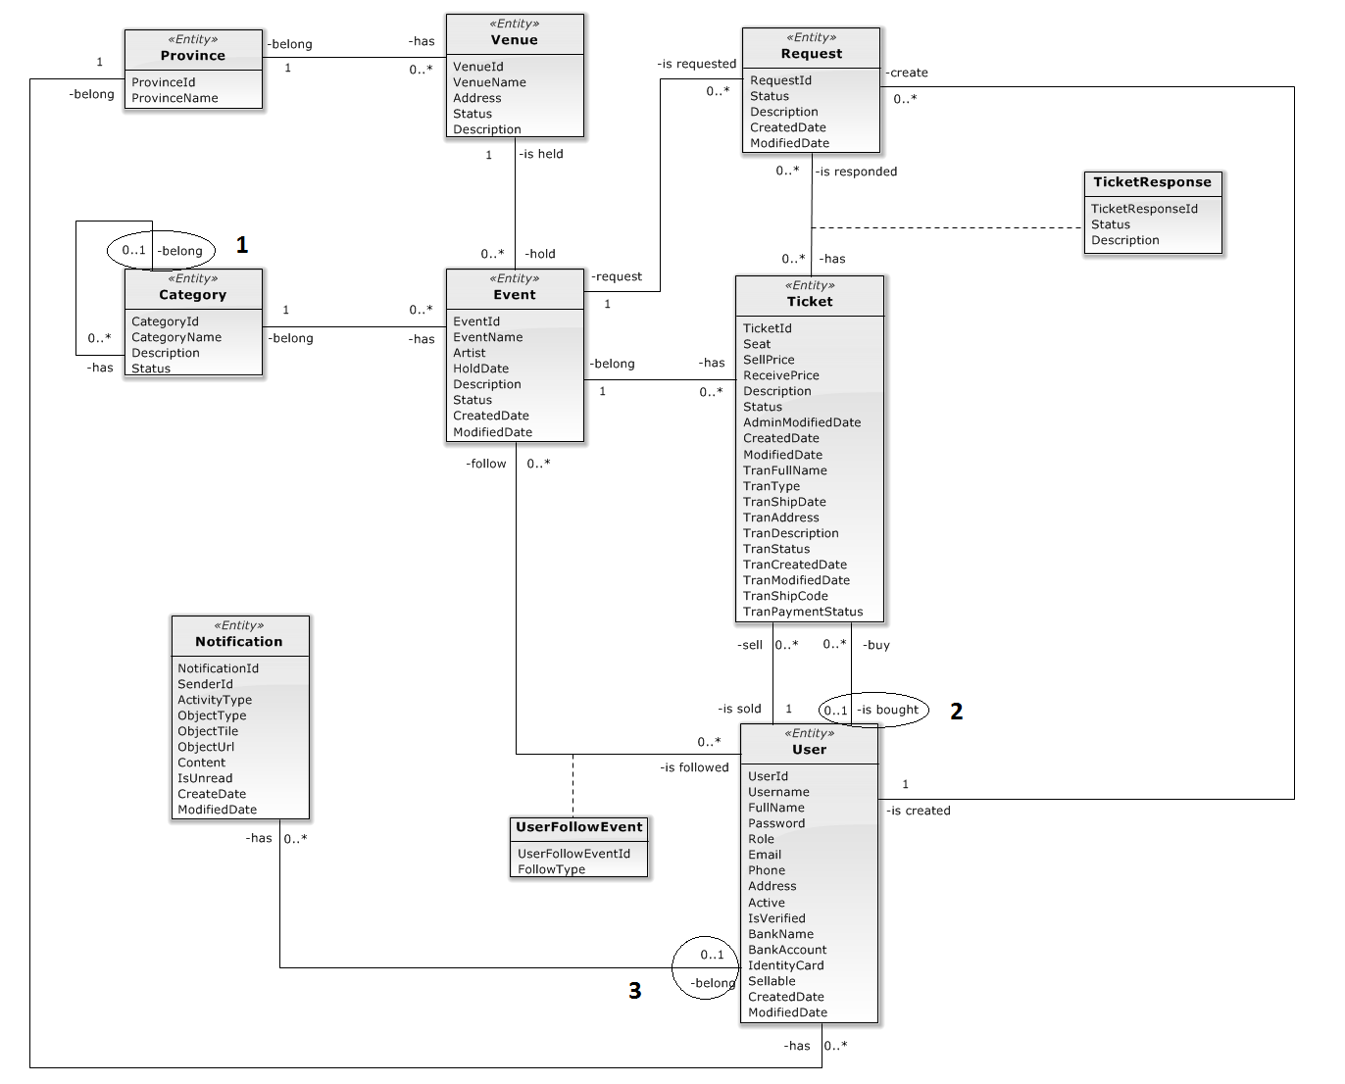

**Update:**

1. Change multiplicity from **1** to **0..1**
2. Change multiplicity from **1** to **0..1**
3. Change multiplicity from **1** to **0..1**