

Report No.3: Software Requirements Specifications (SRS)

# Table of Contents

Table of Contents 1

3.1 User Requirement Specification 2

3.2 System Requirement Specification (Specific Requirements) 3

3.2.1 External Interface Requirements 3

3.2.1.1 User Interfaces 3

3.2.1.2 Hardware Interfaces 4

3.2.1.3 Software Interfaces 4

3.2.1.4 Communications Protocol 4

3.2.2 System Features 4

3.2.2.1. System Feature – Common 5

3.2.1.2. System Feature – Admin 7

3.2.1.2.1 Request post tour 7

3.2.1.2.2 Filter Comment 9

3.2.1.2.3 Post requested tour 11

3.2.1.2.4 View report 12

3.2.1.2.5 Manage User 14

3.2.1.2.6 Manage tour 15

3.2.2.3. System Feature – Agent 17

3.2.2.3.1 Manage a booking 17

3.2.2.3.1.1 Search bookings 17

3.2.2.3.1.2 View bookings 18

3.2.2.3.1.2 View booking details 20

3.2.2.3.1.2 Manage bookings 21

3.2.2.3.2 Manage many bookings at once 22

3.2.2.4. System Feature – Customer 24

3.2.2.4.1 Search 24

3.2.2.4.2 View tour 25

3.2.2.4.3 View schedule 26

3.2.2.4.4 Book 28

3.2.2.4.5 View agent 29

3.2.2.4.6 Like 30

3.2.2.4.7 Unlike 31

3.2.2.4.8 Post comment 32

3.2.2.4.9 Edit comment 33

3.2.2.4.10 Delete comment 34

3.2.2.4.11 Rate tour 35

3.2.2.4.12 Rate agent 36

3.2.2.4.13 Agent CRUD tour 37

3.2.2.4.14 Agent Reply comment 40

3.2.2.4.15 Agent Create Request Post Tour 41

3.2.2.4.16 Request to be agent 43

3.3 Software System Attributes 45

3. 3.1 Reliability 45

3. 3.2 Availability 45

3. 3.3 Security 45

3.3.4 Maintainability 45

3.4 Entity Relationship Diagram or Data Structures 45

3.4.1 Entity-relationship model 45

3.4.2 Data dictionary: 46

3.4.2.1 Description of entities 46

3.4.2.2 Description of relationships 47

3.4.2.3 Description of attributes 48

# User Requirement Specification

1. Common features

* TSW website provide customer and agent manage and find tour easy.
* Website show interesting destinations in the tour program.
* Website have to program evaluate correctly, flexible and effective.

1. Admin’s uses

* Admin website will import information tour base on the agreement of company and agent
* Admin website will approve request post tour from agent
* Admin filtered comments.

1. Agent’s uses

* Agent will create tour by agreement with agent and company
* Agent will view comment and reply comment from user
* Agent will prepare contract will customer booking tour

1. Customer’s uses

* Customer search tour on the system and choose tour. They must be register information on the system and book tour.
* Customer can rate, comment like tour of agent
* Customer can compare tour of many company, and they can choose tour with least expensive and bester.

# System Requirement Specification (Specific Requirements)

## 3.2.1 External Interface Requirements

#### 3.2.1.1 User Interfaces

* User can interact with the system and other users through the user interface. Below are screens available for users:

|  |  |
| --- | --- |
| **Screen Name** | **Function** |
| Register screen | Allow unregistered users to register to the system |
| Login Screen | Allow registered users to login to the system |
| Edit profile Screen | Allow users to edit their profile |
| Change password Screen | Allow users to change their password |
| Update information Screen | Allow users to update their information |
| Update privacy options | Allow users to update their privacy options |
| Search tours screen | Allow users to search all tours |
| View tours screen | Allow users to view all tours(page break, optional sort) |
| Book tour screen | Allow user to book a tour |
| Comment screen | Allow user to post comment |
| Post new comment Screen | Allow users to post a new comment |
| Edit comment Screen | Allow users to edit theirs comment |
| Manage tours Screen | Allow agent to manage their tour |
| Create tour Screen | Allow agent to create a new tour |
| Update tour Screen | Allow agent to update a tour’s information |
| Manage bookings Screen | Allow agent to view and manage their received bookings |
| View bookings Screen | Allow agent to view all their received bookings. |
| Search bookings Screen | Allow agent to search their received bookings |
| View booking details Screen | Allow agent to view a booking’s details |
| Manage requested tour Screen | Allow agent to manage requested tours |
| View requested tours Screen | Allow agent to view requested tours |
| Manage comments Screen | Allow agent to manage their received comments |
| View comments Screen | Allow agent to view their received comments |
| Reply comment Screen | Allow agent to reply a comment |
| Post request tour Screen | Allow admin to post a request tour |
| Manage agent requests Screen | Allow admin to view and manage agent requests |
| Manage filtered comments Screen | Allow admin to view and manage filtered comments |

#### 3.2.1.2 Hardware Interfaces

* N/A

#### 3.2.1.3 Software Interfaces

* Server : ASP.NET framework 4.5, MVC4, SQL Server 2008, IIS 7.5
* Client : Web browsers support html4, html 5, javascript, CSS 2, CSS 3

#### 3.2.1.4 Communications Protocol

* N/A

## 3.2.2 System Features

The overall use case model of TSW Website:

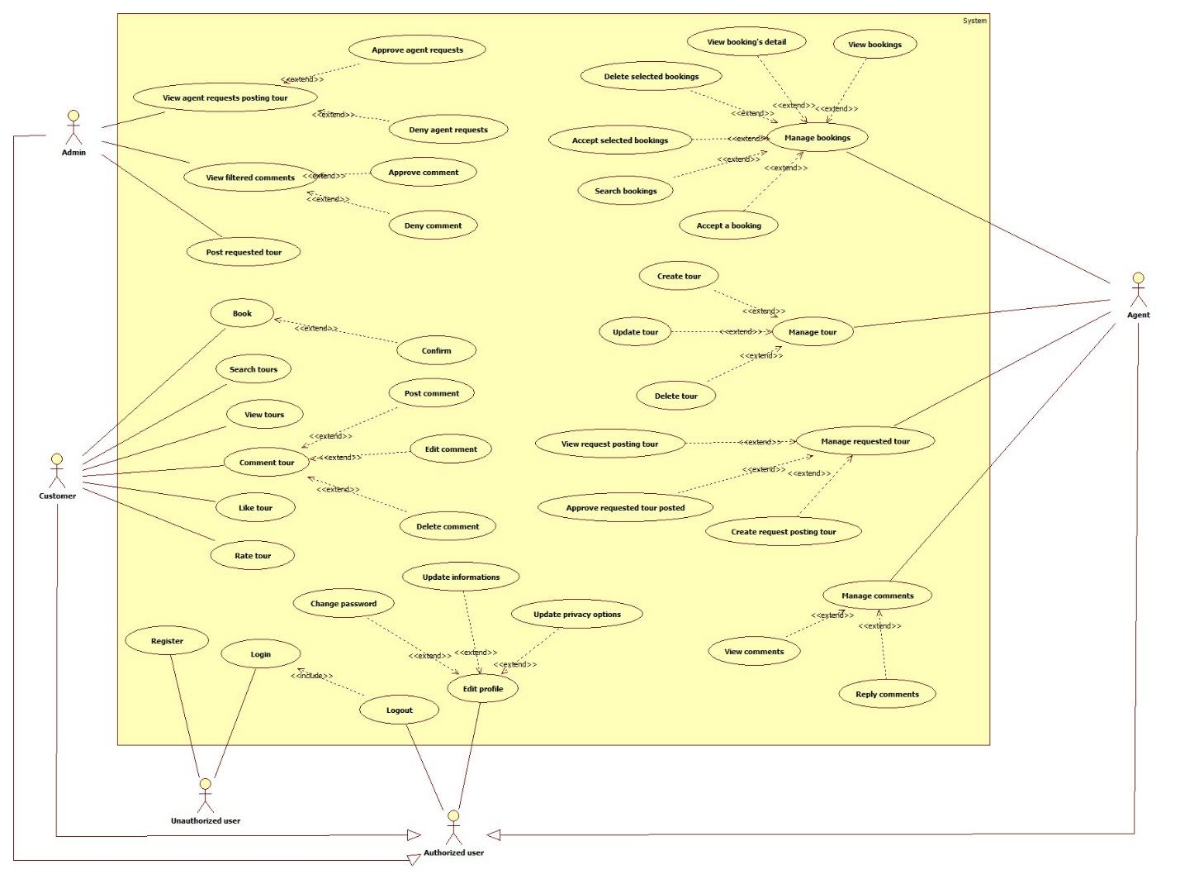

#### 3.2.2.1. System Feature – Common



|  |  |  |  |  |
| --- | --- | --- | --- | --- |
| **USE CASE-1 SPECIFICATION** | | | | |
| **Use-case No.** | <UC00> | **Use-case Version** | | <1.0> |
| **Use-case Name** | Common | | | |
| **Author** | ThanhVL | | | |
| **Date** | 02/02/2013 | **Priority** | High | |
| **Actor:** Unauthorized user, Authorized user (Customer, Agent, Admin)  **Summary:** This use case is about features that everyone want to use this website is also related to it.  **Goal:** Let user register (if they don’t have any account), login to website, then they can edit their profile and change password. They can also logout off the website if they want  **Triggers***: Enter to the website*  **Preconditions:** If they want to have an account, they register.  If they want to log in to the website, they have to login.  If they don’t want to use website, they can logout.  **PostConditions:** N/A  **Main Success Scenario:**   |  |  | | --- | --- | | Actors action:   1. *Unauthorized user click register* 2. *Enter input*   *Unauthorized user become Authorized user* | System Response:   1. Display registration form 2. Validate information from user register | | 1. Authorized user Click login |  | | 7. Enter input account info (username/password)  *Authorized user want to edit profile*  9. Authorized user click their profile  11. Authorized user choose 1 of 3 options  12. Authorized user choose edit info they want | 1. Display login form   8. Validate data  10. Display 2 option to edit (change password, update info)  11. Display all information that is in that option.  12. Update database  13. Display all edited list of user in the system |     **Alternative Scenario:** N/A  **Exceptions:**   * When database connection or network has problem, the system will ask user for doing being failed step again.   **Relationships:** N/A  **Business Rules:**   * Unauthorized user register then login to become authorized user. * Authorized user edit their info. * Authorized user logout to become unauthorized user. | | | | |

#### 3.2.1.2. System Feature – Admin

#### 3.2.1.2.1 Request post tour

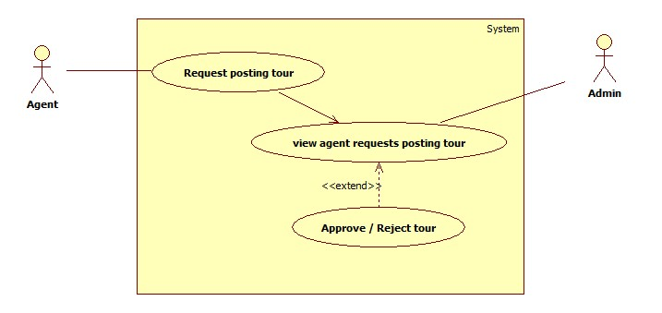

|  |  |  |  |  |
| --- | --- | --- | --- | --- |
| **USE CASE-1 SPECIFICATION** | | | | |
| **Use-case No.** | <UC01> | **Use-case Version** | | <1.0> |
| **Use-case Name** | Request post tour | | | |
| **Author** | ThanhVL | | | |
| **Date** | 01/02/2013 | **Priority** | High | |
| **Actor:** Agent, Admin  **Summary:** This use case is about requesting for posting tour from agent when they cannot post directly.  **Goal:** Agent still can add their tour to the website without do it directly (through requesting admin).  **Triggers***: Agent* send request for *Admin.*  **Preconditions:** The *Agent* don’t know how to add tour or they cannot post at that time (for any reasons).  **PostConditions:** Issue is added to database successful with basic information.  **Main Success Scenario:**   |  |  | | --- | --- | | Actors action:   1. *Agent* request posting tour to *Admin* 2. *Admin* receive notifications and view those requests | System Response:   1. Send request to *Admin* and notify *Admin* 2. Show list of request from all *Agents* | | 1. *Admin* Approve or deny the request |  | |  | 1. Notify *Agent* their request |   **Alternative Scenario:** N/A  **Exceptions:**   * When database connection or network has problem, the system will ask user for doing being failed step again.   **Relationships:** N/A  **Business Rules:**   * All requests is approved by *Admin*, it must be true and properly. (*Admin* check that) | | | | |

#### 3.2.1.2.2 Filter Comment

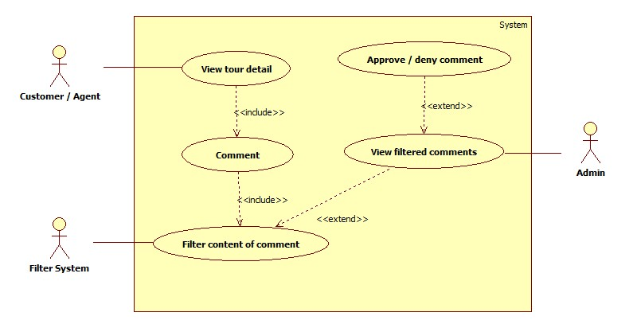

|  |  |  |  |  |
| --- | --- | --- | --- | --- |
| **USE CASE-1 SPECIFICATION** | | | | |
| **Use-case No.** | <UC02> | **Use-case Version** | | <1.0> |
| **Use-case Name** | Filter Comment | | | |
| **Author** | ThanhVL | | | |
| **Date** | 01/02/2013 | **Priority** | Normal | |
| **Actor:** Agent / Customer, Admin, filter System  **Summary:** This use case is about filter system that will send to admin any comment that has some bad words.  **Goal:** Make the website become fresher and cleaner by removing bad comments.  **Triggers***: Customer / Agent* Click Post button.  **Preconditions:** Any comment has content, and that content contains bad words in black list.  **PostConditions:** Comments that the *Filter System* is filtered will be still show if *Admin* approve that comments and otherwise, it will be gone if *Admin* deny.  **Main Success Scenario:**   |  |  | | --- | --- | | Actors action:   1. *Customer or Agent* view detail of any tour   *3. Customer or Agent* write review comment for that tour | System Response:  2. Return detail of that tour  4. Show that comment when it is posted successful. | | *5. Filter System* will filter bad comments (bad words)  6. Make list of these bad comments  7. Sent to *Admin* |  | | *9. Admin* view list of bad comments  10. Approve / Deny those comments | 8. Notify *Admin* |   **Alternative Scenario:** N/A  **Exceptions:**   * When database connection or network has problem, the system will ask user for doing being failed step again.   **Relationships:** N/A  **Business Rules:**   * *Admin* will read bad comments that the *Filter System* is filtered, and *Admin* will have to make sure the comments is exactly right or wrong. | | | | |

#### 3.2.1.2.3 Post requested tour

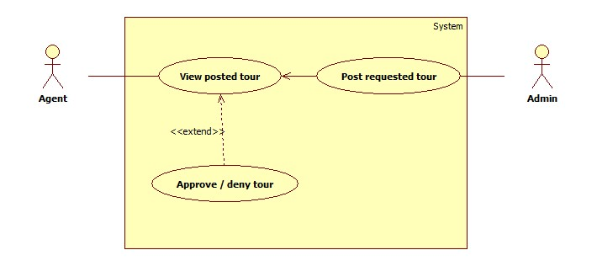

|  |  |  |  |  |
| --- | --- | --- | --- | --- |
| **USE CASE-1 SPECIFICATION** | | | | |
| **Use-case No.** | <UC03> | **Use-case Version** | | <1.0> |
| **Use-case Name** | Post requested tour | | | |
| **Author** | ThanhVL | | | |
| **Date** | 01/02/2013 | **Priority** | High | |
| **Actor:** Agent, Admin  **Summary:** This use case is about posting tour for any requested tour that is approve by *Admin* in usecase AUC01.  **Goal:** Help *Agent* add tour to the website  **Triggers***: Admin filled all information of that tour then* click add tour.  **Preconditions:** Requested tour is approved by *Admin*.  **PostConditions:** Any tour that is requested by *Agent* is added to website successful (if Agent approved that post) with basic information.  **Main Success Scenario:**   |  |  | | --- | --- | | Actors action:   1. *Admin* fill all information of the tour then click add tour 2. *Agent* receive notifications and view those posted tour | System Response:   1. Validate data input 2. Return with success and notify *Agent*   5. Show list of requested tour from *Agent* | | *6. Agent* Approve or deny the request |  | |  |  |   **Alternative Scenario:** N/A  **Exceptions:**   * When database connection or network has problem, the system will ask user for doing being failed step again.   **Relationships:** N/A  **Business Rules:**   * If *Admin* approved request and post tour, they must make sure that the info about tour is correctly. If not, *Agent* will reject that. (*Agent* check that) | | | | |

#### 3.2.1.2.4 View report

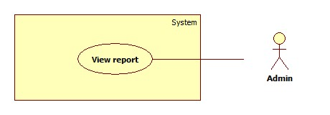

|  |  |  |  |  |
| --- | --- | --- | --- | --- |
| **USE CASE-1 SPECIFICATION** | | | | |
| **Use-case No.** | <UC04> | **Use-case Version** | | <1.0> |
| **Use-case Name** | View report | | | |
| **Author** | ThanhVL | | | |
| **Date** | 01/02/2013 | **Priority** | High | |
| **Actor:** Admin  **Summary:** This use case is about viewing report from *Admin*.  **Goal:** Help *Admin* view all report and statistic of user, tour, schedule of the website  **Triggers***: Admin* click view report.  **Preconditions:** N/A.  **PostConditions:** Show all detailed information or overall information.  **Main Success Scenario:**   |  |  | | --- | --- | | Actors action:  *1. Admin* click view report | System Response:  2. Display all kind of information that is about statistic | |  |  | |  |  |   **Alternative Scenario:** N/A  **Exceptions:**   * When database connection or network has problem, the system will ask user for doing being failed step again.   **Relationships:** N/A  **Business Rules:**   * *Admin* want to see report of some kinds of information about the website | | | | |

#### 3.2.1.2.5 Manage User

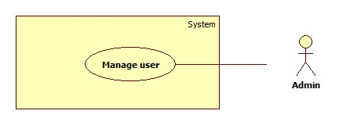

|  |  |  |  |  |
| --- | --- | --- | --- | --- |
| **USE CASE-1 SPECIFICATION** | | | | |
| **Use-case No.** | <UC05> | **Use-case Version** | | <1.0> |
| **Use-case Name** | Manage User | | | |
| **Author** | ThanhVL | | | |
| **Date** | 01/02/2013 | **Priority** | High | |
| **Actor:** Admin  **Summary:** This use case is about managing user in the system.  **Goal:** *Admin can* manage all users in the website more detailed and clearly.  **Triggers***: Admin* click Add/Edit/Delete user (or manage user).  **Preconditions:** N/A.  **PostConditions:** User management system is managed by *Admin*.  **Main Success Scenario:**   |  |  | | --- | --- | | Actors action:  *1. Admin* click manage user  3. Admin click Add / Edit / Delete user | System Response:  2. Display all user in the system | |  | 4. Update database  5. Display all edited list of user in the system | |  |  |   **Alternative Scenario:** N/A  **Exceptions:**   * When database connection or network has problem, the system will ask user for doing being failed step again.   **Relationships:** N/A  **Business Rules:**   * *Admin* want to manage user in the website | | | | |

#### 3.2.1.2.6 Manage tour

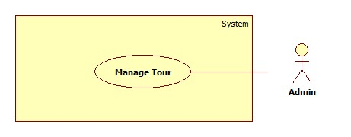

|  |  |  |  |  |
| --- | --- | --- | --- | --- |
| **USE CASE-1 SPECIFICATION** | | | | |
| **Use-case No.** | <UC06> | **Use-case Version** | | <1.0> |
| **Use-case Name** | Manage Tour | | | |
| **Author** | ThanhVL | | | |
| **Date** | 01/02/2013 | **Priority** | High | |
| **Actor:** Admin  **Summary:** This use case is about managing tour in the system.  **Goal:** *Admin can* manage tour of all agent in the website more detailed and clearly.  **Triggers***: Admin* click Add/Edit/Delete tour (or manage tour).  **Preconditions:** N/A.  **PostConditions:** Tour management system is managed by *Admin*.  **Main Success Scenario:**   |  |  | | --- | --- | | Actors action:  *1. Admin* click manage tour  3. Admin click Add / Edit / Delete tour | System Response:  2. Display all tour in the system | |  | 4. Update database  5. Display all edited list of tour in the system | |  |  |   **Alternative Scenario:** N/A  **Exceptions:**   * When database connection or network has problem, the system will ask user for doing being failed step again.   **Relationships:** N/A  **Business Rules:**   * *Admin* want to manage tour in the website | | | | |

#### 3.2.2.3. System Feature – Agent

#### 3.2.2.3.1 Manage a booking

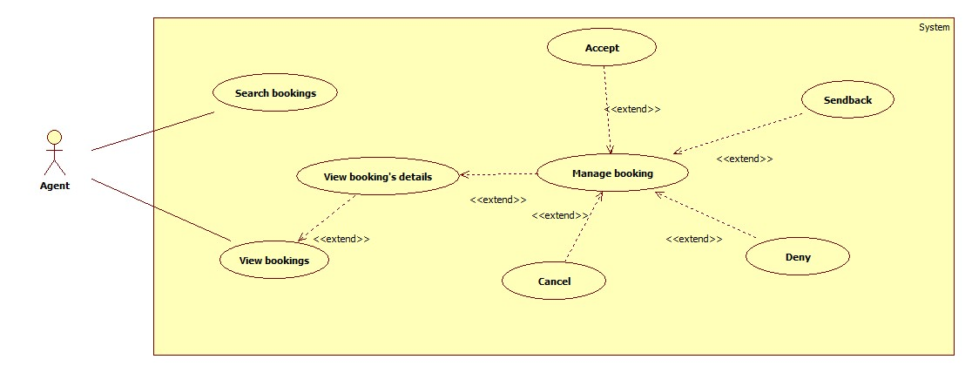

#### 3.2.2.3.1.1 Search bookings

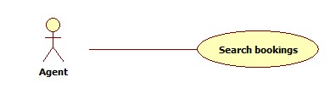

|  |  |  |  |  |
| --- | --- | --- | --- | --- |
| **USE CASE-01 SPECIFICATION** | | | | |
| **Use-case No.** | <UC07> | **Use-case Version** | | 1.0 |
| **Use-case Name** | Search bookings | | | |
| **Author** | ThachNV | | | |
| **Date** | 31/01/2013 | **Priority** | Normal | |
| **Actor:** Agent  **Summary:**This use case is about agent search for bookings  **Goal:** Actor can search bookings.  **Triggers***:* Actor go to search bookings page.  **Preconditions:** Login with role agent.  **PostConditions:** list bookings match the search.  **Main Success Scenario:**   |  |  | | --- | --- | | Actors action:   1. Enter value and slick search bookings. | System Response:   1. Show all bookings match the search. |   **Alternative Scenario:**N/A  **Exceptions:** N/A  **Relationships:** N/A  **Business Rules:** N/A | | | | |

#### 3.2.2.3.1.2 View bookings

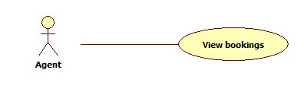

|  |  |  |  |  |
| --- | --- | --- | --- | --- |
| **USE CASE-02 SPECIFICATION** | | | | |
| **Use-case No.** | <UC08> | **Use-case Version** | | 1.0 |
| **Use-case Name** | View all bookings | | | |
| **Author** | ThachNV | | | |
| **Date** | 31/01/2013 | **Priority** | Normal | |
| **Actor:** Agent  **Summary:**This use case is about agent view all bookings.  **Goal:** Actor can view all bookings  **Triggers***:* Actor chose view all bookings button.  **Preconditions:** Login with role agent  **PostConditions:** List all the bookings.  **Main Success Scenario:**   |  |  | | --- | --- | | Actors action:   1. User click button view all bookings | System Response:   1. Show a list of all bookings |   **Alternative Scenario:**N/A  **Exceptions:** N/A  **Relationships:** N/A  **Business Rules:** N/A | | | | |

#### 3.2.2.3.1.2 View booking details

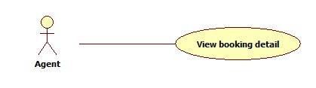

|  |  |  |  |  |
| --- | --- | --- | --- | --- |
| **USE CASE-03 SPECIFICATION** | | | | |
| **Use-case No.** | <UC09> | **Use-case Version** | | 1.0 |
| **Use-case Name** | View booking details | | | |
| **Author** | ThachNV | | | |
| **Date** | 31/01/2013 | **Priority** | Normal | |
| **Actor:** Agent  **Summary:**This use case is about agent view details of a booking.  **Goal:** Actor can view details of a booking.  **Triggers***:*  Actor click on a bookings in the list (after view all or search bookings).  **Preconditions:** Login with role agent  **PostConditions:** View detail of the booking  **Main Success Scenario:**   |  |  | | --- | --- | | Actors action:   1. Search bookings or request to view all bookings 2. Select a booking to view detail | System Response:   1. Show all bookings match the search or all bookings. 2. Show detail page of the booking |   **Alternative Scenario:**N/A  **Exceptions:** N/A  **Relationships:** N/A  **Business Rules:** N/A | | | | |

#### 3.2.2.3.1.2 Manage bookings

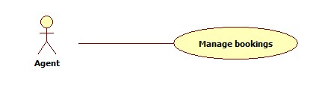

|  |  |  |  |  |
| --- | --- | --- | --- | --- |
| **USE CASE-04 SPECIFICATION** | | | | |
| **Use-case No.** | <UC10> | **Use-case Version** | | 1.0 |
| **Use-case Name** | Manage bookings | | | |
| **Author** | ThachNV | | | |
| **Date** | 31/01/2013 | **Priority** | Normal | |
| **Actor:** Agent  **Summary:**This use case descript how agent manage booking  **Goal:** Actor can manage bookings  **Triggers***:* Actor go to bookings management page  **Preconditions:** Login with role agent  **PostConditions:**Change status of the booking  **Main Success Scenario:**   |  |  | | --- | --- | | Actors action:   1. Search bookings or request to view all bookings   3. Select a booking to view detail   1. Select an actions(Accept, Sendback, Deny, Cancel) | System Response:   1. Show all bookings match the search or all bookings.   4. Show detail page of the booking   1. Update booking’s status |   **Alternative Scenario:**N/A  **Exceptions:** N/A  **Relationships:** N/A  **Business Rules:** N/A | | | | |

#### 3.2.2.3.2 Manage many bookings at once

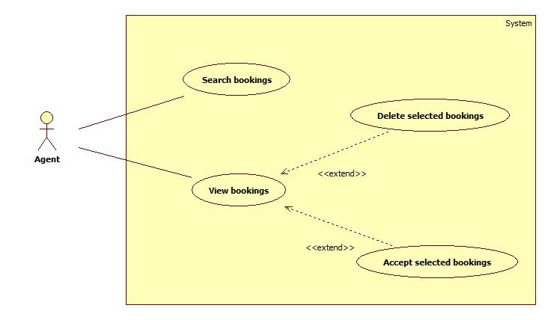

|  |  |  |  |  |
| --- | --- | --- | --- | --- |
| **USE CASE-05 SPECIFICATION** | | | | |
| **Use-case No.** | <UC11> | **Use-case Version** | | 1.0 |
| **Use-case Name** | Manage multi bookings | | | |
| **Author** | ThachNV | | | |
| **Date** | 31/01/2013 | **Priority** | Normal | |
| **Actor:** Agent  **Summary:** This use case descript how agent manage many bookings at the same time.  **Goal:** Actor can manage many bookings.  **Triggers***:* Actor go to bookings management page.  **Preconditions:** Login with role agent.  **PostConditions:** Change status of many bookings.  **Main Success Scenario:**   |  |  | | --- | --- | | Actors action:   1. Search bookings or request to view all bookings 2. Select bookings to apply bulk action.   5. Select action(Delete, accept) | System Response:  2. Show all bookings match the search or all bookings.   1. Check to selected bookings   6. Update selected bookings’s status. |   **Alternative Scenario:**N/A  **Exceptions:** N/A  **Relationships:** N/A  **Business Rules:** N/A | | | | |

#### 3.2.2.4. System Feature – Customer

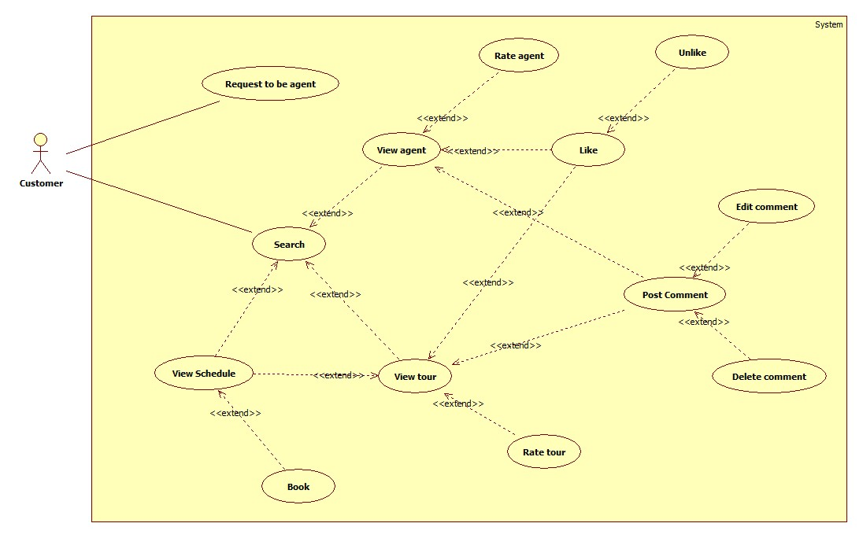

#### 3.2.2.4.1 Search

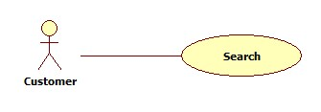

|  |  |  |  |  |
| --- | --- | --- | --- | --- |
| **USE CASE-1 SPECIFICATION** | | | | |
| **Use-case No.** | <UC12> | **Use-case Version** | | 1.0 |
| **Use-case Name** | Customer Search | | | |
| **Author** | HoangTN | | | |
| **Date** | 01/02/2013 | **Priority** | High | |
| **Actor:** Customer  **Summary:** search information about tours, schedules, agents  **Goal:** customer get a result list of what he/she is looking for  **Triggers***:* click Search button  **Preconditions:** input some text into search field  **PostConditions:** Search results are shown and paging  **Main Success Scenario:**   |  |  | | --- | --- | | Actors action:   1. Input some text, click Search button | System Response:   1. Display results to screen |   **Alternative Scenario:** N/A  **Exceptions:** N/A  **Relationships:** N/A  **Business Rules:** N/A | | | | |

#### 3.2.2.4.2 View tour

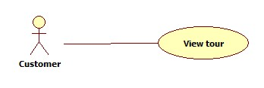

|  |  |  |  |  |
| --- | --- | --- | --- | --- |
| **USE CASE-1 SPECIFICATION** | | | | |
| **Use-case No.** | <UC13> | **Use-case Version** | | 1.0 |
| **Use-case Name** | Customer view tour | | | |
| **Author** | HoangTN | | | |
| **Date** | 01/02/2013 | **Priority** | Normal | |
| **Actor:** Customer  **Summary:** view tour detail information  **Goal:** get tour information supplied from agent  **Triggers***:* click Tour name or thumbnail  **Preconditions:** none  **PostConditions:** go to tour detail page  **Main Success Scenario:**   |  |  | | --- | --- | | Actors action:   1. Click tour name or thumbnail | System Response:   1. Go to tour detail page |   **Alternative Scenario:** N/A  **Exceptions:** N/A  **Relationships:** N/A  **Business Rules:** N/A | | | | |

#### 3.2.2.4.3 View schedule

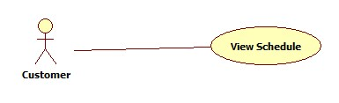

|  |  |  |  |  |
| --- | --- | --- | --- | --- |
| **USE CASE-1 SPECIFICATION** | | | | |
| **Use-case No.** | <UC14> | **Use-case Version** | | 1.0 |
| **Use-case Name** | Customer view schedule | | | |
| **Author** | HoangTN | | | |
| **Date** | 01/02/2013 | **Priority** | Normal | |
| **Actor:** Customer  **Summary:** view schedule detail information  **Goal:** get schedule information supplied from agent  **Triggers***:* click Schedule name or thumbnail  **Preconditions:** being in tour detail page  **PostConditions:** go to schedule detail page  **Main Success Scenario:**   |  |  | | --- | --- | | Actors action:   1. Click schedule name or thumbnail | System Response:   1. Go to schedule detail page |   **Alternative Scenario:** N/A  **Exceptions:** N/A  **Relationships:** N/A  **Business Rules:** N/A | | | | |

#### 3.2.2.4.4 Book

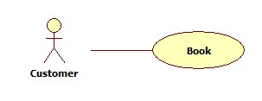

|  |  |  |  |  |
| --- | --- | --- | --- | --- |
| **USE CASE-1 SPECIFICATION** | | | | |
| **Use-case No.** | <UC15> | **Use-case Version** | | 1.0 |
| **Use-case Name** | Customer book | | | |
| **Author** | HoangTN | | | |
| **Date** | 01/02/2013 | **Priority** | Normal | |
| **Actor:** Customer  **Summary:** book a schedule belongs to an agent  **Goal:** create a booking to schedule which is confirmed by agent to join a tour  **Triggers***:* click Book button  **Preconditions:** go to Schedule detail page  **PostConditions:** message shows up  **Main Success Scenario:**   |  |  | | --- | --- | | Actors action:   1. Click Book button | System Response:   1. Validate 2. If validation is passed, show success message 3. If validation is not passed, show error message |   **Alternative Scenario:** N/A  **Exceptions:** customer are not qualified for schedule  **Relationships:** N/A  **Business Rules:** N/A | | | | |

#### 3.2.2.4.5 View agent

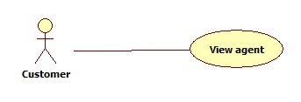

|  |  |  |  |  |
| --- | --- | --- | --- | --- |
| **USE CASE-1 SPECIFICATION** | | | | |
| **Use-case No.** | <UC16> | **Use-case Version** | | 1.0 |
| **Use-case Name** | Customer view agent | | | |
| **Author** | HoangTN | | | |
| **Date** | 01/02/2013 | **Priority** | Normal | |
| **Actor:** Customer  **Summary:** view agent detail information  **Goal:** get agent information  **Triggers***:* click agent name or thumbnail  **Preconditions:** none  **PostConditions:** go to agent detail page  **Main Success Scenario:**   |  |  | | --- | --- | | Actors action:   1. Click agent name or thumbnail | System Response:   1. Go to agent detail page |   **Alternative Scenario:** N/A  **Exceptions:** N/A  **Relationships:** N/A  **Business Rules:** N/A | | | | |

#### 3.2.2.4.6 Like

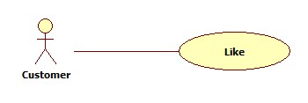

|  |  |  |  |  |
| --- | --- | --- | --- | --- |
| **USE CASE-1 SPECIFICATION** | | | | |
| **Use-case No.** | <UC17> | **Use-case Version** | | 1.0 |
| **Use-case Name** | Customer like | | | |
| **Author** | HoangTN | | | |
| **Date** | 01/02/2013 | **Priority** | Normal | |
| **Actor:** Customer  **Summary:** customer click like icon  **Goal:** to bookmark his/her favorite tour and agent  **Triggers***:* click Like icon  **Preconditions:** like icon exists, user’s being in Tour detail page or Agent detail page  **PostConditions:** like icon change to unlick icon  **Main Success Scenario:**   |  |  | | --- | --- | | Actors action:   1. Click Like icon | System Response:   1. Send like request to server 2. Like icon change to unlike icon |   **Alternative Scenario:** N/A  **Exceptions:** N/A  **Relationships:** N/A  **Business Rules:** N/A | | | | |

#### 3.2.2.4.7 Unlike

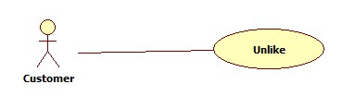

|  |  |  |  |  |
| --- | --- | --- | --- | --- |
| **USE CASE-1 SPECIFICATION** | | | | |
| **Use-case No.** | <UC18> | **Use-case Version** | | 1.0 |
| **Use-case Name** | Customer unlike | | | |
| **Author** | HoangTN | | | |
| **Date** | 01/02/2013 | **Priority** | Normal | |
| **Actor:** Customer  **Summary:** customer click unlike icon  **Goal:** remove previous like from tour or agent  **Triggers***:* click unlike icon  **Preconditions:** clicked like icon before, user’s being in tour detail page or agent detail page  **PostConditions:** unlike icon change to like icon  **Main Success Scenario:**   |  |  | | --- | --- | | Actors action:   1. Click unlike icon | System Response:   1. Send unlike request to server 2. Revert unlike icon to like icon |   **Alternative Scenario:** N/A  **Exceptions:** N/A  **Relationships:** N/A  **Business Rules:** N/A | | | | |

#### 3.2.2.4.8 Post comment

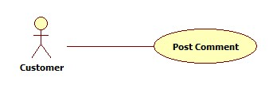

|  |  |  |  |  |
| --- | --- | --- | --- | --- |
| **USE CASE-1 SPECIFICATION** | | | | |
| **Use-case No.** | <UC19> | **Use-case Version** | | 1.0 |
| **Use-case Name** | Customer post comment | | | |
| **Author** | HoangTN | | | |
| **Date** | 01/02/2013 | **Priority** | Normal | |
| **Actor:** Customer  **Summary:** write comment to express his/her opinion about anything  **Goal:** customer’s comments appear on comment list  **Triggers***:* click Post button  **Preconditions:** Comment field is not empty  **PostConditions:** new comment added to comment list  **Main Success Scenario:**   |  |  | | --- | --- | | Actors action:   1. Input some text, click Post button | System Response:   1. System auto filter if there is banned word contained in comment content 2. Add comment to list of previous comment on screen |   **Alternative Scenario:** N/A  **Exceptions:** N/A  **Relationships:** N/A  **Business Rules:** N/A | | | | |

#### 3.2.2.4.9 Edit comment

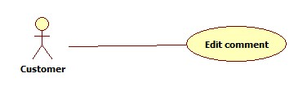

|  |  |  |  |  |
| --- | --- | --- | --- | --- |
| **USE CASE-1 SPECIFICATION** | | | | |
| **Use-case No.** | <UC20> | **Use-case Version** | | 1.0 |
| **Use-case Name** | Customer edit comment | | | |
| **Author** | HoangTN | | | |
| **Date** | 01/02/2013 | **Priority** | Normal | |
| **Actor:** Customer  **Summary:** edit posted comment about tours or agents  **Goal:** edit his/her own posted comment  **Triggers***:* right mouse on his/her own comment, choose edit  **Preconditions:** time since message posting to edit decision isn’t longer than 24 hours  **PostConditions:** comment is edited  **Main Success Scenario:**   |  |  | | --- | --- | | Actors action:   1. Right mouse on comment, choose edit option | System Response:   1. Check if pass 24 hours 2. If it isn’t, show textbox containing comment content which can be modified 3. If it is, show error message |   **Alternative Scenario:** N/A  **Exceptions:** N/A  **Relationships:** N/A  **Business Rules:** N/A | | | | |

#### 3.2.2.4.10 Delete comment

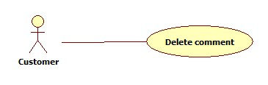

|  |  |  |  |  |
| --- | --- | --- | --- | --- |
| **USE CASE-1 SPECIFICATION** | | | | |
| **Use-case No.** | <UC21> | **Use-case Version** | | 1.0 |
| **Use-case Name** | Customer delete comment | | | |
| **Author** | HoangTN | | | |
| **Date** | 01/02/2013 | **Priority** | Normal | |
| **Actor:** Customer  **Summary:** delete posted comment about tours or agents  **Goal:** remove his/her own posted comment  **Triggers***:* right mouse on his/her own comment, choose delete  **Preconditions:** time since message posting to delete decision isn’t longer than 24 hours  **PostConditions:** comment is deleted  **Main Success Scenario:**   |  |  | | --- | --- | | Actors action:   1. Right mouse on comment, choose delete option | System Response:   1. Check if pass 24 hours 2. If it isn’t, delete comment 3. If it is, show error message |   **Alternative Scenario:** N/A  **Exceptions:** N/A  **Relationships:** N/A  **Business Rules:** N/A | | | | |

#### 3.2.2.4.11 Rate tour

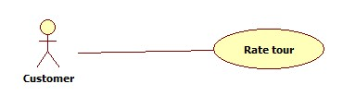

|  |  |  |  |  |
| --- | --- | --- | --- | --- |
| **USE CASE-1 SPECIFICATION** | | | | |
| **Use-case No.** | <UC22> | **Use-case Version** | | 1.0 |
| **Use-case Name** | Customer rate tour | | | |
| **Author** | HoangTN | | | |
| **Date** | 01/02/2013 | **Priority** | Normal | |
| **Actor:** Customer  **Summary:** customer rate for each tour’s attribute to get an average number  **Goal:** customer rate tour based on his/her experiences about tour’s quality  **Triggers***:* click Rate button  **Preconditions:** user’s in tour detail page  **PostConditions:** tour’s rating changed and thank-for-rating message shows up  **Main Success Scenario:**   |  |  | | --- | --- | | Actors action:   1. Use slide bar to edit rating for each attributes. When satisfied, click Rate button | System Response:   1. Send result to server, update to database 2. Show up thanks message |   **Alternative Scenario:** N/A  **Exceptions:** N/A  **Relationships:** N/A  **Business Rules:** N/A | | | | |

#### 3.2.2.4.12 Rate agent

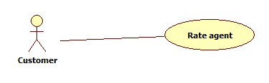

|  |  |  |  |  |
| --- | --- | --- | --- | --- |
| **USE CASE-1 SPECIFICATION** | | | | |
| **Use-case No.** | <UC23> | **Use-case Version** | | 1.0 |
| **Use-case Name** | Customer rate agent | | | |
| **Author** | HoangTN | | | |
| **Date** | 01/02/2013 | **Priority** | Normal | |
| **Actor:** Customer  **Summary:** customer rate for each agent’s attribute to get an average number  **Goal:** customer rate agent based on his/her experiences about agent’s services  **Triggers***:* click Rate button  **Preconditions:** user’s in agent detail page  **PostConditions:** agent’s rating changed and thank-for-rating message shows up  **Main Success Scenario:**   |  |  | | --- | --- | | Actors action:   1. Use slide bar to edit rating for each attributes. When satisfied, click Rate button | System Response:   1. Send result to server, update to database 2. Show up thanks message |   **Alternative Scenario:** N/A  **Exceptions:** N/A  **Relationships:** N/A  **Business Rules:** N/A | | | | |

#### Agent CRUD tour



|  |  |  |  |  |
| --- | --- | --- | --- | --- |
| **USE CASE-01 SPECIFICATION** | | | | |
| **Use-case No.** | <UC24> | **Use-case Version** | | 1.0 |
| **Use-case Name** | Agent CRUD tour | | | |
| **Author** | ThangCM | | | |
| **Date** | 01/02/2013 | **Priority** | Normal | |
| **Actor:** Agent  **Summary:** This use case descript Agent create, delete, update tour  **Goal:** Actor can create, delete, update tour  **Triggers***:* Actor go to view tour page  **Preconditions:** Login with role agent  **PostConditions:** create, delete, update tour  **Main Success Scenario:**   |  |  | | --- | --- | | Actors action:  Create tour  1. Fill information tour follow template  3. Click post button  Delete tour  5. Search all tour  7. Select tour need delete  9. Click delete tour button  Update tour  10. Search all tour  12. Select tour need update  14. Fill information need update  15. Click update button | System Response:  2. Save into database tour have been created  4. View information this tour on system  6. Delete tour to select into database  8. Don’t show information this tour on system  11. Update information tour into database  13. View information tour have been update | |  |  |   **Alternative Scenario:**N/A  **Exceptions:** N/A  **Relationships:** N/A  **Business Rules:** N/A | | | | |

#### Agent Reply comment



|  |  |  |  |  |
| --- | --- | --- | --- | --- |
| **USE CASE-01 SPECIFICATION** | | | | |
| **Use-case No.** | <UC25> | **Use-case Version** | | 1.0 |
| **Use-case Name** | Agent Reply comment | | | |
| **Author** | ThangCM | | | |
| **Date** | 01/02/2013 | **Priority** | Normal | |
| **Actor:** Agent, user  **Summary:** This use case descript how agent reply comment form user  **Goal:** Actor can reply comment from user  **Triggers***:* Actor go to view comment page  **Preconditions:** Login with role agent  **PostConditions:** Reply comment user  **Main Success Scenario:**   |  |  | | --- | --- | | Actors action:  1. User view tour and comment tour  3. Agent search all tour and select tour have comment  5. Select action reply comment | System Response:  2. Show tour detail page have comment  4. Show comment user have been comment  6. Show comment agent have been reply |   **Alternative Scenario:**N/A  **Exceptions:** N/A  **Relationships:** N/A  **Business Rules:** N/A | | | | |

#### Agent Create Request Post Tour



|  |  |  |  |  |
| --- | --- | --- | --- | --- |
| **USE CASE-01 SPECIFICATION** | | | | |
| **Use-case No.** | <UC26> | **Use-case Version** | | 1.0 |
| **Use-case Name** | Agent Create Request Post Tour | | | |
| **Author** | ThangCM | | | |
| **Date** | 01/02/2013 | **Priority** | Normal | |
| **Actor:** Agent, Admin  **Summary:** This use case descript how agent request post tour for admin  **Goal:** Actor can request post tour for admin  **Triggers***:* Actor go to request post tour page  **Preconditions:** Login with role agent  **PostConditions:** Admin receive tour that agent request post tour  **Main Success Scenario:**   |  |  | | --- | --- | | Actors action:  1. Agent fill all information tour that they need request posting  3. Agent fill note information for admin that admin will post tour follow this note.  5. Admin will information this tour and check this information from company  7. Admin will accept or deny this tour | System Response:  2. Show page create posting tour and validate information tour that agent fill  4. If admin accept: tour will be pots on system  6. If admin deny: tour will be not post on system and admin will send to back agent. |   **Alternative Scenario:**N/A  **Exceptions:** N/A  **Relationships:** N/A  **Business Rules:** N/A | | | | |

#### Request to be agent

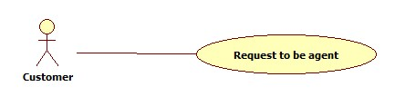

|  |  |  |  |  |
| --- | --- | --- | --- | --- |
| **USE CASE-1 SPECIFICATION** | | | | |
| **Use-case No.** | <UC27> | **Use-case Version** | | 1.0 |
| **Use-case Name** | Customer request to be agent | | | |
| **Author** | HoangTN | | | |
| **Date** | 01/02/2013 | **Priority** | Normal | |
| **Actor:** Customer  **Summary:** post a request to admin included photo of related documents between travel company and customer or confirmation email from travel company  **Goal:** admin approves and changes customer role to agent role  **Triggers***:* click “Change to agent” link  **Preconditions:** user logined with customer role  **PostConditions:** message informed request sent successfully  **Main Success Scenario:**   |  |  | | --- | --- | | Actors action:   1. Click “Change to agent” link 2. Click Select image to browse image from computer. Enter some information in description field. Click Send button. | System Response:   1. Go to request page 2. Validate request. 3. If failed, error message shows up 4. If succeed, successful message shows up. |   **Alternative Scenario:** N/A  **Exceptions:** If system crash or client network has problem, error message  **Relationships:** N/A  **Business Rules:** N/A | | | | |

# Software System Attributes

## 3. 3.1 Reliability

* Database can be backed up and recovered
* Mean Time Between Failures (MTBF): more than 6 months.
* Mean Time To Repair (MTTR): less than 24 hours.
* Accuracy: 100%
* Maximum Bugs and Defect Rate: 0.5 bugs per thousand lines of code (0.5 bugs/KLOC).

## 3. 3.2 Availability

* Acceptable time for maintenance or backup should not be over 24 hours a month
* When maintaining is happening, message should be informed to users visit by

## 3. 3.3 Security

* User password must be encrypted when storing in database
* Validate input data in SQL query before execute to avoid SQL Injection
* User information in easy to adjusted to be public or private depends on his/her preference

## 3.3.4 Maintainability

* All code must follow C# .NET coding convention.
* All program files shall include comments concerning authorship and date of last change.
* The code shall be modular to permit future modifications.

# Entity Relationship Diagram or Data Structures

## Entity-relationship model



## Data dictionary:

#### Description of entities

|  |  |
| --- | --- |
| Name | Description |
| Agent | Describe all information of an agent. |
| Booking | Describe all information of booking tour. |
| Comment | Comment of user |
| Contract | Contract between agent and |
| Customer | Describe all information of an agent. |
| Location | Location of the tour |
| MemberShip |  |
| Preference | Settings of user that let user show what they want or not |
| Rating | Rating of customer about the tour |
| Roles | Role in the system |
| Route | Route from what location and to what location |
| Schedule | Schedule of tour, means how many schedules of same tour |
| Tour | Describe all information of an tour. |
| TravelPlan | Plan of travel |
| UserProfile | More detailed information of user |
| UsersInRoles | Role of user |

#### 3.4.2.2 Description of relationships

|  |  |  |  |  |
| --- | --- | --- | --- | --- |
| Entity 1 | Entity 1 -> Entity 2 | Name | Entity 2 -> Entity 1 | Entity 2 |
| Agent | 0,n | approve | 0,1 | Booking |
| Contract | 0,n | approved | 0,1 | Booking |
| UserProfile | 0,1 | as | 1,1 | Agent |
| UserProfile | 0,1 | as | 1,1 | Customer |
| Agent | 0,n | at | 0,1 | Location |
| Agent | 0,n | cancel | 0,1 | Booking |
| Booking | 1,1 | cancel | 0,n | Customer |
| TravelPlan | 0,n | completed | 0,1 | Contract |
| Rating | 0,1 | for | 0,n | Tour |
| Rating | 0,1 | for | 0,n | Agent |
| Comment | 1,1 | From | 0,1 | UserProfile |
| Route | 1,n | From | 0,1 | Location |
| TravelPlan | 0,n | has | 0,1 | Customer |
| Schedule | 0,n | has | 0,1 | Contract |
| TravelPlan | 1,1 | has | 0,1 | Schedule |
| Preference | 1,1 | has | 1,1 | UserProfile |
| Schedule | 0,n | has | 1,1 | Route |
| Tour | 0,n | has | 1,1 | Schedule |
| UserProfile | 0,n | Has | 0,1 | MemberShip |
| UserProfile | 0,n | Has | 1,1 | UsersInRoles |
| UsersInRoles | 1,1 | Has | 0,n | Roles |
| Schedule | 0,1 | orderTo | 1,1 | Booking |
| Agent | 0,n | owns | 1,1 | Tour |
| Customer | 0,n | pay | 0,1 | Contract |
| Customer | 0,n | rate | 1,1 | Rating |
| Agent | 0,n | receive | 0,1 | Contract |
| Booking | 1,1 | request | 0,n | Customer |
| Route | 1,n | To | 0,1 | Location |
| Comment | 1,1 | To | 0,1 | UserProfile |
| Comment | 1,1 | To | 0,1 | Schedule |
| Comment | 1,1 | To | 0,1 | Tour |

#### 3.4.2.3 Description of attributes

|  |  |  |
| --- | --- | --- |
| Name | Data Type | Description |
| AccountID | Integer | Id of Account |
| Age | Integer | Age of user owned that account |
| AgentID | Integer | Id of agent who is with role agent in system |
| ArticleContent | Text | Whole content of an Article |
| ArticleDate | Date | Date of article posted |
| ArticleHeader | 255 long variable characters | Subject of an article |
| ArticleID | Integer | Id of article |
| ArticleSubHeader | 255 long variable characters | Sub-Header of an article |
| ArticleType | Integer | Types of an article |
| Attendant | Integer | Number of real attendant in that tour |
| AvatarPath | 255 long variable characters | Path of avatar of user |
| AvgRating | Float | Average rating point of the tour |
| Birthdate | Date | Birthdate of user |
| BookingAvailableFrom | Date & Time | Duration of that tour from what date |
| BookingAvailableTo | Date & Time | Duration of that tour to what date |
| BookingLimit | Integer | Maximum attendant in 1 tour |
| CommentContent | Text | Comment about 1 tour |
| CommentID | Integer | Id of comment |
| CommisionRate | Float | Commission rate that agent can receive |
| CompanyID | Integer | Id of company |
| CompanyName | 50 long variable characters | Name of company |
| CompetitivePrice | Integer | One of Standards point of that tours reviewed by user |
| ContractDate | Date & Time | Date of contract |
| ContractID | Integer | Id of contract |
| ContractType | 20 long variable characters | Type of contract |
| CreatedBy | Integer | Who create what stuff |
| CreatedDate | Date | When someone create what stuff |
| CustomerID | Integer | Id of customer |
| CustomerName | 50 long variable characters | Name of Customer |
| CustomerService | Integer | What service that the tour support |
| Description | 255 long variable characters | Description of what stuff |
| DisplayFullName | Boolean | User accept display their name in website |
| DisplayNickName | Boolean | User accept nick name in website |
| DisplayPicturePath | 255 long variable characters |  |
| EaseOfBooking | Integer | One of Standards point of that tours reviewed by user |
| Email | 100 long variable characters | Email of user |
| EndDate | Date & Time | End date of the tour |
| FromAccountID | Integer |  |
| FromDate | Date & Time |  |
| FromStaffID | Integer |  |
| FullName | 50 long variable characters | Full name of user |
| HomeAddress | 100 long variable characters | Address of user |
| isEmailPublic | Boolean | User accept display their email in website |
| isMale | Boolean | Gender of user. True = male, false = female |
| isReported | Boolean |  |
| isSucribed | Boolean |  |
| LastLoginDate | Date & Time | When that datetime user login to the website |
| LastUpdatedBy | Integer | Who update what stuff |
| LastUpdatedDate | Date | When someone update what stuff |
| Latitude | Float | Latitude of 1 location |
| LocationID | Integer | Id of location |
| LocationLevel | Integer | 1 of many location in the tour |
| LocationName | 100 long variable characters | Name of location |
| Longitude | Float | Longitude of 1 location |
| MaxAttendant | Integer | Max Attendant that the tour can be success |
| MessageContent | Text | Content of message sent from another user |
| MessageID | Integer | Id of message |
| MessageSubject | 50 long variable characters | Subject of message sent |
| MessageType | 20 long variable characters | Type of Subject of message |
| MinAttendant | Integer | Min attendant that the tour can be success |
| NickName | 50 long variable characters | Nick name of user |
| OverallSatisfaction | Integer | One of Standards point of that tours reviewed by user |
| ParentID | Integer | Id of previous location |
| Password | 20 long variable characters | Password of account |
| PaymentMethod | Text | Customer booking by what payment |
| Phone | 20 long variable characters | Phone of User |
| PreferenceID | Integer | Id of preference that is in user settings |
| RatingID | Integer | Id of rating |
| ReportedDate | Date & Time | Date of report |
| ReportedReason | Text | Reason of report |
| RequestDate | Date & Time | Date of Request |
| RequestID | Integer | Id of request |
| RoleID | Integer | Id of role |
| RoleLevel | Integer |  |
| RoleName | 20 long variable characters | Name of role |
| RouteID | Integer | Id of Route |
| RouteLevel | Integer | 1 of many level in the tour |
| RouteName | 100 long variable characters | Name of route |
| Salary | Float | Salary of user |
| ScheduleID | Integer | Id of Schedule |
| ScheduleName | 100 long variable characters | Name of Schedule |
| StaffID | Integer | Id of Staff |
| StaffName | 50 long variable characters | Name of Staff |
| StartDate | Date & Time | Date start of the tour |
| Status | 2 character | Status of what stuff |
| ToArticleID | Integer | Id of article Commented or liked |
| ToCompanyID | Integer | Id of company Commented or liked |
| ToDate | Date & Time |  |
| TotalPrice | Float | Total price that customer have to pay for that tour |
| TourID | Integer | Id of tour |
| TourName | 50 long variable characters | Name of tour |
| TourType | 20 long variable characters | Type of tour |
| UsefulInformation | Integer | One of Standards point of that tours reviewed by user |
| Username | 20 long variable characters | Username of account |
| WorkingAddress | 50 long variable characters | Working address of user |