|  |  |
| --- | --- |
| **Logo_FPT_University_doc** | **MINISTRY OF EDUCATION AND TRAINING** |

|  |
| --- |
| **FPT UNIVERSITY** |
| Capstone Project Document |
| Drop It |
|  |
| |  |  | | --- | --- | | **Group 08** | | | **Group Members** | Lê Khôi Phong  Đào Như Tùng  Công Minh Hiếu  Nguyễn Thanh Tùng  Đặng Quốc Duy | | **Supervisor** | Lâm Hữu Khánh Phương | |
|  |

- Ho Chi Minh City, 08/2013 –

**Record of Changes**

|  |  |  |  |  |
| --- | --- | --- | --- | --- |
| **Date** | **Changed Item** | **Description** | **By** | **Version** |
| Aug-1-2013 | All | Create the document | TungNT | 0.1 |
|  |  |  |  |  |
|  |  |  |  |  |

Table of Contents

**No table of contents entries found.**

# Installation Guide

## **Setting up the environment at server side**

The following software must be installed into the server machine:

#### **Hardware requirements:**

* Personal computers for developing with the minimum configuration: CPU Core 2 Duo 2.0GHz, 4GB of RAM, 120GB of hard disk, and internet.

#### **Software requirements**:

* + Operating system: Windows 7, Windows Server 2008 R2 or higher
  + Web Server: IIS 7.5 or higher
  + Microsoft SQL Server 2012 or higher: used to create and manage the database for web application

## **Deployment at server side**

# User‘s Guide

## **Admin’s Guide**

### Active/Deactive User

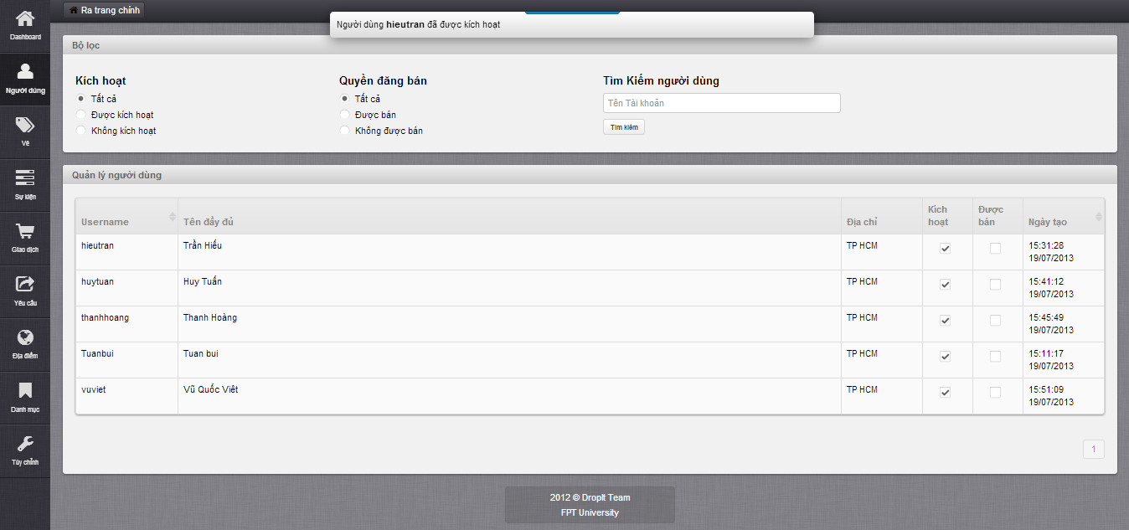

* Choose deactive user and check “Kích hoạt” box to active
* Choose active user and uncheck “Kích hoạt” box to deactive
* Message active/deactive successful displays on top

### Salable/Unsalable User

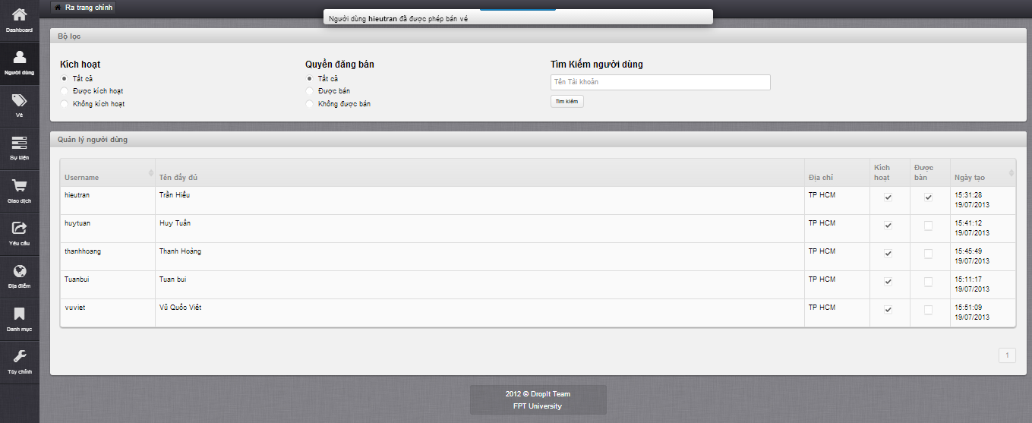

* Choose unsalable user and check “Được bán” box to allow selling
* Choose salable user and uncheck “Được bán” box to not allow selling
* Message salable/unsalable successful displays on top

### Update Ticket

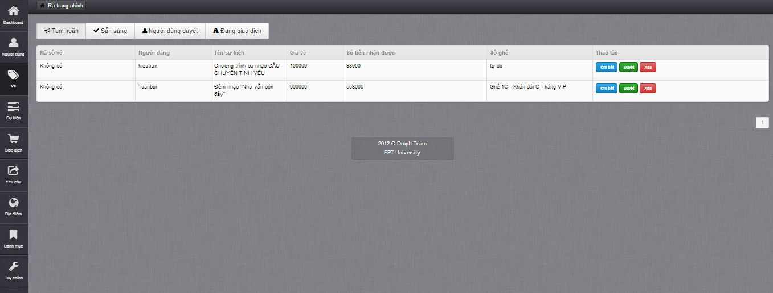

* Click on “Chi tiết” button to view ticket details and update ticket

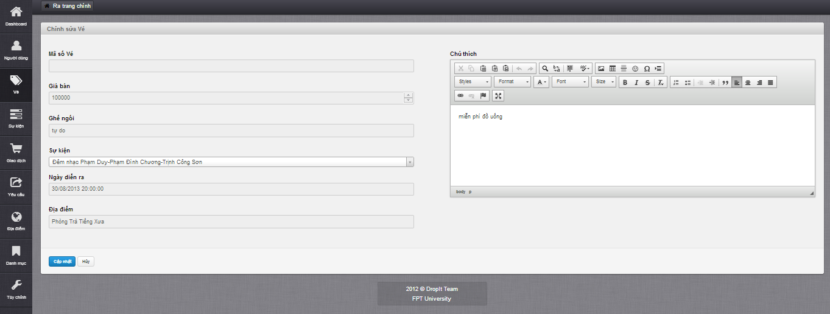

* In edit ticket page, only field “Sự kiện” can be edited
* After edited, click “Cập nhật” to save

### Delete Ticket



* Click on “Xóa” button to delete ticket

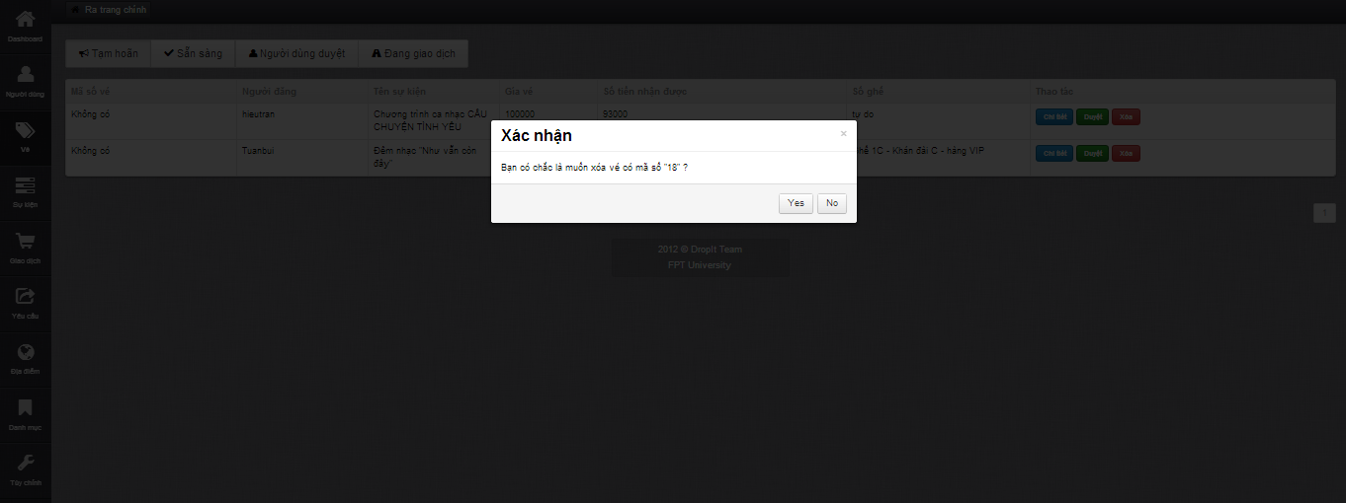

* Click “Yes” button to confirm delete ticket, finish delete

### Approve/Disapprove Ticket

* Click on “Duyệt” button to approve a ticket
* Click on “Bỏ duyệt” button to disapprove a ticket

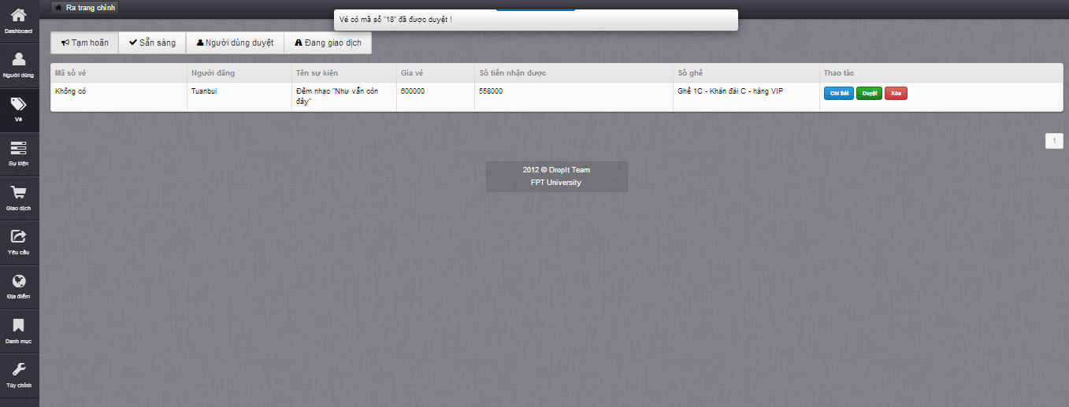

* Message approve/disapprove successful displays on top

### Create Event

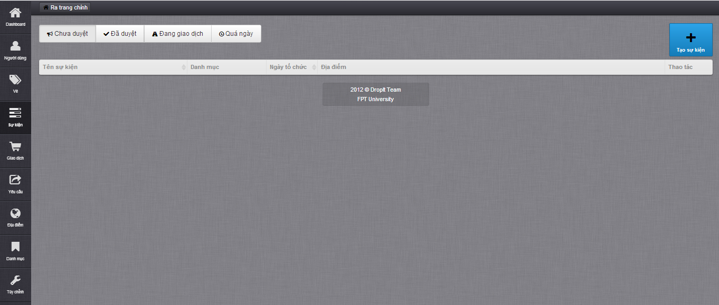

* Click on “Tạo sự kiện” button to create new event

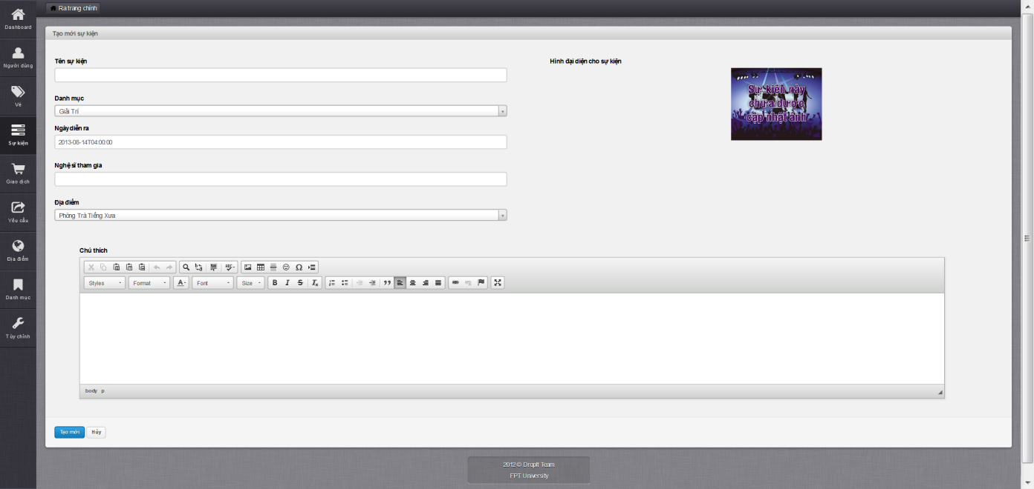

* Fill in all mandatory field
* Click on “Tạo mới” button
* After creating completed, navigate back to Manage Event page

### Update Event

* Click on an event

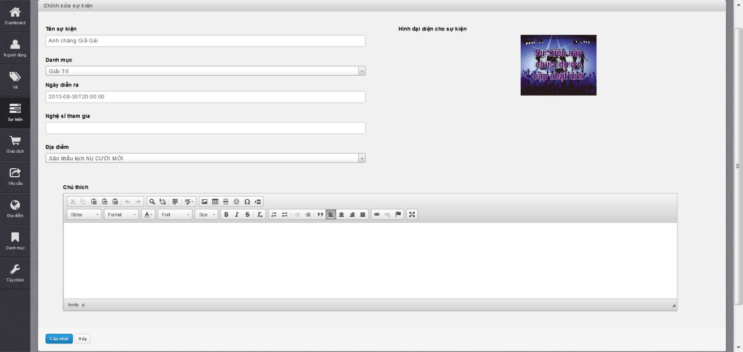

* Fill in need to update field
* Click on “Cập nhật” button
* After updating complete, navigate back to Manage Event page

### Delete Event

* Choose an event in Disapprove tab and click “Xóa” button

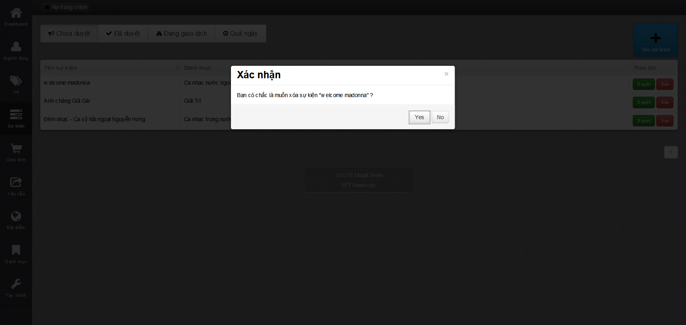

* Click on “Yes” button to confirm delete event, finish delete event

### Approve/Disapprove Event

* Choose a disapprove event in “Chưa duyêt” tab and click “Duyệt” button

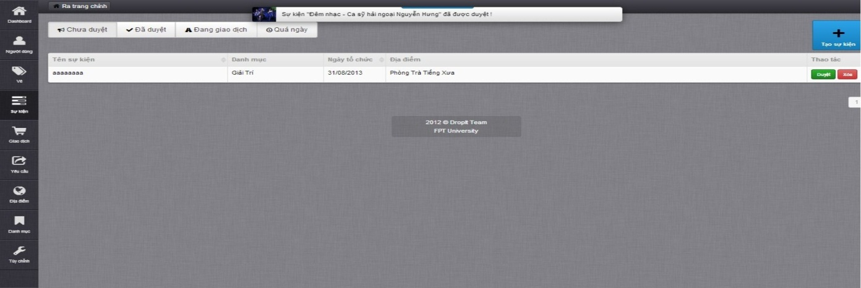

* Display message approve event success on top
* Choose an approve event on “Đã duyệt” tab and click “Bỏ duyệt” button

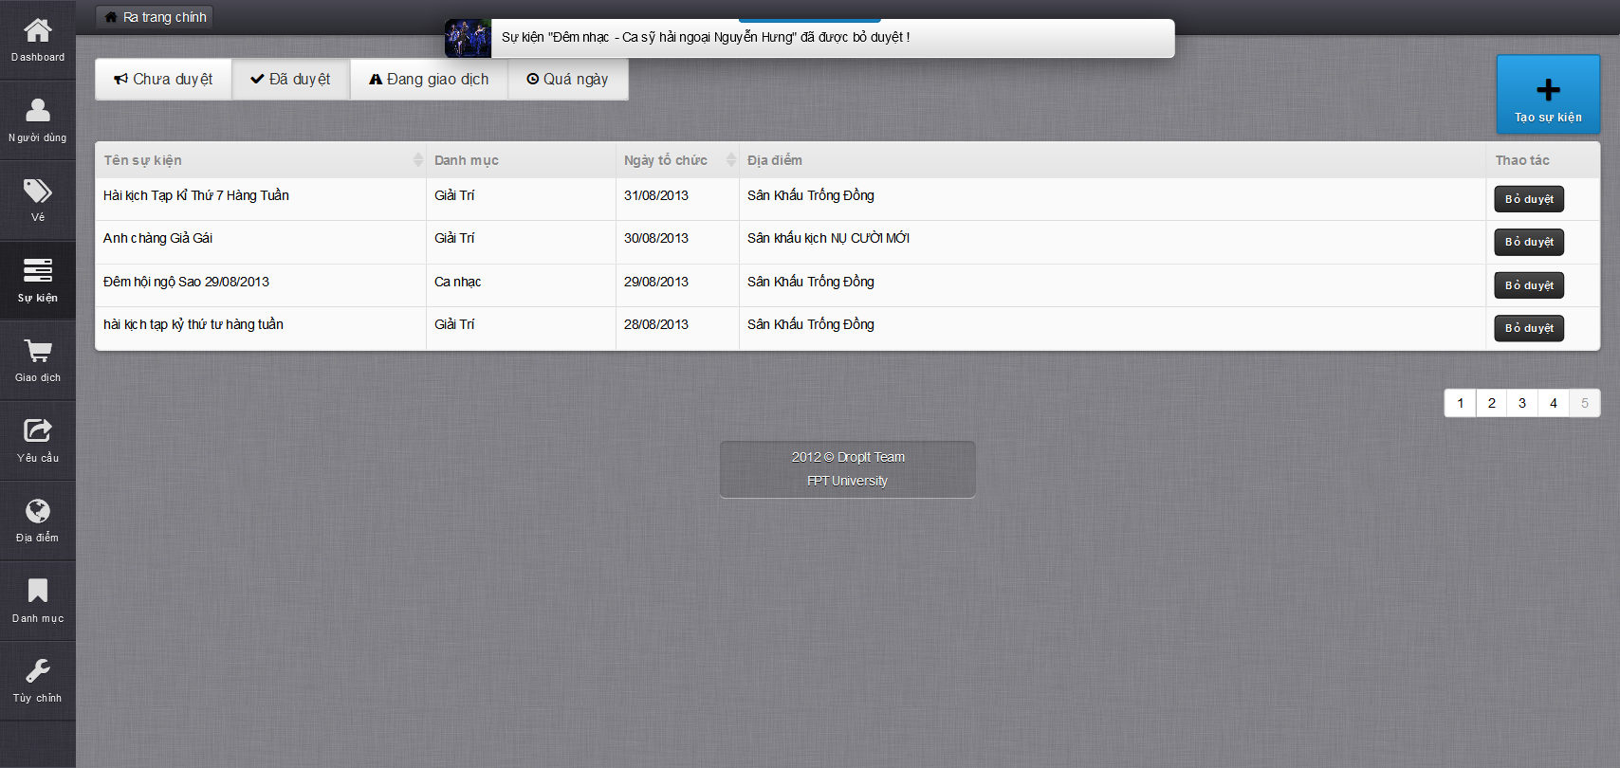

* Display message disapprove event success on top

### Create Venue

### Update Venue

### Approve/Disapprove Venue

### Create Category

### Update Category

### Show/Hide Category

### Close Request

### Update Transaction

### Create Setting

### Update Setting

### Delete Setting

## **User’s Guide**

### Register

### Login

### Buy Ticket

### Post Ticket

### Update Posted Ticket

### Delete Posted Ticket

### Request Ticket

### Respond Ticket

### Close Ticket Request

### View Buy History

### View Sell History

### Follow/Unfollow Buy Event

### Follow/Unfollow Sell Event

### Follow/Unfollow Buy and Sell Event

### View Follow List

### View Notification List

### Change Password

### Change Personal Information

### Search Event

### Logout