Phong Nguyen
Razi Khanom

CSC 2201
Date: 02/01/2018
Laboratory 1 version 1.2

Contents

Class Index 5
  - Class List 5

File Index 7
  - File List 7

Class Documentation 9
  - Text Class Reference 5
    - Constructor & Destructor Documentation 6
. . . . . . . . . . . . . . . . . . . . . . . . . . . . . . . 6
 | 3.1.1.1 | Text() [1/2] . . . . .
 | 3.1.1.2 | Text() [2/2] . . . . .
3.1.2 | 3.1.1.3  Member | ∼Text() . . . . . . . .  Function Documentation

. . . . . . . . . . . . . . . . . . . . . . . . . . . . . . . 6
. . . . . . . . . . . . . . . . . . . . . . . . . . . . . . . 6
. . . . . . . . . . . . . . . . . . . . . . . . . . . . . . 7 3.1.2.1 clear() . . . . . . . . . . . . . . . . . . . . . . . . . . . . . . . . . . . . . . . 7
      - getLength() 7
      - operator<() 8
      - operator=() 8
      - operator==() 8
      - operator>() 8
      - operator[]() 8
      - showStructure() 9
      - toLower() 9
      - toUpper() 9
. . . . . . . . . . . . . . . . . . . . . . . . 9
3.1.3 | Friends | And Related Function Documentation
 | 3.1.3.1 | operator<< . . . . . . . . . . . .
 | 3.1.3.2 | operator>> . . . . . . . . . . . .
3.1.4 | Member | Data Documentation . . . . . . . . .
 | 3.1.4.1 | buffer . . . . . . . . . . . . . . . .
 | 3.1.4.2 | bufferSize . . . . . . . . . . . . .

. . . . . . . . . . . . . . . . . . . . . . . . 10
. . . . . . . . . . . . . . . . . . . . . . . . 10
. . . . . . . . . . . . . . . . . . . . . . . . 10
. . . . . . . . . . . . . . . . . . . . . . . . 10
. . . . . . . . . . . . . . . . . . . . . . . . 10
ii CONTENTS

- File Documentation 11
  - E:/SCHOOL/c++/CSC 2200/Lab01/Lab01/config.h File Reference 11
    - Macro Definition Documentation 11
      - LAB1_TEST1 11
      - LAB1_TEST2 12
  - E:/SCHOOL/c++/CSC 2200/Lab01/Lab01/lexical.cpp File Reference 12
    - Function Documentation 12
4.2.1.1 main() 12
  - E:/SCHOOL/c++/CSC 2200/Lab01/Lab01/test1.cpp File Reference 13
    - Function Documentation 13
      - copyTester() 13
4.3.1.2 main() 14
4.3.1.3 print_help() 15
  - E:/SCHOOL/c++/CSC 2200/Lab01/Lab01/text.cpp File Reference 15
    - Function Documentation 16
      - operator<<() 16
      - operator>>() 16
  - E:/SCHOOL/c++/CSC 2200/Lab01/Lab01/Text.h File Reference 17
  - E:/SCHOOL/c++/CSC 2200/Lab01/Lab01/textio.cpp File Reference 17
    - Function Documentation 18
      - operator<<() 18
      - operator>>() 18
Index 19
- Attachments 24
  - Lab Report 24
    - Cover Sheet 24

iii CONTENTS

    - Implementation Testing 25
    - Programming Exercise 1 28
    - Analysis Exercise 1 29
  - Program Output 30
    - Test Plan 1-1 (constructors) 30
    - Test Plan 1-2 (length operation) 30
    - Test Plan 1-3 (subscript operation) 31
    - Test Plan 1-4 (assignment and clear operations) 31
    - Test Plan 1-5 (lexical analysis program) 32
  - Source Codes 33
    - Text.h 33
    - Text1.cpp 34
    - Text.cpp 38
    - Lexical.cpp 42

Chapter 1

Class Index

1.1 Class List

Here are the classes, structs, unions and interfaces with brief descriptions:

Text 5
Class Index

Chapter 2

File Index

2.1 File List

Here is a list of all files with brief descriptions:
E:/SCHOOL/c++/CSC 2200/Lab01/Lab01/config.h 11
E:/SCHOOL/c++/CSC 2200/Lab01/Lab01/lexical.cpp 12
E:/SCHOOL/c++/CSC 2200/Lab01/Lab01/test1.cpp 13
E:/SCHOOL/c++/CSC 2200/Lab01/Lab01/text.cpp 15
E:/SCHOOL/c++/CSC 2200/Lab01/Lab01/Text.h 17
E:/SCHOOL/c++/CSC 2200/Lab01/Lab01/textio.cpp 17
4 File Index

Chapter 3
Class Documentation

  - Text Class Reference

#include <Text.h>

Public Member Functions

    - Text (const char ∗charSeq="")
Constructors and operator=.
    - Text (const Text &other)
Initialize using char∗.
    - void operator= (const Text &other)
Copy constructor.
    - ∼Text ()
Assignment.
    - int getLength () const
Text operations.
    - char operator[ ] (int n) const

characters
    - void clear ()
Subscript.
    - void showStructure () const
Clear string.
    - Text toUpper () const
    - Text toLower () const
Create upper-case copy.
    - bool operator== (const Text &other) const
Create lower-case copy.
    - bool operator< (const Text &other) const
    - bool operator> (const Text &other) const
6 Class Documentation

Private Attributes

- int bufferSize
Data members.
- char ∗ buffer
Size of the string buffer.

Friends

- istream & operator>> (istream &input, Text &inputText)
Text buffer containing a null-terminated sequence of characters.
- ostream & operator<< (ostream &output, const Text &outputText)

3.1.1 Constructor & Destructor Documentation

3.1.1.1 Text() [1/2]

Text::Text (

const char ∗ charSeq = "" )

Constructors and operator=.

Creates a string containing the delimited sequence of characters charSeq. Allocates enough memory for this string. Copy the string

3.1.1.2 Text() [2/2]

Text::Text (
const Text & other )

Initialize using char∗. Copy constructor.

3.1.1.3 ∼Text() Text::∼Text ( ) Assignment.
Frees the memory used by the Text object buffer.

Destructor

  - Text Class Reference 7

    - Member Function Documentation

      - clear()

void Text::clear ( )

Subscript.

Clears a Text object – i.e., makes it empty. The buffer size remains unchanged. Here is the caller graph for this function:

main
Text::clear
copyTester

      - getLength()

int Text::getLength ( ) const

Text operations.

Returns the number of characters in the Text object buffer (excluding the null character). Here is the caller graph for this function:

main
Text::getLength
Text::operator=
8 Class Documentation

      - operator<()

bool Text::operator< (
const Text & other ) const

      - operator=()

void Text::operator= (
const Text & other )

Copy constructor.

Assigns other to a Text object. Here is the call graph for this function:

Text::operator=
Text::getLength

      - operator==()

bool Text::operator== (
const Text & other ) const

Create lower-case copy.

Relational operations (Programming Exercise 3)

      - operator>()

bool Text::operator> (
const Text & other ) const

      - operator[]()

char Text::operator[ ] (int n ) const

characters
Returns the nth character in a Text object – where the characters are numbered beginning with zero.
If the subscript is out of range, return an empty character (/0)
3.1 Text Class Reference 9

      - showStructure()

void Text::showStructure ( ) const

Clear string.

Output the string structure – used in testing/debugging

Outputs the characters in a string. This operation is intended for testing/debugging purposes only. Here is the caller graph for this function:

main
Text::showStructure
copyTester

      - toLower()

Text Text::toLower ( ) const

Create upper-case copy.

      - toUpper()

Text Text::toUpper ( ) const

In-lab operations toUpper/toLower operations (Programming Exercise 2)

3.1.3 Friends And Related Function Documentation
10 Class Documentation

      - operator<<

ostream& operator<< (
ostream & output,
const Text & outputText ) [friend]

Text output function. Inserts outputText in ostream output. Returns the state of the output stream.

      - operator>>

istream& operator>> (
istream & input,
Text & inputText ) [friend]

Text buffer containing a null-terminated sequence of characters. Friends Text input/output operations (In-lab Exercise 1)
Text input function. Extracts a string from istream input and returns it in inputText. Returns the state of the input stream. Large (but finite)

text buffer

Read a string into textBuffer, setw is used to prevent buffer overflow.

Apply the Text(char ) constructor to convert textBuffer to a string. Assign the resulting string to inputText us- ing the assignment operator.
∗
Return the state of the input stream.

    - Member Data Documentation

      - buffer

char∗ Text::buffer [private]
Size of the string buffer.

      - bufferSize

int Text::bufferSize [private]

Data members.

The documentation for this class was generated from the following files:

        - E:/SCHOOL/c++/CSC 2200/Lab01/Lab01/Text.h
        - E:/SCHOOL/c++/CSC 2200/Lab01/Lab01/text.cpp

Chapter 4

File Documentation

E:/SCHOOL/c++/CSC 2200/Lab01/Lab01/config.h File Reference

This graph shows which files directly or indirectly include this file:

E:/SCHOOL/c++/CSC 2200
/Lab01/Lab01/test1.cpp
E:/SCHOOL/c++/CSC 2200
/Lab01/Lab01/config.h

Macros
    - #define LAB1_TEST1 0
    - #define LAB1_TEST2 0

Macro Definition Documentation

LAB1_TEST1

#define LAB1_TEST1 0

Text class (Lab 1) configuration file. Activate test 'N' by defining the corresponding LAB1_TESTN to have the value 1.
12 File Documentation

LAB1_TEST2

#define LAB1_TEST2 0

E:/SCHOOL/c++/CSC 2200/Lab01/Lab01/lexical.cpp File Reference

#include <fstream>
#include <iostream>
#include "Text.h"
Include dependency graph for lexical.cpp:

E:/SCHOOL/c++/CSC 2200
/Lab01/Lab01/lexical.cpp
fstream
Text.h
iostream
stdexcept

Functions

- int main ()

Function Documentation

main()

int main ( )

Project Name : Lab 1-Exercise 1
Developer Name : Phong Nguyen
Date : 01/19/2018
Description : Lexical Analysis Program Token

Open the specified program file. Counts tokens
4.3 E:/SCHOOL/c++/CSC 2200/Lab01/Lab01/test1.cpp File Reference 13

E:/SCHOOL/c++/CSC 2200/Lab01/Lab01/test1.cpp File Reference

#include <iostream>
#include "Text.h"
#include "config.h"
Include dependency graph for test1.cpp:
Text.h
config.h
iostream
stdexcept

E:/SCHOOL/c++/CSC 2200
/Lab01/Lab01/test1.cpp

Functions

    - void copyTester (Text copyText)

    - void print_help ()
copyText is passed by value
    - int main ()

Function Documentation

copyTester()

void copyTester (
Text copyText )

Laboratory 1 test1.cpp Test program for the operations in the Text ADT Function prototype
14 File Documentation

Dummy routine that is passed a text object using call by value. Outputs copyText and clears it. Here is the call graph for this function:
copyTester
Text::clear

Text::showStructure

Here is the caller graph for this function:

main
copyTester

main()

int main ( )

Predefined test text objects Destination for assignment Input text object
Input subscript

Character specified by subscript Input test selection
Get user test selection.
Execute the selected test.
Test 1 : Tests the constructors. Test 2 : Tests the length operation.
4.4 E:/SCHOOL/c++/CSC 2200/Lab01/Lab01/text.cpp File Reference 15

Test 3 : Tests the subscript operation.

Test 4 : Tests the assignment and clear operations.

Test 5 : Tests the copy constructor and operator= operations. Here is the call graph for this function:

main
Text::showStructure
print_help
Text::getLength
copyTester
Text::clear

4.3.1.3 print_help()

void print_help ( )

copyText is passed by value

Here is the caller graph for this function:

main
print_help

4.4 E:/SCHOOL/c++/CSC 2200/Lab01/Lab01/text.cpp File Reference

#include <iostream>
#include <iomanip>
#include <cassert>
#include <cstring>
16 File Documentation

#include "Text.h"
Include dependency graph for text.cpp:

E:/SCHOOL/c++/CSC 2200
/Lab01/Lab01/text.cpp
Text.h
iomanip
cassert
cstring
iostream
stdexcept

Functions
- istream & operator>> (istream &input, Text &inputText)
- ostream & operator<< (ostream &output, const Text &outputText)

Function Documentation

operator<<()

ostream& operator<< (
ostream & output,
const Text & outputText )

Text output function. Inserts outputText in ostream output. Returns the state of the output stream.

operator>>()

istream& operator>> (
istream & input,
Text & inputText )

Text input function. Extracts a string from istream input and returns it in inputText. Returns the state of the input stream. Large (but finite)
text buffer
Read a string into textBuffer, setw is used to prevent buffer overflow.

Apply the Text(char ) constructor to convert textBuffer to a string. Assign the resulting string to inputText us- ing the assignment operator.
∗
Return the state of the input stream.
4.5 E:/SCHOOL/c++/CSC 2200/Lab01/Lab01/Text.h File Reference 17

E:/SCHOOL/c++/CSC 2200/Lab01/Lab01/Text.h File Reference

#include <stdexcept>
#include <iostream>
Include dependency graph for Text.h:

E:/SCHOOL/c++/CSC 2200
/Lab01/Lab01/Text.h
stdexcept
iostream

This graph shows which files directly or indirectly include this file:
E:/SCHOOL/c++/CSC 2200
/Lab01/Lab01/text.cpp

E:/SCHOOL/c++/CSC 2200
/Lab01/Lab01/Text.h
E:/SCHOOL/c++/CSC 2200
/Lab01/Lab01/lexical.cpp
E:/SCHOOL/c++/CSC 2200
/Lab01/Lab01/test1.cpp

Classes

    - class Text

E:/SCHOOL/c++/CSC 2200/Lab01/Lab01/textio.cpp File Reference

#include <iostream>
#include <iomanip>
18 File Documentation

Include dependency graph for textio.cpp:

E:/SCHOOL/c++/CSC 2200
/Lab01/Lab01/textio.cpp
iostream
iomanip

Functions
- istream & operator>> (istream &input, Text &inputText)
- ostream & operator<< (ostream &output, const Text &outputText)

Function Documentation

operator<<()

ostream& operator<< (
ostream & output,
const Text & outputText )

Text output function. Inserts outputText in ostream output. Returns the state of the output stream.

operator>>()

istream& operator>> (
istream & input,
Text & inputText )

Friends Text input/output operations (In-lab Exercise 1)

Text input function. Extracts a string from istream input and returns it in inputText. Returns the state of the input stream. Large (but finite)

text buffer

Read a string into textBuffer, setw is used to prevent buffer overflow.

Apply the Text(char ) constructor to convert textBuffer to a string. Assign the resulting string to inputText us- ing the assignment operator.
∗
Return the state of the input stream.

Index

Text
∼
Text, 6

buffer
Text, 10 bufferSize
Text, 10

clear

Text, 8 operator==
Text, 8 operator[]
Text, 8

print_help
test1.cpp, 15

Text, 7 config.h
LAB1_TEST1, 11
LAB1_TEST2, 11
copyTester
test1.cpp, 13

E:/SCHOOL/c++/CSC 2200/Lab01/Lab01/Text.h, 17
E:/SCHOOL/c++/CSC 2200/Lab01/Lab01/config.h, 11
showStructure Text, 9

test1.cpp
copyTester, 13
main, 14
print_help, 15
Text, 5
∼Text, 6

E:/SCHOOL/c++/CSC 2200/Lab01/Lab01/lexical.cpp, 12
buffer, 10
bufferSize, 10

E:/SCHOOL/c++/CSC 2200/Lab01/Lab01/test1.cpp, 13
E:/SCHOOL/c++/CSC 2200/Lab01/Lab01/text.cpp, 15
E:/SCHOOL/c++/CSC 2200/Lab01/Lab01/textio.cpp, 17

getLength
Text, 7

LAB1_TEST1
config.h, 11 LAB1_TEST2
config.h, 11 lexical.cpp
main, 12

main
lexical.cpp, 12
test1.cpp, 14

operator<
Text, 7 operator<<
Text, 9
text.cpp, 16
textio.cpp, 18 operator>
Text, 8 operator>>
Text, 10
text.cpp, 16
textio.cpp, 18 operator=
clear, 7
getLength, 7
operator<, 7
operator<<, 9
operator>, 8
operator>>, 10
operator=, 8
operator==, 8
operator[], 8
showStructure, 9
Text, 6
toLower, 9
toUpper, 9 text.cpp
operator<<, 16
operator>>, 16 textio.cpp
operator<<, 18
operator>>, 18 toLower
Text, 9 toUpper
Text, 9

Chapter 5

Attachments

Laboratory 1: Cover Sheet

Name Razi Khanom/ Phong Nguyen Date 01/25/2018 Section
Place a check mark in the Assigned column next to the exercises your instructor has assigned to you. Attach this cover sheet to the front of the packet of materials you submit following the laboratory.

Activities | Assigned: Check or list exercise numbers | Completed
Implementation Testing | ✓ | ✓
Programming Exercise 1 | ✓ | ✓
Programming Exercise 2
Programming Exercise 3
Analysis Exercise 1 | ✓ | ✓
Analysis Exercise 2
 | Total | 3

Laboratory 1: Implementation Testing

Name Razi Khanom/ Phong Nguyen Date 01/25/2018 Section
Check with your instructor whether you are to complete this exercise prior to your lab period or during lab.

Test your implementation of the Text ADT using the program in the file test1.cpp. This program supports the following tests.

Lab 1 Online Test Plans
Test | Action
1-1 | Tests the constructors.
1-2 | Tests the length operation.
1-3 | Tests the subscript operation.
1-4 | Tests the assignment and clear operations.

Test Plan 1-1 (constructors)
Test case | String | Expected result | Checked
Simple string Longer string  Single-character string Empty string | alpha epsilon  a  empty | alpha epsilon  a  \0 | ✓  ✓  ✓  ✓

Test Plan 1-2 (length operation)
Test case | String | Expected length | Checked
Simple string Longer string  Single-character string Empty string | alpha epsilon  a  empty | 5  7  1  0 | ✓  ✓  ✓  ✓

Test Plan 1-3 (subscript operation)
Test case | n | Expected character | Checked
Middle character First character Last character Out of range | 2  0  4  10 | p  a  a  empty | ✓  ✓  ✓  ✓

Test Plan 1-4 (assignment and clear operations)
Test case | Assignment statement | Expected result | Checked

Simple assignment Single-character string Empty string  Source string longer than destination buffer  Assign to self  Check assignment by clearing destination | assignStr = alpha; assignStr = a;  assignStr = empty; assignStr = epsilon; assignStr = assignStr;  assignStr = alpha; assignStr.clear(); | alpha  a  \0  epsilon epsilon alpha  \0 | ✓  ✓  ✓  ✓  ✓  ✓  ✓  ✓

Laboratory 1: Programming Exercise 1

Name Date Section

Test Plan 1-5 (lexical analysis program)
Test case | Expected result | Checked
Program in the file progsamp.dat | - : [void]  - : [main] | ✓
 | 3 : [(]
 | 4 : [)]
 | 5 : [{]
 | 6 : [int]
 | 7 : [j]
 | 8 : [,]
 | 9 : [total]
 | 10 : [=]
 | 11 : [0]
 | 12 : [;]
 | 13 : [for]
 | 14 : [(]
 | 15 : [j]
 | 16 : [=]
 | 17 : [1]
 | 18 : [;]
 | 19 : [j]
 | 20 : [<=]
 | 21 : [20]
 | 22 : [;]
 | 23 : [j]
 | 24 : [++]
 | 25 : [)]
 | 26 : [total]
 | 27 : [+=]
 | 28 : [j]
 | 29 : [;]
 | 30 : [}]

Laboratory 1: Analysis Exercise 1

Name Date Section

A full-page version of this exercise with space for writing in answers is available in the online supplements for Lab 1.

Part A
What are the implications of having no destructor in a class like Text that does dynamic memory allocation? What are the practical consequences of not having a destructor for these classes in a long-running program?

One of the most obvious consequence of not having a destructor is memory leak and accumulates over time, gradually crippling or even crashing a program.

Delete[]buffer; Deallocate the buffer, This statement includes inside the destructor to frees the memory used by the string buffer allocated.

Part B
What other operators might it make sense to overload in the Text class? Name four and briefly describe how they would work.
1. Operator new []: to allocate storage required for a single object; We can use this overloaded operator to include inside the Text constructor to allocate new array for buffer.
2. Bool operator <: return true if the left object is lexically before the right object. Otherwise, return false.
3. Bool operator >: return true if the left object is lexically after the right object. Otherwise, return false.
4.Bool operator ==: return true if the left object is lexically equivalent to the right object. Otherwise, return false.
5. Operator +,+=: String concatenation; we can concatenate two string objects to produce a new string objects.
Part C
Are there any operators that it does not make sense to overload in the Text class? Why not?
The increment (++) and decrement (--) operator
These operators don’t apply to strings; it is not make sense to increase or decrease a string value.

Test Plan 1-1 (constructors)

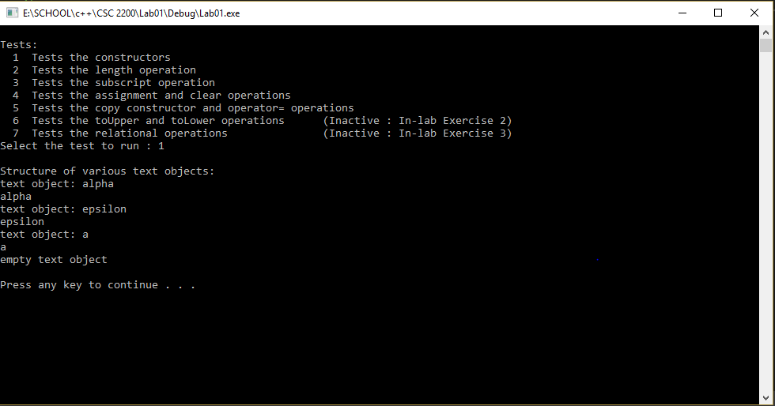

Test Plan 1-2 (length operation)

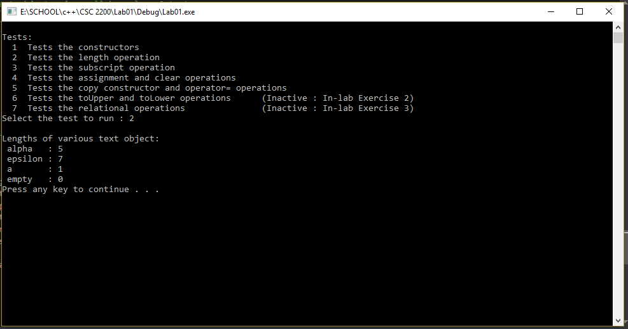

Test Plan 1-3 (subscript operation)

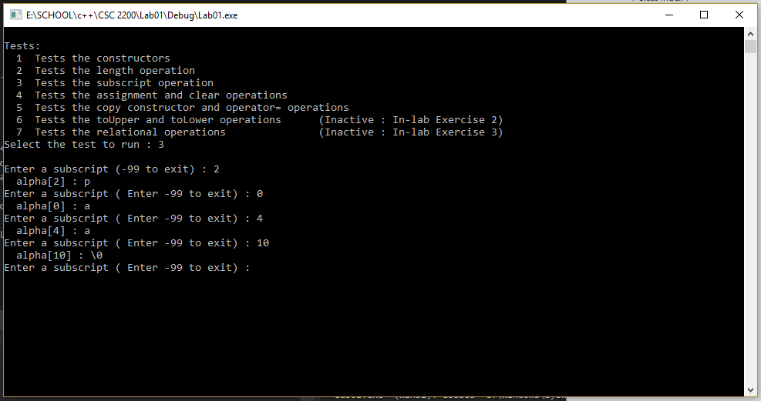

Test Plan 1-4 (assignment and clear operations)

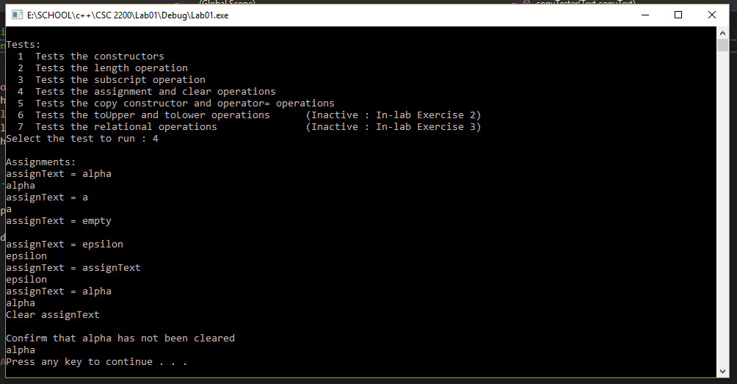

Test Plan 1-5 (lexical analysis program)

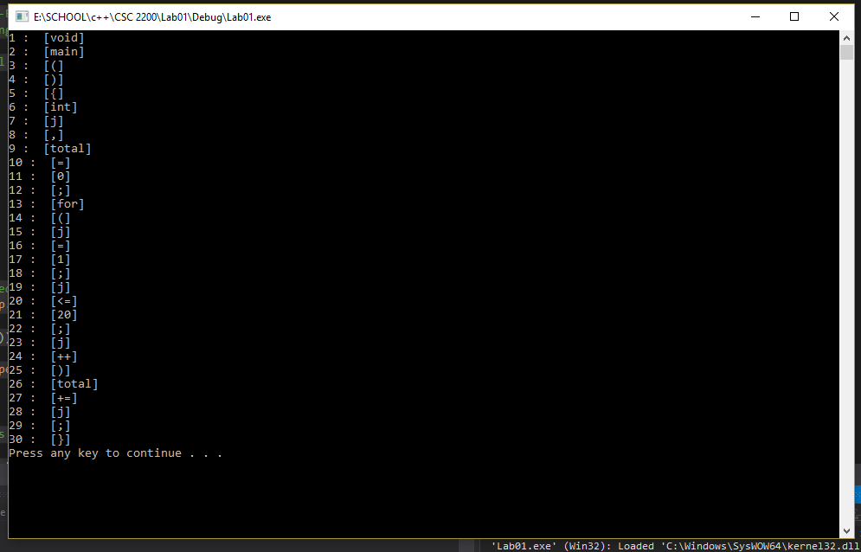

Attachments
Text.h
//--------------------------------------------------------------------
//
//! Laboratory 1 Text.h
//! **Instructor's Solution**
//! Class declaration for the array implementation of the Text ADT
//
//--------------------------------------------------------------------

#ifndef TEXT_H
#define TEXT_H

#include <stdexcept>
#include <iostream>

using namespace std;

class Text
{
public:

//! Constructors and operator=
Text ( const char *charSeq = "" ); //! Initialize using char*
Text ( const Text &other ); //! Copy constructor
void operator = ( const Text &other ); //! Assignment

//! Destructor
~Text ();

//! Text operations
int getLength () const; //! # characters
char operator [] ( int n ) const; //! Subscript
void clear (); //! Clear string

//! Output the string structure -- used in testing/debugging
void showStructure () const;

//--------------------------------------------------------------------
//! In-lab operations
//! toUpper/toLower operations (Programming Exercise 2)
Text toUpper( ) const; //! Create upper-case copy
Text toLower( ) const; //! Create lower-case copy

//! Relational operations (Programming Exercise 3)
bool operator == ( const Text& other ) const;
bool operator < ( const Text& other ) const;
bool operator > ( const Text& other ) const;

private:

//! Data members
int bufferSize; //! Size of the string buffer
char *buffer; //! Text buffer containing a null-terminated sequence of characters

//! Friends

//! Text input/output operations (In-lab Exercise 1)
friend istream & operator >> ( istream& input, Text& inputText );
friend ostream & operator << ( ostream& output, const Text& outputText );

};

#endif
Text1.cpp
//!--------------------------------------------------------------------
//
//! Laboratory 1 test1.cpp
//
//! Test program for the operations in the Text ADT
//
//--------------------------------------------------------------------

#include <iostream>
#include "Text.h"
#include "config.h"

//--------------------------------------------------------------------
//
//! Function prototype

void copyTester ( Text copyText ); //! copyText is passed by value
void print_help ( );

//--------------------------------------------------------------------

int main()
{
Text a("a"), //! Predefined test text objects
alp("alp"),
alpha("alpha"),
epsilon("epsilon"),
empty,
assignText, //! Destination for assignment
inputText; //! Input text object
int n; //! Input subscript
char ch, //! Character specified by subscript
selection; //! Input test selection

//! Get user test selection.
print_help();

//! Execute the selected test.
cin >> selection;

cout << endl;
switch ( selection )
{
case '1' :
//! Test 1 : Tests the constructors.
cout << "Structure of various text objects: " << endl;
cout << "text object: alpha" << endl;
alpha.showStructure();
cout << "text object: epsilon" << endl;
epsilon.showStructure();
cout << "text object: a" << endl;
a.showStructure();
cout << "empty text object" << endl;
empty.showStructure();
break;
case '2' :
//! Test 2 : Tests the length operation.
cout << "Lengths of various text object:" << endl;
cout << " alpha : " << alpha.getLength() << endl;
cout << " epsilon : " << epsilon.getLength() << endl;
cout << " a : " << a.getLength() << endl;
cout << " empty : " << empty.getLength() << endl;
break;

case '3' :
//! Test 3 : Tests the subscript operation.
cout << "Enter a subscript (-99 to exit) : ";
cin >> n;
while (n != -99)
{
ch = alpha[n];
cout << " alpha[" << n << "] : ";
if (ch == '\0')
cout << "\\0" << endl;
else
cout << ch << endl;
cout << "Enter a subscript ( Enter -99 to exit) : ";
cin >> n;
}

break;

case '4' :
//! Test 4 : Tests the assignment and clear operations.
cout << "Assignments:" << endl;
cout << "assignText = alpha" << endl;
assignText = alpha;
assignText.showStructure();
cout << "assignText = a" << endl;
assignText = a;
assignText.showStructure();
cout << "assignText = empty" << endl;
assignText = empty;
assignText.showStructure();
cout << "assignText = epsilon" << endl;
assignText = epsilon;
assignText.showStructure();
cout << "assignText = assignText" << endl;
assignText = assignText;
assignText.showStructure();
cout << "assignText = alpha" << endl;
assignText = alpha;
assignText.showStructure();
cout << "Clear assignText" << endl;
assignText.clear();
assignText.showStructure();
cout << "Confirm that alpha has not been cleared" << endl;
alpha.showStructure();
break;

case '5' :
//! Test 5 : Tests the copy constructor and operator= operations.
cout << "Calls by value:" << endl;
cout << "alpha before call" << endl;
alpha.showStructure();
copyTester(alpha);
cout << "alpha after call" << endl;
alpha.showStructure();

cout << "a before call" << endl;
a.showStructure();
a = epsilon;
cout << "a after call" << endl;
a.showStructure();
cout << "epsilon after call" << endl;
epsilon.showStructure();
break;

#if LAB1_TEST1
case '6' : // In-lab Exercise 2
// Test 6 : Tests toUpper and toLower
cout << "Testing toUpper and toLower."
<< "Enter a mixed case string: " << endl;
cin >> inputText;
cout << "Input string:" << endl;
inputText.showStructure();
cout << "Upper case copy: " << endl;
inputText.toUpper().showStructure();
cout << "Lower case copy: " << endl;
inputText.toLower().showStructure();
break;
#endif // LAB1_TEST1

#if LAB1_TEST2
case '7' : // In-lab Exercise 3
// Test 7 : Tests the relational operations.
cout << " left right < == > " << endl;
cout << "--------------------------------" << endl;
cout << " alpha epsilon " << (alpha<epsilon)
<< " " << (alpha==epsilon) << " "
<< (alpha>epsilon) << endl;
cout << " epsilon alpha " << (epsilon<alpha)
<< " " << (epsilon==alpha) << " "
<< (epsilon>alpha) << endl;
cout << " alpha alpha " << (alpha<alpha) << " "
<< (alpha==alpha) << " " << (alpha>alpha) << endl;
cout << " alp alpha " << (alp<alpha) << " "
<< (alp==alpha) << " " << (alp>alpha) << endl;
cout << " alpha alp " << (alpha<alp) << " "
<< (alpha==alp) << " " << (alpha>alp) << endl;
cout << " a alpha " << (a<alpha) << " "
<< (a==alpha) << " " << (a>alpha) << endl;
cout << " alpha a " << (alpha<a) << " "
<< (alpha==a) << " " << (alpha>a) << endl;
cout << " empty alpha " << (empty<alpha) << " "
<< (empty==alpha) << " " << (empty>alpha) << endl;
cout << " alpha empty " << (alpha<empty) << " "
<< (alpha==empty) << " " << (alpha>empty) << endl;
cout << " empty empty " << (empty<empty) << " "
<< (empty==empty) << " " << (empty>empty) << endl;
break;
#endif // LAB1_TEST2

default :
cout << "'" << selection << "' specifies an inactive or invalid test" << endl;
}
system("pause");
return 0;
}

//--------------------------------------------------------------------

void copyTester ( Text copyText )

//! Dummy routine that is passed a text object using call by value. Outputs
//! copyText and clears it.

{
cout << "Copy of text object" << endl;
copyText.showStructure();
cout << "Clear copy" << endl;
copyText.clear();
copyText.showStructure();
}

//--------------------------------------------------------------------

void print_help()
{
cout << endl << "Tests:" << endl;
cout << " 1 Tests the constructors" << endl;
cout << " 2 Tests the length operation" << endl;
cout << " 3 Tests the subscript operation" << endl;
cout << " 4 Tests the assignment and clear operations" << endl;
cout << " 5 Tests the copy constructor and operator= operations" << endl;

cout << " 6 Tests the toUpper and toLower operations "
#if LAB1_TEST1
<< "(Active : "
#else
<< "(Inactive : "
#endif // LAB1_TEST1
<< "In-lab Exercise 2)" << endl;

cout << " 7 Tests the relational operations "
#if LAB1_TEST2
<< " (Active : "
#else
<< " (Inactive : "
#endif // LAB1_TEST2
<< "In-lab Exercise 3)" << endl;
cout << "Select the test to run : ";
}

Text.cpp
#include <iostream>
#include <iomanip>
#include <cassert>
#include <cstring>
#include "Text.h"

using namespace std;

using namespace std;

Text::Text(const char* charSeq)
//! Creates a string containing the delimited sequence of characters
//! charSeq. Allocates enough memory for this string.
{
bufferSize = strlen(charSeq) +1 ;
try
{
buffer = new char[bufferSize];
}
catch (bad_alloc& e)
{
cout << "Allocate Memory Failed" << e.what() << endl;
}

strcpy(buffer, charSeq); //! Copy the string
}

//--------------------------------------------------------------------

Text::Text(const Text& other)
//! Copy constructor
{
bufferSize = other.bufferSize;
buffer = new char[bufferSize];
strcpy(buffer, other.buffer);
}

//--------------------------------------------------------------------

void Text::operator = (const Text& other)
//! Assigns other to a Text object.
{
if (other.getLength() > bufferSize) {
delete[] buffer;
bufferSize = other.getLength() + 1;
buffer = new char[bufferSize];

}
strcpy(buffer, other.buffer);
}

//--------------------------------------------------------------------

char Text::operator [] (int n) const

//! Returns the nth character in a Text object -- where the characters are
//! numbered beginning with zero.

{

if (n >= 0 && n <= bufferSize)
return buffer[n];
else
return '\0'; //Out of range return empty symbol
}

//--------------------------------------------------------------------

int Text::getLength()const
//! Returns the number of characters in the Text object buffer (excluding the
//! null character).

{
return strlen(buffer);
}

//--------------------------------------------------------------------

void Text::clear()

//! Clears a Text object -- i.e., makes it empty. The buffer size
//! remains unchanged.

{
buffer[0] = '\0';
}

//--------------------------------------------------------------------

Text::~Text()
//! Frees the memory used by the Text object buffer.
{
delete []buffer;
bufferSize = 0;
}

void Text::showStructure()const

//! Outputs the characters in a string. This operation is intended for
//! testing/debugging purposes only.

{

cout << buffer << endl;
}

//--------------------------------------------------------------------

istream & operator >> (istream &input, Text &inputText)

//! Text input function. Extracts a string from istream input and
//! returns it in inputText. Returns the state of the input stream.

{
const int textBufferSize = 256; //! Large (but finite)
char textBuffer[textBufferSize]; //! text buffer

//! Read a string into textBuffer, setw is used to prevent buffer
//! overflow.

input >> setw(textBufferSize) >> textBuffer;

//! Apply the Text(char*) constructor to convert textBuffer to
//! a string. Assign the resulting string to inputText using the
//! assignment operator.

inputText = textBuffer;

//! Return the state of the input stream.

return input;
}

//--------------------------------------------------------------------

ostream & operator << (ostream &output, const Text &outputText)

//! Text output function. Inserts outputText in ostream output.
//! Returns the state of the output stream.

{
output << outputText.buffer;
return output;
}

Lexical.cpp

/**
* Project Name : Lab 1-Exercise 1
* Developer Name : Phong Nguyen
* Date : 01/19/2018
* Description : Lexical Analysis Program
*/

#include <fstream>
#include <iostream>
#include "Text.h"

int main()
{
ifstream infile;

//! Token
Text token;

//! Open the specified program file.
infile.open("progsamp.dat");

if (!infile.is_open())

cout << "Error opening file" << endl;

else
{
//! Counts tokens
int i = 0;
while (infile >> token)
{
i++;
cout << i << " : " << " [" << token << "]" << endl;
}
}

system("pause");
return 0;

}

