Name __Phong Nguyen, Razi Khanom______________ Date _2/14/2018
Laboratory 9: Cover Sheet

Section _________________________________________
Place a check mark in the Assigned column next to the exercises your instructor has assigned to you. Attach this cover sheet to the front of the packet of materials you submit following the laboratory.

Activities | Assigned: Check or list exercise numbers | Completed
Implementation Testing | ✓ | ✓
Programming Exercise 1 | ✓ | ✓
Programming Exercise 2 | ✓ | ✓
Programming Exercise 3
Analysis Exercise 1 | ✓ | ✓
Analysis Exercise 2 | ✓ | ✓
 | Total | 5

Name __Phong Nguyen, Razi Khanom______________ Date _2/14/2018
Laboratory 9: Implementation Testing

Section _________________________________________

Check with your instructor whether you are to complete this exercise prior to your lab period or during lab.

Test Plan 9-1 (Binary Search Tree ADT operations)
Test case |  | Commands | Expected result | Checked
Single-branch  (unbalance tree)  Balanced Tree |  | +12+25+32  +50+70+45 | 12  \  25  \  32  50  ^  45 70 | ✓  ✓

Name __Phong Nguyen, Razi Khanom______________ Date _2/14/2018
Laboratory 9: Programming Exercise 1

Section _________________________________________

Test Plan 9-2 (accounts database indexing program)
Test case |  | Expected result | Checked
4892  9523  5552 |  | Record Account ID First Name Last name Balance  2 4892 Maureen Albright 51462.6  5 9523 Bruce Gold 719.32  No record # found | ✓  ✓  ✓

Name __Phong Nguyen, Razi Khanom______________ Date _2/14/2018
Laboratory 9: Programming Exercise 2

Section _________________________________________

Test Plan 9-3 (getCount operation)
Test case |  | Commands | Expected result | Checked
Empty Tree  Insert 1 nodes  Insert 4 nodes |  | G  +25G  +58+45+68+15G | 0  1  4

Test Plan 9-4 (getHeight operation)
Test case |  | Commands | Expected result | Checked
One node  Balanced Tree  Longest path to leaf node |  | +14H  +45+58+23H  +56+78+45+23+50+20H | 1  2  4

Name __Phong Nguyen, Razi Khanom______________ Date _2/14/2018
Laboratory 9: Analysis Exercise 1

Section _________________________________________

What are the heights of the shortest and tallest binary search trees that can be constructed from a set of N distinct keys? Give examples that illustrate your answer.

Name __Phong Nguyen, Razi Khanom______________ Date _2/14/2018
Laboratory 9: Analysis Exercise 2

Section _________________________________________

Given the shortest possible binary search tree containing N distinct keys, develop worst-case, order-of-magnitude estimates of the execution time of the following Binary Search Tree ADT operations. Briefly explain your reasoning behind each of your estimates.

retrieve O( )
Explanation:

insert O( )
Explanation:

remove O( )
Explanation:

writeKeys O( )
Explanation:

Program Output: Test Plan 9-1 (Binary Search Tree ADT operations)

Single-branch (unbalance tree)

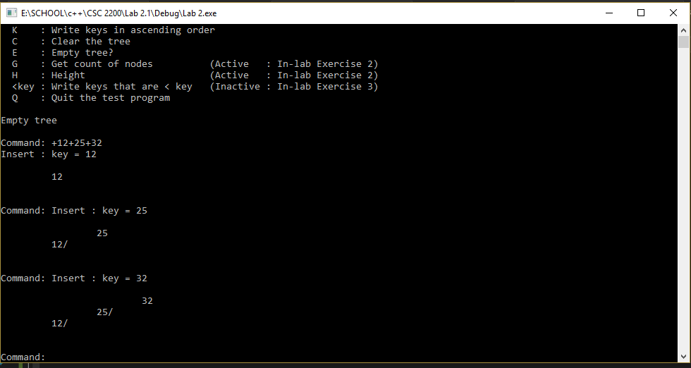

Balanced Tree
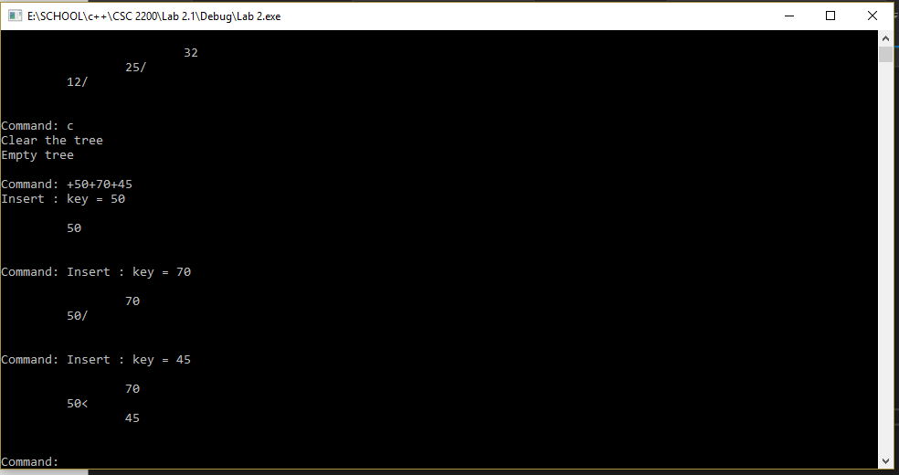

Program Output: Test Plan 9-2 (accounts database indexing program)
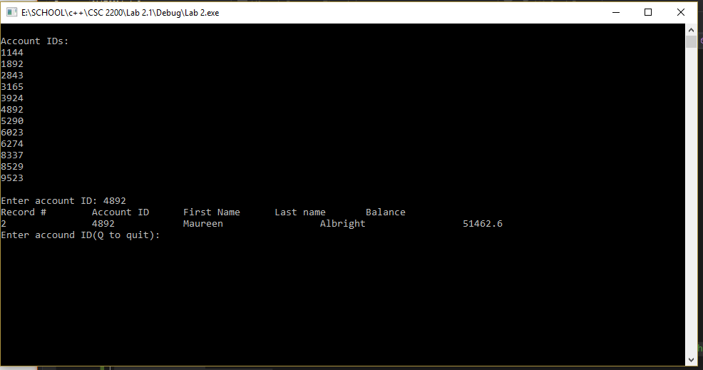
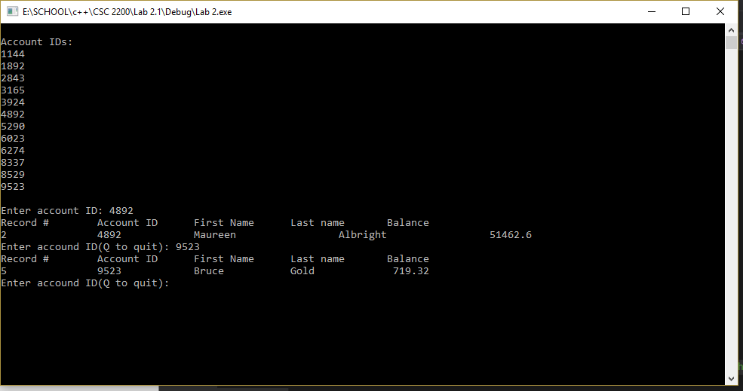
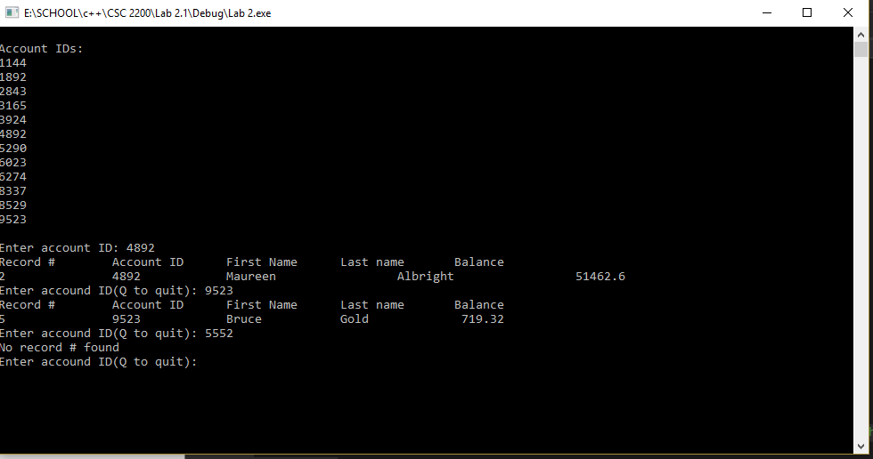
Program Output: Test Plan 9-3 (getCount operation)
Empty Tree
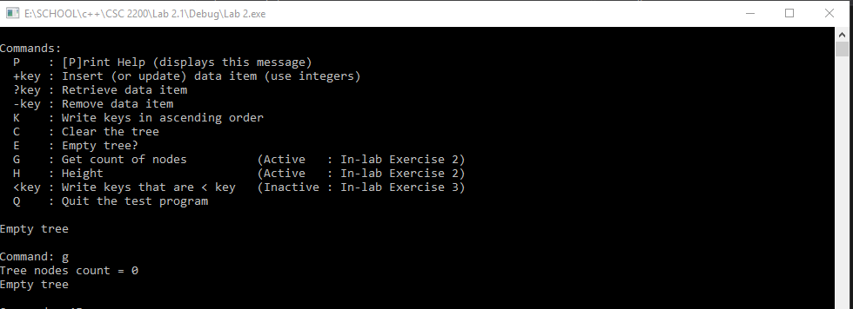
Insert 1 node
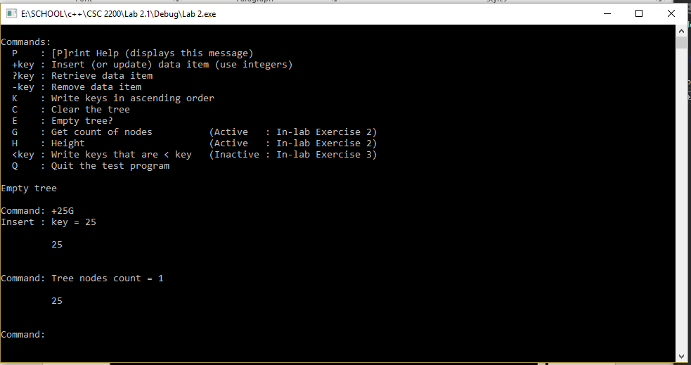
Insert 4 nodes
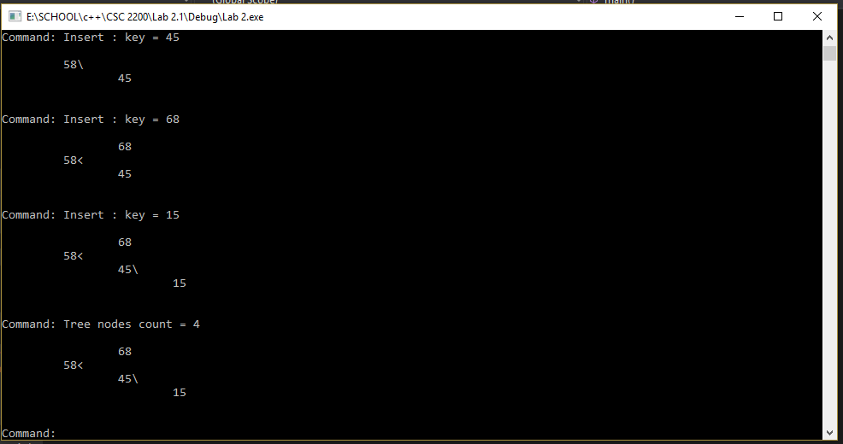
Program Output: Test Plan 9-4 (getHeight operation)
One node
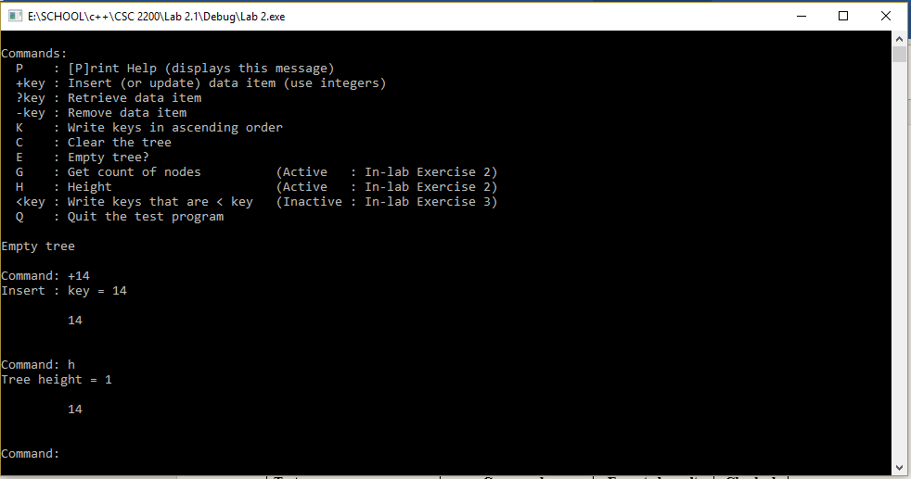
Balanced Tree (3 nodes)
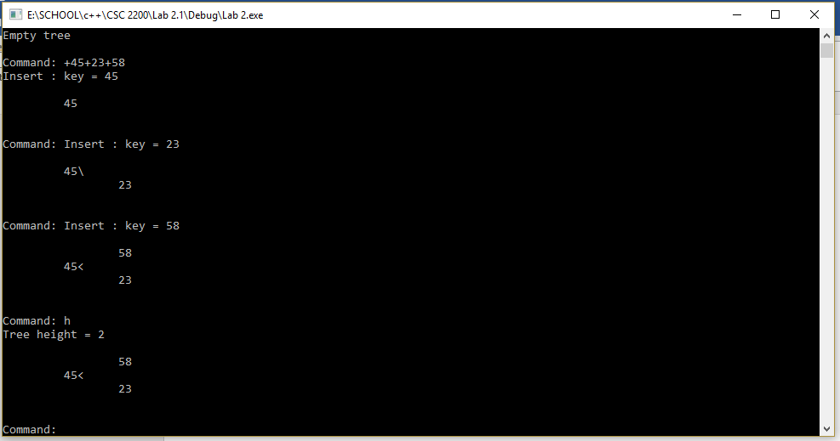
Longest Path the Leaf Node
