Name: Trần Đỗ Phong Nhã
Mssv: QE190161
Link github: https://github.com/phongnha230/PE_MMA
Link expo:
Link download:

Report PE MMA302:

- Register with a new e-mail works at once; registering the same e-mail again shows Firebase’s message in error-auth.
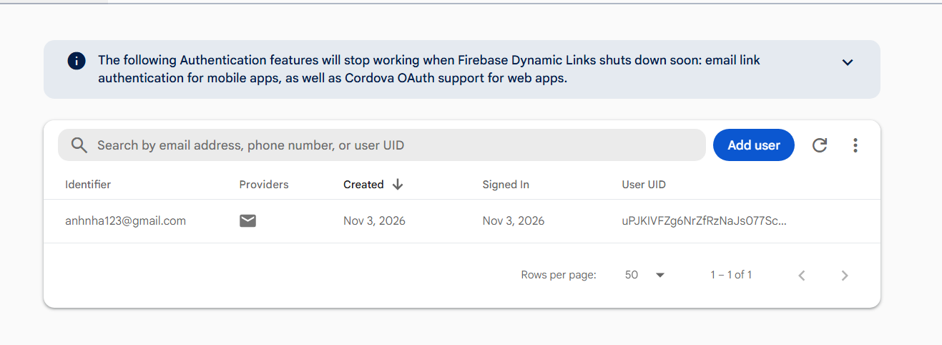

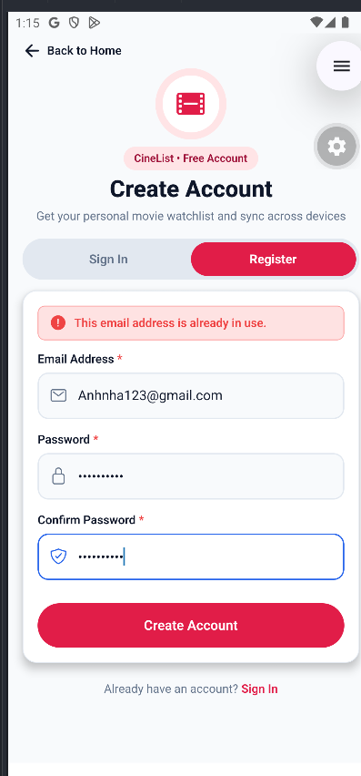
Information database in firebase:

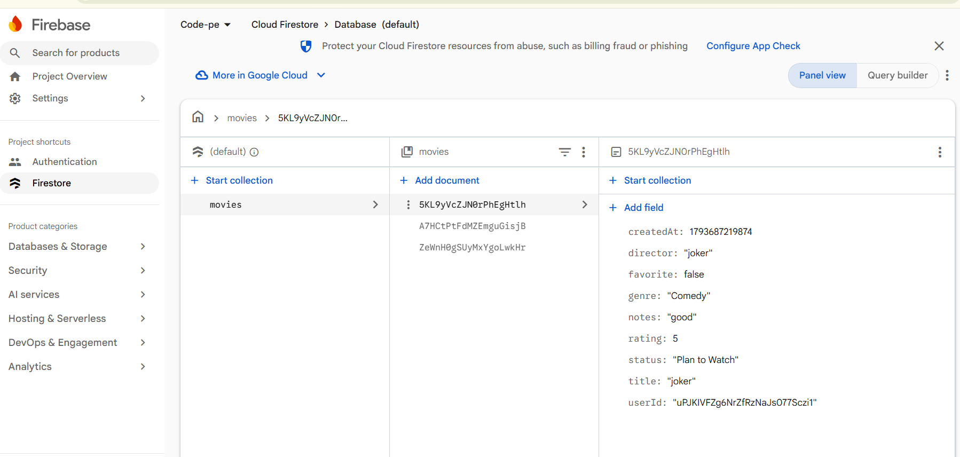

Rule Database:

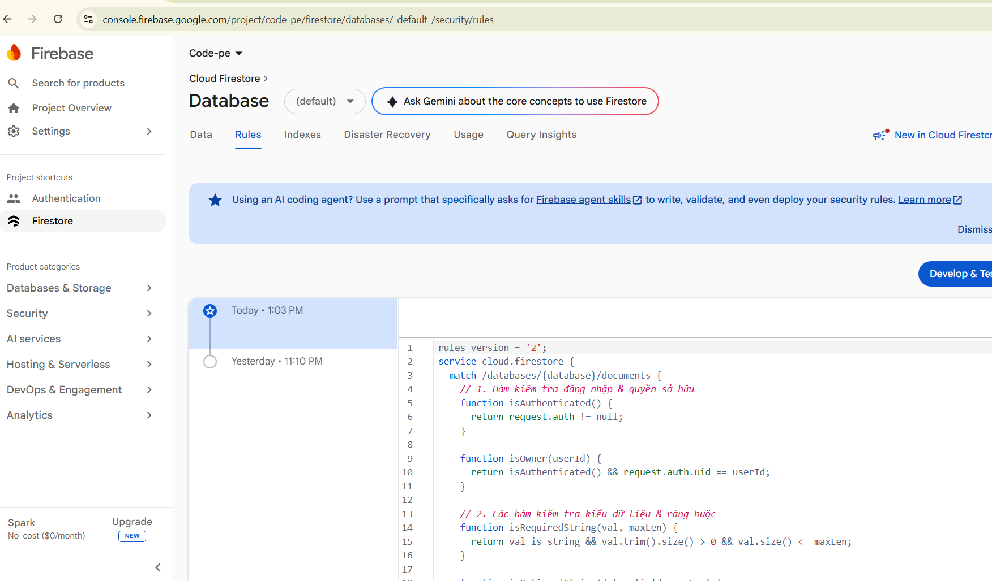

- Logged out, the app opens on the Home screen; after logging in you land on the List screen, which shows your e-mail and a working Logout.
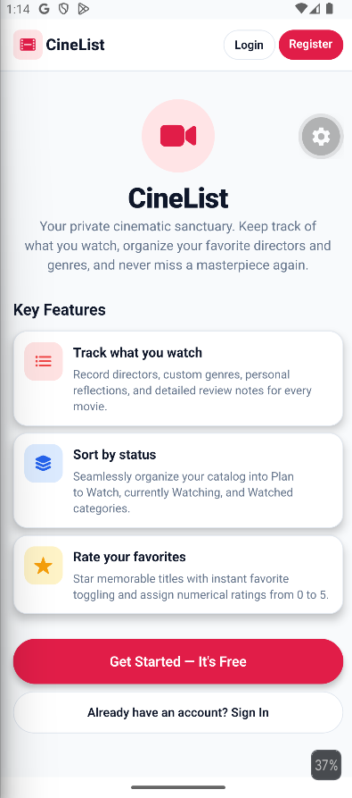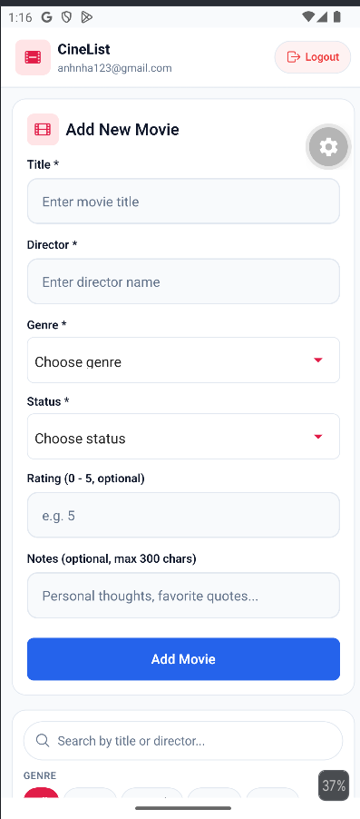

- Submitting the empty Add Movie form shows the title, director, genre and status messages; none are visible when the screen first loads.
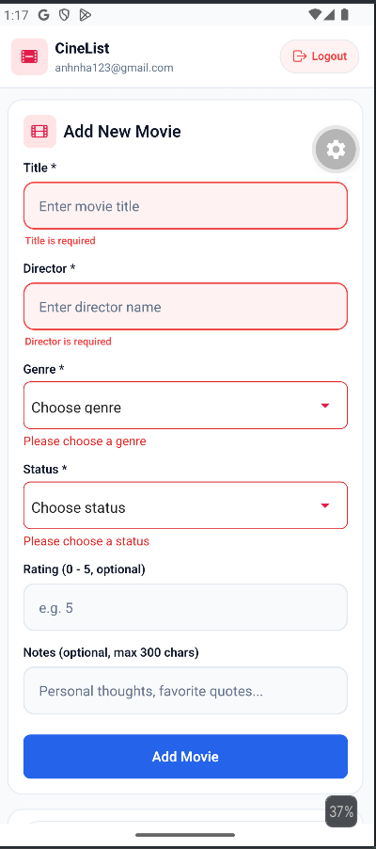

- Adding a movie shows it at once in alphabetical position; closing and reopening the app keeps it; adding the same title + director again shows error-movie and adds nothing.
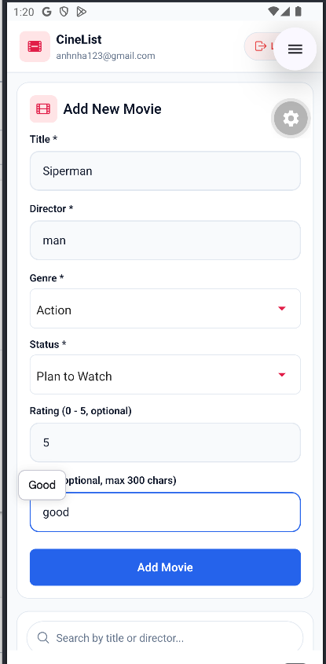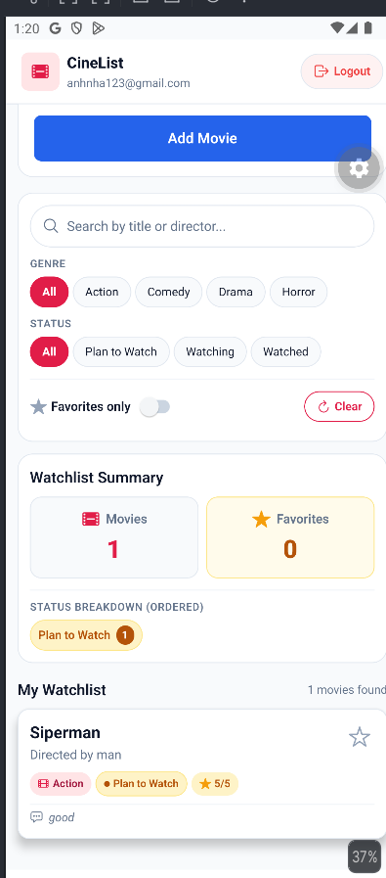

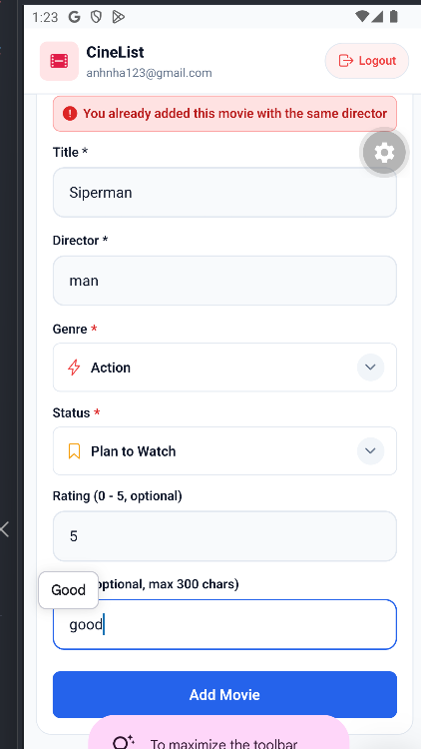

- The favorite star toggles at once and stays after the app restarts; with “favorites only” on, un-starring a movie removes it from the list.

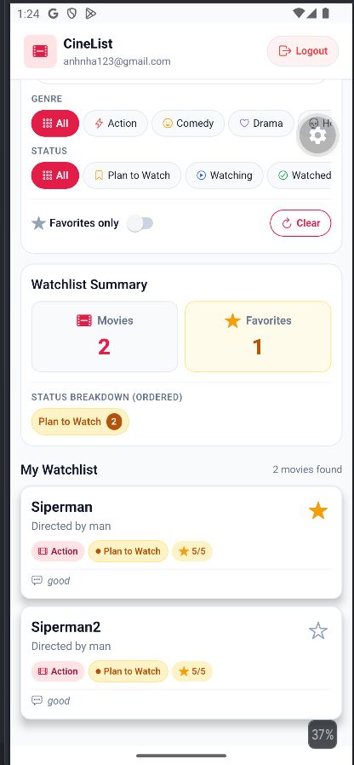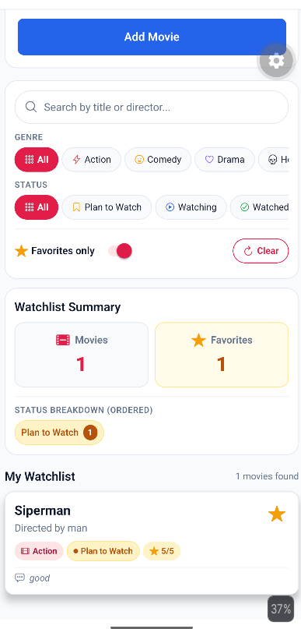

- With at least five movies in at least two statuses: genre filter, status filter, favorites-only, search, count, favorite count and breakdown all change correctly together; Clear resets all four.
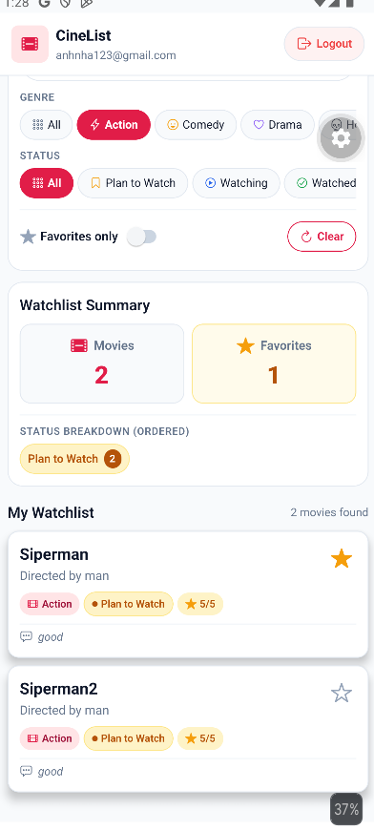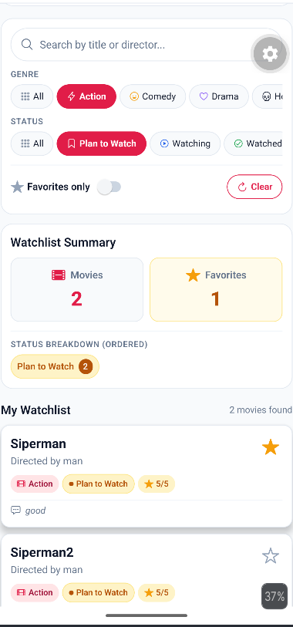

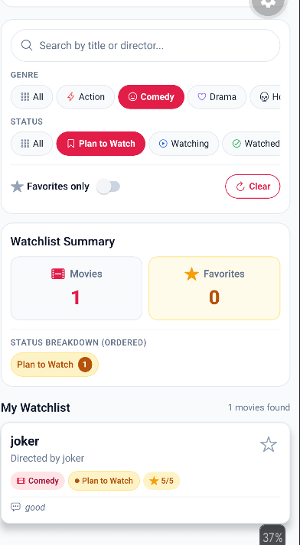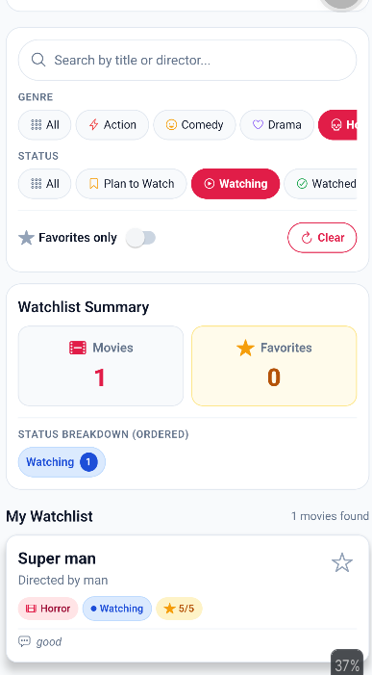

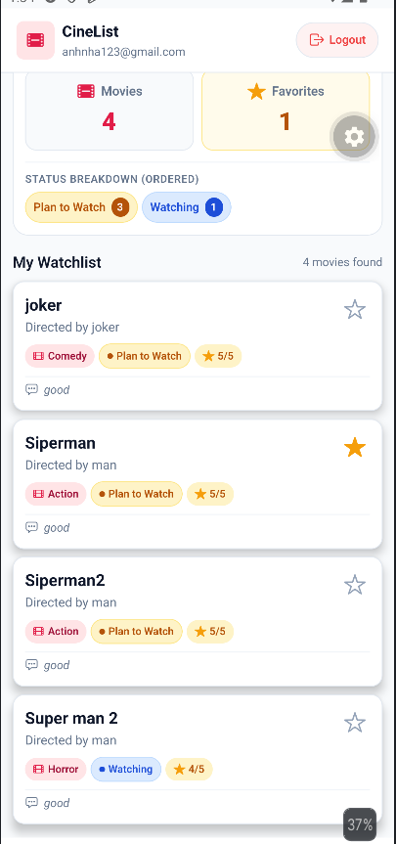
- Opening a movie’s Detail screen shows the right data; editing and saving updates both the Detail screen and the List screen; Delete removes the movie, also after restarting the app.

Edit movie:
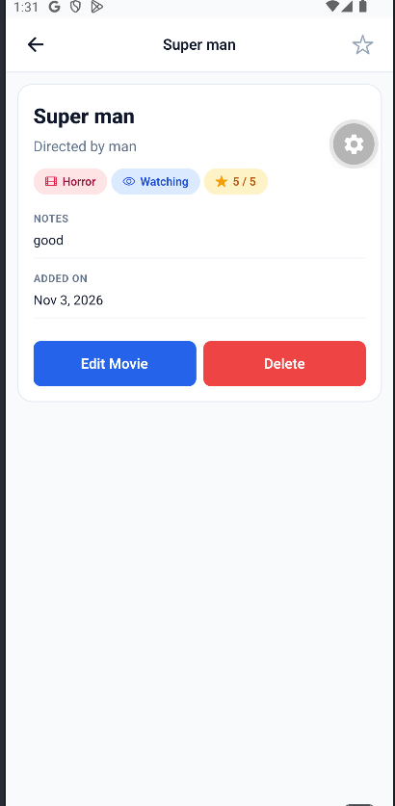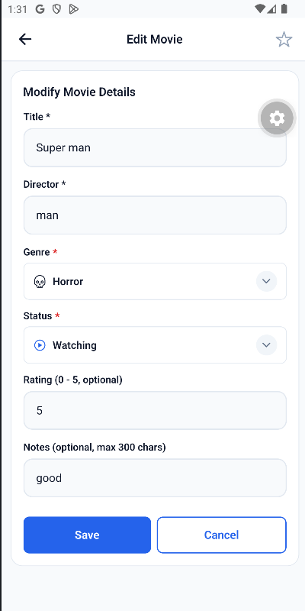

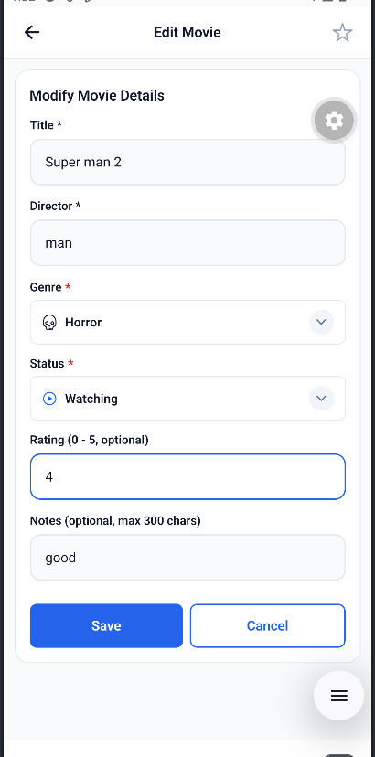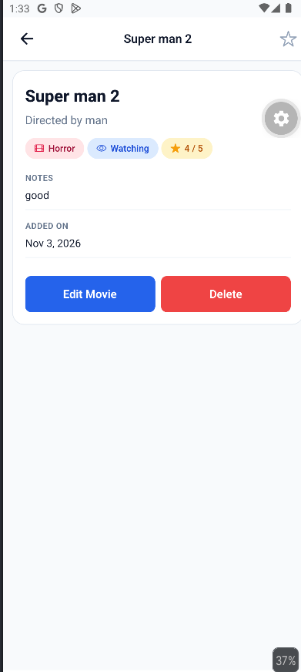

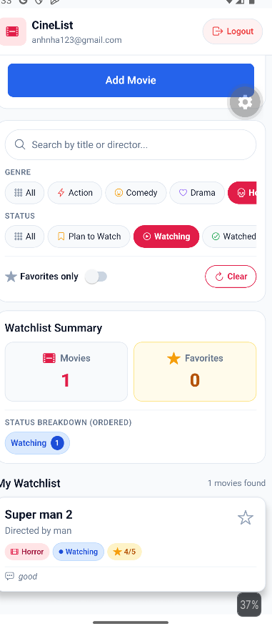

Delete movie:
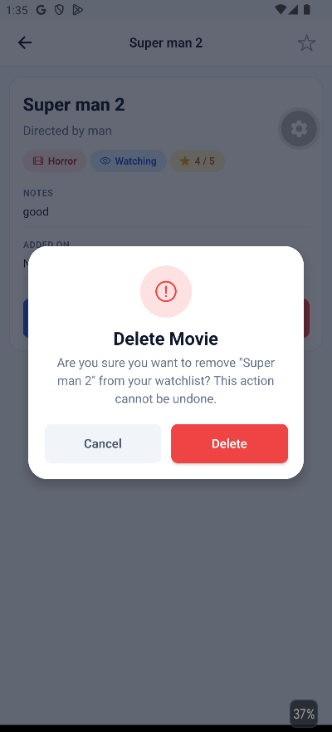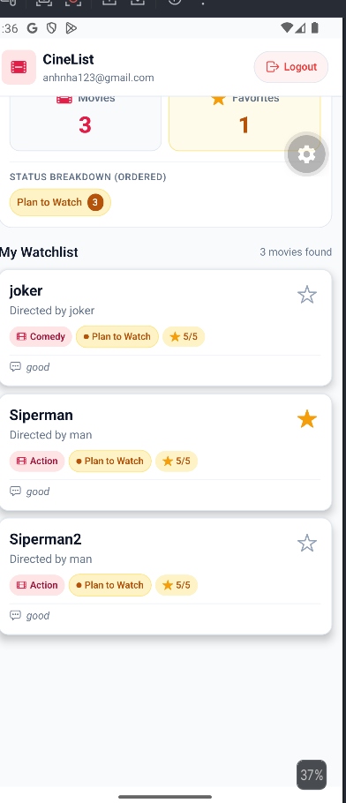

- Logging out and logging in with another account shows an empty list, not the first account’s movies.

