Building Effective Roadmaps
Quoc Phong Ngo
Concordia University, Montréal, Quebec, Canada
quocphong.ngo@mail.concordia.ca
Abstract. In today’s world of advanced information technology, roadmaps are definitely effective tools for project management. Specifically, a roadmap serves as the backbone for any development team, guiding the team in the right direction as well as providing team members with clear goals of the project. This report examines various roles of roadmaps, focusing on user-centric outcomes, impact measurement, strategic alignment, trade-offs, uncertainty management, and feature rollout planning.
User-centric roadmaps prioritize outcomes over outputs, fostering user behaviors align with Agile development. To enhance impact measurement, it is important to consider stakeholder collaboration and documented hypotheses for better estimation of impact in the future. Besides, gaining an understanding of strategic objectives is essential for aligning roadmaps with organizational goals and maintaining consistency through the use of Objectives and Key Results. Additionally, managing uncertainty is addressed through active testing and identifying irreversible steps with stakeholder consensus on potential risks. Feature rollout planning is another crucial aspect of effective roadmaps. Before releasing features in the roadmap, proper roadmap planning should be prepared and customer feedback should be collected.
Keywords: Building roadmaps, project management, Objectives and Key Results, measure impact.
- Introduction
In simple terms, a product roadmap outlines how the organization plans to achieve the product vision over a specific period. In other words, roadmaps serve as a tool that guides project, align stakeholders to transform ideas into tangible outcomes. They are the plan of actions that align the organization in pursuing both short and long-term goals for the project and the methods by which they will be realized. This report examines a comprehensive investigation of the roles that roadmaps play in software project management, providing insights into the associated strategies.
To begin with, this report commences by underscoring the importance of adopting a user-centric thinking when creating roadmaps. As a fundamental aspect of Agile development, this user-centric approach encapsulates the main concept of a roadmap that speaks to the behavioral impact it intends to catalyze. In the next section, this report delves into the importance of measuring impact. Collaborative engagements with stakeholders establish a consensus on how to measure impact and identifies expected features they desire. In section 3, this report shows real-world case studies and practical examples to illustrate the significant influence of aligning roadmaps with Objectives and Key Results. The concept of trade-offs and opportunity costs will be explored in the subsequent section. Highlighting the features that will not be pursued can reveal the underlying strategy. Furthermore, the roadmap should serve as a tool for addressing and mitigating uncertainty, rather than a fixed plan. Next section, the report discusses the significance of feature rollout planning. This section also provides concrete examples of how roadmap planning can result in the effective management of feature rollout. In the last section, the report presents a set of best practices that are aimed at ensuring the roadmap remains consistently updated and actionable.
In the software development lifecycle, product roadmaps offer benefits to the internal team, including developers, designers, QA testers, external stakeholders, consisting of investors, partners, board members, and customers. Product roadmaps not only keep everyone aligned and on the right track but also provide clarity on the direction and purpose.
- Impact on Users
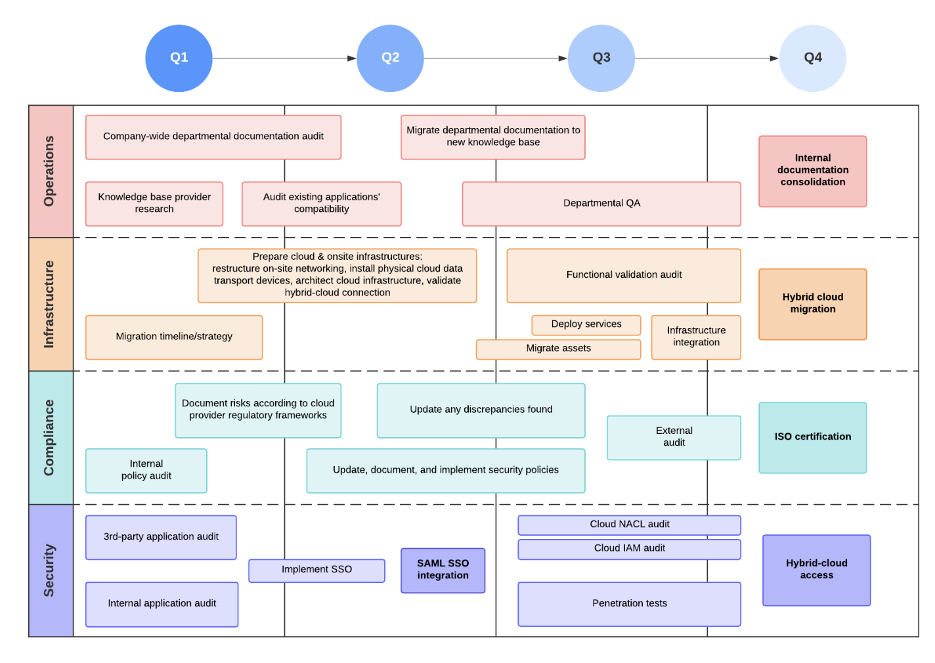
Fig. 1. Technology Roadmap Example [1]

To commence with, elements of a product roadmap may include customer insights and needs, product objectives and goals, key features, budgets and resources, a timeline for the release of specific features, how progress will be measured, and how performance will be monitored.
Effective roadmaps transcend a simple project outline; they are strategic tools for guiding software project management. In today’s world of software development, prioritizing user outcomes over mere outputs is crucial in roadmap planning. This part examines the importance of placing users at the forefront of roadmap planning, provides concrete examples of user-centric roadmap, and explains roadmaps in Agile, specifically user stories.

  - Significance of user outcomes
A user-centric thinking emphasizes the importance of roadmaps articulating the behavioral changes, not merely focusing on outputs. Therefore, this necessitates a shift from mere outputs to user outcomes, ultimately contributing to the success of software projects.
Prioritizing user outcomes at the forefront of roadmap planning ensures that product development aligns with the actual needs and preferences of the stakeholders. Furthermore, focusing on user outcomes provides clarity of purpose and cultivates active engagement from stakeholder. User-centric roadmaps plays a pivotal role in aligning product development with the strategic objectives of the organization.

  - Examples of User-Centric Roadmap [2]
Feature-Outcome mapping
Instead of presenting a list of features, a user-centric roadmap explicitly connects each feature with the user outcomes. For example, rather than saying “Implement chat functionality”, the roadmap might articulate a more user-focused objective “Enhance user engagement through the implementation of real-time chat functionality”, promoting more interactive user experiences.

User Story integration
A fundamental component of Agile development, the user story follows a simple template: “As a [type of user], I want to [activity]”. User stories are a natural fit for user-centric roadmap planning, highlighting a commitment to view projects from the user’s perspective and prioritizing desired outcomes. By incorporating Agile principles, particularly user stories, roadmaps become dynamic tools that prioritize impact and continuous user feedback.

Outcome Metrics
User-centric roadmap may incorporate outcome metrics that measure the success of a specific feature. For instance, a roadmap may include metrics such as “Increase user engagement by 15% through the implementation of X features.”
- Measuring Impact
Measuring the impact is essential for gaining insights, allowing us to approach and validate the roadmap. This section explores the significant of measuring impact, emphasizing the crucial collaboration with stakeholders to reach a consensus on impact measurement. Additionally, the role of documented hypotheses is mentioned in guiding impact measurement.

  - Significance of Measuring Impact
Measuring impact plays a crucial role in contributing to the comprehensive planning of roadmap, ensuring that projects reach their ultimate goals. More specifically, it serves as a verification method for intended outcomes, ensuring their alignment with the roadmap. In other words, it guarantees that projects meet the goals.
Another advantage of measuring impact is that it supports informed decision making, facilitating adjustments to roadmap planning and changes the prioritization of features promptly.

  - Collaboration with Stakeholders for Impact Measurement
Collaborating with stakeholders is an important aspect of impact measurement. Sustaining continuous engagement with stakeholders contributes to defining key metrics, including customer satisfaction, user engagement, and other metrics. These metrics plays a pivotal role in the overall success of the project. Besides, maintaining regular communication with external stakeholders, such as customers and end-users, can receive their feedback so that immediate actions should be taken into account to solve existing problems.

  - Example of Documented Hypotheses [2]
The purpose of documenting hypotheses is to provide the clarity of intended outcomes of roadmap item and drive other aspects in some cases. For example, by documenting hypotheses, a commitment is made to a data-driven evaluation process.
“Implementation of a personalized recommendation engine will increase user engagement by 20% within the first quarter after deployment”.
“Integration of a customer feedback feature will lead to a 25% improvement in user satisfaction scores within the next release cycle”.
“Enhancing the onboarding tutorial will result in a 10% increase in user retention over the next six months”.
“Introduction of a streamlined checkout process will reduce cart abandonment rates by 15%, leading to an improvement in overall conversion rates”.
- Strategic Objectives and Trade-offs
This section examines the significance of strategic objectives in building an effective roadmap, contributing to shape roadmap planning. Understanding what the product strategy and roadmap are and how they relate is important to effectively use the plans, align the stakeholders, and direct the work of the development team [3]. Furthermore, trade-offs and opportunity costs should be considered to make informed choices that drive the team project forward effectively.

  - Connection with Objectives and Key Results (OKRs)
Strategic alignment is integral to the success of roadmap planning. Roadmaps not only support project planning but also aligns with the long-term strategic objectives of an organization. Therefore, an effective roadmap might be a valuable tool in achieving the OKRs of corporations.
To adapt the market environment, various roadmapping formats have been reported [4]. These include the feature-based product roadmap, goal-oriented product roadmap, and outcome-driven product roadmap, consisting of OKRs.
Out-come driven roadmaps are built around customer and business values rather than features that may or may not deliver value to the customers. The approach for an outcome driven roadmap proposed by Gothelf [Go20] consists of strategic themes, quarterly objectives and key results goals, and product hypotheses.

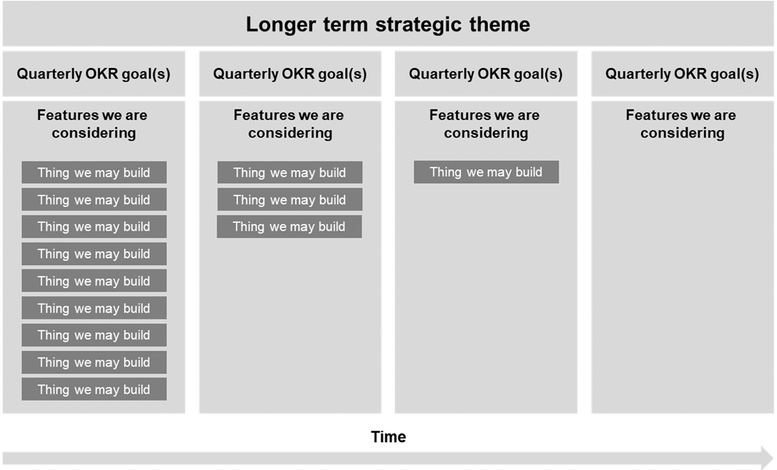
Fig. 2. Outcome-driven roadmap according to Gothelf [4]
The author stresses that customer behavior should be used as a metric in the “key results” part of an OKR goal. By looking at a quarter in advance, a team can make educated assumption about which product or feature is appropriate to meet the quarterly goals. Long-term assumptions are created as learnings from the previous quarter.
It is worth noting that the product strategy is represented in the business objectives. Table below gives some examples about business objectives and key results.
Table 1. Business objectives and key results [5]
Business Objective | Key Result
1. Support Product’s Core Value | Increase customer satisfaction by 5%
2. Create Barriers to Competition | Reduce competitive take-away by 5%
3. Grow Market Share | Increase revenue share by 5%
4. Fulfill More Demand | Increase time to market by 5%

  - Linking strategy to product plans in the corporation [6]
Deploying roadmaps across a corporation helps achieve several key objectives. Roadmaps help focus attention on longer-term planning and improve communication and ownership of plans. Finally, the process helps focus a team’s thinking on the few most important priorities at each step of the planning process. At every stage of roadmap development, the group strives to define the two or three most important drivers, elements or issues. In addition, strategic objectives involve in determining timing and priority of operations. Identifying features that align with both short-term goals and longer-term objectives aids in efficient planning and resource allocation.

  - Trade-offs and opportunity costs
Every product roadmap may contain various of choices and a diverse range of features to develop. Sometimes, these choices are most evident in the trade-offs made and reflect what the team is willing to give up. Certain features may be excluded for various reasons. These omission of them become opportunity costs, turning the roadmap into a tool that communicates the values and priorities of the product.
By highlighting opportunity costs – the features left unexplored – it becomes a means to make explicit the values the product express. Additionally, the features chosen in product roadmap are a manifestation of the underlying product strategy. Each decision to include or exclude a feature should align with the product’s priorities and the strategic objectives.

  - Balancing product roadmap trade-offs [7]
To balance trade-offs, it is essential to define the criteria that will guide the prioritization and evaluation of different features. Some common criteria include customer value, business value, effort, risk and alignment. The next step involves employing a framework that helps you compare and rank your options based on the criteria, such as the RICE score, the Kano model, the MoSCoW method, or the opportunity solution tree. Subsequently, using market research, competitive analysis can validate assumptions and hypotheses, reducing uncertainty and increase confidence in decision-making.
- Managing Uncertainty
In today’s technology-driven world, software projects often encounter uncertainty. Therefore, an effective roadmap may acknowledge uncertainty as an inherent aspect of the roadmap planning.

  - Uncertainty in Software Project Management
Uncertainties in software development can stem from various sources, including user needs, fluctuations in market demands, technologies advancements, and the team itself. Effective navigating these unforeseen challenges can be one of the critical factors contributing to the success of a project.
User needs are dynamic and iterative development proves to be a feasible approach that allows for flexibility. Additionally, the ever-changing of technology introduces ongoing uncertainties in roadmaps. As a result, roadmap should be aligned to seamlessly adapt the cutting-edge technologies.

  - How to deal with Uncertainty in Software Development
Uncertainty in projects is defined as the lack of information and an inability to define the probability of an event to happen [8]. Uncertainties cannot be eliminated from project, but some approaches may apply to reduce them.
It is advisable to promptly identifying the source of uncertainty in the project as a proactive measure for addressing problems. In the realm of project management methods, depending on project goals and solutions, the selection of appropriate methods will be given instead of the other one. For instance, when project goals are well-defined but the solutions remain unclear, opting for Agile as the suitable project methodology. Extreme project management, on the other hand, emerges as a fitting choice for both unclear goals and solutions. Another viable strategy involves breaking down the project into smaller tasks and milestones. By doing this, project managers can make more accurate estimations in terms of how long project will take, facilitating improved project planning. An effective testing strategy is crucial, requiring consideration on each delivery prior to its release to users. This approach serves to identify potential issues, preventing them from escalating into serious problems in the future.
According to research [8], the 25 project managers agreed that the strategy of Flexibility in management and ability to react to changes must exist, mainly in projects with many uncertainties. The 25 managers indicated that it was necessary to building trust between team manager and client. A participant said that trust between the three parties is necessary in projects. 22 of the participants believed that managers should facilitate self-organization and team adaptability.
The collaborative work can be seen as essential for the project development. In face of uncertainties, it is crucial to prepare the team for how better react to unexpected events. Creativity in teams may be a differential. A participant stated that: “Brainstorming, prototyping are part of our activities as a creativity stimulus! I think in projects with many uncertainties creativity is essential”.

- Feature Rollout Planning
Feature rollout involves the introduction of new product features to end-users. The primary objective of feature rollout planning is to put all teams engaged in the development and release of new features, identifying what are the key elements of each phase in the rollout process.

  - The Role of Roadmap in Feature Rollouts
Failure of managing the release of new features could lead to a low-quality product, damaging the customer satisfaction. This may jeopardize the company’s reputation and competitiveness relative to its rivals. Hence, a meticulous roadmap planning is not only a static plan; it serves a dynamic tool that plays a crucial role in the rollout of features.
Roadmap planning provides a transparent timeline for the introduction of new features, ensuring managers, developers, and stakeholders are on the same page. This alignment is essential for effective planning and optimal resource allocation. In addition, for efficient project tracking, setting key milestones not only ensures alignment among all stakeholders but also facilitates meticulous monitoring at every stage.
Rollout features in roadmap may not exist in isolation, they exhibit interconnections and dependencies, allowing team to figure out the unforeseen challenges. It serves as a mechanism for risk mitigation, minimizing disruptions and elevating the quality of feature introductions. Lastly, roadmaps can outline a phased implementation, clearly indicating which rollout features are released for each phase. This approach effectively manages complexity by enabling team to focus on specific features in a sequential manner.

  - Managing Feature Rollout through Roadmap Planning
There are some examples of how roadmap planning can be leveraged to navigate the challenges associated with feature introductions [2].
Roadmaps can incorporate a soft launch strategy, introducing features to a limited audience for initial feedback. This approach allows for iterative improvement based on real-world user experiences before a full rollout.
Roadmaps can outline the use of feature flags, enabling a controlled release of features to specific users. This controlled rollout mitigates risks and provide teams with the flexibility to monitor and adjust based on user response.
Roadmaps can integrate plans for user training and onboarding alongside feature rollouts. This ensures that users are not only introduced to new features but also provided with the necessary resources and support to maximize their utilization.
In conclusion, the meticulous planning of feature rollout is an indispensable task that demands not only an appropriate strategy but also collaborative efforts with stakeholders.
- Best Practices for the Best Roadmaps
  - Road mapping process in smaller companies
According to Vähäniitty (2015), product development has numerous shortcomings due to poor planning and scheduling [9]. Vähäniitty (2015) suggests the following four metrics for smaller organizations while creating a product roadmap.
- Outline product goal, classify and present clear business objectives.
- Analyze the market parameters, customer requirements and internal resources and technical capabilities.
- Establish release cycles and objectives based on allocated resources.
- Estimate product life cycle and check developmental process in line with product vision and success metrics. (Vähäniitty 2015)
The technological requirements and market demands are the key parameters in preparing a roadmap that helps to bridge the gaps between product vision, latest technologies, and market requirements.

  - A Process Outline for Product Roadmapping
The process for creating and updating product roadmaps can also be thought as a checklist for what practitioners should take into consideration when conducting long-term release planning [10].
Table 2. Steps in creating and updating product roadmaps [10]
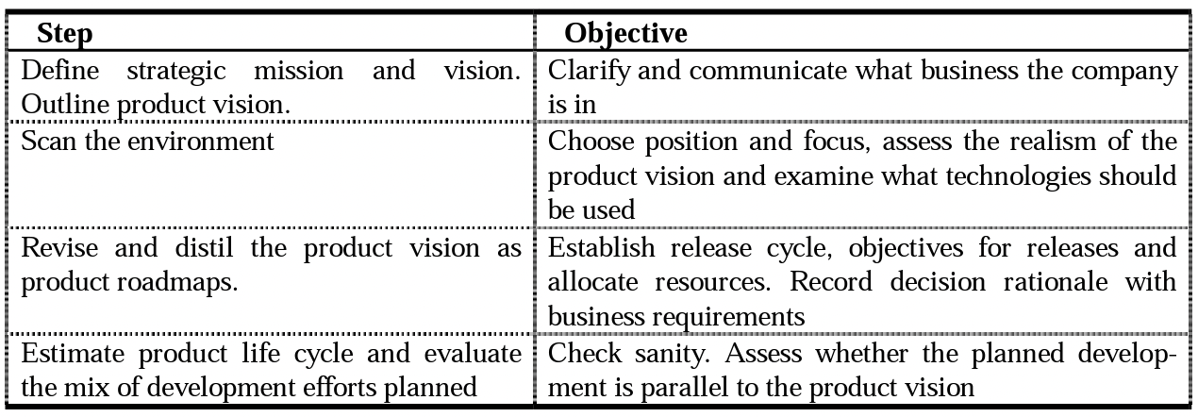

The first step is to define and analyze the strategic mission and vision of the company. Mission and vision should act as the guideline for shaping the product vision and choosing between strategic alternatives. The second step is to identify major trends in the general environment. The third step is to revise the product vision based on the analysis conducted. The final step is to state expectations regarding the life cycle and financial implications of product releases, components and platforms, and consider the mix of planned development activities from the business objectives’ perspective.
Finally, building and maintaining product roadmaps is as much an ongoing process as it is a cultural practice to embark upon with the product team. There are simple ways to set yourself up for success [11]:
- Only include as much details as necessary for your audience.
- Keep the roadmap evenly focused on short-term tactics and how these relate to long-term goals.
- Review roadmaps on a regular basis and make adjustments when plans change.
- Make sure everyone has access to the roadmap.
- Stay connected with stakeholders at all levels to ensure alignment.

Conclusion
In conclusion, building effective roadmap plays a crucial role in software project management aspect. By leveraging strategic objectives, navigating uncertainty, and fostering cross-functional collaboration, roadmap is not only a static plan but also a dynamic tool that propels the team towards the success of the project.

References
- Maria Vasserman, Canny Blog, https://canny.io/blog/complete-guide-roadmaps, 2023/10/27, last accessed 2023/11/07.
- ChatGPT, “Example of User-centric Roadmap”, “Example of Documented Hypotheses”, “Roadmap planning with feature rollout”.
- Roman Pichler, Strategize: Product Strategy and Product Roadmap Practices for the Digital Age, 2nd Edition (2022).
- Jürgen Münch, Stefan Trieflinger, Emre Bogazköy, Patrick Eißler, Bastian Roling, Jan Schneider, Product Roadmap Formats for an Uncertain Future: A Grey Literature Review, Lecture Notes in Informatics (LNI), Gesellschaft für Informatik, Bonn (2021).
- SargenGoldfish3001, Course Sidekick, University of Rochester, MKT 432 course, The Product Roadmap – Why & How, https://www.coursesidekick.com/management/515119, 2023/10/30.
- Richard E. Albright & Thomas A. Kappel (2003) Roadmapping In the Corporation, Research-Technology Management, 46:2, 31-40, Published Online (2016).
- LinkedIn community, How do you balance product road map trade-offs, https://www.linkedin.com/advice/0/how-do-you-balance-product-road-map-trade-offs, (2023)
- Marcelo Marinho, Suzana Sampaio, Alexandre Luna, Telma Lima, Hermano Moura: Dealing with Uncertainties in Software Project Management. In: IEEE International Conference on Computer and Information Technology, Ubiquitous Computing and Communications, Dependable, Autonomic and Secure Computing; Pervasive Intelligence and Computing (2015)
- Vijayalakshmi Sadhineni, Developing a Product Roadmap for the Case Company, Master’s Thesis, Metropolia University of Applied Sciences (2022).
- Jarno Vähäniitty, Casper Lassenius and Kristian Rautiainen, Helsinki University of Technology, An Approach to Product Roadmapping in Small Software Product Businesses, POB 9600, FIN-02015 HUT, Finland.
- Bree Davies, Atlassian, Product Roadmap Guide: What is it & How to create one, https://www.atlassian.com/agile/product-management/product-roadmaps, last accessed 2023/11/27.

