Learning Journals
Quoc Phong Ngo 40230574
Concordia University, Montréal, Quebec, Canada
quocphong.ngo@mail.concordia.ca

INTRODUCTION TO SOFTWARE RISK MANAGEMENT
Risks include problem, issue, defect, etc.
5. UNDERSTANDING THE ORIGINS OF RISKS: “IT’S AN IMPERFECT WORLD”

What is tacit knowledge?
the difference between tacit knowledge and explicit knowledge

16. RISK ANALYSIS
High Likelihood (“occurs when vulnerabilities are exploited by threats more than once a month”)
Medium Likelihood (“occurs when vulnerabilities are exploited by threats more than once a year, but less than once a month”), and
Low Likelihood (“occurs when vulnerabilities are exploited by threats less than once a year”).
21. RISK REDUCTION LEVERAGE
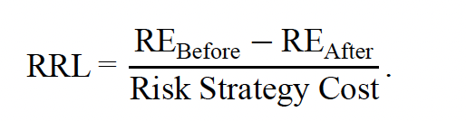
Questions/ Concerns:
15.1. RISK REGISTER
- discover the meaning and example of “Illusion of Control”.
- discover the meaning and example of “Optimism Bias”.
- discover the meaning and example of “Confirmation Bias”.
- discover the meaning and example of “Holism”.

