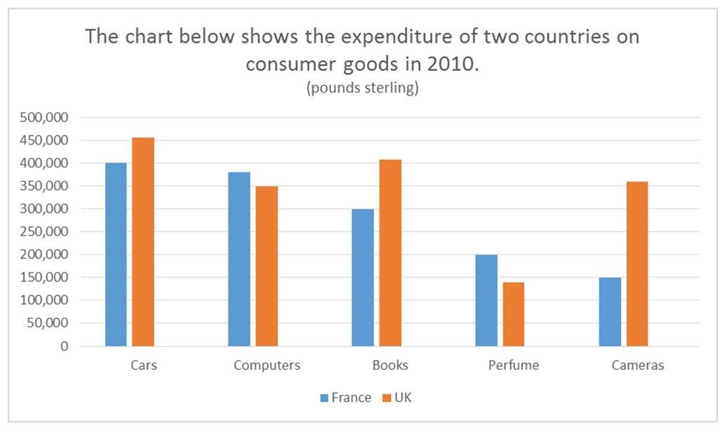

French people spent the most money on cars.

The most money was spent on cars, ….

SO SÁNH: 1 mốc thgian / 0 mốc thgian

**A. Intro**

The given chart / table describe(s) the information concerning (ĐỀ BÀI).

**B. Overview: highest AND lowest**

1. based on category (màu)

2. based on group

*In general*, S + V [cao nhất] [mục cao nhất] while [mục thấp nhất] is/was the category that they …..

**C. Body 1: 1 mục**

Looking at the data for [1 mục], it can be seen that [cao nhất], at + [số liệu], respectively. By contrast, [ thấp nhất ], at + số liệu. The statistic(s) for the other categories / category, namely …, is/are/was/were + [số liệu].

**D. Body 2: 1 mục còn lại**

As can be observed from the data for [mục còn lại], [cao nhất], at + [số liệu]. On the other hand, [thấp nhất], at + số liệu. The figure(s) for the remaining categories, [tên], is/are/was/were + [số liệu].

The bar chart shows type of media to get daily news, by age group 2011

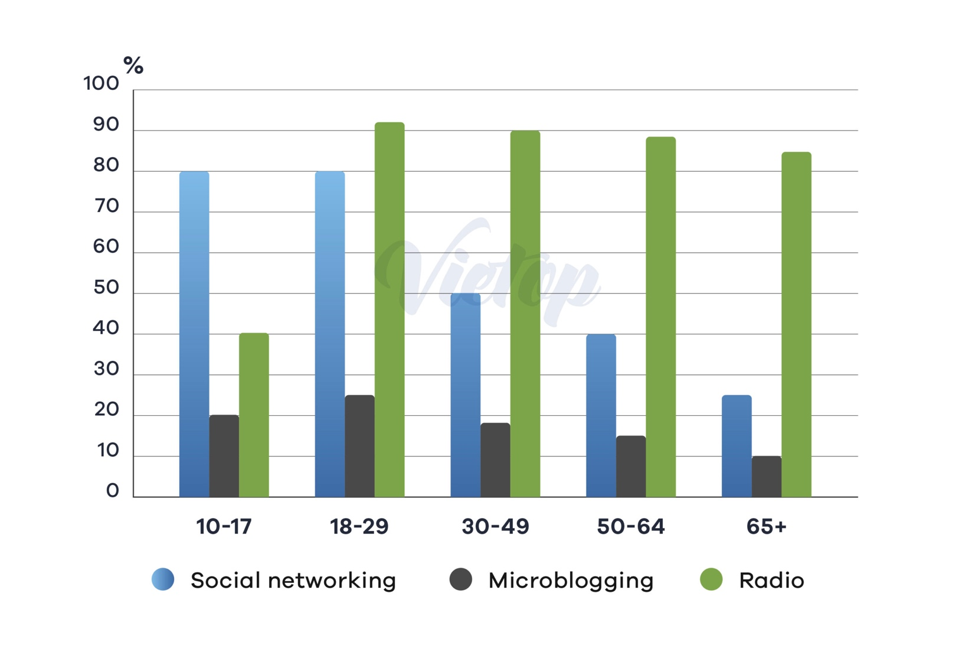

**C. Body 1: 1 mục**

Looking at the data for [1 mục], it can be seen that [cao nhất], at + [số liệu], respectively. By contrast, [ thấp nhất ], at + số liệu. The statistic(s) for the other categories / category, namely …, is/are/was/were + [số liệu].

**D. Body 2: 1 mục**

As can be observed from the data for [1 mục], [cao nhất], at + [số liệu]. On the other hand, [thấp nhất], at + số liệu. The figure(s) for the remaining categories, [tên], is/are/was/were + [số liệu].

**E. Body 3: 1 mục còn lại**

Regarding the information for [1 mục còn lại], [nxet]. In detail, …

range from x to y

Regarding the information for microblogging, its figures did not differ much among these age groups. In detail, …ranged from [số thấp nhất] for [ nhóm~] to [số lớn nhất] for [nhóm ~].

