PROJECT README & TECHNICAL SPECIFICATION
Project Name: FreshFind – Fresh All Along
Theme: eGreen Basket | Category: Web Innovation Unleashed
System Architecture: Frontend Single Page Application (SPA) built using React 19 + Vite, running purely on client-side logic with pre-populated JSON datasets and browser storage, adhering strictly to the zero-backend constraint of the TechWiz competition.

1. PROBLEM DEFINITION & BACKGROUND

1.1. Background & Necessity
Farmers markets play a vital role in bridging local communities with regional growers who harvest fresh, healthy, seasonal produce for local households. However, in reality, information regarding market schedules, geographic locations, operating hours, and produce availability remains fragmented across paper flyers, community physical bulletin boards, social media groups, and word of mouth. There has been no single, consolidated, and reliable digital platform for neighborhood residents to access this information seamlessly.

1.2. Key User Pain Points
- Unpredictable Operating Hours: Unlike conventional supermarkets, farmers markets operate on sporadic schedules (e.g., only Saturday mornings, alternate Sundays, or specific weekday afternoons). Residents struggle to plan their visits without knowing whether a market is currently open.
- Produce Availability Uncertainty: Shoppers rarely know in advance which fresh fruits, herbs, or vegetables are currently in season or supplied at particular market stalls.
- Navigation & Proximity Hurdles: Consumers often find it inconvenient to calculate travel distances, view map directions, or discover newer markets located nearest to their current whereabouts.

1.3. Proposed Solution (FreshFind)
FreshFind addresses these challenges by delivering an accessible, browser-based Single Page Application (SPA) designed to consolidate farmers market information into one unified hub:
- Aggregating real-time market details: exact street addresses, weekly operating timetables, interactive maps, and cataloged produce inventories.
- Providing an interactive Seasonal Produce Guide that educates consumers on peak harvesting periods and links them directly to nearby markets stocking those items.
- Leveraging Browser Geolocation to compute real-time distances (via the Haversine formula) and surface nearest markets instantly.
- Equipping users with a client-side Bookmarking and Session Notes System to plan shopping itineraries effortlessly without requiring complex server-side accounts.

2. DESIGN SPECIFICATIONS

2.1. UI/UX Design Philosophy
The FreshFind user interface embodies an organic, minimalist, and approachable design language. The visual identity reflects fresh agriculture through lush greens, warm harvesting ambers, and clean white backdrops that enhance readability and create an airy, positive user atmosphere. The interface is fully responsive, catering seamlessly to desktop monitors, tablets, and mobile smartphones.
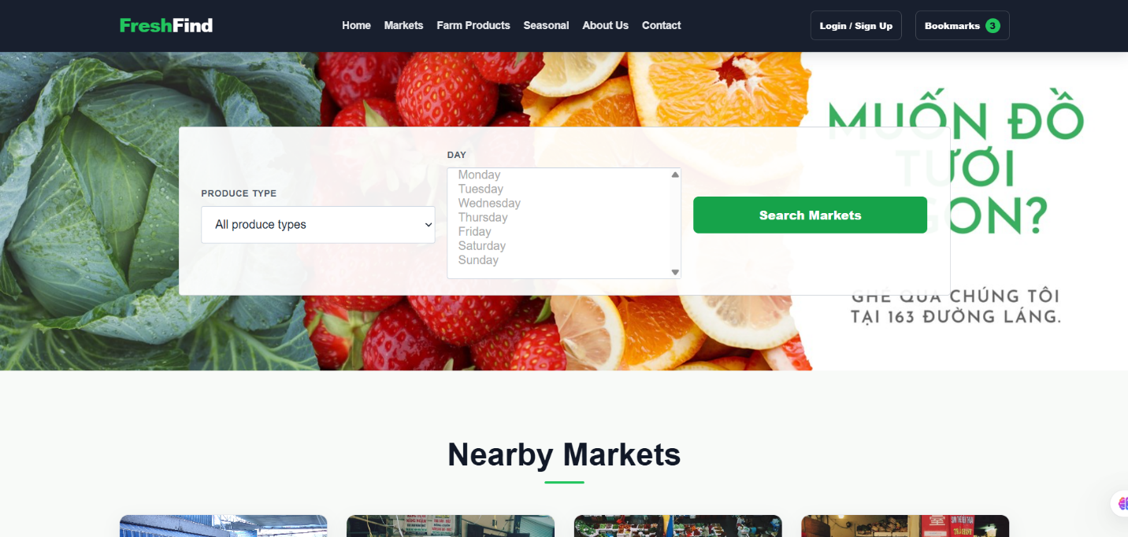

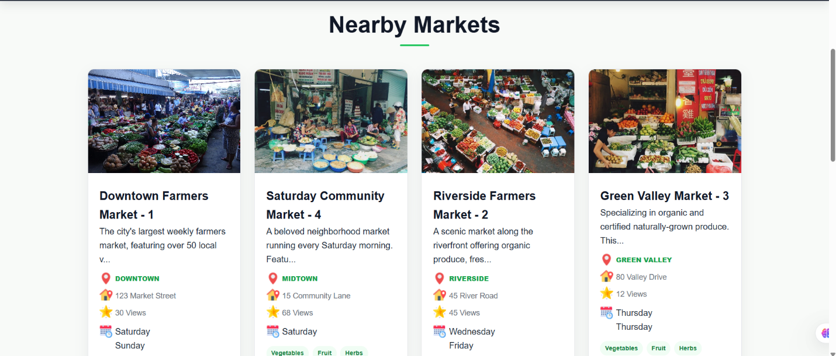
(Homepage FreshFind)

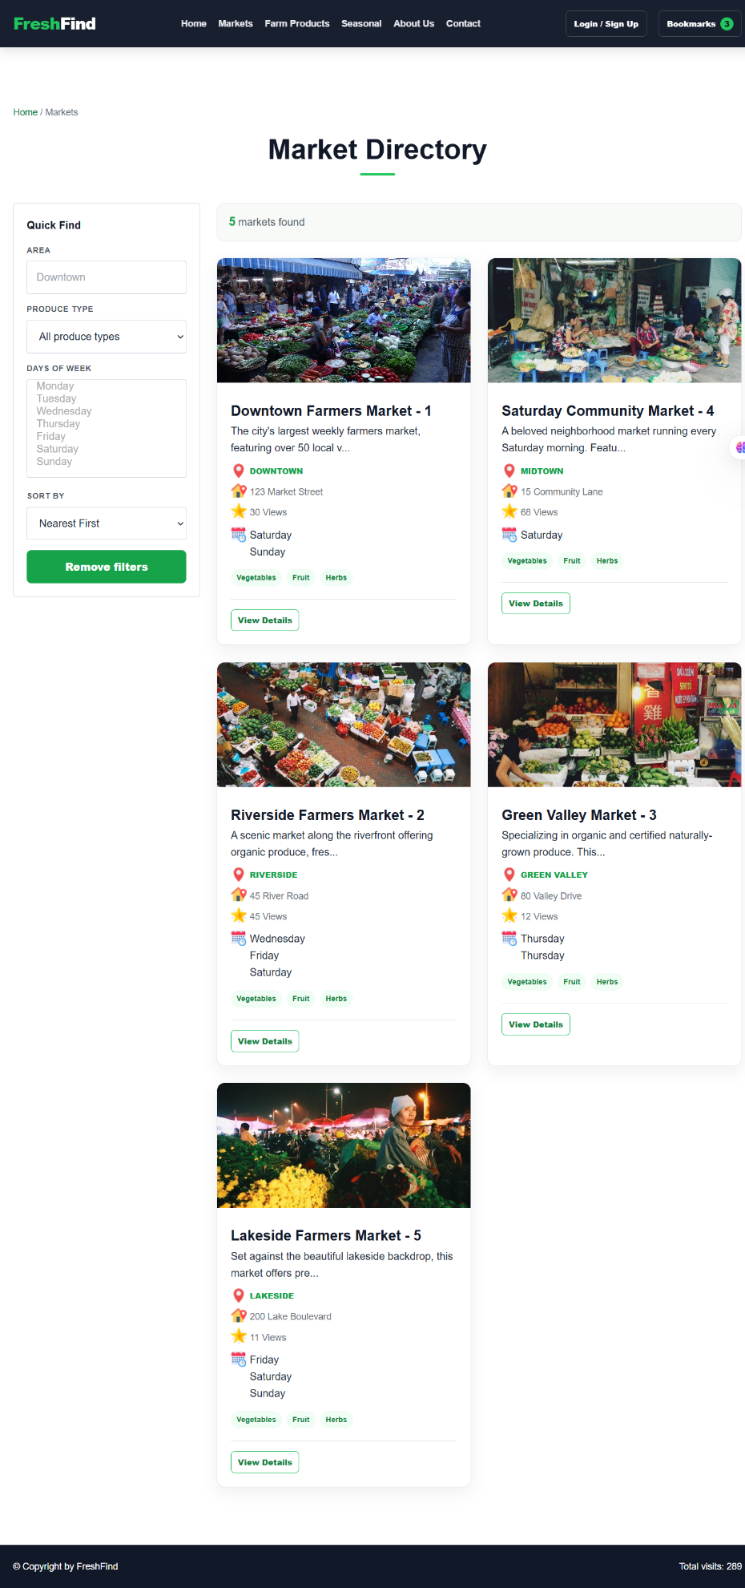
(Markets list page)

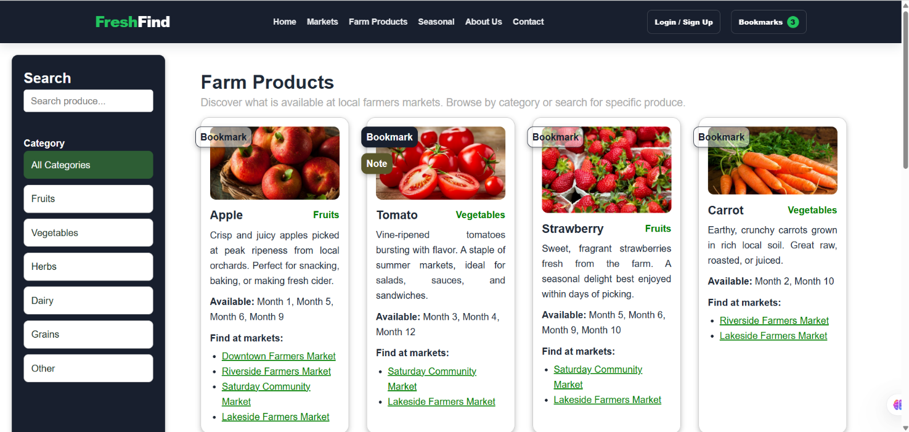
(Farm products page)

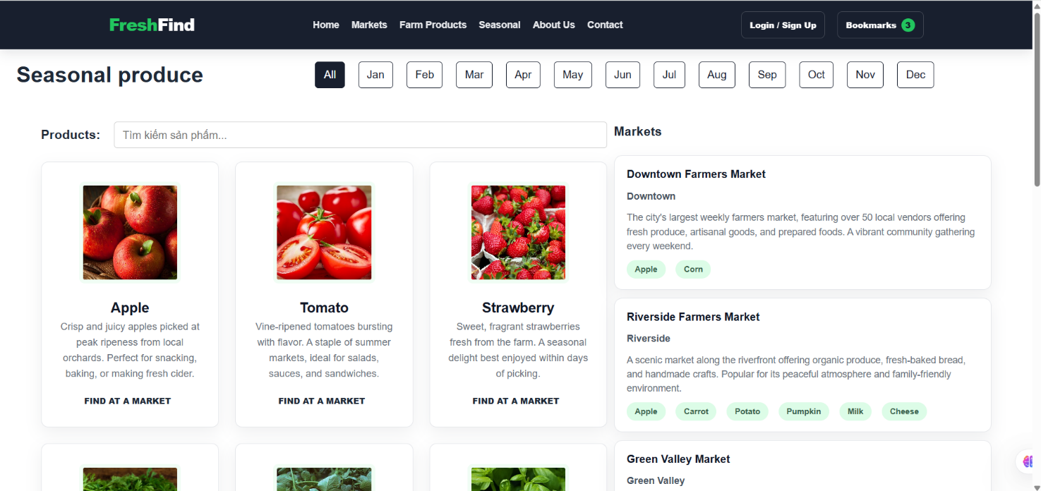
(Seasonal produce page)

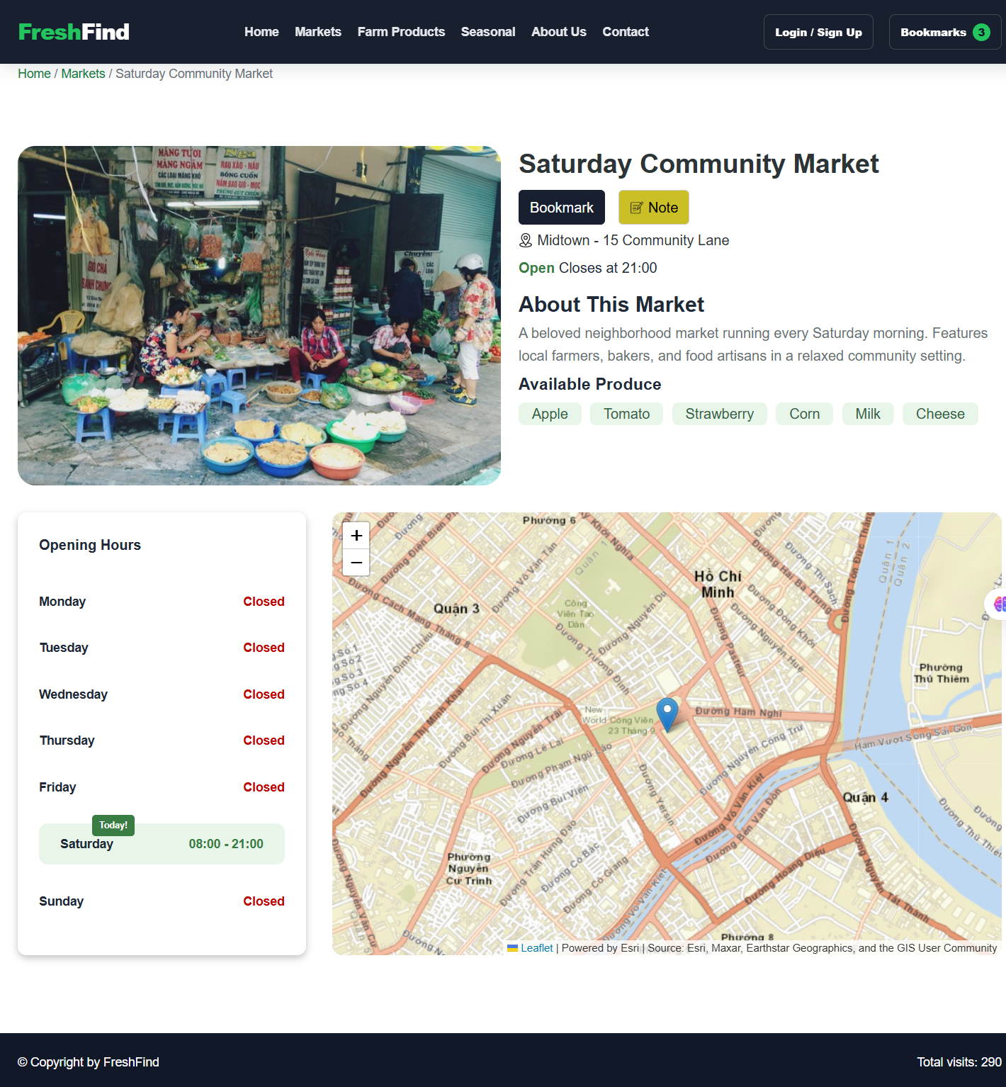
(Market details page)

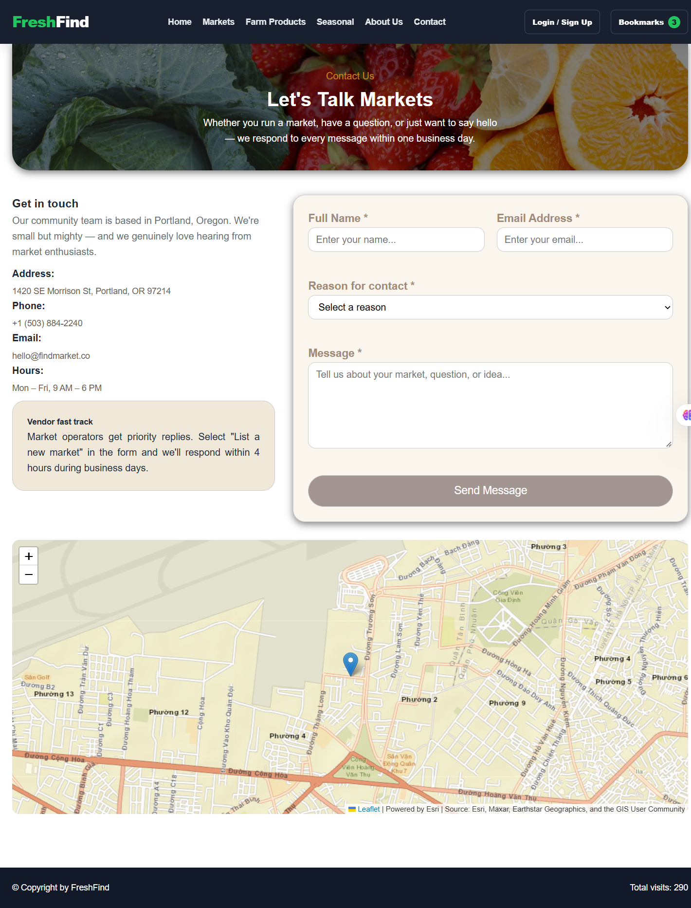
(Contact page)

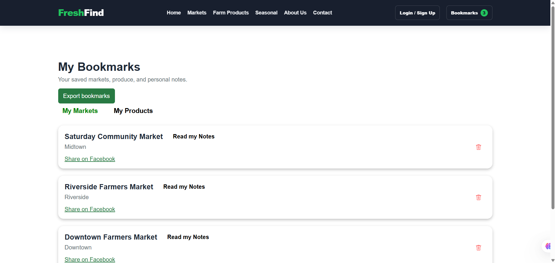
(Bookmark page)

2.2. Color Palette & Typography
Design Token | Color Code / Font Family | Design Rationale & Application
Primary Color | #2e7d32 (Forest Green) / #4caf50 | Represents fresh produce, organic harvest, used for Header, primary Call-To-Action buttons, and section titles.
Secondary Accent | #fbc02d / #ffa000 (Harvest Amber) | Warm sunshine and ripe crops, utilized for "Open Right Now" live badges, seasonal highlights, and bookmark stars.
Background Canvas | #ffffff / #f8fbf8 (Clean Soft Off-White) | Ensures maximum readability, clarity, and visual contrast for food photography.
Typography Neutral | #2c3e50 / #455a64 (Dark Slate) | High-contrast text color providing strict compliance with WCAG Accessibility guidelines.
Typeface Family | 'Segoe UI', system-ui, -apple-system, sans-serif | Clean, modern sans-serif typography ensuring legibility across Windows, macOS, Android, and iOS devices.

2.3. Design Mockup & Wireframe Placeholders

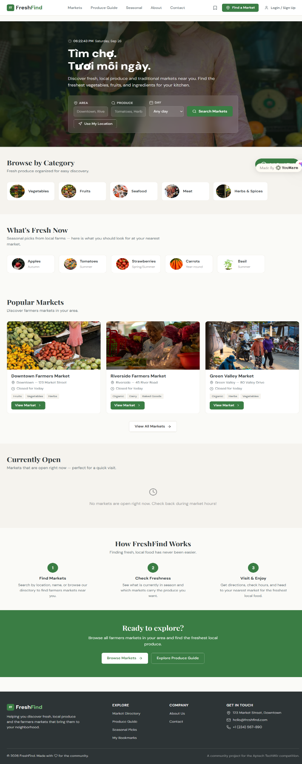
My team is designing based on the template at the following URL: https://freshfind-market.youware.app/markets/downtown-farmers-market

3. DETAILED SPECIFICATION OF EXISTING WEB FEATURES

3.1. Global Navigation & Utilities
- Header Navigation (NavBar): Hosts the brand identity "FreshFind", primary navigation links (Home, Markets, Farm Products, Seasonal, About Us, Contact), a live bookmark badge displaying the current number of saved items, and a dummy Login / Sign Up action button.
- Browser Geolocation & Distance Calculation (Haversine Formula): Integrated within AppContext via navigator.geolocation.getCurrentPosition() to acquire live user latitude and longitude. The core service (calculateDistance() in marketService.js) applies the mathematical Haversine Formula (Earth radius R = 6371 km) to compute precise spherical great-circle distances between the user and every market venue. This real-time distance is displayed as an informative badge (e.g., "2.4 km away") on each market card and powers the automated "Nearest First" sorting algorithm on both the Home page (Nearby Markets) and the Directory page. If GPS access is declined or unavailable, the system gracefully falls back to default sorting without interruption.
- Simulated Visitor Counter: Located in the footer, this counter uses JavaScript coupled with localStorage to dynamically track and display cumulative page visit counts across user sessions.
- Real-Time Schedule Status Checker: An automated algorithm that compares client system time (day of week and current HH:mm) against each market's timetable to immediately indicate whether it is "Open Right Now" or "Closed".
- Breadcrumb Navigation: Renders clear hierarchical location paths (e.g., Home / Markets / Downtown Farmers Market) for seamless user orientation.

3.2. SEO-Friendly Slug & Dynamic Entity Lookup (`/:id/:slug`)
- Human-Readable, SEO-Friendly URL Structure: Markets and detailed product resources utilize an intuitive slug routing pattern: /markets/:marketId/:marketSlug (for example: /markets/1/downtown-farmers-market).
- Flexible Entity Lookup (`getMarketByIdOrSlug`): The service layer can resolve market entities either by numeric identifier (id) or by textual slug string (slug). This enables easy social link sharing, bookmark preservation, and enhanced search engine optimization.
- Dual-Entity Lookups: Enables quick cross-referencing between products and markets; clicking a produce item or market link seamlessly resolves the corresponding target entity.

3.3. Home Page (`/`)
- Hero Section Quick Find (HomeMarketSearchBox): A prominent search widget allowing visitors to select a Produce Category (dynamically populated from categories.json) and multiple Days of the Week. Submitting the form navigates directly to the Market Directory with serialized URL search parameters.
- Nearby Markets Showcase: Automatically computes and renders markets sorted in ascending order of physical distance based on user GPS coordinates.
- Featured Currently Open Markets: A filtered view that exclusively surfaces markets operating right at the time of browsing (onlyOpenNow: 1), sorted by promotional prominence.

3.4. Market Directory (`/markets`)
- Sidebar Multi-Criteria Filter:
  - Area Search: Text input for neighborhood or district names (e.g., "Downtown", "Westside").
  - Produce Category: Dropdown selecting specific food types (Fruits, Vegetables, Herbs, Dairy, etc.).
  - Days of Week: Multi-select control to filter markets active on chosen weekdays.
  - "Remove Filters" Button: Clears all active filters and restores the full directory catalog.
- Sorting Options: Supports 4 distinct ordering algorithms:
  - Nearest First: Evaluates GPS distance and lists nearest venues first.
  - Name A-Z: Alphabetical ascending sort.
  - Name Z-A: Alphabetical descending sort.
  - Open next day: Prioritizes markets holding sessions on the nearest forthcoming day.
- Market Card Grid: Displays thumbnail images, market name, calculated distance badge, neighborhood area, working hours summary, and direct link to full market details.

3.5. Market Details Page (`/markets/:marketId/:marketSlug`)
- Real-Time Schedule Evaluation & Next Open Day: Accurately determines whether the market is open during the current visit. If closed, the algorithm triggers getNextOpenDay() to calculate the next upcoming operating date (e.g., "Closed today • Next open: Saturday at 08:00 AM").
- Weekly Schedule Table: A full 7-day breakdown displaying daily start and closing hours or "Closed" badges.
- Interactive Leaflet Map: Embedded OpenStreetMap powered by Leaflet, displaying an exact coordinate pin (Marker) and an informational Popup containing the market title and street address.
- Available Farm Produce Grid: Displays farm-fresh goods available at this specific market, cross-referenced from products.json via productIds.
- Bookmark & Personal Notes System: Includes an instant bookmark toggle and a "Read my Notes" button that launches an interactive Modal to view, draft, and delete customized shopping notes.

3.6. Produce Guide (`/produce-guide`)
- Instant Keyword Search: Real-time filtering matching against produce titles and descriptions.
- Category Filter Tabs: Quick switches for All Categories, Vegetables, Fruits, Herbs, Dairy & Eggs, Bakery, Honey & Preserves, etc.
- Produce Information Cards: Presents vivid food photography, descriptive nutritional/culinary notes, ideal harvesting seasons, and direct links to all local markets stocking this item.
- Item Bookmarks & Notes: Allows saving individual produce items to personal favorites alongside private notes.

3.7. Seasonal Produce (`/products-seasons`)
- 12-Month Switcher: Horizontal selector enabling users to inspect produce harvested in any month (January to December) or view the full annual cycle.
- Seasonal Produce Ingestion: Displays items matching the selected month via the availableMonths dataset attribute.
- Related Markets Discovery: Automatically queries and presents all local markets that currently stock the seasonal items on display.

3.8. Bookmarking & Notes Management (`/bookmarks`)
- Tabbed Layout: Segregated tabs for "My Markets" and "My Products".
- Quick Delete Action: Dedicated remove button on each saved item.
- Empty State Handling: Informative placeholder screen directing visitors back to the directory when no bookmarks have been saved yet.
- Personal Notes Modal: Interactive popup allowing users to add dated notes, review thoughts, and remove individual entries seamlessly.
- Export Bookmarks via Formatted `.txt` File Download: A dedicated "Export bookmarks" button on the /bookmarks page triggers an instant, purely client-side data export. The handler (exportBookmarks() in BookMarks.jsx) compiles all saved markets (numbered with names, areas, and canonical slug URLs: ${origin}/markets/:id/:slug) and all bookmarked produce items (numbered with direct search query URLs) into a structured plain text document. It constructs an in-memory Blob([content], { type: 'text/plain;charset=utf-8' }) and triggers an automatic browser file download named freshfind-bookmarks.txt via URL.createObjectURL(), requiring zero backend server interaction.

3.9. Contact Us & About Us (`/contact`, `/about`)
- About Us: Narrative describing FreshFind's community mission and support for sustainable agriculture.
- Contact Us with Full Form Validation: Includes contact coordinates, hours, Leaflet headquarter map, and an interactive contact form validated with real-time feedback:
  - Full Name: Mandatory, minimum 2 characters.
  - Email Address: Mandatory, validated against strict regex /^[^\s@]+@[^\s@]+\.[^\s@]{2,}$/.
  - Inquiry Reason: Mandatory dropdown selection.
  - Message Body: Mandatory, minimum 10 characters.
  - Field Lifecycle Handling: Active tracking of touched, errors, and isSubmitted states with immediate error hints and successful submission banners.

3.10. Dummy Authentication Prototype (`/login`, `/signup`)
- Clean login and sign-up user interfaces providing aesthetic and functional prototype completeness (UI Continuity) as requested by SRS Section 1.8.

4. APPLICATION WORKFLOW & ARCHITECTURE

4.1. System & Architectural Data Flow
FreshFind adopts React’s Unidirectional Data Flow combined with React Context Providers and Browser LocalStorage:
- Application Bootstrapping: At startup, App.jsx wraps all routes within four foundational Context Providers: AppProvider (Geolocation GPS), ProductsSeasonProvider (Season & month filter state), BookmarkProvider (Favorite markets and produce), and NoteProvider (Personal notes).
- Data Ingestion: Static datasets (markets.json, products.json, categories.json, seasons.js) are imported directly into memory.
- Client-Side Business Logic: Geospatial distance calculation (Haversine formula), real-time schedule checks, keyword matching, and multi-criteria sorting execute on the client with zero latency.
- State Persistence: User bookmarks and personal notes synchronize bidirectionally with localStorage, preserving user data across page refreshes and route transitions.

4.2. User Journey Workflows
- Market Discovery Journey: Visitor enters Home ➔ Initiates Quick Find or browses Market Directory ➔ Adjusts area, day, or produce filters ➔ Selects Nearest First sort ➔ Clicks market card to open SEO-friendly URL (/markets/:id/:slug) ➔ Inspects timetable and Leaflet map ➔ Toggles Bookmark or adds personal notes.
- Seasonal Produce Journey: Visitor enters Seasonal Produce ➔ Selects current calendar month ➔ Discovers in-season crops ➔ Views list of stocking markets ➔ Clicks market link to schedule a visit.
- Shopping Planning Journey: Visitor navigates to Bookmarks ➔ Reviews saved venues and goods ➔ Launches Notes Modal to review shopping lists ➔ Exports or shares itinerary.

5. COMPREHENSIVE SYSTEM FLOWCHARTS
The following 5 structured flowcharts illustrate the core business logic and algorithms powering the FreshFind web portal:

5.1. Flowchart 1: Site Navigation & Dynamic Route Flowchart (`/:id/:slug`)
START: User opens FreshFind in web browser
↓
Browser initializes React Router DOM & Mounts Context Providers (App, Bookmark, Note, Seasonal)
↓
Which route / page did the user request?
• Path / (Home):  Fetches GPS position, renders Hero Quick Find, Nearby Markets, and Featured Open Markets. | • Path /markets (Directory):  Renders full market catalog, multi-criteria sidebar filter, and sorting dropdown.
• Path /markets/:id/:slug (Details):  Executes getMarketByIdOrSlug() to resolve entity by ID/Slug; renders Leaflet map, timetable, and produce. | • Path /produce-guide & /products-seasons:  Loads produce catalog, 12-month switcher, and cross-references selling markets.
↓
END: Target View renders smoothly with client-side SPA routing (Zero page reload)

5.2. Flowchart 2: Market Search, Multi-Criteria Filter & Haversine Distance Sort
START: User accesses Market Directory (`/markets`)
↓
System queries Browser Geolocation API: Obtains user latitude & longitude
↓
User configures filters: Types Area keyword, Selects Produce Category, Selects Weekdays
↓
getMarketsByFilters() iterates through markets.json to evaluate matching criteria
↓
Do any markets satisfy all active filter criteria?
[ YES: MATCH FOUND ] ↓  Execute sortMarketsByType():  - Nearest First: Applies Haversine formula against GPS position.  - Name A-Z / Z-A: Performs string collation.  - Open next day: Sorts by closest upcoming market session.  ➔ Render Market Cards grid with total count badge. | [ NO: NO MATCHES ] ↓  Handle Empty Search State:  - Displays "No markets found matching your criteria".  - Renders "Remove Filters" button to reset parameters to default catalog.
↓
END: Filtered and sorted market cards are displayed interactively

5.3. Flowchart 3: Real-Time Schedule & Next Open Day Calculation Algorithm
START: User navigates to Market Details (`/markets/:marketId/:marketSlug`)
↓
Retrieve current system time: Active day of week (key) and current time in HH:mm format
↓
Is the market scheduled to open today? (`todaySchedule.open === true`)
[ YES: SCHEDULED TODAY ] ↓  Evaluate Time Window:  Check if (Current Time >= Start Hour) AND (Current Time < End Hour).  • If True: Display prominent green badge "Open Right Now".  • If False: Mark as "Closed for today" (before or after hours). | [ NO: CLOSED TODAY ] ↓  Execute getNextOpenDay():  Loop through upcoming 7 calendar days to find the next day marked with open: true.  ➔ Display: "Closed today • Next open: [Day] at [Start Hour]".
↓
Render 7-day Weekly Schedule Table and Interactive Leaflet Map with Coordinates Marker
↓
END: User receives accurate opening times and geographic directions

5.4. Flowchart 4: Seasonal Produce Month Selector & Related Markets Lookup
START: User opens Seasonal Produce page (`/products-seasons`)
↓
User selects a month button (Jan - Dec) OR enters a search term
↓
Produce filtering algorithm: Evaluates if product.availableMonths.includes(activeMonth)
↓
Render filtered Produce Cards with photos, titles, and harvest durations
↓
Trigger Related Markets Cross-Lookup Algorithm:
Extract set of visible product IDs (validProductIds), then filter markets.json for venues whose productIds contain at least one matching item
↓
END: Displays markets stocking in-season items; user can click any card to visit that market

5.5. Flowchart 5: Bookmarking & Personal Notes Management Modal
START: User views a Market or Produce card across the site
↓
Which interaction does the user trigger?
[ CLICK BOOKMARK BUTTON ] ↓  - If already saved: Remove ID from favorites array.  - If not saved: Add ID to favorites array.  - Updates live badge count in Navbar.  - Automatically synchronizes with localStorage. | [ CLICK "READ MY NOTES" ] ↓  - Opens the interactive Notes Modal for this specific item.  - Fetches existing notes from NoteContext.  - User inputs new note and submits form.  - User clicks "x" icon to delete individual notes.  - Notes persist in client storage.
↓
User can navigate to /bookmarks anytime to review all saved markets and produce
↓
Export Option: User clicks "Export bookmarks" ➔ Client builds Blob & downloads freshfind-bookmarks.txt with direct URLs
↓
END: User shopping itinerary and personal annotations remain permanently saved

6. ASSUMPTIONS MADE IN THE PROJECT
In accordance with the competition guidelines and the SRS document (Sections 1.5 Constraints and 1.8 Interface Requirements), the project is engineered upon the following foundational assumptions:
- Pure Client-Side Architecture (Zero-Backend): Per SRS constraint 1.5, the application operates entirely without a server-side database backend. All market profiles, schedules, product catalogs, and category lists are served from local static JSON/JS files (markets.json, products.json, categories.json, seasons.js). The application treats these files as read-only.
- Client-Side Storage for Bookmarks and Notes: User preferences, favorites, and notes are managed in client memory and persisted through browser storage (localStorage and sessionStorage), ensuring a seamless experience across page reloads without requiring server user accounts.
- Device Real-Time Clock Reliability: Operating status indicators ("Open Right Now" vs. "Closed") rely on the user device's local system time to match the market's operating hours.
- Simulated Visitor Metrics: In the absence of a global analytics server, the visitor counter in the footer is simulated via client-side JavaScript and updated per session in localStorage as suggested by SRS Section 1.8.
- OpenStreetMap & Leaflet Integration: Interactive location mapping utilizes Leaflet.js with OpenStreetMap tiles, ensuring accurate spatial visualization and routing coordinates without external commercial API key restrictions.
- Dummy Authentication Prototype: Login and registration pages are functional prototypes designed to complete the user journey (UI Continuity) as requested by SRS Section 1.8.

7. SYSTEM REQUIREMENTS & INSTALLATION INSTRUCTIONS (MANDATORY)
Follow the step-by-step instructions below to set up and run the FreshFind application on a local development environment:

7.1. Prerequisites:
- Node.js Runtime: Version 18.x, 20.x, or newer (bundled with npm package manager).
- Web Browser: Google Chrome, Microsoft Edge, Mozilla Firefox, or Apple Safari (latest stable release).
- Display Resolution: Fully responsive; optimized for mobile (375px+), tablet (768px+), and desktop (1024px+).

7.2. Step-by-Step Installation:
- Step 1: Extract Project Source Code: Extract the submitted SourceCode.zip archive into your desired local directory (e.g., https://github.com/phongtoquach/freshFind_web.git).
- Step 2: Open Terminal / Command Prompt: Open your Terminal, Command Prompt, or PowerShell, and navigate to the project root directory:
cd path/to/freshfind-web
- Step 3: Install Project Dependencies: Execute the following command to download and install all necessary packages specified in package.json:
npm install
- Step 4: Start the Local Development Server: Launch the Vite development server by running:
npm run dev
- Step 5: Access the Application: Open your web browser and navigate to the local URL displayed in the terminal output:
http://localhost:5173/
- Step 6 (Optional): Build Production Bundle: To compile and preview an optimized production build, run:

- npm run build
- npm run preview

8. AI CHATBOT INTEGRATION

[RESERVED SECTION: AI CHATBOT INTEGRATION - TO BE UPDATED UPON REQUEST]
This section is reserved as requested. Once you provide the specific scripted Q&A dataset, rule-based response logic, or third-party widget integration details (Tidio / Tawk.to / Custom Chat Component), the technical specifications will be populated here.
FreshFind Project – TechWiz Competition | Technical Specification & ReadMe Documentation

