# NetXMS Integration with HP Operations Manager

## Event forwarding from NetXMS to HP OM

To forward events (messages in HP OM terms) from NetXMS to HP Operations Manager, the following steps are necessary:

1. Install HP Operations Manager agent on machine with NetXMS server
2. Create Operations Manager policy of type “Open Message Interface” with single rule to accept any message and create message in active message browser (see screenshot)

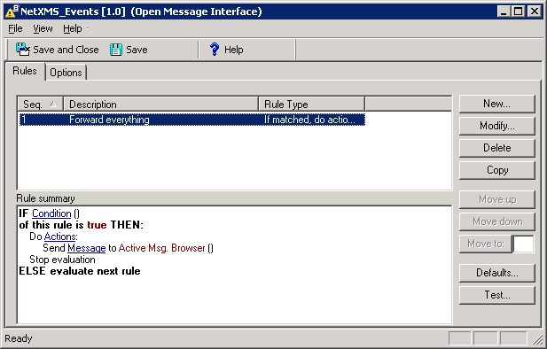

1. Deploy this policy to agent on NetXMS server
2. In NetXMS, create server action of type “execute command on management server”, and as command enter

**opcmsg severity=%S application=NetXMS object=%n msg_text=”%m”**

If nodes in NetXMS also registered in Operations Manager under same names and you wish to associate Operations message with this node, you can add **node=%n** to the command above.

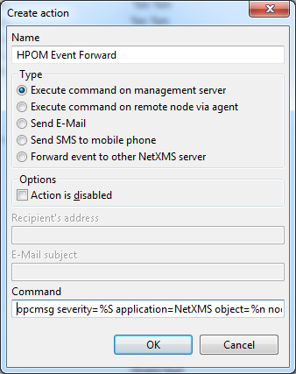

1. In NetXMS add rule to event processing policy to forward desired events to Operations Manager. On screenshot below is an example rule:

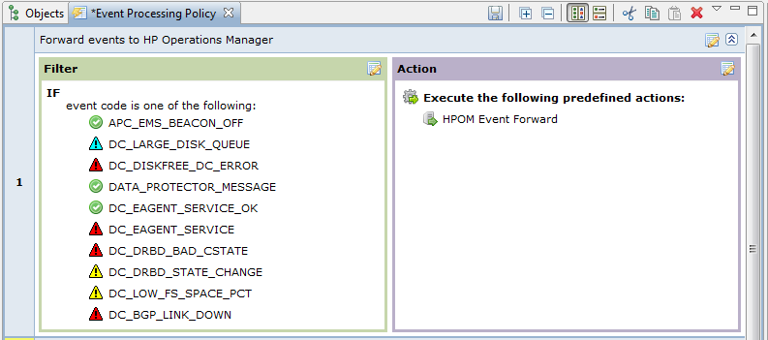

After completing these steps, you will have events flowing from NetXMS into HP Operations Manager.

## Collecting data from NetXMS agent to HP Operations Manager

It is possible to use parameters provided by NetXMS agents in HP Operations Manager’s measurement threshold policies. To be able to provide data for HP OM agent, nxget command line tool must be installed on the machine used for collecting data. It is installed automatically when NetXMS server is installed. Example policy for collecting data from NetXMS agent:

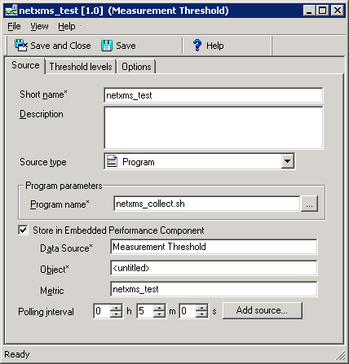

And netxms_collect.sh script can looks like following:

#!/bin/sh

value=`nxget 127.0.0.1 System.IO.DiskQueue`

opcmon netxms_test=$value