**ZipSun Flow Description RC2**

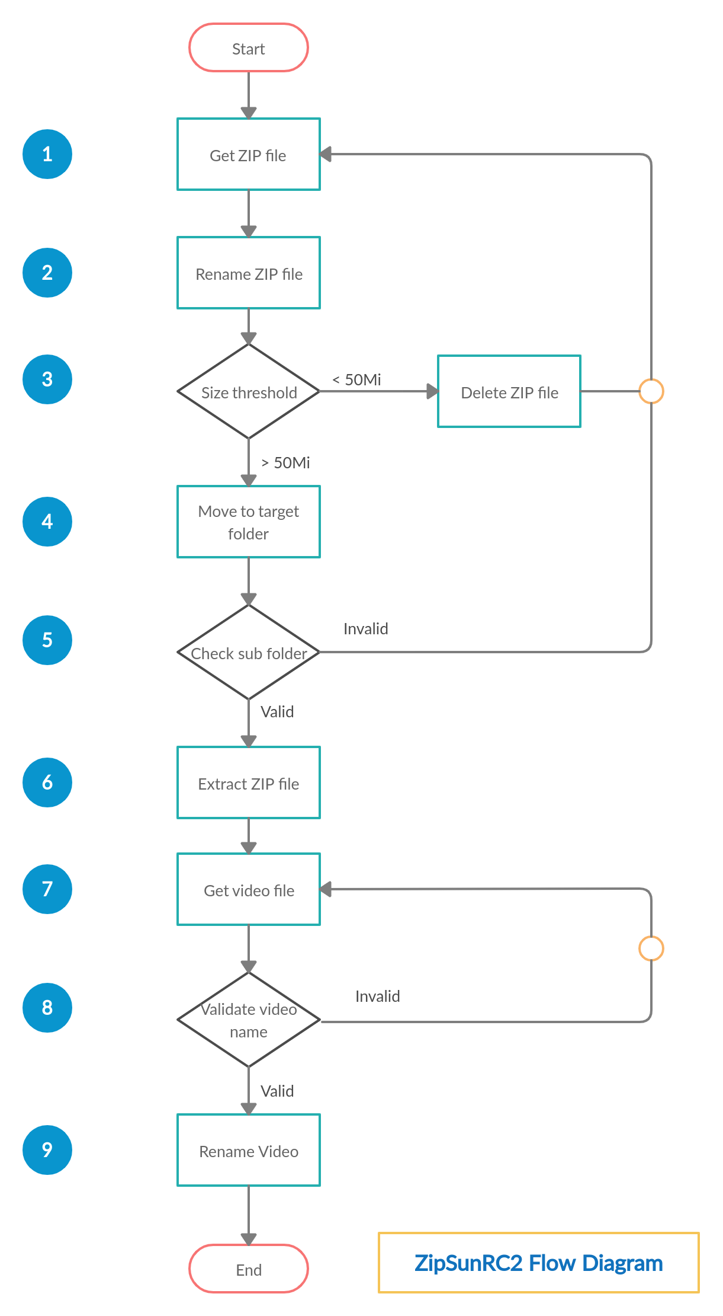

***Steps description:***

1. **Get all Zip file from input folder (.zip / .ZIP / .Zip extention)**
2. **Rename zip file by rules**
3. **Check Zip file size**
   * If zip file size < 50 Mb -> Delete zip file
   * If zip file size > 50 Mb -> Go to step 4
4. **Move zip file to target folder base on file name and threshold size**
   * ES zip files size over threshold size -> move to ES_OVER_DIR
   * AR zip files size over threshold size -> move to AR_OVER_DIR
   * EN zip files size over threshold size -> move to EN_OVER_DIR
   * ES zip files size smaller than threshold size -> move to ES_UNDER_DIR
   * AR zip files size smaller than threshold size -> move to AR_UNDER_DIR
   * EN zip files size smaller than threshold size -> move to EN_UNDER_DIR
   * Zip file name doesn't match any of rule -> move to OTHER_DIR
5. **Quick check zip file content (without unzip) to find important folder**

(Important folder must contain: "CUT"/"EXPORT" in folder name)

* + If zip file doesn't have any important folder -> Ignore this zip file
  + If zip file has at least one important folder -> Go to setp 6

1. **Extract Zip file**
2. **Get all video file**
   * Loop all important folder (from extracted zip directory) and get all file
3. **Validate video**

Rules:

* + Video file name must have suffix : "SUB" "SUBS" "FINAL" "CLEAN" "TW" "TWITTER" "FB" "FACEBOOK" "YT" "YOUTUBE" "IG" "INSTAGRAM"
  + Video must have extention : mp4 / mxf / mov
  + If video is invalid -> Ignore this video
  + If video is valid -> Goto step 9

1. **Rename video file name by rules**