COMP1682 Final Report

**Project Name**

**Student Name**

**Supervisor: **name\*\***

**Final Year Report**

**COMP1682 Final Year Project**

**Program Title: BSc Hons Computing**

**Word count: 10.000 (Minimum)**

**Abstract**

**Words: 200 - 350**

An abstract is a brief summary of your project: for Endeavor abstracts, from **200 to 350 words**. It is used typically for academic presentations to give the reader a synopsis of the research project, and it can also be used to summarize a creativity project.

Sample’s abstract:

Project Name: **Using GIS Site Suitability Analysis to Study Adaptability and Evolution of Life: Locating Springs in Mantle Units of Ophiolites**

GIS is a powerful tool that can be used to locate springs sourced in ophiolites. The unique features associated with these springs include a reducing subsurface environment reacting at low temperatures producing high pH, Ca-rich formation fluids with high dissolved hydrogen and methane. Because of their unique chemical characteristics, these areas are often associated with microbes and are thought to be similar to the features that enabled life to evolve on Earth. Locating and sampling these springs could offer a deeper look into Earth's deep biosphere and the history of life on Earth. Springs have traditionally been located using expensive and time-consuming field techniques. Field work can be dangerous. The goal of this study was to develop a model that could locate these unique geological features without first going into the field, thus saving time, money and reducing the risks associated with remote field localities. A GIS site suitability analysis works by overlaying existing geo-referenced data into a computer program and adding the different data sets after assigning a numerical value to the important fields. For this project, I used surface and ground water maps, geologic maps, a soil map, and a fault map for four counties in Northern California. The model has demonstrated that it is possible to use this time of model and apply it to a complex geologic area to produce a usable field map for future field work.

**Acknowledgements**

Words: 200 - 500

I would like to express my deepest appreciation to all those who provided me the possibility to complete this report. A special gratitude I give to our final year project manager, [Ms/Mr/Dr Surname], whose contribution in stimulating suggestions and encouragement, helped me to coordinate my project especially in writing this report.

Furthermore, I would also like to acknowledge with much appreciation the crucial role of the staff of [Ms/Mr/Dr Surname], who gave the permission to use all required equipment and the necessary materials to complete the task “SPECIFY NAME”. A special thanks goes to my team mate, [Ms/Mr/Dr Surname], who help me to assemble the parts and gave suggestion about the task “SPECIFY NAME”. Last but not least, many thanks go to the head of the project, [Ms/Mr/Dr Surname] whose have invested his full effort in guiding the team in achieving the goal. I have to appreciate the guidance given by other supervisor as well as the panels especially in our project presentation that has improved our presentation skills thanks to their comment and advices.

*Note: cái này là tham khảo, không sử dụng lại vì sẽ dính đạo văn*

Table of contents

1. Introduction 6

1.1 Background 6

1.2 Aim 6

2. Objectives 7

3. Approach 8

3.1 Justification of the suitability of a Methodology or a Framework followed. 8

4. Literature Review 9

4.1 Overview 9

4.2 Technology A 9

4.3 Technology B 9

4.4 Technology C 9

4.5 Market analysis 9

4.5.1 Survey Introduction / Research Activity / Research Methods 9

4.5.2 Result Analysis 9

4.5.3 Conclusion 9

4.5.4 User Persona 9

5. Legal, Social, Ethical and Professional Issues and Considerations 11

6. Requirements 12

6.1 Analysis of requirements 12

6.2 Existing Solutions 12

6.2.1 Product A 12

6.2.2 Product B 12

6.2.3 Product C 12

6.2.4 Conclusion 12

7. Business Requirements 13

7.1 Overall Picture 13

7.2 Functional Requirements with MoSCoW prioritisation 13

7.3 Non-functional Requirements 14

8. Analysis and Design 15

8.1 Context Diagram 15

8.2 Container Diagram 15

8.2.1 Assumptions 16

8.2.2 3rd party Services 16

8.2.3 Programming language 16

8.2.4 Front End technology 16

8.2.5 Back End technology 16

8.2.6 Database 16

8.2.7 Mobile App (opt.) 16

8.2.8 Operation System 16

8.2.9 Hosting ( AWS, GCloud, Heroku, Azure … ) 17

8.3 Component Diagram 17

8.3.1 API Endpoints 17

8.4 Code Diagram 17

8.4.1 Use Case diagram 17

8.4.2 Entity Relationship Diagrams 17

8.4.3 Class Diagram 17

8.4.4 Activity Diagram 17

9. Implementation 18

9.1 Database 18

9.2 Project Overview 18

9.3 Front End 19

9.3.1 Project Folder Structure 19

9.3.2 Source code samples 19

9.4 Back End 20

9.4.1 Project Folder Structure 20

9.4.2 Swagger Documentation 20

9.4.3 Source code samples 20

9.5 GitHub 20

9.6 Project Management (Trello, Jira, GitHub Projects, etc.. ) 20

9.7 Deployment 21

9.8 Images 21

10. Testing 22

11. Evaluation 23

11.1 Summarised Key findings from the project 23

11.2 Recommendations for future development 23

11.3 Project Evaluation 23

11.4 Personal Evaluation 23

11.5 Conclusion 23

12. References 24

13. Appendix A – Project Proposal 25

14. Appendix B - Planning 26

15. Appendix C 27

# Introduction

## Background

Words: 200 - 300

## Aim

Note: triển khai thêm từ Project Proposal

Words: 30 – 50

# Objectives

*Note: lấy từ project proposal, chỉnh sửa và triển khai thêm sau quá trình chạy dự án*

Words: 300 - 500

# Approach

## Justification of the suitability of a Methodology or a Framework followed.

*Note: lựa chọn và giải thích mô hình SDLC nào được sử dụng trong việc chạy dự án: Waterfall, DSDM, Scrum …*

Words: 500 – 700

* Introduce chosen framework (100 – 200 words)
* Reason 1 (100 – 150 words)
* Reason 2 (100 – 150 words)
* Reason 3 (100 – 150 words)
* Conclusion (50 – 100 words)

# Literature Review

## Overview

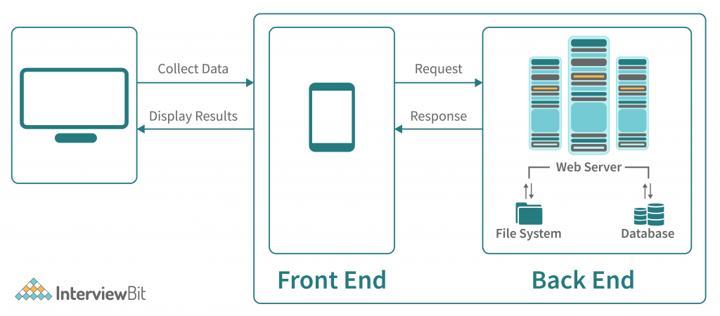

Figure 1 – Overview

Introduce the Overview of the System Technology ( 150 – 200 words)

## Software architecture: Monolithic Architecture

Monolithic architecture combines all components of a software application, from input handling to user interface rendering, into a single program with a unified codebase. This approach simplifies development, deployment, and testing but can lead to scalability challenges and limited flexibility as the application grows. It is suitable for small, stable applications but often gives way to microservices architectures in larger, more complex projects to improve scalability and manageability.

According to Smith (2023), monolithic architecture in software engineering involves integrating all functionalities of an application into a single codebase. While this approach simplifies initial development and deployment, it can create significant scalability and manageability challenges as the application expands, potentially hindering continuous integration and rapid updates. (Smith, 2023)

## Back-end framework: .NET

.NET is a free, open-source platform by Microsoft that supports multiple languages like C#, F#, and Visual Basic, enabling development across different platforms including Windows, macOS, Linux, and Docker. It features ASP.NET for web development, Entity Framework for database management, and Visual Studio as an IDE. Known for supporting microservices and containerization, .NET is ideal for creating scalable, high-performance applications, making it widely used in enterprise environments.

Johnson and Lee (2024) highlight the significance of .NET in the software development industry, noting its comprehensive framework, compatibility with multiple programming languages, and robust support for scalable enterprise applications. They emphasize that .NET’s commitment to open-source development has played a critical role in fostering a collaborative and innovative environment among developers. (Johnson & Lee, 2024)

## Front-end framework: ReactJs

React.js is an open-source JavaScript library from Facebook for building dynamic user interfaces, especially for single-page applications. It uses a component-based architecture for efficient code reuse, a virtual DOM for optimal performance, and a declarative approach for predictable UI updates. React supports JSX to combine HTML with JavaScript, facilitating integration with other frameworks. Widely favored for its robust community support and versatility, React is a popular choice for modern web development.

Thompson and Kumar (2023) highlight the significant influence of React.js in modern web development, noting its component-based architecture and dynamic UI rendering capabilities that greatly enhance scalability and maintainability of web applications. They credit React with elevating user experience by improving the responsiveness of complex applications, which is a critical factor in today's digital landscape. (Thompson & Kumar, 2023)

## Database management: MS SQL Server

Microsoft SQL Server (MS SQL Server) is a relational database management system by Microsoft, designed to manage and retrieve data for various applications. It features robust transaction management, SQL Server Management Studio for administration, Analysis Services for data analytics, and Reporting Services for report generation. Additionally, it offers high availability options, strong security features, and Integration Services for ETL processes. MS SQL Server supports scalability and can be deployed on-premises, in the cloud via Azure, or in hybrid setups. It is widely used across industries for transactional systems, website back-ends, and business intelligence, making it a crucial tool for enterprise data management.

Anderson et al. (2022) explore the performance and security capabilities of Microsoft SQL Server in enterprise settings, noting its effectiveness in managing complex transactional systems and ensuring data security. They emphasize that SQL Server’s advanced integration services and security measures, including encryption and data masking, not only enhance operational efficiencies but also meet stringent compliance requirements, thereby protecting sensitive data from potential security breaches. (Anderson, et al., 2022)

## Market analysis

### Survey Introduction / Research Activity / Research Methods

Survey Introduction

The first stage of market evaluation for Earthpnp, our room booking platform, begins with this introduction. We aim to clarify the purpose and importance of the survey, explaining how your feedback will help enhance our services. Market research is crucial for understanding user preferences and assessing competitors' strengths and weaknesses. We assure you that your information will remain confidential and will be used solely to improve Earthpnp’s functionality and user experience. Your insights are invaluable, guiding us to provide the best booking experiences and benefits.

Research Activity

The research activity for Earthpnp aims to understand our target demographic, their preferences, and the competitive landscape in the room booking sector. We will collect qualitative data through interviews, focus groups, and observations to gain insights into user motivations, and quantitative data via online surveys to gather evidence on user preferences and industry trends.

Our research will test several hypotheses:

* There is a demand for more customizable room booking options.
* Users would benefit from a platform that integrates local travel experiences with accommodations.
* Post-pandemic, safety and cleanliness are top priorities for users.
* Combining comprehensive travel solutions with room bookings will enhance user engagement.
* A user-friendly interface will attract users and encourage loyalty.

Research Methods

For Earthpnp, we employ a dual-focus research methodology to deeply understand market dynamics and traveler preferences. **Primary research** involves structured surveys and detailed interviews with frequent travelers and accommodation providers, aimed at gathering both qualitative and quantitative insights about user expectations and satisfaction levels with current room booking platforms. Simultaneously, **secondary research** examines leading travel and accommodation platforms to identify evolving trends and consumer behaviors. This comprehensive approach helps Earthpnp innovate and enhance the room booking experience, aiming to surpass the needs of today’s sophisticated travelers by creating a seamless and engaging platform.

### Result Analysis

Secondary research

In conducting secondary research for Earthpnp, we assess key metrics like user base size and revenue from leading room booking platforms to understand market trends and consumer preferences.

Firstly, Airbnb, a major player in the room booking sector, boasts over 150 million users worldwide and generated approximately $6 billion in revenue in 2022. This data highlights Airbnb's wide appeal, driven by its user-friendly platform and unique local experiences (Forbes, 2023).

Next, Booking.com reports nearly 200 million active users and achieved around $17 billion in revenue in 2022. The platform is known for its extensive inventory and seamless booking experience, making it a preferred choice for global travelers (Financial Times, 2023).

Additionally, Luxury Retreats, a niche platform for high-end vacation rentals, serves about 1 million users annually, underscoring the potential in targeting specialized market segments (MarketWatch, 2023).

This analysis will help Earthpnp refine its services, enhance user engagement, and optimize its market strategy to meet the needs of modern travelers.

conclusion

This research underscores the burgeoning trend in the room booking sector towards integrated travel experiences that cater to modern travelers' desires for convenience and customization. It provides crucial insights for Earthpnp in developing its platform, especially in enhancing user interface and functionality, while integrating local experiences to enrich the value offered to users. By focusing on a user-friendly platform that combines comprehensive booking options with personalized travel experiences, Earthpnp can position itself as a leader in the evolving travel industry, meeting the high expectations of today's savvy travelers.

Primary research

In the realm of room booking and travel services, pinpointing and fulfilling user expectations is crucial for standing out in a competitive market. Earthpnp has launched a detailed user survey aimed at collecting essential data about the customer experience on our platform. This survey incorporates both quantitative and qualitative questions to gain a well-rounded understanding of user preferences. We are engaging a focused group of 20 individuals whose detailed feedback is invaluable, ensuring that even with a modest number of participants, we can derive significant insights.

The primary objective of this research is to discover actionable ways to refine Earthpnp, enhancing the interface and overall service for various user groups. This survey specifically seeks to assess the current functionalities and explore additional features that users find beneficial or lacking. The feedback collected will inform vital enhancements and innovations in our service offerings. We plan to meticulously analyze the data from this survey to make informed strategic decisions, setting a robust foundation for the ongoing evolution and improvement of the Earthpnp platform.

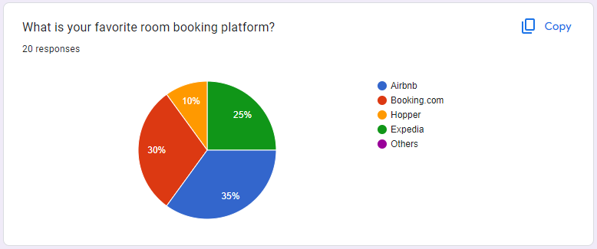

Figure 2: primary research (1)

Based on the survey results from 20 individuals regarding their preferred room booking platforms, we can conclude the following:

* **Airbnb** emerges as the most favored, chosen by 35% of respondents, highlighting its popularity due to unique lodging options and user-friendly interface.
* **Booking.com** is selected by 30% of the participants, showcasing its appeal for its wide array of global accommodation options and robust travel services that cater to a diverse range of travelers.
* **Expedia** is preferred by 25% of the survey respondents, illustrating its solid reputation for providing comprehensive travel packages that include hotels, flights, and car rentals, which appeals to those looking for an all-in-one travel planning solution.
* **Hopper**, favored by 10% of the respondents, shows niche appeal, particularly among those valuing innovative features like predictive pricing. This distribution reflects varying preferences for platform features among travelers.

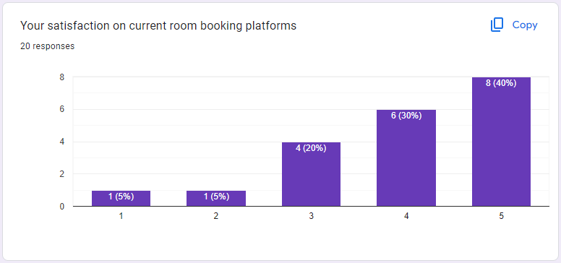

Figure 3: Primary Research (2)

The survey conducted with 20 participants on their satisfaction with room booking platforms yields encouraging results. A significant 40% of respondents report high satisfaction, showcasing a robust appreciation for the platform's features and usability. Another 30% indicate they are generally satisfied, acknowledging that while the platform meets many of their needs, there is scope for further enhancement. 20% of participants remain neutral, suggesting that while many users are decisive in their views, a fraction remains indifferent. Only a small segment, 5% for each category, express low levels of satisfaction, highlighting minimal dissatisfaction among users overall.

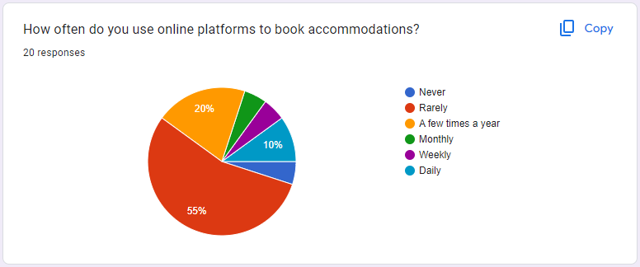

In the primary research conducted on user habits related to room booking platforms, the survey data from a sample of 20 respondents reveals diverse usage frequencies that highlight significant insights into consumer behavior. Here’s a detailed breakdown of the results:

* **Daily**: 10% of respondents use room booking platforms daily, indicating a dedicated segment of users who may rely on these services for frequent travel or business purposes.
* **A few times a year**: 20% of participants book rooms a few times a year, reflecting typical usage patterns for vacations or occasional travel.
* **Rarely**: 55% of the respondents use booking platforms rarely, suggesting that while they are aware of and have access to these platforms, they do not have frequent needs or they prefer other accommodation options.
* **Weekly and Monthly**: Each accounting for 5%, these users likely engage with the platforms for regular personal or professional commitments.
* **Never**: Another 5% of the survey participants never use online booking platforms, indicating a potential segment either not reached by current marketing strategies or who prefer traditional methods of booking.

This segmentation reveals a clear picture of user engagement levels and presents opportunities for targeted improvements and marketing strategies. The significant proportion of infrequent users suggests potential areas for increasing engagement, possibly by addressing barriers such as perceived complexity, lack of trust, or insufficient incentives for more regular use.

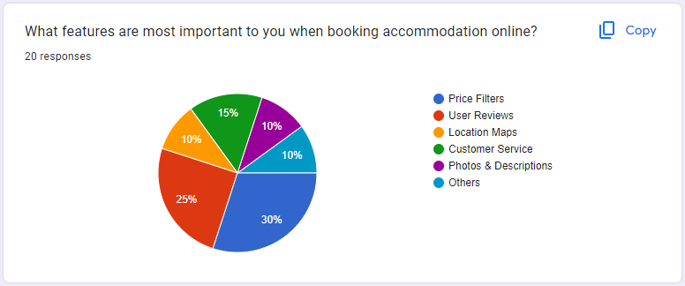

User’s Expectation Features

A primary focus for Earthpnp should be on offering unique lodging options along with a user-friendly interface. This means providing intuitive navigation and a streamlined booking process that makes finding and securing accommodations simple and efficient.

Additionally, Earthpnp should ensure a diverse portfolio of accommodations. By catering to both casual travelers and those needing longer stays or business facilities, Earthpnp can broaden its appeal and usability.

Integrating innovative features like predictive pricing tools could also attract users who prioritize budget and value. Utilizing AI-driven analytics to forecast price trends and offer the best deals will help in attracting budget-conscious travelers looking for optimal booking times.

Considering different user engagement levels, from daily users to those who book occasionally, Earthpnp should also tailor its marketing and functionality to appeal across this spectrum. This includes potentially developing loyalty programs or offering special discounts to encourage more frequent use.

By focusing on these aspects, Earthpnp can better meet the evolving needs of today’s travelers, increasing user satisfaction and fostering platform loyalty.

User-preferred and unpreferred features of current platforms:

Users of booking platforms like Earthpnp typically prefer features such as easy navigation, personalized recommendations, strong security, and responsive customer service. These elements contribute to a seamless booking experience, enhancing engagement and user satisfaction. Features like an intuitive interface and tailored suggestions based on user history are particularly valued.

On the other hand, features that lead to dissatisfaction include intrusive advertising, irrelevant content suggestions, weak privacy controls, slow performance, and complex booking processes. Users are less likely to favor platforms that feel cumbersome or fail to respect their privacy and preferences.

The most successful booking platforms create a secure, efficient, and user-centered experience, simplifying the process of finding and booking accommodations while ensuring data protection. Platforms that do not meet these expectations in usability and privacy are generally less favored.

### Conclusion

After conducting a comprehensive analysis of user feedback and platform usage patterns, we have drawn valuable conclusions that can guide the enhancement of Earthpnp's features:

**Personalized Recommendations:** Given the user preference for tailored suggestions, Earthpnp should focus on improving its recommendation algorithms to offer accommodations and travel options that closely align with individual preferences and past behavior. This will likely increase user engagement and booking frequency.

**Seamless Booking Experience:** As users appreciate a straightforward and efficient booking process, Earthpnp must ensure its platform facilitates easy navigation and a hassle-free reservation system. Implementing features like quick-fill forms and one-click bookings can significantly enhance user satisfaction.

**Robust Security:** Users consistently prioritize security, particularly in the handling of personal and payment information. Earthpnp should strengthen its security measures, ensuring data protection is paramount, which will help in maintaining user trust and loyalty.

**Minimize Unfavored Features:** To reduce user dissatisfaction, Earthpnp should avoid overloading the platform with intrusive advertising and complex booking processes. Streamlining these aspects will make the platform more user-friendly and competitive in the crowded travel booking market.

### User Persona

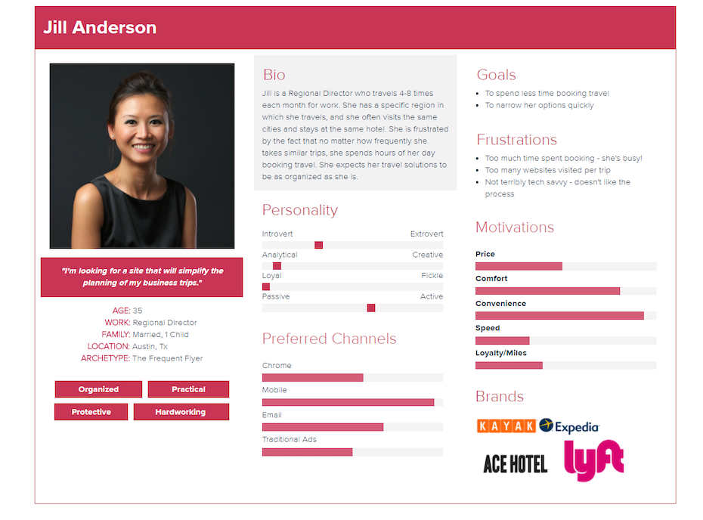

Figure 4 - User Persona

Persona explanation: 150 – 200 words

# Legal, Social, Ethical and Professional Issues and Considerations

Legal Considerations

**Data Protection and Privacy**: Adherence to data protection laws such as the General Data Protection Regulation (GDPR) is mandatory. This includes securing user data, obtaining proper consent for data collection and usage, and granting users control over their personal information.

**Intellectual Property Rights**: It is essential to respect the intellectual property rights of others, particularly with user-generated content. Measures should be put in place to prevent copyright infringement.

**E-commerce and Travel Regulations**: Compliance with e-commerce and travel industry laws is critical. This covers consumer protection, transaction security, as well as specific rules regarding booking cancellations, refunds, and returns.

**Content Moderation**: There is a legal obligation to moderate content to prevent the dissemination of harmful or illegal material, including hate speech, misinformation, and explicit content.  
**Accommodation Licensing and Tax Compliance:** It is essential that Earthpnp verifies all accommodations are compliant with local laws and regulations, including zoning and hospitality requirements. Additionally, the platform must guide hosts in understanding and fulfilling their tax obligations, such as income and tourist taxes.

Ethical Considerations

**User Data Privacy and Transparency**: Managing user data with integrity is essential. This involves being transparent about how data is collected, used, and shared, ensuring that users are well-informed and can control their personal information.

**Equitable Service Access**: Platforms must strive to provide equal access to all users, actively addressing any potential biases and enhancing inclusivity, particularly for individuals with disabilities.

**Fair Marketing Practices**: Adhering to ethical marketing standards is crucial. This means avoiding deceptive practices and being clear and honest about any advertising and promotional content.

**Community Impact**: Consideration of the platform’s impact on local communities is important. Promoting responsible tourism that supports local economies and respects the social dynamics of travel destinations is vital.

Professional Considerations

**Quality and Reliability:** It's crucial to maintain high standards in the platform's operations, with rigorous testing and quality assurance to ensure reliability and build user trust.

**Continuous Improvement and Feedback:** Implementing a system for continuous improvement is essential. This includes regular updates and actively incorporating user feedback to enhance functionality and user satisfaction.

**Professional Development and Training:** Regular training and updating team members on the latest technologies, legal regulations, and ethical standards are necessary. This ensures the team remains competent and professional, effectively supporting the platform's integrity.

Consider is your project Legal, Social, Ethical and Professional Issues and Considerations

In developing our project, addressing legal, social, ethical, and professional considerations is paramount, with a specific focus on safeguarding personal data and regulating our approach to online advertising and user interaction.

Data Privacy: It is critical to align with global data protection regulations such as the EU's General Data Protection Regulation (GDPR), the UK's Data Protection Act 2018, and the US's Federal Trade Commission Act. We commit to:

* Enabling users to access, modify, or delete their personal data under any circumstances.
* Clearly detailing the usage, processing, and storage of data in our Privacy Policy.
* Ensuring that user data is not utilized in any Artificial Intelligence systems or algorithms without explicit user consent.

# Requirements

## Analysis of requirements

Earthpnp is an online accommodation booking platform that needs specific functionalities for efficient operation and a user-friendly experience. It must allow users to search for and book accommodations, view property details, and leave reviews and ratings. Hosts require tools for listing management such as creating and updating listings, tracking reservations, and managing availability calendars; a financial dashboard is also essential for viewing earnings and transactions. The platform needs a robust admin panel for oversight, which includes functionalities for managing listings, monitoring user activity, and analyzing booking and financial data to support decision-making, ensuring Earthpnp remains competitive and accessible in the online accommodation booking market.

## Existing Solutions

### Airbnb

Introduction

Airbnb, founded in 2008, has significantly transformed the way people think about travel accommodation. As Guttentag (2015) emphasizes, Airbnb has not only disrupted traditional hotel industries by offering a unique marketplace for people to list, discover, and book accommodations worldwide but has also impacted local housing markets and urban planning (Guttentag, 2015). It leverages technology to connect hosts who have spare rooms, apartments, or homes to rent, with travelers seeking non-traditional, often cheaper, lodging options. This peer-to-peer platform has grown exponentially, attributing its success to a business model that caters to the desire for more authentic, personalized travel experiences and the economic benefits of sharing economy practices.

Pros

**Diverse Accommodations**: Airbnb provides access to a wide range of unique lodging options worldwide, from apartments and homes to treehouses and castles, allowing travelers to experience destinations in a more authentic and personalized way.

**Local Experience**: Staying in an Airbnb can offer travelers a more local experience, often with opportunities to interact with hosts who can provide insights and tips about the area, enhancing the travel experience beyond typical tourist pathways.

**Cost-Effective Options**: Often more affordable than hotels, Airbnb listings can provide cost-effective accommodations, especially for longer stays and group travel, making it easier for more people to explore new places.

**Economic Opportunity for Hosts**: Airbnb enables homeowners to earn extra income by renting out their property, which can help cover living expenses and encourage economic activity in local communities.

Cons  
Airbnb, while popular, does face certain drawbacks:

**Inconsistency in Quality**: Unlike hotels that often provide standardized amenities and services, Airbnb listings can vary greatly in quality, comfort, and safety, sometimes not matching their descriptions or reviews.

**Regulatory Challenges**: Airbnb hosts and guests can face complex legal and regulatory environments that differ by city and country. These regulations can affect the availability and legality of rentals, creating potential complications for travelers.

**Impact on Local Housing Markets**: In some cities, Airbnb has been criticized for contributing to rising rental prices and housing shortages, as properties are converted into short-term rental spaces instead of being available for long-term residents.

**Privacy and Security Concerns**: Guests and hosts may encounter privacy issues or security risks, ranging from hidden cameras to personal safety concerns, due to the intimate nature of staying in someone else's property.

These issues underscore some of the potential negatives associated with using Airbnb, affecting both guests and the communities where properties are located.

*Words: 100 – 200 words*

### Product B

Introduction

A relevant academic reference that discusses platforms like Booking.com in the context of their technological influence in the tourism industry can be drawn from Guttentag (2010), who explores how these platforms utilize technology to transform travel behaviors (Guttentag, 2010). Specifically, Guttentag highlights how Booking.com has streamlined the accommodation booking process, making it more efficient and significantly altering how consumers plan their travel. This efficiency has not only increased user satisfaction but also competitive pressures within the hotel industry.

Pros

Booking.com offers several advantages that enhance the travel booking experience:

**Wide Range of Options:** The platform features a vast array of accommodations worldwide, accommodating all preferences and budgets.

**Ease of Use:** Booking.com is designed for easy navigation, allowing users to quickly find and book their ideal accommodations with efficient search and immediate confirmation features.

**Verified Reviews:** The platform provides reliable and authenticated user reviews, aiding travelers in making informed decisions based on others' experiences.

Cons

Despite its many benefits, Booking.com also has some drawbacks:

**Inconsistent Pricing:** Some users find pricing on Booking.com to be inconsistent, with fluctuations that can occur based on demand, time of booking, and hidden fees that may not be immediately apparent.

**Overwhelming Choices:** The vast selection of accommodations can sometimes be overwhelming for users, making it difficult to make a decision, especially without adequate filtering.

**Quality Variability:** The quality of accommodations listed can vary significantly, and the photos and descriptions provided may not always accurately reflect the current state of the property.

**Customer Service Issues:** Some users report challenges with customer service, particularly when dealing with cancellations, refunds, or disputes about accommodation standards.

*Words: 100 – 200 words*

### Product C

Introduction

Expedia has established itself as a cornerstone in the online travel industry, offering a comprehensive suite of travel services. According to research by Law, Buhalis and Cobanoglu (2010), Expedia provides consumers with a streamlined platform that not only simplifies the booking process for hotels, flights, and car rentals but also enhances the travel planning experience through integrated services. This synergy across different travel components makes it a preferred choice for users seeking a holistic approach to planning and booking their travel. (Law, et al., 2010)

Pros

Expedia offers several advantages for travelers:

**Comprehensive Travel Solutions:** Expedia serves as a one-stop-shop for all travel needs, providing users with the ability to book flights, hotels, car rentals, and vacation packages all from a single platform. This integration simplifies the travel planning process and can offer cost savings through package deals.

**User-Friendly Interface:** The platform is known for its intuitive design, making it easy for users to navigate and find the best options for their travel needs. Advanced filters and a powerful search engine help streamline the selection process.

**Price Match Guarantee:** Expedia offers a price match guarantee, which ensures that travelers get the best available rates for their bookings. This policy enhances customer confidence and satisfaction by providing value and assurance in their travel purchases.

Cons

While Expedia offers numerous benefits, there are some drawbacks to using the platform:

**Customer Service Challenges:** Users sometimes report difficulties with customer service, particularly when it comes to resolving issues related to cancellations, changes, or discrepancies in bookings.

**Complexity in Deals:** The numerous options and deals available can be overwhelming and sometimes misleading, with restrictions and conditions that are not always clear upfront.

**Dependence on Third-Party Providers:** As Expedia aggregates services from various providers, any inconsistencies in service quality or availability from these third parties can affect the overall user experience, leading to potential dissatisfaction.

*Words: 100 – 200 words*

*Note: từ yêu cầu, đi so sánh với những sản phẩm / giải pháp đang tồn tại trên thị trường, chỉ ra điểm mạnh / yếu*

### Conclusion

*Note: sau khi đã so sánh, rút ra kết luận là sản phẩm của minh sẽ có những ưu điểm gì vượt trội so với những sản phẩm đang có trên thị trường*

*Words: 150 words*

# Business Requirements

## Overall Picture

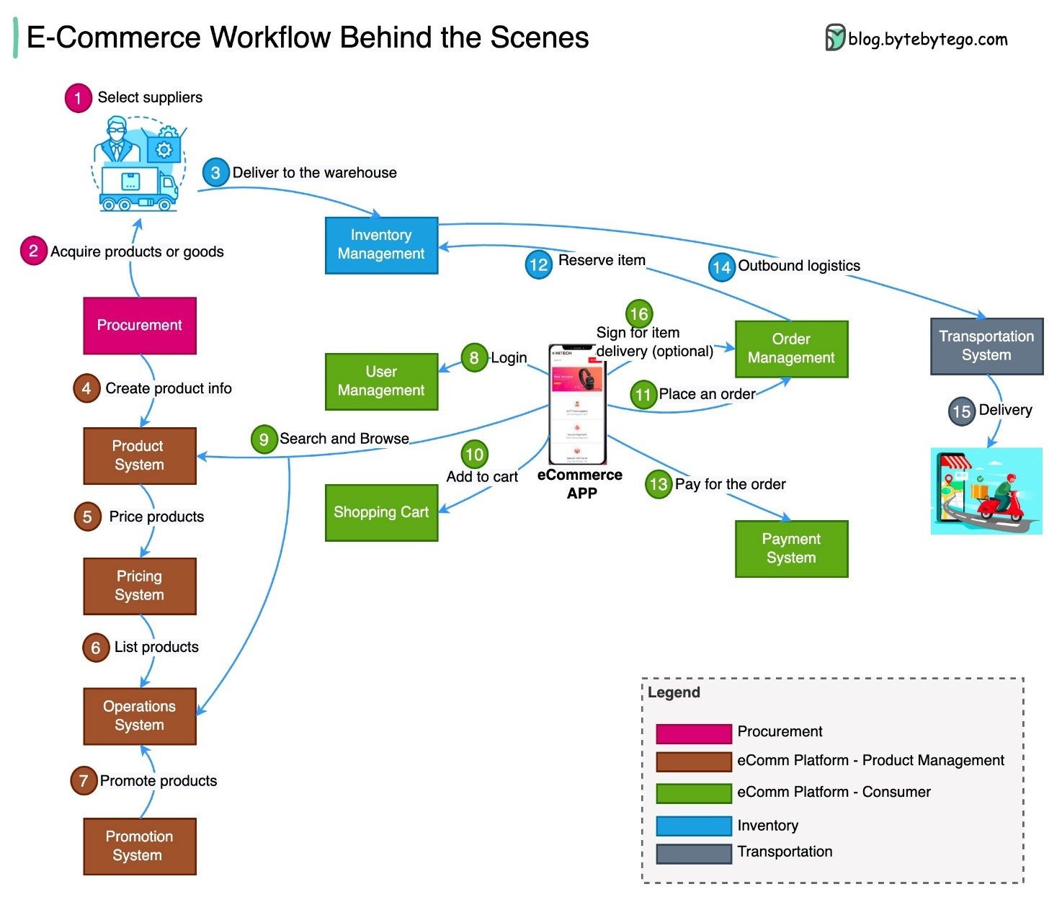

Figure 5 - Rich picture

*Note: include hình miêu tả tổng về dự án của minh*

Words: 100 - 150

## Functional Requirements with MoSCoW prioritisation

*Note: học kỹ hơn ở môn Requirements Management*

Words: 300 - 500

|  |  |  |  |
| --- | --- | --- | --- |
| ID | Description | Priority  (Must – Should – Could -Won’t) | Estimation  (2 – 3 – 5- 8 days) |
| USR_01 | As an *<user>,* I want *<something>¸* so that *<why>* | Must | 8 days |
| USR_02 | As an *<user>,* I want *<something>¸* so that *<why>* | Should | 2 days |
| ADM_01 | As an *<user>,* I want *<something>¸* so that *<why>* | Could | 2 days |

|  |  |  |
| --- | --- | --- |
| SUMMARY | | |
| Priority | **Number of features** | **Number of days** |
| Must | 1 | 8 |
| Should | 1 | 2 |
| Could | 1 | 2 |
| TOTAL | 3 | 14 |

## Non-functional Requirements

*Note: học kỹ hơn ở môn Requirements Management*

|  |  |
| --- | --- |
| ID | Description |
| NF_01 | Description |
| NF_02 | Description |
| NF_03 | Description |

Words: - 50 – 100 words

# Analysis and Design

## Context Diagram

*Here is an example of a system context diagram that describes an Internet banking system that you may be building:*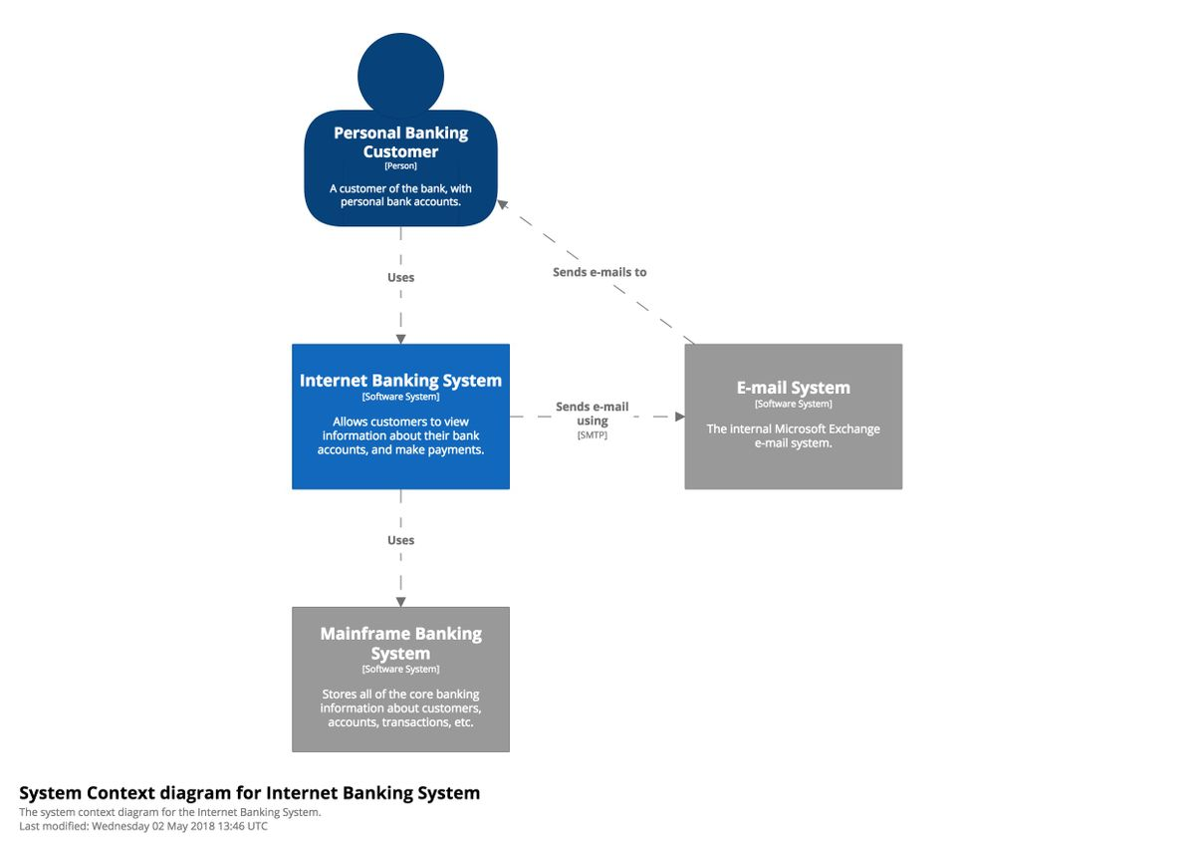

Figure 6 – System Context Diagram

Introduction the chosen architecture: 100 – 150 words

## Container Diagram

Below is a sample container diagram for the Internet banking system.

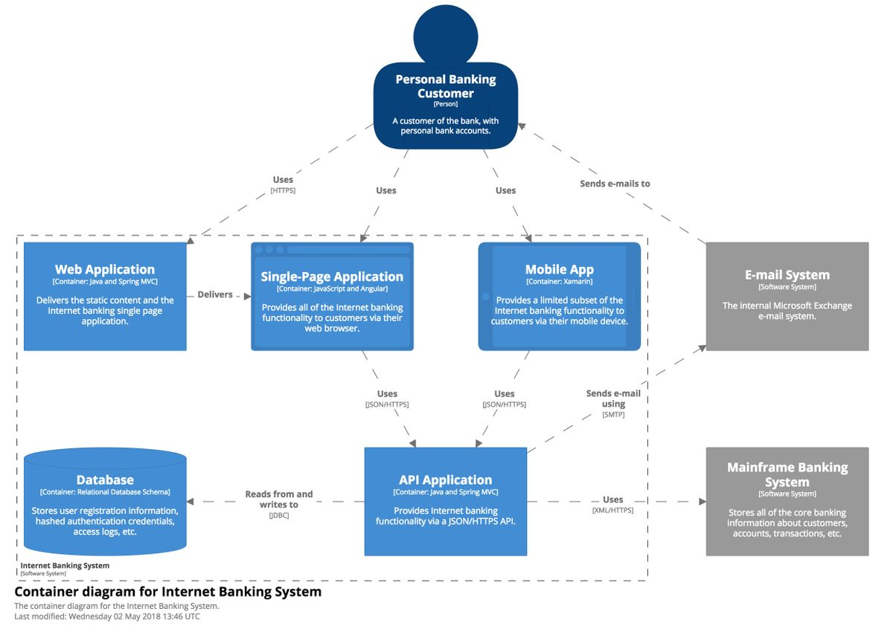

Figure 7 – Container Diagram for Internet Banking System

### Assumptions

*Words: 300 - 500*

### 3rd party Services

*Note: làm rõ là dự án có dùng những Service bên thứ 3 ví dụ: login với Google, Payment với paypal hay VNPay*

Words: 100 – 150 words

### Programming language

Words: 50 - 70

### Front End technology

Words: 50 - 70

### Back End technology

Words: 50 - 70

### Database

Words: 50 - 70

### Mobile App (opt.)

Words: 50 - 70

### Operation System

Words: 50 - 70

### Hosting ( AWS, GCloud, Heroku, Azure … )

Words: 50 - 70

## Component Diagram

Here is a sample component diagram for the fictional Internet banking system that shows some (rather than all) of the components within the API application.

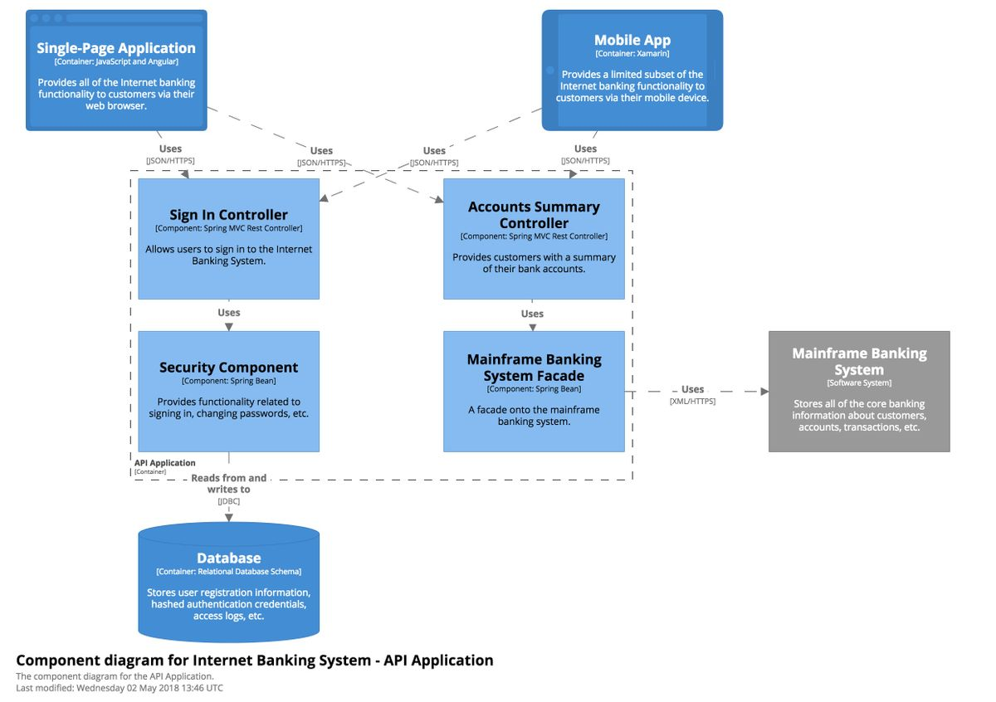

Figure 8 - Component diagram for Internet Banking System

### API Endpoints

|  |  |  |  |  |  |
| --- | --- | --- | --- | --- | --- |
| Id | URL | Method | Description | Params | Returns |
| 1 | /reservation | POST | Users reserve parking slot | user_id, garage_id, slot_id | reservation_id |
|  |  |  |  |  |  |
|  |  |  |  |  |  |

## Code Diagram

### Use Case diagram

### Entity Relationship Diagrams

### Class Diagram

### Activity Diagram

# Implementation

## Database

*Note: đưa những dẫn chứng những thứ mình đã dev.*

*Database: final ERD + giải thích implement như thế nào*

## Project Overview

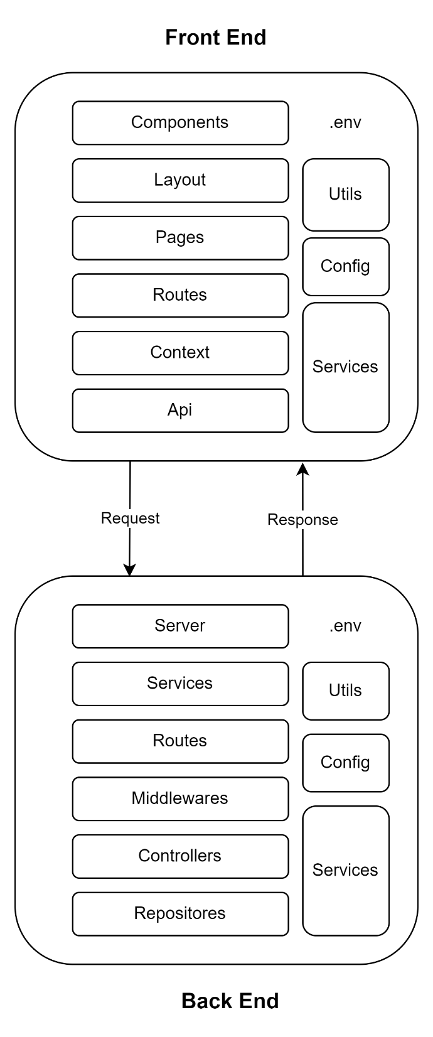

Figure 9 - Project overview

Explanation: 200 – 300 words

## Front End

### Project Folder Structure

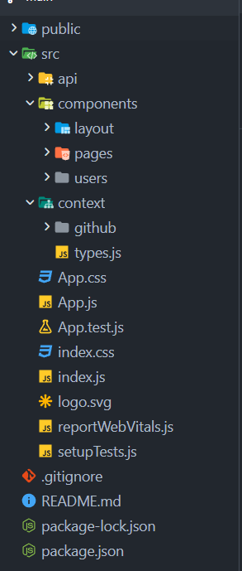

Figure 10 - Front end folder structure

Explanation: 200 – 300 words

### Source code samples

*Note: đưa ra samples những đoạn code hay component quan trọng của front end*

Words: 300 – 500 words

## Back End

### Project Folder Structure

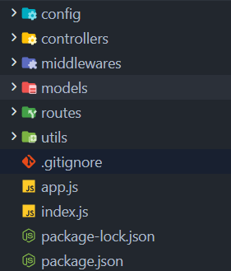

Figure 11 - Back end folder structure

Explanation: 200 – 300 words

### Swagger Documentation

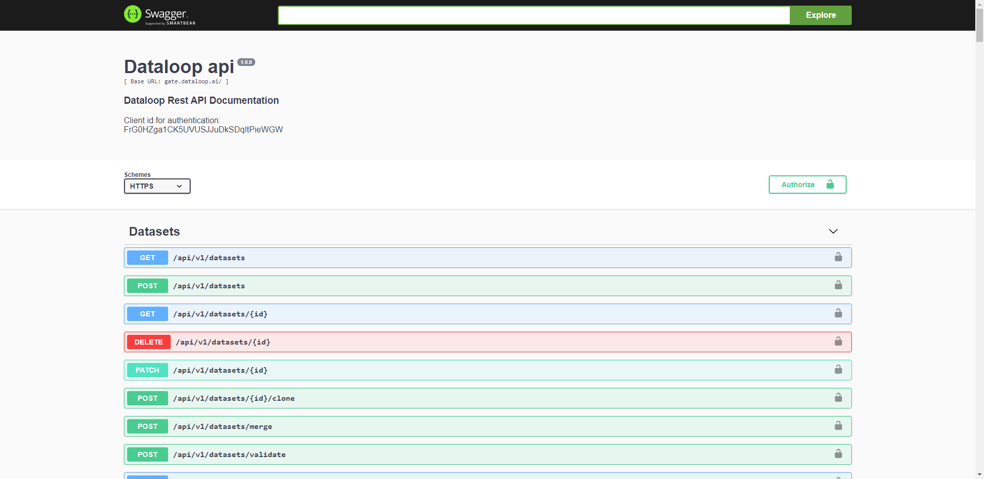

Figure 12 - Swagger Documentation

### Source code samples

*Note: đưa ra samples những đoạn code hay component quan trọng của front end*

Words: 300 – 500 words

## GitHub

Words: 100 - 150

## Project Management (Trello, Jira, GitHub Projects, etc.. )

Words: 100 - 150

## Deployment

*Note: đưa ra những hình ảnh mô tả việc deploy + kết quả cuối cùng*

## Images

*Note: đưa ra kết quả cuối cùng của dự án (screenshots + giải thích 2 – 3 dòng)*

# Testing

Words: 300 - 500

# Evaluation

## Summarised Key findings from the project

*Note: tóm tắt lại những gì minh đã khám phá được trong quá trình chạy dự án*

* *Về mặt tech*
* *Về mặt business*
* *150 – 200 words*

## Recommendations for future development

*Note: nêu ra những gì có thể được phát triển thêm trong tương lai*

*150 – 200 words*

## Project Evaluation

* *Review lại dự án*
* *Những gì đã hoạt động tốt*
* *Những gì chưa hoạt động*
* *150 – 200 words*

## Personal Evaluation

* *Những gì tốt*
* *Những gì chưa tốt*
* *Những gì đã học được trong quá trình dự án*
* *150 – 200 words*

## Conclusion

150 words

# References

# Appendix A – Project Proposal

# Appendix B - Planning

# Appendix C