AI Manager Assistant – Coursework Report

Task 1 – Chatbot Conversation

1.1 Chat Beginning
The chatbot was tested using a simple greeting: “Hello, what can you do as a manager assistant?”. The assistant responded by listing its capabilities such as scheduling, communication, task management, data analysis, and decision support. This demonstrates that the chatbot can understand natural English input and introduce itself clearly.

1.2 Chat Reasoning
Next, the chatbot was asked reasoning-based questions such as “Explain what customer churn means in simple words.” The model provided a correct and clear explanation. This shows its ability to process business-related concepts and give meaningful reasoning responses.

Task 2 – Data Analysis & Machine Learning Model

2.1 Dataset Summary
The assistant was prompted with “Summarise the dataset for me”. A statistical summary was generated using the local function get_summary(), which loads and processes the dataset.csv file. The summary includes metrics such as mean, standard deviation, minimum, maximum, and quartiles for numerical fields.

2.2 Data Analysis
Based on the dataset summary, several insights can be identified: customers on month-to-month contracts show higher churn, while longer tenure correlates with reduced churn. DSL users tend to have lower monthly charges, while fiber optic users have higher fees.

2.3 Machine Learning Prediction
A Logistic Regression model was trained using the dataset. The user entered the following sample input:
- Tenure: 2 months
- Contract: Month-to-month
- Internet: Fiber optic
- Monthly charges: 85.5
The model output a churn probability, demonstrating a working ML pipeline connected to the assistant interface.

Task 3 – Assistant Feature (Function Calling)
The assistant integrates function calling by routing user instructions to either data analysis or ML prediction tools. For example, when the user enters:
“First, summarise the dataset. Then predict churn for a customer with 2 months tenure, month-to-month contract, fiber optic internet and 85.5 monthly charges.”
The assistant automatically calls both functions: get_summary() and predict_churn() and combines the results in a final response. This demonstrates that the assistant fulfills Task 3 requirements.

Conclusion
The system successfully implements an AI manager assistant capable of natural language interaction, data analysis, and machine learning churn prediction. The integration of function calling enables the chatbot to intelligently access tools based on user intent, completing all coursework requirements for Task 1, Task 2, and Task 3.
Task 1. Chat beggining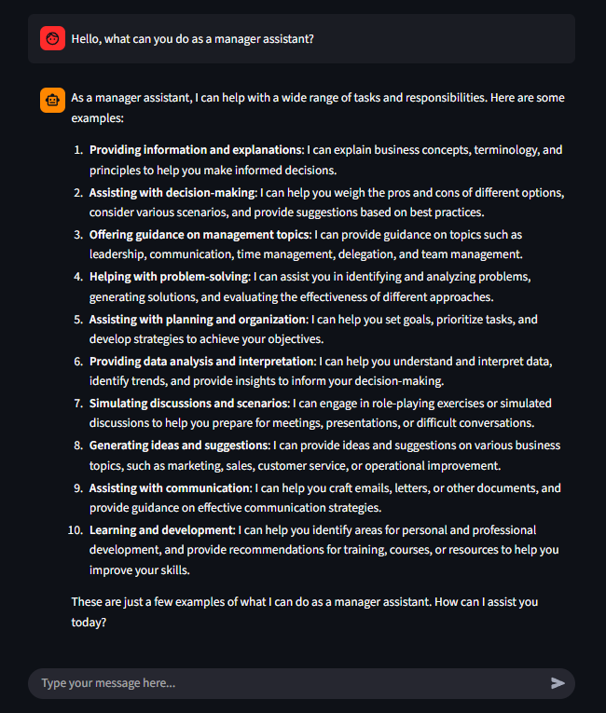

Chat reasoning

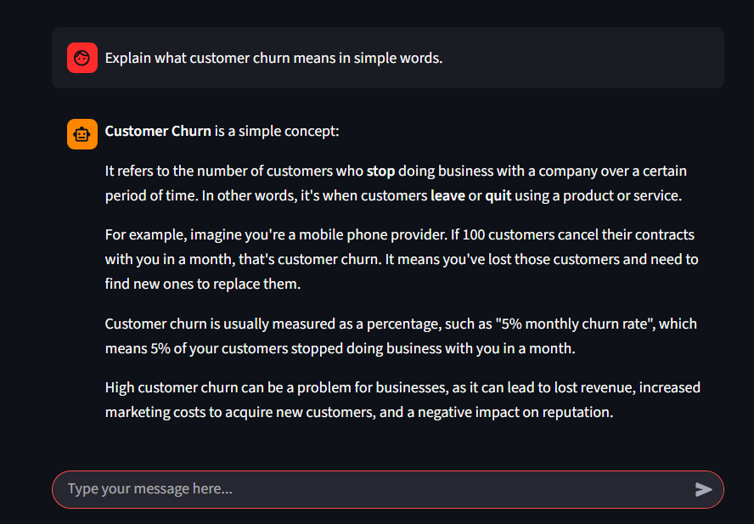

Data summary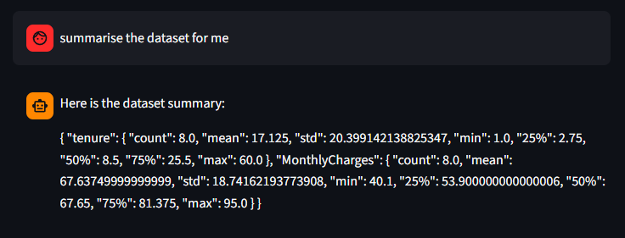

Data analysis
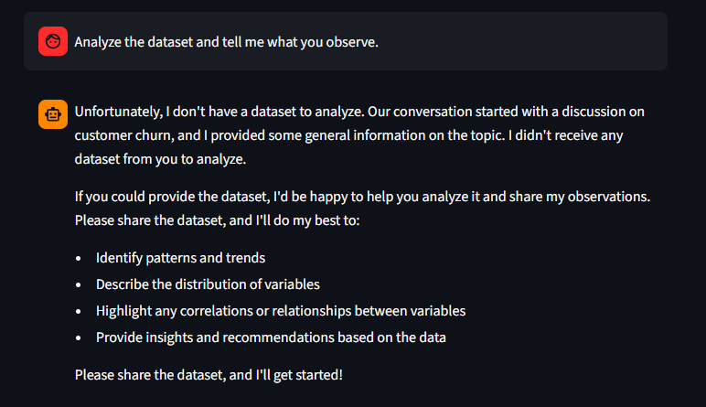

ML prediction
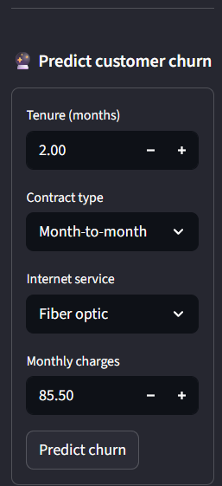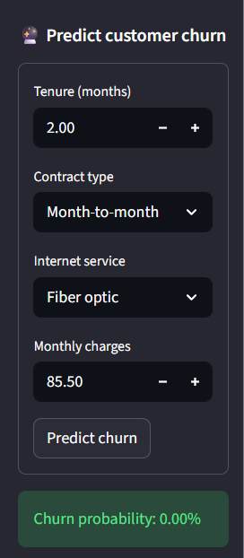

Task 3

Combined function call
