GUIDING MANUAL

**EOLT KBB45**

Supplier: **BK Technic s.r.o**.

Zámecká 63

436 43 Český Dub

Czech Republic

Customer: **Grupo Antolin Bratislava s.r.o.**

Opletalova 73

841 07 Bratislava

Slovakia

Line / machine production number: N16-1097

Content

1 Software capabilities 3

1.1 Directory structure 3

2 User management and settings 5

2.1 Server setting 6

2.2 User management 7

2.3 Database backup and restore 10

3 Traceability 11

3.1 Search 11

1.1 Export table 13

4 Station monitor 14

5 Environment monitor 15

# Software capabilities

Webasto traceability and database software is used for storing run-time data about side covers and roof frames, output data about roof frames, bottles with chemicals and environment information. Additional is used for stations monitoring, displaying environment information in graph, printing birth labels for roof frame, generating csv files and in limited way manipulate with stored data.

## Directory structure

Data are stored in internal SQLite database, which is represented db_content.db file, stored in directory structure on path:

C:\Program Files (x86)\webasto_database_traceability_software\db\db_content.db

This file is necessary to correctly run the application.

All images which are used in the application are stored in directory on path:

C:\Program Files (x86)\webasto_database_traceability_software\icons\

If it is necessary, it is possible replace them for other images. Just replace them with image with the same format and name and internal algorithm automatically resize new image.

If the connection to the Webasto server is not available, then all generated csv files are stored to directory on path:

C:\Program Files (x86)\webasto_database_traceability_software\csv_backup\

When the connection is reconnected, all csv files from directory csv_backup are automatically moved to server.

In the application directory is file webasto_database_traceability_software_vX.jar. This file is executable file for run the database and traceability application, but run the application correctly with bat file webasto_traceability_software.bat. On this file should be link on the desktop. The application is executed automatically after power on the PC. After run the application is everything ready for work with line stations.

# User management and settings

Access to application is able only under username and password. Default username and password are:

Username: Webasto

Password: Webasto

After run the application is first displayed login window:

## Server setting

After log on the application is shown setting window, where is possible manage application parameters:

1. TCP port for PLC 1 – TCP communication port for main PLC

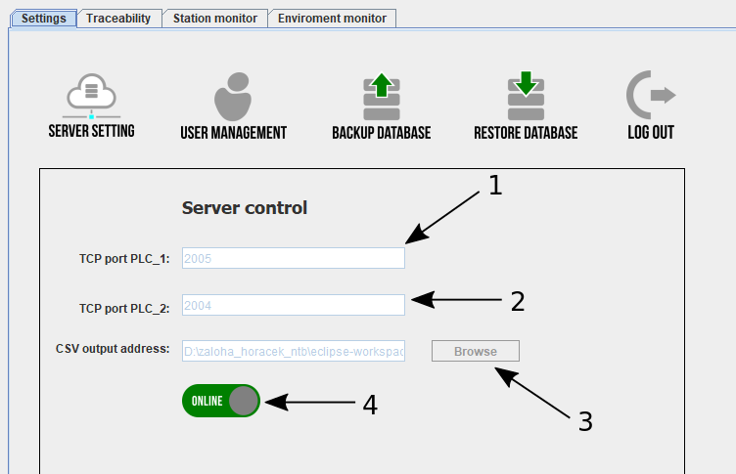  
Figure 2: Setting window

1. TCP port for PLC 2 – TCP communication port for robot station PLC
2. Address for storing Webasto csv files – server address
3. Switch for network control

**All parameters are able to manage only if the network is switched off (Offline)!**

## User management

Clicking on icon **User management** is window switched to user management card, where is list of all users in system.

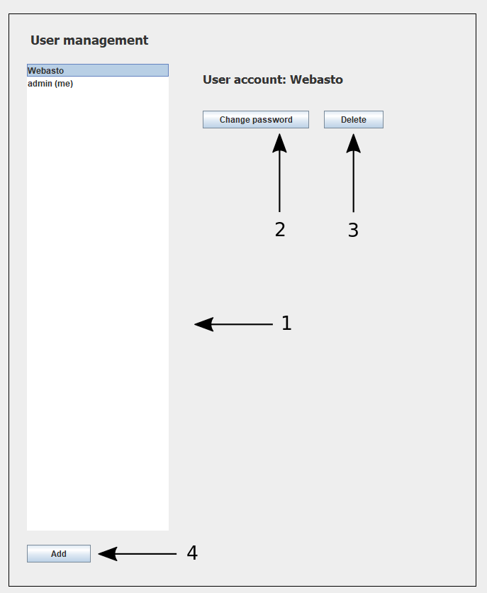  
Figure 3: User management window

1. List of all users in system
2. Button for password changing
3. Button for user account delete
4. Button for creating new user

Users are stored in ordinary database table named **users**, but in this application is not possible manipulating with this table in Traceability card. This table is protected.

After clicking on user name is shown menu for user account managing. There is possible change password or delete user from system. It is not possible to delete current logged user account (delete button is not shown). This is the protection against deletion of all users from the system.

By clicking on **Delete** button is user account after confirmation simply deleted.

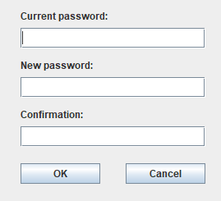  
Figure 4: Form to change password

By clicking on **Add** button is shown form for creating new user account, where is needed setup user name and password.

By clicking on **Log out** icon is possible log out from the application and lock user interface.

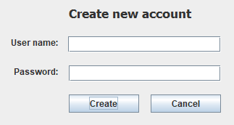  
Figure 6: Form to create a new user account

## Database backup and restore

In sections **Database backup** and **Database restore** is possible do backup of current state of database and if something happened width local database file (for example computer burned) then is possible restore it to previous state. It is good do backups in regular cycles (every day or week) and save the backup to a safe place.

# Traceability

In traceability section is possible browse with records in tables, remove them, but not editing. In **Create table** is possible create new database table inserting of SQL command. In window **Delete table** is possible delete database table by choosing its name in pop-down menu.

**This two operations are not normally needed.**

## Search

Search window is more interesting and important. In search window is possible browse all records in database tables and searching specific record.

For only display data in current database table just choose database table name in pop-down menu and its content is displayed in spreadsheet. If is necessary find specific record(s) there is simple search system, where is possible based on selected parameters find subset of records in database table. In second pop-down menu is list of record items you can searching the records. For example if you want find all left covers in the table, choose in first pop-down menu database table **covers**, in second pop-down menu choose parameter **orientation** and into the input field type value “left”.

To return back to default view of the database table press simply **Back** button.

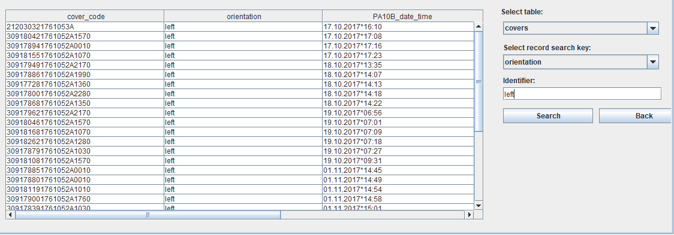  
Figure 7: Search window

After clicking on some record in spreadsheet is displayed **delete** button for delete selected record. After clicking on the delete button is displayed pup up confirmation window where is selection yes or no. Delete some record is possible in ordinary view or after finding current record in search system.

In case you searching in database table **glued_frame_581** or **glued_frame_582** is possible print out birth label for glued frame. The output label is printed on Zebra printer on filling station (on Zebra printer with IP address 192.168.0.30). The **print** button is displayed after finding some record. If is in searching process found only one record, then is possible only press the print button. When is in searching process found more than one record, then is necessary select for which one record should be new birth label printed.

Content of database table in the spreadsheet is not automatically updated, so if new data from stations are stored, for its view is necessary click on icon **Refresh**:

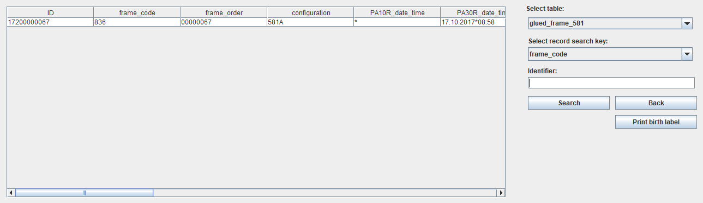  
Figure 8: Print birth label

  
Figure 9: Refresh icon

## Export table

Export table is used for generating table csv file. This file has other format than Webasto csv file generated in the end of roof frame application cycle. This csv file has the same format as data in the database table. For export table is necessary only choose the current database table in pop-down menu an address of output file and click on button **export**.

# Station monitor

Station monitor is window where is displayed all important information about internal state of all line stations. Both PLCs sending to the application information about its internal state only if they state is changed.

If the current station is in OK state the color line above the station picture is green. In other way is the color line red.

# Environment monitor

Environment monitor is part of application where is possible view data from temperature and humidity sensor in graphic representation.

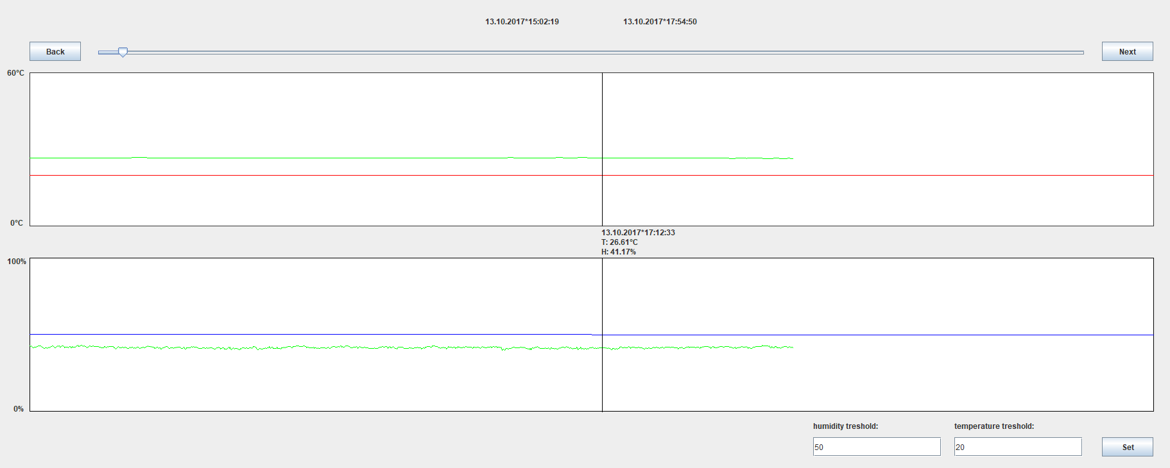  
Figure 11: Environment monitor window

With horizontal slider in upper side of window is possible move the displayed interval of temperature and humidity. Above the horizontal slider is shown date and time of edges of displayed interval.

By clicking with cursor on graph area are displayed detailed information about temperature and humidity in current time point.

If is needed monitoring evolution of temperature or humidity in time is possible set **threshold line** to current value and check graph amplitude.

List of figures

Figure 1: Login window 5

Figure 2: Setting window 6

Figure 3: User management window 7

Figure 4: Form to change password 8

Figure 5: Log out icon 9

Figure 6: Form to create a new user account 9

Figure 7: Search window 11

Figure 8: Print birth label 12

Figure 9: Refresh icon 12

Figure 10: Station monitor window 15

Figure 11: Environment monitor window 16