N20-1024
Content
1 General 1
2 Main screen 2
3 Welding program settings 4
4 System settings 5
4.1 User management 6
4.2 Carriages configuration 7
4.3 Pressure watching setup 8
5 Manual control 9
5.1 Sonotrodes 10
5.2 Punching mechanism 11
5.3 Tape locking 12
5.4 Fabric locking 13
6 Servo-drive control 14
6.1 Feeding drives control 15
6.2 Welding drives 16
6.3 Fabric winding drives 17
7 System alarms 18
7.1 Alarms overview 18

General
In general in every HMI screens is placed red alarm line which shows last appeared alarm description. In case that there is no error this line is green.
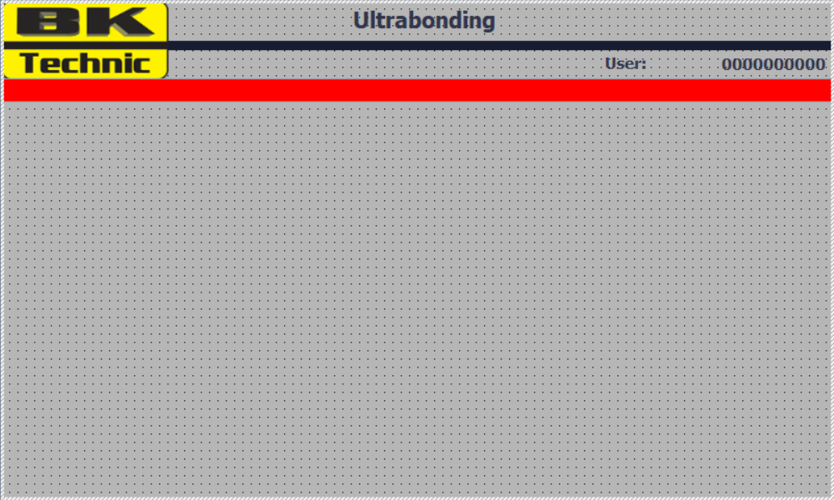Image 1: General screen look
In right upper edge of screen is displayed name of current logged user.

Main screen
In the top of main screen is placed entry for settings of current welding program which is supplemented by its name.
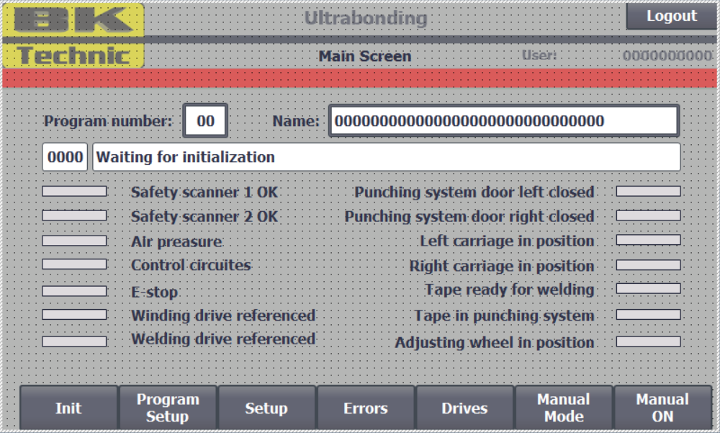Image 2: Main screen overview
Under welding program configuration is displayed machine state and its description supplemented by conditions for start production cycle.
In the bottom of screen is main menu for navigation in HMI screen hierarchy.
Button Init or Reset Cycle (depending on machine state, but its function is the same) is used for reset machine in automatic mode to default state for start production. Before pressing this button is necessary to check state of tape inside the machine. If is the tape inside machine in position for start welding, but in main HMI screen is condition Tape ready for welding in red, it means that tape is in wrong position and before cycle reset is necessary remove this tape out of the machine. In other case there is risk of collision with tape inside the punching mechanism.
Button Manual ON/Manual OFF shows current state of machine work mode and allow switching between automatic and manual mode. If the key under the main HMI is in automat position, then this button is invisible. For display this button is necessary switch this key to position manual. This allow to lock the machine mode in current state, because this button will disappear allways after switching key to automat position.
After switching between manual an automatic mode of the machine, there is always necessary to initialize machine by pressing button Init/Reset Cycle for settings machine to default position for start cycle. Machine automatically detects if the drives are referenced (in known position) and in right position for start and if the tape is prepared for welding (on the end stops of linear carriages) or somewhere in middle position. It the plastic tape is on the end stops, then is jumped automatically to step when is waiting for start welding otherwise is started tape initialization.

Welding program settings
Screen for setting up of welding program is similar to settings screen in previous Ultrabonding machines. Here is new item Tape length which means the length of tape loaded during automatic welding cycle and corresponding linear carriages position. For easier welding positions settings is there Minimal welding position which is counted based on the tape length.
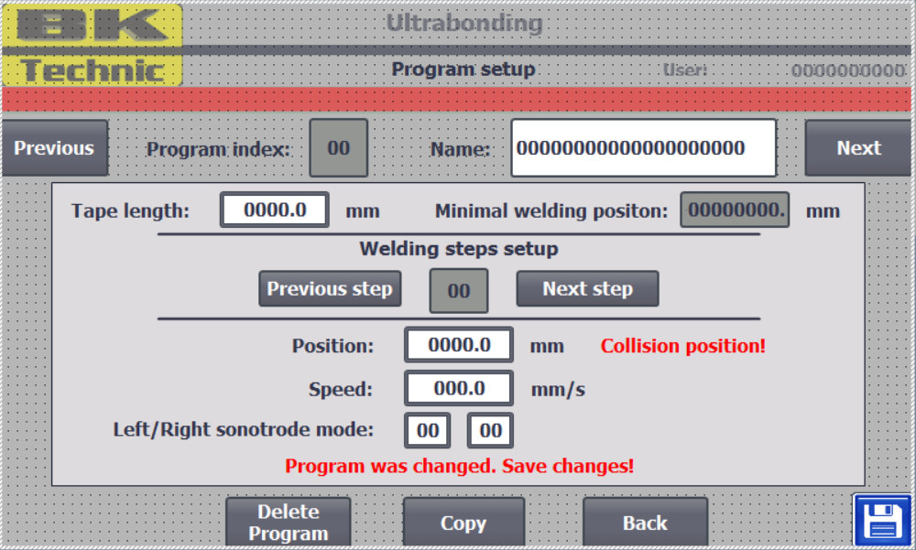Image 3: Welding program settings
One new important feature is, that every change is necessary to save by pressing to blue button in left bottom edge of screen. Every change made in welding program will not take the effect in welding cycle until it is saved. Every new change is notify by red label in the bottom of the screen.

System settings
In system settings is possible to set number of punching cycles for warn of full trash and empty plastic tape in punching system. Both punching mechanisms have own counters, which value is visible in punching manual control screen.
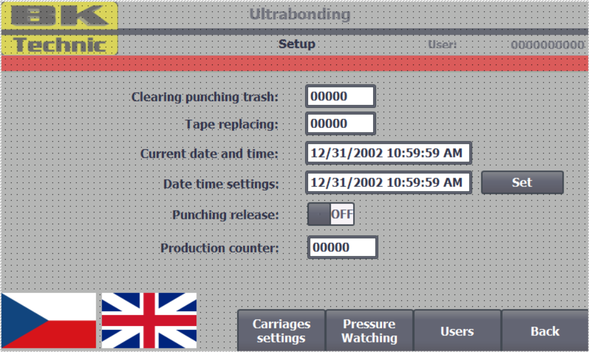Image 4: System settings
Except settings of current time is there button switch for release cylinders in punching mechanism for purpose of replacing punching part.
On last place is visible counter value means total produced fabrics by this machine from the beginning.
Under system settings is also screen for configuration of linear carriages based on given welding program and pressure watching setup during welding with sonotrodes and user management settings.

User management
In user management screen is possible change user password, login and logout given user from HMI for advance machine control.
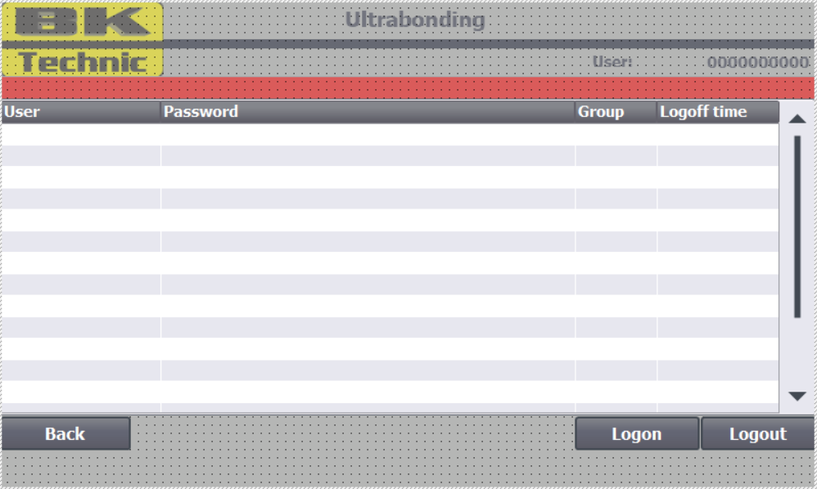Image 5: User management

Carriages configuration
In screen for linear carriages calibration is displayed current program index and its name, required linear carriages position and its current position.
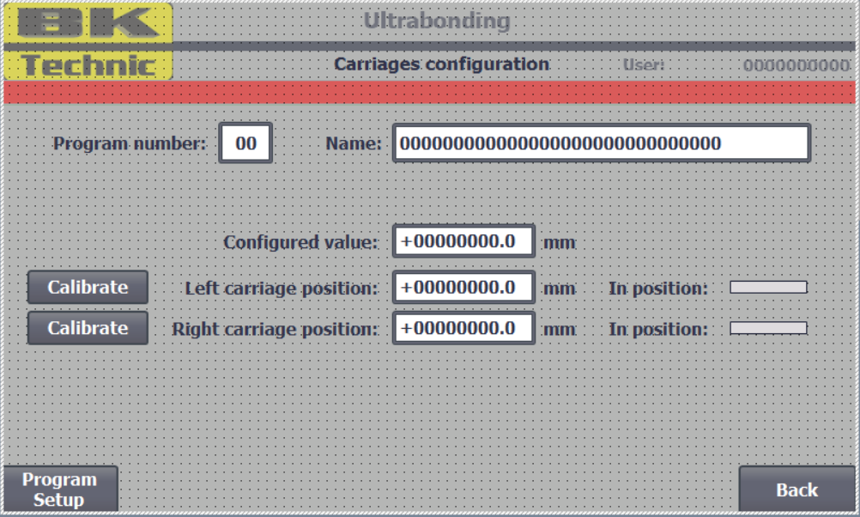Image 6: Carriages configuration
If the rectangle in left side of the screen is green, then the carriage is in right position, otherwise the position is wrong. There is tolerance for correct position: ± 0.3 mm
Buttons Calibrate are used to calibration of counting current position of given linear carriage. For this process is necessary to move both carriages to mechanical end stop position (minimal possible position next to punching mechanism). In this position should be position of both carriages right 700 mm. If not, then by pressing calibrate button is updated offset value needed for correct evaluation of current carriage position. During normal function of the machine this event shouldn’t occur.

Pressure watching setup
Screen for pressure watching during welding is the same as in previous Ultrasonic machines.
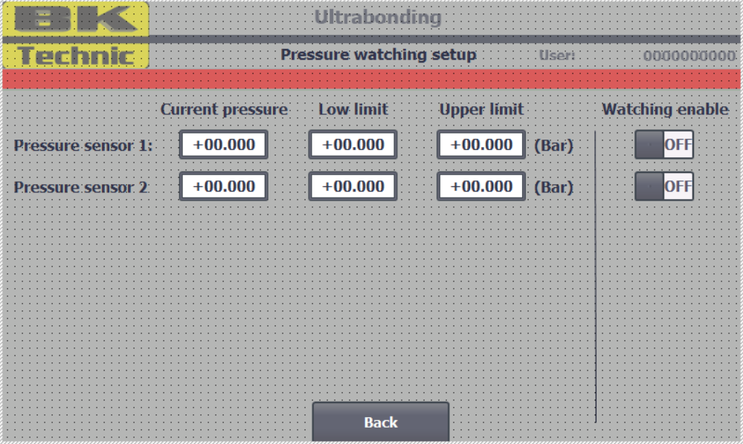Image 7: Pressure watching setup

Manual control
In manual mod is possible to control every part of the machine separately.
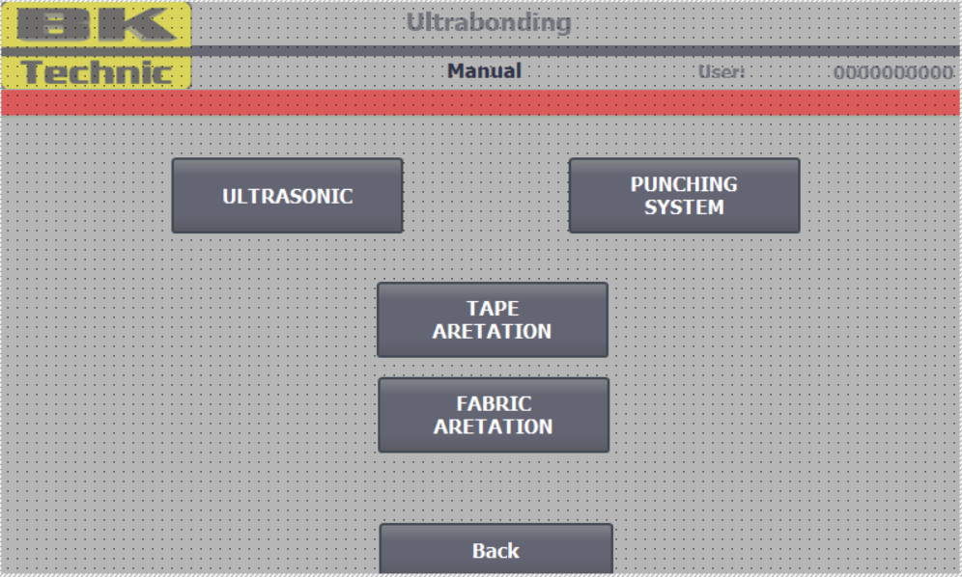Image 8: Manual control

Sonotrodes
In Sonotrodes manual control screen is possible descending by the sonotrodes cylinders, but only in save position for descending where is no danger for collision with linear carriages or unload gippers. Danger position for descending is presented with red label in upper side of the screen and with impossibility to descend with sonotrodes.
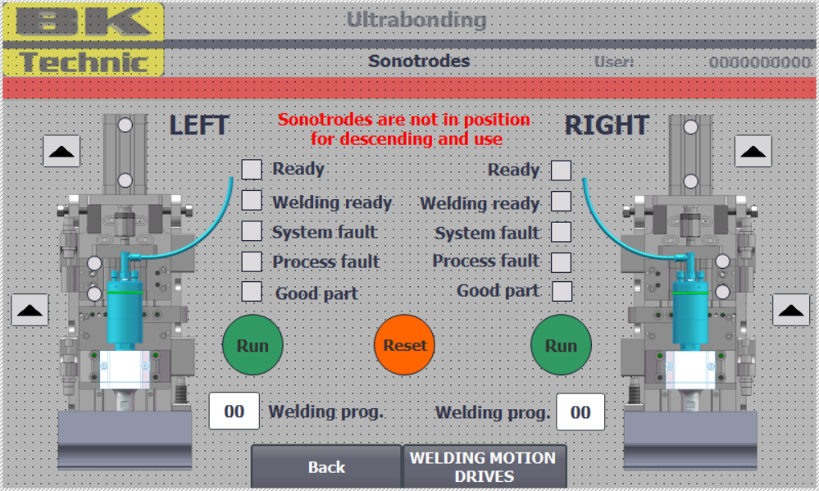Image 9: Sonotrodes manual control
When one or both sonotrodes are descended, then is not possible to control of servo-drives for avoiding of sonotrod mechanical damage.
Next to the sonotrode image are status indicators for display of current state of both sonotrodes. Under the status indicators are control buttons for manual control of the sonotrodes. This buttons are green if the sonotrode is ready for welding and red if there is an error. Under this buttons is entry for settings of required welding program in sonotrode driver.

Punching mechanism
In punching system manual control screen are displayed values of punching counters, one for detecting of (almost) empty tape spool and second for full trash in punching.
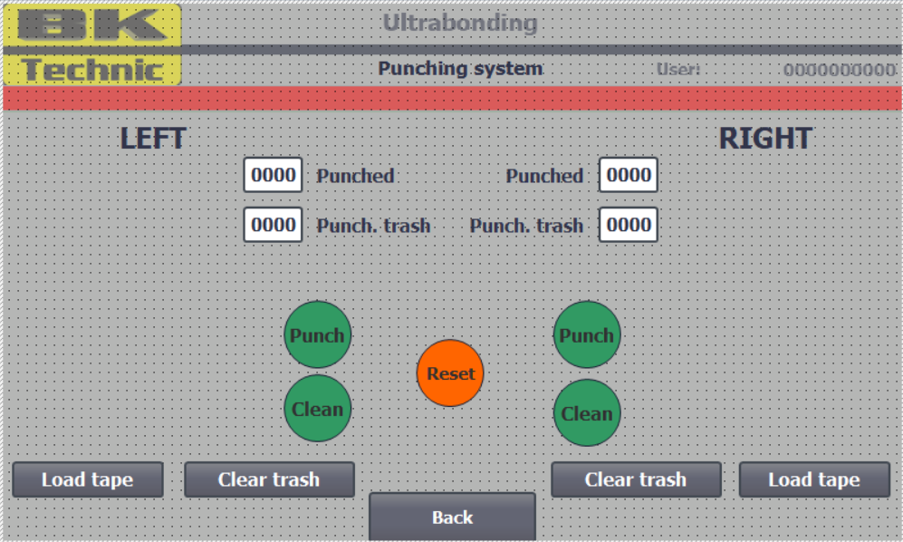Image 10: Punching mechanism manual control
When the plastic tape spool is replaced, then is necessary initial punch for make the hole on the tape. For this purpose is used button Load tape. This button starts initialization procedure for new tape and reset the counter Punched.
After empty the trash is necessary to press button Clear trash which reset counter Punch. trash

Tape locking
In this screen is possible to manual control cylinder positions for tape locking and tape end stop descending cylinder placed on linear cariages.
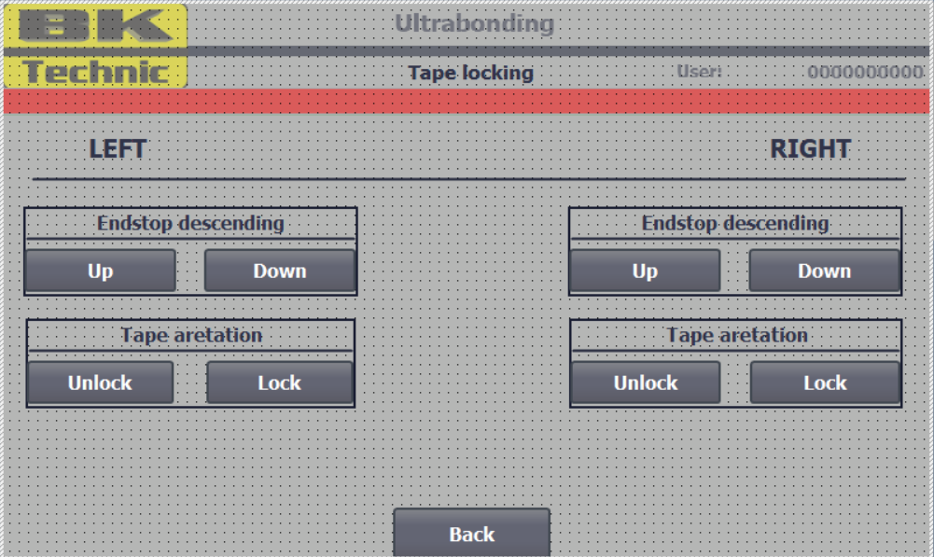Image 11: Tape locking manual control

Fabric locking
In this screen is possible to manual control position fabric locking cylinders
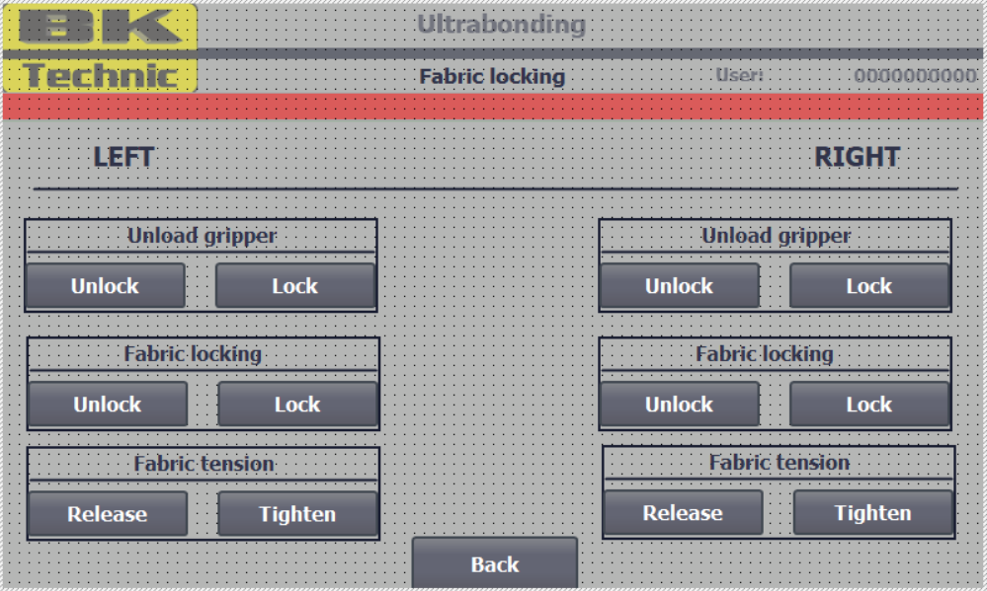Image 12: Fabric locking manual control

Servo-drive control
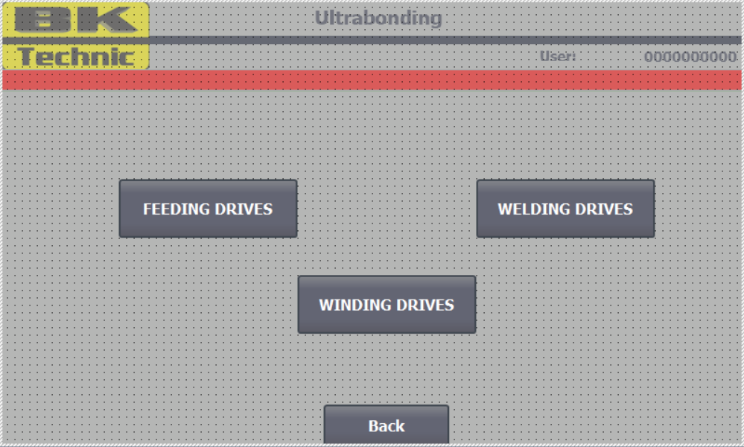Image 13: Servo-drive control

Feeding drives control
In this screen is shown current state of plastic tape feeding servo drives. It is possible manually jogging in forward or backward direction. After finishing the move, current position is automatically reset to zero. It is for necessary for continuously moving in forward direction during tape feeding in welding cycle.
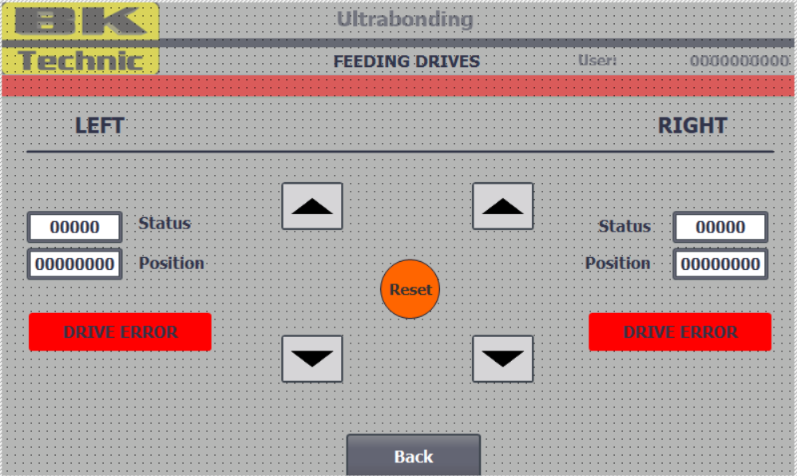Image 14: Feeding drives manual control

Welding drives
Screen for manual control of welding drives is similar to screen in previous Ultrabonding machines
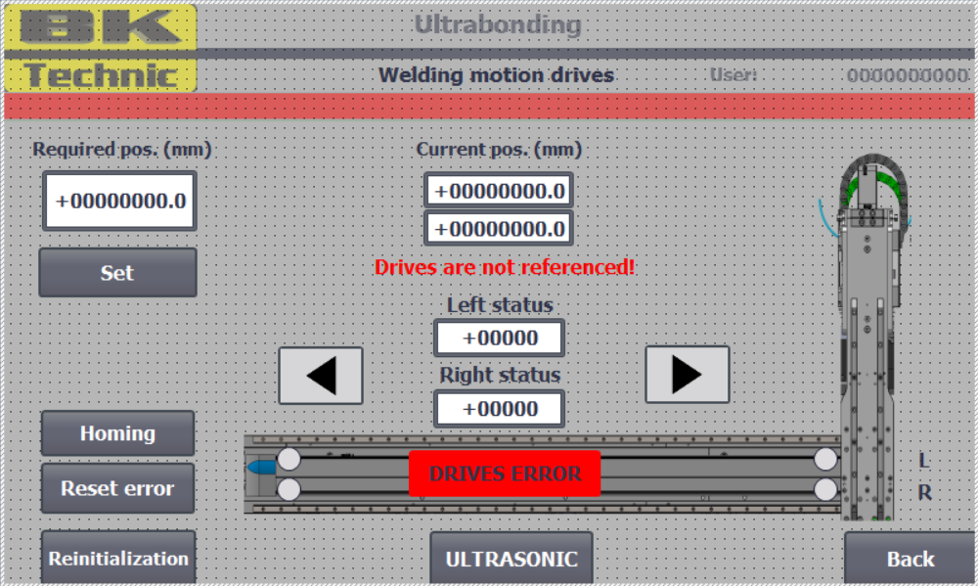Image 15: Welding drives manual control

Fabric winding drives
Screen for manual control of fabric winding drive is practically the same as screen for manual control of welding drives.
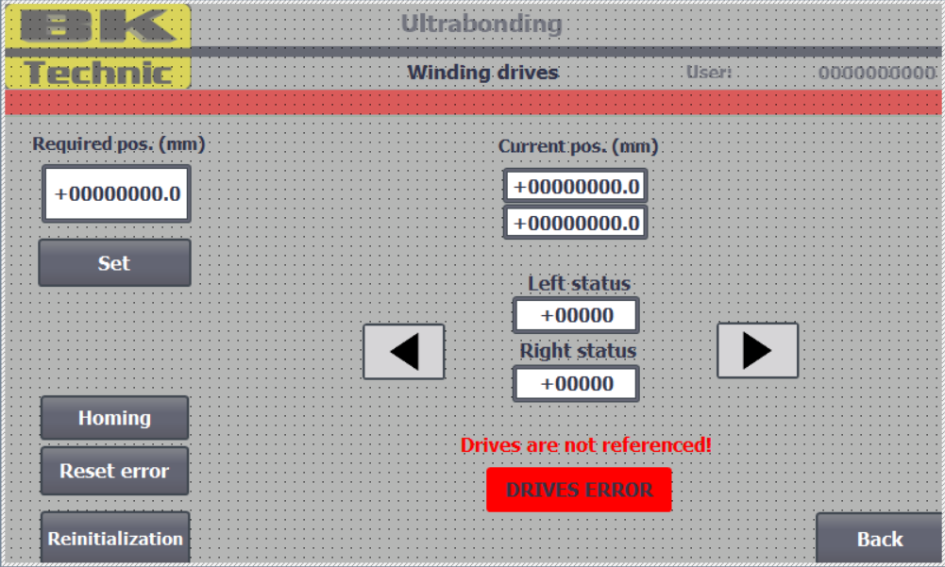Image 16: Fabric winding drives manual control

System alarms
In system alarm screen is one of the most important button, for machine control. This button is Reset error. This button is used for reset error states in control system.
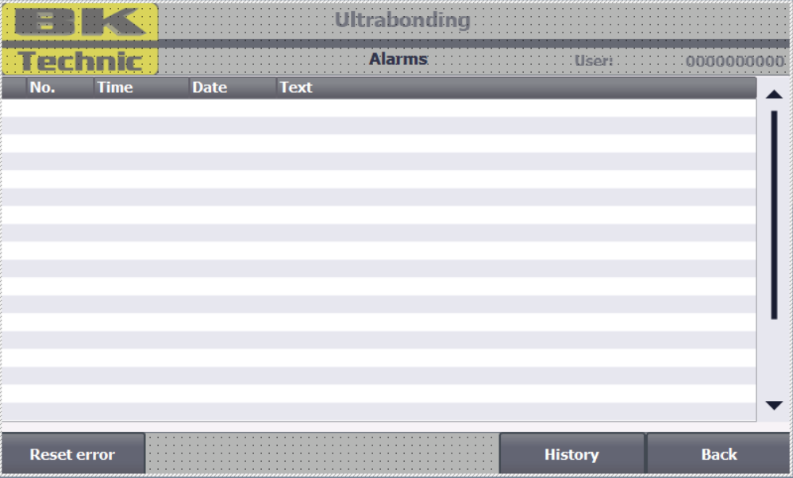Image 17: System alarms
In alarm screen is displayed list of current alarms and is possible to show also the alarm history by pressing the History button.
Every alarm automatically disappear after its solving.

Alarms overview
In control system is defined number of alarm states:
- Estop – Emergency stop was pressed, estop button release and alarm reset is expected
- Control circuites – Control ciruites are not actived, pressing white button under main hmi is expected
- Air pressure – Air pressure is not detected in main air pressure controler, check air input to machine or check control circuite ativation or estop was actived
- Left sonotrode pressure out range during welding - corresponding to pressure watching setup
- Right sonotorode pressure out of range during welding – corresponding to pressure watching setup
- Left carriage out of configured position – corresponding to tape length settings in welding program
- Left carriage out of configured position - corresponding to tape length settings in welding program
- Manual mode – manual mode is actived and it is not possible to start production cycle
- Work sequence initialization error – error during machine initialization
- Work sequence error – error during production see another alarms
- Left punch – tape loading error – loading procedure was not successful
- Right punch – tape loading error – loading procedure was not successful
- Tape not in end position – during tape feeding the tape is not arrived to end stop position
- Tape not in presence sensor – during tape feeding in work cycle before punching the tape is not on the laser presence sensor
- Reserve
- Reserve
- Cylinder LPV17 reference sensor SE17.1 – given reference sensor was not actived during cylinder moving
- Cylinder LPV17 reference sensor SE17.2 – given reference sensor was not actived during cylinder moving
- Cylinder RPV18 reference sensor SE18.1 – given reference sensor was not actived during cylinder moving
- Cylinder RPV18 reference sensor SE18.2 – given reference sensor was not actived during cylinder moving
- Cylinder LPV19 reference sensor SE19.1 – given reference sensor was not actived during cylinder moving
- Cylinder LPV19 reference sensor SE19.2 – given reference sensor was not actived during cylinder moving
- Cylinder RPV20 reference sensor SE20.1 – given reference sensor was not actived during cylinder moving
- Cylinder RPV20 reference sensor SE20.1 – given reference sensor was not actived during cylinder moving
- Cylinder LPV21 reference sensor SE21.1 – given reference sensor was not actived during cylinder moving
- Cylinder LPV21 reference sensor SE21.2 – given reference sensor was not actived during cylinder moving
- Cylinder RPV22 reference sensor SE22.1 – given reference sensor was not actived during cylinder moving
- Cylinder RPV22 reference sensor SE22.2 – given reference sensor was not actived during cylinder moving
- Cylinder LPV13 reference sensor SE13.1 – given reference sensor was not actived during cylinder moving
- Cylinder LPV13 reference sensor SE13.2 – given reference sensor was not actived during cylinder moving
- Cylinder RPV14 reference sensor SE14.1 – given reference sensor was not actived during cylinder moving
- Cylinder RPV14 reference sensor SE14.2 – given reference sensor was not actived during cylinder moving
- Cylinder LPV15 reference sensor SE15.1 – given reference sensor was not actived during cylinder moving
- Cylinder LPV15 reference sensor SE15.2 – given reference sensor was not actived during cylinder moving
- Cylinder RPV16 reference sensor SE16.1 – given reference sensor was not actived during cylinder moving
- Cylinder RPV16 reference sensor SE16.2 – given reference sensor was not actived during cylinder moving
- Cylinder LPV09 reference sensor SE09.1 – given reference sensor was not actived during cylinder moving
- Cylinder LPV09 reference sensor SE09.2 – given reference sensor was not actived during cylinder moving
- Cylinder RPV10 reference sensor SE10.1 – given reference sensor was not actived during cylinder moving
- Cylinder RPV10 reference sensor SE10.2 – given reference sensor was not actived during cylinder moving
- Cylinder LPV11 reference sensor SQ55 – given reference sensor was not actived during cylinder moving
- Cylinder LPV11 reference sensor SQ5 – given reference sensor was not actived during cylinder moving
- Cylinder LPV12 reference sensor SQ66 – given reference sensor was not actived during cylinder moving
- Cylinder LPV12 reference sensor SQ6 – given reference sensor was not actived during cylinder moving
- Reserve
- Reserve
- Reserve
- Reserve
- Punching mechanism error – see another alarms
- Left punching mechanism tape spool near empty – replace the tape spool and press button “Load tape” in punching system manual control screen in HMI
- Left punching trash full – empty the trash in left punching and press “Clear trash” in punching system manual control screen in HMI
- Right punching mechanism tape spool near empty - replace the tape spool and press button “Load tape” in punching system manual control screen in HMI
- Right punching trash full – empty the trash in left punching and press “Clear trash” in punching system manual control screen in HMI
- Left feeding drive not ready – check control circuite is actived, estop, punching door are closed or peripheral scanners
- Right feeding drive not ready – check control circuite is actived, estop, punching door are closed or peripheral scanners
- Welding drives not ready - check control circuite is actived, estop, punching door are closed or peripheral scanners
- Winding drives not ready - check control circuite is actived, estop, punching door are closed or peripheral scanners
- Reserve
- Reserve
- Reserve
- Reserve
- Punching cylinders released – punching cylinders are released by button in settings screen in HMI and is not possible to use them
- Reserve
- Reserve
- Left sonotrode invalid welding program – welding program is out of range
- Left sonotrode system fault – check sonotrode drive inside electricity box
- Left sonotrode process fault – welding fault
- Left sonotrode not ready - check sonotrode drive inside electricity box
- Left sonotrode error – error during welding, reset the error
- Right sonotrode invalid welding program – welding program is out of range
- Right sonotrode system fault – check sonotrode drive inside electricity box
- Right sonotrode process fault – welding fault
- Right sonotrode not ready - check sonotrode drive inside electricity box
- Right sonotrode error – error during welding, reset the error
- Reserve
- Reserve
- Reserve
- Reserve
- Reserve
- Reserve

Image table
Image 1: General screen look 1
Image 2: Main screen overview 2
Image 3: Welding program settings 4
Image 4: System settings 5
Image 5: User management 6
Image 6: Carriages configuration 7
Image 7: Pressure watching setup 8
Image 8: Manual control 9
Image 9: Sonotrodes manual control 10
Image 10: Punching mechanism manual control 11
Image 11: Tape locking manual control 12
Image 12: Fabric locking manual control 13
Image 13: Servo-drive control 14
Image 14: Feeding drives manual control 15
Image 15: Welding drives manual control 16
Image 16: Fabric winding drives manual control 17
Image 17: System alarms 18

Human interface – device for control and machine overview

