***Travellers’ Aid Society***

Providing Excellence for travellers since 488

***Travellers’ Aid Society***

Most Class A starports

X-Boat: TAS

www.liberated--technologies.com

Second to none lifetime member benefits and the trust you deserve!

**How do I join?**

**TAS membership may be acquired upon mustering out of a service. It is given as a reward for heroism or extraordinary service to the Society, rather than an "official" benefit of the service involved.**

1. **Membership may also be purchased, at a cost of MCr1.**
2. **Member-sponsored membership is provided when another, usually high ranking Member, champions a candidate to the Society’s Membership Review Board. The candidate must provide essential value to the Society to waive the standard membership entry requirements.**

**When can I start using my membership?**

**From application to notification, the duration of notification is usually sixty days. Notification will be sent via X-Boat message starting with facilities closest to the origin of application outwards. Presenting proper identification to a TAS facility after notification is all that is required to activate your membership.**

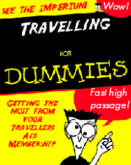

Best-selling guidebook included with membership

What is the Travellers’ Aid Society?

The Travellers’ Aid Society (“TAS”), a private club of interstellar wanderers and adventurers, has been serving the galaxy’s finest since 488. TAS has made efforts to have a presence at all Class-A and most Class-B starports throughout charted space. TAS does not accept just anyone as a member, extensive background checks, other member sponsorship, and character tests are performed to ensure the candidate meets the TAS standards.

Membership is for the life of the member and is not transferable. TAS invests its membership fees and other income; it uses its capital to provide benefits to members. Every two months it pays dividends in the form of one High Passage ticket to each member. This ticket may be used, retained, or sold.

Member Benefits

TAS membership includes a lifetime of rewards and benefits.

* Bi-monthly high passage ticket
* Access to all TAS facilities
* Library research access
* Legal representation
* Language translation
* Star charts
* Identification and credit services
* Travellers; News Service (TNS)
* Conventions
* Secure communication services
* System reviews
* Top-rated accommodations
* Background checks
* Career services
* Financial services
* Product discounts

Membership Levels

Your membership advantages don’t just stop with joining, TAS offers additional benefits through membership levels/ranks. Become one of the elite few who rise through the Society’s ranks. From Level 1 Charter Member, through Level 9 Lanthanum Member, you will be amongst respected peers.

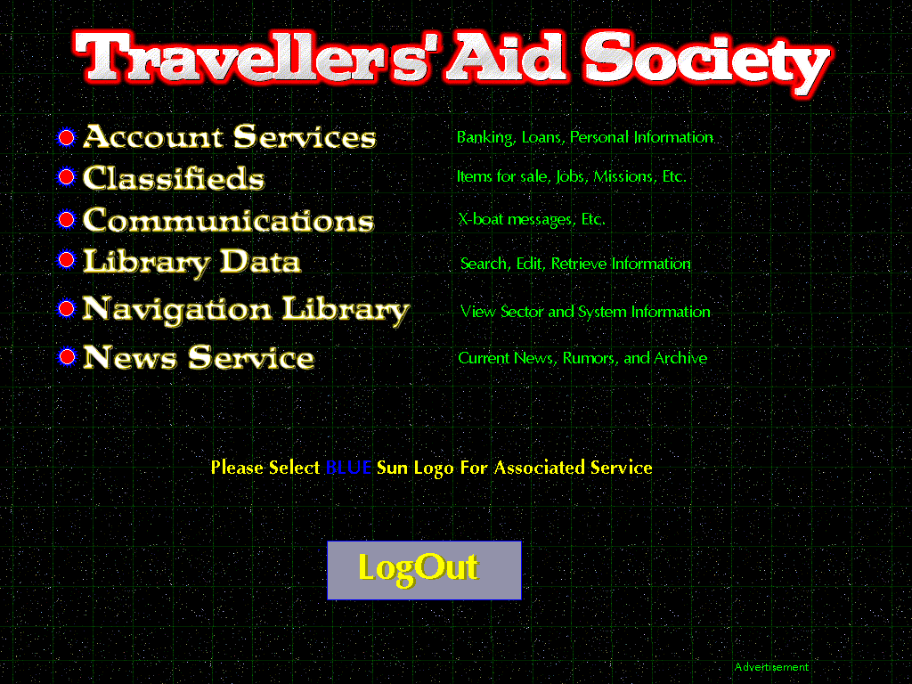

"The difference between a 'tourist' and a 'traveller' is that the tourist gets himself into trouble and then can't get out, while the traveller gets himself into trouble and then saves himself somehow."

Travellers' Digest #13

|  |  |
| --- | --- |
| **Access Level** | **Membership** |
| 0 | none |
| 1 | Charter Member |
| 2-3 | Bronze Member |
| 4-7 | Silver Member |
| 8 | Gold Member |
| 9 | Lanthanum Member |



Always Here for You

Consider TAS as your personal concierge and safe-haven for all of your travels and endeavors. From our top-rated hotels and hostels, to our up-to-date system reviews and travel notifications, you can rest well and sure that someone is looking out for you.