**Background**

Relocating for new job opportunities can be a stressful and daunting ordeal, especially when relocating to large cities like New York, Chicago, or Los Angeles. Where should you live given the type and amount of jobs available in your domain of expertise? Does one part of the city cater to a particular labor market compared to other parts of the city?

Having convenient answers to these questions may significantly reduce the stress associated with relocation. In this research, a team of data scientist will investigate the distribution of job opportunities, throughout the various boroughs of New York City.

**Research Question**

*How are job vacancies geospatially distributed across New York City boroughs?*

**Data (3,123 Rows; 28 Columns)**

Link: https://www.kaggle.com/new-york-city/new-york-city-current-job-postings

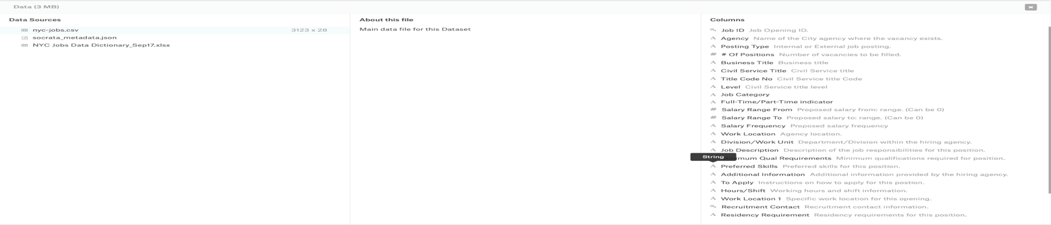

**Visualization Prototypes (3 – 4 inspirational screenshots)**

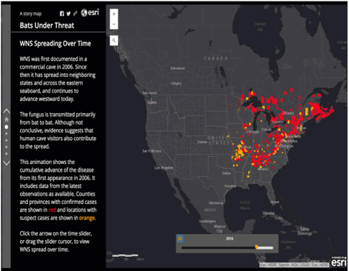 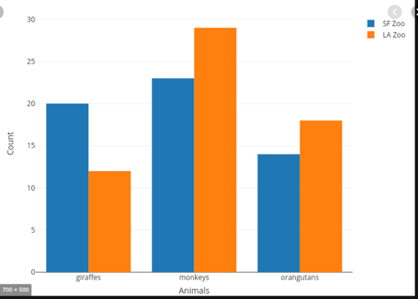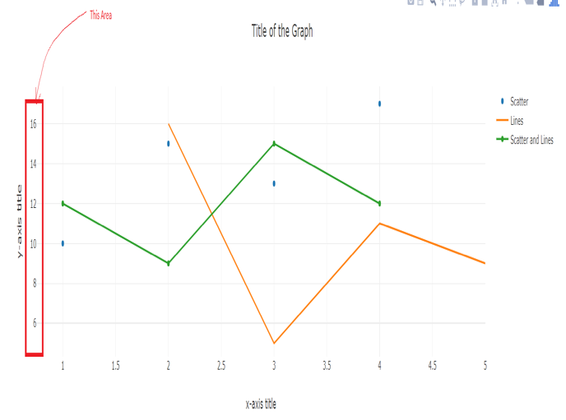

**Sketch of Final Design**

(See Attachment)

**Github Link:** https://github.com/phortitude/DataViz-Project2-TeamBlue.git

