**theClock v3.2 - Quick Start Guide**

Welcome to theClock v3.2 !!

This clock has been especially **hand-crafted** for **YOU**.



**PACKING LIST:**

* **Hand Made Wooden Clock**
* **5V Power Supply**
* **Allen Wrench**

[**https://github.com/phorton1/Arduino-theClock3**](https://github.com/phorton1/Arduino-theClock3)

**Quick Start Overview**

* Unpacking
* Preparation
* Power Up!
* Connect to the Clock -- Change Default Password -- Specify Wi-Fi SSID and password -- Verify Connection
* Reboot
* Start Clock Synchronized
* Brief Description of LEDs
* Stop the Clock
* Changing the LED brightness
* Getting to the WebUI

**1. Unpacking**

* Open the box and remove piece(s) of styrofoam as needed.
* Remove the **power supply** and **baggy with allen wrench** from the lower portion of the clock.
* Remove **the Clock** from the box and **carefully** remove it from the **plastic bag**.
* Place the Clock it on a flat level surface.
* Remove the **pieces of cardboard** at the top of the clock that are securing the mechanism.
* From the back **remove the piece of green tape** and the **pieces of cardboard** that are securing the pendulum.

**2. Preparation**

Efforts were made to ensure that the clock would not be damaged during transport. However, some shifting may have taken place during shipping, and so, before anything else we need to make sure that the mechanism is properly aligned and engaged, that the pendulum swings freely, that the gears turn correctly, and that the hands are aligned so that they don't collide.

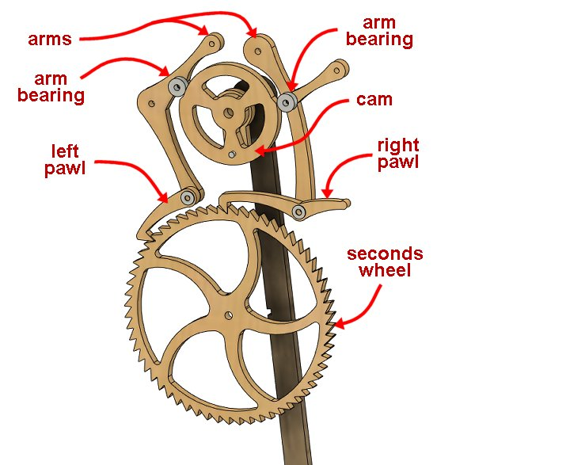

* From the top of the clock, the two **pawls** should be resting directly on top of the **seconds wheel**
* The **pawls** and **arms** should move freely.
* The **arm bearings** should be riding squarely on the **cam**
* The **hands** should be square to the tubes they are connected to with approximately equal spacing between them. Adjust them slightly as necessary to ensure that they don't hit each other as they turn.
* You should be able to move the **seconds hand** (which is connected to the *seconds wheel*) clockwise and the **pawls** should go "clickity-clack" as the second hand moves.
* There should be **very little resistance** when moving the second hand!!
* As you move the second hand clockwise multiple revolutions, the minute hand and hour hand **should move** slightly, but noticeably, so.
* The **penduluum** should swing freely in the middle of the **channel** and not touch the plastic at any point.
* The **pendulum** should swing 4-5 times back and forth when released from an extreme position. It should NOT swing only once or twice and then stop.

If the **pawls** are not moving freely you can use a Phillips screwdriver to loosen their screws slightly. If the **arms** are not moving freely, you can use the included Allen wrench to loosen their bolts slightly. Jiggle stuff around!

If the pendulum is not aligned to the middle of the channel, you can move it on its shaft, but please refer to the online **Trouble Shooting** guide for detailed instructions on how to adjust it if you cannot get it aligned to the channel.

At this point you should be able to swing the pendulum back and forth, and the clock should tick-tock, with each pawl, in turn, grabbing and turning the seconds wheel clockwise. You can put your index finger into the hole on the top of the clock and move the pendulum back and forth and it should not take much force to keep the pendulum moving and the clock ticking.

**3. Power Up**

When the clock is mechanically ok and everything is nice and loosy-goosey it is time to connect the power supply and boot it for the first time.

You can connect the USB power supply from the left, or right of the clock as you desire.

When the USB power supply is connected the computer will boot, and you will (should) see the five LEDs on the front of the clock light up in **cyan** from left to right, followed by various other LED colors as the clock boots.

When the clock has successfully booted for the first time, the **left most LED should be purple** and no other LEDs should be lit, and particularly **NO LEDS SHOULD BE FLASHING!!** Please see the online **Trouble Shooting** guide or contact me if you see flashing LEDs!

The meaning of the LEDs is described a bit more fully below, but for now suffice it to say that the **Left Purple LED** indicates that the clock is in **AP (Access Point)) Mode** which means that you can connect to it via Wi-Fi.

**4. Connect to the Clock (in Access Point Mode)**

When the clock is in **AP (Access Point)) Mode** (the left-most LED is **purple**) it will show up on your home computer or phone as a **Wi-Fi Network** to which you can attach. *You will now* ***connect*** *to the clock, be required to* ***change it's password****, and then will tell it how to* ***connect to your home Wi-Fi network****. By connecting to your home Wi-Fi network (and presumably to the internet via that) the clock will have access to the* ***NTP (Network Time Protocol)*** *from which it can find the correct time.*

Just in case you are concerned, **apart from connecting to NTP, the clock does not use or present itself in any way to the internet!!** However, once it is connected to your home Wi-Fi network, **YOU** will be able to access it via a browser based **WebUI** if you so wish.

In any case, please perform the following steps to connect the clock to your Wi-Fi network.

* From a laptop or home computer (preferable) or phone/tablet connect to **theClock3** access point.
* The default password is **11111111** (eight ones).

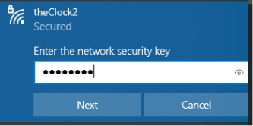

* After a few seconds your system **browser should automatically pop up** with a (redirect page and then) a page which requires you to set a **new password**. On some newer Android phones this page does not pop up automatically. IF YOU DON’T SEE THE BELOW WINDOW, please open a browser on your machine and enter **192.168.1.254/captive** into the location bar to bring up the clock’s AP Mode UI (user interface).
* Enter (and re-enter) and **write down!!** a new password for your clock's AP Mode. You will need this password (or a Factory Reset) in the future if you change your home network SSID or credentials.

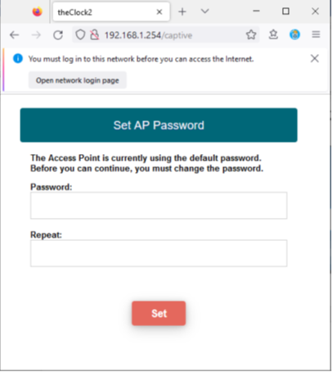

* After you set the new password, you will be presented with a page that allows you to tell the clock the **SSID** and **password** of your home Wi-Fi network.
* These credentials are stored in an encrypted form on the clock's computer and will *never be shown to anyone.*

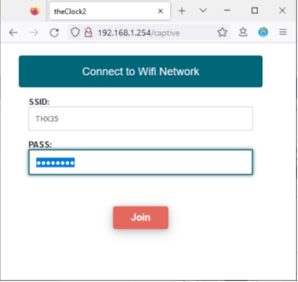

* **Enter the SSID and password of your home Wi-Fi network** and press the **Join Button**.
* If, after 15 seconds or so, **you do NOT receive an error message, then everything worked ok!!**

That's it! The only thing that can be done from **AP Mode** is to tell the clock a Wi-Fi network to connect to.

The clock *tries* to report when it has successfully connected to your home Wi-Fi network, but, because it cannot be connected in both AP and STA mode at the same time (unless your home Wi-Fi network *happens* to be on the same "channel" as the clock's AP mode), typically it is not able to report to the browser that it connected successfully. However, you may get lucky and see a message of the form "theClock3 successfully connected to Y**OUR_SSID** at IP Address [XXX.XXX.XXX.XXX](http://XXX.XXX.XXX.XXX)".

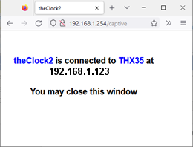

In any case, **if you DONT see an error message at this point** after 10-15 seconds then the clock has successfully connected to your home Wi-Fi network. If you **DO RECEIVE AN ERROR MESSAGE,** please re-enter the SSID and password and try again. You can reboot the clock (disconnect and reconnect the power supply) and try this again. You may need to reboot your laptop/tablet/phone, although everything *should* work the first time through.

When the clock is connected to your home wifi network, it is said to be in **Station (STA) Mode** and the leftmost LED will turn **green.**

**5. Reboot**

Once you have connected the clock to your Wi-Fi network, you may disconnect from it and *reconnect your Laptop/Tablet/Phone to your home Wi-Fi network*. When you do so (and thus have disconnected from the Clock), after about 15 seconds, the leftmost LED should change from **purple to green**. When the leftmost LED is **green,** it indicates the Clock is correctly attached to your home Wi-Fi network in **STA Mode**.

If after 15 seconds or so the LED does NOT turn **green**, you may need to reboot the clock by disconnecting and reconnecting the USB power supply.

**It is not a bad idea to reboot the clock in any case at this point**.

When you reboot and the clock connects to your Wifi network, the same pattern of LEDs should occur (the five LEDS will light up left-to-right in **cyan**, and then various other colors will show) except for now, when the boot is complete, only the left-most LED should be on, and it should be **green**.

**6. Starting the Clock (Synchronized)**

For this step you will need a toothpick, or other item (you can use the included Alen wrench) that you can insert into the **left** hole on the front of the clock to press a button.

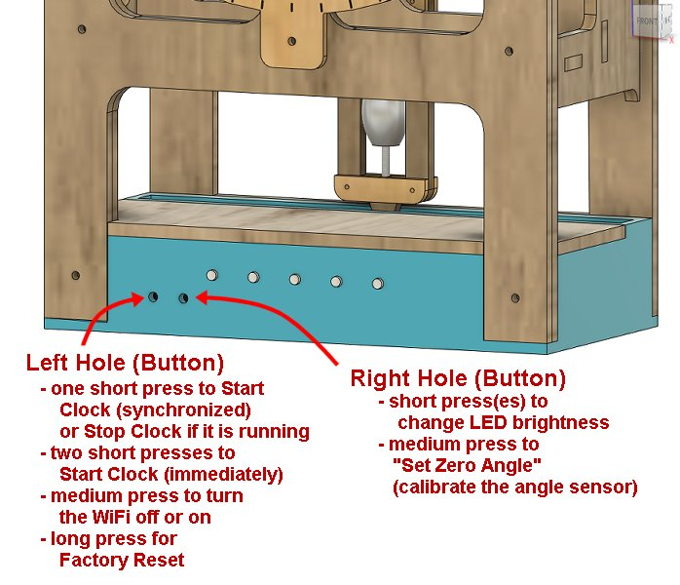

You will also need a reference clock for the current time. I typically use the clock on my computer which conveniently shows the seconds in a HH:MM:SS format. If you use a clock that does not have a seconds hand as the reference, then you will need to notice when the minute on your reference clock changes.

The idea is that we set the clock up so that it is pointing at the correct time for the **next minute** crossing, then we will press the left button **once briefly** sometime during the minute before the start time, and, when the clock notices that it is time to start, it will start ticking, hopefully within 1 or 2 seconds of the correct time.

* Move the **seconds hand** clockwise (clickity-clack) until it is pointing straight up at 12 o’clock.
* Move the hour hand to the correct position ... it is designed to slip on the shaft. Note that if you are starting the clock at 11:30, for example, the hour hand should be about halfway between the 11 and the 12.
* Move the minute hand to the **next minute** that will occur. So, if your reference clock shows 11:29, set the minute hand to the 30 minute position (pointing straight down at the 6).
* Sometime during the minute before the clock should start **press the left button** with the toothpick **one time briefly**.
* The 2nd LED should turn **white** indicating that the clock is waiting to do a synchronized start.
* When the clock's internal computer thinks it is appropriate (a parameterized number of milliseconds before the minute crossing), it will deliver the initial impulse to start the pendulum moving.

At that point 4 of the 5 LEDs will light up in various colors. The clock should start ticking. Hopefully it will be within a second or two of the correct reference time.

It can take up to a few minutes for the clock to stabilize and a description of that process, and describing the colors of the LEDs during that process is beyond the scope of this Quick Start guide.

Suffice it to say that for up to a few minutes the LEDs will show a variety of colors. Within 5 minutes or so, there should be **four green (or close to green) LEDs**.

Generally speaking **four green (or close to green) LEDs** indicates that the clock is running correctly and is accurate to within a few milliseconds of the correct time.

**7. Brief Description of the LEDs**

**Four green-ish LEDs** indicate that the clock is running normally.

The LEDs, from left to right, have the following meanings

* the **left most LED** is **the System LED** and shows the status of the system, particularly the state of the **Wifi Connection**.
* the **second LED** is the **Clock State LED** it shows if the clock is running or not, and what stage of the startup process it is in.
* the **third (middle) LED** is the **Clock Accuracy LED**. If it is **green** then the clock is running, overall, within a few milliseconds of the correct time. The color shifts to **blue-ish** tints if the clock is running slightly slow, or **red-ish** tints if it is running slightly fast, overall
* the **fourth (second from right) LED** is the **Cycle Accuracy LED** which shows the accuracy of each swing of the pendulum. As with the *clock accuracy LED* if this LED is green, it means that the pendulum is swinging within a few milliseconds of one swing per second. It turns **blu-ish** as the pendulum swings slightly slower, or **red-ish** as the pendulum swings slightly quicker.
* the **fifth (right-most) LED** is the **Sync LED**. It lights up every so often when the clock is doing a *synchronization cycle*. As with the *clock accuracy LED* it is **blue** if the clock needs to speed up, or **red** it needs to slow down.

It is normal for the 3rd and 4th LEDs to shift slightly from **green** to **red-ish** or **blue-ish** and **it is normal for the 5th (right most) LED** to occasionally light up as **red** or **blue** and work it's way to **green** and then turn itself off.

What you are seeing is the process of the clock correcting itself.

So, for example, the *clock accuracy LED* may shift slightly towards **blue,** indicating that the clock, overall, is running a little slow. To compensate, the pendulum will swing a little quicker, and the *cycle accuracy LED* will shift slightly towards a **red** color as it speeds up. The clock accuracy LED will then return from **blue-ish** to **green** as the clock catches up to the correct time, and the clock cycle led will shift from red-ish to **green** as the cycle is adjusted.

This process is continuous.

In general the clock is busy counting the milliseconds for each beat and doesn't really pay attention to the time. It just tries to keep the pendulum swinging at or near 1000ms and minimize the cumulative error in that process.

However, once per hour (parameterized) the clock compares the number of milliseconds it has counted off to the number that should have occurred based on the RTC (Real Time Clock) in the computer. If there is a difference (which is normal due to the algorithms used), then the clock will enter a *synchronization cycle* where it speeds up, or slows down, as necessary to get the number of beats to agree with the computer's RTC.

Typically, once per hour the clock will speed up (or slow down) by 20-30 milliseconds. This adjustment is spread out over up to 1-3 minutes. If the **sync LED** stays on for more than 2 or 3 minutes this means the clock is having a hard time speeding up or slowing down and probably indicates that an adjustment or lubrication is needed.

It's complicated!

If at any time the clock is found to be running faster (or slower) than 3 seconds from the correct time, then the **clock accuracy LED will flash red or blue**. In correct operation this should not happen, but if it does it means that the clock likely needs a physical adjustment or lubrication of some kind, and you should refer to the **User Manual** or **Trouble Shooting Guide** for more information.

Finally, once every 3 hours (parameterized) the clock will compare the RTC (Real Time Clock) to the NTP (Network Time Protocol) time, and adjust the RTC accordingly. Typically, this will result in a change of, say, 100 milliseconds (plus or minus) or so, or a second or two total per day, overall. This will in turn, at the next hour, trigger a *synchronization cycle*.

In any case, with luck, you will generally see **four green-ish LEDs** indicating that the clock is running ok, and if they vary from that, then over a few minutes they should return to four green-ish LEDs.

**8. Stopping the Clock**

If the clock loses power, it will stop and will need to be restarted.

You can also explicitly **stop the clock** by pressing the left-button one time briefly while it is running. All LEDs except the left-most one should turn off indicating that the clock is no longer running.

When it has come to a complete stop, you can restart it as described in *6. Starting the Clock (Synchronized)* above.

FWIW, **two short presses of the left button** will *start the clock immediately* if it is not running, I generally prefer to use the *synchronized start* method as described here but if you are in a hurry, just set the current time on the clock and press the left button twice.

**9. Changing the LED brightness**

There are two buttons on the clock.

There is a difference between a **short press** (brief), **medium press** (more than 2 seconds), and a **long press** (more than 8 seconds) of the buttons.

The online **User Manual** will describe more fully what the buttons do, and you have already seen that **a short press of the left button** will *start the clock (synchronized)* when the clock is not running, and will *stop the clock* when it is running.

If you find the LEDs to be too bright or irritating, you can **short press the right button** to *change the LED brightness*. Successive presses will make the LED's brighter until their brightest, and then will cycle off and then to their minimum brightness to start the cycle over again. There are 15 levels of brightness for the LEDS.

**10. Getting to the WebUI**

To get to the WebUI for the clock all you need to know is the **IP Address** that your Wi-Fi network has assigned to the clock, and, if you go to that IP address from a web-browser, you will be connected to the **Web UI** which allows you to control the clock, but also can show you more detailed statistics about how it is running, to set various other modes of operation, and to tune and adjust the clock by changing various parameters.

Typically, once I have connected a clock to my own Wi-Fi network, I go to my router's browser-based UI and assign it a **fixed IP address** based on its MAC address and set a bookmark in my browser so that I can easily access the WebUI and check on the status and/or adjust the clock's parameters.

However, particularly if your home computer is a **Microsoft Windows** machine (i.e. Win10 or Win11), since **the clock is a valid SSDP device** (SSDP stands for "Service Search and Discovery Protocol"), it is worth knowing that if you **open Windows Explorer** and go to the **Network** location, and **right click in the window** and select **Refresh**, the clock *should* show up as a network device. Then, by merely double clicking on it's icon, a browser *should* pop up and show you the WebUI (and will also show you the IP address of the clock).

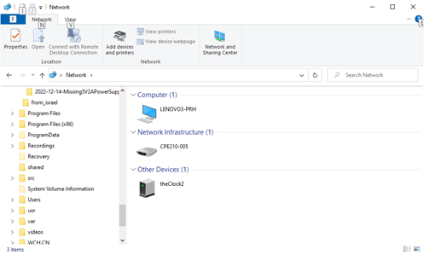

The **WebUI** is described more fully in the **User Manual** and on the **Tuning** documentation page, but it might be fun (?!?) to try this once and see if it works for you.

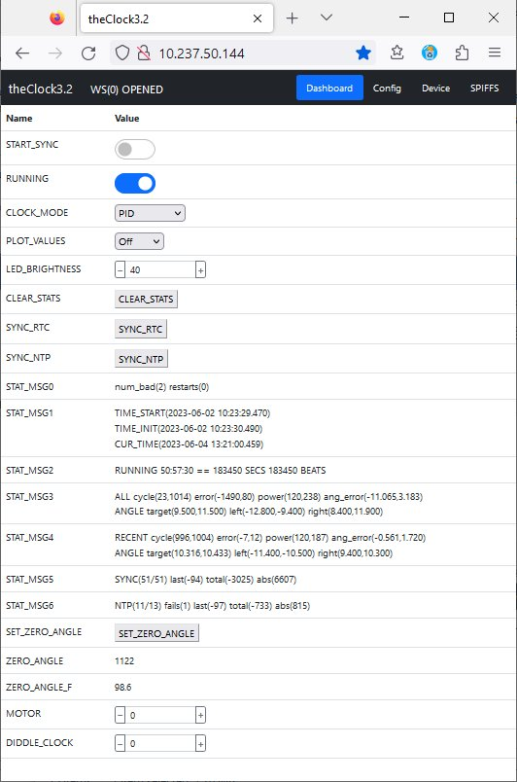

**Final Notes:**

Please visit [**https://github.com/phorton1/Arduino-theClock3**](https://github.com/phorton1/Arduino-theClock3) and view the web pages in the repository for many more details about the clock, it's design, construction, maintenance, and operation. Particularly, there you will find the **User Manual** for the clock.

Although you could theoretically merely unpack the clock, plug it in, and press the left button twice to start it ticking, **it is highly recommended that you follow this Quick Start guide** and **first connect it to your local WiFi network**, and use the **Synchronized Start** method to start the clock.

The clock is designed to **synchronize itself** to the Network Time Protocol (NTP) if it is given a Wi-Fi connection, with the idea that it should run within a second or so of the correct time for the foreseeable future (until, hopefully, at least the *Y2038 problem*, when Unix time will overflow 32 bits). If it is not connected to the internet, the best it can do is synchronize itself to the internal RTC (Real Time Clock) on the embedded computer, which, at best, will only be correct to within a few seconds a day.

* The clock was shipped to you after a fresh **Factory Reset**. You can, at any time, return the clock's software to it's initial state by issuing a Factory Reset as described in the **User Manual**.
* The **Wifi has been enabled by default**. It can be turned off (as described in the **User Manual**). Substantial efforts were put into ensuring that the clock does not create any significant security risk to your home network, but just in case, I added the ability for you to disable the clock's Wifi access entirely.
* Although I have tried my best to produce a reliable clock, **some maintenance may be necessary**. In particular it may be necessary once every few years, or more often, to lubricate the bearings and brass tubes.
* **PLEASE DO NOT TURN THE SECONDS HAND COUNTER-CLOCKWISE!!** The hands are merely compression fitted to the brass tubes, and the seconds hand was intentionally designed to be a tighter fit. It is not intended to slip on it’s shaft, whereas the hour and minute hands ARE intended to slip on their shaftsin order to for you to be able to set the time. **When moving the seconds hand** please always turn it **clockwise**!! It should turn the *seconds wheel* smoothly and go "clickity-clack" as the pawls slide over the seconds wheel.
* **ANY FLASHING LEDS ARE INDICATIVE OF A PROBLEM**. If you see any LEDS that are flashing regularly (once per second or so) it means something is wrong!! Please see the online **Trouble Shooting** guide or contact me if you see flashing LEDs!

That’s it for now! I hope you enjoy your new clock!

- Patrick