GDAT 622 Investigation 6

Pavan Hothi

7/5/2020

I will be pulling and looking at the last 500 tweets of Nike.

get_timeline(c("Nike"), n = 500) -> nike

Keeping only the reply screen name and tweet text replied with.

nike %>%  
 select(., reply_to_screen_name, text) %>%   
 na.omit(.) %>%  
 distinct(.) -> nike

Plot

graph.data.frame(nike) -> nike_graph  
plot(nike_graph, vertex.label = NA)

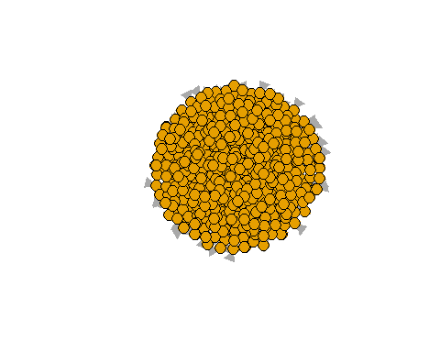

Pull Nike’s following list in order to better understand interactions.

get_friends(415859364) -> nike_following

Get following lists of some of Nike’s following.

get_friends(23151437) -> following1  
get_friends(2511477648) -> following2  
get_friends(21870081) -> following3  
get_friends(184241421) -> following4  
get_friends(69347129) -> following5

Combine following lists

bind_rows(nike_following, following1, following2, following3, following4, following5) -> following_combined

Plot

graph.data.frame(following_combined) -> following_combined_graph  
plot(following_combined_graph)

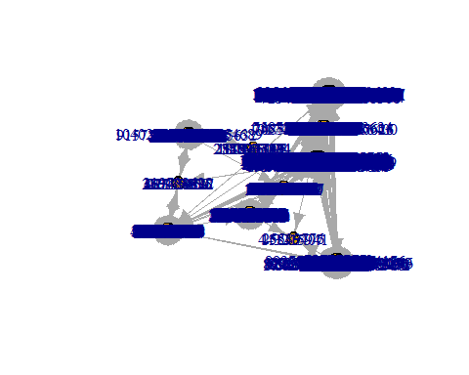

Look up one of the connections

lookup_users("71026122")

## # A tibble: 1 x 90  
## user_id status_id created_at screen_name text source  
## <chr> <chr> <dttm> <chr> <chr> <chr>   
## 1 710261~ 12799729~ 2020-07-06 02:58:37 McDonalds @bre~ Sprin~  
## # ... with 84 more variables: display_text_width <int>,  
## # reply_to_status_id <chr>, reply_to_user_id <chr>,  
## # reply_to_screen_name <chr>, is_quote <lgl>, is_retweet <lgl>,  
## # favorite_count <int>, retweet_count <int>, quote_count <int>,  
## # reply_count <int>, hashtags <list>, symbols <list>, urls_url <list>,  
## # urls_t.co <list>, urls_expanded_url <list>, media_url <list>,  
## # media_t.co <list>, media_expanded_url <list>, media_type <list>,  
## # ext_media_url <list>, ext_media_t.co <list>,  
## # ext_media_expanded_url <list>, ext_media_type <chr>,  
## # mentions_user_id <list>, mentions_screen_name <list>, lang <chr>,  
## # quoted_status_id <chr>, quoted_text <chr>, quoted_created_at <dttm>,  
## # quoted_source <chr>, quoted_favorite_count <int>,  
## # quoted_retweet_count <int>, quoted_user_id <chr>,  
## # quoted_screen_name <chr>, quoted_name <chr>,  
## # quoted_followers_count <int>, quoted_friends_count <int>,  
## # quoted_statuses_count <int>, quoted_location <chr>,  
## # quoted_description <chr>, quoted_verified <lgl>,  
## # retweet_status_id <chr>, retweet_text <chr>,  
## # retweet_created_at <dttm>, retweet_source <chr>,  
## # retweet_favorite_count <int>, retweet_retweet_count <int>,  
## # retweet_user_id <chr>, retweet_screen_name <chr>, retweet_name <chr>,  
## # retweet_followers_count <int>, retweet_friends_count <int>,  
## # retweet_statuses_count <int>, retweet_location <chr>,  
## # retweet_description <chr>, retweet_verified <lgl>, place_url <chr>,  
## # place_name <chr>, place_full_name <chr>, place_type <chr>,  
## # country <chr>, country_code <chr>, geo_coords <list>,  
## # coords_coords <list>, bbox_coords <list>, status_url <chr>,  
## # name <chr>, location <chr>, description <chr>, url <chr>,  
## # protected <lgl>, followers_count <int>, friends_count <int>,  
## # listed_count <int>, statuses_count <int>, favourites_count <int>,  
## # account_created_at <dttm>, verified <lgl>, profile_url <chr>,  
## # profile_expanded_url <chr>, account_lang <lgl>,  
## # profile_banner_url <chr>, profile_background_url <chr>,  
## # profile_image_url <chr>

Funnily enough, it appears that the McDonald’s twitter account has some connections to some of the same accounts as Nike’s twitter. Wouldn’t have expected a fast food chain to have connections with an athletic company.