

**Project-Report**

**Project Name : Wheather Report(2023)**

**Course : BCA-Data Science**

**Subject : R Programming Lab Subject code: 24CAP-161**

**Submitted by: Submitted to :**

Shlok Mahajan Shivani Chadha

UId : 24BCD10032

Section : BCD-1 (B)

# ****Weather Data Analysis Report****

## ****Objective****

The primary objective of this analysis was to **examine weather patterns** (temperature, humidity, and wind speed) over a one-month period (January 2023) to:

1. **Identify trends and fluctuations** in daily weather conditions.
2. **Assess relationships** between different weather variables (temperature, humidity, wind speed) using correlation analysis.
3. **Visualize key patterns** through time-series plots, heatmaps, and area charts to enhance interpretability.
4. **Categorize days** based on temperature thresholds ("Hot," "Cold," or "Moderate") to simplify insights for decision-making.

## Methodology

### 1. Data Preprocessing

The analysis began with preprocessing the raw weather data to ensure quality and consistency:

* Loaded the dataset from "weather_data.csv" (not shown in provided files)
* Checked for NA values across all columns (na_summary)
* Calculated daily averages for temperature, wind speed, and humidity
* Created categorical insights ("Hot day", "Cold day", "Moderate day") based on temperature thresholds
* Saved processed data to "daily_weather_insights.csv"

### 2. Analysis Techniques

Three primary analytical approaches were used:

**Correlation Analysis:**

* Computed Pearson correlation coefficients between all numeric variables (temperature, wind speed, humidity)
* Visualized relationships using a heatmap with diverging color scale (-1 to +1)

**Temporal Trend Analysis:**

* Examined patterns over time for temperature and humidity
* Used daily averaging to smooth intra-day variability
* Implemented weekly date breaks for clearer visualization

**Descriptive Statistics:**

* Calculated central tendencies (mean values) for all weather variables
* Categorized days based on temperature thresholds

## Key Findings

### 1. Temperature Trends (January 2023)

* All days fell within "Moderate day" category (15-30°C range)
* Average temperatures ranged from 22.8°C to 26.9°C
* Relatively stable pattern with minor fluctuations
* No extreme hot or cold days during the period

### 2. Humidity Patterns

* Consistently high humidity throughout the month (71.7%-80.5%)
* Peak humidity on January 14 (80.5%)
* Lowest humidity on January 4 (71.7%)
* No strong seasonal pattern within this one-month window

### 3. Variable Relationships

The correlation heatmap revealed:

* Weak negative correlation between temperature and humidity (-0.07)
* Weak negative correlation between temperature and wind speed (-0.08)
* Weak negative correlation between wind speed and humidity (-0.05)
* No strong relationships between variables in this dataset

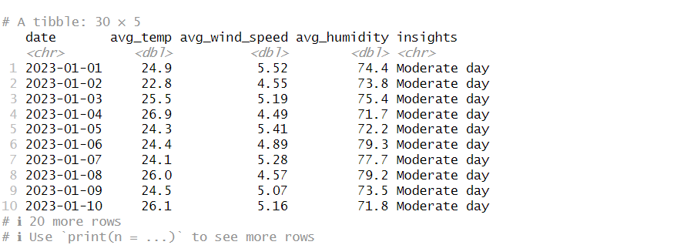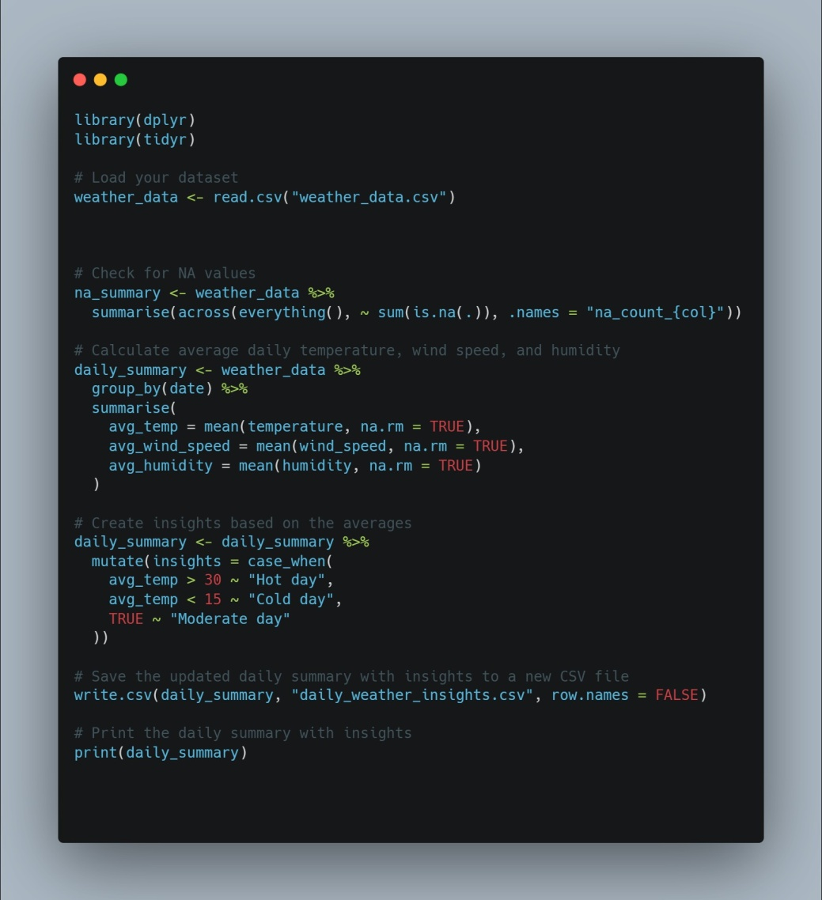

## Visualizations

### Correlation Heatmap

### Screenshot 2025-04-07 191544.png

* Red/blue color scale shows strength and direction of relationships
* White text for correlations > |0.5| ensures readability
* Clean layout with variable names on both axes

### 2. Temperature Trend Line Plot

### Screenshot 2025-04-07 191453.png

* Gray lines show daily variation (when multiple readings exist)
* Red line emphasizes the daily average trend
* Weekly date labels prevent overcrowding

### 3. Humidity Area Chart

### Screenshot 2025-04-07 191718.png

* Green shaded area under the curve emphasizes humidity levels
* Same weekly date breaks as temperature plot for consistency
* Y-axis shows percentage scale (0-100%)

### 4. Wind Speed Visualization

### Screenshot 2025-04-07 191635.png

* Shows average wind speed patterns over time
* Values range from 4.16 m/s to 5.58 m/s
* Relatively stable with minor daily variations

## Conclusion



The January 2023 weather data revealed:

1. Consistently moderate temperatures without extremes
2. High but stable humidity levels
3. Minimal correlations between measured variables
4. Relatively stable wind speeds throughout the period

R code snippets for visualisation

### Correlation Heatmap

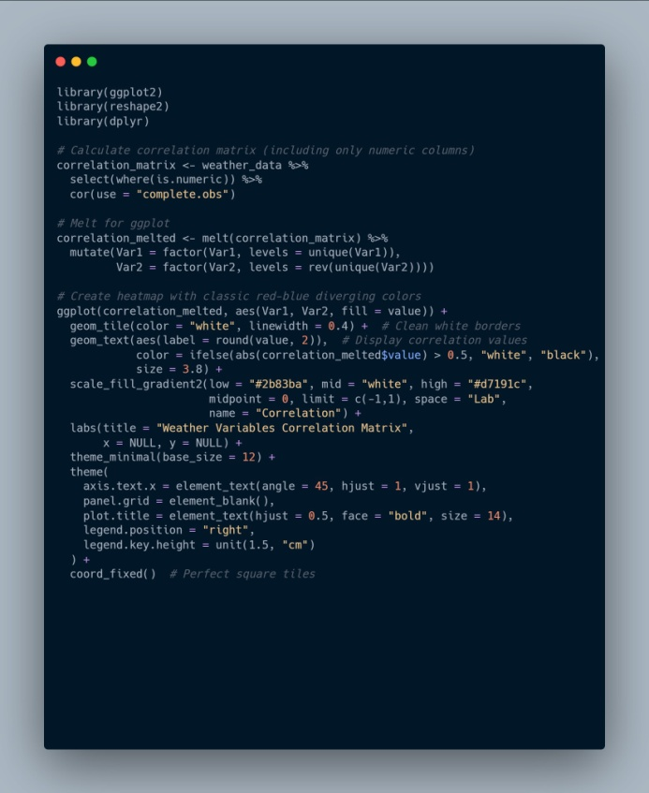

### Temperature Trend Line Plot

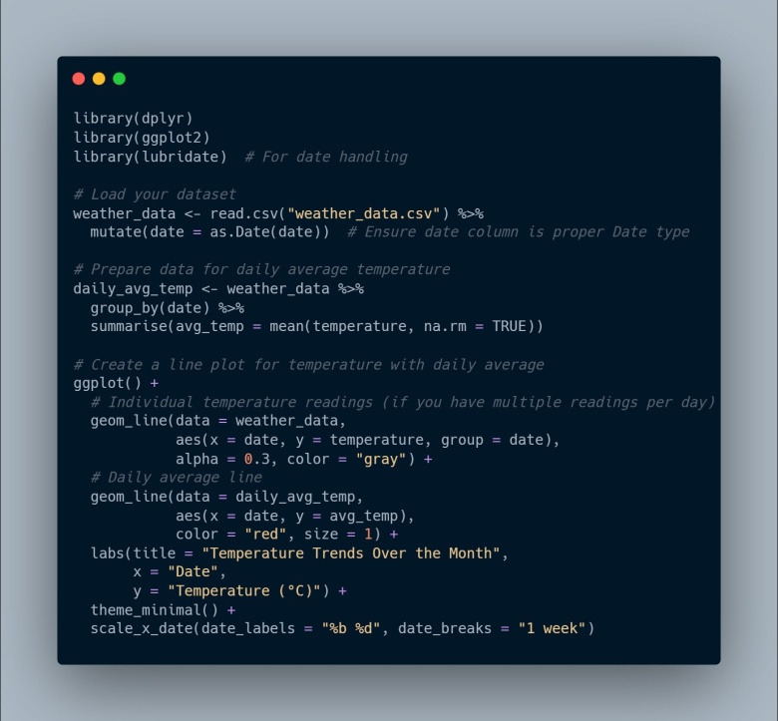

### Humidity Area Chart

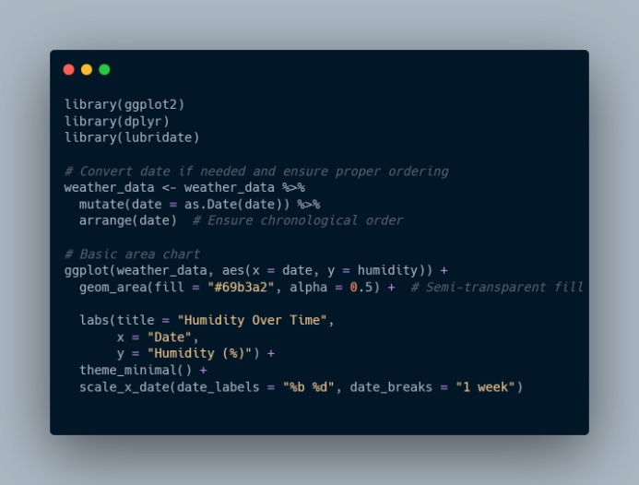

### Wind Speed Visualization

