SharePoint Alert Management
Phresco
V 1.0
Oct 2011

Record of Release
Ver No. | Release Date | Description of Change | Authored / Revised By | Reviewed By | Approved By
1.0 | 27/10/2011 | Alert Management | Sindhuja. R, Ganesan. J

Table of Contents
1. Create an Alert for a List or Library 4
2. Create an Alert for a Folder, File or List item 7
3. View My Alerts on a Site 10
4. Change My Alert Settings 10
5. Cancel an Alert for Myself 12
6. View Alerts for other people on a Site 13
7. Cancel an Alert for Another person 14

Create an Alert for a List or Library
The following procedure explains how to create Alert for a list or library.

If the list or library is not already open, click its name on the Quick Launch.

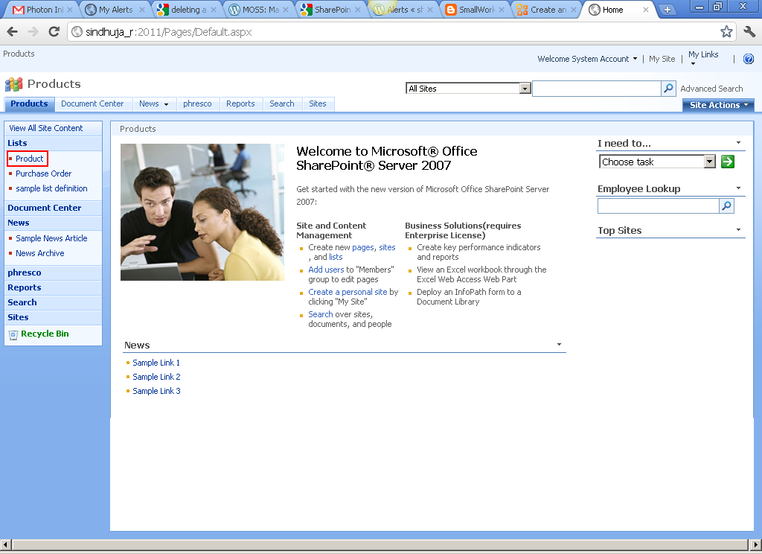

If the name of your list or library does not appear, click View All Site Content, and then click the name of your list or library.

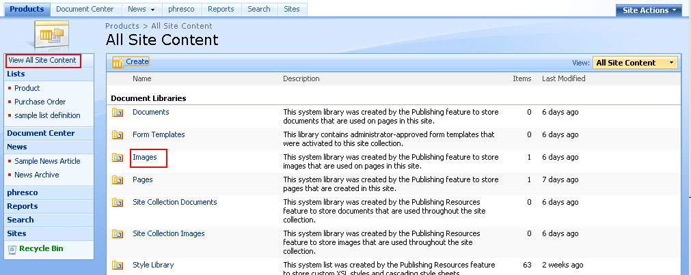

On the Actions menu , click Alert Me.

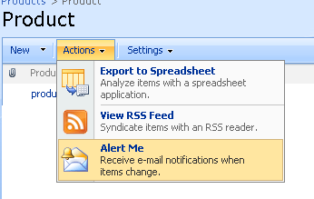

On the New Alert page, in the Alert Title section, change the title for the alert if you want.

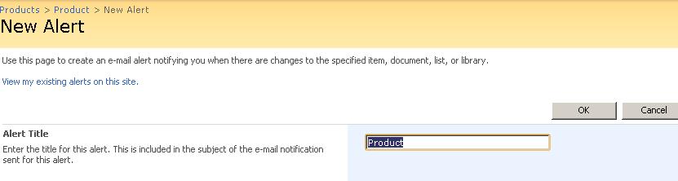

The title appears in the subject line of the alert e-mail message and is also used for managing alerts.

In the Send Alerts To section, verify that your contact information is correct.

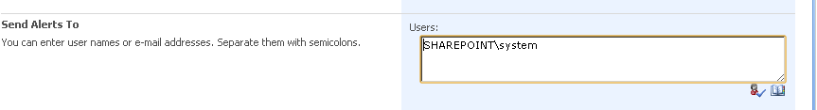
TIP: If you have permission to manage alerts, you can also create an alert for another person by typing his or her information into the Users box.

If the Change Type section is available, choose the types of changes that you want to be notified about. For example, you can receive alerts about all changes or only when items are deleted.

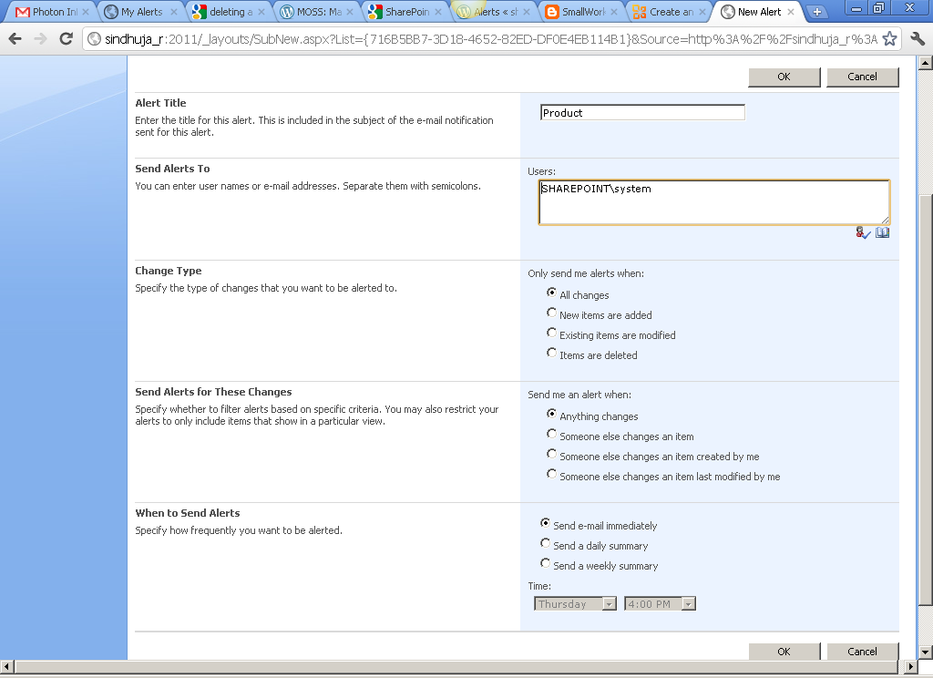

In the Send Alerts for These Changes section, specify whether you want to be alerted for all types of changes, or for specific changes, such as when anything changes or only when someone changes an item that you created or recently changed.

In the When to Send Alerts section, choose how frequently you want to receive the alerts, such as immediately or in a daily or weekly summary, and at what days or times.

Click OK.

NOTE Depending on how your site and servers are set up, the person you created an alert for may receive an e-mail message that confirms that you created an alert. The alert e-mail message may provide links to the list or library, alert settings, the name of the person who created the alert, a mobile view, and other information and commands.

Create an Alert for a Folder, File or List item

If the list or library is not already open, click its name on the Quick Launch.

If the name of your list or library does not appear, click View All Site Content, and then click the name of your list or library.

Point to the item for which you want to create an alert, click the arrow that appears, and then click Alert Me.

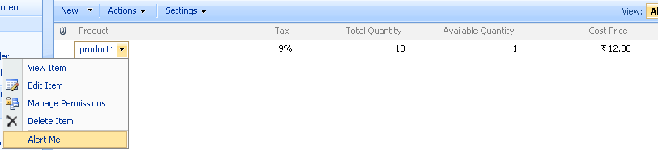

In some views, such as a view of items in a calendar, you may need to click the item, and then click Alert Me.
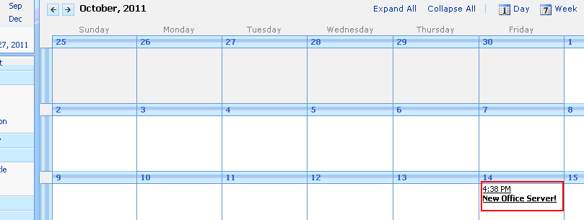

On the New Alert page, in the Alert Title section, change the title for the alert if you want.
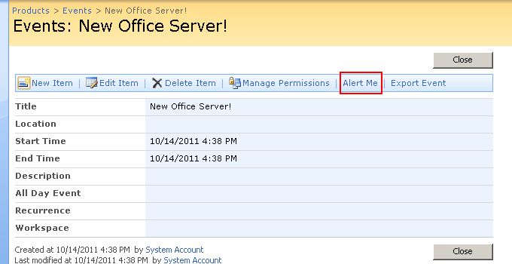

The title appears in the subject line of the alert e-mail message and is also used for managing alerts

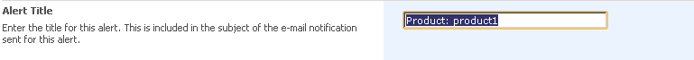.

In the Send Alerts To section, verify that your contact information is correct.

TIP: If you have permission to manage alerts, you can create an alert for another person by typing his or her information into the Users box.

If the Change Type section is available, choose the types of changes that you want to be notified about. For example, you can receive alerts about all changes or only when items are deleted.

In the Send Alerts for These Changes section, specify whether you want to be alerted for all types of changes, or for specific changes, such as when anything changes or only when someone changes an item that you created or recently changed.

In the When to Send Alerts section, choose how frequently you want to receive the alerts, such as immediately or in a daily or weekly summary, and at what days or times.

Click OK.

NOTE Depending on how your site and servers are set up, the person you created an alert for may receive an e-mail message that confirms that you created an alert. The alert e-mail message may provide links to the list or library, alert settings, the name of the person who created the alert, a mobile view, and other information and commands.

View My Alerts on a Site

At the top of the site, click Welcome User name , and then click My Settings.
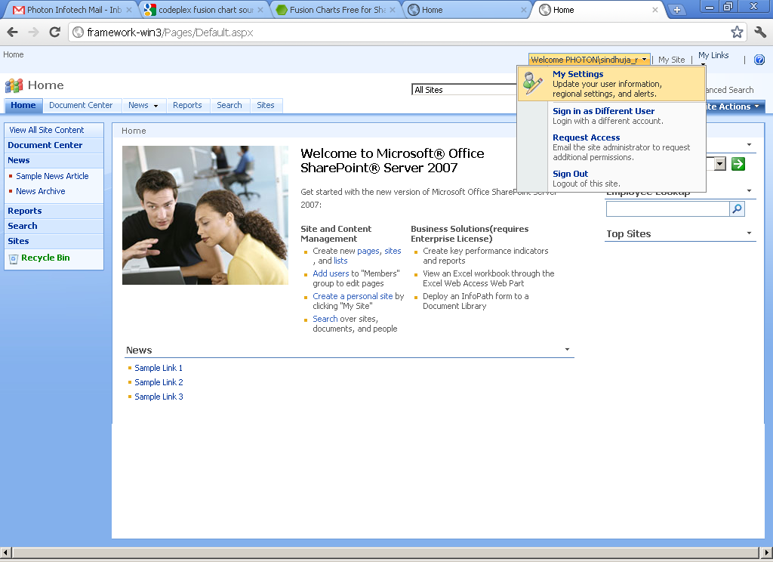

Click My Alerts.
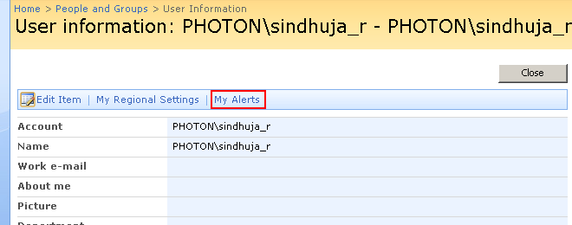

Change My Alert Settings

At the top of the site, click Welcome User name , and then click My Settings.

Click My Alerts.

Click the name of the alert that you want to change.
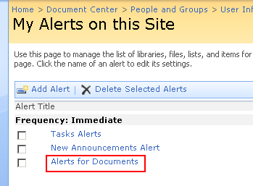

On the Edit Alert page, change the settings that you want to change.
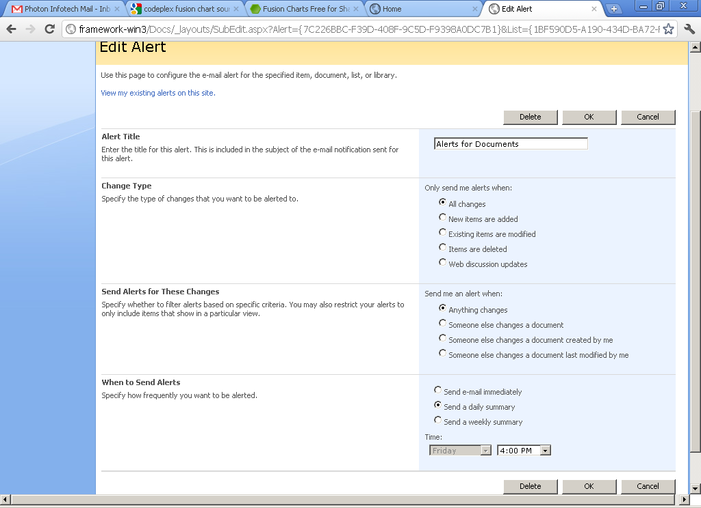

Click OK.
TIP: When you receive an e-mail alert, you can click a link to see alert information on the site.
NOTE: If you are a site designer or administrator, you can change the alert e-mail message by modifying the XML files for alerts. The alert confirmation, however, cannot be customized.

Cancel an Alert for Myself

At the top of the site, click Welcome User name , and then click My Settings.

Click My Alerts.

Select the check box next to the alert or alerts that you want to cancel.
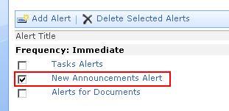

Click Delete Selected Alerts.
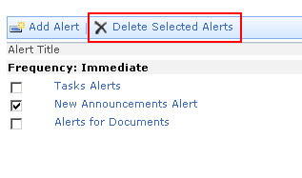

When you are prompted to confirm the deletion, click OK, if you are sure that you want to cancel the selected alerts.
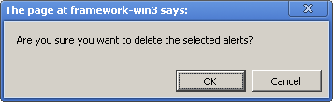

View Alerts for other people on a Site
To view alerts for other people, you must have permission to manage site settings.
On the Site Actions menu , click Site Settings.
NOTE : On a site for which the Site Actions menu is customized, point to Site Settings, and then click the settings that you want to view.

Under Site Administration, click User alerts.
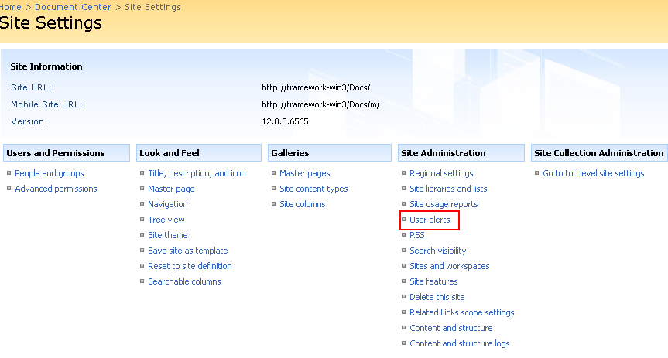

In the list next to Display alerts for, select the person whose alerts you want to view.
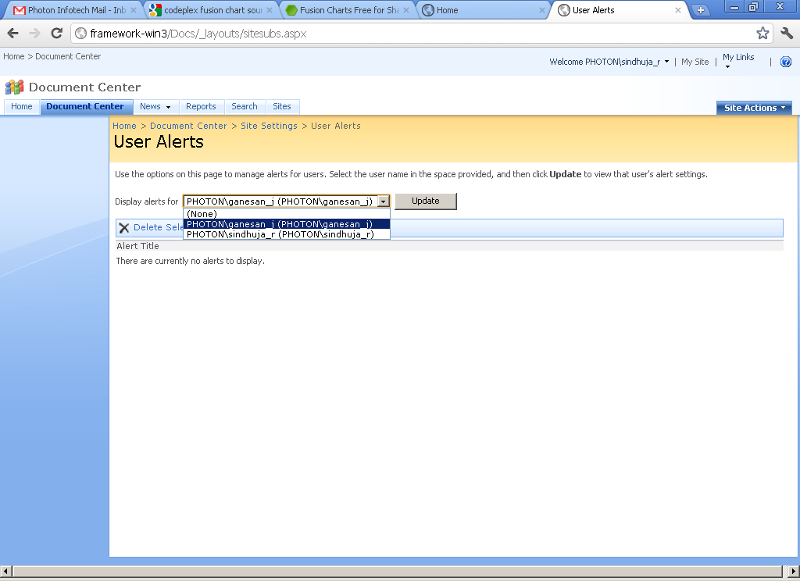

Click the Update button.
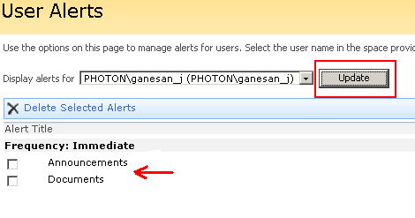

Cancel an Alert for Another person
To view and cancel alerts for other people, you must have permission to manage site settings.
On the Site Actions menu, click Site Settings.
NOTE: On a site for which the Site Actions menu is customized, point to Site Settings, and then click the settings that you want to view.

Under Site Administration, click User alerts.

In the list next to Display alerts for, select the person whose alerts you want to cancel.

Click the Update button.
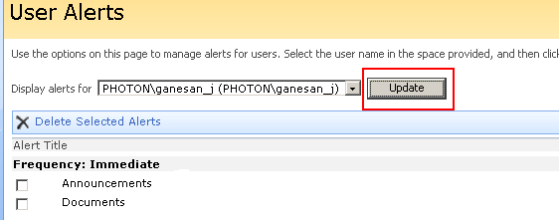

Select the check box next to the alert or alerts that you want to cancel.
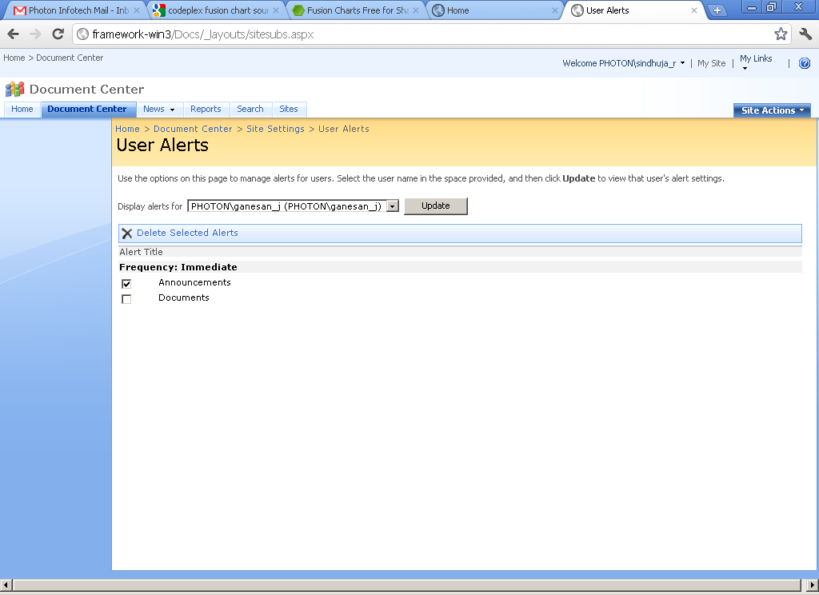

Click Delete Selected Alerts.
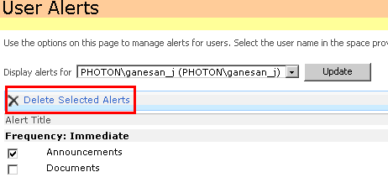

When you are prompted to confirm the deletion, click OK, if you are sure that you want to cancel the selected alerts

