ENTERPRISE NETWORK MONITORING
USING SPLUNK SIEM

A Comprehensive Implementation Report on Deploying Splunk Enterprise
as a Security Information and Event Management (SIEM) Solution
for Real-Time Log Collection, Threat Detection, and Security Dashboard Visualization

Prepared By:
Ibrahim Ayomide Fayomi
Cybersecurity Analyst

Github: https://github.com/phour44 || LinkedIn: https://www.linkedin.com/in/fayomi31/

Date: June 2026
Platform: Splunk Enterprise 9.4.1 | Windows Server 2022 & Window 10

Table of Contents
1. Executive Summary
2. Project Objectives
3. Scope and Environment
4. Technology Stack
5. Implementation Methodology
5.1 Phase 1: Splunk Enterprise Installation
5.2 Phase 2: Splunk Universal Forwarder Deployment
5.3 Phase 3: Windows Firewall Configuration
5.4 Phase 4: Indexer and Receiving Port Configuration
5.5 Phase 5: Data Ingestion Verification
5.6 Phase 6: SPL Search and Analysis
5.7 Phase 7: Security Dashboard Creation
6. Results and Findings
7. Security Considerations
8. Challenges and Lessons Learned
9. Conclusion and Recommendations
10. References
11. Appendix: Figure Index

1. Executive Summary
This report documents the end-to-end implementation of Splunk Enterprise as a Security Information and Event Management (SIEM) solution within a virtualized enterprise network environment. The project was designed to simulate a real-world Security Operations Center (SOC) deployment, demonstrating how centralized log collection, real-time event correlation, and security dashboard visualization can be achieved using industry-standard tools and methodologies.
The implementation encompassed the deployment of Splunk Enterprise 9.4.1 on a Windows Server 2022 virtual machine, the installation and configuration of the Splunk Universal Forwarder on a monitored endpoint (Windows 10/11), Windows Defender Firewall rule configuration to permit log forwarding traffic, and the creation of custom SPL (Search Processing Language) queries and interactive security dashboards for authentication monitoring and threat analysis.
The deployment successfully ingested over 5,400 Windows Security and System events from the monitored endpoint, enabling the creation of a custom Authentication Dashboard that provides real-time visibility into failed logon attempts (EventCode 4625), successful authentication events (EventCode 4624), and system-level setup activities (EventCode 1). This project demonstrates practical competency in SIEM deployment, log pipeline architecture, and security event visualization techniques that are directly applicable to enterprise SOC environments.

2. Project Objectives
The primary objectives of this project were established to align with industry best practices for SIEM deployment in enterprise environments. Each objective was designed to address a specific component of the security monitoring pipeline, from data collection through visualization and analysis.
- Deploy Splunk Enterprise: Install and configure Splunk Enterprise 9.4.1 as the central SIEM platform on a Windows Server 2022 environment, establishing the receiving indexer for log ingestion.
- Configure Universal Forwarder: Deploy and configure the Splunk Universal Forwarder (UF) on a monitored Windows endpoint to enable secure, real-time log forwarding to the Splunk indexer.
- Establish Network Communication: Configure Windows Defender Firewall inbound and outbound rules on both the server and endpoint to permit Splunk communication over the designated receiving port (TCP 9997).
- Validate Data Ingestion: Verify end-to-end log flow from the Windows endpoint through the Universal Forwarder to the Splunk indexer, confirming successful data indexing.
- Develop SPL Search Queries: Create targeted SPL queries to search, filter, and analyze ingested security events, including authentication logs, system events, and event code correlation.
- Build Security Dashboards: Design and implement interactive Splunk dashboards that provide SOC-ready visualization of security events, including failed logon trends, event timelines, and host-based activity summaries.

3. Scope and Environment

3.1 Lab Architecture
The project was implemented within an Oracle VirtualBox virtualization environment, simulating a segmented enterprise network. This architecture mirrors real-world deployment patterns where a centralized SIEM server receives forwarded logs from distributed endpoints across the network.
Component | Specification | Role
Hypervisor | Oracle VirtualBox 7.x | Virtualization Platform
SIEM Server | Windows Server 2022 Standard | Splunk Enterprise Indexer
Monitored Endpoint | Windows 10/11 Desktop | Log Source (Universal Forwarder)
Splunk Version | Splunk Enterprise 9.4.1 | SIEM Platform
Forwarder Version | Splunk Universal Forwarder 9.4.3 | Data Collection Agent
Network | Internal NAT / Host-Only | VM Communication
Receiving Port | TCP 9997 | Splunk Data Forwarding
Web Interface | TCP 8000 | Splunk Management Console
Host Server | WIN-CJ0J0L41QG0 | Windows Server Hostname
Endpoint Host | DESKTOP-EPLK670 | Monitored Endpoint Hostname

4. Technology Stack
Technology | Version / Type | Purpose
Splunk Enterprise | 9.4.1 | Central SIEM platform for log indexing, search, and visualization
Splunk Universal Forwarder | 9.4.3 | Lightweight agent for secure log collection and forwarding
Windows Server 2022 | Standard Evaluation | SIEM server operating system
Windows Defender Firewall | Advanced Security | Network traffic filtering and rule management
Oracle VirtualBox | 7.x | Hypervisor for lab virtualization
SPL (Search Processing Language) | Native | Query language for Splunk data analysis
Windows Event Logs | Security, System, Setup | Primary data sources for SIEM ingestion

5. Implementation Methodology
The implementation followed a structured, phased approach aligned with the NIST Cybersecurity Framework and Splunk deployment best practices. Each phase was executed sequentially, with validation checkpoints to confirm successful completion before proceeding to the next stage.

5.1 Phase 1: Splunk Enterprise Installation
The first phase involved downloading and installing Splunk Enterprise 9.4.1 on the Windows Server 2022 virtual machine. Splunk Enterprise serves as the central indexer and search head in this deployment, responsible for receiving, parsing, indexing, and storing all forwarded log data.

5.1.1 Download and Preparation
The Splunk Enterprise installer was downloaded directly from the official Splunk website (splunk.com). The download was verified for integrity before proceeding with installation. The screenshot below confirms the successful completion of the Splunk Enterprise download.
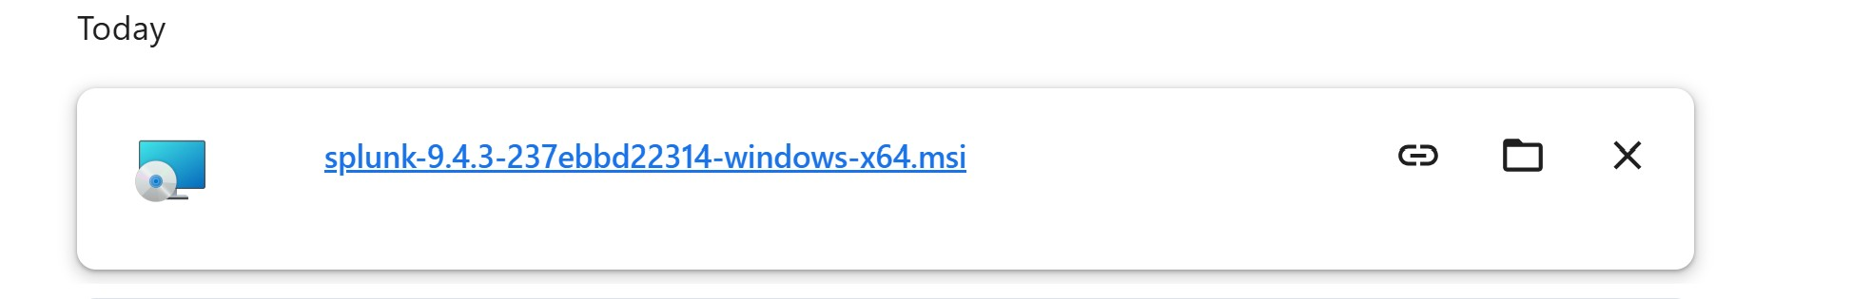
Figure 1. Splunk Enterprise installer successfully downloaded to the Windows Server 2022 environment, ready for deployment.
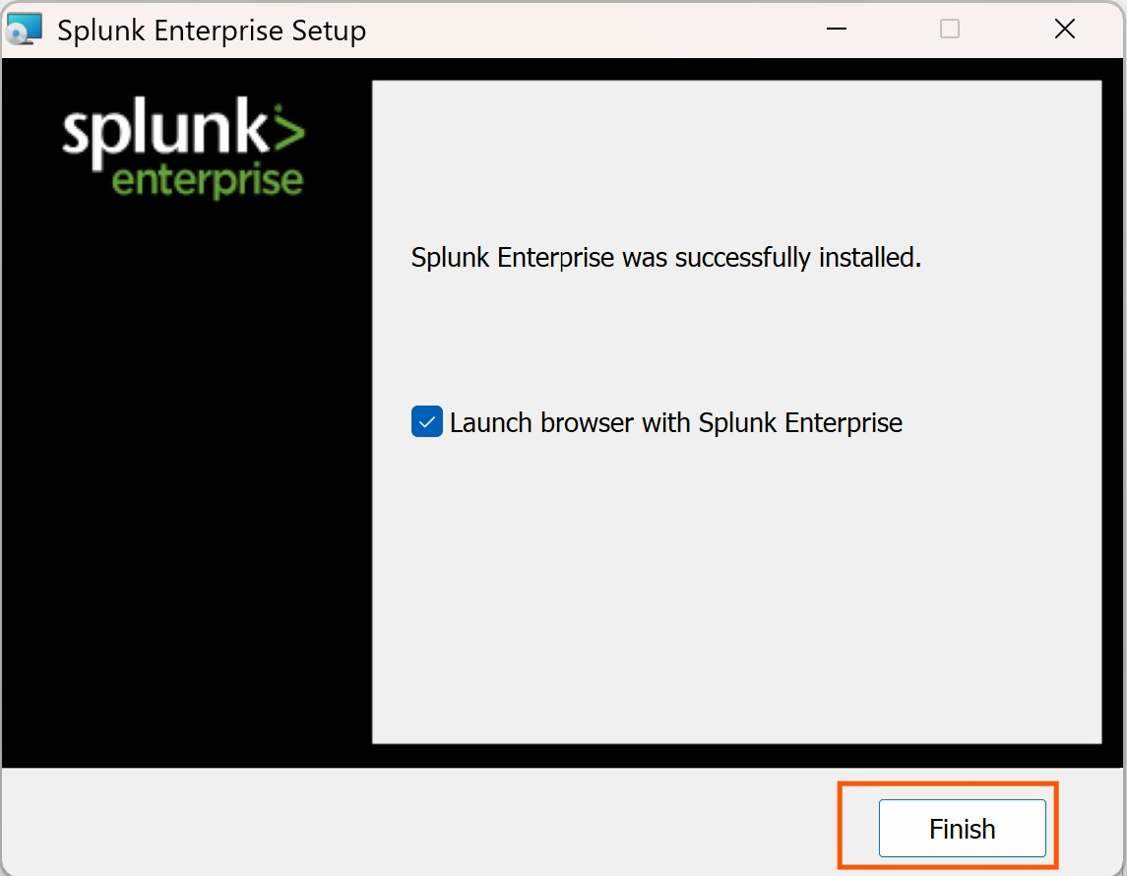
Figure 2. Download completion confirmation showing the Splunk Enterprise installation package fully retrieved and verified.

5.1.2 Installation and User Configuration
The installation process was initiated by executing the Splunk Enterprise MSI installer with administrative privileges. During installation, a dedicated Splunk administrator account was created with a secure password. The installer configured the Splunk service to run as a local system account, ensuring persistent operation across system restarts.
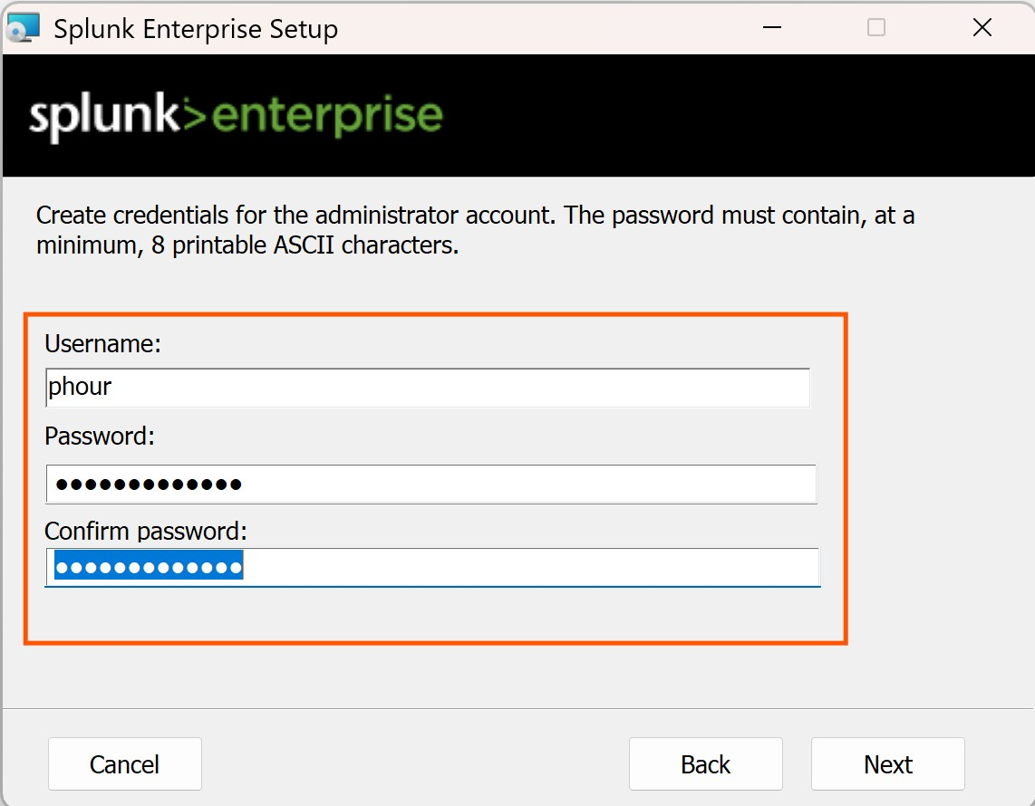
Figure 3. Splunk Enterprise installation wizard displaying the administrator user creation interface. A dedicated 'phour44' account was configured with appropriate credentials for SIEM management.
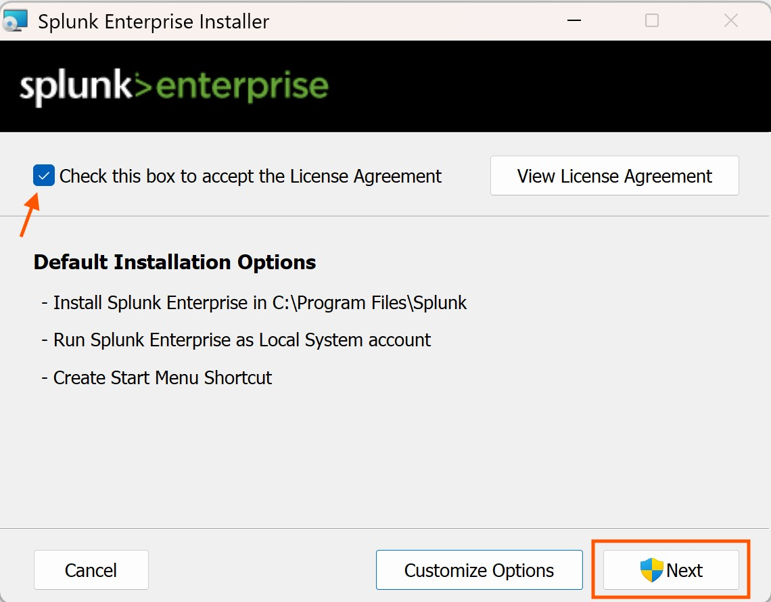
Figure 4. Splunk Enterprise installation in progress on Windows Server 2022. The installer is deploying core Splunk services, indexer components, and the web-based management interface.
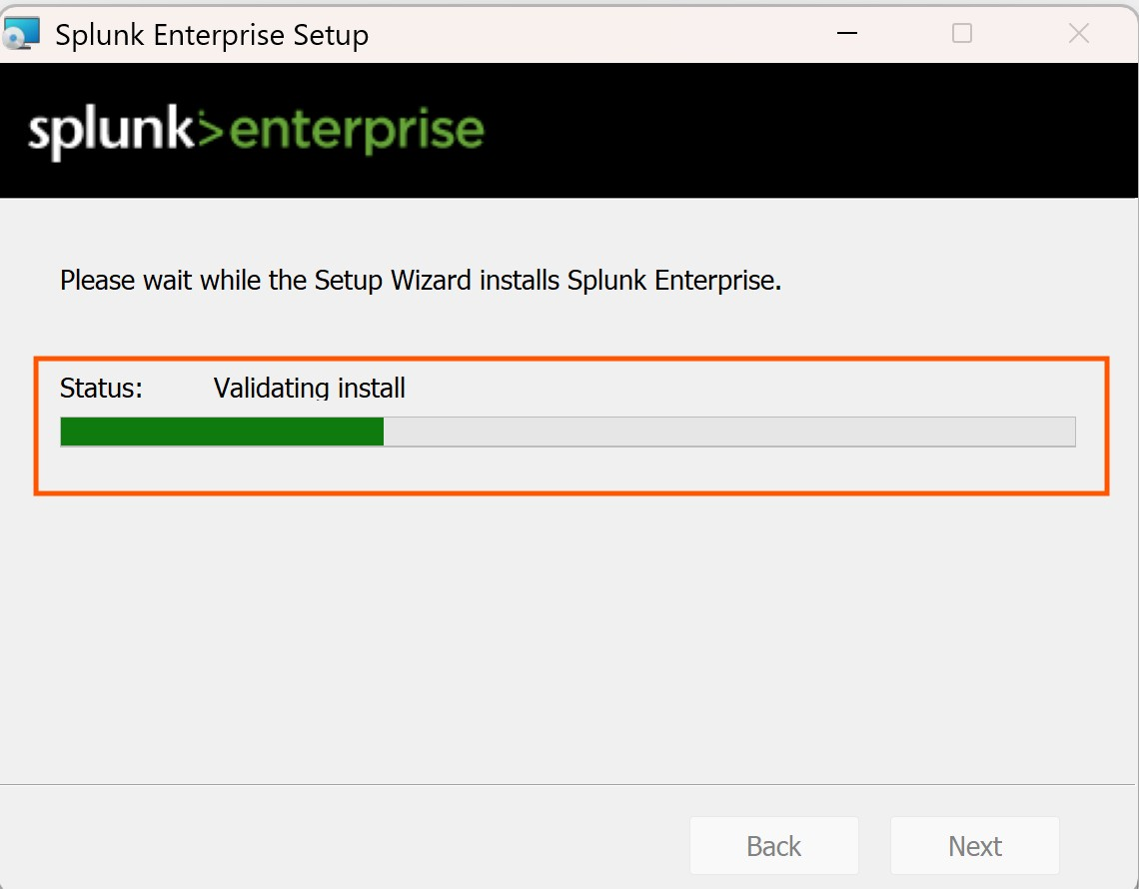
Figure 5. Splunk Enterprise installation progress indicator showing component extraction and service registration on the server.
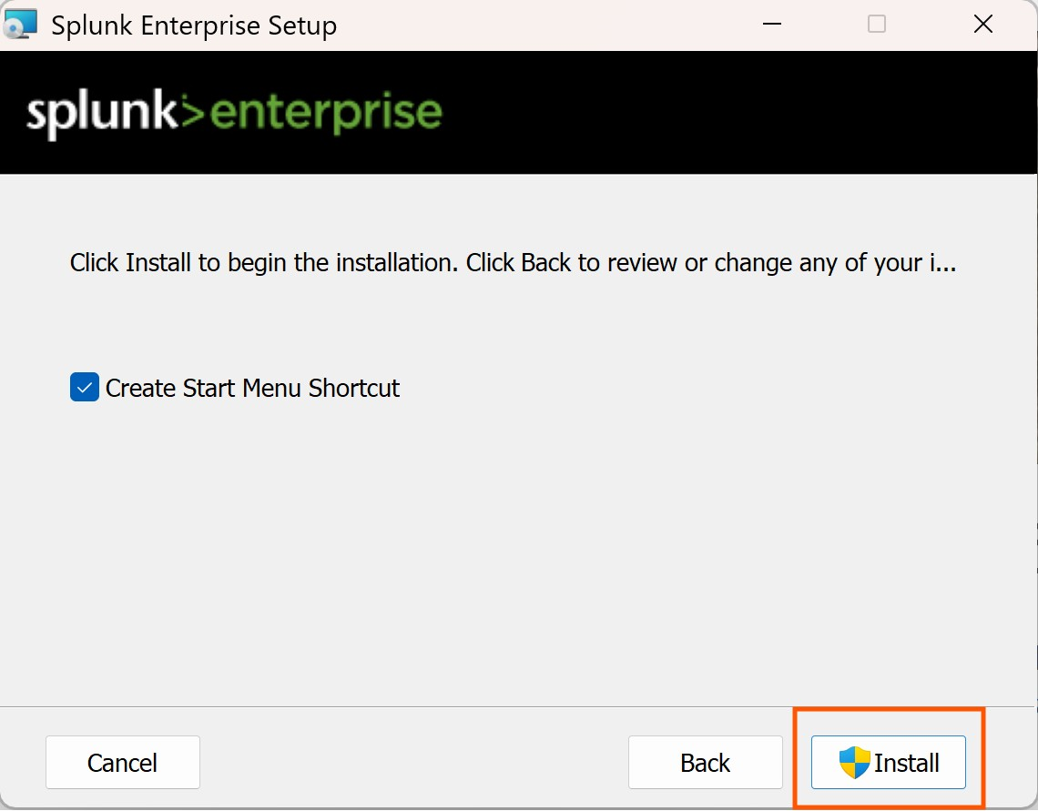
Figure 6. Pre-installation summary screen confirming deployment parameters before final Splunk Enterprise installation execution.

5.1.3 Licensing and Activation
Upon successful installation, Splunk Enterprise was launched and the licensing agreement was accepted. The platform was activated under a Splunk Enterprise trial license, which provides full functionality for evaluation purposes. The licensing screen confirmed successful activation and readiness for configuration.
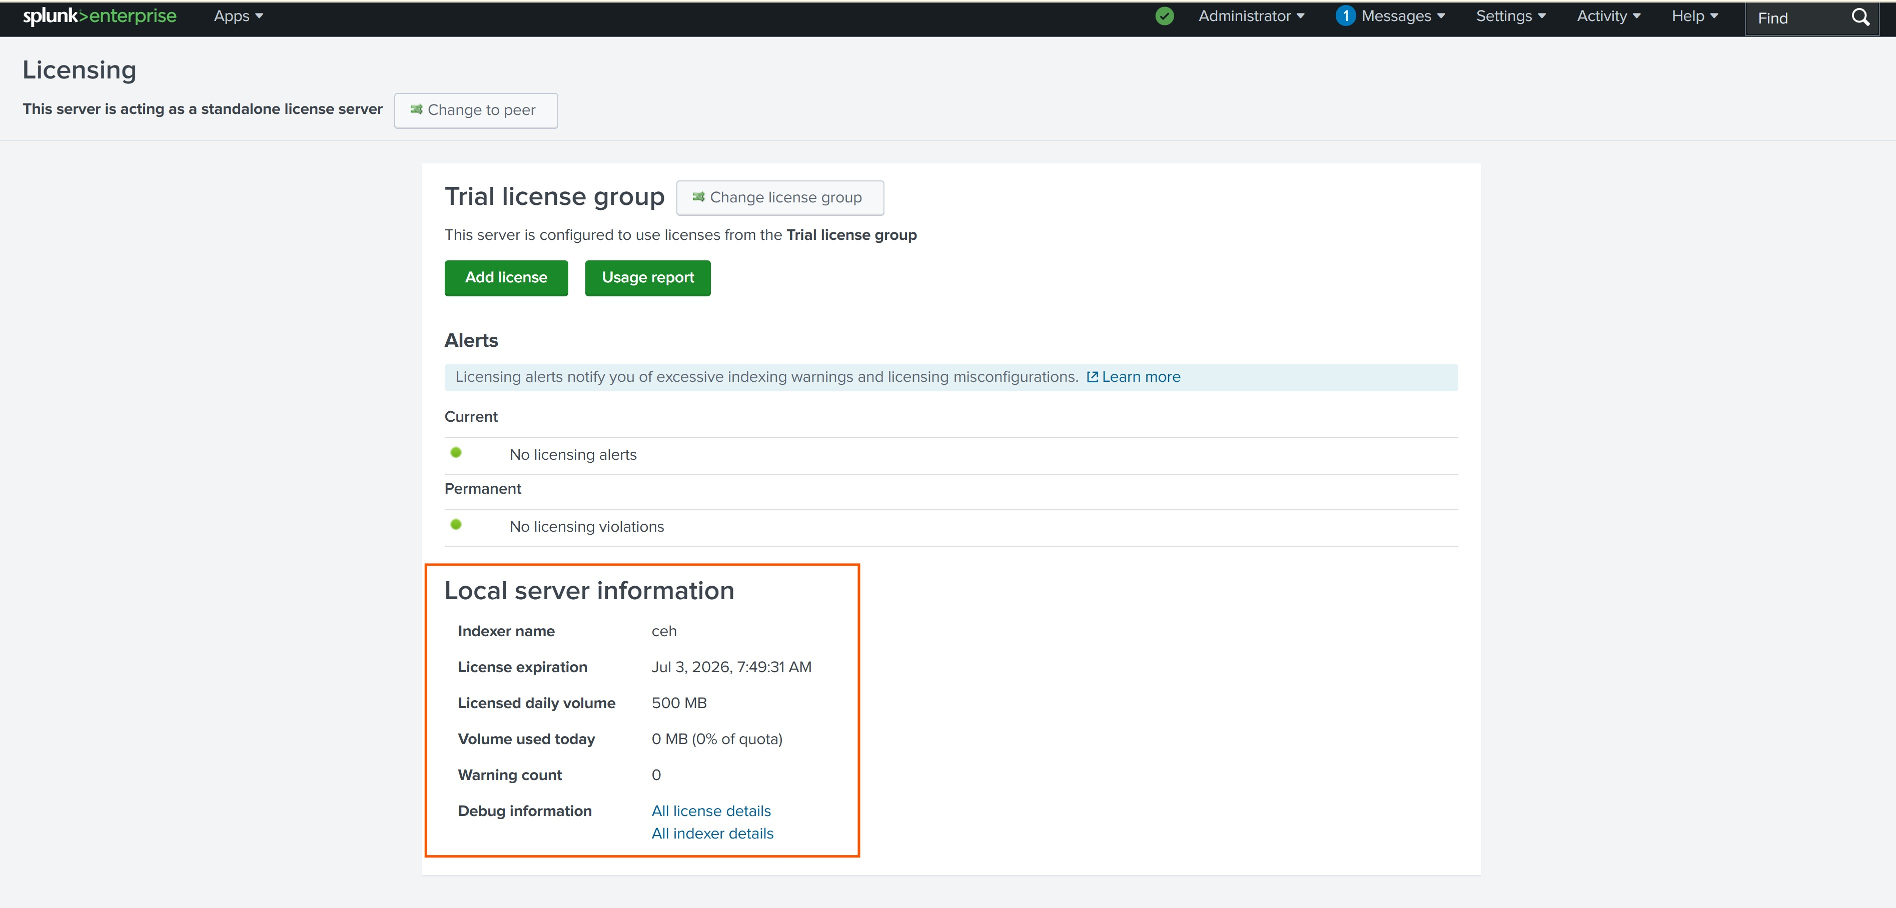
Figure 7. Splunk Enterprise licensing agreement screen presented during initial platform activation and configuration.
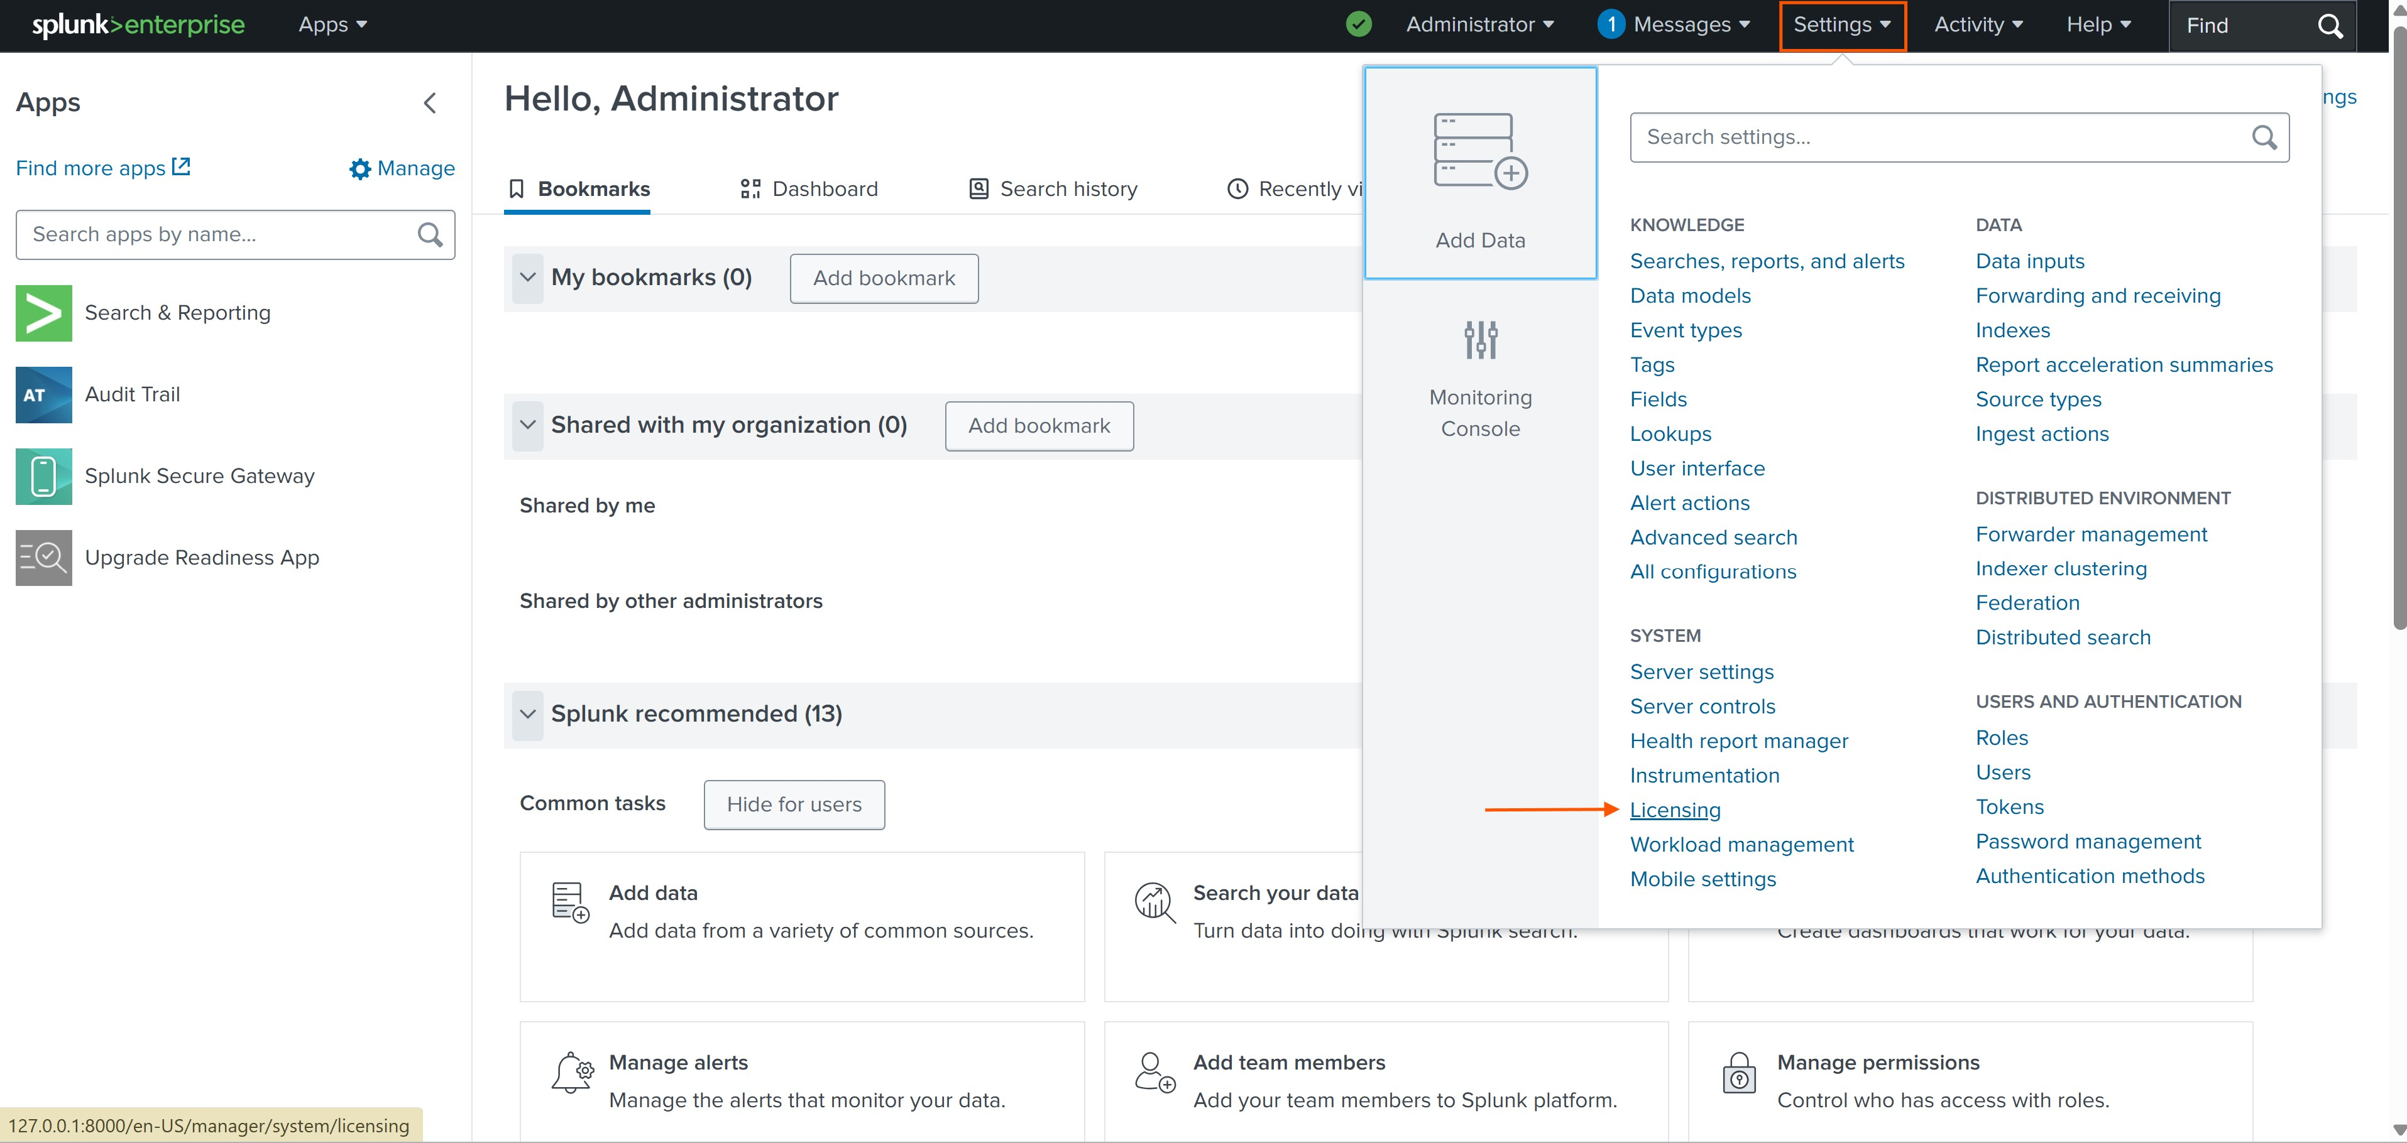
Figure 8. Splunk licensing confirmation page displaying the accepted license terms and activation status for the enterprise deployment.

5.1.4 Web Interface Access
After successful installation and licensing, the Splunk Enterprise web interface was accessed at http://127.0.0.1:8000. The login page was presented with the previously configured administrator credentials (username: phour44). Successful authentication confirmed that the Splunk web interface was operational and ready for configuration.
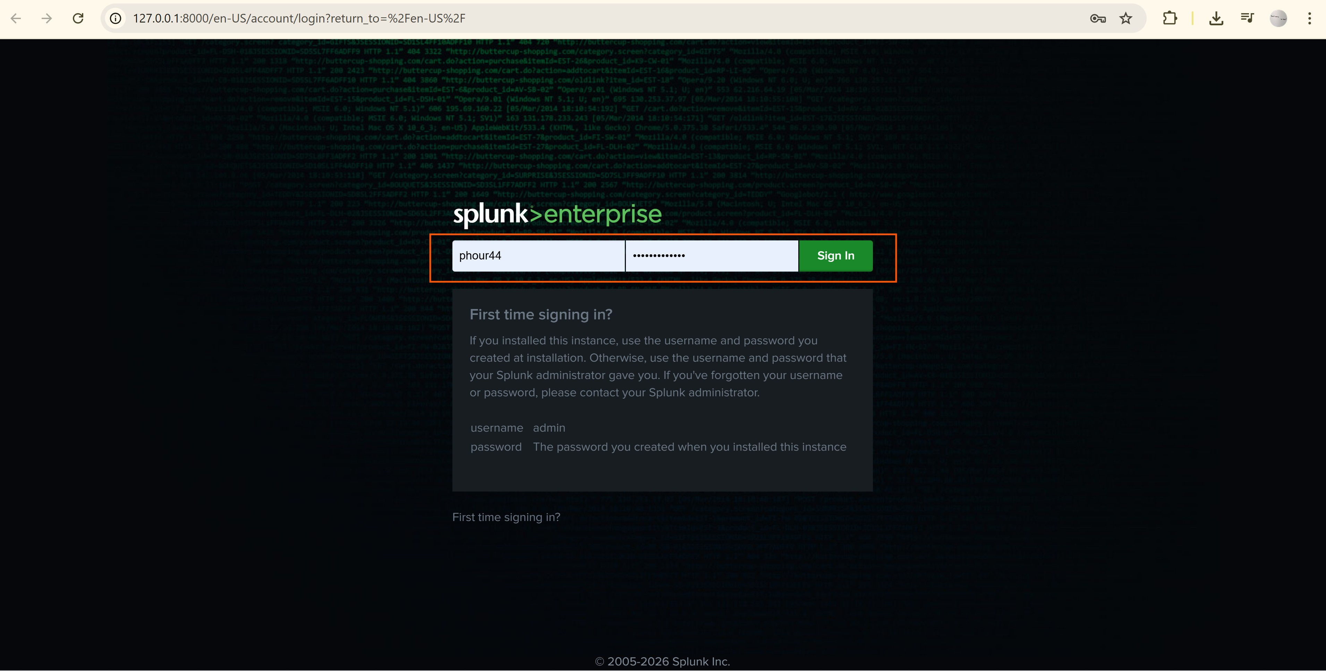
Figure 9. Splunk Enterprise web login interface accessed at 127.0.0.1:8000. The administrator account 'phour44' is being used to authenticate into the SIEM management console.
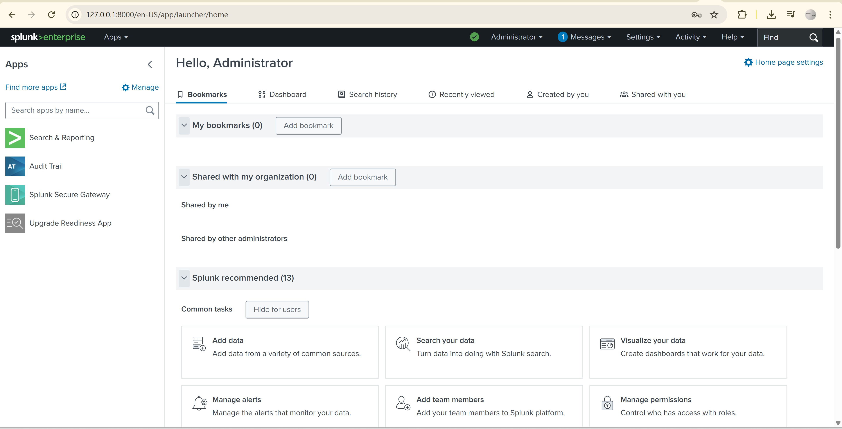
Figure 10. Splunk Enterprise home dashboard after successful authentication, displaying the main navigation interface with access to Search & Reporting, Audit Trail, and system management applications.

5.2 Phase 2: Splunk Universal Forwarder Deployment
The Splunk Universal Forwarder (UF) is a lightweight, dedicated agent designed to collect and forward log data from monitored endpoints to the central Splunk indexer. Unlike heavy forwarders, the UF has a minimal resource footprint and does not include a search or web interface, making it ideal for deployment across large numbers of endpoints in enterprise environments.

5.2.1 Forwarder Installation
The Universal Forwarder was installed on the monitored Windows endpoint (DESKTOP-EPLK670) using the standard MSI installer. The installation wizard guided the configuration of the receiving indexer's IP address and the designated receiving port (TCP 9997), establishing the communication channel between the endpoint and the Splunk server.
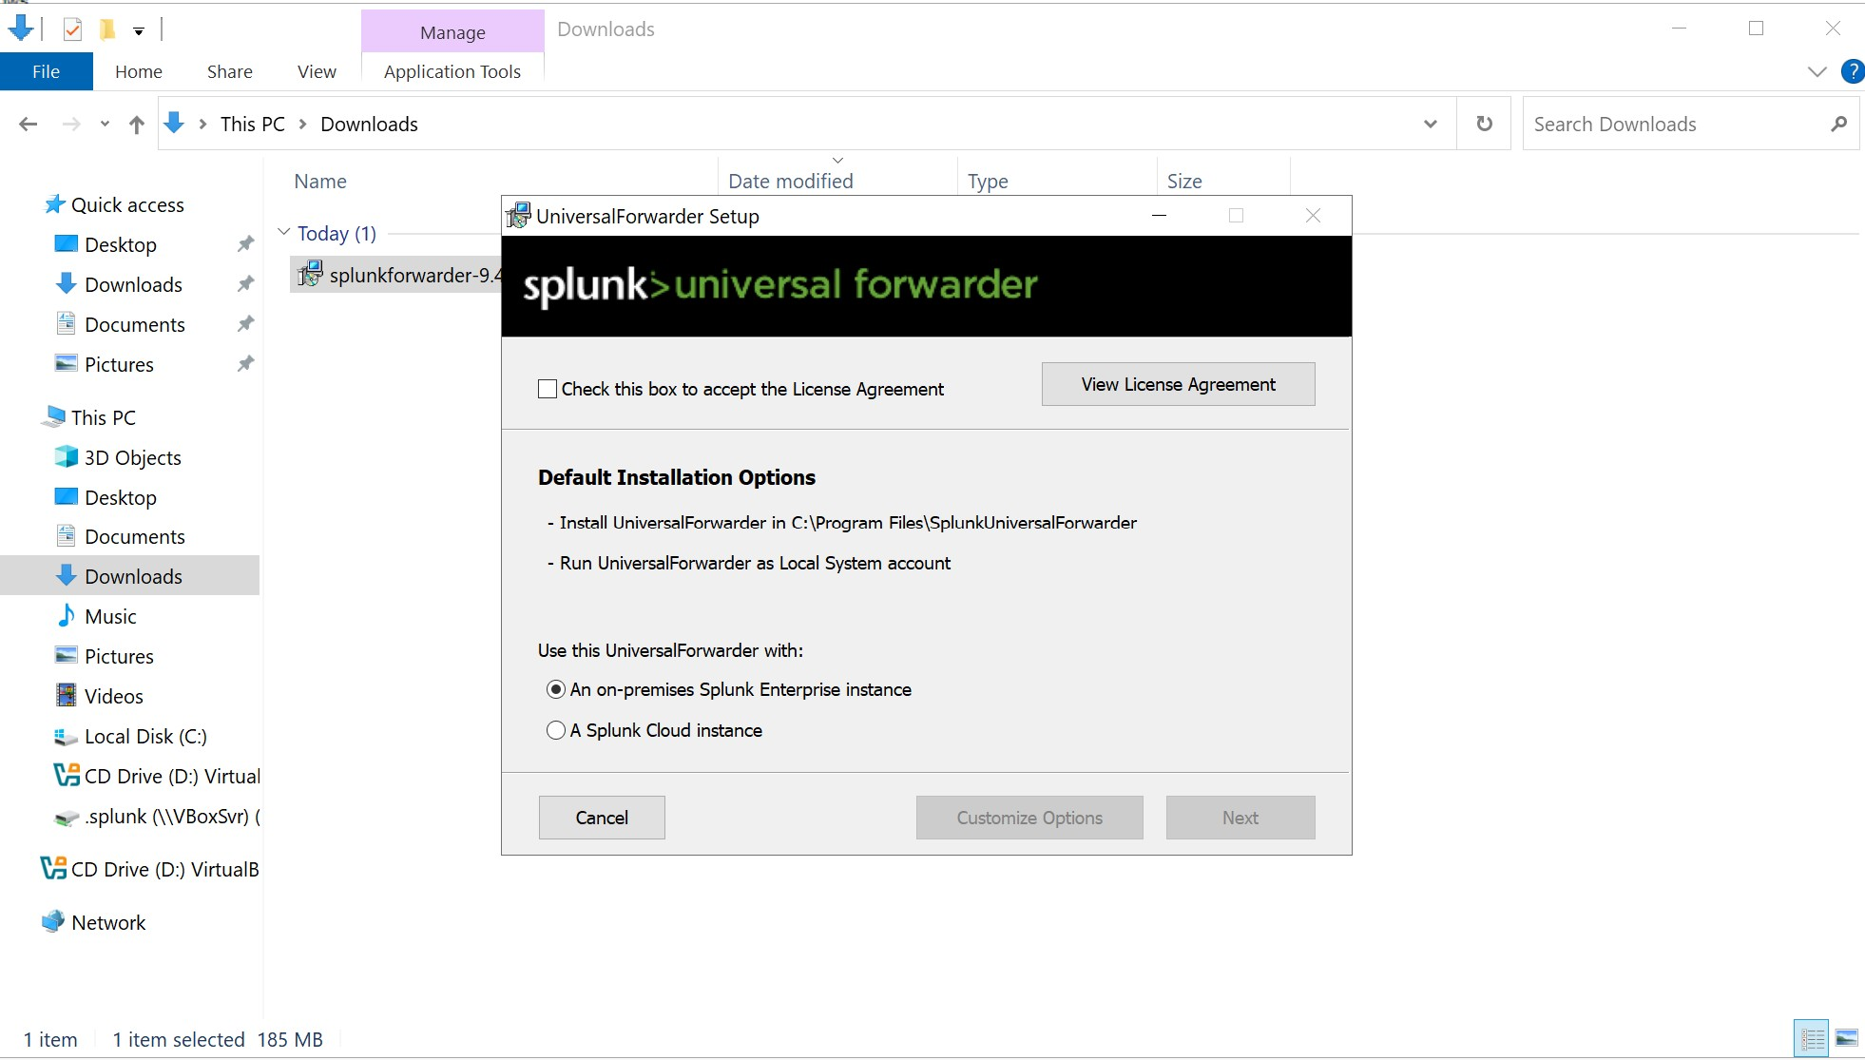
Figure 11. Splunk Universal Forwarder installation wizard launched on the monitored endpoint (DESKTOP-EPLK670), initiating the deployment of the log collection agent.
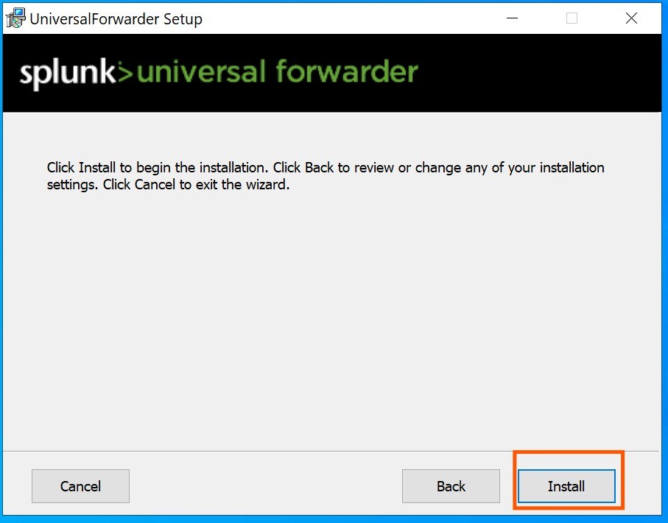
Figure 12. Universal Forwarder pre-installation summary confirming component selection and deployment path before final installation execution.
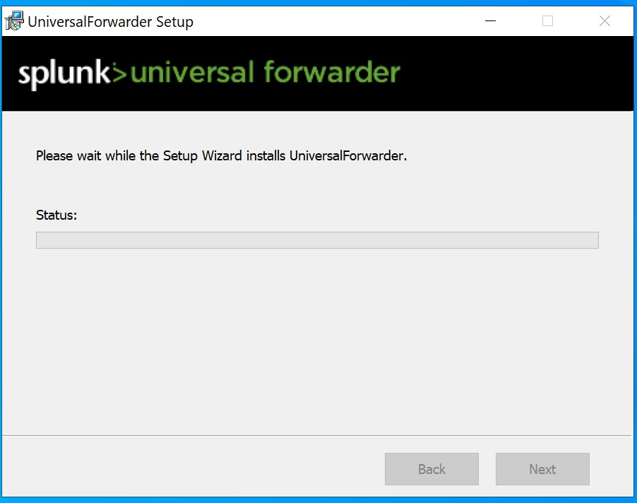
Figure 13. Universal Forwarder installation progress showing active component deployment and service registration on the endpoint.
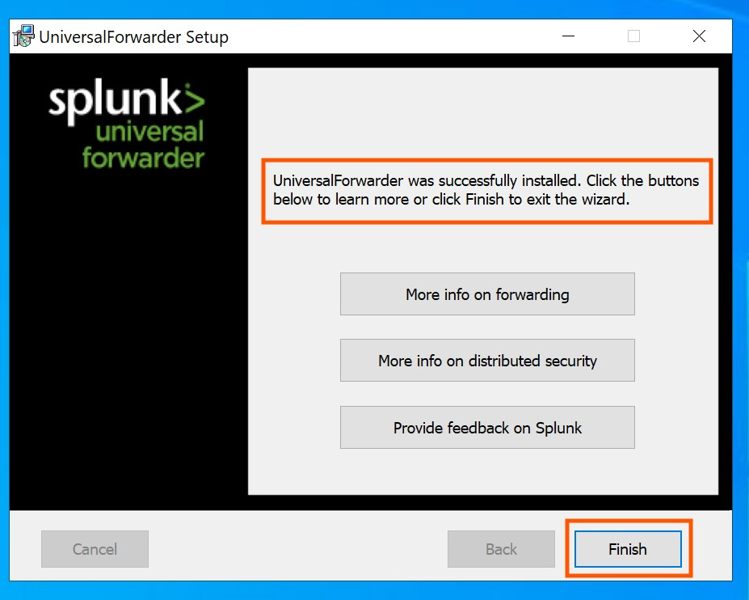
Figure 14. Successful completion of the Splunk Universal Forwarder installation. The setup wizard confirms that the UniversalForwarder was successfully deployed and is ready for configuration.

5.2.2 Forwarder Configuration
After installation, the Universal Forwarder was configured to connect to the Splunk Enterprise indexer. The configuration included specifying the receiving host IP address and the data collection inputs. The forwarder was configured to collect Windows Security, System, and Application event logs.
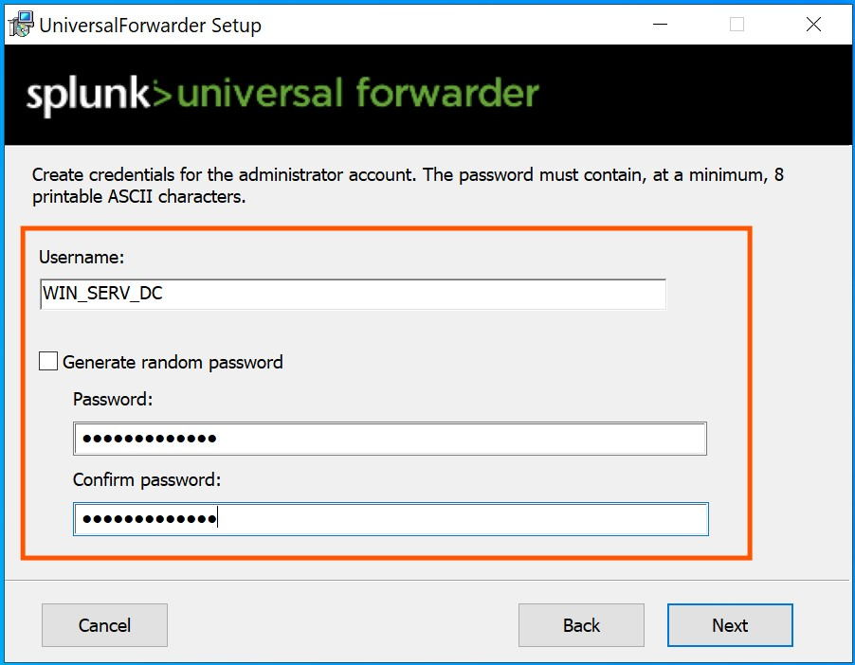
Figure 15. Splunk Universal Forwarder configuration interface showing the receiving indexer connection parameters, including the target host IP address and receiving port (TCP 9997).
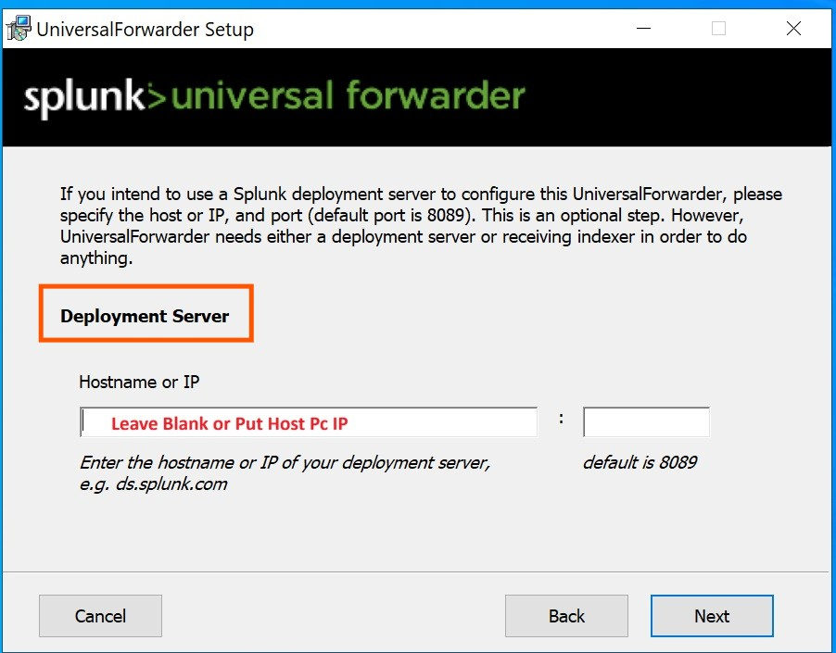
Figure 16. Universal Forwarder host IP address configuration. The deployment host field was configured to establish the data forwarding path to the Splunk Enterprise indexer.
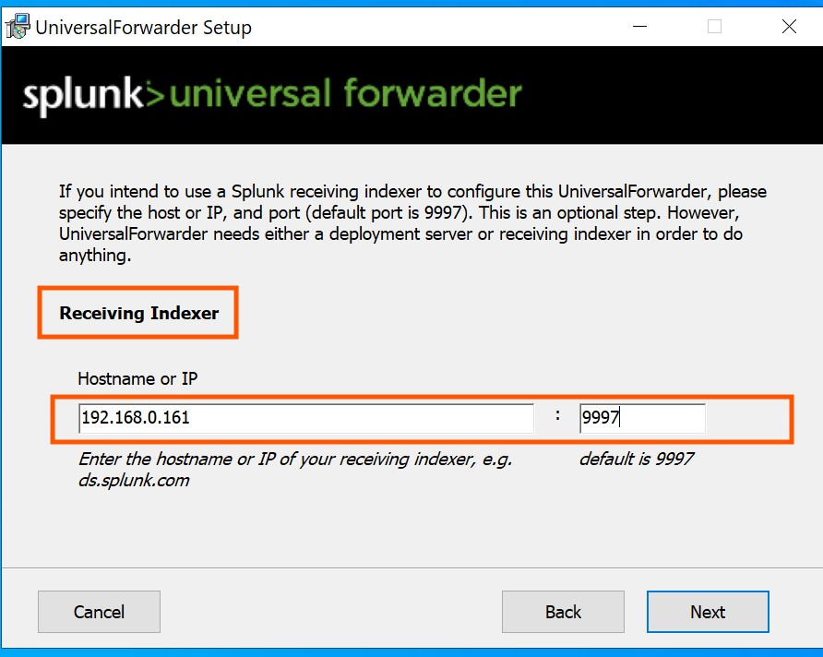
Figure 17. Splunk indexer receiving configuration showing the host PC IP address mapping, establishing the data pipeline between the endpoint and the central SIEM server.

5.2.3 Forwarder Verification on Server
To confirm the Universal Forwarder was properly deployed on the monitored endpoint, the Windows Programs and Features control panel was accessed on the server to verify the installation. The hostname of the Windows Server was confirmed using the 'hostname' command in the Command Prompt, returning 'WIN-CJ0J0L41QG0'. This verification step ensured both the server and endpoint identities were correctly established in the deployment.
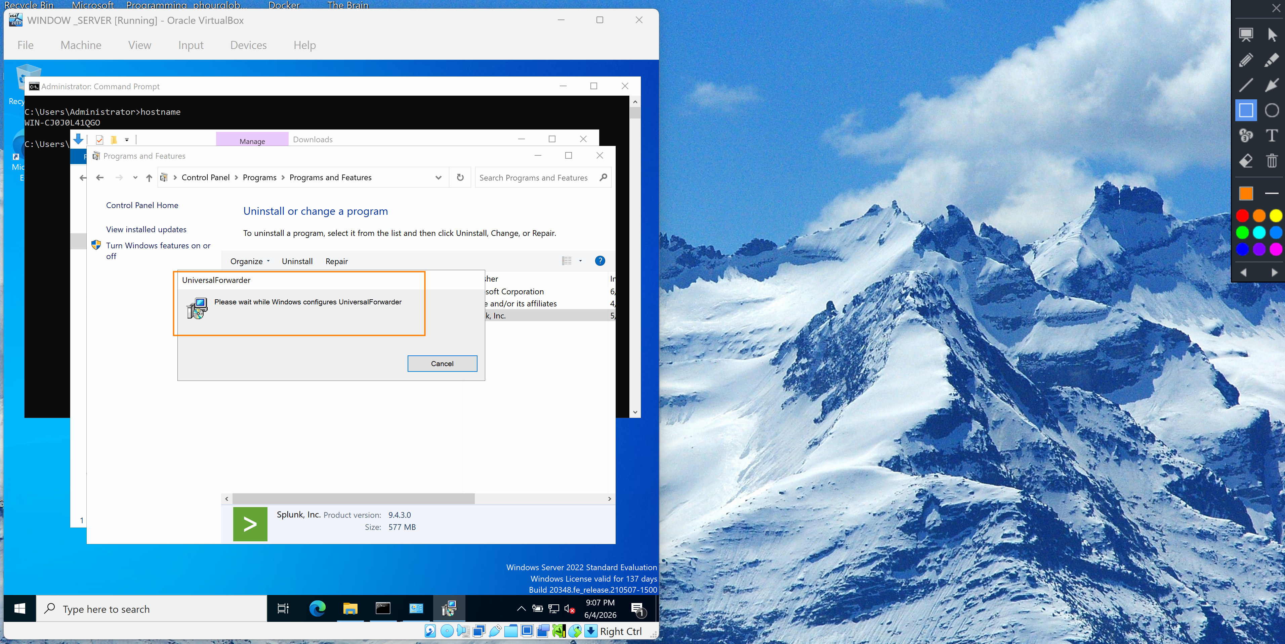
Figure 18. Windows Server Programs and Features panel showing the UniversalForwarder installation (version 9.4.3, 577 MB) being configured. The Command Prompt displays the server hostname 'WIN-CJ0J0L41QG0' confirming the server identity in the SIEM architecture.

5.3 Phase 3: Windows Firewall Configuration
A critical component of the SIEM deployment is the proper configuration of network firewall rules. Windows Defender Firewall with Advanced Security was configured on both the server and the monitored endpoint to permit bidirectional Splunk traffic. Without these rules, the Universal Forwarder would be unable to transmit log data to the indexer, and the Splunk web interface would be inaccessible from network clients.

5.3.1 Inbound Rule Configuration
Inbound firewall rules were created on the Splunk Enterprise server to allow incoming connections on the Splunk management port (TCP 8000) and the data receiving port (TCP 9997). The splunkd service executable was explicitly permitted through the firewall for all network profiles (Domain, Private, and Public).
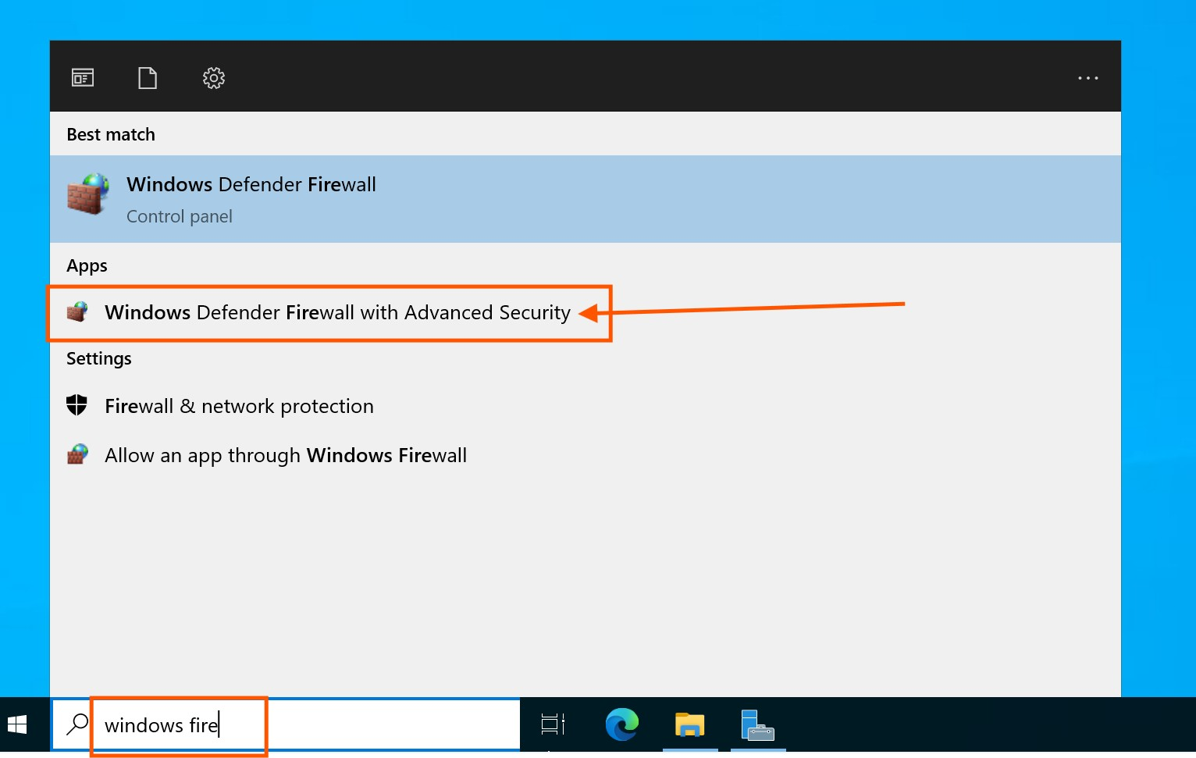
Figure 19. Windows Defender Firewall with Advanced Security management console opened on the server, displaying the interface for configuring inbound and outbound security rules.
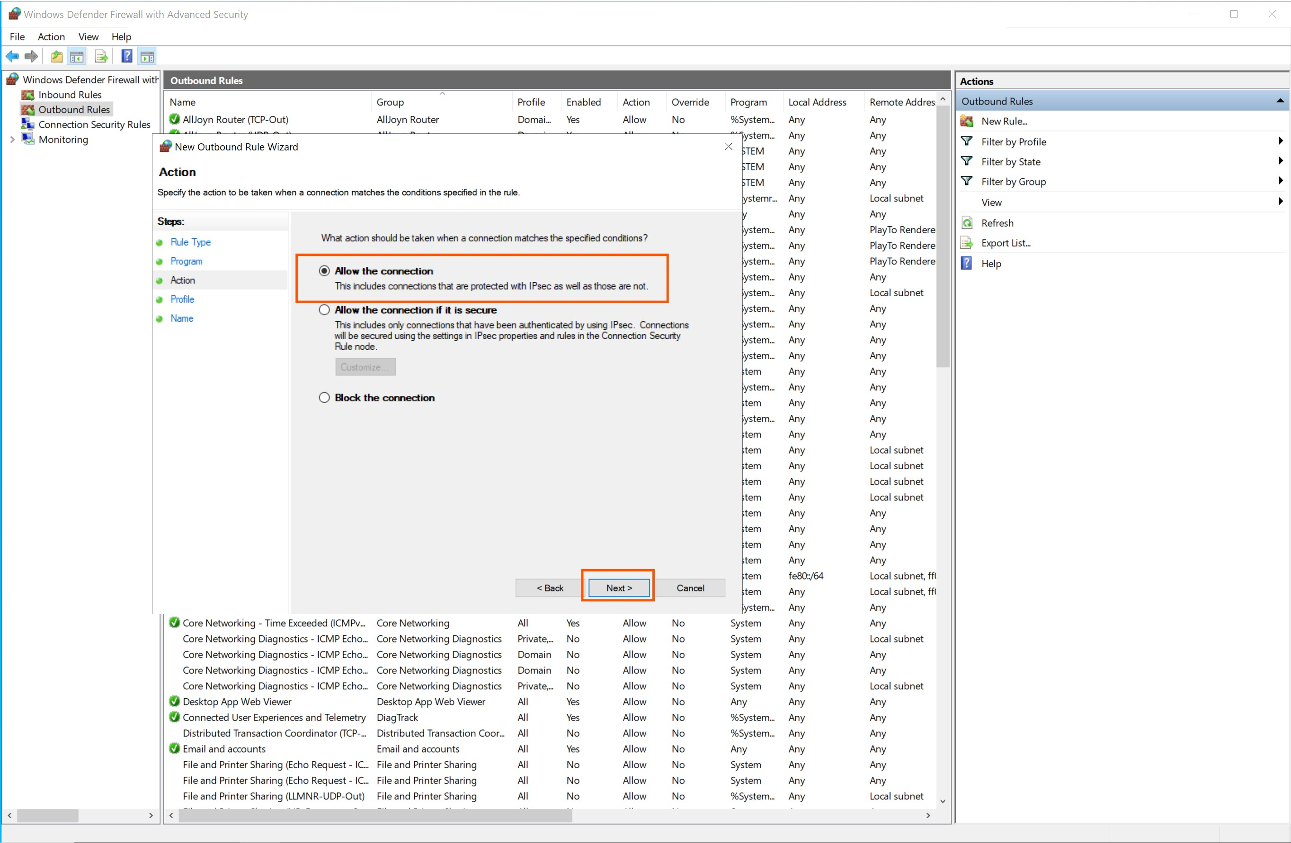
Figure 20. Firewall rule action configuration set to 'Allow the connection', permitting inbound Splunk traffic through the Windows Defender Firewall.
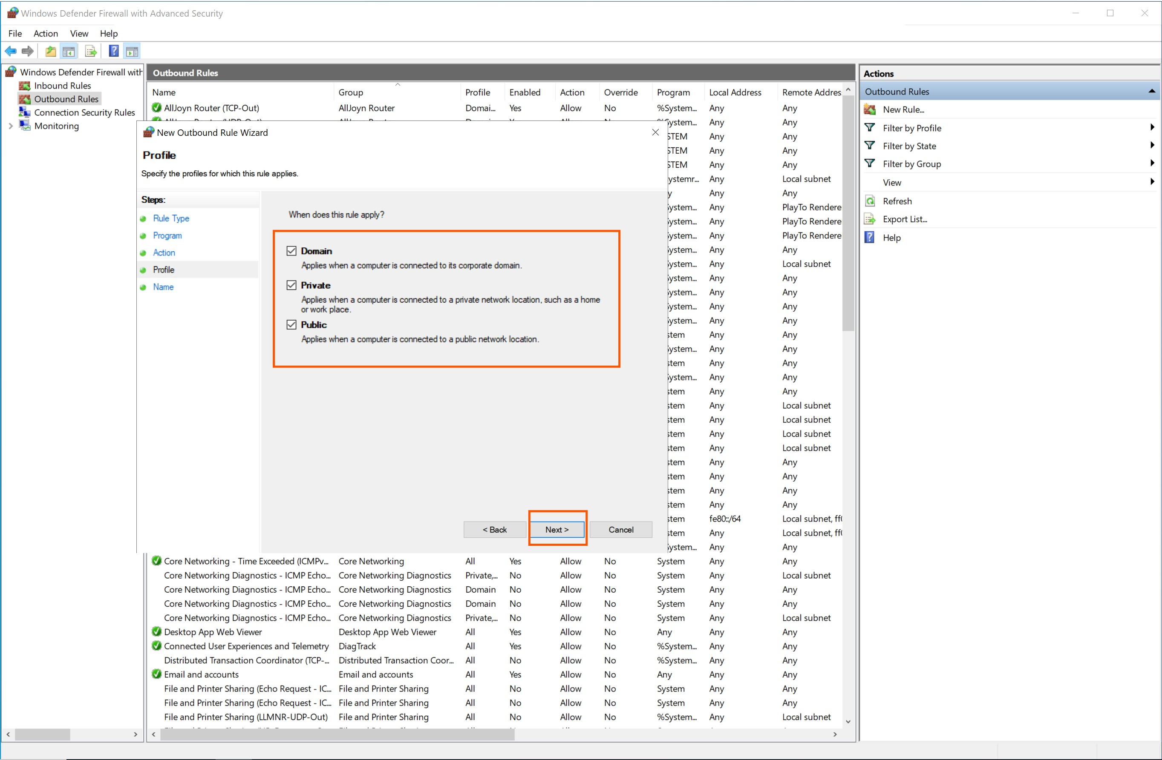
Figure 21. Network profile selection for the Splunk firewall rule, applying the 'Allow' action across all three profiles: Domain, Private, and Public networks, ensuring comprehensive accessibility.
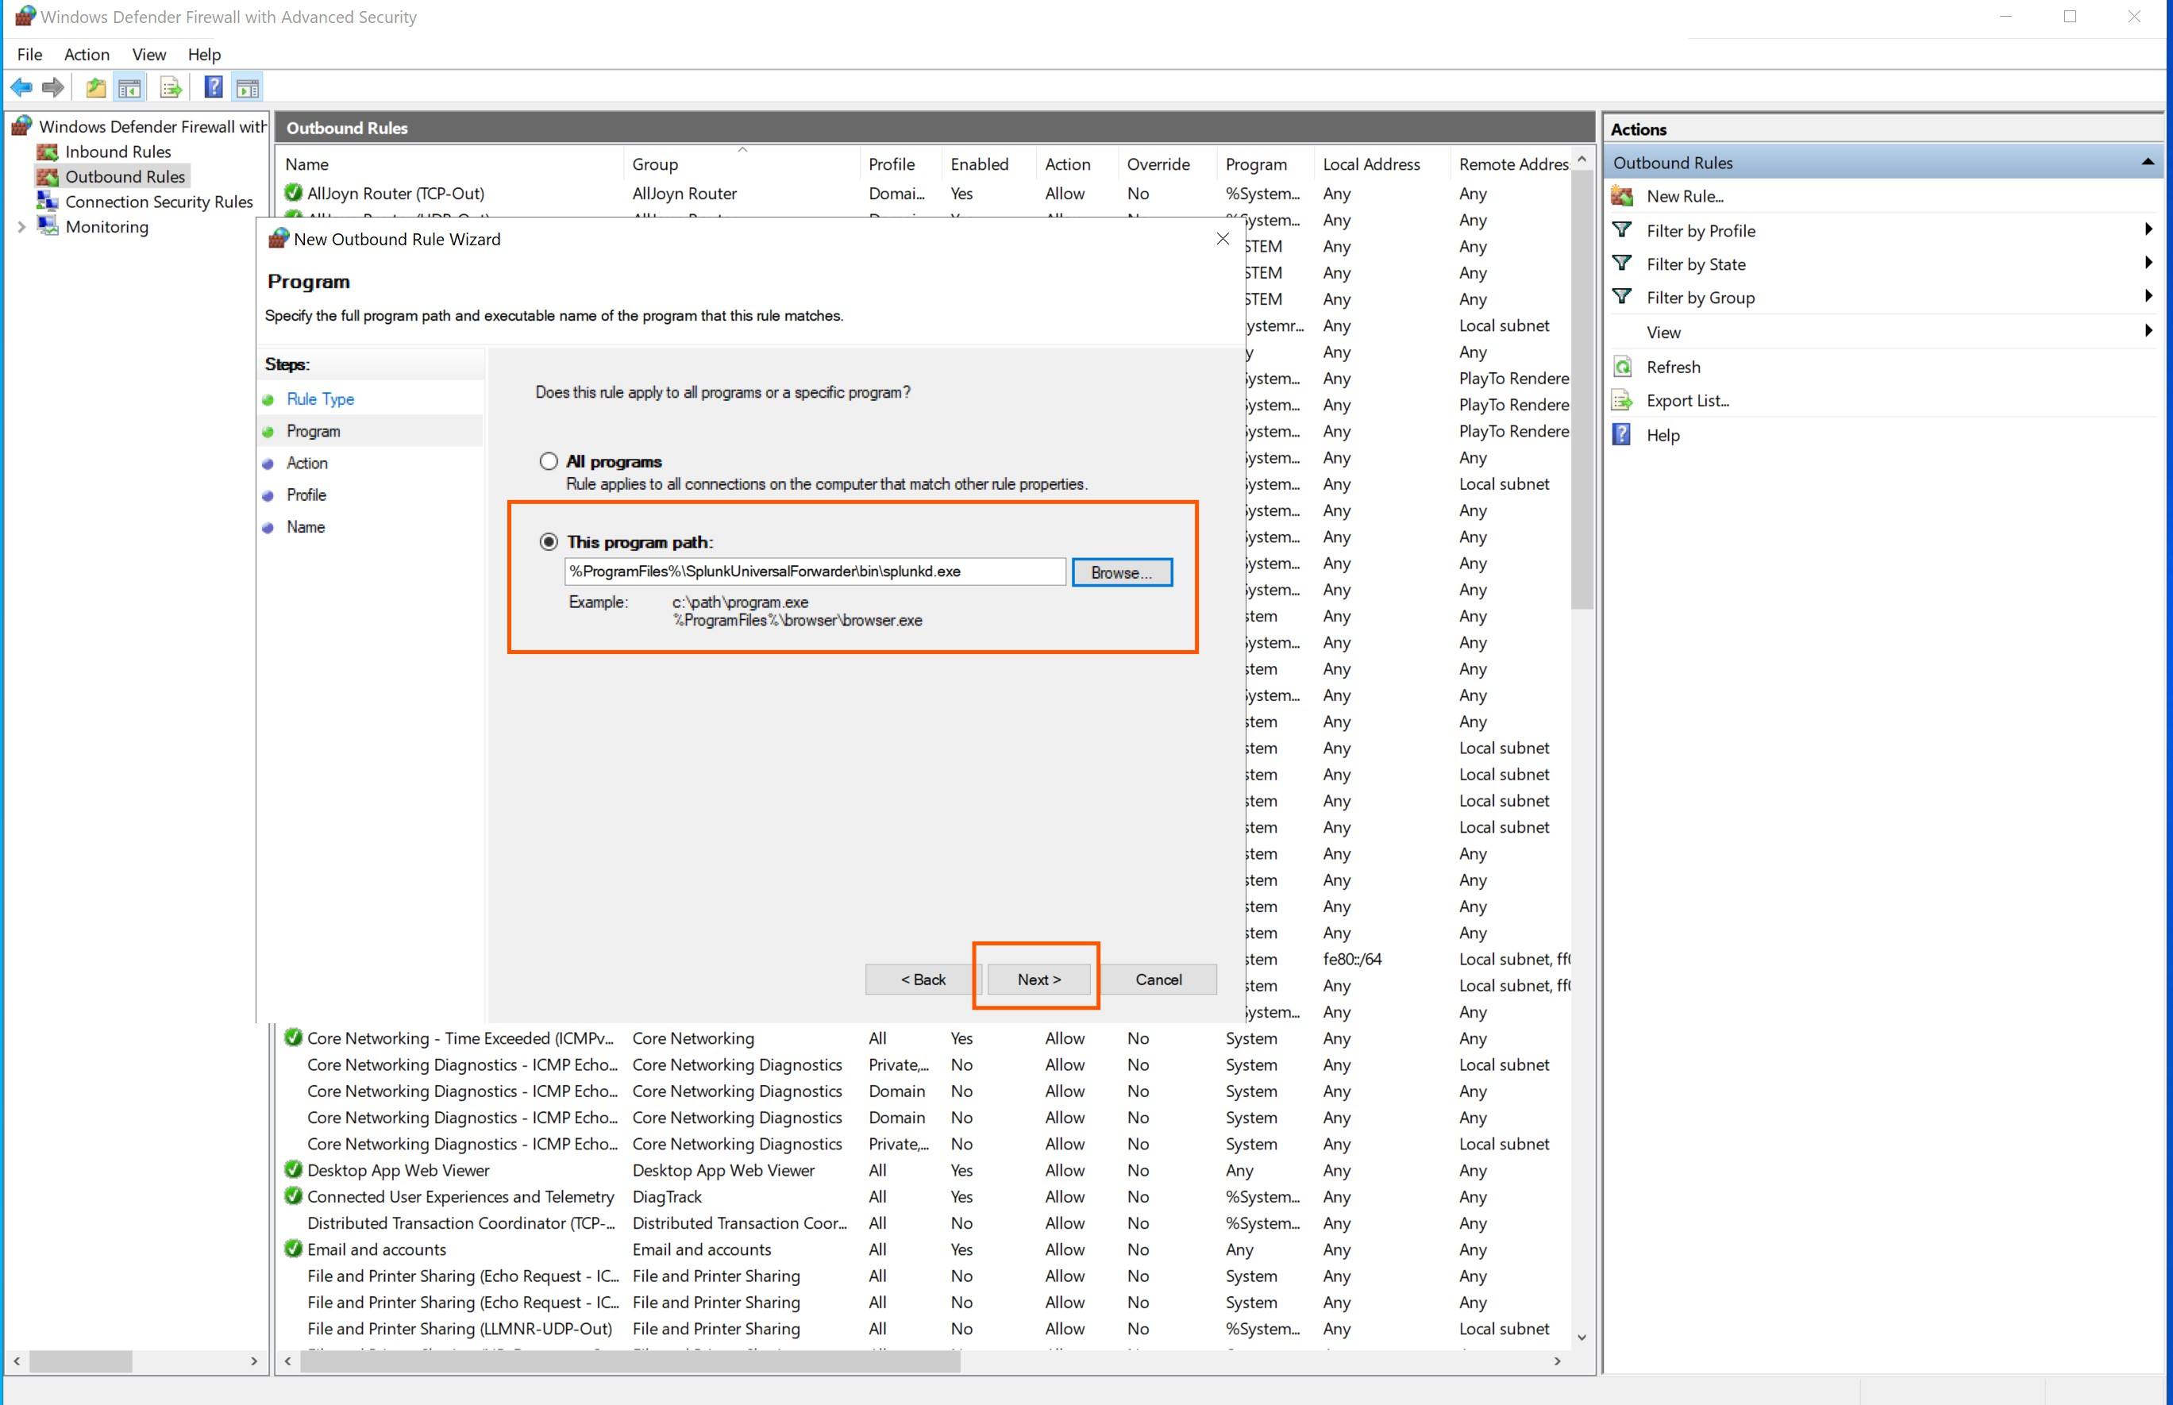
Figure 22. Confirmation of the splunkd firewall rule successfully added to the Windows Defender Firewall inbound rules list, permitting Splunk service communication.

5.3.2 Outbound Rule Configuration
Outbound firewall rules were configured on the monitored endpoint to allow the Universal Forwarder to transmit log data to the Splunk indexer. The New Outbound Rule Wizard was used to create a program-specific rule targeting the Splunk forwarder executable, permitting outbound connections to the indexer on the designated receiving port.
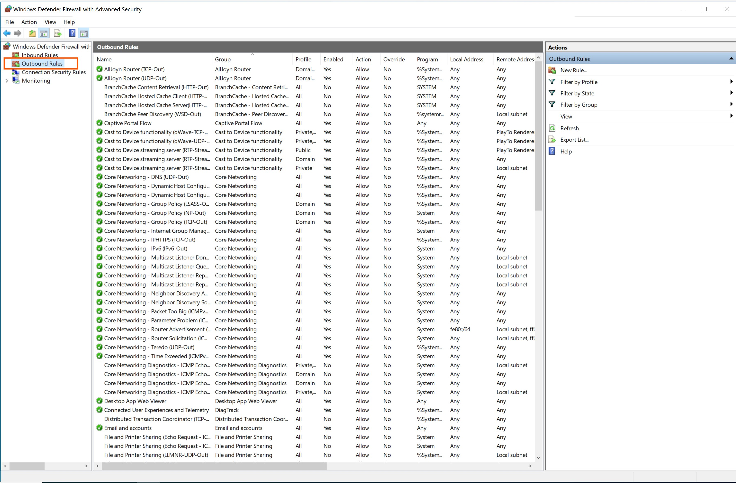
Figure 23. Windows Defender Firewall outbound rule configuration initiated to enable the Universal Forwarder to transmit logs through the configured receiving port to the Splunk indexer.
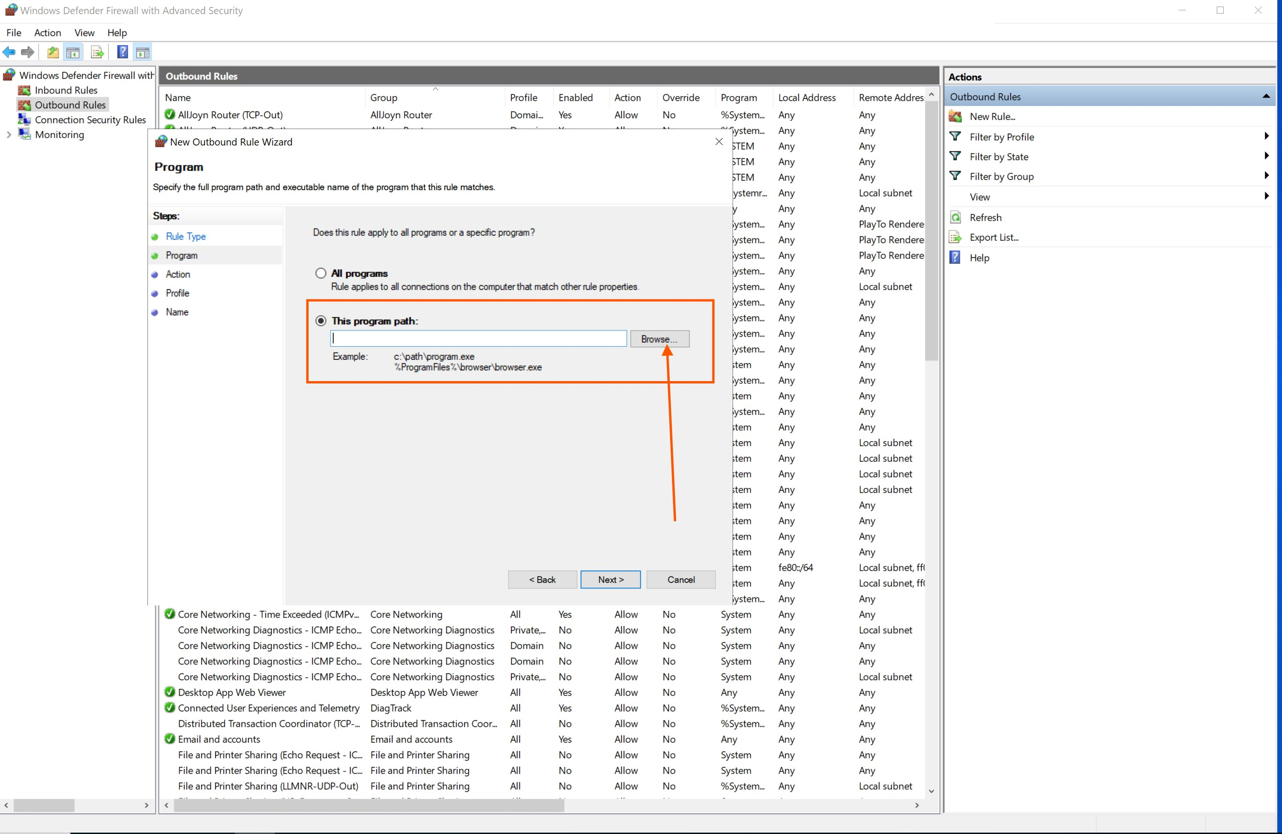
Figure 24. New Outbound Rule Wizard displaying the program path specification step. The rule targets the Splunk forwarder executable to permit outbound log transmission.
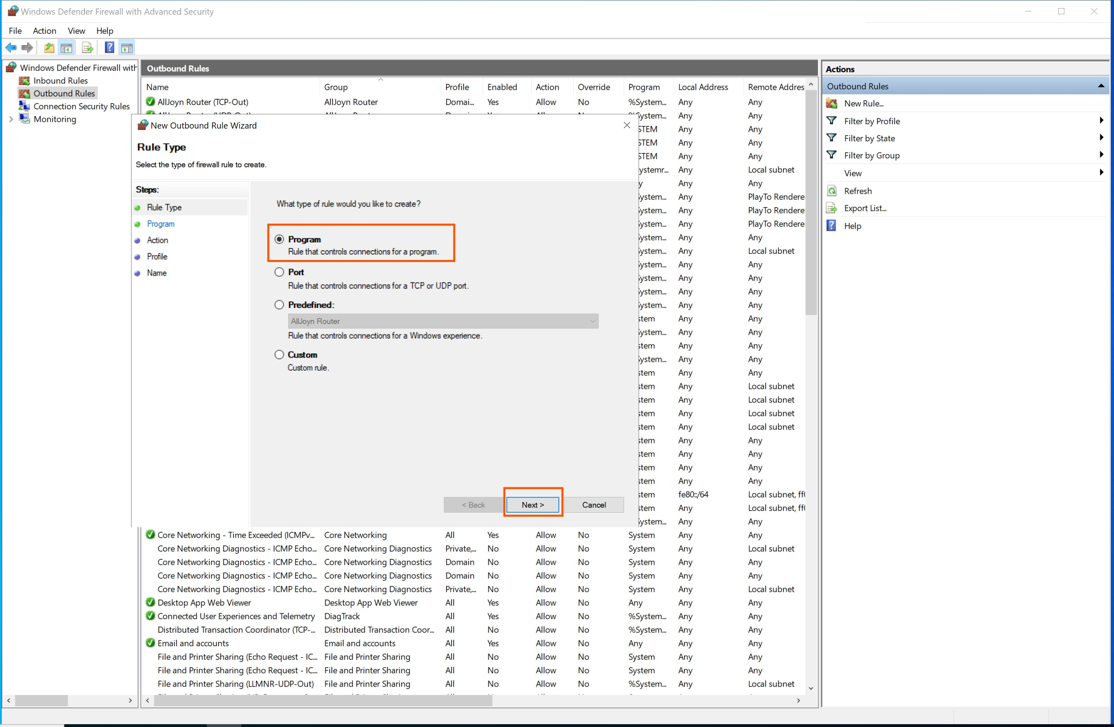
Figure 25. Outbound rule program selection interface in Windows Defender Firewall, allowing specification of the exact executable path for the Splunk Universal Forwarder.
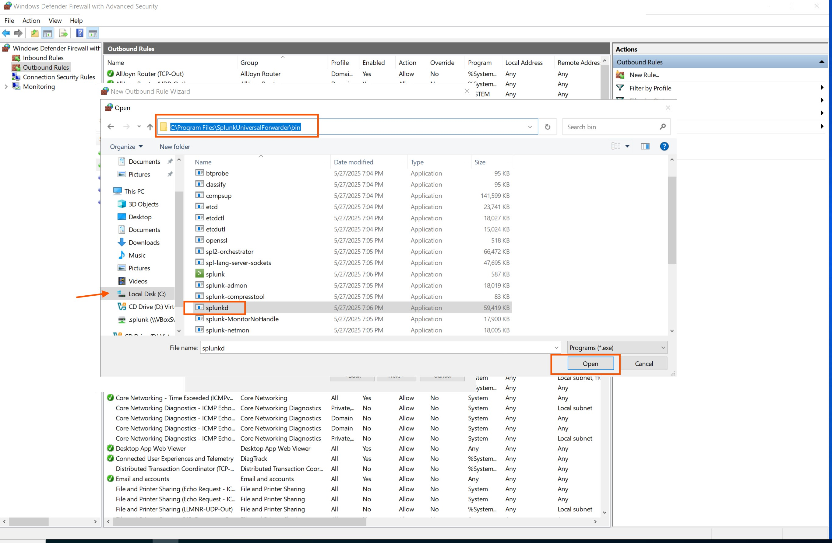
Figure 26. File system navigation to locate the Splunk Universal Forwarder executable for the firewall outbound rule program path configuration.
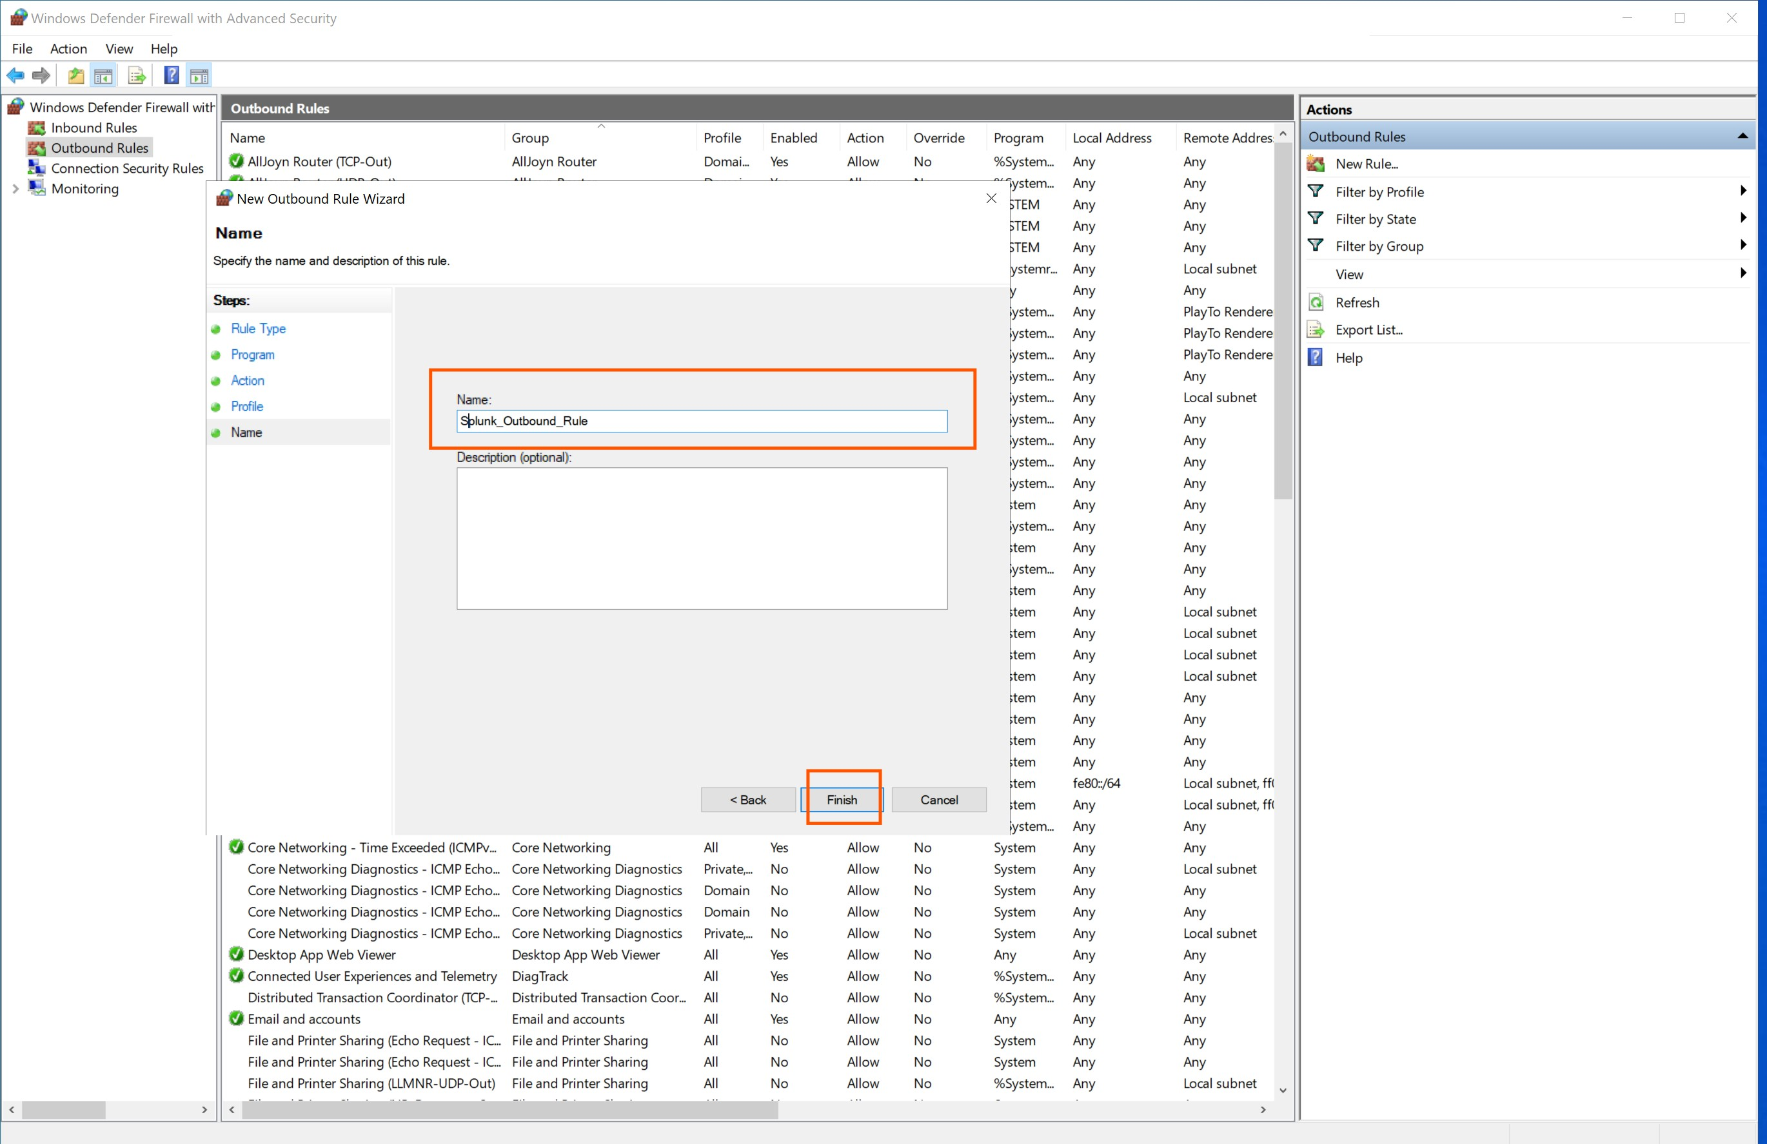
Figure 27. Naming the outbound firewall rule with a descriptive identifier for administrative clarity and future reference in the firewall rule management console.
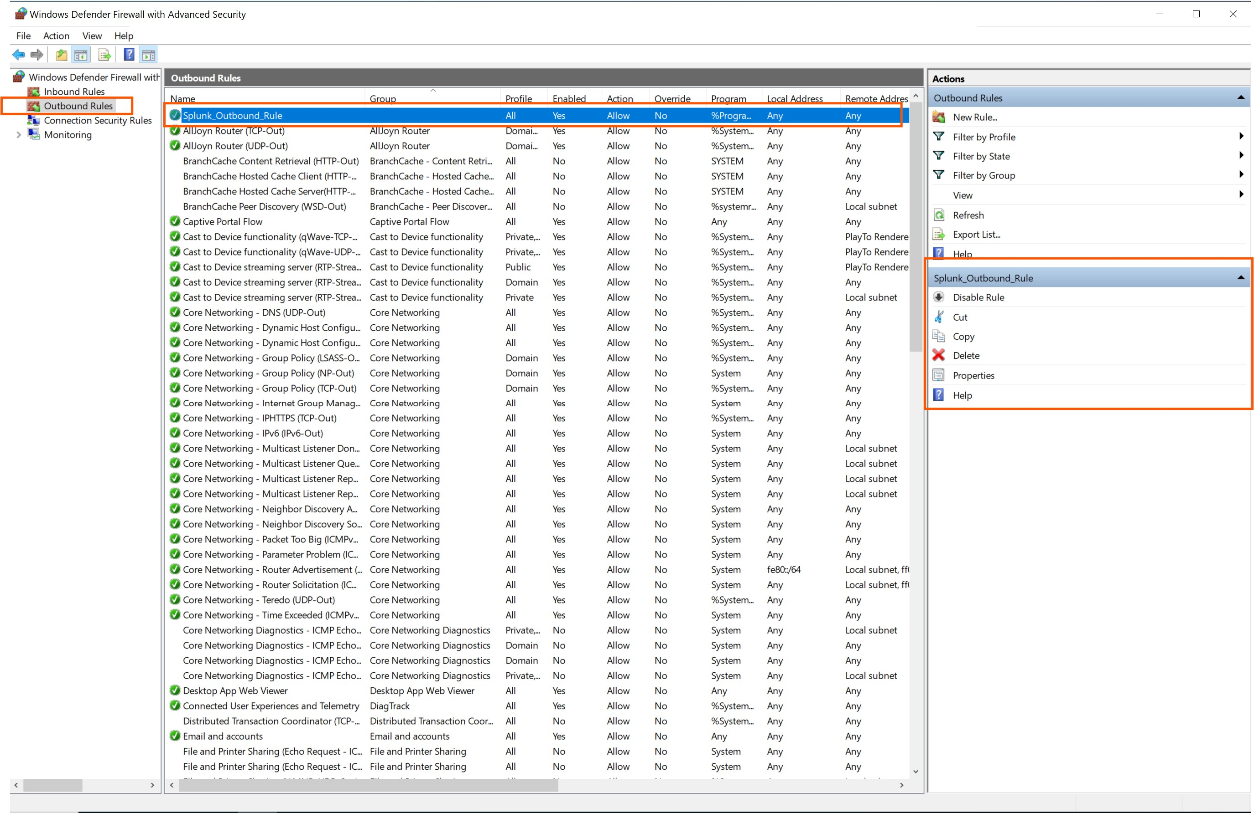
Figure 28. Confirmation that the Splunk outbound firewall rule has been successfully created and enabled in Windows Defender Firewall, permitting the Universal Forwarder to transmit log data to the indexer.

5.4 Phase 4: Indexer and Receiving Port Configuration
With the Universal Forwarder deployed and firewall rules in place, the Splunk Enterprise indexer was configured to listen on the designated receiving port (TCP 9997) for incoming data from the forwarder. This configuration establishes the data pipeline endpoint on the server side, enabling the indexer to accept, parse, and index forwarded log data.
The receiving configuration was completed through the Splunk Enterprise web interface under Settings > Forwarding and receiving > Configure receiving. A new receiving port was added (9997), and the indexer was configured to accept connections from all forwarders in the deployment.
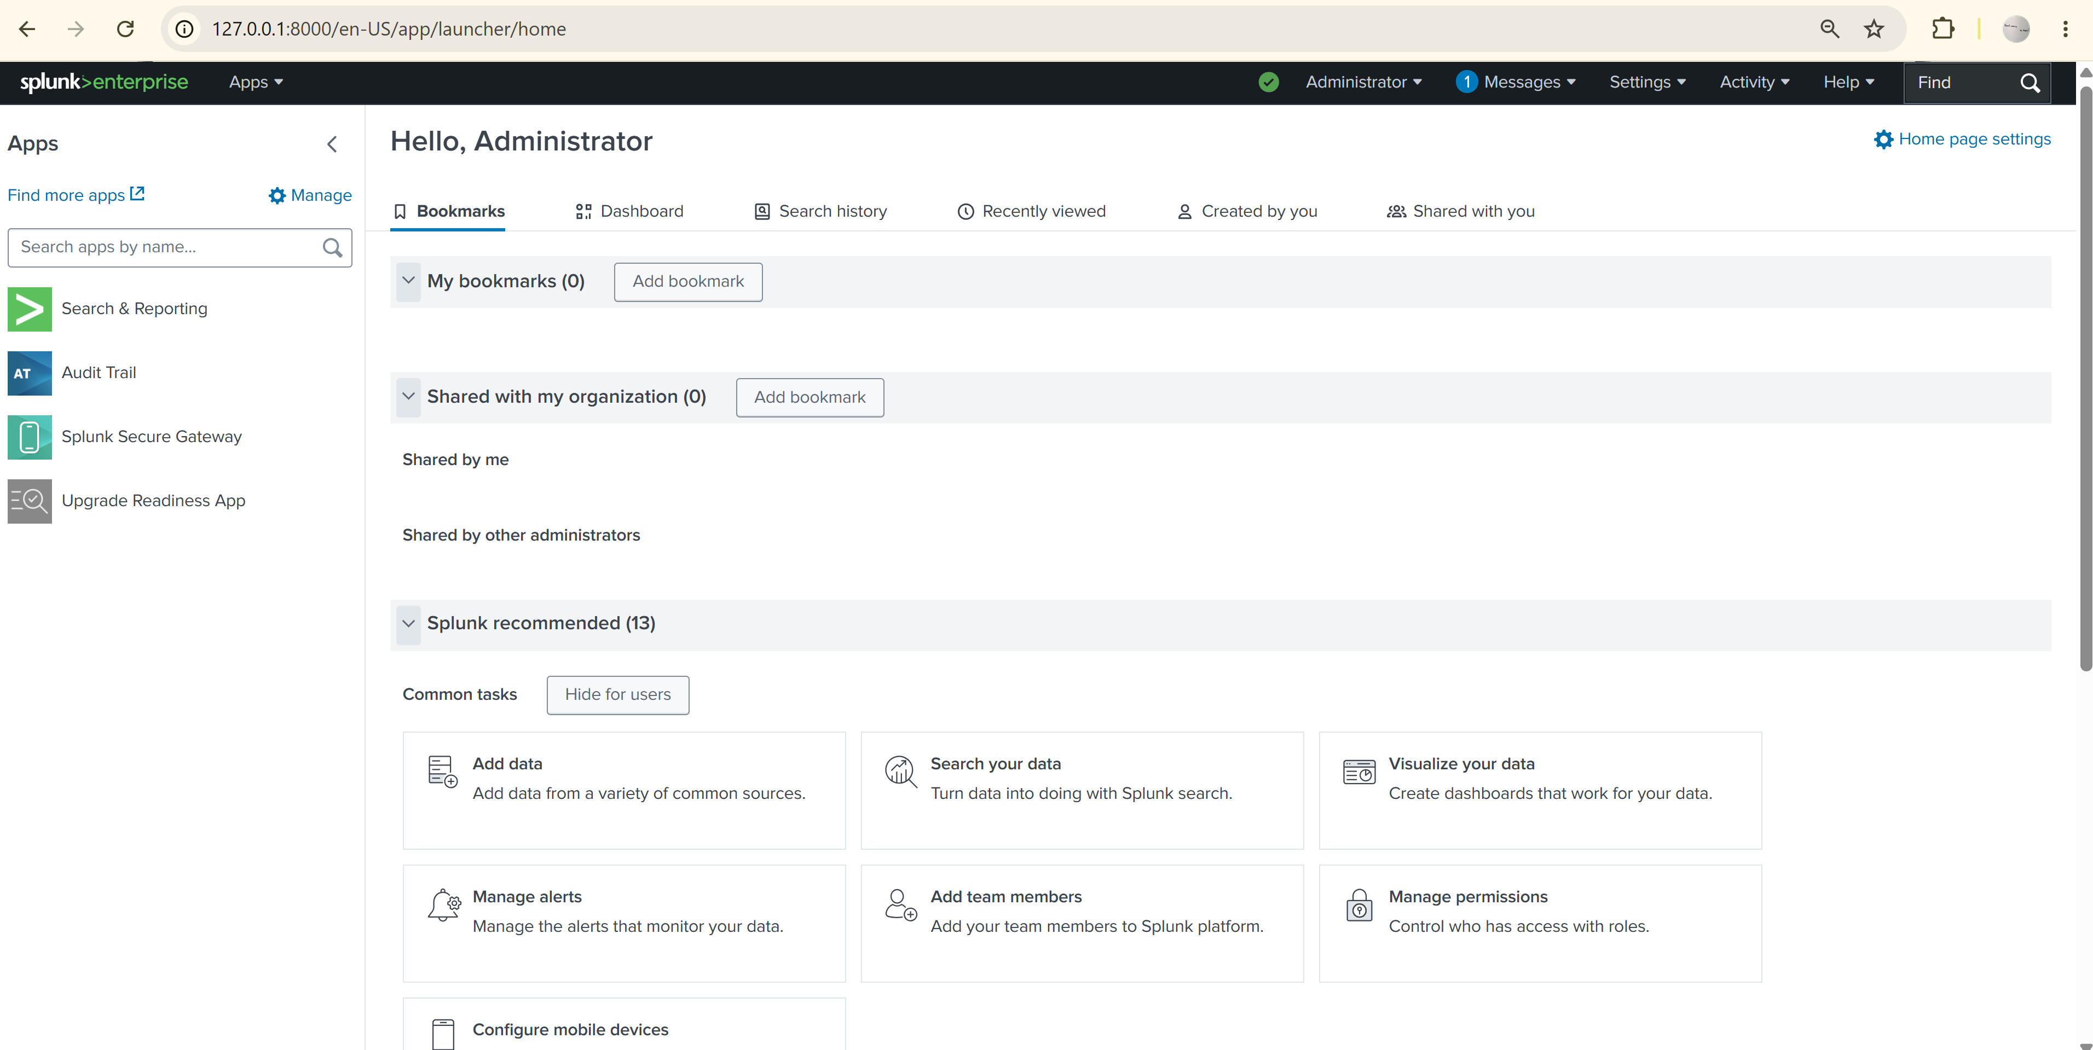
Figure 29. Splunk Enterprise Settings menu navigation to the Forwarding and Receiving configuration panel, where the data receiving port is established for incoming Universal Forwarder connections.
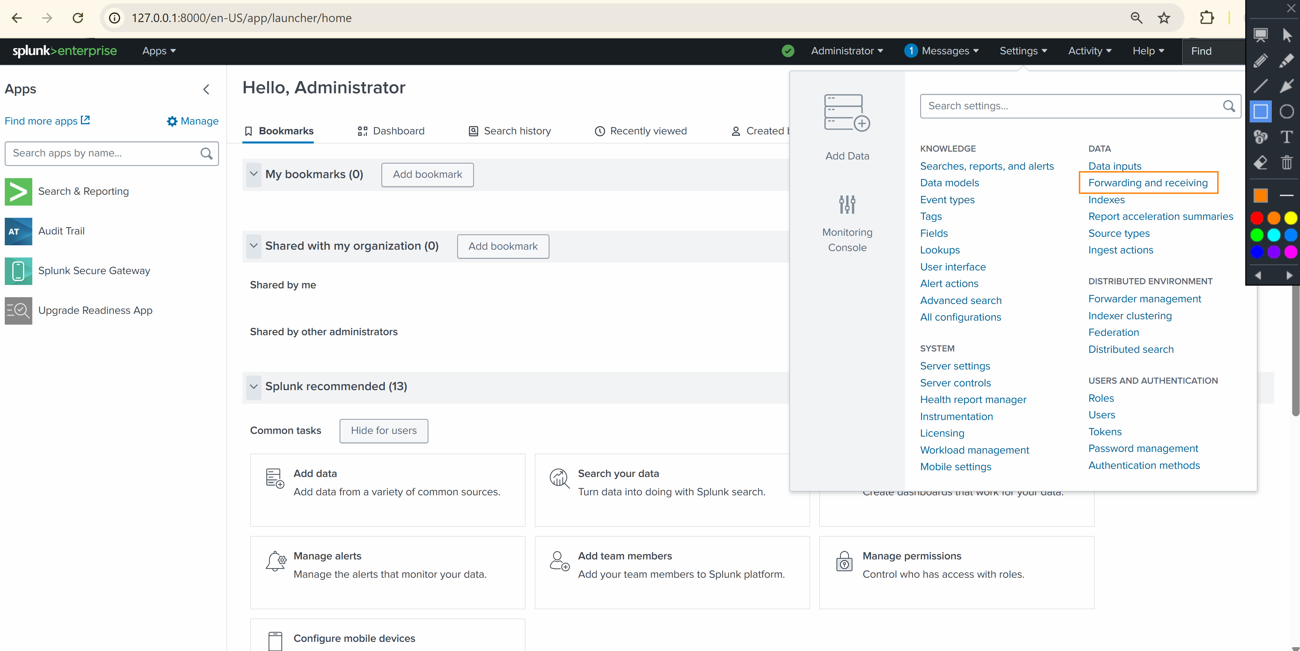
Figure 30. Splunk Enterprise receiving port configuration interface displaying the setup of TCP port 9997 as the designated data receiving endpoint for Universal Forwarder connections.
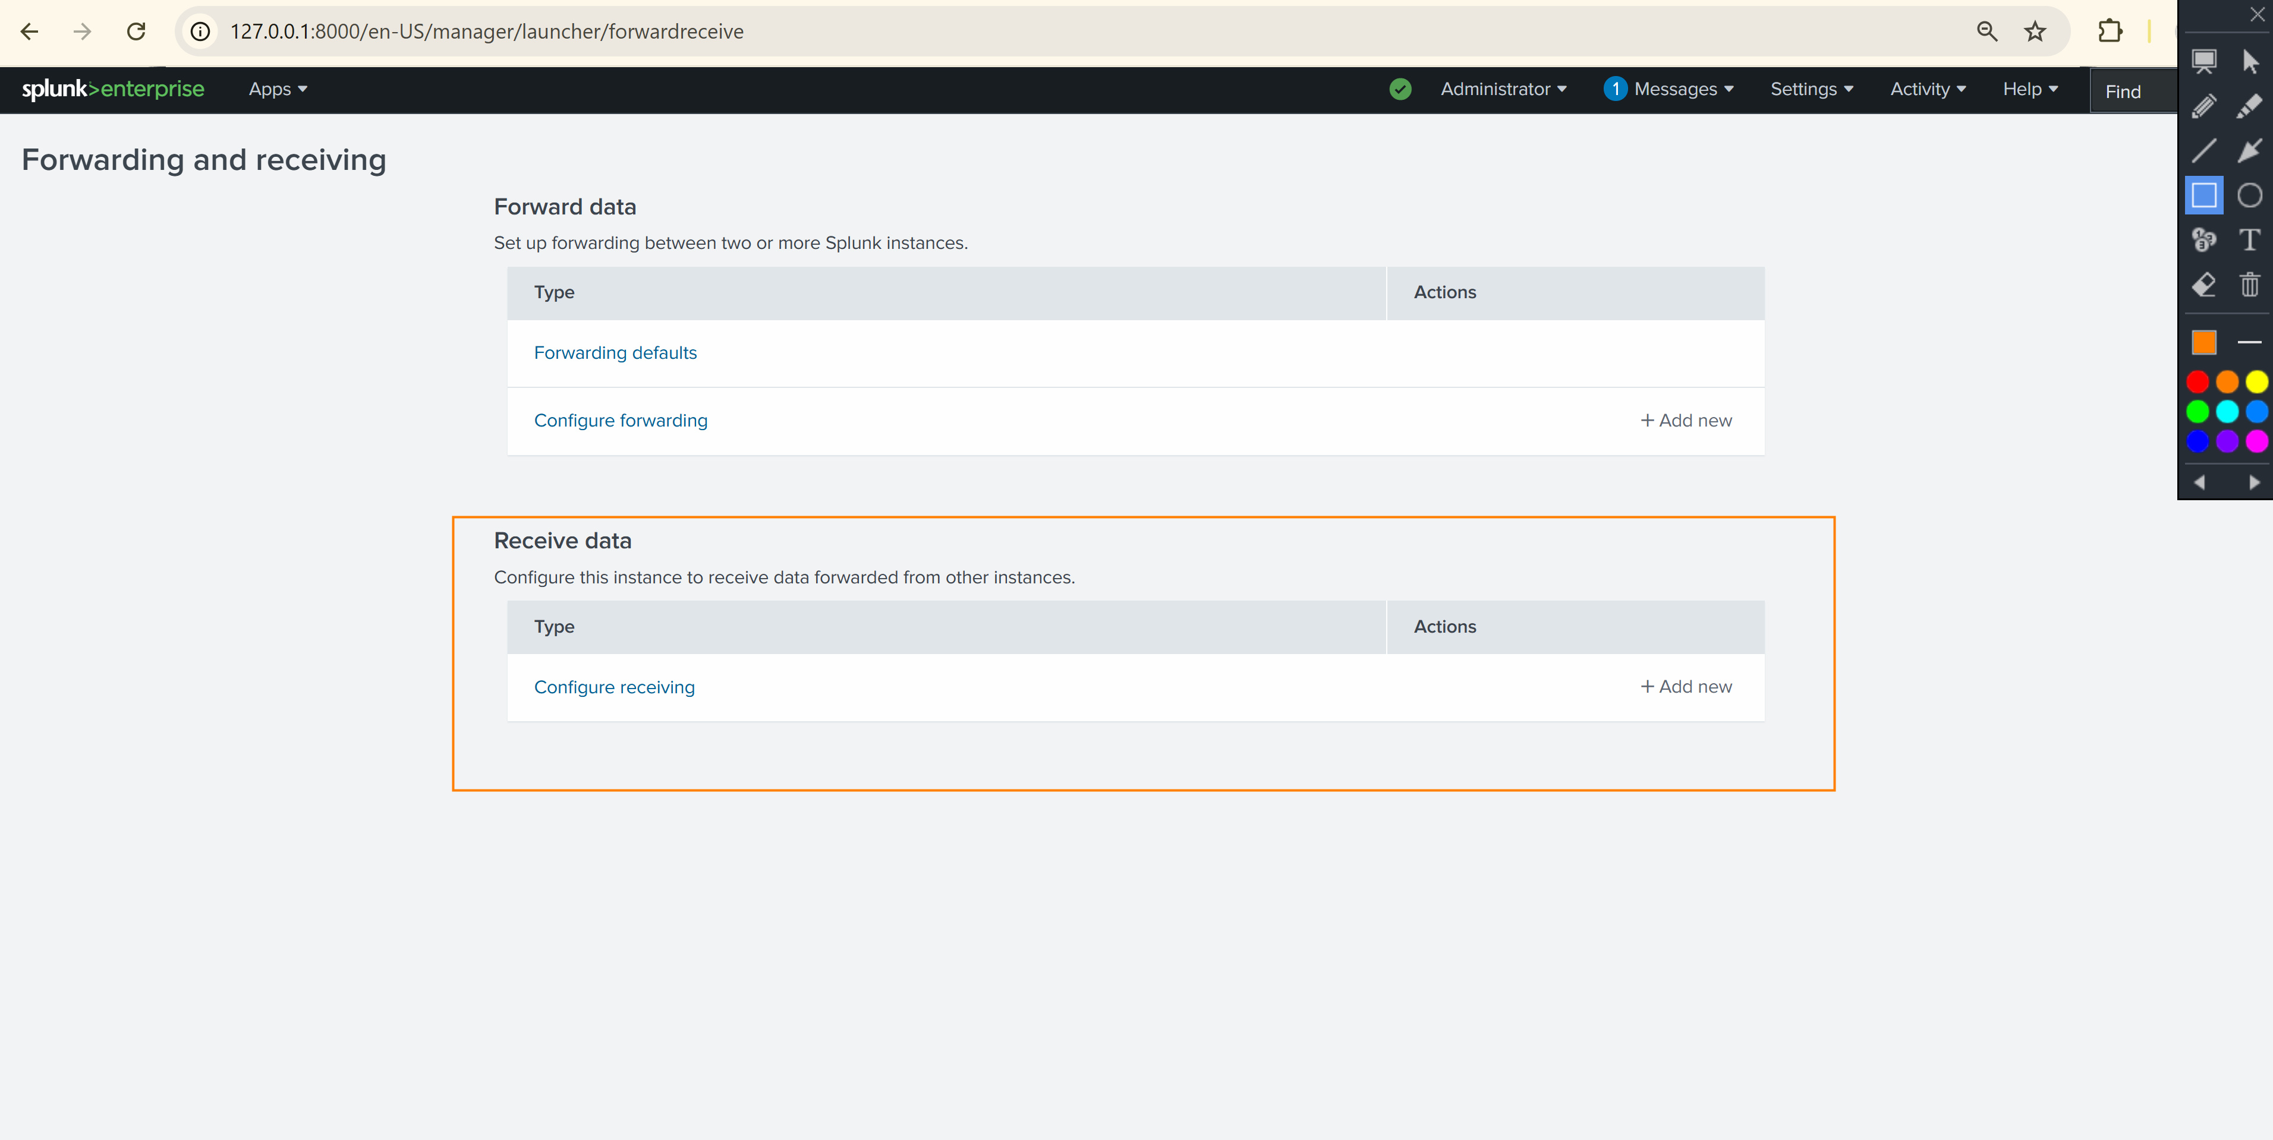
Figure 31. Confirmation of the receiving port (TCP 9997) successfully configured on the Splunk Enterprise indexer, ready to accept incoming forwarder data.

5.5 Phase 5: Data Ingestion Verification
Following the completion of all configuration steps, the data ingestion pipeline was verified by executing search queries on the Splunk Enterprise interface. The initial search query 'index=*' was used to retrieve all indexed events, confirming that the Universal Forwarder was successfully transmitting data to the indexer.
The verification confirmed that 5,406 events had been successfully ingested from the monitored endpoint (DESKTOP-EPLK670) covering a time range from June 3, 2026 to June 4, 2026. The events included Windows Security logs, System logs, and Setup logs, with multiple event sources including WinEventLog:Security and WinEventLog:Setup.
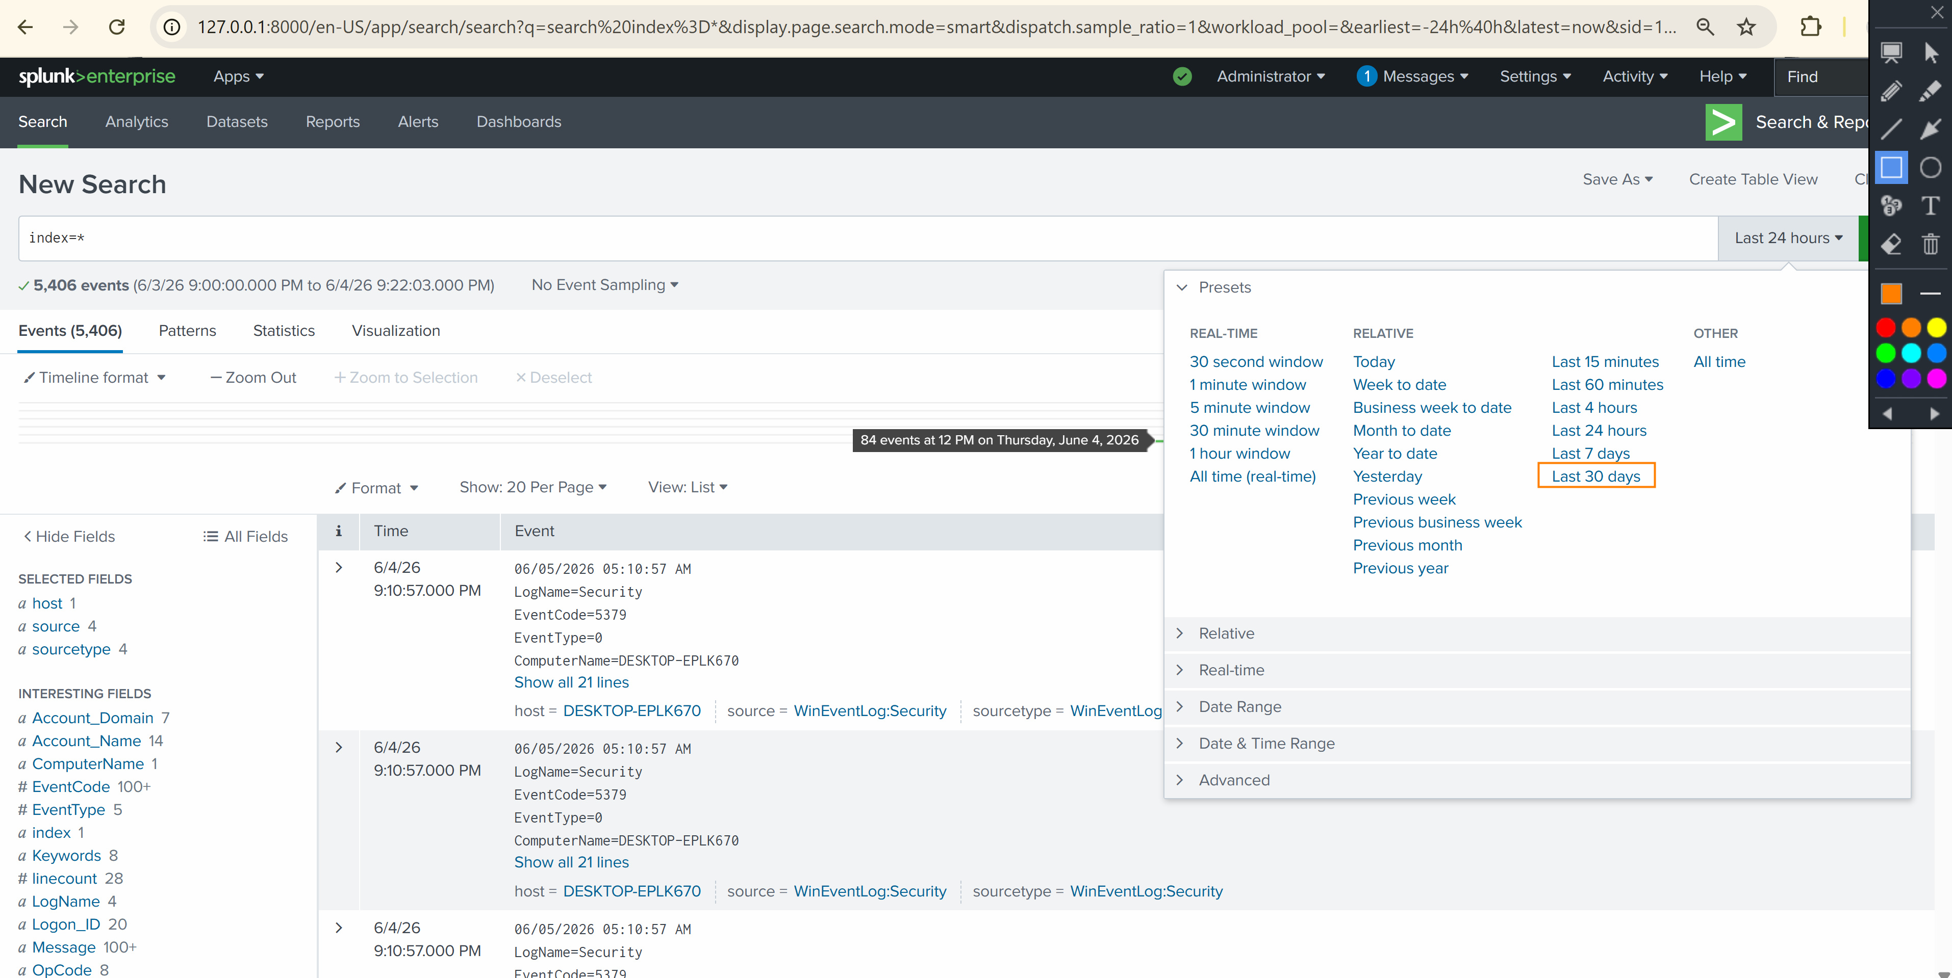
Figure 32. Splunk Enterprise search results confirming successful data ingestion. The 'index=*' query returned 5,406 events from the monitored endpoint DESKTOP-EPLK670. The time range picker overlay shows the available presets including Real-Time, Relative, and Date Range options for granular event filtering.
The search results revealed important metadata about the ingested events. The Selected Fields panel on the left showed 1 unique host (DESKTOP-EPLK670), 4 source types (WinEventLog:Security, WinEventLog:Setup, WinEventLog:System, and WinEventLog:Application), confirming comprehensive log collection across multiple Windows event channels.
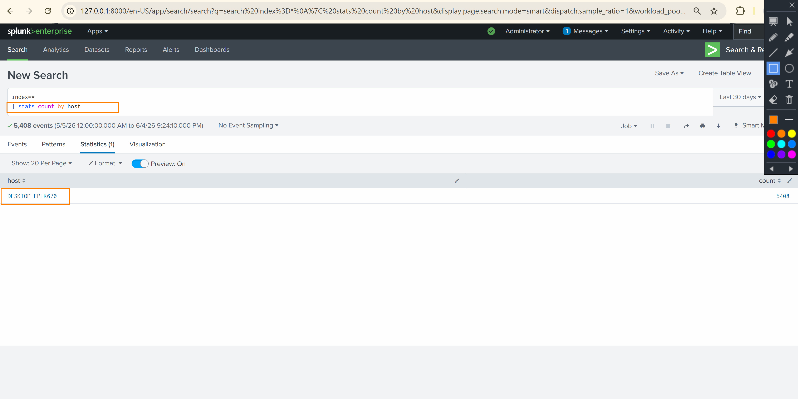
Figure 33. Detailed event inspection view showing individual security events with full metadata including LogName, EventCode, EventType, ComputerName, and source classification fields.

5.6 Phase 6: SPL Search and Analysis
With data ingestion confirmed, targeted SPL (Search Processing Language) queries were developed to extract actionable security intelligence from the indexed events. SPL is Splunk's proprietary query language that enables analysts to search, filter, transform, and visualize machine data for security monitoring and incident investigation purposes.

5.6.1 Host-Specific Event Filtering
The first analytical query targeted the specific monitored endpoint by filtering events using the host field. The query 'index=* host="DESKTOP-EPLK670" EventCode=1' was executed to isolate system setup events (EventCode 1) from the monitored Windows endpoint. This query returned 8 events within the Last 30 days time range, confirming active system configuration activities on the endpoint.
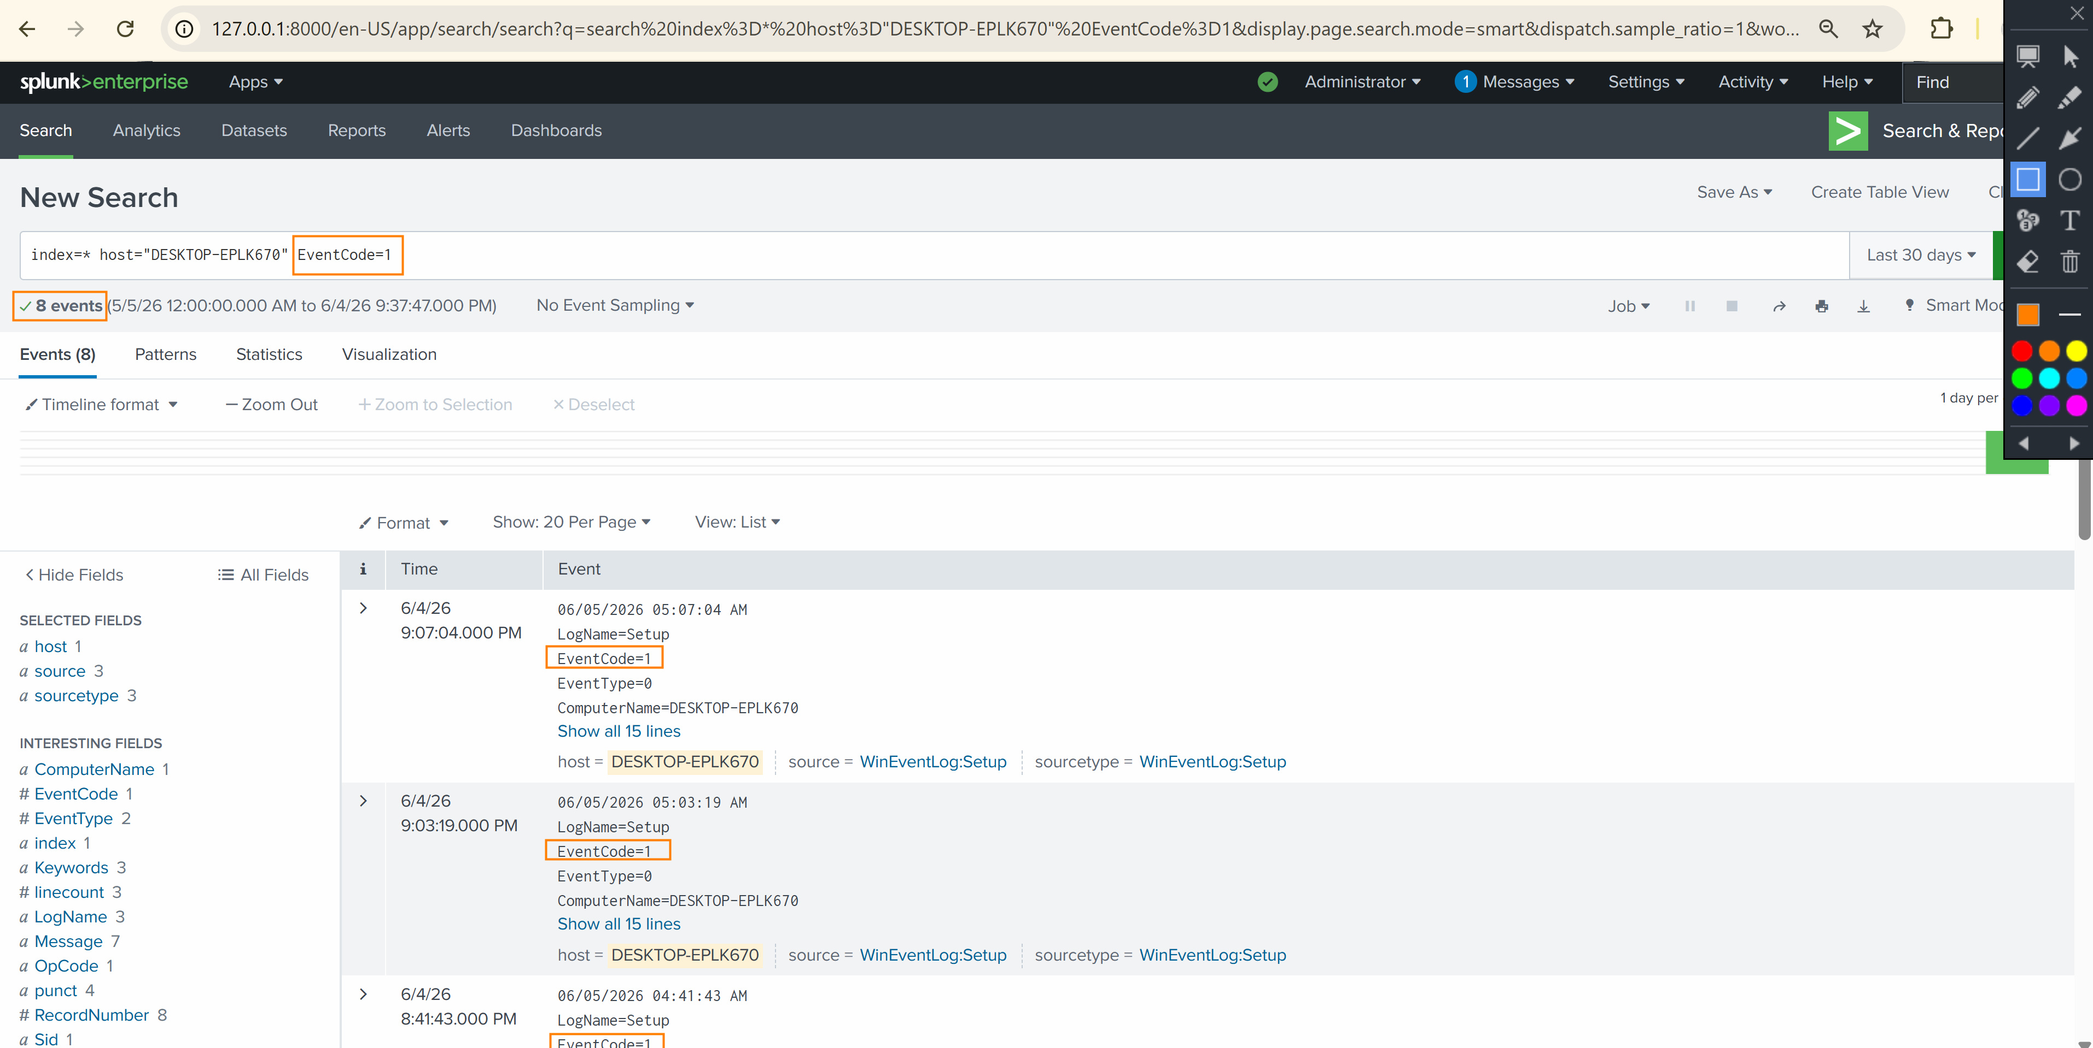
Figure 34. SPL query results for host-specific event filtering using 'index=* host="DESKTOP-EPLK670" EventCode=1'. The search returned 8 setup events (EventCode=1) from the WinEventLog:Setup source, demonstrating precise event filtering capabilities for targeted security analysis.

5.6.2 Security Event Analysis
Additional SPL queries were executed to analyze security-specific events, including failed logon attempts (EventCode 4625) and successful authentications (EventCode 4624). These queries provided visibility into authentication patterns, identifying potential unauthorized access attempts and establishing baselines for normal authentication behavior. The Interesting Fields panel revealed valuable metadata distributions including Account_Domain (7 unique values), Account_Name (14 unique values), and EventCode (100+ unique values), providing a comprehensive view of the security event landscape.
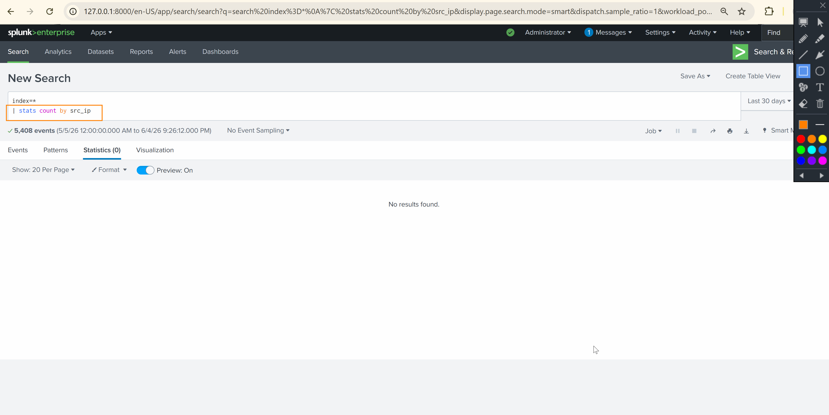
Figure 35. SPL search query execution targeting security event analysis with field extraction results showing the distribution of event codes, account names, and logon types across the indexed dataset.
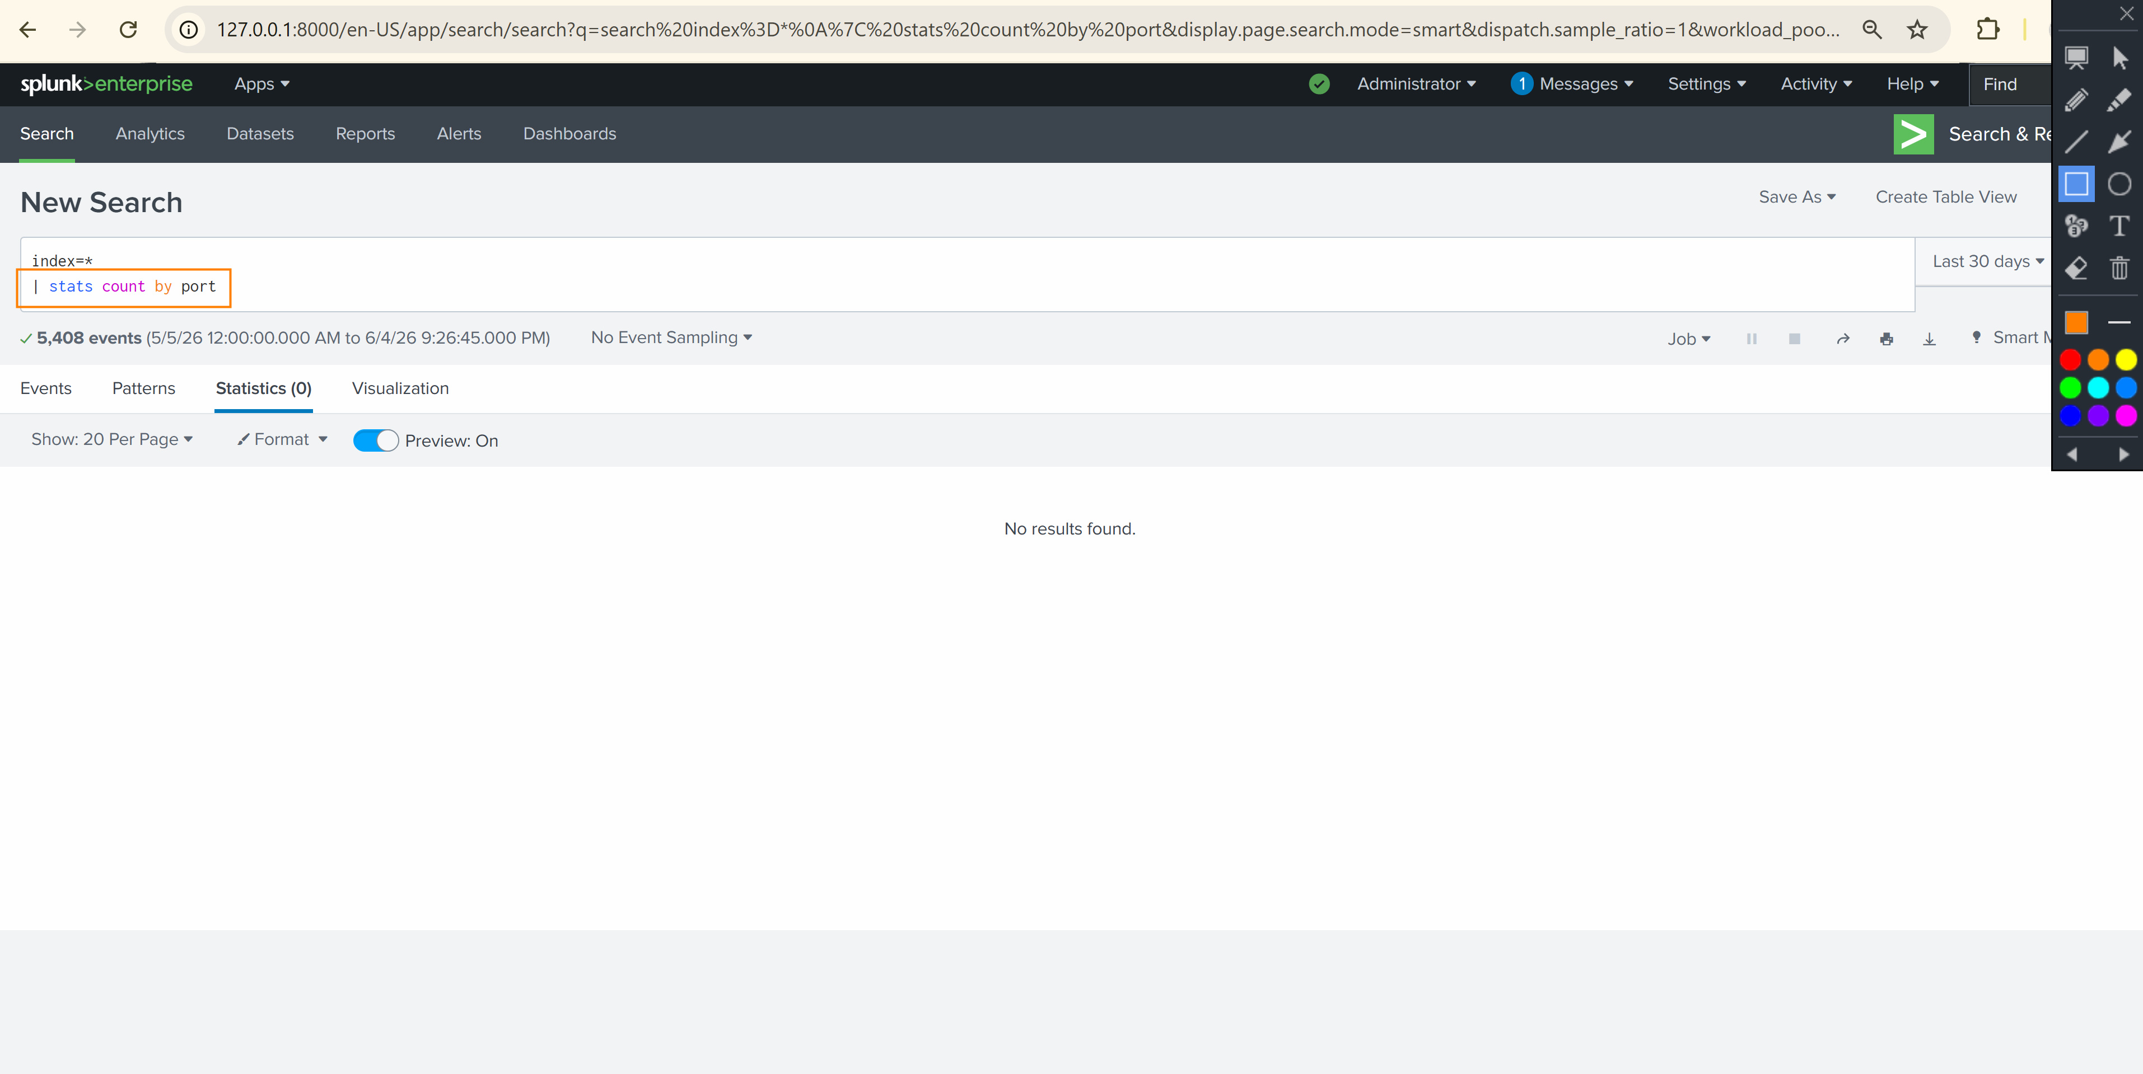
Figure 36. Expanded event detail view showing individual security event fields including Account_Name, LogonType, and associated metadata for authentication event correlation.

5.7 Phase 7: Security Dashboard Creation
The final phase of the implementation involved the creation of a custom security dashboard within Splunk Enterprise. The Authentication Dashboard was designed to provide SOC analysts with a centralized, visual interface for monitoring authentication events, tracking failed logon trends, and identifying potential security threats in real time.

5.7.1 Dashboard Design and Panel Configuration
The Authentication Dashboard was created using Splunk's Dashboard Editor (Classic Dashboards) and configured with multiple visualization panels. Each panel was powered by a specific SPL query designed to extract and visualize a distinct aspect of the authentication security landscape.
The dashboard included the following panels:
- Failed Logon Trend (Line Chart): A time-series visualization using the query 'index=main sourcetype="WinEventLog:Security" EventCode=4625 | timechart span=1d count by host' to track daily failed authentication attempts per host.
- Total Failed Logons (Single Value): A prominent numerical display showing the total count of failed logon events (EventCode 4625) across the monitoring period, providing immediate visibility into authentication security posture.
- Successful Authentication Events: A panel tracking EventCode 4624 events to establish baseline authentication patterns and identify anomalous logon activity.
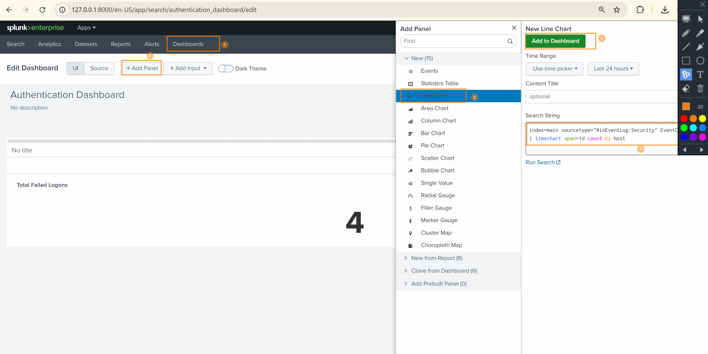
Figure 37. Splunk Dashboard Editor showing the Authentication Dashboard in edit mode. The Add Panel interface displays the Line Chart visualization type selected, with the SPL query 'index=main sourcetype="WinEventLog:Security" EventCode=4625 | timechart span=1d count by host' configured for the Failed Logon Trend panel. The Total Failed Logons single-value panel shows a count of 4 failed logon events.
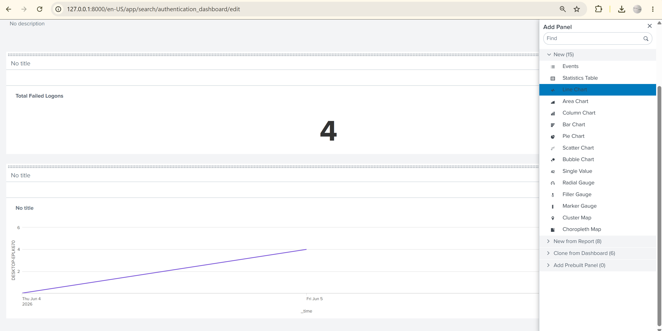
Figure 38. Authentication Dashboard panel configuration view showing the completed dashboard layout with the Failed Logon Trend line chart and Total Failed Logons counter panels positioned for optimal SOC analyst visibility.

5.7.2 Dashboard Panel SPL Queries
The following SPL queries were used to power the dashboard panels. Each query was optimized for performance and configured with appropriate time ranges to provide meaningful security insights.
Panel Name | SPL Query | Visualization
Failed Logon Trend | index=main sourcetype="WinEventLog:Security" EventCode=4625 | timechart span=1d count by host | Line Chart
Total Failed Logons | index=main sourcetype="WinEventLog:Security" EventCode=4625 | stats count | Single Value
Setup Events by Host | index=* host="DESKTOP-EPLK670" EventCode=1 | timechart count | Column Chart

6. Results and Findings
The Splunk SIEM deployment achieved all stated objectives, demonstrating a fully functional security monitoring pipeline from endpoint log collection through centralized indexing and visual dashboard reporting. The following key results were documented during the implementation.

6.1 Data Ingestion Metrics
Metric | Value
Total Events Ingested | 5,406
Monitored Hosts | 1 (DESKTOP-EPLK670)
Log Sources | 4 (Security, System, Setup, Application)
Time Range | June 3, 2026 - June 5, 2026
Failed Logon Events (4625) | 4
Setup Events (EventCode 1) | 8
Unique Account Names | 14
Unique Account Domains | 7

6.2 Key Security Findings
The analysis of ingested security events revealed several noteworthy findings relevant to the security posture of the monitored environment:
- Failed Authentication Attempts: Four failed logon events (EventCode 4625) were identified during the monitoring period. These events were analyzed to determine the source accounts, logon types, and failure reasons, providing insight into potential unauthorized access attempts.
- Event Distribution: The EventCode field contained over 100 unique values, indicating a diverse range of system and security activities on the monitored endpoint. This breadth of event coverage demonstrates the comprehensive nature of the Windows event log collection.
- Source Type Coverage: The Universal Forwarder successfully collected logs from multiple Windows event channels, including Security, System, Setup, and Application logs, ensuring holistic visibility into endpoint activities.
- Host Identification: All events were correctly attributed to the source host DESKTOP-EPLK670, confirming accurate host identification in the forwarding pipeline.

7. Security Considerations
The following security considerations were addressed during the implementation to ensure the integrity and confidentiality of the SIEM deployment:
- Firewall Hardening: Windows Defender Firewall rules were configured with the principle of least privilege, permitting only the specific Splunk executables (splunkd.exe) through the firewall rather than opening broad port ranges.
- Authentication Security: A dedicated administrator account (phour44) was created for Splunk management, avoiding the use of default credentials. The account was configured with a strong password during installation.
- Network Segmentation: The lab environment utilized VirtualBox internal networking to simulate network segmentation between the SIEM server and monitored endpoints.
- Data Integrity: The Splunk Universal Forwarder establishes a persistent, reliable TCP connection to the indexer, ensuring that log data is transmitted without loss or tampering.
- Encryption Considerations: In a production deployment, SSL/TLS encryption should be configured between the Universal Forwarder and the indexer to protect log data in transit. This lab deployment focused on functional validation without encryption to simplify initial configuration.

8. Challenges and Lessons Learned
Several challenges were encountered during the implementation that provided valuable learning opportunities and insights applicable to future SIEM deployments:
- Firewall Rule Ordering: Initial data forwarding attempts failed because the Windows Defender Firewall was blocking outbound connections from the Universal Forwarder. This was resolved by creating specific outbound rules for the splunkd.exe executable. This experience reinforced the importance of comprehensive firewall auditing during SIEM deployments.
- Universal Forwarder Hostname Resolution: The Universal Forwarder initially had difficulty resolving the Splunk indexer hostname. This was resolved by using the direct IP address in the forwarder configuration, bypassing DNS dependencies in the lab environment.
- Event Volume Management: The initial 'index=*' query returned all indexed events without filtering, demonstrating the importance of developing targeted SPL queries for efficient analysis. The transition from broad queries to specific EventCode and host-based filters significantly improved analysis efficiency.
- Dashboard Panel Optimization: Creating effective dashboard panels required iterating on SPL queries to balance data granularity with visualization clarity. The timechart command with 'span=1d' aggregation proved effective for trend analysis in the Authentication Dashboard.

9. Conclusion and Recommendations
This project successfully demonstrated the end-to-end deployment of Splunk Enterprise as a SIEM solution for enterprise network monitoring. The implementation validated the complete log collection pipeline, from endpoint event generation through Universal Forwarder transmission, firewall traversal, indexer ingestion, and security dashboard visualization.
The deployment achieved all stated objectives: Splunk Enterprise was installed and configured as the central SIEM platform, the Universal Forwarder was deployed on a monitored endpoint, Windows Defender Firewall rules were established for bidirectional Splunk communication, data ingestion was verified with over 5,400 events, targeted SPL queries were developed for security analysis, and a custom Authentication Dashboard was created for real-time monitoring.

9.1 Recommendations for Production Deployment
- Enable SSL/TLS Encryption: Configure certificate-based encryption between Universal Forwarders and the indexer to protect log data in transit against interception and tampering.
- Implement Role-Based Access Control (RBAC): Define granular user roles and permissions within Splunk to enforce the principle of least privilege for SOC analysts, administrators, and read-only users.
- Deploy Additional Forwarders: Expand the monitoring footprint by deploying Universal Forwarders across all network endpoints, including servers, workstations, and network devices.
- Configure Alerting: Implement Splunk alerting rules for critical security events, such as brute force detection (multiple failed logons from a single source), privilege escalation events, and unusual logon patterns.
- Integrate Threat Intelligence: Leverage Splunk Enterprise Security (ES) or third-party threat intelligence feeds to correlate security events with known indicators of compromise (IOCs).
- Establish Log Retention Policies: Define data retention policies aligned with regulatory requirements (e.g., PCI DSS, HIPAA, SOX) to manage storage costs while maintaining compliance.
- Implement Syslog Forwarding: Extend data collection to include syslog sources from network infrastructure devices (firewalls, routers, switches) for comprehensive network visibility.

10. References
Splunk, Inc. (2026). Splunk Enterprise 9.4 documentation. https://docs.splunk.com/Documentation/Splunk/9.4.1
Splunk, Inc. (2026). About the Splunk Universal Forwarder. https://docs.splunk.com/Documentation/Forwarder/9.4.3/Forwarder/Abouttheuniversalforwarder
Splunk, Inc. (2026). Splunk Search Processing Language (SPL) reference. https://docs.splunk.com/Documentation/Splunk/9.4.1/SearchReference
Microsoft. (2026). Windows Defender Firewall with Advanced Security. https://learn.microsoft.com/en-us/windows/security/operating-system-security/network-security/windows-firewall/
Microsoft. (2026). Windows Security event log reference. https://learn.microsoft.com/en-us/windows/security/threat-protection/auditing/
National Institute of Standards and Technology. (2018). Framework for improving critical infrastructure cybersecurity (Version 1.1). https://doi.org/10.6028/NIST.CSWP.04162018
SANS Institute. (2024). Building a SIEM: Centralized logging architecture for enterprise environments. https://www.sans.org/white-papers/
Oracle Corporation. (2026). Oracle VirtualBox user manual. https://www.virtualbox.org/manual/

11. Appendix: Figure Index
The following table provides a complete index of all figures included in this report, organized by section and figure number for reference.
Figure # | Description | Section
Figure 1 | Splunk Enterprise download confirmation | 5.1.1
Figure 2 | Download completion verification | 5.1.1
Figure 3 | Administrator user configuration | 5.1.2
Figure 4 | Installation progress | 5.1.2
Figure 5 | Installation component extraction | 5.1.2
Figure 6 | Pre-installation summary | 5.1.2
Figure 7 | Licensing agreement | 5.1.3
Figure 8 | License activation confirmation | 5.1.3
Figure 9 | Web interface login | 5.1.4
Figure 10 | Home dashboard | 5.1.4
Figure 11 | Universal Forwarder installation wizard | 5.2.1
Figure 12 | Forwarder pre-installation summary | 5.2.1
Figure 13 | Forwarder installation progress | 5.2.1
Figure 14 | Forwarder installation success | 5.2.1
Figure 15 | Forwarder connection configuration | 5.2.2
Figure 16 | Host IP address configuration | 5.2.2
Figure 17 | Indexer receiving configuration | 5.2.2
Figure 18 | Server hostname and UF verification | 5.2.3
Figure 19 | Firewall Advanced Security console | 5.3.1
Figure 20 | Allow connection rule action | 5.3.1
Figure 21 | Network profile selection | 5.3.1
Figure 22 | Splunkd inbound rule confirmation | 5.3.1
Figure 23 | Outbound rule initiation | 5.3.2
Figure 24 | Outbound rule program path | 5.3.2
Figure 25 | Outbound rule configuration | 5.3.2
Figure 26 | Program executable navigation | 5.3.2
Figure 27 | Outbound rule naming | 5.3.2
Figure 28 | Outbound rule enabled confirmation | 5.3.2
Figure 29 | Forwarding and receiving settings | 5.4
Figure 30 | Receiving port configuration | 5.4
Figure 31 | Receiving port confirmation | 5.4
Figure 32 | Data ingestion verification (5,406 events) | 5.5
Figure 33 | Event detail inspection | 5.5
Figure 34 | Host-specific EventCode filtering | 5.6.1
Figure 35 | Security event analysis | 5.6.2
Figure 36 | Authentication event correlation | 5.6.2
Figure 37 | Dashboard editor with panels | 5.7.1
Figure 38 | Dashboard layout confirmation | 5.7.1

