**Software Requirement Specification (SRS)**

**Phase 1**

**For Pay Per All**

|  |  |
| --- | --- |
| **Document Date** | 06 July 2018 |
| **Client Name** | Pay Per All |
| **Prepared by** | Aries Estrrado Technologies Pvt Ltd |
| **Document Version** | V 1.1 |

Contents

**1.** **Overview Introduction** 3

**2.** **General Requirements** 4

**3.** **Project Requirements** 5

**4.** **User Based Login** 5

**5.** **Phase 1 Modules** 7

**I.** **User** 8

**II.** **Agent** 17

**III.** **Marketing User** 25

**IV.** **Admin Panel** 31

**V.** **Admin User** 32

**1.** **Marketing agent** 32

**2.** **Add Agent** 33

**3.** **Customers** 35

**4.** **Products , Categories, Advertisements, Banner** 37

**5.** **Payments/Bill Generation** 37

**VI.** **Payments** 38

1. **Overview Introduction**

The objective of the Software Requirement Specification document is to describe the business requirements and activities of **PAY PER ALL**, which covers the all levels of operational processes. It describes in detail what the system development shall do and how it shall be expected to perform once the development is complete.

Once the SRS has been signed off, **PAY PER ALL GROUP** cannot demand additional features that have **not** been defined in the SRS. The same stands for **Aries Estrrado Technologies** who cannot claim that the system is ready for deployment without meeting all the requirements stated in the same document. However, minor changes such as UI and layout amendments are acceptable but will be subject to timeline extension depending on the changes.

1. **General Requirements**
2. **Project Requirements**

**Phase 1:**

1. User Module
2. Web Based Admin Module
3. **User Based Login**

Pay Paper All is integrated web portal that can be used by in the field or at the office. The program is cloud based and allows multiple users to log in at the same point of time. There will be automated transition to newer updates / releases without any data loss.

The key features in the web based log in include:

1. User can sign in or login to the account.
2. User can sign up as a normal Subscribers or Agents.
3. User can register using Name, Email id, Pin code, Agent code Number, Address, Subscriber code, Phone number.
4. User can submit the form after confirming all details.

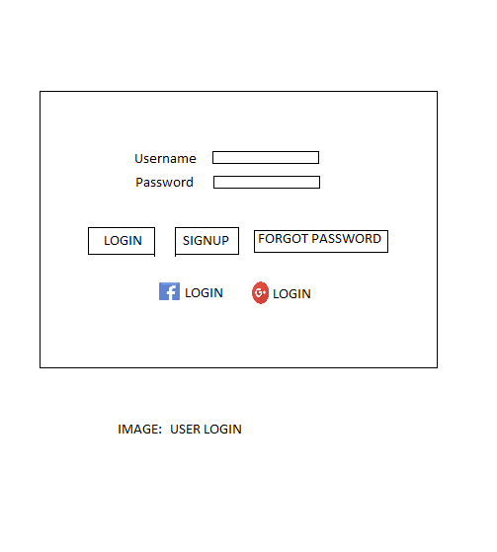

|  |  |  |  |  |  |  |
| --- | --- | --- | --- | --- | --- | --- |
| No | Field Name | Field Type | Field Length | Editable | Auto-Filled | Mandatory |
| 1 | User name | Text Field | Varchar | Y | N | Y |
| 2 | Password | Text Field | Varchar | Y | N | Y |
| 3 | Login | Link |  |  |  |  |
| 4 | Signup | Link |  |  |  |  |
| 5 | Forget password | Link |  |  |  |  |

* Once login, the user can manage their profiles by updating relevant details like uploading the profile picture, username, Email, phone number, address, Billing address etc.
* User can also edit user profile.
* The user verification is done via OTP process.

1. **Phase 1 Modules**
2. Subscriber/User
3. Agents
4. Marketing user
5. Admin user
6. Admin Panel
7. Billing
8. **Subscriber /User**

* A user login would be available – signup or use social media accounts or using name.
* User can manage their profile.
* User verification is done via an OTP.
* User would be mapped under an Agent code the user code will be generated.
* The user can see the details in their profile.



* When a New user clicks register button, option to select customer or agent should be available as given below.

|  |  |  |  |  |  |  |
| --- | --- | --- | --- | --- | --- | --- |
| No | Field Name | Field Type | Field Length | Editable | Auto-Filled | Mandatory |
| 1 | User name | Text Field | Varchar | Y | N | Y |
| 2 | Password | Text Field | Varchar | Y | N | Y |
| 3 | Login |  |  |  |  |  |
| 4 | Signup |  |  |  |  |  |
| 5 | Forget password |  |  |  |  |  |

* Once sign up is clicked, a pop up would be generated as shown below. The user has to select any one of the following.

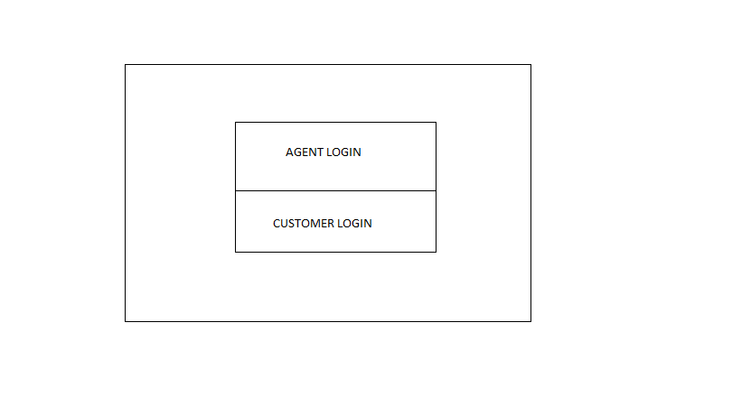

* Once an user click customer button, the register page should launch as given below:

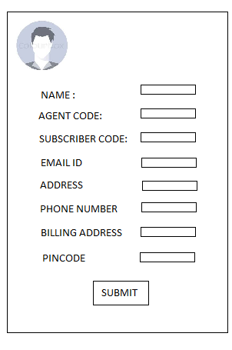

|  |  |  |  |  |  |  |
| --- | --- | --- | --- | --- | --- | --- |
| No | Field Name | Field Type | Field Length | Editable | Auto-Filled | Mandatory |
| 1 | Name | Text Field | Varchar | Y | N | Y |
| 2 | Agent code | Text Field | Varchar | Y | N | Y |
| 3 | Subscriber / user code |  |  |  |  |  |
| 4 | Email id |  |  |  |  |  |
| 5 | Address |  |  |  |  |  |
| 6 | Phone number |  |  |  |  |  |
| 7 | Billing address |  |  |  |  |  |
| 8 | Pincode |  |  |  |  |  |

* When user submits button clicked the user is redirected to an OTP page. The OTP should be send to the registered phone number. Once the OTP is entered the user is redirected to the respective Dashboard.

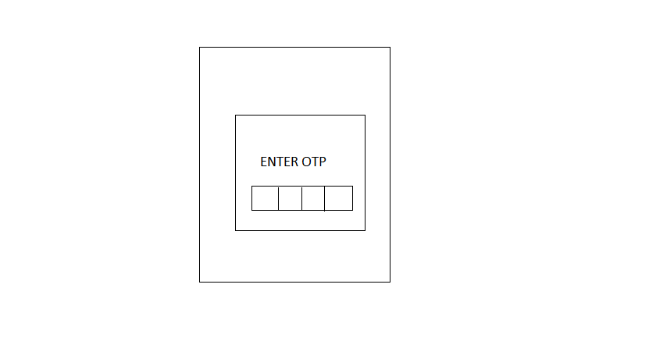

* The user homepage/Dashboard would have the space for displaying Advertisements. The Advertisements banners should be visible to the user. Slider option is needed inside the dashboard.
* Pop up should be enabled when the user logins.
* The Subscriber can select categories from the category page which would be a drop down.
* The Subscriber can select the type of newspaper, magazine and others from the option.
* The Subscriber can view Due amount from their dashboard.
* Subscriber can view Invoices generated by the agents.

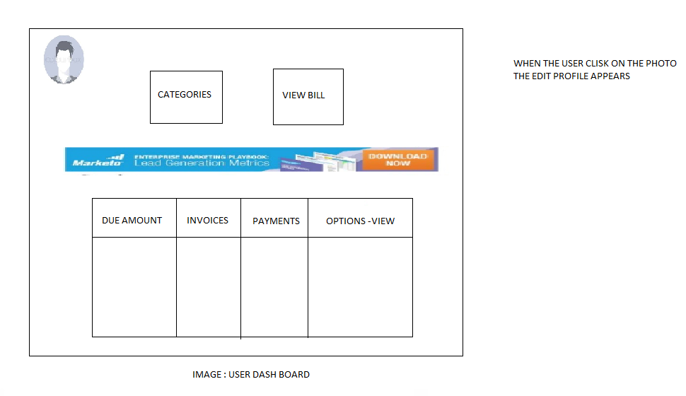

* When the Subscriber clicks the image option a new window will appear and the subscriber can edit the details. The sample layout of the page is as given below.

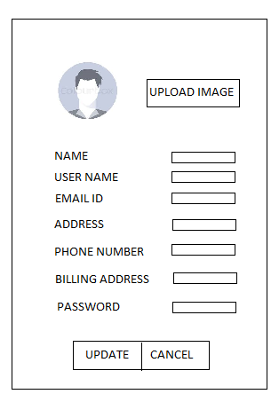

|  |  |  |  |  |  |  |
| --- | --- | --- | --- | --- | --- | --- |
| No | Field Name | Field Type | Field Length | Editable | Auto-Filled | Mandatory |
| 1 | name | Text Field | Varchar | Y | N | Y |
| 2 | Password | Text Field | Varchar | Y | N | Y |
| 3 | Phone number |  |  |  |  |  |
| 4 | email |  |  |  |  |  |
| 5 | Username |  |  |  |  |  |
| 6 | Address |  |  |  |  |  |
| 7 | Billing address |  |  |  |  |  |

* When Subscriber clicks on the product icon from the dashboard the subscriber can view all the details of the subscriptions list that entered by the Agents.

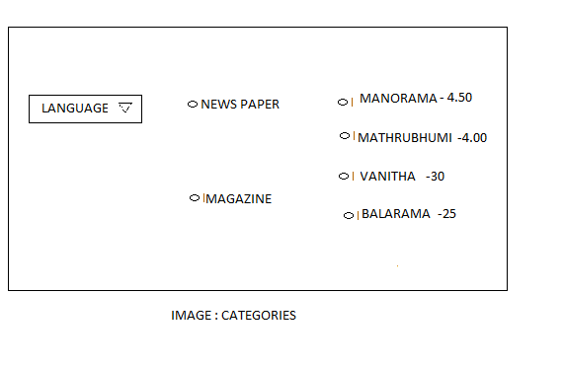

Submit

|  |  |  |  |  |  |  |
| --- | --- | --- | --- | --- | --- | --- |
| No | Field Name | Field Type | Field Length | Editable | Auto-Filled | Mandatory |
| 1 | Language | Drop down | Varchar | Y | N | Y |
| 2 | Newspaper | Radio button |  | Y | N | Y |
| 3 | Magazine | Radio button |  | Y | N | Y |
| 4 | News paper names listed with price | Radio button |  | Y | N | N |
| 5 | Magazine names listed with price | Radio button |  | Y | N | N |

* When Subscriber clicks on the Bill icon from the dashboard the subscriber can view all the details of the payments. Subscriber can view the list of the history of the payments. If the Subscriber clicks the due amount button, the payment page would pop up and the user can do the payment. 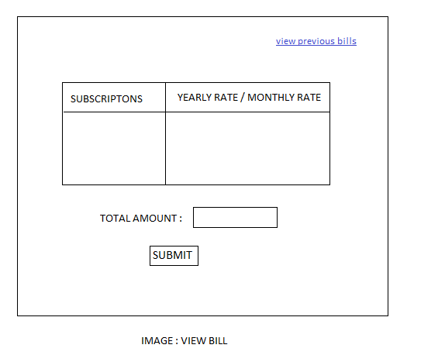

|  |  |  |  |  |  |  |
| --- | --- | --- | --- | --- | --- | --- |
| No | Field Name | Field Type | Field Length | Editable | Auto-Filled | Mandatory |
| 1 | Subscriptions | Varchar | - | Y | N | Y |
| 2 | Yearly/Monthly rate | Varchar | - | Y | N | Y |
| 3 | Total Amount | Numeric | - | N | Y | Y |
| 4 | View previous bills | Link |  | N | N | N |

* When the Subscribers clicks view previous bills link. The subscriber can view last previous 6 months bill.
* The payments page has two options. The Subscribers can either choose Debit card option or net banking this is purely based on the Payment gateway support.

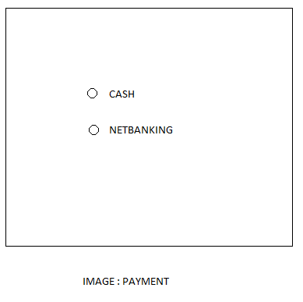

|  |  |  |  |  |  |  |
| --- | --- | --- | --- | --- | --- | --- |
| No | Field Name | Field Type | Field Length | Editable | Auto-Filled | Mandatory |
| 1 | Cash | Radio button |  | Y | N | N |
| 2 | Net banking | Radio button |  | Y | N | N |

1. **Agent**

* Agent signup flow would be similar as subscriber sign up.
* Each agent would be mapped under a marketing user.
* Each agent enters a code from the marketing user.
* Unique Agent code will be generated by the system itself during the Agent signup. Agent code which can used by the subscriber during the registration process.

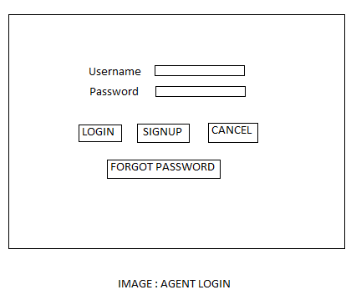

|  |  |  |  |  |  |  |
| --- | --- | --- | --- | --- | --- | --- |
| No | Field Name | Field Type | Field Length | Editable | Auto-Filled | Mandatory |
| 1 | User name | Text Field | Varchar | Y | N | Y |
| 2 | Password | Text Field | Varchar | Y | N | Y |
| 3 | Login |  |  |  |  |  |
| 4 | Signup |  |  |  |  |  |
| 5 | Forgot password |  |  |  |  |  |

* When the Agents clicks signs up button from the login screen, the page below should pop up. From the pop up the agents click agent login.



* When the agent clicks agent login, the agent signup page should launch as given below.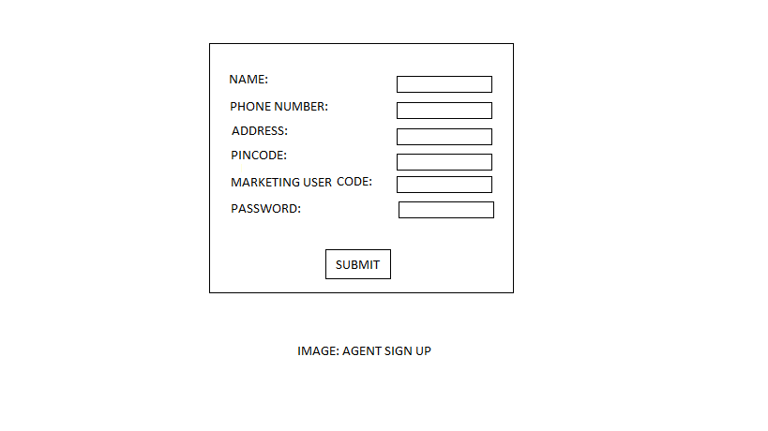

|  |  |  |  |  |  |  |
| --- | --- | --- | --- | --- | --- | --- |
| No | Field Name | Field Type | Field Length | Editable | Auto-Filled | Mandatory |
| 1 | Name | Text Field | Varchar | Y | N | Y |
| 2 | Phone number | Text Field | Varchar | Y | N | Y |
| 3 | Address | Text field | Varchar |  |  |  |
| 4 | Pincode | Text field | Numerics |  |  |  |
| 5 | Marketing user code | Text field | Varchar |  |  |  |
| 6 | Password | Text field | Varchar |  |  |  |

* Once Agent clicks submit button an OTP message is send to the registered number. The OTP pop up window should launch for the agent to login to the dash board.



* After the OTP is entered the dashboard should launch as shown below.

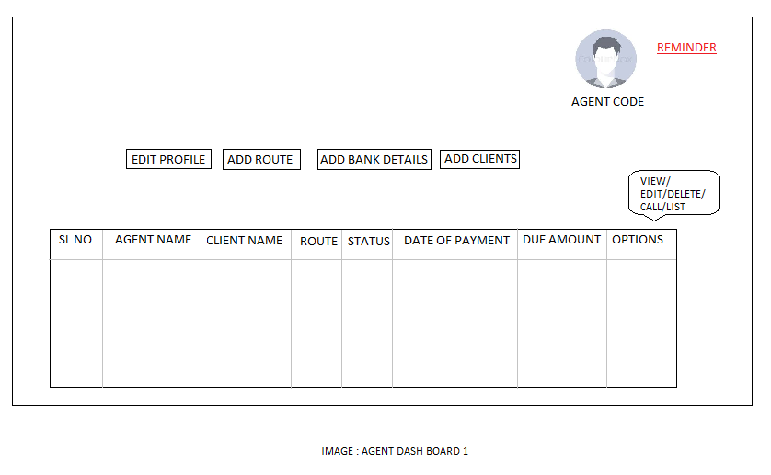

* After successful login Agent will be redirect to Dashboard.
* Agent would have the option for Add routes.
* Based on the route the agent can add the Subscribers.
* Agent will get a unique subscriber code for each subscriber.
* Agents can view user registration from the dashboard.
* Agents can map subscribers according to the subscriptions.
* Agents can edit or delete the customers from the dashboard.

|  |  |  |  |  |  |  |
| --- | --- | --- | --- | --- | --- | --- |
| No | Field Name | Attributes | Field Length | Editable | Auto-Filled | Mandatory |
| 1 | Edit profile | Button |  |  |  |  |
| 2 | Add route | Button |  |  |  |  |
| 3 | Add bank details | Button |  |  |  |  |
| 4 | Add clients | Button |  |  |  |  |

|  |  |  |  |  |  |  |  |
| --- | --- | --- | --- | --- | --- | --- | --- |
| Sl No | Agent name | Client name | Route | Status | Date of payment | Due Amount | Options |
| 1 |  |  |  |  |  |  | View/Edit/Delete/Call/List |
| 2 |  |  |  |  |  |  |  |
| 3 |  |  |  |  |  |  |  |

* When the agent clicks on the call option a call should be placed to the customer. Similarly when view option is clicked the image below should be launched.

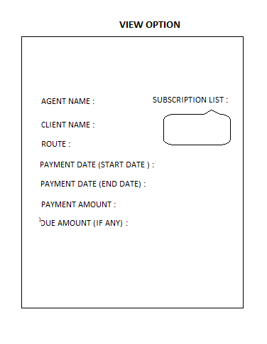

|  |  |  |  |  |  |  |
| --- | --- | --- | --- | --- | --- | --- |
| No | Field Name | Field Type | Field Length | Editable | Auto-Filled | Mandatory |
| 1 | Agent name | Text | Varchar |  |  |  |
| 2 | Client name | Text | Varchar |  |  |  |
| 3 | Route | Text | Varchar |  |  |  |
| 5 | Payment date start date | Date picker | Date picker |  |  |  |
| 6 | Payment date end date | Date picker | Date picker |  |  |  |
| 7 | Payment amount | Text | Varchar |  |  |  |
| 8 | Due amount if any | Text | Varchar |  |  |  |
| 9 | Subscription list | Text | Varchar |  |  |  |

* Similarly when edit option is clicked the image below should be launched.

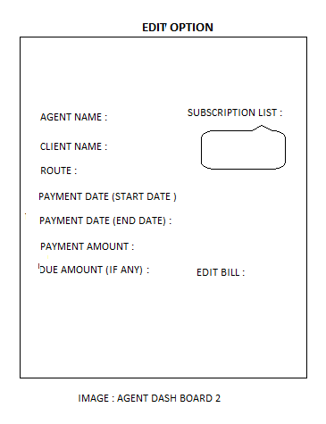

|  |  |  |  |  |  |  |
| --- | --- | --- | --- | --- | --- | --- |
| No | Field Name | Field Type | Field Length | Editable | Auto-Filled | Mandatory |
| 1 | Agent name | Text | Varchar |  |  |  |
| 2 | Client name | Text | Varchar |  |  |  |
| 3 | Route | Text | Varchar |  |  |  |
| 5 | Payment date start date | Date picker | Date picker |  |  |  |
| 6 | Payment date end date | Date picker | Date picker |  |  |  |
| 7 | Payment amount | Text | Varchar |  |  |  |
| 8 | Due amount if any | Text | Varchar |  |  |  |
| 9 | Subscription list | Text | Varchar |  |  |  |
| 10 | Edit Bill | Text | Varchar |  |  |  |

* Similarly when list option is clicked the image below should be launched.

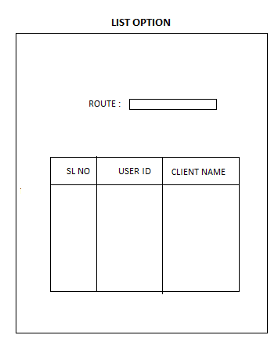

|  |  |  |  |  |  |  |
| --- | --- | --- | --- | --- | --- | --- |
| No | Field Name | Attribute | Field Length | Editable | Auto-Filled | Mandatory |
| 1 | Route | Text | Varchar |  |  |  |

List view:

|  |  |  |
| --- | --- | --- |
| Sl No | User id | Client name |
| 1 |  |  |

* The agents would have the privilege to edit the pricing set by the admin
* The agent would also have the privilege to edit the pricing according to their concern. They would be having a remarks field in which the data can be entered for which the pricing was changed.
* Agents would be getting a real time bill.
* The agent has the privilege to change the bill till the customer pays for the subscriptions.
* Agents can set reminders for clients due date.
* Agents can print and view the customer payment due list.
* Agents would have the option to edit bills of each customer.
* Agents would have the access to view the client subscription list and the due date.
* The set reminder would be a date picker to set a reminder to the user. The reminder would be shown as a flash message or a pop up when the user logins in his account.
* In the payment status, the print option allows the agent to print the current status bill.
* The bill generation column would have a Yes or No button in order to generate the bill for each customer.

1. **Marketing User**

* Each marketing user will have a unique code.
* The code would be a four digit number.
* Marketing users will have access to the portal based on the access privilege given by the admin
* Marketing user can add agents under them.
* Each agent when added would be given a 5 digit code which would be mapped under the marketing user code.

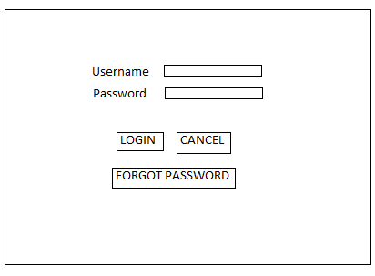

|  |  |  |  |  |  |  |
| --- | --- | --- | --- | --- | --- | --- |
| No | Field Name | Attribute | Field Length | Editable | Auto-Filled | Mandatory |
| 1 | Username | Text | Varchar |  |  |  |
| 2 | Password | Text | Varchar |  |  |  |
| 3 | Login | Button |  |  |  |  |
| 4 | Cancel | Button |  |  |  |  |
| 5 | Forgot password | Button |  |  |  |  |

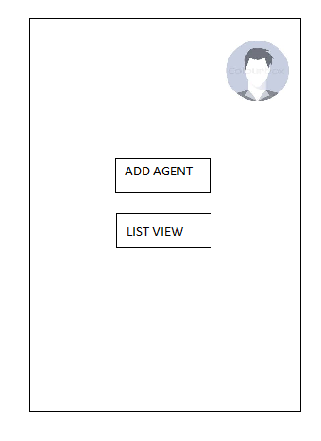

|  |  |  |  |  |  |  |
| --- | --- | --- | --- | --- | --- | --- |
| No | Field Name | Attribute | Field Length | Editable | Auto-Filled | Mandatory |
| 1 | ADD AGENT | BUTTON |  |  |  |  |
| 2 | LIST VIEW | BUTTON |  |  |  |  |

When marketing user clicks on add agents, the form below should launch.

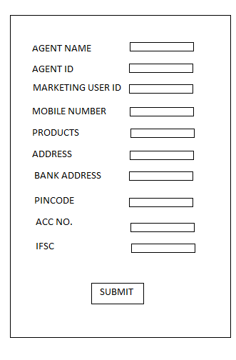

|  |  |  |  |  |  |  |
| --- | --- | --- | --- | --- | --- | --- |
| No | Field Name | Field Type | Field Length | Editable | Auto-Filled | Mandatory |
| 1 | Agent name | Text |  | Y | N | Y |
| 2 | Agent id | Varchar |  | N | Y | Y |
| 3 | Mobile number | Text |  |  |  |  |
| 5 | Address | Varchar |  |  |  |  |
| 6 | Pincode | Numeric |  |  |  |  |
| 7 | Products | Varchar |  |  |  |  |
| 8 | Bank address | Varchar |  |  |  |  |
| 9 | Acc No | Varchar |  |  |  |  |
| 10 | IFSC | Varchar |  |  |  |  |
| 11 | Marketing person code | Varchar |  |  | Y |  |

When marketing user clicks on list view, the form below should launch. The actions should allow editing or deleting the entry.

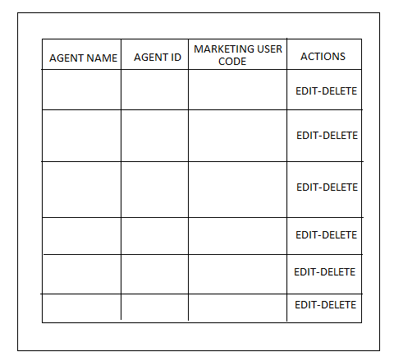

List View

|  |  |  |  |  |
| --- | --- | --- | --- | --- |
| Sl No | Agent name | Agent ID | Mobile number | Edit/Delete |
| 1 |  |  |  |  |
| 2 |  |  |  |  |
| 3 |  |  |  |  |

If the marketing agent wants to edit his details, he can click on the photo image. A page would be launched as below.

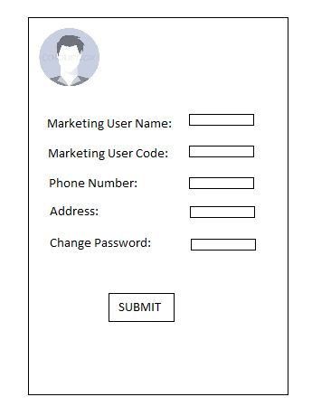

|  |  |  |  |  |  |  |
| --- | --- | --- | --- | --- | --- | --- |
| No | Field Name | Field Type | Field Length | Editable | Auto-Filled | Mandatory |
| 1 | Marketing user name | Text |  | Y | N | Y |
| 2 | Marketing User Code | Varchar |  | N | Y | Y |
| 3 | Phone number | Text |  |  |  |  |
| 5 | Address | Varchar |  |  |  |  |
| 6 | Change password | Numeric |  |  |  |  |

1. **Admin Panel**

* Has the authority to add the role for each user

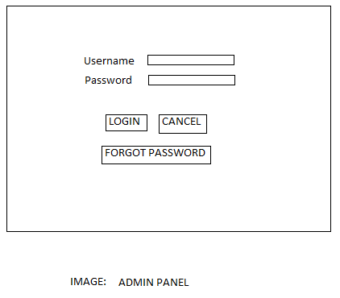

|  |  |  |  |  |  |  |
| --- | --- | --- | --- | --- | --- | --- |
| No | Field Name | Attribute | Field Length | Editable | Auto-Filled | Mandatory |
| 1 | Username | Text | Varchar |  |  |  |
| 2 | Password | Text | Varchar |  |  |  |
| 3 | Login | Button |  |  |  |  |
| 4 | Cancel | Button |  |  |  |  |
| 5 | Forgot password | Button |  |  |  |  |

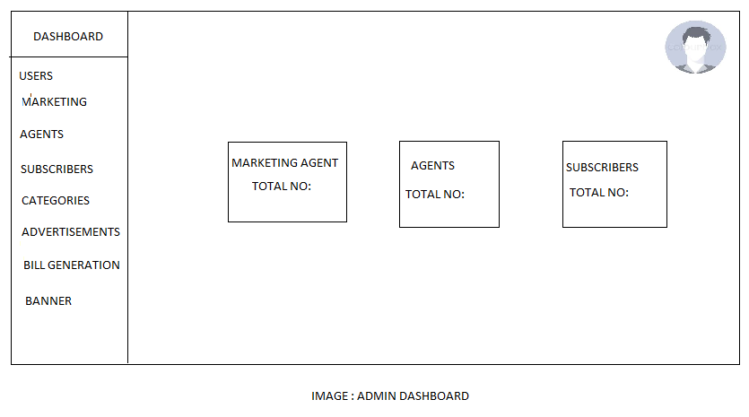

1. **Admin User**
2. **Marketing agent**

* Admin can add the marketing agent
* They have a code set by the admin – 4digit code

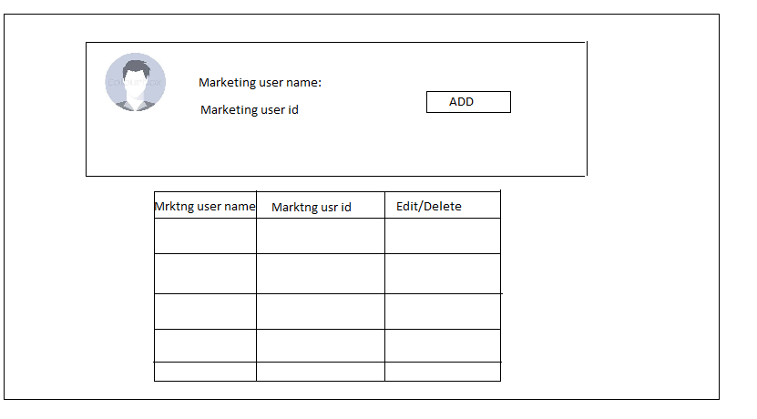

|  |  |  |  |  |  |  |
| --- | --- | --- | --- | --- | --- | --- |
| No | Field Name | Field Type | Field Length | Editable | Auto-Filled | Mandatory |
| 1 | Marketing user name | Text |  | Y | N | Y |
| 2 | Marketing user id (4 digit) | Varchar |  | N | Y | Y |

When the marketing agent is added, the entry will be shown below the list. Here the admin can edit or delete the marketing agent details.

**List view:**

|  |  |  |  |
| --- | --- | --- | --- |
| Sl No | Marketing user name | Marketing user id | Edit/Delete |
| 1 |  |  |  |
| 2 |  |  |  |

1. **Add Agent**

* Admin user has the ability to login using the username and password
* Admin can add/ update, enable or disable the agent’s profiles.
* Admin user can manage the agents

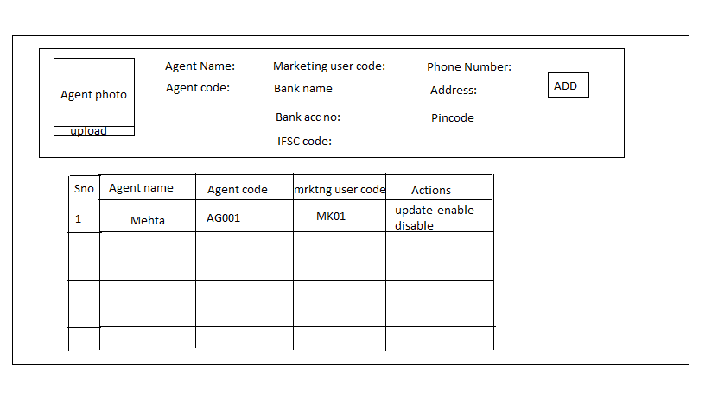

|  |  |  |  |  |  |  |
| --- | --- | --- | --- | --- | --- | --- |
| No | Field Name | Field Type | Field Length | Editable | Auto-Filled | Mandatory |
| 1 | Agent name | Text Field | Varchar(Max) | Y | N | Y |
| 2 | Agent code | Text Field | Auto Generate | N | Y | Y |
| 3 | Marketing user code | Text Field | Auto Generate | N | Y | Y |
| 4 | Agent phone number | Text Field | varchar(max) | Y | N | Y |
| 5 | Address | Text Area | Varchar(max) | Y | N | Y |
| 6 | Pin code | Text Field | Number | Y | N | N |
| 7 | Bank Name | Text Field | varchar(max) | Y | N | Y |
| 8 | Bank account | Text Field | varchar(max) | Y | N | Y |
| 9 | IFSC Code | Text Field | varchar(max) | Y | N | Y |

List view:

|  |  |  |  |  |
| --- | --- | --- | --- | --- |
| Sl No | Agent name | Agent code | Marketing code | Actions |
|  |  |  |  |  |
|  |  |  |  |  |

1. **Customers**

Admins can manage customers

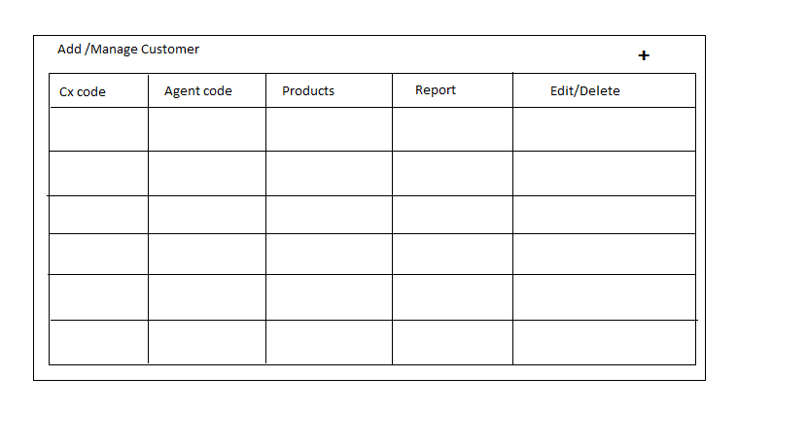

|  |  |  |  |  |  |
| --- | --- | --- | --- | --- | --- |
| Sl No | Cx code | Agent code | Products | Report | Edit/Delete |
| 1 | CX001 | AG01 | Cat1 Cat2 |  |  |
| 2 |  |  |  |  |  |

When the + button is clicked the window below should pop up

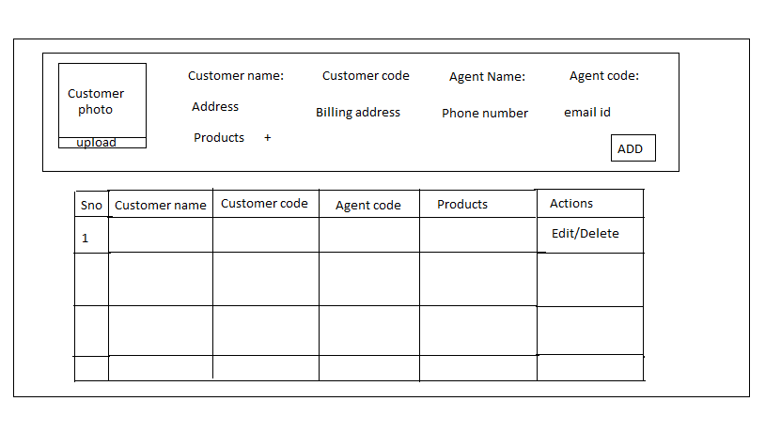

|  |  |  |  |  |  |  |
| --- | --- | --- | --- | --- | --- | --- |
| No | Field Name | Field Type | Field Length | Editable | Auto-Filled | Mandatory |
| 1 | Customer name | Text |  | Y | N | Y |
| 2 | Customer code | Varchar |  | N | Y | Y |
| 3 | Agent name |  |  |  |  |  |
| 4 | Agent code |  |  |  |  |  |
| 5 | Address |  |  |  |  |  |
| 6 | Billing address |  |  |  |  |  |
| 7 | Phone number |  |  |  |  |  |
| 8 | Email id |  |  |  |  |  |
| 9 | Products |  |  |  |  |  |

List view:

|  |  |  |  |  |  |
| --- | --- | --- | --- | --- | --- |
| Sl No | Cx name | Cx code | Agent code | Products | Edit/Delete |
| 1 | Customer | CX001 | AG01 | Cat1 Cat2 |  |
| 2 |  |  |  |  |  |

1. **Products , Categories, Advertisements, Banner**

* Admin user can send real time updates to the users
* Admin can add delete edit the notification text
* Admin can add categories and sub categories and sub-sub categories.

1. **Payments/Bill Generation**

* Admin can view and add reconciliation of payments received (offline and online )
* Admins can view the payments processed
* Admins can view the pending payments and can generate various daily reports
* Admin can auto generate the bill by the end of the month or by the start of the month.

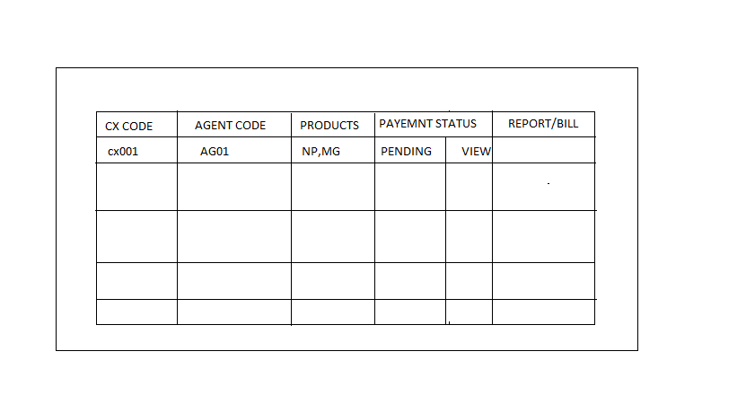

|  |  |  |  |  |  |
| --- | --- | --- | --- | --- | --- |
| Sl No | Cx Code | Agent code | Products | Payment status | Report/BIll |
| 1 | Cx001 | AG01 | Cat1,Cat2,Cat3 | Pending | Generate Report |
| 2 | Malyalam | Newspaper | Mathrubhumi | Completed | Generate Bill |

1. **Payments**

* Payments tab would be available in the dash board
* Each user, admin, agent, marketing user would have to add the bank details to which the payment tab will be linked for the transactions.
* Invoices would be generated by the agents and the customer can do the payment from the payment tab
* The payments tab would also have the option to display the month wise bills
* Admin can view and add reconciliation of payments received
* The agents can edit the payment details till the customer pays the bill
* Bill should be auto generated