

G H Patel College of Engineering & Technology

(CVM University)

Bakrol, Vidyanagar

COMPUTER ENGINEERING DEPARTMENT

Project Report on

Image Classification of Cats & Dogs

Submitted By

Nisarg Panchal :12302040501035
Prabhav Patel :12302040501042

PYTHON FOR DATA SCIENCE (202045603)

A.Y. 2025-26 ODD TERM

Movie Recommendation Engine
Big Data Analytics Mini Project
1 Project Overview
- The project suggests movies based on a user’s previous ratings.
- A user can select an existing profile or rate a few movies.
- The system scores unseen movies and displays the best matches.
- Results can be filtered by genre and minimum rating count.
1.1 Dataset
Item | Details
Source | GroupLens MovieLens latest small
Size | 100,836 ratings, 610 users and 9,742 movies
ratings.csv | userId, movieId, rating, timestamp
movies.csv | movieId, title, genres
Rating scale | 0.5 to 5 in half-star steps

1.2 Project Flow
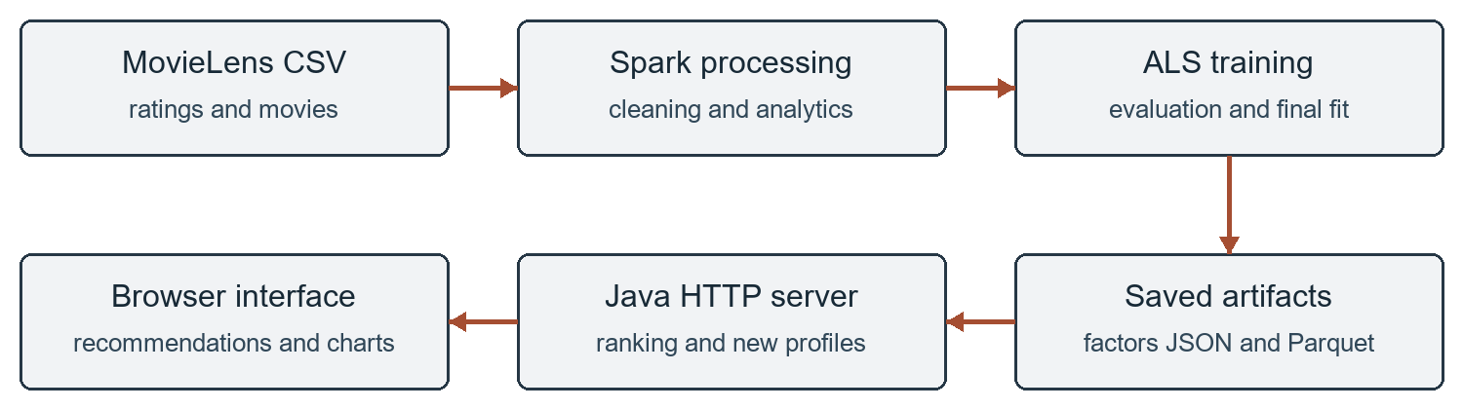
Figure 1 From CSV files to movie recommendations
1.3 Requirements
- JDK 17, Maven 3.9.11 and a browser.
- Spark 3.5.7 handles data processing and model training.
- About 4 GB RAM and 2 GB free disk space for setup and training.
- Setup scripts download the required libraries.
2 Dataset and Cleaning Rules
2.1 Understanding a Rating Record
Field | Meaning | Example
userId | Anonymous user identifier | 1
movieId | Identifier used to join movie details | 1
rating | Preference entered by the user | 4.0
timestamp | Unix time in seconds | 964982703

- This example is the MovieLens record for User 1 and Toy Story. The movie name is stored in movies.csv, not repeated in every rating row.
- A movie can have several genres separated by a vertical bar, such as Adventure|Animation|Children|Comedy|Fantasy.
2.2 Validation Rules
- User and movie IDs must be positive integers that fit into a 32-bit integer.
- A rating must be between 0.5 and 5, in steps of 0.5. Values such as 0, 5.5 and 3.7 are rejected.
- A timestamp must be nonnegative. Missing or invalid values are removed.
- Movie details must have a positive movie ID and a nonempty title.
- When a user/movie pair repeats, keep the record with the latest timestamp. If timestamps tie, keep the higher rating.
- Remove ratings whose movie ID does not appear in the movie catalogue.
2.3 Cleaning Results
Check | Rows removed
Invalid ratings | 0
Duplicate user/movie pairs | 0
Unknown movie IDs | 0
Final valid ratings | 100,836 retained

- The supplied files already pass these checks. The rules remain useful when a different ratings file is used.
2.4 Data Use
- The model uses ratings.csv and movies.csv. The original tags.csv and links.csv files are included but are not used for training.
- MovieLens contains historical, anonymous ratings. The original dataset README and its research/noncommercial licence are included with the project.
3 Working of the Project
3.1 Data Preparation
- Read the movie and rating CSV files.
- Check that IDs are positive and ratings are valid half-star values.
- Keep the latest rating when a user rates the same movie more than once.
- Join ratings with movie details and remove unknown movie IDs.
- Calculate rating counts, averages and genre statistics.
3.2 Recommendation Method
- ALS stands for Alternating Least Squares. It learns rating patterns across users.
- Each user and movie gets a short list of numbers called a factor vector.
- The dot product of these vectors gives a score for a user and movie.
- Movies already rated by the user are removed from the result.
- Genre and rating-count filters are applied before showing the top results.
- For a new user, entered ratings are used to calculate a user vector. The whole model is not retrained.
3.3 Main Files
File | Purpose
TrainPipeline.java | Clean data, calculate statistics, train and evaluate ALS
Recommender.java | Score movies, fit new profiles and apply filters
WebServer.java | Handle browser requests
ModelData.java | Store movie, rating and factor data
web folder | HTML, CSS and JavaScript interface

3.4 Output Files
- model.json stores learned factors, movie details and rating histories.
- analytics.json and metrics.json store statistics and evaluation results.
- Cleaned data is saved as Parquet; recommendations are also exported as JSON documents.
4 Recommendation Example
4.1 From Ratings to Suggestions
- Suppose a new user likes Toy Story and Star Wars. The user enters a rating for each film in My ratings.
- The system retrieves the saved factor vectors for the selected films.
- It solves a regularised least-squares problem to calculate the new user vector.
- That vector is compared with the remaining movie vectors to produce scores.
- The selected films are removed from the result. The remaining films are sorted by score.
4.2 Simple Score Calculation
- The following two-factor example explains the arithmetic. These numbers are illustrative; the actual model learns 12 factors.
Vector | Factor 1 | Factor 2
User | 0.8 | 0.4
Movie A | 1.0 | 0.5
Movie B | 0.2 | 0.9

- Movie A score = (0.8 × 1.0) + (0.4 × 0.5) = 1.00.
- Movie B score = (0.8 × 0.2) + (0.4 × 0.9) = 0.52.
- Movie A is placed before Movie B because its score is higher.
- If Movie A was already rated, it is excluded even though it has the higher score.
4.3 Applying the Filters
Setting | Effect
Genre = Drama | Keep movies containing the Drama genre
Minimum ratings = 50 | Keep movies with at least 50 dataset ratings
Results = 10 | Return up to 10 matching unseen movies

4.4 Reading the Result
- Score is the personalised model estimate. Average is the movie’s average across dataset users. Ratings is the number of ratings behind that average.
- For an unknown user ID, the API falls back to a popularity score. It shrinks movie averages toward the global mean so a film with very few ratings does not automatically lead the list.
5 Data Processing Implementation
5.1 RDD Operations
- The following Java code counts distinct users. Each rating becomes a user/count pair, repeated user IDs are combined, and count triggers execution.
long userCount = ratings.javaRDD()
.mapToPair(r -> new Tuple2<>(r.getInt(0), 1L))
.reduceByKey(Long::sum)
.count();
- mapToPair and reduceByKey are transformations. They describe the processing steps.
- count is an action. Spark executes the work when the result is needed.
- Frequently reused DataFrames are persisted with MEMORY_AND_DISK to reduce repeated computation.
5.2 SQL Aggregation
- Movie statistics are grouped by movie ID before joining them with movie names and genres.
SELECT movieId,
COUNT(*) AS ratingCount,
AVG(rating) AS averageRating
FROM ratings
GROUP BY movieId
- The app also displays the rating distribution and the most-rated movies. The overall average rating is 3.502; a rating of 4.0 occurs 26,818 times.
5.3 Parquet and JSON
- Cleaned ratings are written as Parquet, partitioned by rating year. A year-filtered query can skip unrelated partitions.
- The Parquet data was read back and returned all 100,836 ratings.
- recommendations.ndjson contains one document per user with a userId and a recommendations array.
- The web app reads saved model and statistics files. It does not start a new training job for each request.
5.4 Syllabus Coverage
Topic | Project use
Spark and MLlib | Implemented: RDDs, DataFrames, SQL and ALS
NoSQL | Document-shaped JSON export; optional import example
HDFS and Hive | Optional upload script and external-table SQL
YARN, Sqoop, Pig and HBase | Not part of the tested local application

6 Using the Application
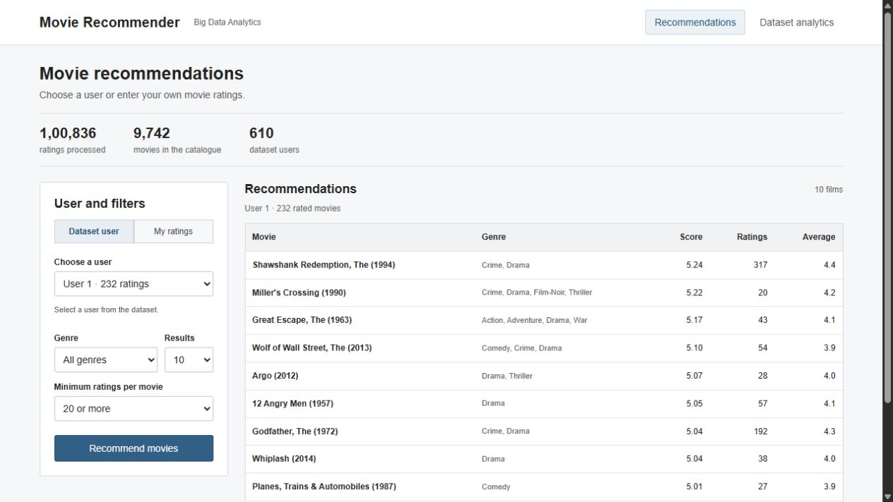
Figure 2 User selection, filters and recommended movies
6.1 Run the Project
- Windows: run setup.cmd once, then run run.cmd.
- Open http://127.0.0.1:8080 in a browser.
- Use train.cmd to rebuild the model from the CSV files.
- Linux and macOS: use bash setup.sh and bash run.sh.
6.2 Demo Steps
- Select User 1 and click Recommend movies.
- Change the user to compare the recommendations.
- Select a genre or increase the minimum rating count.
- Open My ratings, search for movies and give them ratings.
- Click Recommend movies to get suggestions for the new profile.
- Open Dataset analytics to view rating counts and test results.
- Scores are model estimates and can exceed 5. The Average column shows the actual movie average in the dataset.
7 Results and Limitations
- For each user, the earliest 80% of ratings train the model. The remaining ratings test it.
- Settings: 12 factors, 10 iterations, regularisation 0.1 and seed 42.
- After evaluation, a separate model is trained on all ratings for the application.
Measurement | Result
Training / test ratings | 80,419 / 20,417
Test ratings scored | 18,715
Test ratings excluded | 1,702 without known factors
Prediction coverage | 91.66%
ALS RMSE / MAE | 0.9316 / 0.7176
Mean baseline RMSE | 1.0569
Parquet read-back count | 100,836 ratings

- Lower RMSE and MAE mean less rating-prediction error. They are not accuracy percentages.
- The mean baseline and ALS are compared on the same scored test rows.
- All 16 Java tests passed. Checks include rated-movie exclusion, filters, new profiles and invalid input.
7.1 Limitations
- MovieLens is historical data. New profile ratings are temporary and are not saved.
- The split is per user, not one global date cutoff; later ratings from other users may be in training.
- Movies without learned factors cannot receive an ALS score.
- The app runs locally and loads the model into memory. Ranking precision and recall have not been measured.
7.2 Findings
- The project reads rating data, learns user preferences and returns unseen-movie suggestions. Possible improvements are a global time-based split, ranking evaluation and movie metadata for new films.
8 Testing and Evaluation Details
8.1 Functional Checks
Test | Expected result | Observed
Existing user | Return matching unseen movies | Passed
Rated-movie exclusion | Do not return a previously rated movie | Passed
Genre filter | Every result contains the selected genre | Passed
Minimum rating count | Each result meets the selected count | Passed
New profile | Return suggestions excluding entered films | Passed
Invalid rating | Reject values outside valid half-star steps | Passed
Duplicate profile entry | Reject the same movie entered twice | Passed
Unknown user ID | Return popularity fallback | Passed
Parquet round trip | Keep all cleaned ratings | Passed

- All 16 Java unit tests passed. API checks and browser checks also covered user selection, profile input, movie search and analytics.
8.2 Why the Baseline Is Included
- The baseline predicts the global average of training ratings for every scored test row.
- ALS RMSE is 0.9316; the baseline RMSE is 1.0569 on the same rows.
- This comparison checks whether the learned model improves on a simple prediction.
- RMSE measures rating error. It does not directly measure how useful the top-10 movie list is.
8.3 Cold Start and Coverage
- The evaluation model could score 18,715 of the 20,417 test ratings.
- The other 1,702 rows did not have the required learned factors and were excluded.
- Coverage = 18,715 ÷ 20,417 × 100 = 91.66%. Reporting it makes the excluded cases visible.
8.4 Improvements
- Use a single global date cutoff for a stronger future-time evaluation.
- Measure precision and recall for top-10 recommendations.
- Add movie metadata to help with films that have no ratings.
9 Source Code
ALS als = new ALS().setUserCol("userId")
.setItemCol("movieId").setRatingCol("rating")
.setRank(rank).setMaxIter(iterations)
.setRegParam(regularization).setSeed(42L)
.setNumUserBlocks(4).setNumItemBlocks(4)
.setColdStartStrategy("drop").setImplicitPrefs(false);
ALSModel evalModel = als.fit(train);
Dataset<Row> predictions = evalModel.transform(test)
.persist(StorageLevel.MEMORY_AND_DISK());
long scored = predictions.count();
RegressionEvaluator evaluator = new RegressionEvaluator()
.setLabelCol("rating").setPredictionCol("prediction");
double rmse = evaluator.setMetricName("rmse")
.evaluate(predictions);
double mae = evaluator.setMetricName("mae")
.evaluate(predictions);

public List<Recommendation> forUser(int id, int limit,
String genre, int minimumRatings) {
Set<Integer> seen = new HashSet<>();
for (Rating r : model.histories.getOrDefault(id, List.of()))
seen.add(r.movieId());
return rank(model.users.get(id), seen, limit,
genre, minimumRatings);
}

for (Movie movie : model.movies) {
if (seen.contains(movie.movieId()) ||
movie.ratingCount() < minimumRatings) continue;
if (genre != null && !genre.isBlank() &&
!Arrays.asList(movie.genres().split("\|"))
.contains(genre)) continue;
double[] item = model.items.get(movie.movieId());
if (vector != null && item == null) continue;
double score = vector == null
? movie.weightedRating() : dot(vector, item);
if (Double.isFinite(score))
result.add(new Recommendation(movie.movieId(),
movie.title(), movie.genres(), movie.ratingCount(),
movie.averageRating(), score));
}
10 Conclusion
- The application demonstrates the complete path from CSV ratings to movie suggestions. The submission includes working code, measured results, saved data and scripts to run the project again.
References
1. GroupLens MovieLens dataset and licence: grouplens.org/datasets/movielens/latest/ and data/ml-latest-small/README.txt.
2. Harper and Konstan. The MovieLens Datasets: History and Context, 2015. doi.org/10.1145/2827872
3. Apache Spark ALS documentation: spark.apache.org/docs/3.5.7/ml-collaborative-filtering.html

