**Volunteer Scheduling  
Application**

**Application Development**

**Functionality Specifications Document (F-Spec) 1.1**

**Prepared by**



**UIM Internet Solutions**

324 Horner Ave., Suite 4

Toronto, ON M8W 1Z3

(416) 490-7556

**September 15, 2014** (original release)Table of Contents

1 Functionality Specifications (F-Spec) Orientation 4

2 Revision History 5

3 Overview 6

4 Web Application Details 7

4.1 URL 7

4.2 Technical Details 7

5 Application Site Framework 8

6 Application Sub Domain Access 9

7 Roles 10

7.1 Credentials 10

7.2 Menus 10

8 Sign In & Sign Out 11

9 Create an Account 13

9.1 Step 1 – Personal Information 13

9.2 Step 2 – Contact Information 14

9.3 Step 3 – Additional Information 15

9.4 Step 4 – Additional Information 16

10 Site Administrator 17

10.1 Side Menu Requirements 17

10.2 Header Requirements (Administrators and Users) 18

10.3 Dashboard (Site Administrator) 19

10.4 Directory (Site Administrator and User Administrator) 24

10.5 User Account Edit (Site Administrator and User Administrator) 26

10.6 Shift Schedule (Site Administrator and User Administrator) 28

10.7 Add Shift/Event (Site Administrator and User Administrator) 31

10.7.1 Overview 31

10.7.2 Spaces 33

10.7.3 Location 35

10.7.4 Adding Shift/Event 36

10.7.5 Information Tips 36

10.8 Edit Shift/Event (Site Administrator and User Administrator) 37

10.8.1 Overview 37

10.8.2 Spaces 38

10.8.3 Registrations 39

10.8.4 Location 41

10.8.5 Editing Shift/Event 41

10.9 Message Center (Administrator and Users) 42

10.9.1 Overview 42

10.9.2 Inbox 42

10.9.3 Compose Message 43

10.9.4 Sent Items 44

10.10 Approvals (Site Administrator and User Administrator) 45

10.10.1 Overview 45

10.10.2 Shift Registrations 45

10.10.3 User Registrations 46

10.11 Report Management (Site Administrator and User Administrator) 47

10.11.1 Overview 47

10.12 Organization Settings (Site Administrator) 48

10.12.1 Overview 48

10.12.2 Billing 49

10.12.3 Branding 50

10.12.4 Language 51

10.12.5 Localization 52

10.12.6 Terms and Conditions 53

10.13 System Management (Site Administrator) 54

10.13.1 Overview 54

10.13.2 Approvals 54

10.13.3 Categories 55

10.13.4 Roles 56

10.13.5 Skills 58

10.14 My Profile (Site Administrator) – from header 59

10.15 Lock Screen (Administrator and User) – from header 60

11 Email Notifications 61

# Functionality Specifications (F-Spec) Orientation

This document serves as an overview for the development of the **Volunteer App** (by UIM Internet Solutions Inc.) **cloud based** application and mobile solution.

This document is a development plan for the project and is meant to undergo a series of revisions in order to solidify the vision for the project..

This document will serve as the road map in completion of this project. Creative mock-ups for the various pages will be presented for major sections at a later stage of the process, if applicable.

Richard Dilda

Project Manager

**rdilda@userinmind.com**

416-490-7556 ext. 222

# Revision History

|  |  |  |
| --- | --- | --- |
| **Date** | **Revision No.** | **Description** |
| **September 15, 2014** | 1.0 | Original Document |
| **September 30, 2014** | 1.1 | Updates |
|  |  |  |
|  |  |  |
|  |  |  |
|  |  |  |

# Overview

The Volunteer App is an online scheduling system for volunteers.

The Volunteer App contains the following roles:

* System Administrators (UIM Staff)
* Site Administrators (top level client access)
* Administrators (scheduled users with admin access)
* Viewers (non-scheduled users with viewer access)
* Users

The following sections with highlight the various functionality differences, where applicable. The terms ‘shift’ and ‘event’ are for display purposes only. The system will default all references to “shift”, however client may change term to anything via their Language properties. Please ensure site can dynamically change terms based on these settings.

***NOTE 1:*** *This document* ***DOES NOT*** *provide the System Administrator interface at this time but will require basic screen requirements to ADD/MODIFY/DELETE clients. Please design these pages based on look and feel of provided composites and template availability. Features required for system administrators will be noted throughout this document without design. Future requirements will include the ability to track client data such as contact information, billing data, expiry dates and other metrics.*

***NOTE 2:*** *All composites presented may be subject to change based on design requirements. They are presented for functionality and information display purposes only unless otherwise noted.*

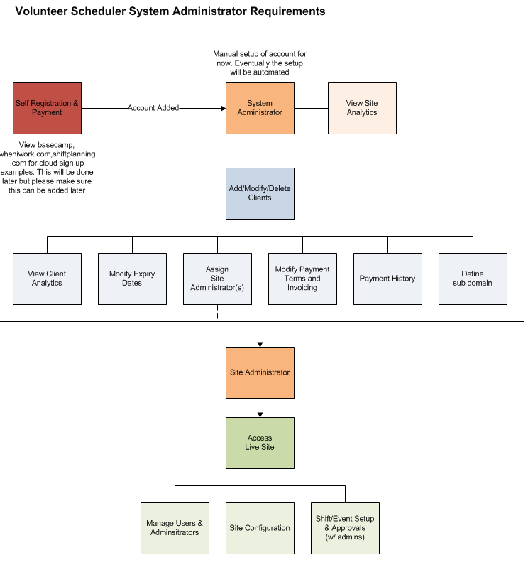

# Web Application Details

## URL

The website application URL is not known at this time.

## Technical Details

The following details summarize certain technical aspects of this project.

* PHP 5.3.28
* Responsive design for tablet and mobile ready viewing
* MySQL 5.5.37
* Browser support: IE 9.x and above, Firefox 14.x and above, Chrome 25.x and above.
* Optimized for 1024x768 screen resolution

# Application Site Framework

The web application is structured in 3 easy to manage sections as follows:

**Main Display**

Corresponds to side or main header menu selections

**Side Bar**

Menu items specific to role

**Main Header**

Logo, breadcrumbs, notifications, alerts, personal settings, avatar

***NOTE:*** *Website to use Bootstrap framework – CLIPONE template (composites shown within use base template with modification). Please note many composites are using screenshot modifications from the CLIPONE template and should be used for maximum efficiency.*

# Application Sub Domain Access

The future requirements for this application will include self registration and account setup. This setup will include the sub domain creation of an account.

For example, ABC Company Inc. may setup the sub domain prefix ‘abc’ and the login URL will be **https://abc.volunteerapp.com**.

System administrator client setup should allow for the inclusion of sub domain setup and validation – cannot duplicate existing sub domain within system. All valid character validation should be performed at this time.

# Roles

The following role specific information shall be configured.

## Credentials

**System Administrator**

**Email**

sysadmin@volunteerapp.com

**Password**

V0lunt33r

**Instructions**

On login there should be capability to change email and password as per page design shown in other roles below.

**Site Administrator (for client sites)**

No predefined credentials required.

System Administrator shall create account, add email recipient. On email receipt site administrator should be required to first complete their account profile including setting up first password.

**Users (specific to client site)**

No predefined credentials required.

Users ‘register’ to enter system and provide email and password at that time.

***NOTE:*** *Users are assigned the access rights of ‘viewer’ or ‘administrator’.*

## Menus

Menus throughout this document shown in composites DO NOT reflect the final menu requirements. Please refer to the menu components as defined in each role section for complete display and functionality.

# Sign In & Sign Out

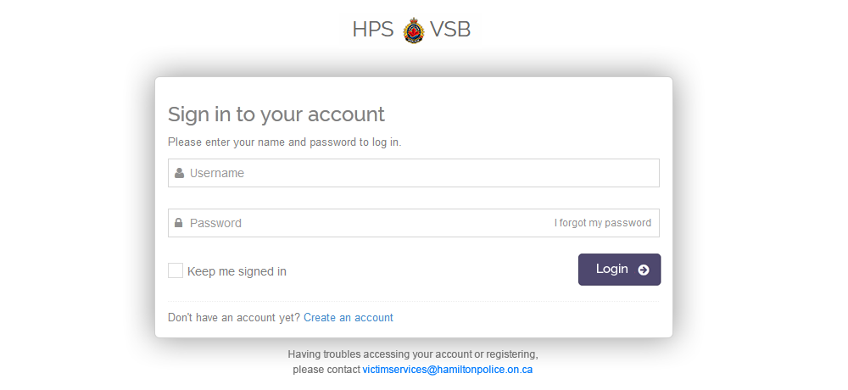

Functionality

1. User will enter URL as per sub domain setup (i.e. https://abc.volunteerapp.com)
2. Based on client configuration custom components will be loaded (i.e. logo and email address)
3. User to enter email and password; select SIGN IN; proper validation required

***NOTE:*** *terminology will be different than composite above; all ‘name’, ‘username’ references should be ‘email’ and all ‘Login’ or ‘Logout’ references should be ‘Sign In’ and ‘Sign Out’ throughout application*

1. User may select ‘I forgot my password’ to initiate Forgot Password screen; on entry of email address email should be sent; Forgot password email will allow user to select link from email to change password
2. User may turn on ‘Keep me signed in’ to automatically allow user to directly access application on return to URL without signing in. Only signing out will require re-sign in.
3. User may select ‘Create an account’ to start the account creation process. Refer to *Create an Account* for more details.
4. User may select support email address as configured from client settings; mail client should be initiated to start email
5. After 5 invalid attempts a warning message should be shown noting “Account has been locked due to 5 invalid attempts. Please try again in 30 minutes.”; for each invalid attempt track the number of attempts; once ‘3’ attempts are remaining show message “3 sign in attempts remaining” and countdown to ‘1’; after the last one the message noted above will display; attempts should always be reset back to 5 after 30 minutes at any time.
6. Select **SIGN OUT** from header under user profile to exit back to the sign in screen.

***NOTE:*** *Both users and administrators will log in from the same login page – no separate administrator access; system administrators will login to a separate portal to access all client information at http://www.volunteerapp.com/cms/access (this page and content within should not be searchable or indexed).*

# Create an Account

The following 4 steps will guide a new user through the account creation process. Step progression will be noted by the top graphic timeline. User may go back to any step or forward if information is completed.  
  
If user abandons the registration process, upon return the user must start over.

## Step 1 – Personal Information

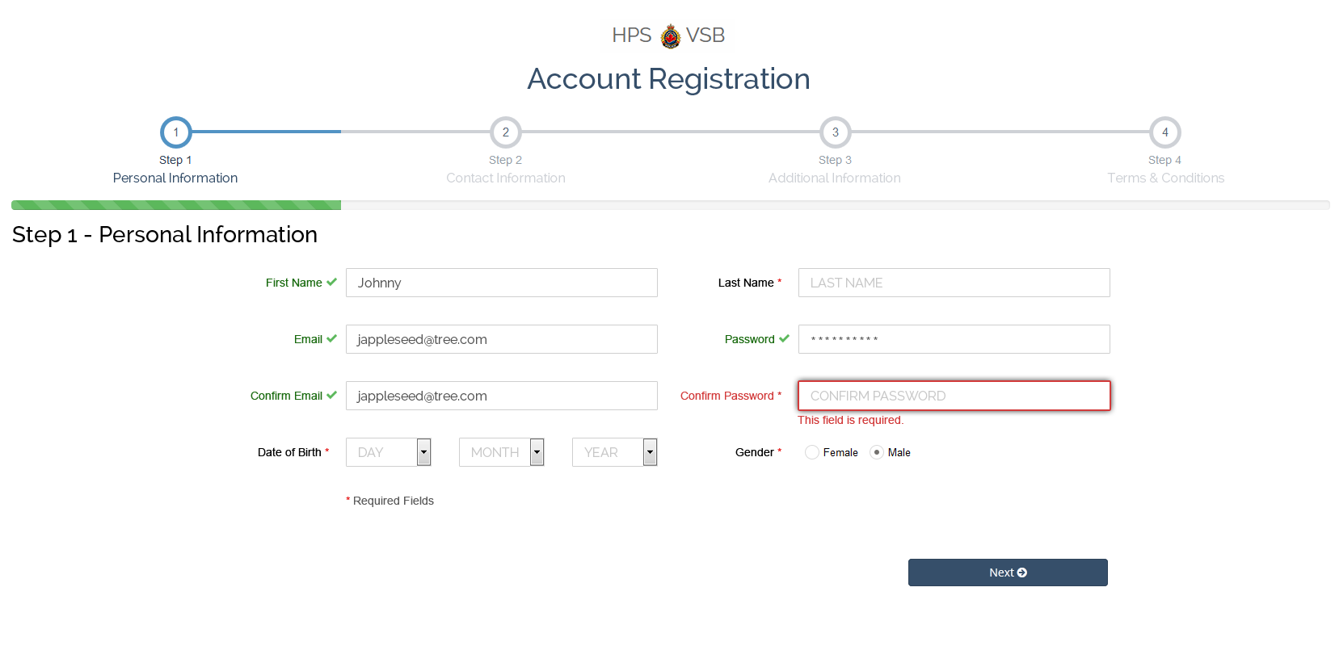

Functionality

1. Enter FIRST NAME, LAST NAME, EMAIL, CONFIRM EMAIL, PASSWORD and CONFIRM PASSWORD; standard validation must occur as shown in sample above.

***NOTE:*** *Valid fields should be denoted with ‘checkmark’; note color changes for success versus failures in validation; all tab out orders should be sequential in completing forms for all pages and throughout application.*

1. Select DATE OF BIRTH (values to include 1 thru 31), MONTH OF BIRTH (values to include January thru December) and YEAR OF BIRTH (values to include 1900 thru to current year, application should always display up to current year).
2. Select GENDER (no default).
3. Select **NEXT** to proceed to STEP 2; validate on action and display as per sample above.

## Step 2 – Contact Information

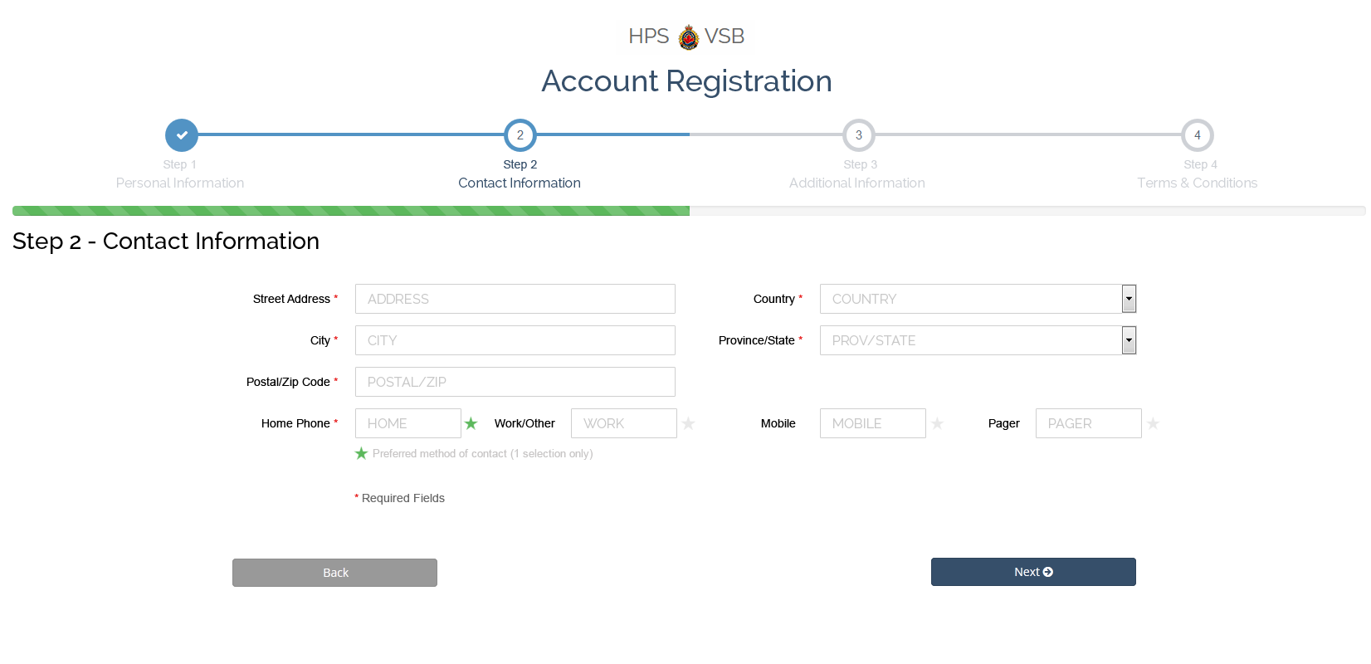

Functionality

1. Enter ADDRESS, CITY, POSTAL/ZIP, COUNTRY, PROVINCE/STATE; standard validation must occur  
     
   Country values should include ‘Canada’ (default) and ‘U.S.’.  
     
   Province values should include all Canadian provinces if ‘Canada’ is selected; sorted alphabetically.  
     
   State values should include all U.S. states if ‘U.S.’ is selected; sorted alphabetically.
2. Enter either HOME, WORK/OTHER, MOBILE or PAGER phone numbers – at least ONE is required; by default set the first one entered as the ‘preferred’ number by enabling star icon; if additional numbers are entered user may select any of the valid numbers as the preferred one; icon should show as ON (green), OFF (enabled but not green) or DISABLED (can’t select due to invalid number).
3. Proper validation of phone numbers, postal and zip required.
4. Select **NEXT** to proceed to Step 3.
5. Select **BACK** to go back to Step 1.

## Step 3 – Additional Information

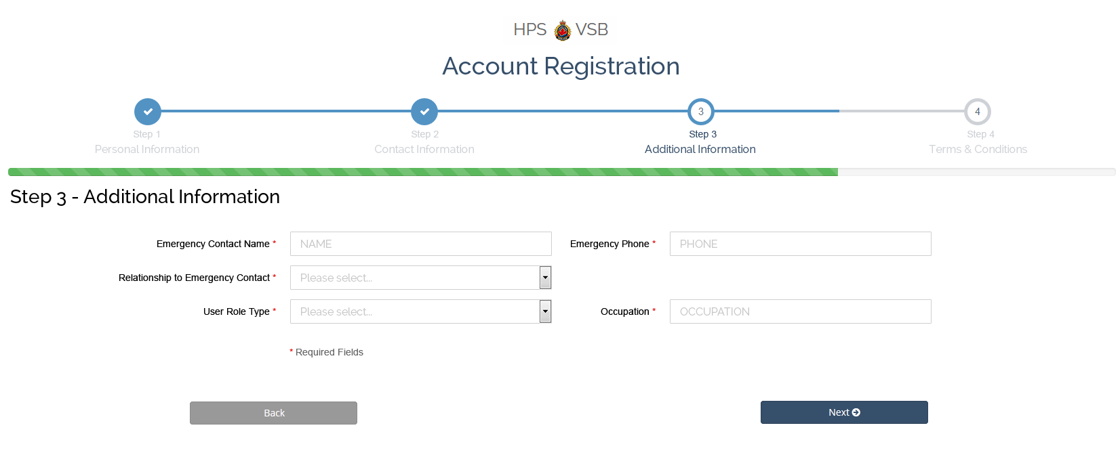

Functionality

1. Enter EMERGENCY CONTACT NAME and EMERGENCY PHONE; standard validation must occur
2. Select RELATIOSHIP TO EMERGENCY CONTACT; default “Please select…” with the following available values sorted based on list below:  
   1. Husband
   2. Wife
   3. Mother
   4. Father
   5. Son
   6. Daughter
   7. Brother
   8. Sister
   9. Partner
   10. Friend
   11. Supervisor
   12. Other
3. Select USER ROLE TYPE; values populated alphabetically from client ROLE settings; refer to *Creating Roles* for more information
4. Enter OCCUPATION.
5. Select **NEXT** to proceed to Step 4.
6. Select **BACK** to go back to Step 2.

## Step 4 – Additional Information

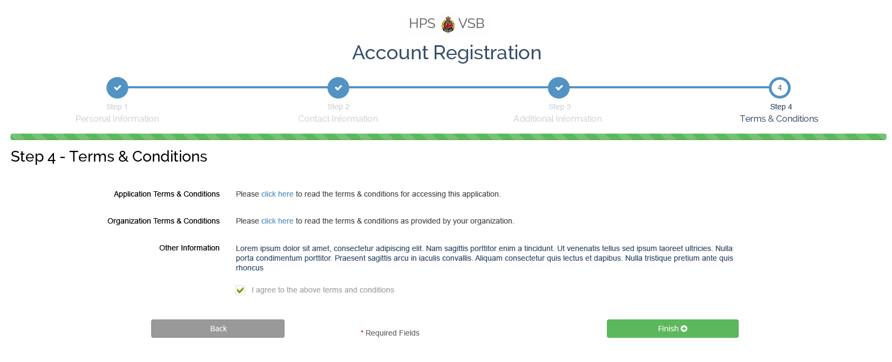

Functionality

1. User may select ‘click here’ for any of the above terms and conditions; slide down dialog to display terms and conditions as configured via client’s Terms and Conditions setup; refer to *Create Terms & Conditions* for more information;

‘Other Information’ is text based from Terms & Conditions setup.  
  
Application Terms & Conditions will always exist and are built-in; only ‘Organization Terms & Conditions’ and ‘Other Information’ are dynamic as per client’s settings.

1. User to select “I agree to the above terms and conditions’; on selection enable FINISH; on selection of finish the user will be redirected to the login page with a success message noting “Thank you for your registration. You will receive a welcome email with further instructions.”; email to be sent to user and system administrator; based on approval settings administrator may be required to approve the user prior to access; on approval confirmation email is sent to user – if automatic approval confirmation email is sent immediately
2. Select **BACK** to go back to Step 3.

# Site Administrator

The following section outlines the features and functionality for the site administrator who is setup by the system administrator.

Some features will be shared with general users and will be noted accordingly.

## Side Menu Requirements

Dashboard

Directory

Shift Schedule

Message Center

Inbox

Sent Items

Compose Message

Approvals

Shift Registrations

User Registrations

Report Management

Schedules

User History

Shift History

Contact Sheet

Assignments

Request Form

Organization Settings

Address

Billing

Branding

Language

Localization

Terms and Conditions

System Management

Approval s

Categories

Roles

Skills

## Header Requirements (Administrators and Users)

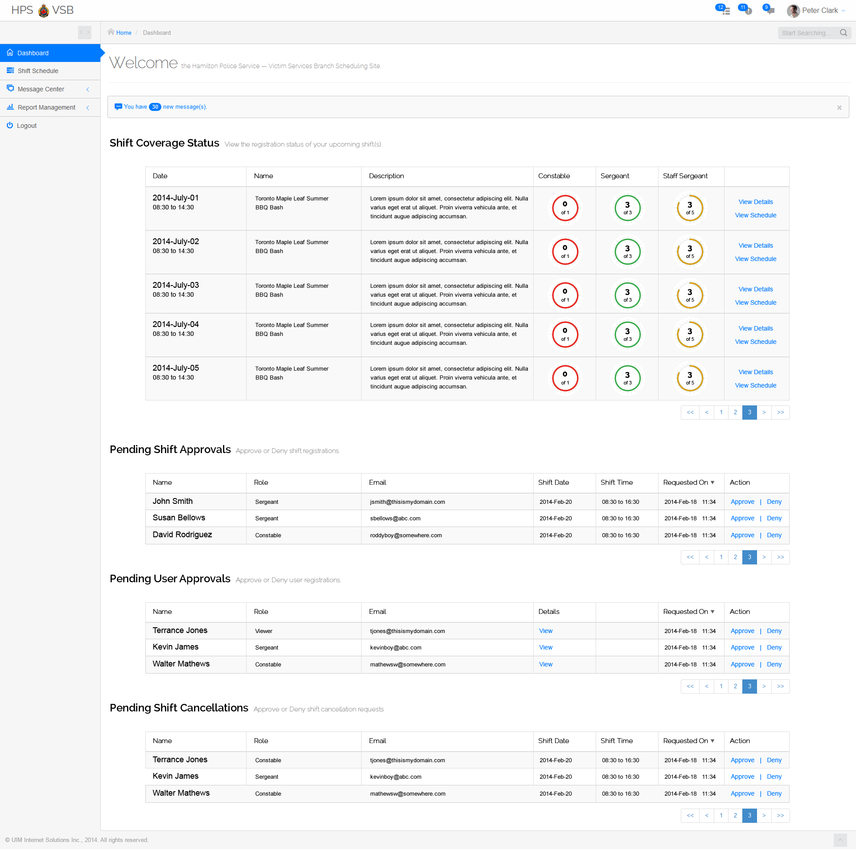

Functionality

1. Logo to display in top left.
2. Breadcrumbs as per side menu drill down to display.
3. Top right options include…
   1. Notifications (select for most recent, badge to indicate latest)
   2. Messages (select for most recent, badge to indicate latest)
   3. DO NOT USE TASK option
   4. User avatar and menu; select to display…
      1. My Profile
      2. My Messages (go to Message Center->Inbox)
      3. Lock Screen
      4. Sign Out
4. Search option not required in header throughout application (other search requirements may exist per specific pages).

## Dashboard (Site Administrator)

The following sample dashboard displays various upcoming shifts/events with differentiating role quantities.

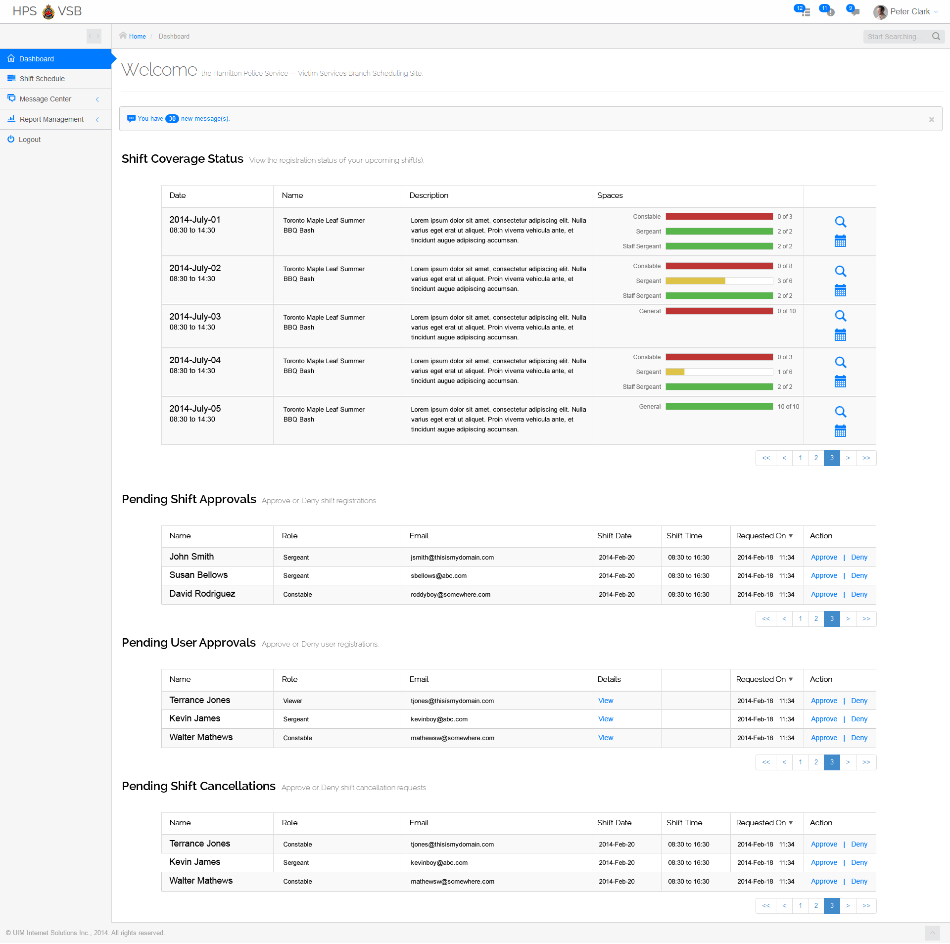

Functionality

1. WELCOME message – custom sub title pulled from client customization under “Branding”
2. Message notification to display how many new messages (unread) are available in INBOX – same badge count as per header message notice.
3. **SHIFT COVERAGE STATUS**  
     
     
   1. Display the following information…
      1. Date including start and end time
      2. Shift/Event name
      3. Shift/Event description (truncate at 3 lines)
      4. Role status showing graphical representation as follows:
         1. Display role (i.e. ‘Constable’ as per shift/even define role spaces
         2. Display registered spaces out of total spaces (i.e. 3 out of 5)
         3. Display colour bar to represent registration status…
            1. RED – shift/event has no users signed up in this role
            2. GREEN – shift/event is fully registered for this role
            3. ORANGE/YELLOW – shift/even is partially full for this role
      5. Select VIEW DETAILS icon (magnifying glass) to display shift/event details (same dialog as per shift schedule for site admins)
      6. Select VIEW SCHEDULE icon (calendar) to jump to schedule displaying WEEK view of the currently selected shift
   2. Dashboard to display the next 5 upcoming shift/events; pagination controls to allow administrator to navigate ahead or back
4. **PENDING SHIFT APPROVALS**  
     
     
   1. Only displayed if Shift Approval is turned ON as per *System Settings*.
   2. Display the following information…
      1. Name
      2. Role
      3. Email
      4. Shift Date
      5. Shift Time
      6. Requested On
      7. Action
         1. Approve to automatically approve – email confirmation sent
         2. Deny to automatically deny – email notice sent
   3. Dashboard to display the oldest 5 shift/event requests first; pagination controls to allow administrator to navigate ahead or back
   4. Column sorting permitted by the following columns:
      1. Name
      2. Role
      3. Shift Date
      4. Requested On

1. **PENDING SHIFT APPROVALS**  
     
     
   1. Only displayed if User Approval is turned ON as per *System Settings*.
   2. Display the following information…
      1. Name
      2. Role
      3. Email
      4. Details – select “view” link to display user’s registration account screen; if administrator makes account ‘active’ it is similar to select ‘Approve’
      5. Requested On
      6. Action
         1. Approve to change user account status to ‘Active’; confirmation email to user sent
         2. Deny to discard user’s registration; confirmation email to user sent; no historical records kept.
   3. Dashboard to display the oldest 5 user registration requests first; pagination controls to allow administrator to navigate ahead or back
   4. Column sorting permitted by the following columns:
      1. Name
      2. Role
      3. Requested On
2. **PENDING SHIFT CANCELLATIONS**



* 1. Display the following information…
     1. Name
     2. Role
     3. Email
     4. Shift Date
     5. Shift Time
     6. Requested On
     7. Action
        1. Approve to automatically approve; replacement popup is displayed to assign another user (optional) to replace cancelled user – email confirmation sent  
           **COMP REQUIRED FOR REPLACE USER**
        2. Deny to automatically deny – email notice sent
  2. Dashboard to display the oldest 5 shift/event cancellation requests first; pagination controls to allow administrator to navigate ahead or back
  3. Column sorting permitted by the following columns:
     1. Name
     2. Role
     3. Shift Date
     4. Requested On

## Directory (Site Administrator and User Administrator)

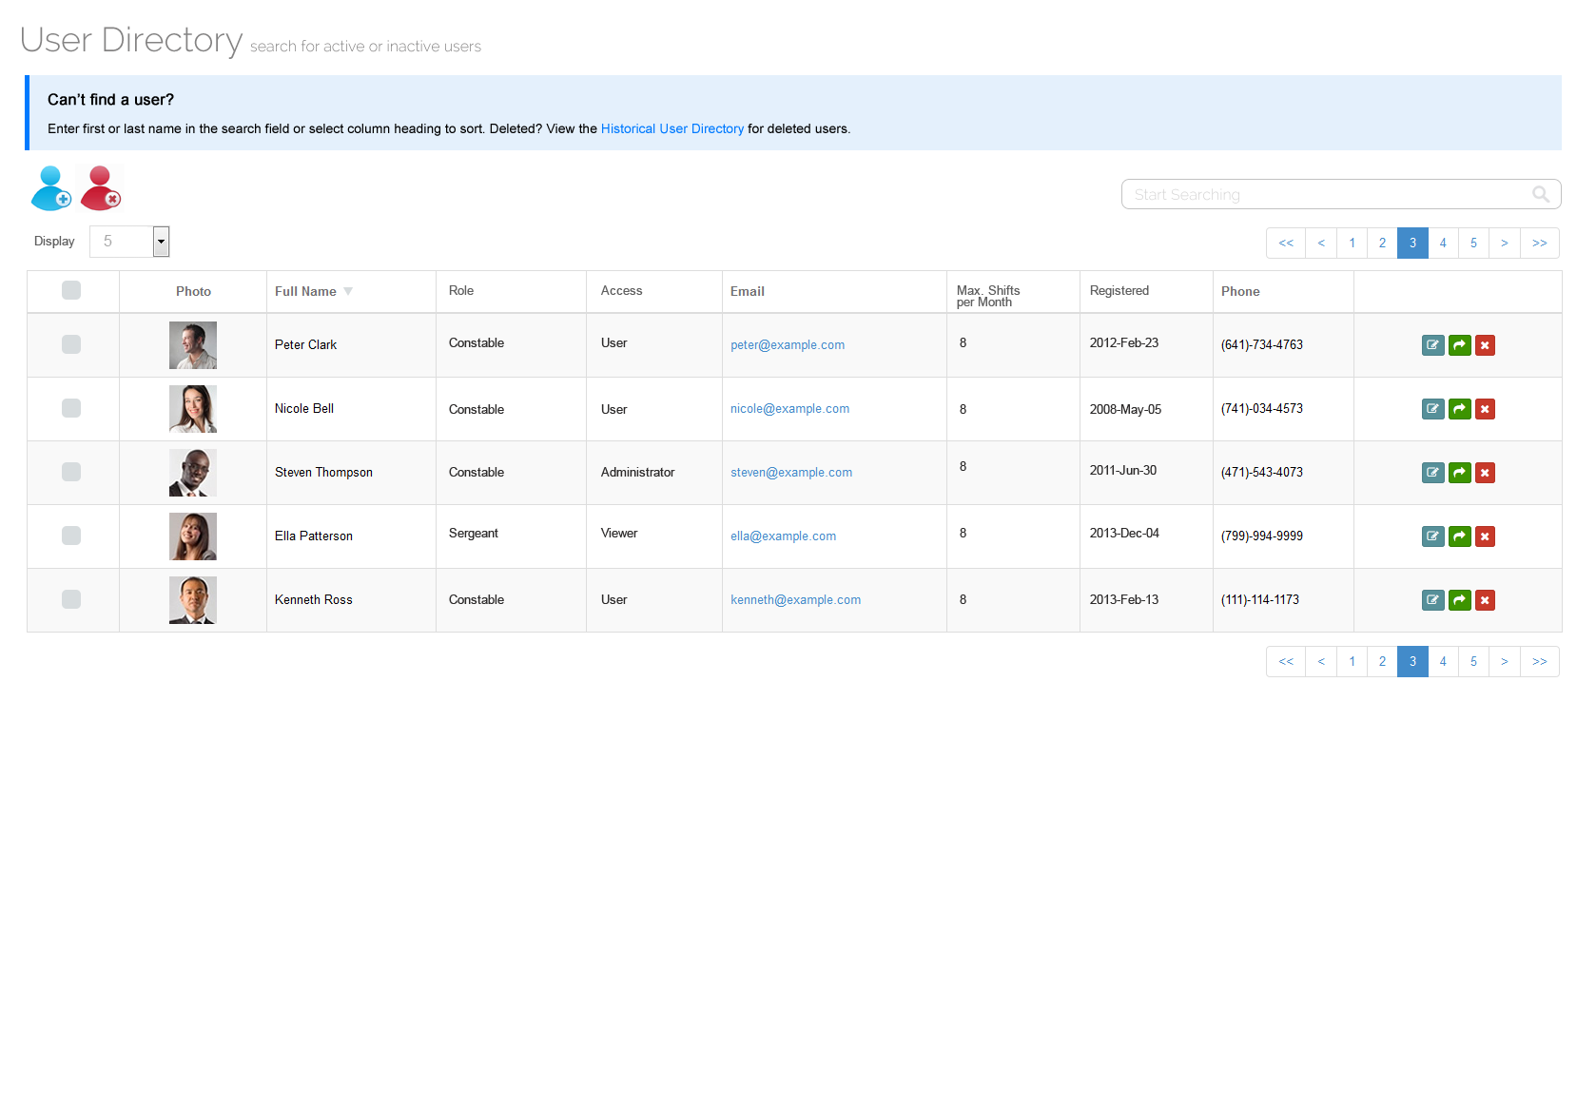

Functionality

1. Select “Display” to change the number of records displayed on the current page.
2. Select paginations controls to navigate forward or reverse based on the number of records displayed.
3. First column denoting check boxes is not required.
4. Enter search criteria to search the following records:
   1. Full Name
   2. Status (‘Active’ or ‘Inactive’) [not displaying on comp]
   3. Role
   4. Access
   5. Email
5. Columns to display:
   1. Photo (avatar)
   2. Full Name
   3. Status [not displaying on comp]
   4. Role
   5. Access
   6. Email
   7. Max. shifts per month
   8. Actions
      1. Edit (refer to *User Account Edit* below)
      2. Active/Inactive toggle (action to set user account ‘Active’ status to OFF or ON depending on current setting)
      3. Delete (only available if ‘Active’ status is OFF; action to set user ‘Delete’ status to ON; will result in displaying in Historical User Directory only)
6. Column sorting permitted by the following columns:
   1. Full Name
   2. Status
   3. Role
   4. Access
7. Select ADD USER icon to manually add user; same User Account screen to display; all fields required; user set to ‘Active’; on SAVE welcome email to user to be sent indicating activation.
8. Select DELETE USER icon to delete one or more selected users; validate if no users selected; confirmation alert should prompt admin (i.e. “Are you sure you wish to delete the selected user(s)?”); on confirmation user account to set ‘Inactive’ and ‘Deleted’ and will appear only in historical directory.
9. Select “Historical User Directory” link to display the following directory…  
     
   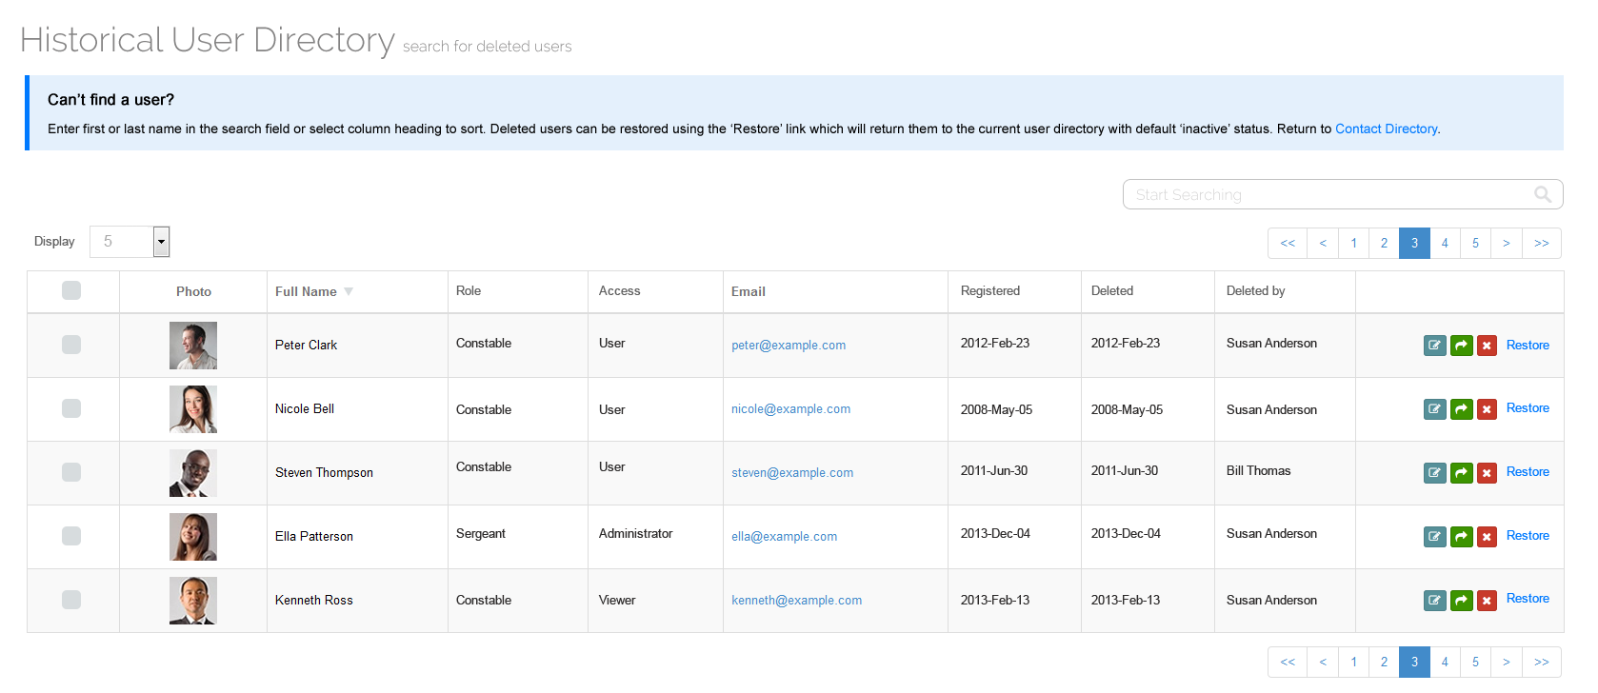
   1. All functionality the same except for the following:
      1. Remove ‘status’, ‘max. shifts per month’, ‘phone’ columns
      2. Add ‘Deleted’ and ‘Deleted by’ columns
      3. Remove Active/Inactive toggle and delete actions
      4. Add ‘Restore’ action (action to set ‘Delete’ status to OFF and set ‘Active’ status to OFF – admin still required to activate)
   2. Select “Contact Directory” link to return to main contact directory.

## User Account Edit (Site Administrator and User Administrator)

Available to administrators who select EDIT from the contact or historical contact directory.

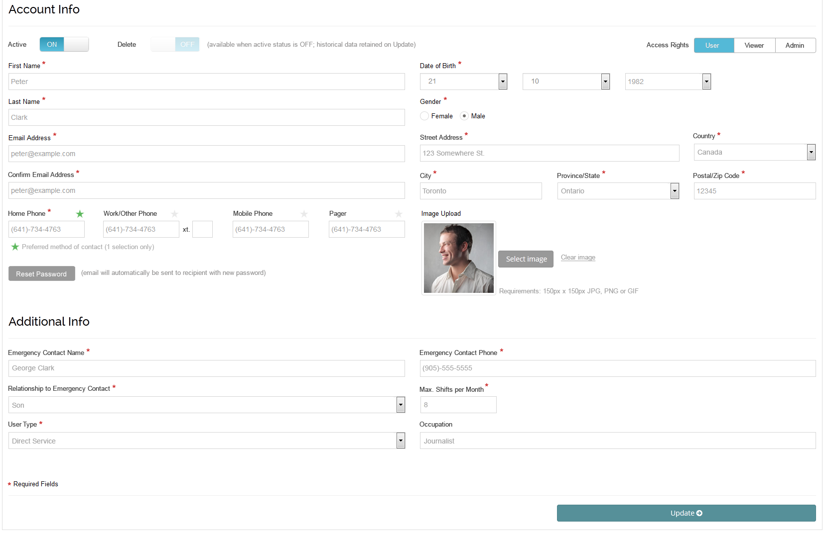

Functionality

1. Set user **ACTIVE** status to ‘On’ or ‘Off’; OFF by default for all new account registrations where approval is required; ‘Off’ users cannot log in.
2. Set user **DELETE** status to ‘On’ or ‘Off’ only if ‘active’ status is OFF; a deleted user will move to the historical contact directory; deleted users are not available to login, not available for manual registrations, messaging or listed within any other part of the site except for the historical contact directory.
3. Set **ACCESS RIGHTS** to ‘User’ (default), ‘Viewer’ or ‘Admin’...  
   1. User is the standard access, follow all functionality as noted within this document
   2. Viewer has the **same access as a user** except they MAY NOT register for shifts, do not appear for manual registration and do not include the Message Center or any related messaging options (including badge alerts on header and dashboard).
   3. Admin has the same access as the site administrator with the following exceptions...
      1. No access to Organization Settings
      2. No access to System Settings
      3. Does not receive ‘site administrator’ emails
      4. May only self register themselves on any shift/event for any role – ability to register like a user is not available, shift/event management is available via calendar
4. Additional field ‘Max. Shifts per Month’ is available (default for all accounts is 4); users do not see this field.
5. Ability to set password is removed for administrator; function to RESET PASSWORD is available; on selection email to be sent to user to confirm receipt – on confirmation password reset process can be followed.
6. Remaining fields to be modified as per User Account functionality.
7. Select **UPDATE** to save changes.

## Shift Schedule (Site Administrator and User Administrator)

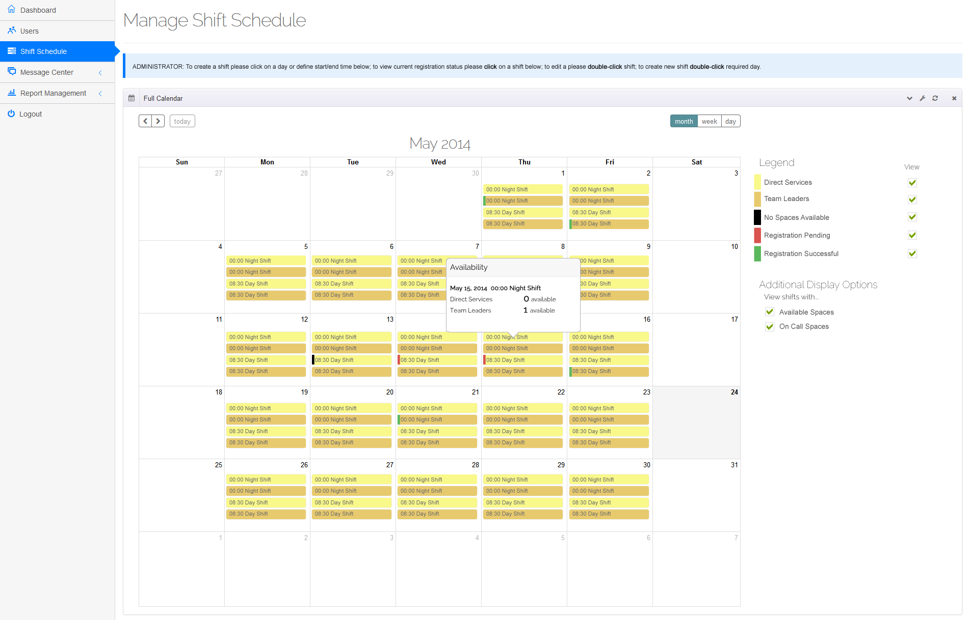

Functionality

1. By default schedule will display the current MONTH view with today’s date highlighted (as per comp); options for week and day as per template
2. Administrator to select forward or back navigation controls to move month-by-month, week-by-week or day-by-day depending on view; ability to select any MONTH from any YEAR should be available to directly jump to in MONTH view; ability to select any WEEK from any MONTH should be available to directly jump to in WEEK view; ability to select any DAY from any MONTH should be available to directly jump to in DAY view.
3. Double-click any ‘day’ (not on a shift/event) to ADD a new SHIFT/EVENT; refer to *Add a Shift/Event* for more information.
4. Double-click any ‘shift/event’ to EDIT an existing setup.
5. Single click any ‘shift/event’ to view the shift/event availability…  
     
   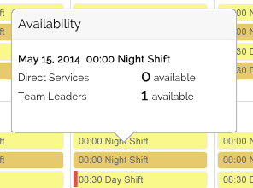  
     
   Popover to display shift/event date, time and name; including number of available spaces for each role defined for the selected shift/event.
6. Schedule to display all shifts/events in the selected category as defined in the Add Shift/Event setup process.
7. Legend to display the following…

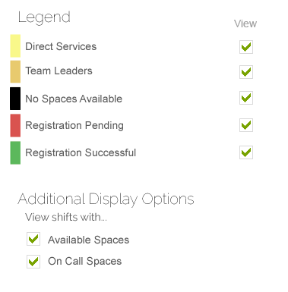

* 1. Each category currently available in the displayed month, week or day view; displayed alphabetically
  2. Category to display in its assigned color (left side swatch) with name of category listed beside
  3. Below all categories will exist 3 fixed legend values
     1. No Spaces Available (black)
     2. Registration Pending (red)
     3. Registration Successful (green)

*Note: administrators may not register for shifts so they will never see red or green shift/event flags on the calendar; however they do have the option of being scheduled.*

* 1. All legend items turned ON by default via ‘view’ toggles, turn off to remove from display; legend settings should be stored for future sessions

1. Calendar to display shift/events in category colour; if shift/event is fully registered display left swatch in ‘black’; if user has a pending registered shift/event display left swatch in ‘red’; if user has a successful registered shift/event display left swatch in ‘green’.  
     
   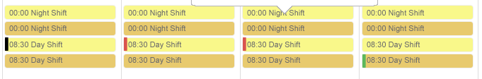
2. Additional Display options, located below legend includes the ‘spaces’ for all defined roles; display [Generic] space first (refer to shift/event creation for definition of generic space) followed by ranking display order of roles;  
     
   Administrator may turn ON only ‘spaces’ they are interested in. For example, the following roles exist: ROLE A, ROLE B, ROLE C and the generic space ‘Available Spaces’, the display might show…  
     
   Available Spaces  
   ROLE A  
   ROLE B  
   ROLE C  
     
   If only AVAILABLE SPACES and ROLE B are turned on, ONLY shifts/events that have the ability to register for these spaces should display (regardless of registration status).

## Add Shift/Event (Site Administrator and User Administrator)

### Overview

Define the basic shift/event parameters. Default to OVERVIEW tab.

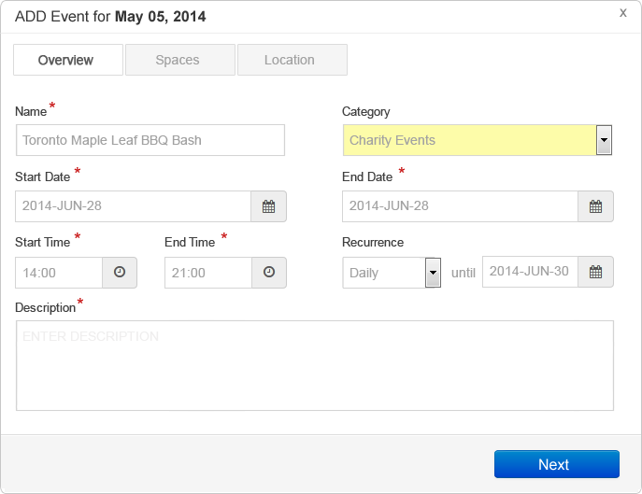

Functionality

1. Double click empty day or time slot via DAY, WEEK or MONTH view; if administrator drags start and end time in DAY or WEEK view default times to match.
2. Enter NAME, select CATEGORY (as pulled from System Settings->Categories), enter START and END DATES, enter START and END TIMES;
3. Select RECURRENCE, if required – valid values include…
   1. None (default)
   2. Daily
   3. Weekly
   4. Monthly

If selected, display ‘until’ with date selector; administrator will select the date the shift/event recurrence will end.  
  
Recurrence will take the currently defined shift/event date and start/end time and duplicate it over the period every day, every week (i.e. each Tuesday if date is on a Tuesday) or every month on the same date (skip months that don’t have the same date) until the end date is reached.

1. Enter DESCRIPTION.
2. Select **NEXT** to proceed to **SPACES** tab; NEXT should not be available until all required fields are complete and validation is passed.

### Spaces

Define the shift/event registration requirements with available spaces.

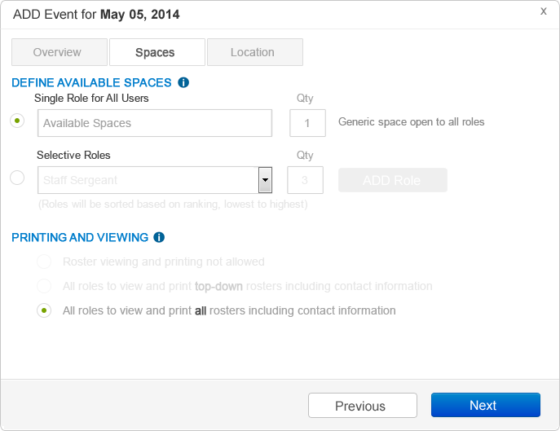

Functionality

1. Select **DEFAULT AVAILABLE SPACES**; by default the “Single Role for All Users” options is selected; “Selective Roles” should be appear disabled unless turned on; default name for “Single Role for All Users” is “General” (not ‘Available Spaces’ as shown in composites) and is editable by administrator; quantity default is “1”;  
     
   This default setting allows the administrator to setup a shift/event without requiring specific spaces setup and can be changed later.  
     
   *Note: This space setup allows all roles to sign up – there are no restrictions; note that the PRINTING AND VIEWING option only includes “All roles to view and print all rosters including contact information”*
2. Select “Selective Roles” to add spaces based on role assignment; list populated from System Settings -> Roles; enter quantity and select ADD ROLE button; role will be added to list below; order will be displayed on Role setting display order.  
   1. Enter number of spaces for each role, default is ‘1’.
   2. Select ‘Remove’ to remove role from shift/event.
   3. If Role is removed from main System Settings then the role shall also be removed from all shift/events; *Note: roles cannot be removed if any ‘user types’ are still assigned to the same value.*
3. If DEFAULT AVAILABLE SPACES is changed the ‘other’ setting is visually disabled and not used.
4. Select PRINTING AND VIEWING…
   1. When “Single Role for All Users” is selected only “*All roles to view and print all rosters including contact information*” is available; otherwise all options available as follows:
      1. ‘Roster viewing and printing not allowed’ – no role is allowed to view and print roster except for administrators
      2. ‘All roles to view and print top-down rosters including contact information’ – any user role can view rosters from their current ranking or below only; printing available
      3. ‘All roles to view and print all rosters including contact information’ – any user role level can view full roster including roles higher than their current ranking; printing available (default selection)
5. Select **NEXT** to proceed to **LOCATION** tab; NEXT should not be available until all required fields are complete and validation is passed.
6. Select **PREVIOUS** to return to **OVERVIEW** tab.

### Location

Define the shift/event location.

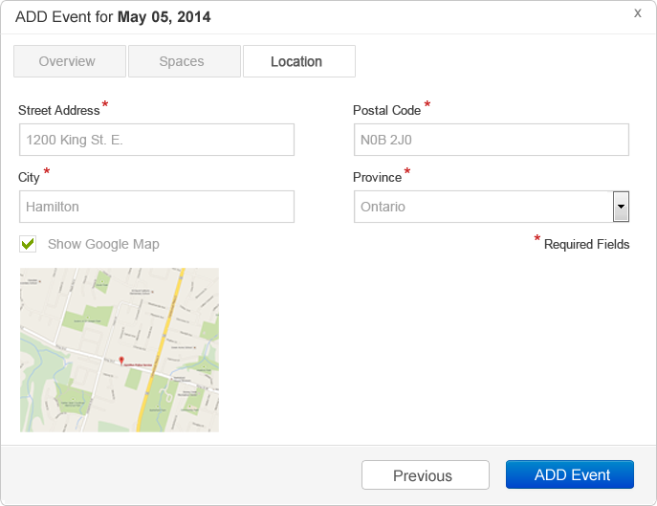

Functionality

1. Enter STREET ADDRESS, POSTAL CODE (label as ZIP CODE if client setting is ‘U.S.”).
2. Select PROVINCE from drop down list (label as STATE if client setting is ‘U.S.:).
3. Turn ON “Show Google Map” if required, display preview below so administrator can confirm location; if ON map will appear in shift/event detail page.
4. Select **ADD EVENT** to add to schedule; validation should occur; success message should appear noting “Shift successfully created.” (remember ‘shift’ may have a language replacement word)
5. Select **PREVIOUS** to return to **SPACES** tab.

### Adding Shift/Event

Once shift/event is added it will display in the calendar in any day, week or month view using the category color assigned.

### Information Tips

Throughout the application user information tips will be denoted by the symbol.

On selection of icon a standard popover will display with brief information tips. Tips to be supplied at a later date but should be editable via Super Administrator interface.

Information tips will be denoted throughout composites with the displayed icon or will only be indicated in copy forms; add applicable information tip where noted in this specification.

## Edit Shift/Event (Site Administrator and User Administrator)

### Overview

Edit the basic shift/event parameters.

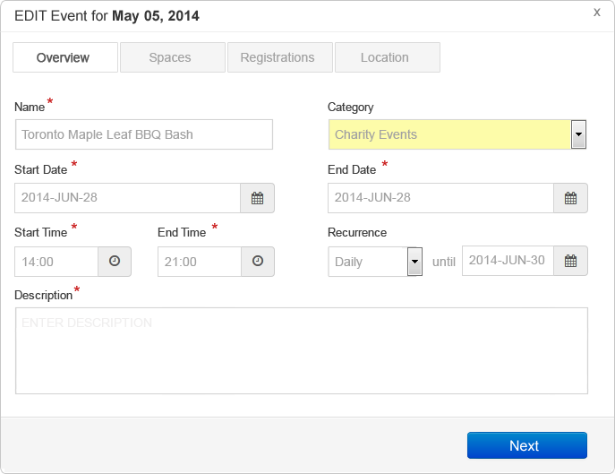

Functionality

1. Modify shift/event parameters using similar functionality as per ‘Add Shift/Event’ process.
2. If values are modified email notification should be sent to all registered users on UPDATE EVENT.
3. Select **NEXT** to proceed to **SPACES** tab.

### Spaces

Edit the shift/event registration requirements with available spaces.

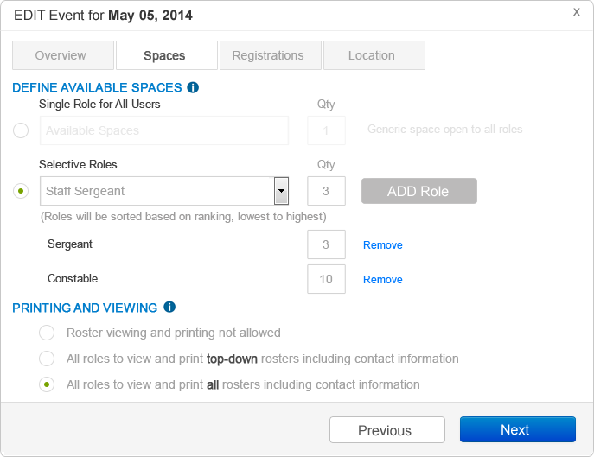

Functionality

1. Modify space parameters using similar functionality as per ‘Add Shift/Event’ process.  
     
   RULES

If roles are removed when active registrations exist an alert should be displayed noting “Warning: Removing this role will result in the removal of registered users. Do you wish to continue?” If yes, remove users and email them cancellation notices.

If role quantities are lowered but registrations already exceed the value, DO NOT allow the change. Alert displayed noting “Warning: Registrations exceeds the requested maximum value. Please remove users and try again.” Administrator must go to the roster and remove users to the new limit maximum.

If available space method is changed from either “Single Role for All Users” to “Selective Roles” or vice-versa, the existing registered users will be removed from registration with the following alert; “Are you sure you wish to change the Available Space method? This will remove all registered users and notify them by email?” On Yes, allow the switch; send email on UPDATE EVENT; on No return to screen with prior settings.

1. Select **NEXT** to proceed to **REGISTRATIONS** tab; select **PREVIOUS** to proceed to **OVERVIEW** tab.

### Registrations

Edit the registrations for the selected shift/event. This is a new tab visible on existing shifts/events only.

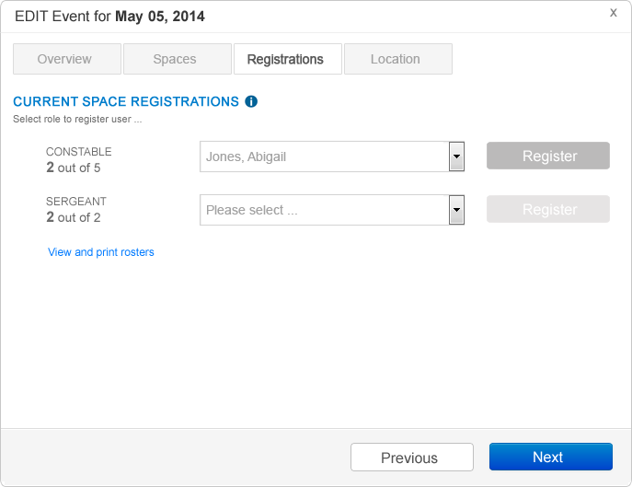

Functionality

1. Tab to display each role assigned to the selected shift/event. Values to display the number of registered users out of the possible spaces available (i.e. 2 out of 5 indicates 2 registered users out of 5 available spaces).
2. To manually assign additional users to a role, select the user name from the user list and select REGISTER; user is automatically assigned; space counter is incremented and email is sent to user notifying of administrator registration; user dashboard to update showing confirmed registration (all on UPDATE EVENT).
3. If role is completely registered the REGISTER and user drop down list shall be disabled.
4. User lists are populated based on matching role; for generic role ALL users are listed.
5. Select VIEW AND PRINT ROSTERS to view currently assigned users to each role.  
     
   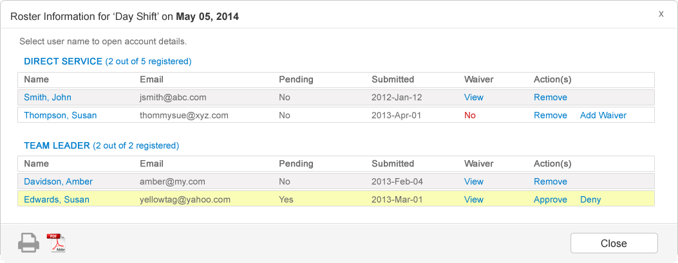  
   1. Display to include shift/event name, date and time (not shown).
   2. Each role will display alphabetically by last name all registered users (pending or approved).
   3. Columns to include…
      1. Name, Email, Pending, Submitted, Waiver, Actions (Remove or Deny) [Ignore Waiver options]
      2. Select “Remove” to remove approved registrant from shift/event; user to be notified by email
      3. Select Approve to approve registrant; pending status changed to confirmed
      4. Select Deny to deny registration and notify user by email (remove and refresh from this list)
   4. Select PRINT icon to print roster.
   5. Select PDF icon to generate PDF version of roster.
   6. Select CLOSE to return to REGISTRATIONS tab.
6. Select **NEXT** to proceed to **LOCATION** tab; select **PREVIOUS** to proceed to **SPACES** tab.

### Location

Edit the shift/event location.

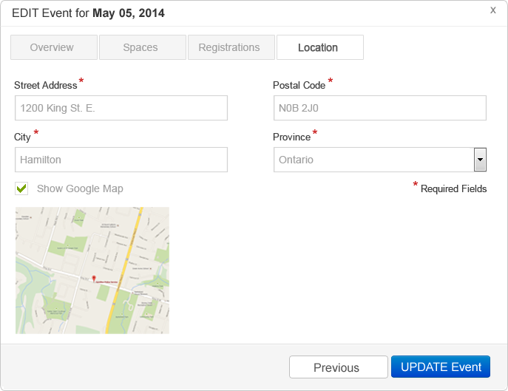

Functionality

1. Modify location using similar functionality as per ‘Add Shift/Event’ process.
2. If values are modified email notification should be sent to all registered users on UPDATE EVENT.
3. Select **UPDATE EVENT** to save changes – email and update as required; select **PREVIOUS** to return to **REGISTRATION** tab.

### Editing Shift/Event

Once shift/event is updated it will refresh in the calendar in any day, week or month view using the category color assigned.

## Message Center (Administrator and Users)

### Overview

The messages component is an ‘internal’ messaging tool similar to most email clients. Message notification will appear in the header and dashboard. Both will indicate via message or badge icon the number of new unread messages.

### Inbox

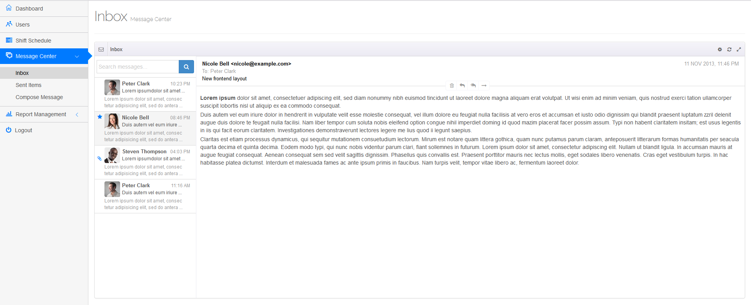

Functionality

1. Message Center Inbox is based on the default template functionality.
2. Features should include ability to note read/unread messages; open attachments; view avatars; flag favorite messages; search messages; delete messages and general sorting.

### Compose Message

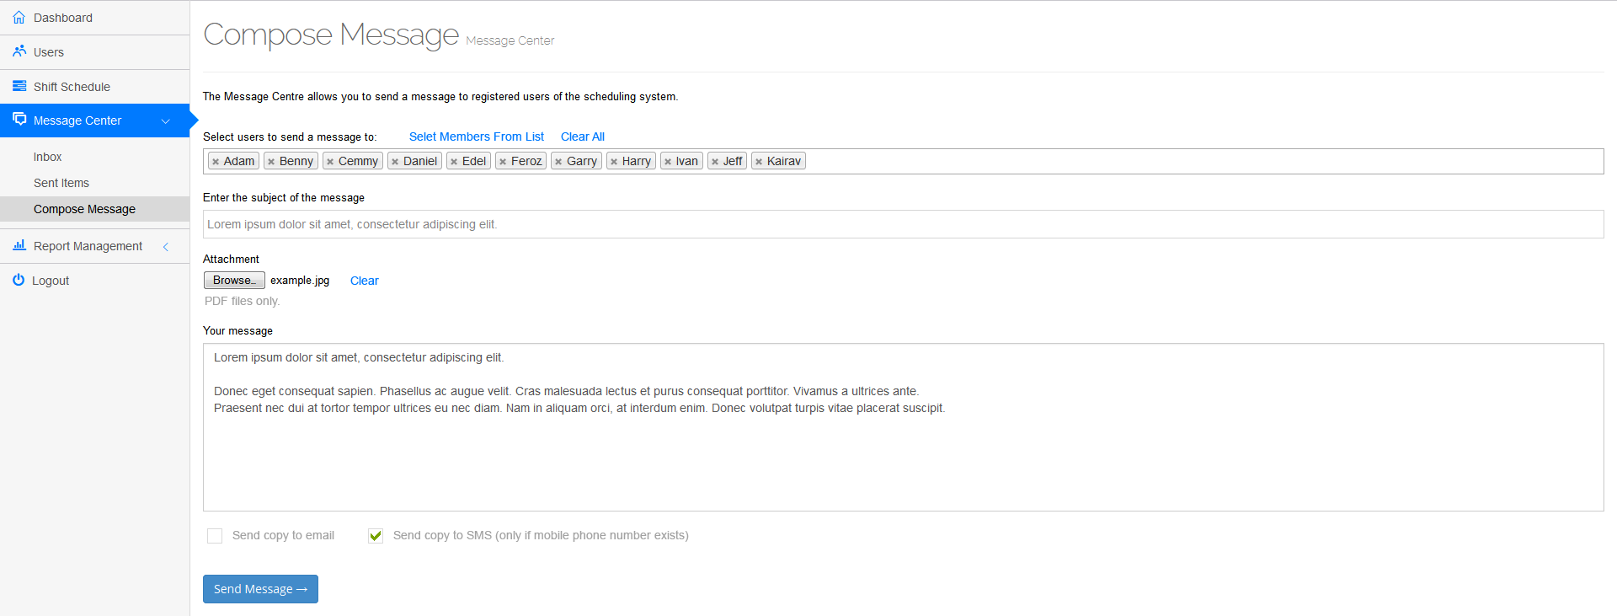

Functionality

1. Message Center Compose Message is based on the default template functionality.
2. Additional features include the ability to ‘Select Members From List’ which should display a slide down list where the composer can select one or more names from an alphabetical list and select ADD to add to the recipient list; recipient list can be edited.
3. ‘Clear All’ link removes all recipients from recipient list.
4. Ability to attach a file or clear from message.
5. Ability to send a copy of the message to recipient emails if turned ON.
6. Ability to send a copy of the message to recipient SMS only if ‘Mobile Phone’ setting exists; both default OFF.
7. Select **SEND MESSAGE** to send; all inboxes and message notification counts updated.

### Sent Items

No composite available.

Functionality

1. Message Center Sent Items is based on the default template functionality.
2. Standard historical records of all messages sent and recipients.

## Approvals (Site Administrator and User Administrator)

### Overview

The approvals provide administrators the ability to approve or deny requests for both shift and user registrations.

### Shift Registrations

No composite available.

The shift registration approval page is similar to the dashboard module “PENDING SHIFT APPROVALS” except it is displayed on its own page.

Default display is 25 records with full pagination controls; in addition “Display” controls should be made available to adjust the number of records to display (i.e. 25, 50, 100, 250, 500, All).



Functionality

* + - 1. Refer to dashboard functionality.

### User Registrations

No composite available.

The user registration approval page is similar to the dashboard module “PENDING USER APPROVALS” except it is displayed on its own page.

Default display is 25 records with full pagination controls; in addition “Display” controls should be made available to adjust the number of records to display (i.e. 25, 50, 100, 250, 500, All).



Functionality

1. Refer to dashboard functionality.

## Report Management (Site Administrator and User Administrator)

### Overview

Report Management provides the administrator with the ability to search one or more users based on specific information like roles or date ranges with optional print or PDF export options.   
  
At this time all reports will match the existing victimservices.hamiltonpolice.on.ca reporting requirements, however these will be redesigned and will be required to be displayed within the same calendar, where applicable, which includes responsive design and dynamic date range. More details to follow.

Reports will include...

* Schedules
* User History
* Shift History
* Contact Sheet
* Assignments
* Request Form

**INCOMPLETE**

## Organization Settings (Site Administrator)

### Overview

Organization Settings provides the configuration environment for various features throughout the applications.

Address

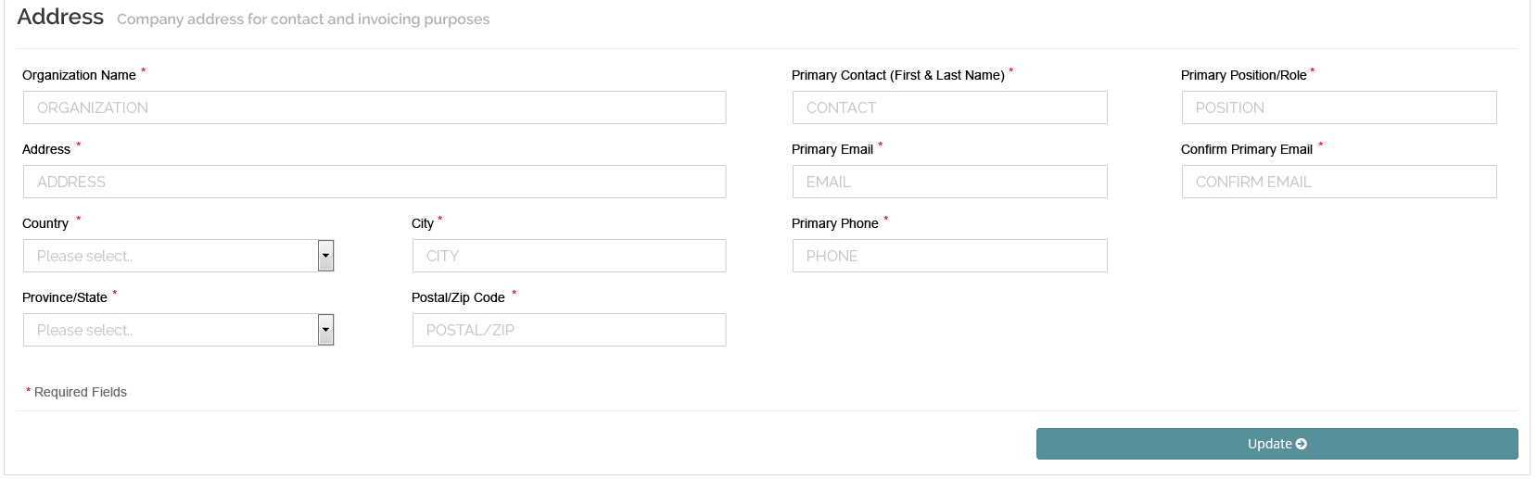

Functionality

1. Set organization contact information (default values populated from system administrator sign up); any changes should be reflected in system administrator environment.
2. Set ORGANIZATION NAME, ADDRESS, COUNTRY, CITY, PROVINCE/STATE, POSTAL/ZIP CODE, PRIMARY CONTACT NAME, PRIMARY POSITION/ROLE, PRIMARY EMAIL, CONFIRM PRIMARY EMAIL and PRIMARY PHONE.

***Note 1:*** *Changing Primary Email DOES NOT change the administrator’s email address – this email is never used for login purposes but for contact purposes only.*

***Note 2:*** *System Adminsitrator ADD CLIENT page should include the same information except for the addition of the ‘site administrator’ contact information as per the site administrator profile account page (i.e. there will be two emails on this page – one for client and one for site administrator, which may be the same).*

1. Country and Province/State drop down values as per prior instructions.
2. Standard validation should be included.
3. Select **UDPATE** to save changes.

### Billing

This page left intentionally blank until complete billing details are completed. Please remove from all menu options.

### Branding

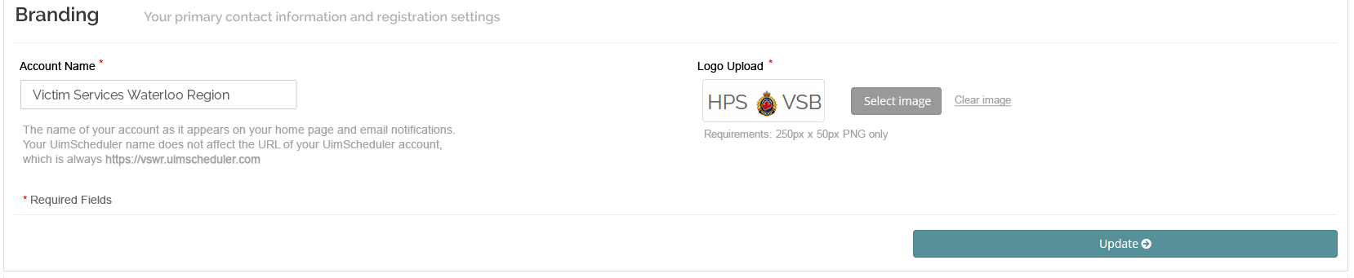

Functionality

1. Enter the ACCOUNT NAME; default assigned by System Adminsitrator.
2. Sub domain noted is set by System Administrator via client setup option.
3. Reference to “UimScheduler” will be changed to application name once provided. Please use consistent ‘placeholder’ name throughout so change is instant via database (i.e. use “VolunteerApp” or other).
4. Choose SELECT IMAGE to upload logo; requirements are 250x50px (subject to change); validation should occur on resolution selected; ability to preview once selected; select “Clear Image” to remove.  
     
   Logo is used on login page, header and throughout where required.
5. Select **UDPATE** to save changes.

### Language

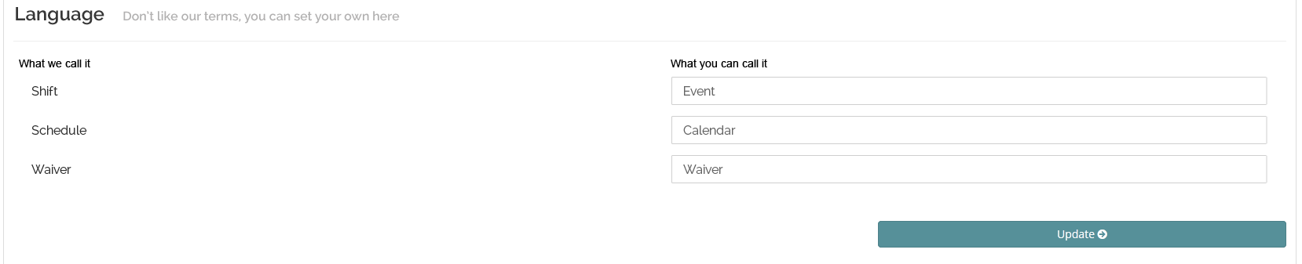

Functionality

1. For each primary term enter replacement term; if blank no changes throughout site; if value exists the original term is replaced throughout the entire site.
2. Current terms to change include...
   1. Shift
   2. Schedule
   3. Waiver (exclude for now)
3. Select **UDPATE** to save changes.

### Localization

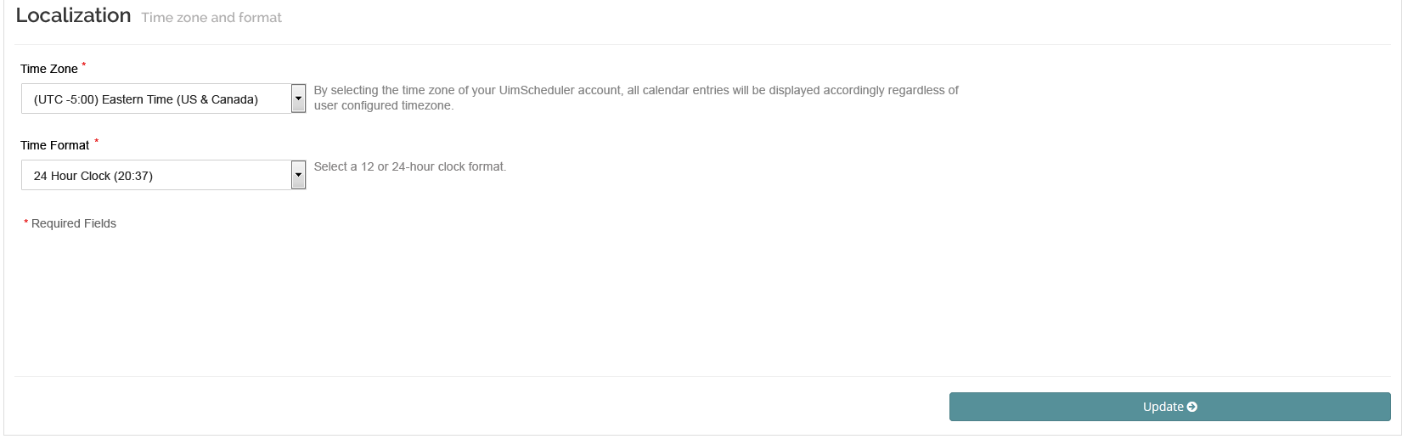

Functionality

1. Set TIME ZONE; list to be standard North American time zones only.
2. Set TIME FORMAT ; options include ’12 Hour Clock (8:37pm)’ or ’24 Hour Clock (20:37)’; default is 24 hour.
3. Select **UDPATE** to save changes.

### Terms and Conditions

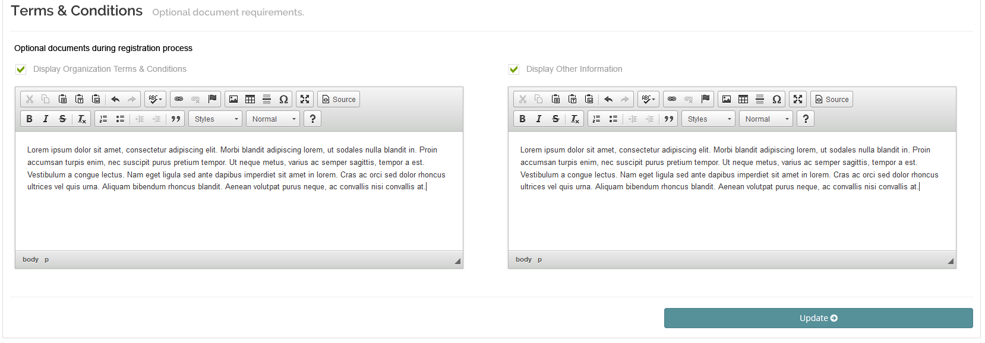

Functionality

1. Standard HTML editors to be made available.
2. Turn ON or OFF both ‘Display Organization Terms & Conditions’ and ‘Display Other Information’.
3. If ‘Display Organization Terms & Conditions’ is ON the HTML content will display in a slide down similar to the Application Terms and Conditions; if this setting is OFF the option on the registration page to view are removed from display.
4. If ‘Display Other Information’ is ON the HTML content will display directly on the Registration page; if this setting is OFF it is removed from display.
5. Select **UDPATE** to save changes.

## System Management (Site Administrator)

### Overview

System Settings provides the setup values for various features throughout the applications.

### Approvals

No composite available.

*Note: Set title to “Approval Management”.*

Functionality

1. Set the following approvals for ON or OFF (both default ON):

[ x ] Shift Approvals

[ x ] User Approvals

[UPDATE]

1. If ON module is displayed on administrator dashboard; if off module is removed from display and approvals are automatic for either scenario.
2. Select **UDPATE** to save changes.

### Categories

*Note: Change title from “Categories” to “Category Management” in composite.*

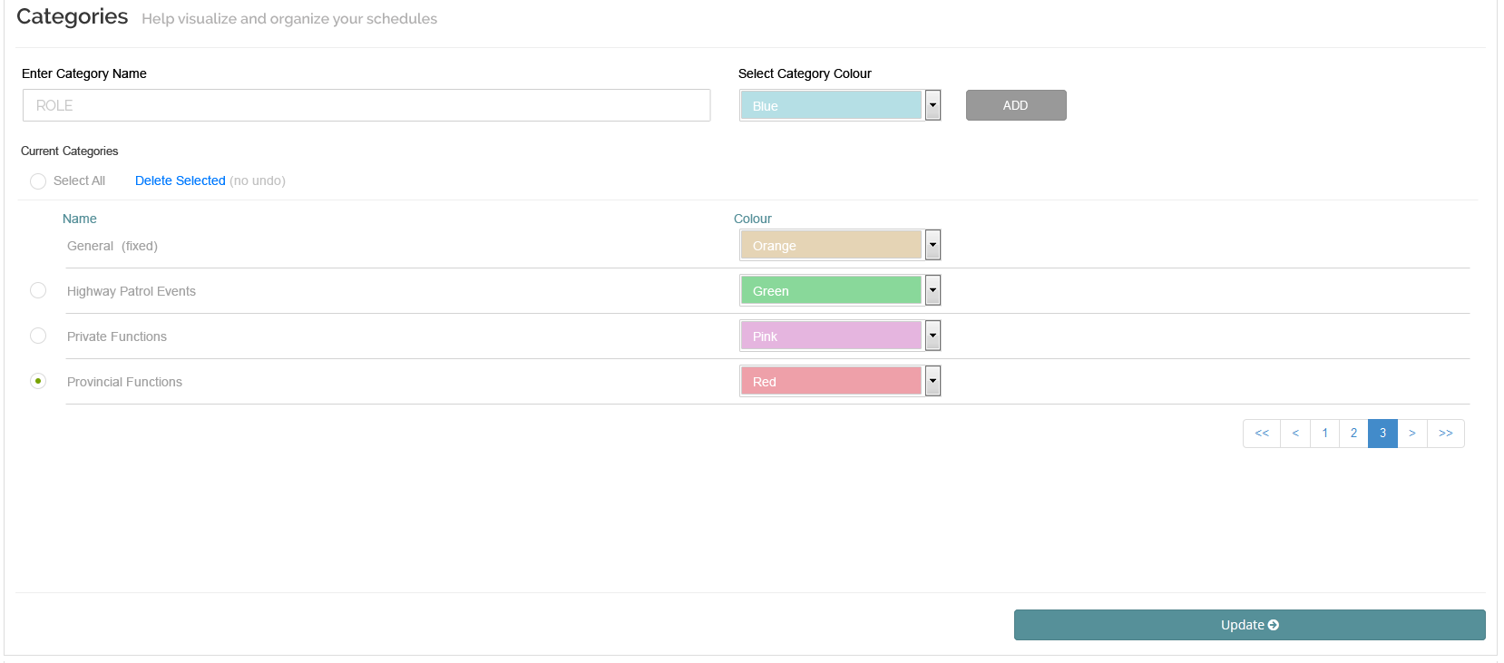

Functionality

1. Default category ‘General’ is included with colour (grey) as HEX #dddddd.
2. Enter CATEGORY NAME, select CATEGORY COLOUR and select ADD; category is added to list and sorted alphabetically.
3. Colours of categories can be changed at any time from corresponding drop down.
4. To delete existing categories, select one or more or SELECT ALL, select “Delete Selected” – warning to confirm deletion of categories to be displayed; existing categories assigned to shifts/events will be changed to “General” category.
5. Pagination controls included; addition of “Display” drop down to control number of categories per page (i.e. 5, 10, 25, 50, All).
6. Extract the corresponding colour codes from the swatches provided below. Allow easy mechanism to add or remove any number of swatches for the future (i.e. via DB or other).

  
  
Administrator to see colours based on swatches; order of display should be available via DB or other.

1. Select **UDPATE** to save changes.

### Roles

*Note: Change title from “Roles” to “Role Management” in composite.*

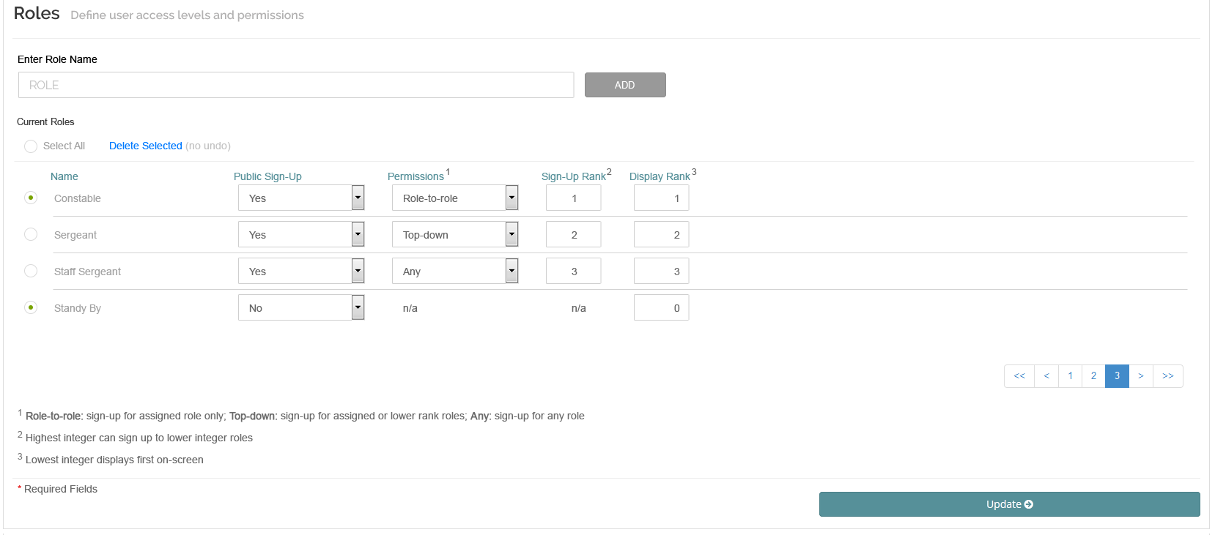

Functionality

1. Enter ROLE NAME, select ADD; role is added to list and sorted alphabetically.
2. To delete existing roles, select one or more or SELECT ALL, select “Delete Selected” – warning to confirm deletion of roles to be displayed; existing roles assigned to shifts/events will be removed;
3. Roles cannot be removed if assigned to any ‘active’ or ‘inactive’ users – warning message should indicate “One or more roles selected cannot be removed due to user assignment. Please change user(s) roles and try again.”  
     
   In the future if an ‘deleted’ user is restored and changed to ‘inactive’ the system should alert the administrator and display “User cannot be restored due to invalid role type. Please change role and try again.” Administrator may edit the user’s account first, change the role and then attempt the restore option.
4. Set “Public Sign Up” to ‘Yes’ or ‘No’.  
     
   If Yes, persons assigned with the associated role may sign up for shifts;   
     
   If No, only administrators may manually register users via EDIT Shift/Event functionality -> Registrations tab; “Permissions” and “Sign-up Rank” values set to ‘n/a’ for not applicable.
5. Set “Permissions” to ‘Role-to-role’, ‘Top-down’ or ‘Any’;
   1. Role-to-role: users with this role type may sign-up only for corresponding roles; user does not view any other role information; ‘sign-up rank’ is ignored
   2. Top-down: users with this role type may sign-up for corresponding role or ANY other role with equal or lesser ‘sign-up rank’ value
   3. Any: users may sign-up for any other role regardless or ‘sign-up rank’ value
6. Set “Sign-Up Rank” with any integer between 0 and 100 (0 is low, 100 is high); roles may have equal integers; value affects only roles set to ‘top-down’ where equal or lower rank values are available to user
7. Set “Display Rank” to determine the order to display all roles in all shift/event registration screens; set with values between 0 and 100 (0 is low, 100 is high); integers must be unique; lower values display first
8. Standard validation techniques should be applied.
9. Pagination and “Display” controls should be available similar to other pages.
10. Select **UDPATE** to save changes.

### Skills

Skills settings allows the administrator to set category and skill requirements.

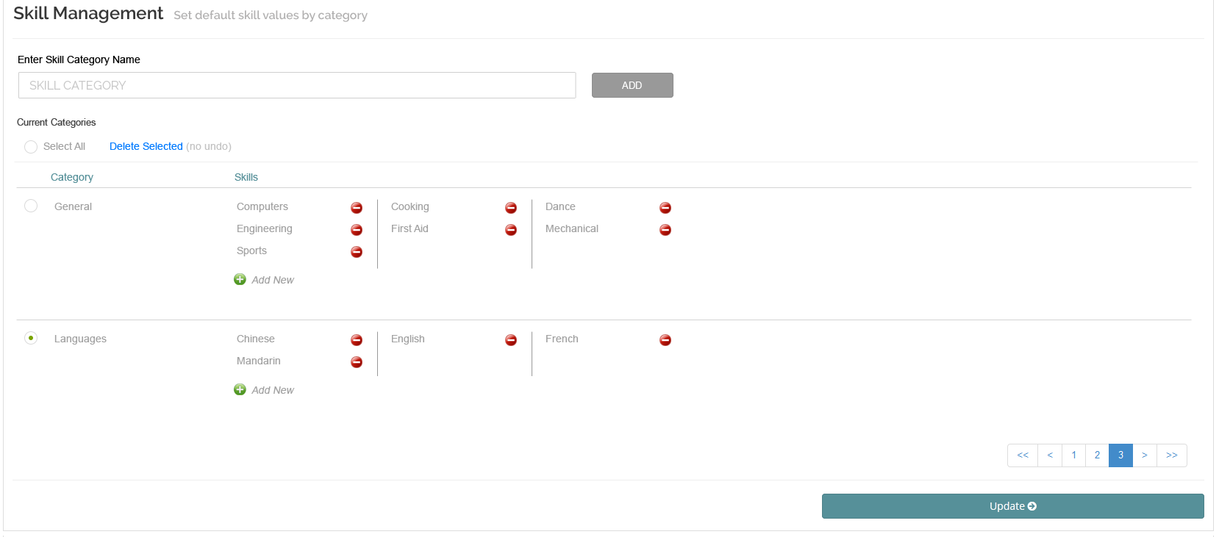

Functionality

1. Enter SKILL CATEGORY NAME; select ADD.
2. To delete existing skill categories, select one or more or SELECT ALL, select “Delete Selected” – warning to confirm deletion of skill categories to be displayed; existing skill categories and all associated skills will be deleted from all user accounts.
3. To add skill, select ADD NEW (or green ‘+’ icon) under the Skill column, popup to display to enter skill name (ADD and CANCEL options); on ADD display skill within associated skill category; sorted alphabetically.
4. To delete a skill, select the delete (red ‘-‘ icon) option beside the associated skill; skill will be removed on final update and all skills associated with users will be deleted.
5. Final layout of page may be modified to account for organization of skills and categories but should display all at once.
6. Pagination and “Display” controls should be available similar to other pages.
7. Select **UDPATE** to save changes.

## My Profile (Site Administrator) – from header

My profile provides the fields required for contact and account setup.

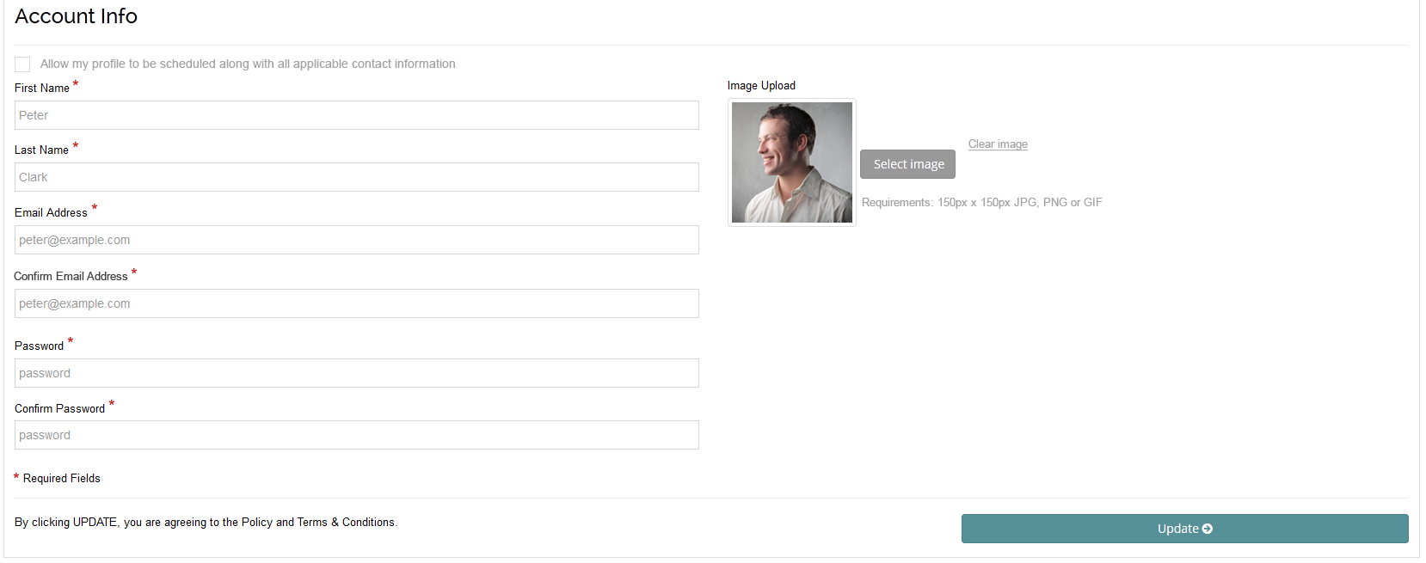

Functionality

1. Turn ON or OFF (default) ‘Allow my profile to be scheduled along with all applicable contact information’; when ON the site administrator’s name will appear in all manual shift/event registration screens BUT may NOT sign up for shift/events via calendar access; when assigned all roster information will include site administrator contact information.
2. Enter FIRST NAME, LAST NAME, EMAIL ADDRESS, CONFIRM EMAIL ADDRESS, PASSWORD and CONFIRM PASSWORD fields.
3. Choose SELECT IMAGE to upload avatar at 150150px; validation on selection should be made; preview on selection; select “Clear image” to remove avatar and restore to default image.
4. Default avatar to include standard silhouette profile for all users.
5. Select **UDPATE** to save changes.

## Lock Screen (Administrator and User) – from header

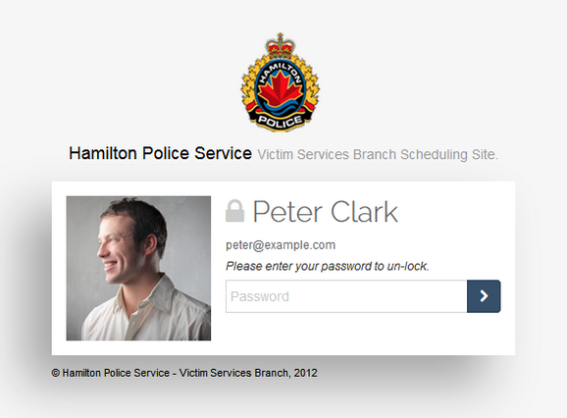

Functionality

1. Select LOCK OUT to lock screen and display information as follows:
   1. Avatar
   2. Full name
   3. Email
2. Only user assigned to this page can unlock and return to last saved page, other users will incur error
3. Logo and footer information is taken from Organization Settings.
4. Timeout will NOT occur on a locked out page; regular timeout of application should be set at 60 minutes.

# Email Notifications

The following emails will be sent out from the system based on the noted action.

**TO BE DETERMINED**

**From:**  noreply@volscheduler.com

**From Name:** volscheduler.com Administrator

**To:** {user email}

**Subject:** volscheduler.com Sign Up Confirmation

{first name},

Your submission to join **volscheduler.com** has been sent to administration for approval.

You have selected the **{subscription choice}** subscription. Upon approval you will receive a welcome email with your login credentials and may start using the system. To upgrade your subscription please refer to your account settings for more information.

If you have any further questions, please contact us at 647-777-3574 or email us at [help@volscheduler.com](mailto:help@volscheduler.com).

Sincerely,

volscheduler.com Administrator

**This is an automated message for information purposes only.**