1. 环境搭载完成后，拉代码至本地；
2. Nginx配置

include vhosts/*.conf;

server {

listen 8008;

server_name 192.168.53.142;

access_log /usr/local/nginx/logs/www.localanxin.com.log;

root /usr/local/nginx/html/api/public;

index index.php index.html index.htm;

charset utf-8;

location / {

try_files $uri $uri/ /index.php?_url=$uri&$args;

}

location /api {

proxy_pass http://192.168.53.142:83/;

#proxy_pass http://192.168.42.163:9000/;

}

location ~ /\.ht {

deny all;

}

location ~ \.php$ {

try_files $uri =404;

fastcgi_pass 127.0.0.1:9000;

fastcgi_index /index.php;

include fastcgi_params;

fastcgi_param HTTPS on;

fastcgi_split_path_info ^(.+\.php)(/.+)$;

fastcgi_param PATH_INFO $fastcgi_path_info;

fastcgi_param PATH_TRANSLATED $document_root$fastcgi_path_info;

fastcgi_param SCRIPT_FILENAME $document_root$fastcgi_script_name;

}

}

1. virtualBox设置共享文件夹：

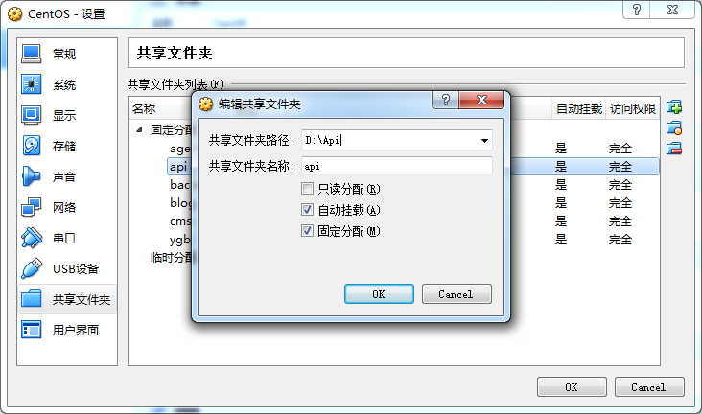

1. 网络端口转发

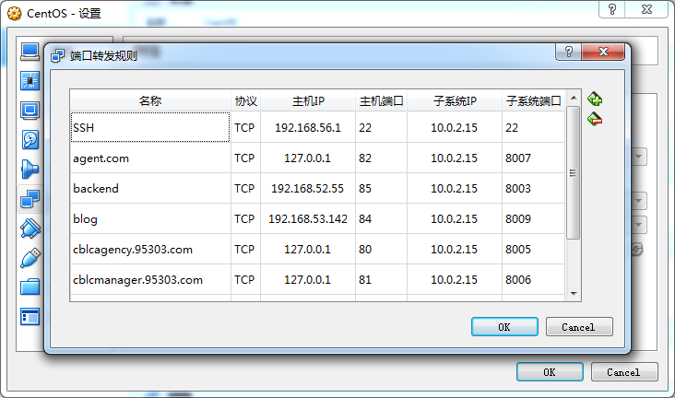

1. linux虚拟机使用mount命令将文件挂载到加载点

/etc/init.d/rc.local 在该文件下设置

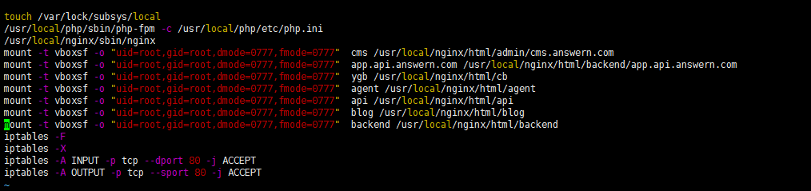

例：mount -t vboxsf -o "uid=root,gid=root,dmode=0777,fmode=0777" api /usr/local/nginx/html/api

1. 在对应目录下创建项目文件夹，重启虚拟机即可挂载.