1. Change base url

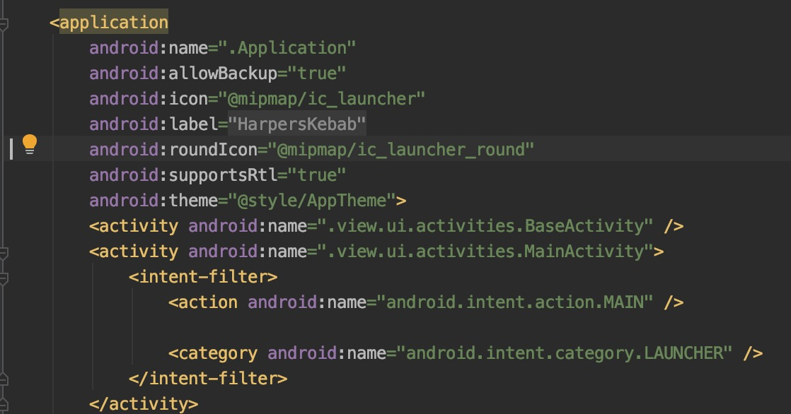

1. Create build apk select Generate Signed Bundle / APK

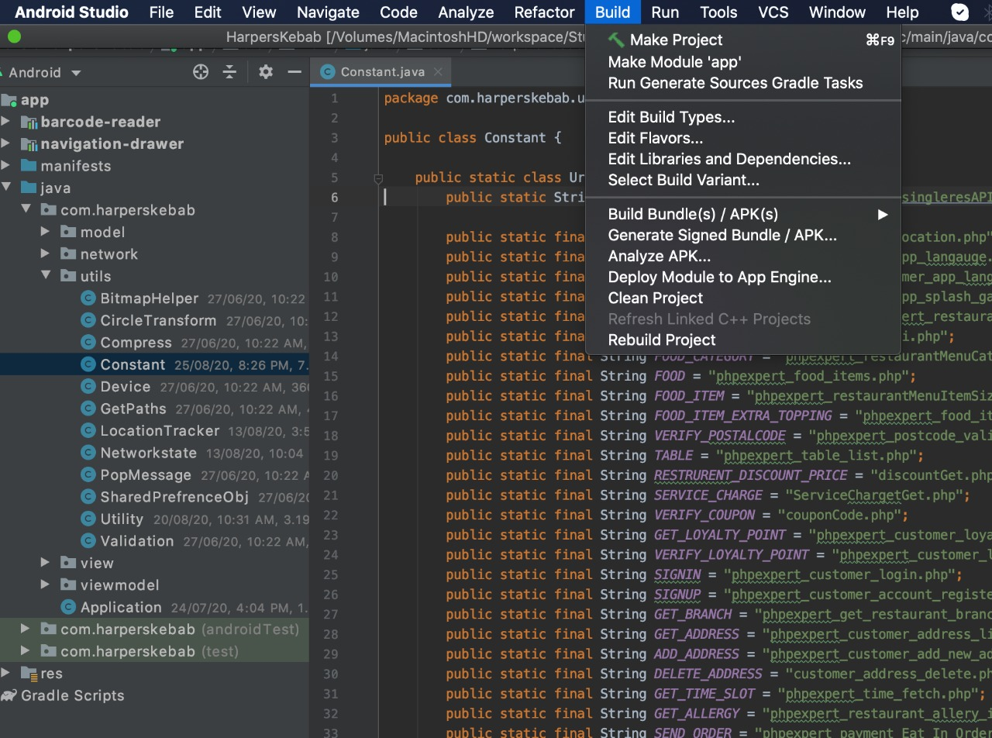

1. To change app icon edit icon and round Icon property



1. Add app icon in mipmap

