Initial Link: <http://localhost/custom_mvc/public/admin/login>

You can change custom_mvc folder name in config.php

Username:admin@gmail.com

Password:admin

**Login screen for Polling page:**

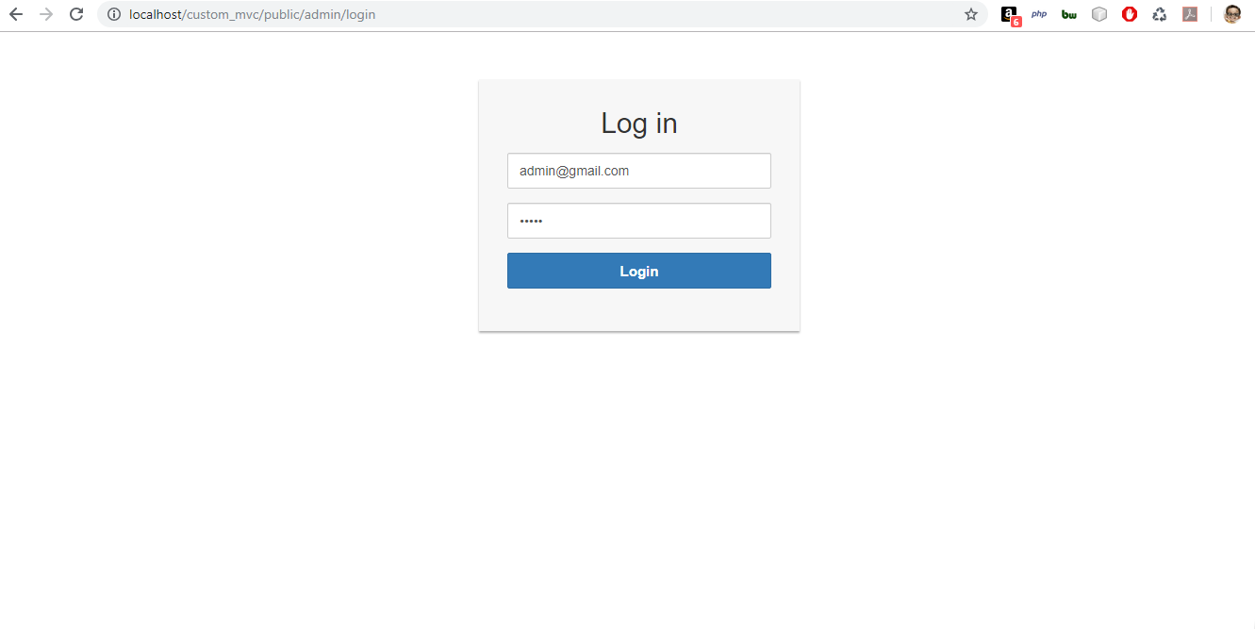

**Polling Page:**

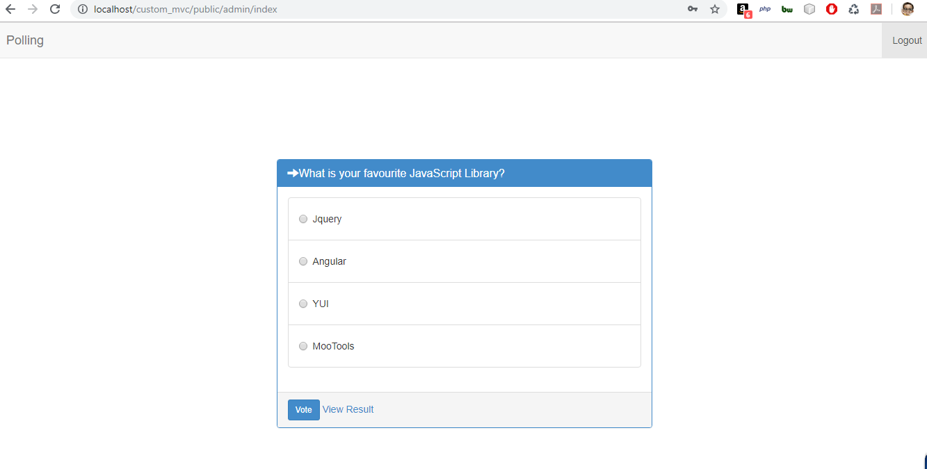

**View results page:**