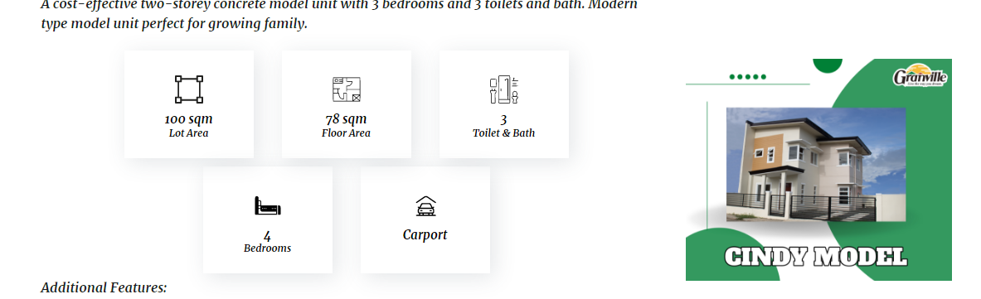

**Pag I click ang model house sir kay mugawas ang floor plan ug Map unta**

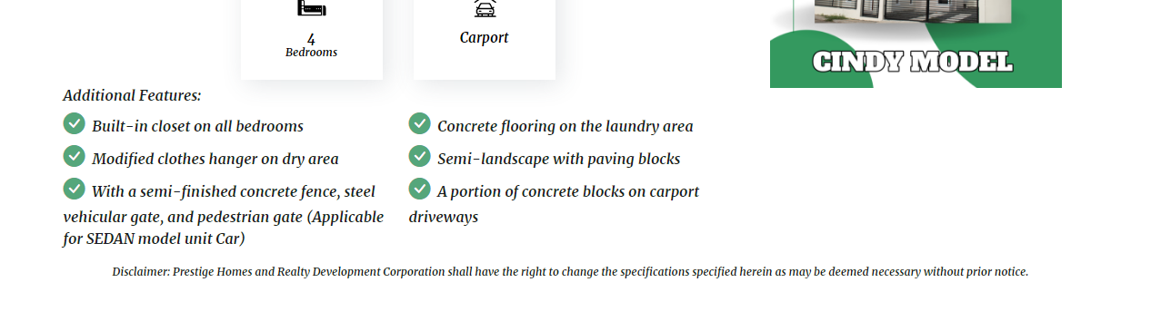

**Available units**

|  |  |  |  |
| --- | --- | --- | --- |
| **BLOCK** | **LOT** | **FLOOR AREA** | **TOTAL CONTRACT PRICE** |
|  |  |  | **5,000,000.00** |
|  |  |  |  |

Kanang ma click gud sya sir mugawas ang computation, na ma download siya Sir.