**Assignment:**

* Design and specify a small modeling language using MetaGME.
* Create a modeling environment in GME.

**Domain:**

For the purposes of this project a passive electrical circuit

consisting of simple passive electronic elements. Specifically passive elements do not generate power. Such a circuit consists of resistors, capacitors, inductors, some simple solid state elements and their assemblies. This modeling language will take as its target audience the ng-spice circuit simulator, <http://ngspice.sourceforge.net/>.

With ng-spice as the audience the modeling language will also allow for some active elements, namely voltage and current sources.

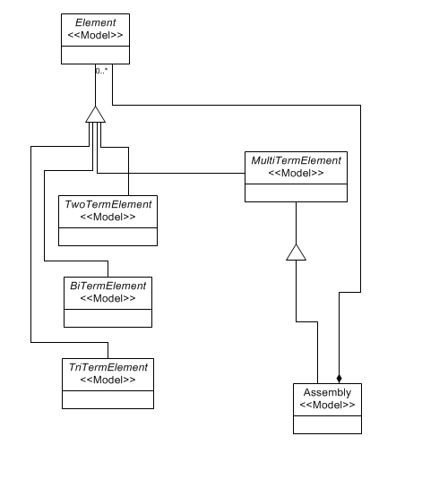

As this is primarily a learning exercise for GME I have made two extensions. The language includes a simple ng-spice resistor model.

These resistor models are then referenced by resistors as described in ng-spice.

The language also makes use of component assemblies.

Assemblies simply expose their terminals as ports.

For this reason element terminals are modeled using contained terminal elements

rather than connections.