Week 6 Robot Car Design Review
AAI05 | 2 October 2026
The robot uses a Pico W and Robo Pico to follow the line, decode barcodes and execute encoder-controlled manoeuvres. It also estimates hump height, avoids obstacles and publishes telemetry. Software uses C, the Pico C SDK, micro T-Kernel and BARR-C:2018. Timing and calibration values are unmeasured test targets. Validate the electrical assumptions before full integration.
GitHub repository: https://github.com/phrypy/AAI05-robot-car

1 Team ownership
Member | Subsystem responsibility
You Yan | Mission, line following, barcode and integration
Daniyal | Motor drive, encoders, ultrasonic scan and servo avoidance
Patrick | IMU calibration, hump detection and height estimation
Brian | WiFi, MQTT telemetry, commands and recovery

Integration may be shared.

2 Functional requirements and acceptance checks
ID | Required behaviour | Acceptance test
FR1 | Follow the 18 mm line using two analog IR sensors. | Complete the route; record line losses and recoveries.
FR2 | Decode the adjacent barcode; reject unknown / incomplete reads. | Test the supplied symbols across the speed range and confirm their commands.
FR3 | Execute left, right, straight and U-turn commands. | Measure distance, turn error and line reacquisition.
FR4 | Detect obstacles, run coarse/fine scans and estimate location, width, closest point and left/right clearance. Detour and regain the line. | Compare with known obstacle positions and widths; stop before contact and regain the line.
FR5 | Estimate hump height in mm and retain the highest valid height. | Test known-height humps. Record height error and invalid estimates. The estimator is unvalidated.
FR6 | Publish state, wheel speed/counts, IR status, barcode, hump height, obstacle profile and travelled distance over MQTT. Accept validated start, stop and configuration commands; exclude remote steering. | Check broker logs and commands; test disconnect/reconnect.
FR7 | Stop on explicit STOP, critical sensor fault, command expiry or recovery timeout. | Inject faults in each active mission state and measure stop response.

3 Nonfunctional requirements
ID | Target | Validation
NFR1 | Motion update 10 ms; line ADC 5 ms; IMU 20 ms. | Record jitter and missed deadlines under full load.
NFR2 | Apply a latched STOP within one 10 ms Motion cycle; detection adds latency. Motion expires targets after 100 ms. | Measure latency from STOP request to driver brake output.
NFR3 | Control operates without WiFi. Network waits are bounded. | Disconnect WiFi and stall the broker during navigation.
NFR4 | Forward ping interval while moving: 65–70 ms. During stopped scans: ≥65 ms between pings, after servo settling. ECHO timeout: 30 ms. Stop requested motion if forward-data age exceeds 150 ms. | Measure with a logic analyser; set settling time from the actual servo.
NFR5 | Critical-event queue or capture-buffer overflow latches a fault and stops motion. Routine telemetry may be dropped with a counter. Stale critical data or expired targets stop motion. | Stress queues and capture buffers, remove critical data and check the fault latch and drop counters.

STOP response measures the time from the request to the driver brake output. Physical stopping distance is a separate measurement. Test timing with sensing and WiFi running together.

Hardware inventory and test equipment
Equipment | Quantity or scope | Role in the design
Pico W and Robo Pico | Mounted controller and carrier | Controller, C SDK, RTOS, radio and motor drivers
Geared motors with encoders | Two mounted wheel assemblies | Independent left/right drive and distance feedback
IR reflective sensors | Three modules shown in supplied photos | Two analog line sensors and one digital barcode sensor
GY-511 and ultrasonic sensor | One each | Acceleration/magnetic field and ultrasonic range
Micro servo | One mounted servo | Ultrasonic scan actuator; mount the sensor before testing
USB power bank and cable | 5 V output confirmed; current rating pending | System power through Pico USB
Debug probe and cables | Development equipment | Programming and debugging through dedicated SWD
Chassis, wheels and caster | Two rubber wheels and one all-direction caster | Mechanical support and differential-drive movement
Mounting parts, cables and tools | Plates, screws, nuts, spacers, screwdriver and nozzle spanner | Assembly and wiring; no signal GPIOs
Combo tiles | Two sets | Track assembly and repeatable tests

The line is 18 mm wide, with a 20 mm gap to the barcode. Barcode length is approximately 141 mm; its nearest edge is 29 mm from the line centre. Place the third IR sensor within the stripe region. Check stripe width, side, mounting height and speed on the track. The A/Z sample does not define the full command alphabet, so keep the mapping configurable.
Confirm the letter-to-action mapping before command acceptance tests.

4 Hardware integration schematic
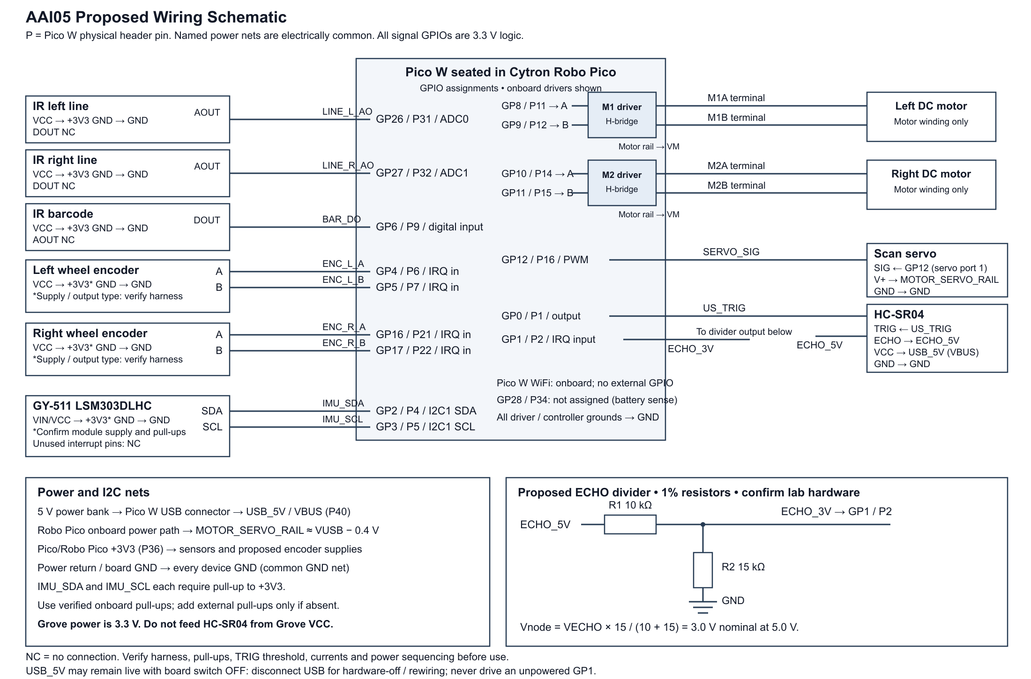
Figure 1 Component wiring. Matching net labels identify electrically common connections. P indicates a physical Pico header pin. The connection table lists assembly locations; the debug drawing shows development connections.

4.1 Connection locations and pin justification
Connect external signals through the labelled Robo Pico GPIO breakout. Grove ports with the same GPIO share one electrical connection. Do not connect a second device to those shared signals.
Component signal | GPIO and physical pin | Connection location | Pin choice and owner
Left motor driver A / B | GP8 P11 / GP9 P12 | Internal driver; motor to M1A/M1B terminals | Fixed Robo Pico wiring; PWM slice 4. Motion control.
Right motor driver A / B | GP10 P14 / GP11 P15 | Internal driver; motor to M2A/M2B terminals | Fixed wiring; PWM slice 5. Motion control.
Left encoder A / B | GP4 P6 / GP5 P7 | GP4/GP5 breakout; same nets as Grove 3 | Two digital edge inputs for quadrature; Encoder ISR / Motion.
Right encoder A / B | GP16 P21 / GP17 P22 | GP16/GP17 breakout; same nets as Grove 4 | Independent quadrature inputs; Encoder ISR / Motion.
Left IR AO | GP26 P31 / ADC0 | GP26 breakout; same net on Grove 5 and 6 | Analog reflectance for steering. Line and barcode.
Right IR AO | GP27 P32 / ADC1 | GP27 breakout; same net as Grove 6 | Second independent analog sample. Line and barcode.
Barcode IR DO | GP6 P9 | GP6 breakout; same net as Grove 5 | Digital comparator edge capture. Barcode ISR / Line and barcode.
GY-511 SDA / SCL | GP2 P4 / GP3 P5 | GP2/GP3 breakout; also Grove 2 / Maker | I2C1 pair; sole bus owner is IMU and hump.
HC-SR04 TRIG / ECHO | GP0 P1 / GP1 P2 | GP0/GP1 breakout; also Grove 1 | TRIG output and conditioned ECHO edge input. Obstacle and servo.
Servo SIG | GP12 P16 | Robo Pico servo port 1 | PWM slice 6, separate from motor PWM. Obstacle and servo.
Sensor supply and return | 3V3 P36 / GND P38 | Labelled 3V3 and GND breakout | Common return and planned 3.3 V sensor supply. Confirm GY-511 terminal and encoder compatibility.
Ultrasonic supply | VBUS P40 / GND | VBUS breakout and common ground | USB 5 V net; use the reviewed lab interface shown in Figure 1.
WiFi radio | Onboard; no external GPIO | Pico W internal radio connection | WiFi and MQTT task; no external pin assignment.
Debug probe SC / SD / GND | SWCLK / SWDIO / GND | Dedicated Pico W SWD connector | Debug/programming interface; no extra signal GPIO.

Leave line-sensor DO, barcode-sensor AO and GY-511 interrupt pins disconnected. GP28 is unassigned because the battery-sense jumper may connect it to a voltage divider. GP18, GP20, GP21 and GP22 serve onboard functions outside this design. Keep the Pico W pins reserved for WiFi free.
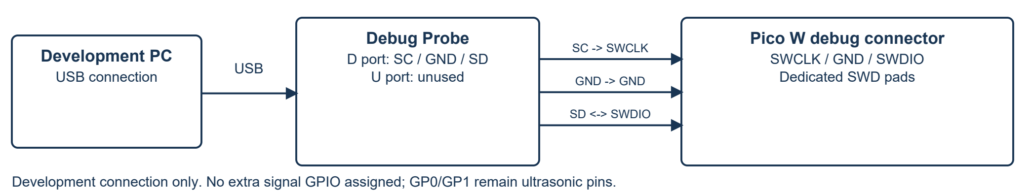
Figure 2 Debug probe connection. Probe UART is unused. GP0/GP1 are assigned to ultrasonic TRIG/ECHO.
Encoder A/B and supply labels identify functions; connector orientation still needs checking. Record the GY-511's printed supply label. Do not confuse its power input with a regulator output.
Motor inputs A/B select 00 brake, 10 forward, 01 reverse and 11 coast. Wheel direction depends on motor polarity. Only Motion writes motor outputs; only the Obstacle and Servo task writes servo PWM. Motors use PWM slices 4 and 5, while GP12 uses slice 6. Grove 2 and Maker share GP2/GP3; GP26 on Grove 5/6 is one signal. GP28 is unassigned.
Unplug the USB power bank before rewiring. Raw VBUS may remain live with the board switch off; check that ECHO cannot drive an unpowered GP1. Before applying power, check the encoder harness and output levels, GY-511 supply and pull-ups, TRIG threshold, ECHO divider and load current, including motor stall and servo startup. Board limits are 1 A continuous per motor channel, 1.5 A peak for <5 s, motor PWM ≤20 kHz and total Grove +3V3 current ≤300 mA. The divider and USB-derived rail values are design values, not measurements.

5 RTOS tasks and ownership
Task / handler | Trigger | Priority order* | Ownership and data path
Encoder / barcode / ECHO ISR | GPIO edge | Interrupt | Encoder ISR updates counts; barcode ISR records edge/time/count snapshots; ECHO ISR records pulse timestamps. Capture is bounded. Overflow latches a fault.
Motion control | 10 ms + stop wakeup | 1 highest | Sole GP8-GP11 writer. Reads counts and timestamped targets, checks STOP and 100 ms expiry, and publishes speed, distance and standstill status.
Mission supervisor | 20 ms / event | 2 | Controls mission state; sends wheel targets, watchdog updates and scan requests.
Line and barcode | 5 ms ADC / edges | 3 | Reads GP26/27 ADC, GP6 captures and encoder distance. Sends latest steering to Mission and symbol/fault events to the queue.
Obstacle and servo | 65–70 ms forward / scan | 4 | Uses GP0 for TRIG, GP1 for ECHO capture and GP12 for servo control. Waits for servo settling, then runs coarse/fine scans to produce a profile.
IMU and hump | 20 ms | 5 | Sole I2C1 owner. Uses calibrated acceleration and encoder distance to estimate height, peak and validity.
WiFi and MQTT | 100 ms / event | 6 lowest | Owns the network stack. Publishes copied status and validates commands.

*The order ranks task urgency; it does not specify micro T-Kernel priority numbers. Confirm the port’s priority rules before assigning them. Motion has the highest task priority to meet output deadlines. Mission follows, then the short sensor tasks. Network work runs last and uses bounded waits. Check execution time and jitter under load. Interrupt priority is separate.

6 Task interactions and resource rules
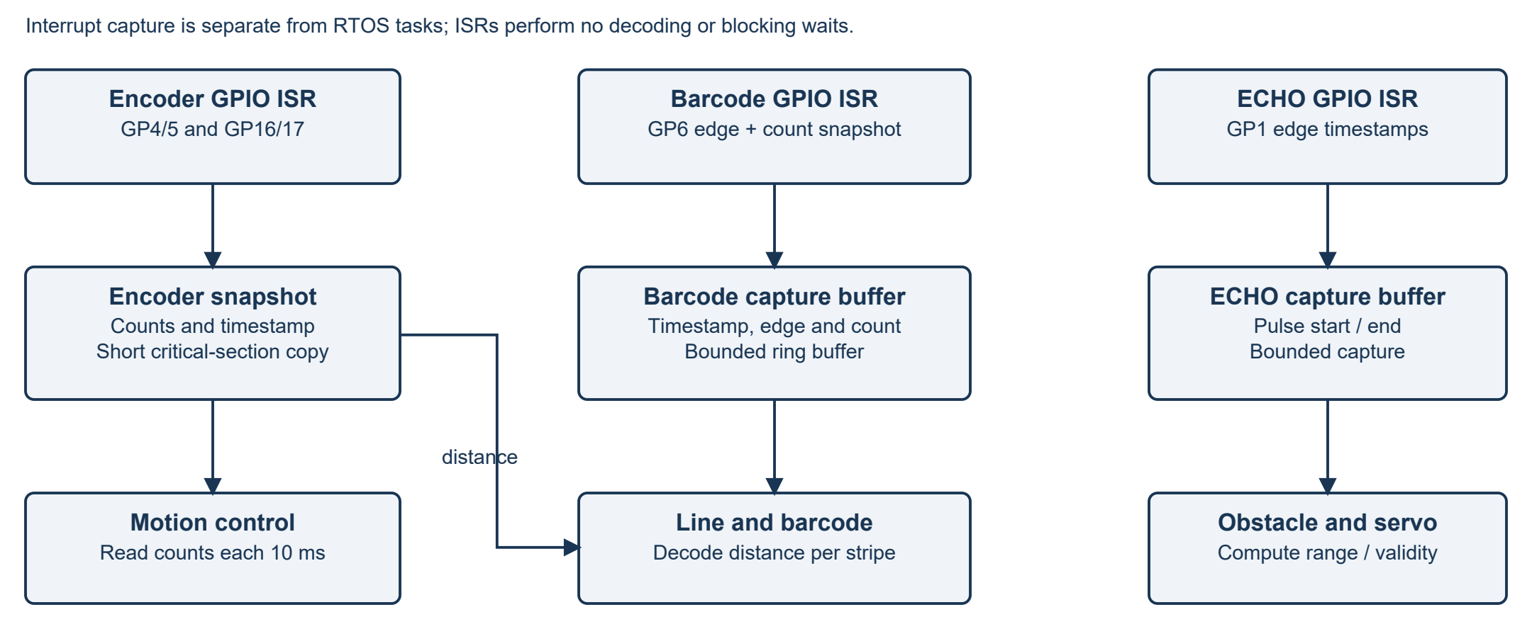
Figure 3 Interrupt capture paths. Each barcode edge records an encoder-count snapshot. The Line and Barcode task converts count differences to stripe distance. Figure 4 shows the distance snapshots used by the IMU estimator.

6.1 Control and communication paths
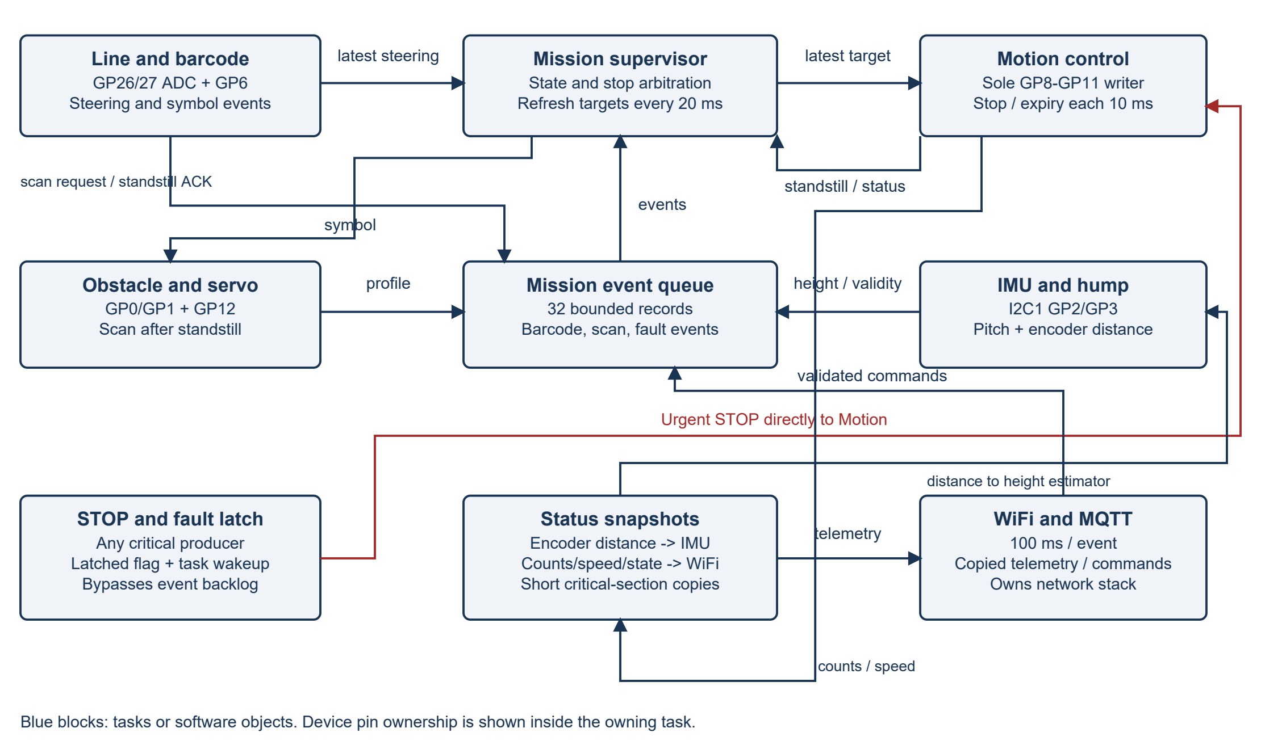
Figure 4 Task and object interactions. Steering and target slots hold the latest record; new values replace old ones. The event queue holds discrete events. Encoder snapshots feed barcode decoding and hump estimation. Telemetry uses copied status.
An encoder snapshot holds left/right counts and a timestamp. Copy it atomically in a short critical section. At each GP6 edge, the barcode ISR records the counts to tie stripe width to travel distance. IMU and Hump reads timestamped distance increments for height estimation. Motion publishes speed, distance and standstill status for Mission and telemetry.
Software object | Rule
Critical event queue | 32 fixed-size records containing source, type, timestamp and payload. Producers do not block. A full queue latches STOP. Telemetry uses a separate copied snapshot.
Steering and target slots | Hold one latest-value record each, protected by short critical sections. Targets carry a timestamp and 100 ms expiry. Mission refreshes them every 20 ms during motion.
STOP flag and wakeup | A latched fault/STOP flag bypasses the queue. Wake Motion with a primitive safe for the calling ISR or task. Motion checks the flag each cycle.
Capture buffers | Barcode/ECHO records are bounded; overflow is a critical fault. ISRs only capture data and update counts/status.
Shared resources | IMU owns I2C1; WiFi owns the network stack; Motion owns motor PWM; Obstacle owns servo PWM. A bus with one task owner needs no mutex.

Use the micro T-Kernel objects supported by the selected port. Check ISR-safe APIs, wakeup behaviour and numeric priority rules before implementation. Never wait for I2C, ECHO, servo settling or networking inside a critical section.
An obstacle requests a temporary brake through Mission. Scan starts only after Motion acknowledges measured standstill within the timeout. Keep the servo forward while moving. Run coarse/fine scans while braked, then settle the servo forward and obtain a fresh valid range before resuming. A successful detour needs no fault reset. Explicit STOP and critical faults stay latched.
Calculate the stop threshold from maximum speed, worst-case sensing and output latency, measured braking distance and clearance margin. It must remain within reliable sonar range. The current policy treats no echo as invalid; test weak returns and open space. Check barcode distance resolution at the narrowest stripe and highest speed.

7 System and subsystem statecharts
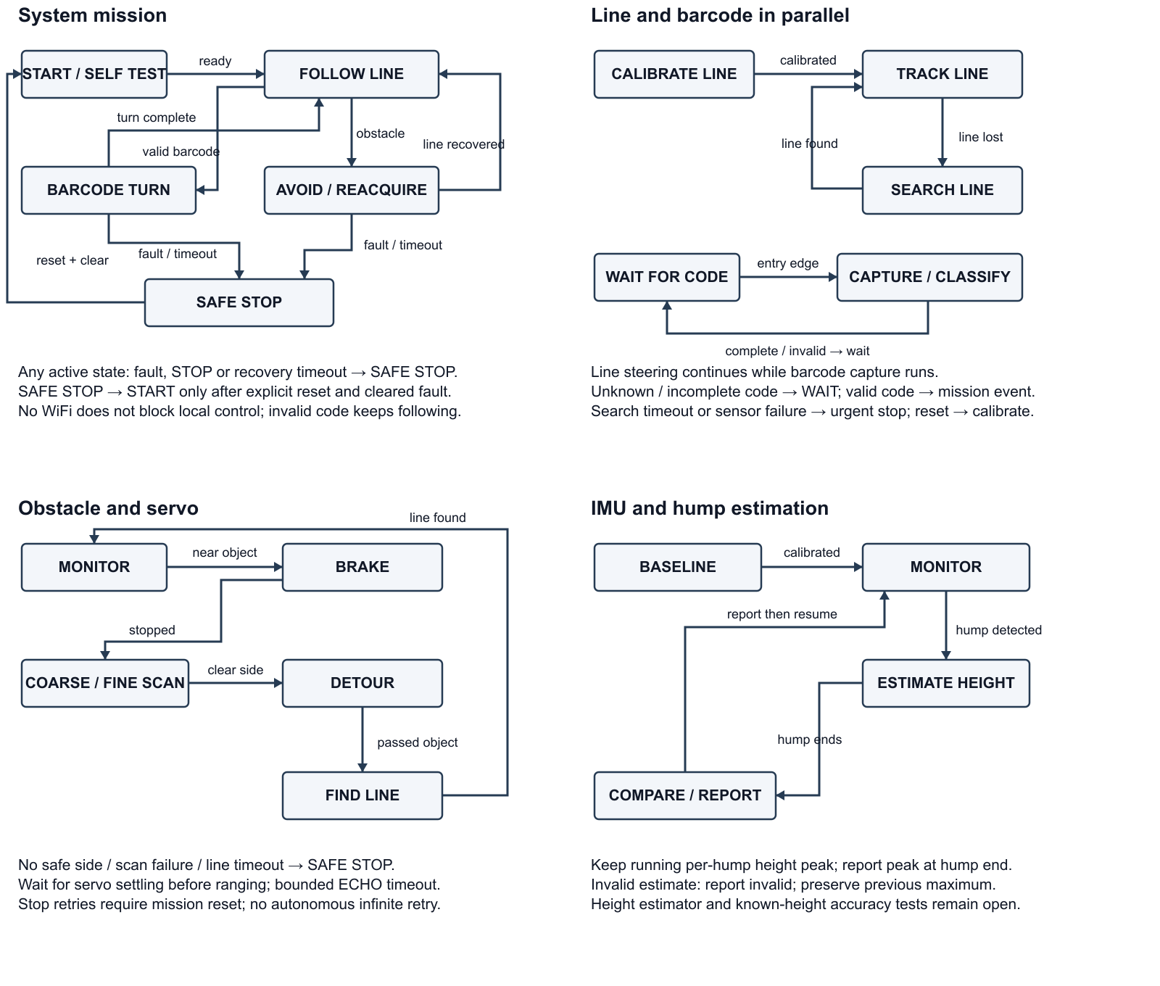
Figure 5 System and three subsystem statecharts. Line tracking continues during barcode capture. STOP and faults override movement.
Transitions use events or bounded conditions. Mission maintains steering during barcode capture and handles STOP/faults before turns or detours. Encoder manoeuvres finish when their targets and recovery conditions are met. Stale sensor data or a turn/search timeout latches SAFE STOP. Reset requires fault clearance and a new self-test.

7.1 Subsystem purpose and task mapping
Subsystem | Related tasks | Statechart purpose
Line and barcode | Line and barcode; Mission; barcode ISR | Keep tracking during barcode capture. States define calibration, search, capture completion, invalid-code rejection and recovery.
Obstacle and servo | Obstacle and servo; Mission; Motion; ECHO ISR | Sequence brake, standstill, coarse/fine scan, detour and line reacquisition. Scan begins only after movement stops.
IMU and hump | IMU and hump; encoder snapshot producer | Track baseline, hump entry/exit, height peak and reporting. Reject invalid estimates when updating the maximum.

Line and barcode: calibrate, then track. Line loss starts a search with a timeout. A valid barcode sends an event to Mission while tracking continues; unknown or incomplete codes are rejected. Search timeout or critical failure latches STOP.
Obstacle and servo: request brake when an obstacle is near. At standstill, scan from settled servo positions. A clear side permits a detour and line search, each with a timeout. No safe side, capture failure or recovery timeout latches STOP. A successful detour needs no fault reset.
The GY-511 measures acceleration and magnetic field. It has no gyroscope. Estimate height from gravity-referenced pitch and encoder path increments: Δh ≈ Δs sin θ. Calibrate the mounting frame and ground baseline, and use a speed range where dynamic acceleration is controlled. Accumulate h[k] = h[k−1] + Δs sin θ. Keep the running peak for each hump and report it at hump end; the integral after descent may be near zero. Update the global maximum only from valid peaks. This method assumes chassis pitch follows the direction of travel. Wheelbase and contact geometry can break that assumption on short humps, while slip, dynamic acceleration and tilt error can bias the result. Compare the reported reference point with known-height humps to establish accuracy. Until validation passes, mark height estimates invalid.
Before an autonomous run, measure and set scan angles, servo limits and settling time, obstacle and freshness thresholds, line/turn timeouts, clearance margin and height-error tolerance. These settings and the hardware still need validation.

8 Assumptions and planned validation
ID / owner | Assumption and risk | Validation / status
A1 / Daniyal | M1 is left, M2 right; encoder supply and A/B outputs are 3.3 V compatible. Wrong harness/direction can damage inputs or reverse control. | Inspect harness/module; low-speed polarity/count test. Open.
A2 / You Yan | Two AO sensors can track while side DO sensor reads all required symbols. Wrong spacing/mapping causes losses or incorrect turns. | Printed track, black/white calibration, speed/stripe test and mapping confirmation. Open.
A3 / Patrick | GY-511 supply/pull-ups and the pitch/encoder estimator are suitable. Dynamic acceleration or slip may bias height. | Inspect module, log baseline/dynamics; compare known-height ramps; set tolerance. Open.
A4 / Brian | The power bank can supply the load, and WiFi/MQTT recovery does not block control. Brownout or blocked updates may stop control. | Calculate the load budget and measure rail voltage/current under combined load. Stress-test broker outages. Open.
A5 / Daniyal | HC-SR04 TRIG accepts 3.3 V and ECHO divider yields safe timing levels. Wrong levels or stale scan can damage GPIO or misroute car. | Inspect lab circuit; scope TRIG/ECHO, >60 ms spacing and switch-off back-power. Disconnect USB for hardware-off; prevent ECHO driving an unpowered GP1. Open.
A6 / Team | The pin map and debug connector locations match the installed boards. Shared nets may cause conflicts. | Check board labels, GP28 sense jumper and SWD connector; compare final harness map with Figure 1 and Section 4.1. Open.

9 AI design evidence

9.1 Member AI discussions
Member | Discussion and status | Useful idea and limitation | Decision or follow-up
You Yan | Asked AI to explain the robot project and suggest a pin map. Also asked it to compare the report with the Week 6 template and address the issues found. | Useful: fixed motor pins, one writer per actuator and explicit data paths. Limitation: a pin map cannot verify harness order, barcode meanings or height accuracy. | Keep the fixed motor pins and sensor data paths, with one task owner per actuator. Check harness order, barcode mapping and height accuracy during integration.
Daniyal | Asked Gemini how the components work together to understand the project. | Useful: clarified how the components interact. Limitation: practical understanding still requires assembling and observing the hardware. | Used this understanding to contribute to schematic and wiring choices.
Patrick | tbc | tbc | tbc
Brian | Asked AI to review WiFi and MQTT telemetry, command handling and connection recovery for the robot. | Useful: prevent network delays from blocking local control and validate incoming commands. Limitation: connection recovery and timing still require hardware testing. | Use copied status for telemetry and pass validated commands to Mission. Test WiFi disconnection and broker outages while the car runs.

9.2 Team architecture decisions
Idea | Team decision | Engineering reason | Affected artefacts
Use Robo Pico onboard drivers; M1 left / M2 right | Accepted | Use the onboard drivers and fixed GPIOs. Keep M1 left and M2 right throughout the design. Check motor polarity and encoder direction during initial tests. | FR3, schematic, task table, A1
Two analog line sensors and side digital barcode sensor | Accepted with validation | Two analog sensors correct line position; the separate digital sensor captures barcodes while tracking continues. Test mounting, black/white calibration and capture across the speed range. | FR1/2, pin map, A2
Single motor and servo task owners | Accepted | Motion Control alone writes the motor outputs; the Obstacle and Servo task alone writes the servo output. Other tasks send requests. This avoids conflicting commands and gives each actuator one output owner for stop testing. | Sections 5/6 and statecharts
Telemetry queue overload always stops movement | Modified | Drop routine telemetry and count losses when communication is congested. Critical-event queue or capture-buffer overflow stops motion: control information may have been lost. | NFR5 and resource rules
Add debug SWD and missing distance/capture paths | Accepted | Include SWD debugging and show how encoder snapshots feed barcode decoding, height estimation and telemetry. These paths connect the wiring diagram to the software dependencies. | Figures 2-4 and Section 4.1
Use pitch and encoder distance to estimate hump height | Accepted with validation | Use this initial method with the available sensors. Test known-height humps, accounting for chassis geometry, slip and acceleration. Set the error tolerance before testing. Revise and document the estimator if it fails. | FR5, height statechart, A3

9.3 AI review findings
Review request: Compare the report with the Week 6 template. Check the schematic, pin mapping, nonfunctional requirements, component coverage and agreement between the diagrams and tables.
Gap found | Response | Action and evidence
Critical and routine queue handling inconsistent | Fixed | NFR5 and Section 6 now distinguish critical events/capture from droppable telemetry.
Debug probe omitted from wiring | Fixed | Dedicated SWD drawing and pin-map entry added; probe UART unused.
Assembly connector locations unclear | Partially fixed | Breakout, servo and terminal locations are listed. Encoder harness order and GY-511 supply label still need the A1/A3 checks.
Encoder distance and capture paths absent | Fixed | Figures 3/4 and task table show barcode count capture, IMU distance and telemetry snapshots.
Subsystem metadata omitted | Fixed | Section 7.1 lists tasks, purpose and state/fault behaviour.
Barcode mapping and height accuracy unconfirmed | Needs validation | The barcode-to-action mapping is unconfirmed. A2 and A3 specify checks for barcode operation and height accuracy.

10 Requirement traceability
FR ID | Task and hardware path | Statechart or requirement link
FR1 / FR2 | Line and barcode -> GP26/27/6 + encoder-distance snapshots | Track/search and barcode capture; NFR1/5
FR3 | Mission -> latest target -> Motion -> GP8-GP11; encoder feedback | Barcode turn and line reacquisition; NFR2
FR4 | Obstacle -> GP0/1/12; profile to Mission; Motion standstill ACK | Brake, scan, detour and find line; NFR4
FR5 | IMU and hump -> I2C1 GP2/3 + encoder distance | Baseline, height estimate and peak report; NFR1
FR6 | WiFi and MQTT -> copied status / validated events; onboard radio | Local control survives network loss; NFR3
FR7 | Critical producers -> STOP latch + wakeup -> Motion brake | SAFE STOP; reset after cleared fault; NFR2/5

