The monitoring server needs an updated package:

wget --no-check-certificate https://psuma.geeko.land/pub/golang-github-prometheus-prometheus-2.11.1-4.1.x86_64.rpm

To gather data about the SUMA server:

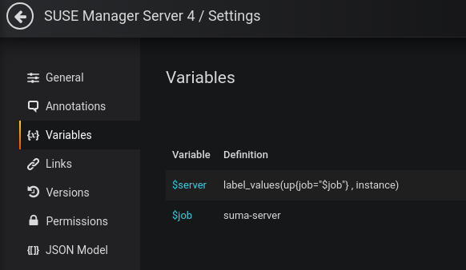

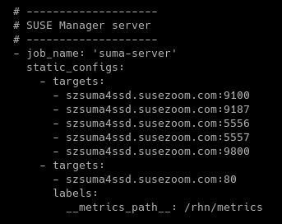

The “job_name” from /etc/prometheus/prometheus.yml is used for the Variable $job

To collect the clients registered to SUMA:

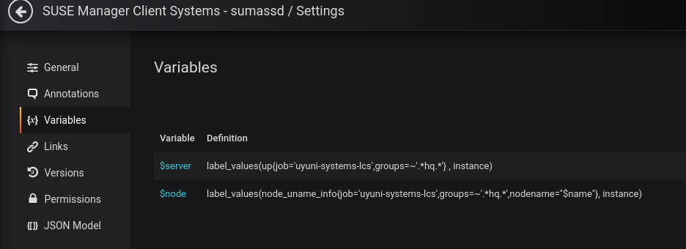

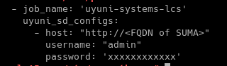

Here the “job_name” is used in the $server and $node Variables

1) Missing setting in rhn.conf, which is required to have SUSE Manager exposing taskomatic internals in port 9800.  
- Can be solved by adding `prometheus_monitoring_enabled = true` to /etc/rhn/rhn.conf  
  
2) Missing JMX metrics. In the end, restart the spacewalk services.

/etc/rhn/taskomatic add the following (no line breaks):

JAVA_OPTS="-Dcom.sun.management.jmxremote.port=3334 -Dcom.sun.management.jmxremote.ssl=false -Dcom.sun.management.jmxremote.authenticate=false"  
   
/etc/sysconfig/tomcat append the following (no line breaks):

-Dcom.sun.management.jmxremote.port=3333 -Dcom.sun.management.jm  
xremote.ssl=false -Dcom.sun.management.jmxremote.authenticate=false

The changes are the same except for the port number. Taskomatic on port 3334, Tomcat on port 3333

To fix the Taskomatic export:

/etc/rhn/rhn.conf add the following

# Added to enable exposing Taskomatic internals on port 9800, per Joao Cavalheiro   
prometheus_monitoring_enabled = true

