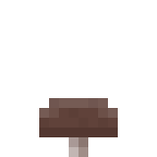



pilzmod
~manual~

pilzmod is a minetest mod that adds a spreading spawnable mushroom biome into the game, overgrown with myzelium and filled with giant versions of the mushroom we all know from minetest game, their smaller cousins, and eight new types of small mushroom, as well as monsters and a boss.

As opposed to „normal“ minetest biomes, mushroom biomes don‘t generate naturally into the world. Instead, you must craft a myzelium block, place it, and watch the mushroom biome slowly spread from it, gradually consuming the world and turning it into a mushroom hell. The only way of stopping it is to find a mushroom boss – a entity you probably won‘t find until the biome reached considerable size – and get the antidote from it, which you can use to seal off the mushroom biome and stop it from spreading further.

Killing the boss also drops a pretty trophy – so will you risk the consumption of your world for the honor of a worthy adventurer, or will you refrain from spawning the biome like a coward?

Some screenshots of the mod:

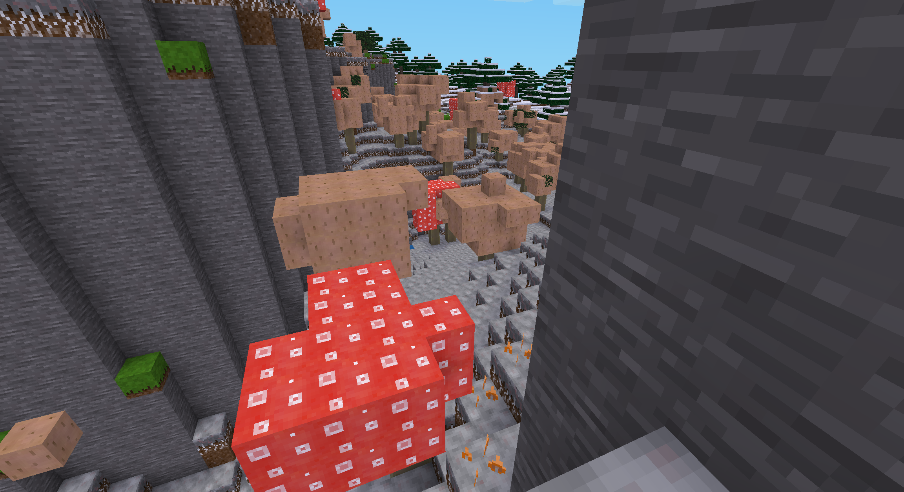
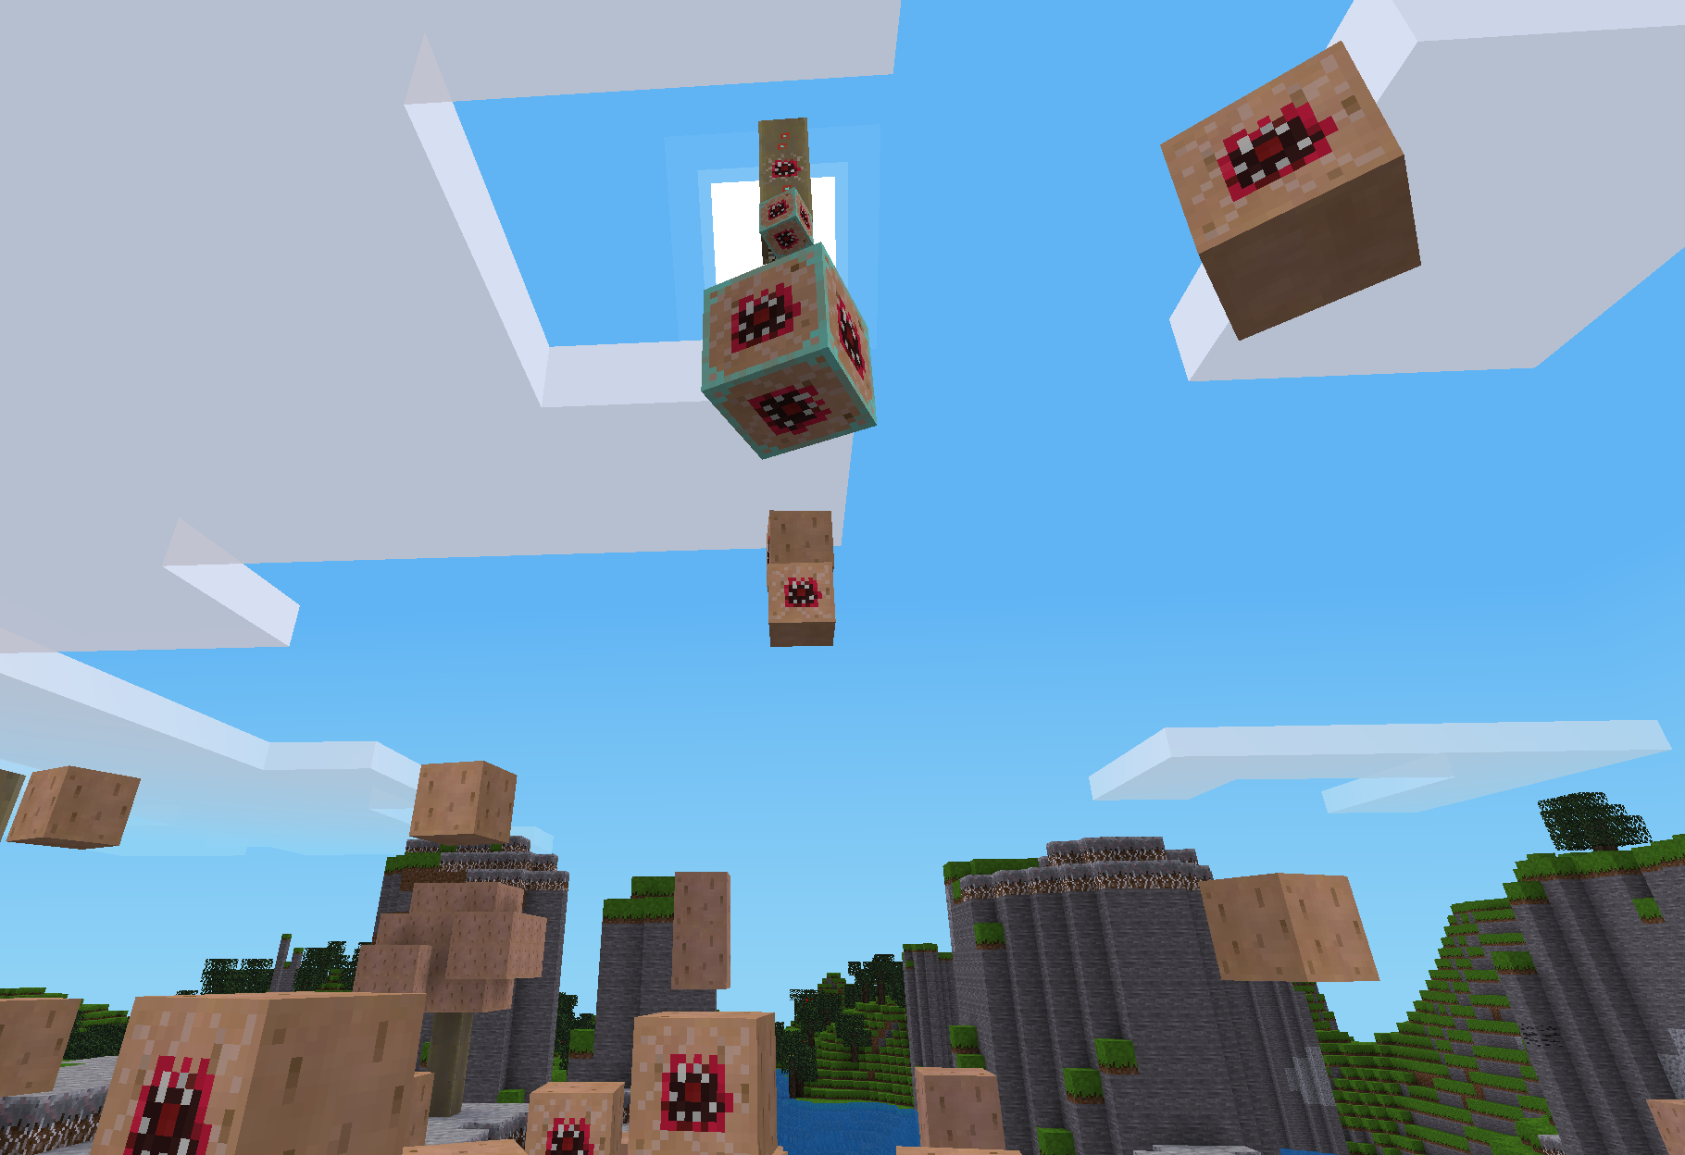
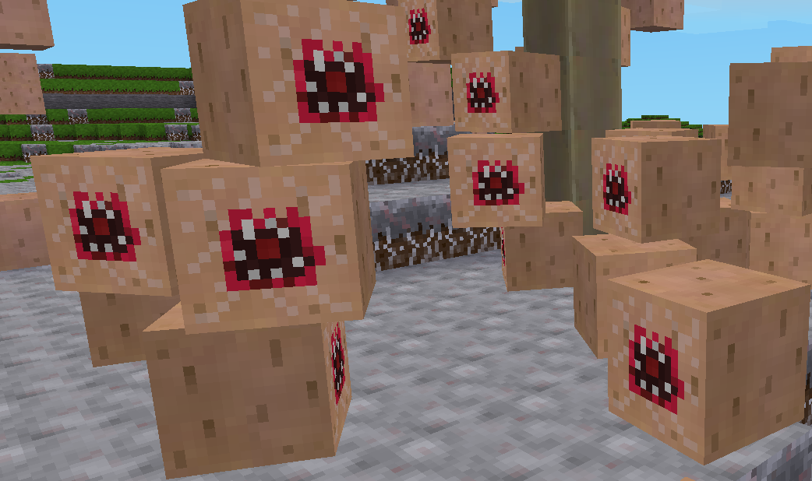

Spawning the mushroom biome

The mushroom biome can only grow in darkness, and can‘t grow on snowy dirt or dirt with dry grass blocks.
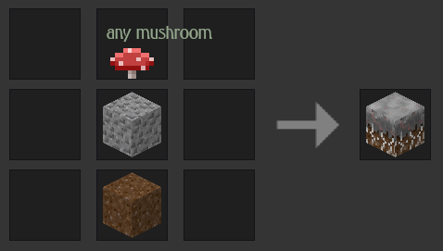
You can spawn the mushroom biome by crafting a myzelium-covered dirt block from any type of (small) mushroom, gravel, as well as dirt. Once you place this block into the world, the myzelium will slowly start to spread to other grass-covered blocks, turning them into myzelium-covered dirt too. Trees will turn into giant brown mushrooms, grass will turn into small red and brown mushrooms, pre-existing (naturally generated) mushrooms will grow into big ones (some of them even covered in smaller ones!), and flowers will turn into pretty small mushrooms of corresponding colors.

This is how some regular landscapes look before and after transformation:

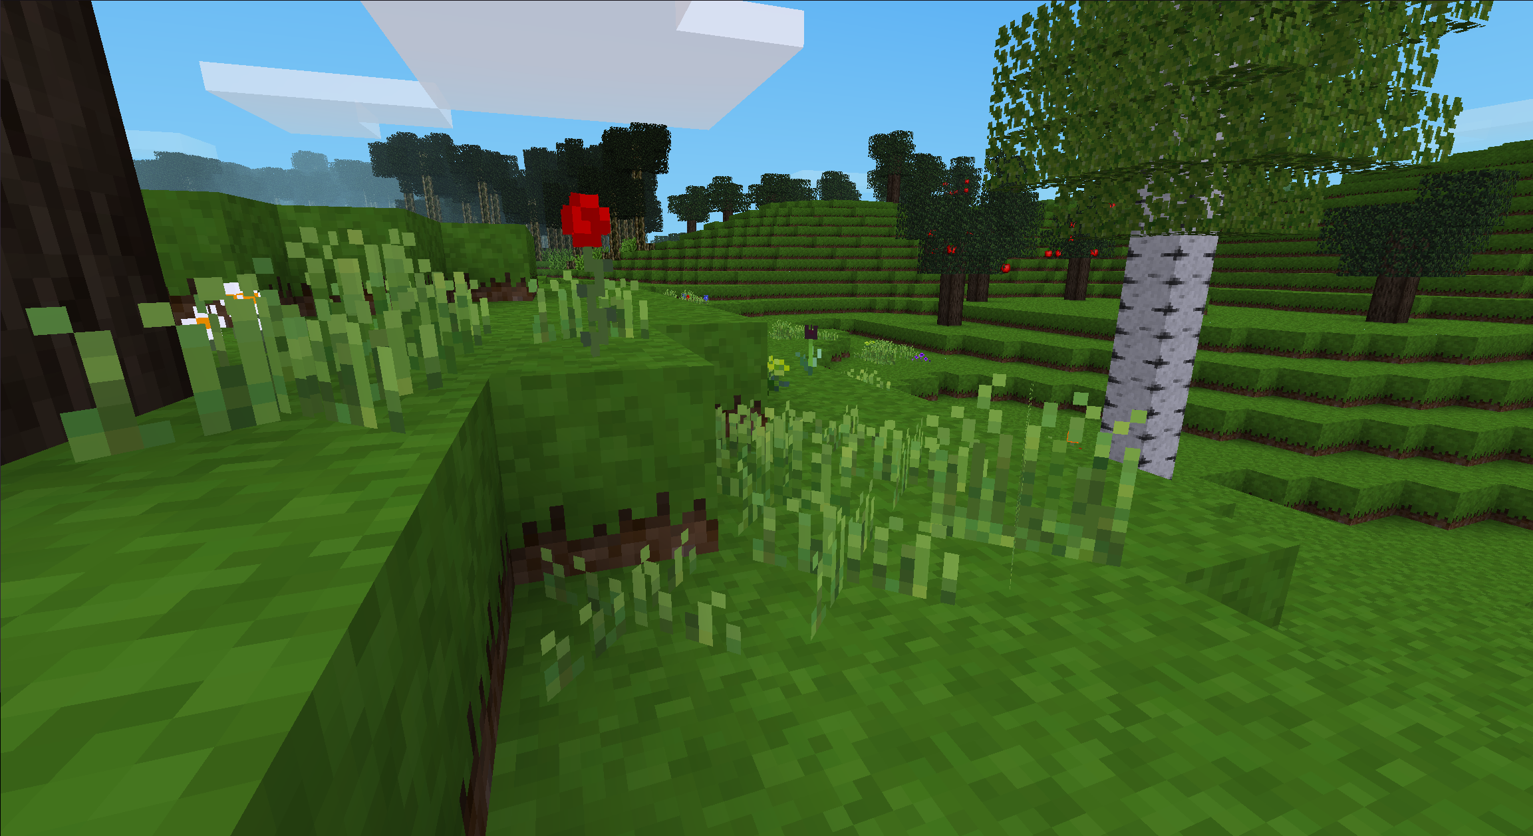

Here are the mushrooms that flowers will turn into, and the colors they become – and they also have delightful silly names that you‘ll find out when playing the game :3
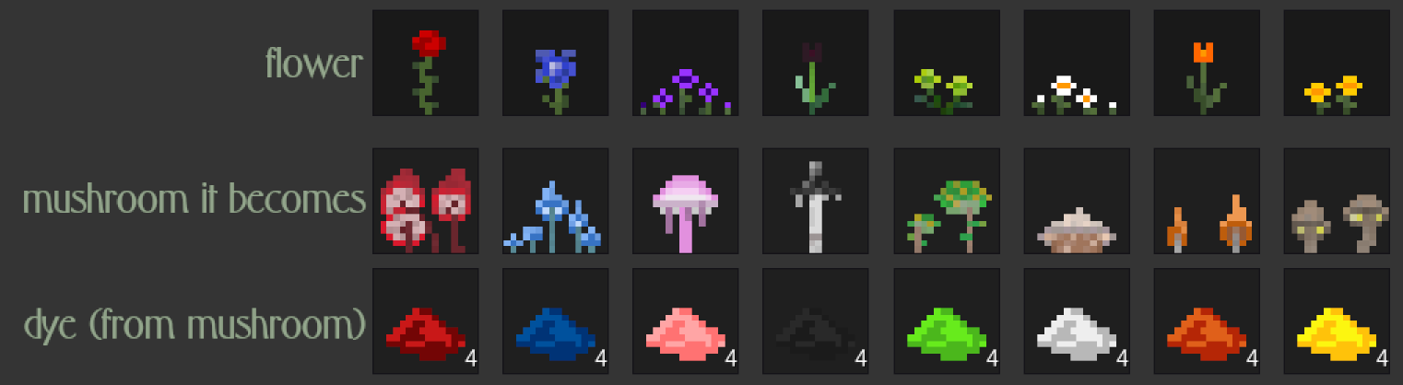
And here‘s some extra images of some pretty mushroom landscapes:
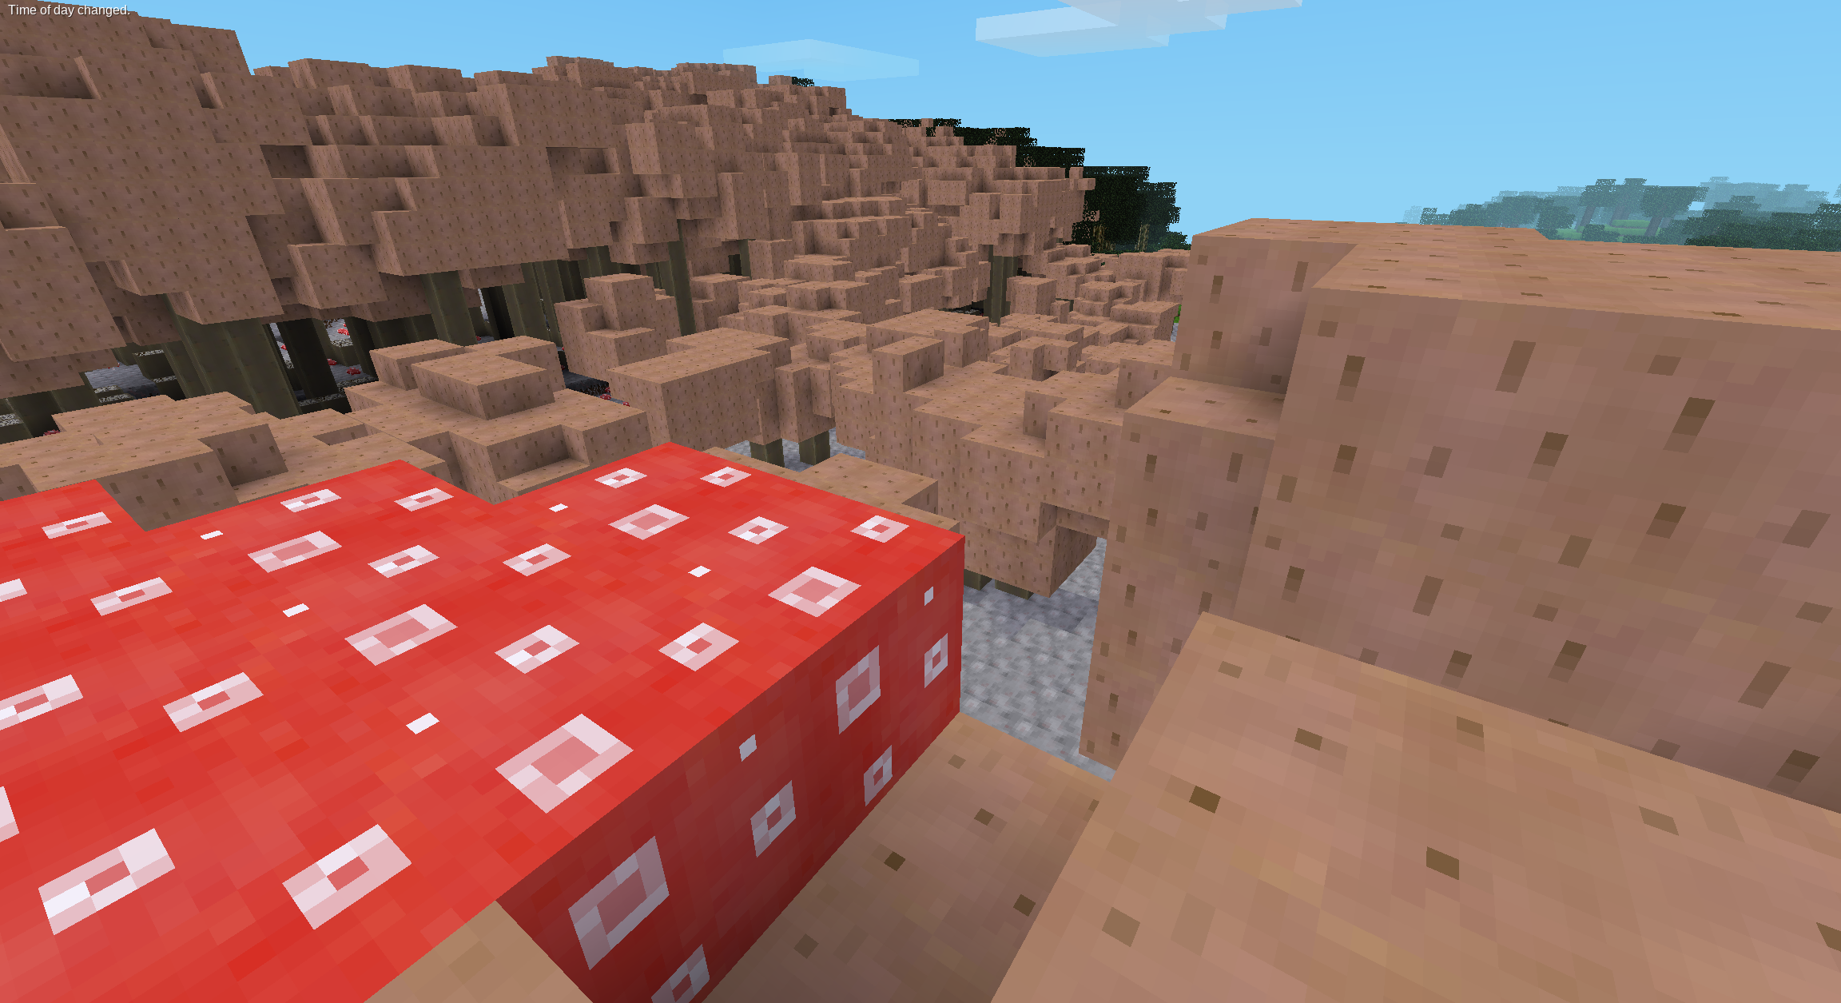
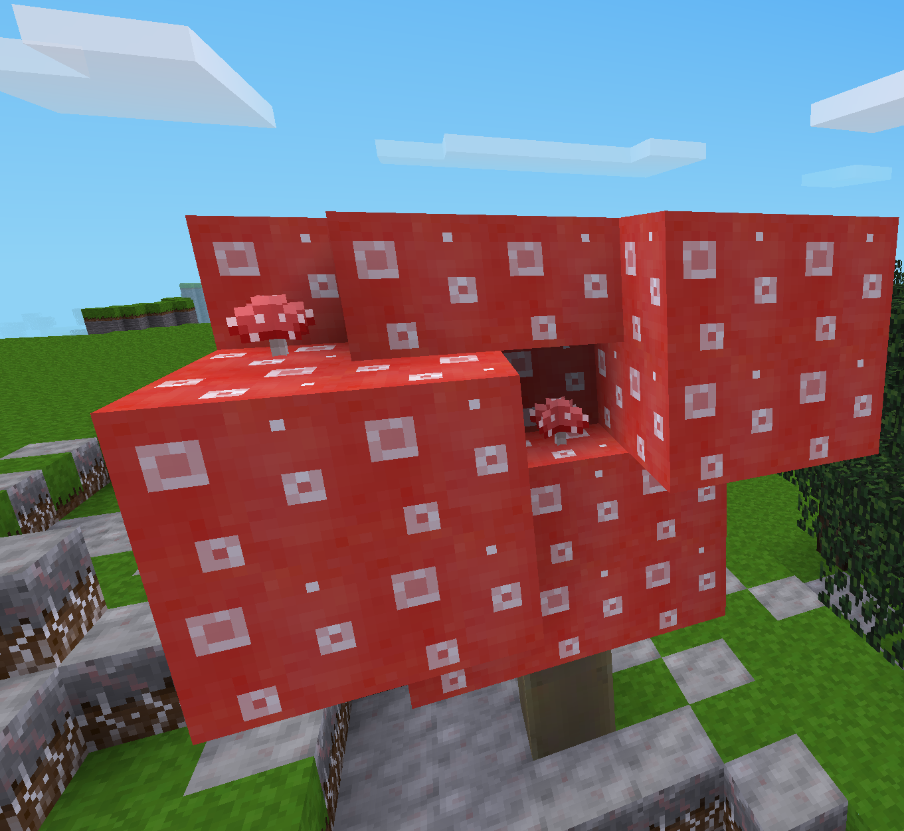
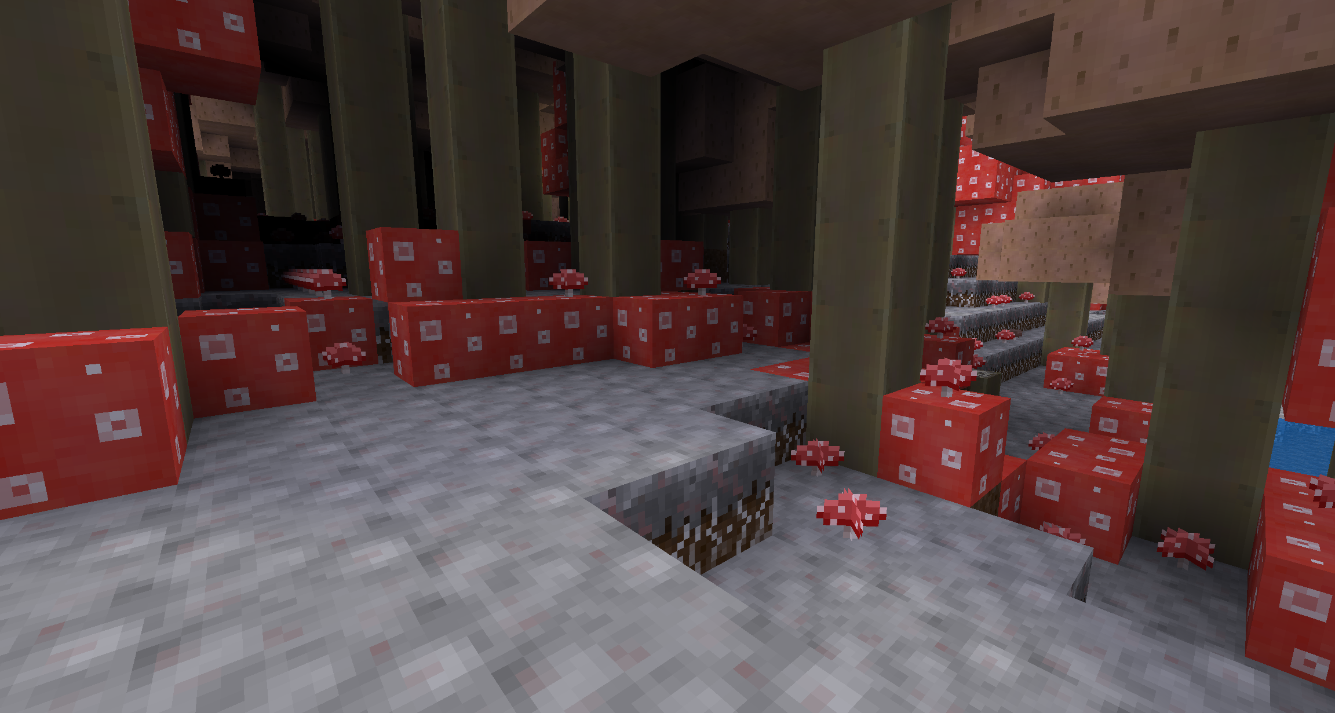
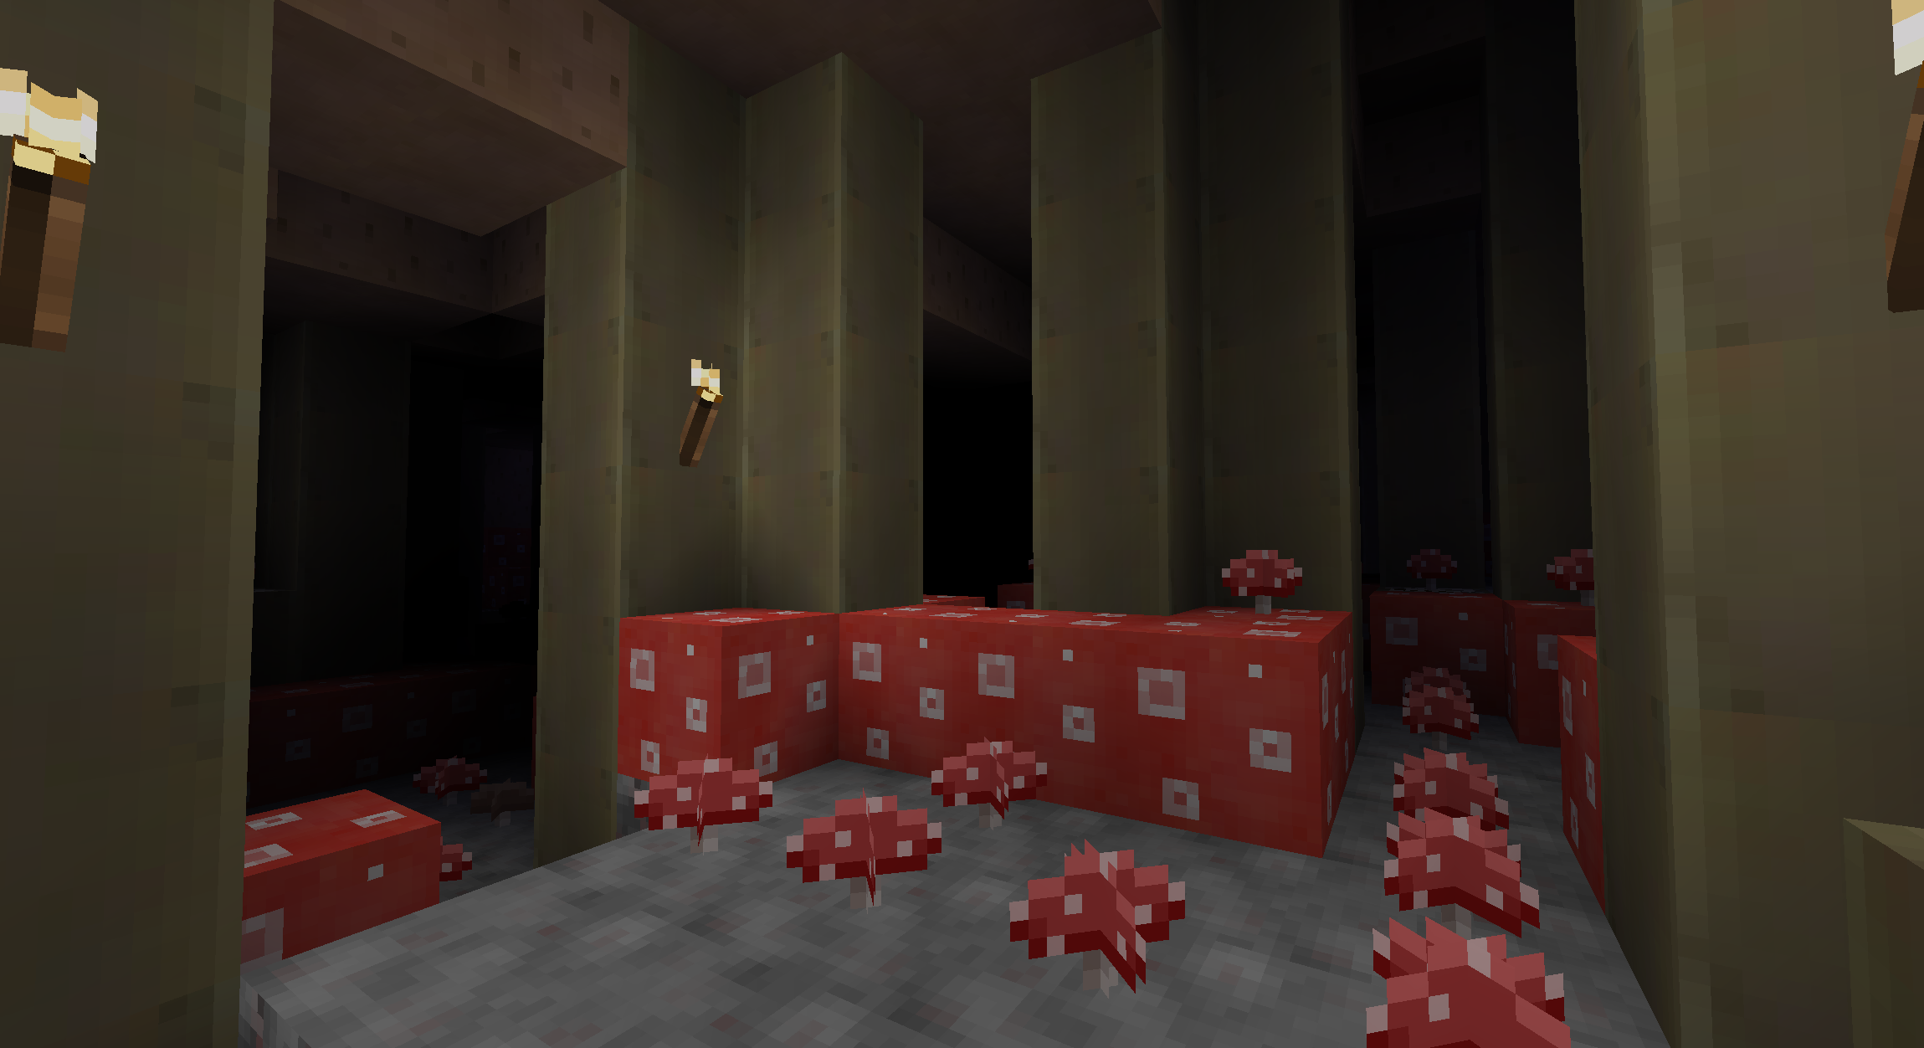

Mushroom biome blocks

The mushroom biome comes with several new blocks, which will be summarized here.

The colorful mini mushrooms were already summarized in the previous section, so we won‘t cover them here.

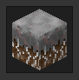
Myzelium, the ground of the mushroom biome, which also causes surrounding suspectible blocks to mushroomificate.

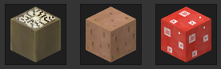
Giant mushroom blocks, which can be used as a fuel just like apple tree wood. Beware, for they can spread mushroomification just like myzelium, and might hide some nasty monstorous surprise inside!


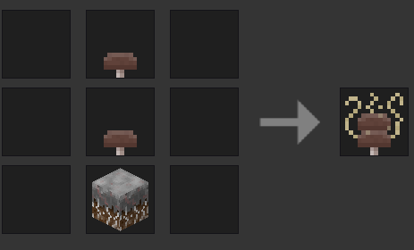
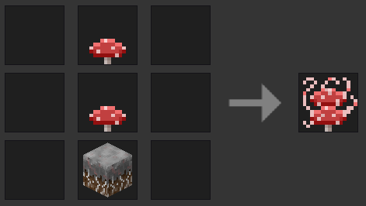
Mushroom Saplings, which grow into giant mushrooms when placed on myzelium at night. They can also be crafted:

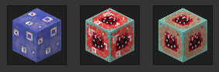
The antidote against mushroomification, which you can use to stop the biome from spreading any further, as well as the Mushroom Heart trophies, can be acquired from defeating the red and brown mushroom bosses, and will be covered in a later section.


Spawneggs (spawnsapplings? Who knows) of monsters (and monster structures) that the game entails. Can only be acquired in creative mode. See next section for details on these monsters.

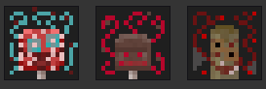
Spawneggs (spawnsapplings? idk) for bosses (or parts of a boss). Can only be acquired in survival.

Mushroom Halls (the nicest building place)

Whilst most classic biomes -regular forests and plains- look relatively uniform in their mushroomificated form, and snow- and hot biomes don‘t even get mushroomificated in the first place, one biome stands out: the jungle biome, which turns into the mushroom halls once it is overrun by mushrooms.

The leave roof of jungles is very dense, meaning mushroom halls are completely dark once the original jungles leaves are converted to brown mushroom hat blocks. That‘s why the mushroom halls have a complete roof that one can walk on, without any holes to fall into, and as opposed to other areas this biomes roof is plastered with lots of small brown mushrooms.

And the jungle grass turns into small red mushrooms and the jungle tree roots into red mushroom blocks, meaning the floor of the dark mushroom halls are covered in red mushroom halls.

There are currently no special creatures inhabiting the mushroom halls, but having some darkness-dwelling monster spawn on myzelium would be an easy way to add some specifically to the mushroom halls, so feel free to add some to an eternal mod or smth :)

If you need a nice place to build in a mushroom biome, I recommend building at the border between normal mushroom biome terrain and mushroom halls, so you have both in your surroundings and a pretty border between them.
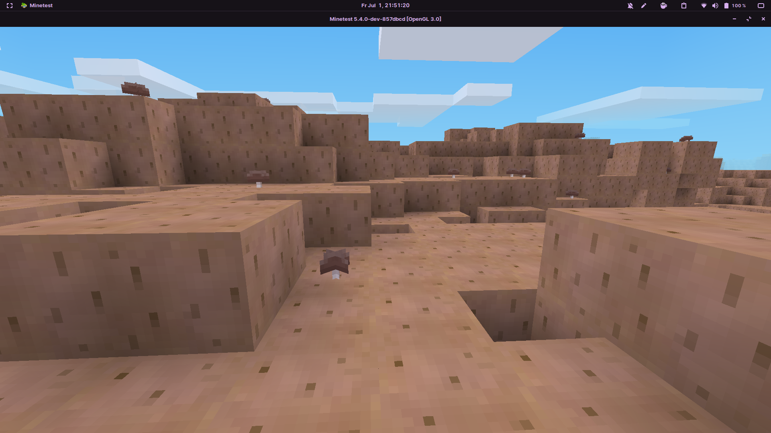
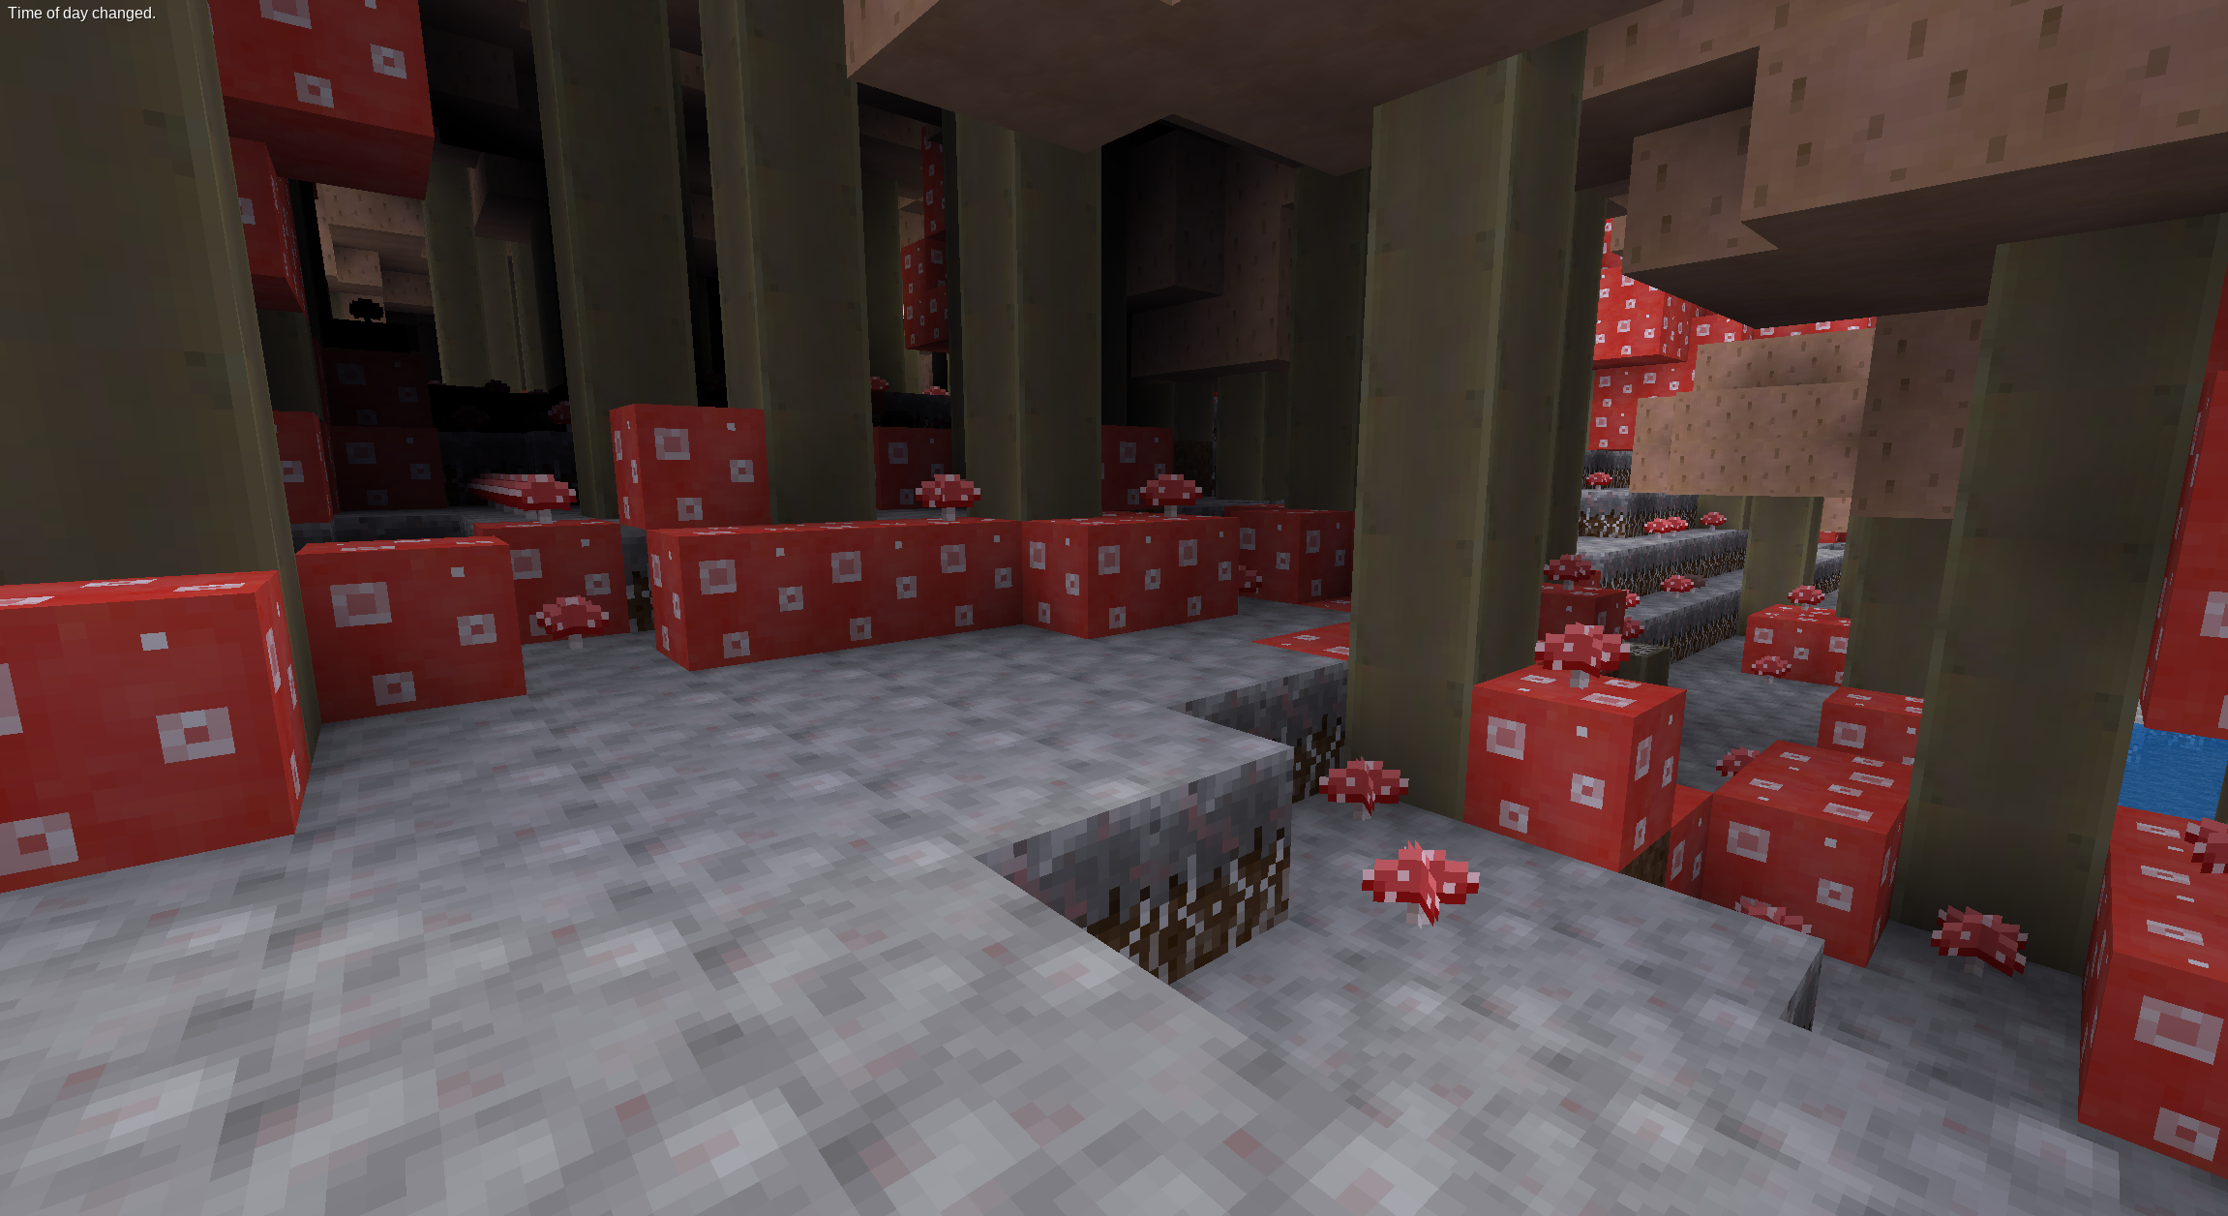

Unfriendly Inhabitants

The mushroom biome features some new threads which may attack you as you venture through its farspread landscape.

Mushroom Mimes

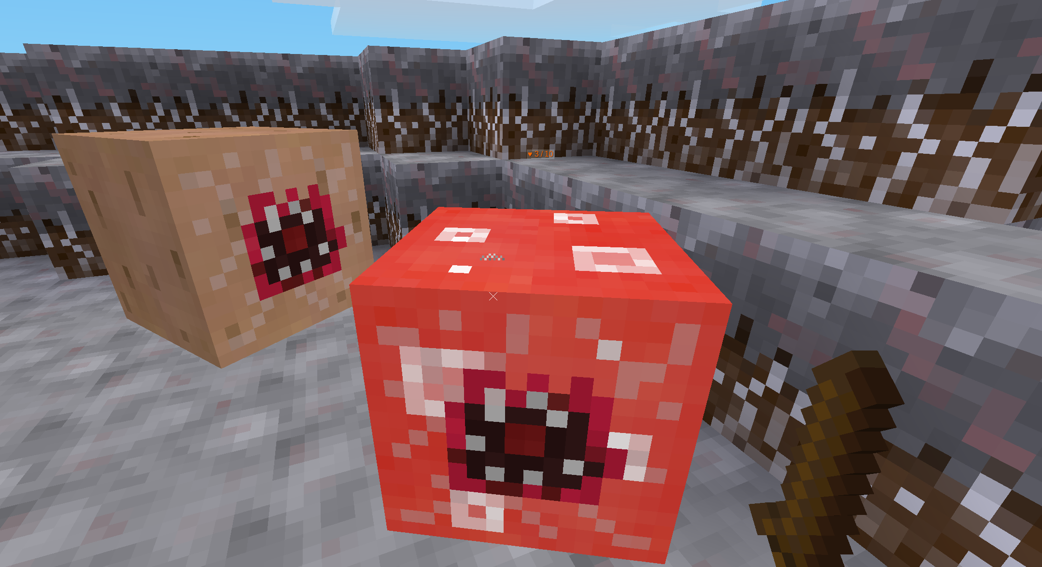
Mushroom mimes are fundamentally peaceful creatures, that spend their life like any other piece of mushroom meat, with dreaming – except that they, when woken up, attack and show their teeth!

Mushroom mimes look like mushroom hats look (either like the red or like the brown one) and usually generate in their block form, in which they are indistinguisheable from the normal block. But when you punch them or try to dig them, they and all their peers within some radius awake and show their teethy mouths, attacking you and trying to kill you if you‘re close enough!

Mushroom mimes can only attack in melee, but all their other properties are somewhat randomized whenever they wake up, depending on the dreams you woke them from. Their damage is between 3 and 5 hp, their jump height (yes, they move by jumping) between 2 and 8 blocks, their fall damage zero, their velocity between 2 and 6 blocks per second, their view range between 5 and 14 blocks, their fall velocity is low to different extends, and also every third of them can fly :3

Sometimes waking up a mushroom mime can make it so enraged that it attacks its peers and other monsters, usually leading to the demise of the attacker, though this only happens in 1/5 of allcases.

When mushroom mimics don‘t see anything that‘s worth attacking for 5 seconds straight then they succumb to tiredness, resuming their restful sleep.

Some mushroom mimics like to spend ther sleepy time around their fellow peaceful mushroom meat, hiding within normal giant mushrooms, so digging up a normal mushroom hat block has a 10% chance of revealing the block to be a mimic.

Mime Trees
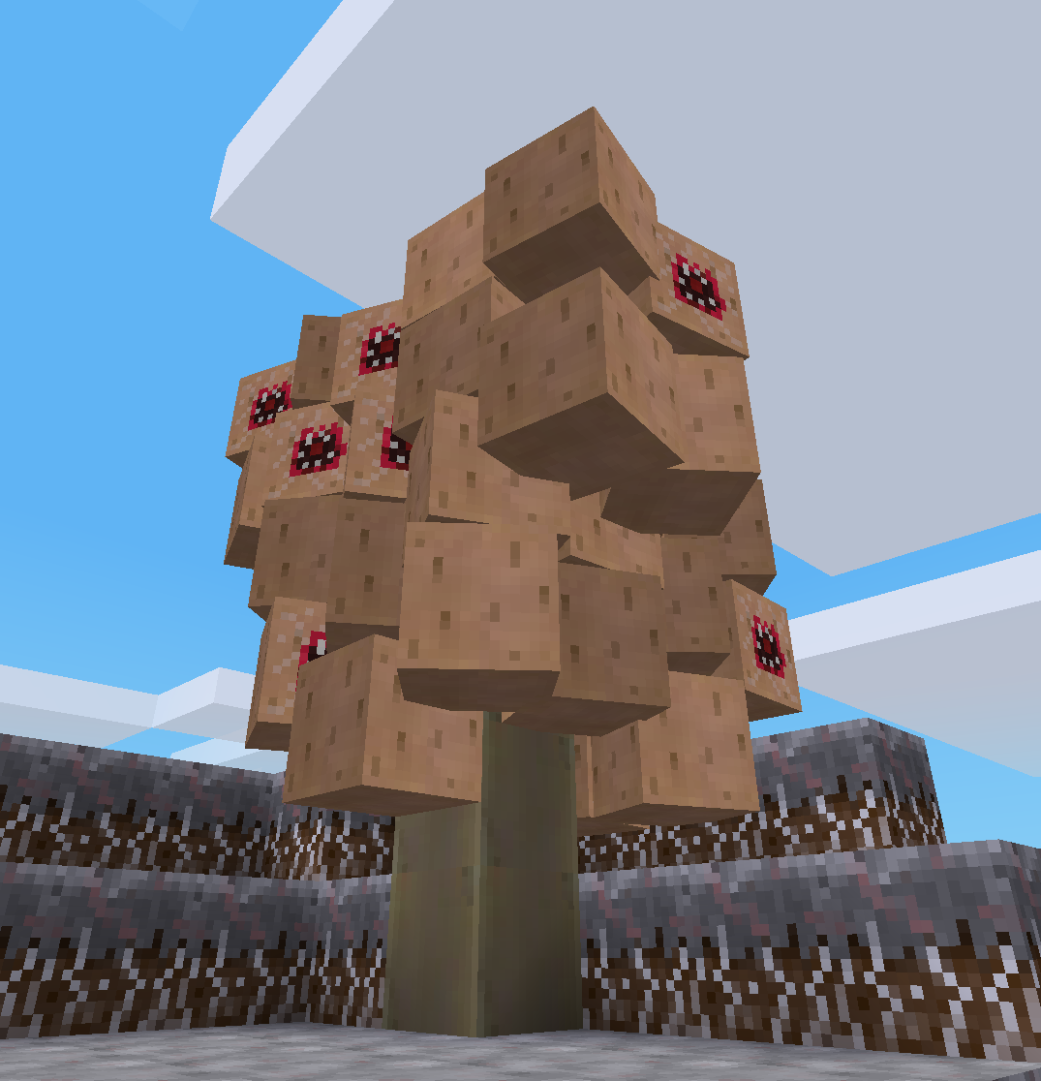
Trees of mushroom mimes – these structures resemble normal giant mushrooms to the point of being indistinguishable from them, except their hat consists entirely of sleeping mushroom memes rather than normal blocks. Try to dig one of these nodes, and you are in for a nasty surprise as they will all attack you!

Mime Trees only spawn at night and on myzelium and never despawn, as they are generated structures made from blocks, but they will never spawn closer than 14 blocks distance to another mime tree, so careless lumberjacks aren‘t at too high of a risk of accidentally attacking one of them. (Image shows mime tree awakening)

Mushroom Biome Boss

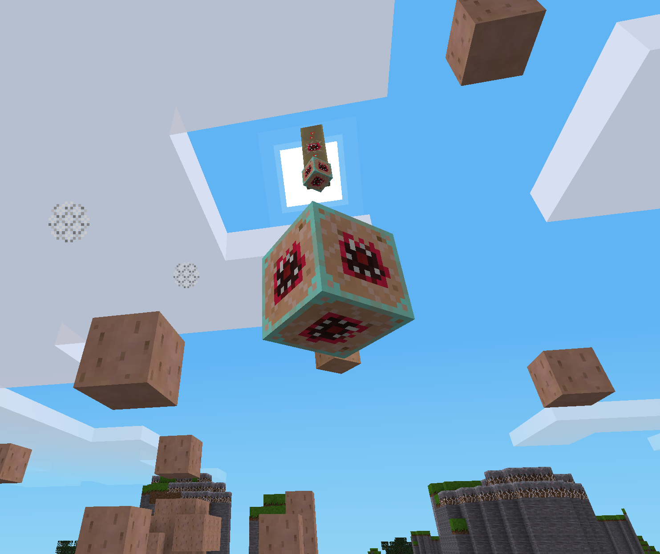
The boss(es) of the mushroom biome are called Mushroom Stem Bosses, and they are floating giant mushroom stems that shoot projectiles at you baring a range of effects from pure damage to summoning mushroom mimes and mime trees. They are also pretty beefy, starting out with 500 HP ready to be taken down!

Mushroom stem bosses hide disguised as normal mushroom stems in mime trees (around 15% of mime trees are infected by them), and if you punch one block of their mime tree all the mushroom mimes as well as the stem boss will come to live and attack you. The stem boss then rises up into the sky, battling its way through those mimes that attack it, and starts shooting projectiles at you.

The projectiles (called Mushroom Heart projectiles) match in color with the mime tree of the boss that shot them, and so do any mime trees and mimes summoned by the projectiles. There are three different effects that mushroom hearts can have when they hit a block or player, each of them equally likely:

- Explosions
Explode, leaving a krater with a radius of around three blocks. If there are sleeping mime blocks within this radius the explosion akes them up; otherwise it deals some damage in a 4.5 block radius since it doesn‘t have to hold itself back to spare the mimes.

- Spawning Mimes
Spawn three mushroom mimics in the position of impact, waking and ready to attack.

- Spawning a Mime Tree
Spawn a mime tree. This never happens when the mushroom heart hits a sleeping mime, as mime trees do not like to grow on mimes.

Mushroom hearts also duplicate every waking mushroom within a radius of 1.7 blocks upon impact, though they aren‘t powerful to cause the existence of more than 9 mimes within their radius with that. The chance of being hit directly by a mushroom heart is fairly low, since stem bosses try shooting at a block in front of the player‘s feet rather than the player itself.

The best strategie to take down a mushroom stem boss is to shoot it with bow and arrow, wear some sturdy armor and defend yourself from its summonings in melee, trying to keep moving constantly – thats why a bow and armor mod is recommended for this mod. Stem bosses never despawn, too, so you will have to get it dead eventually if you want to use the area.

Bosses as well as mime trees never spawn in mushroom halls.

More detail on the bosses behavior and movement pattern can be found on a later page.

Boss Drops & Stopping the Biome‘s Growth

Killing the mushroom boss drops two things:

- 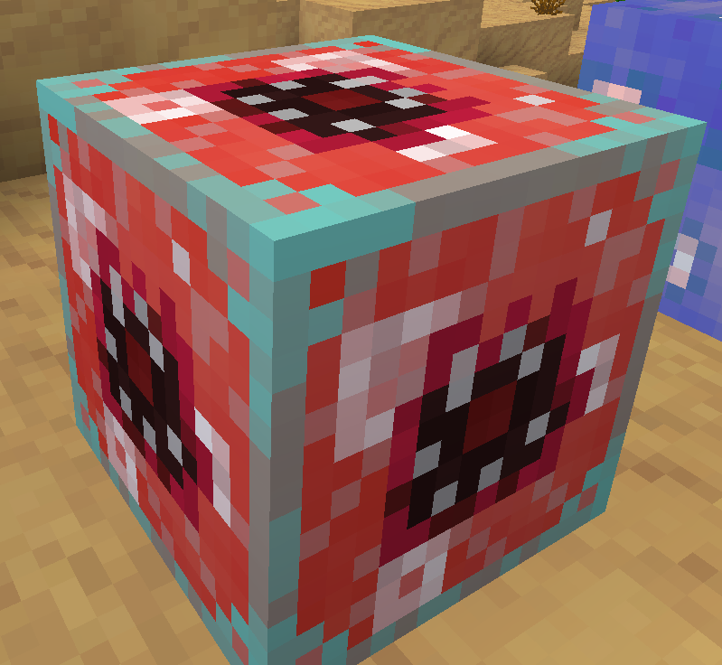 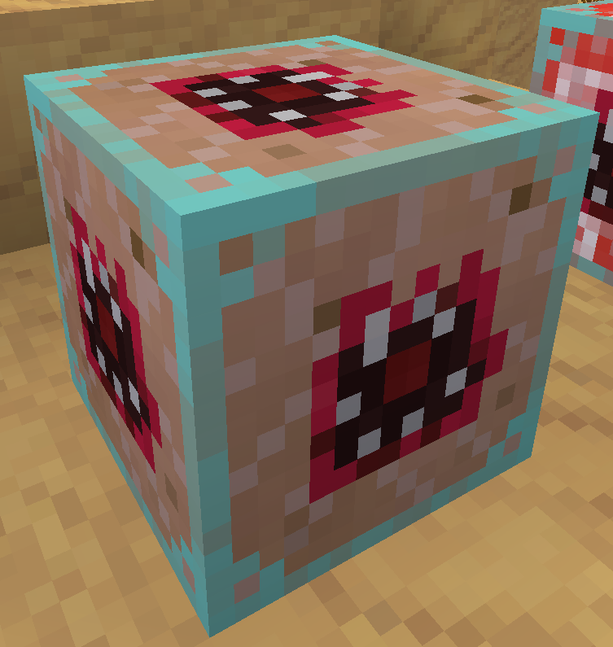 a Mushroom Heart as a block, which you can use e.g. as a trophy or light source

- 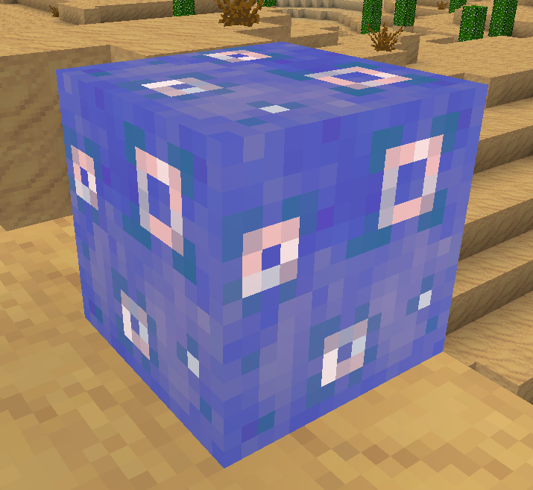 as well as a Mushroomification Antidote

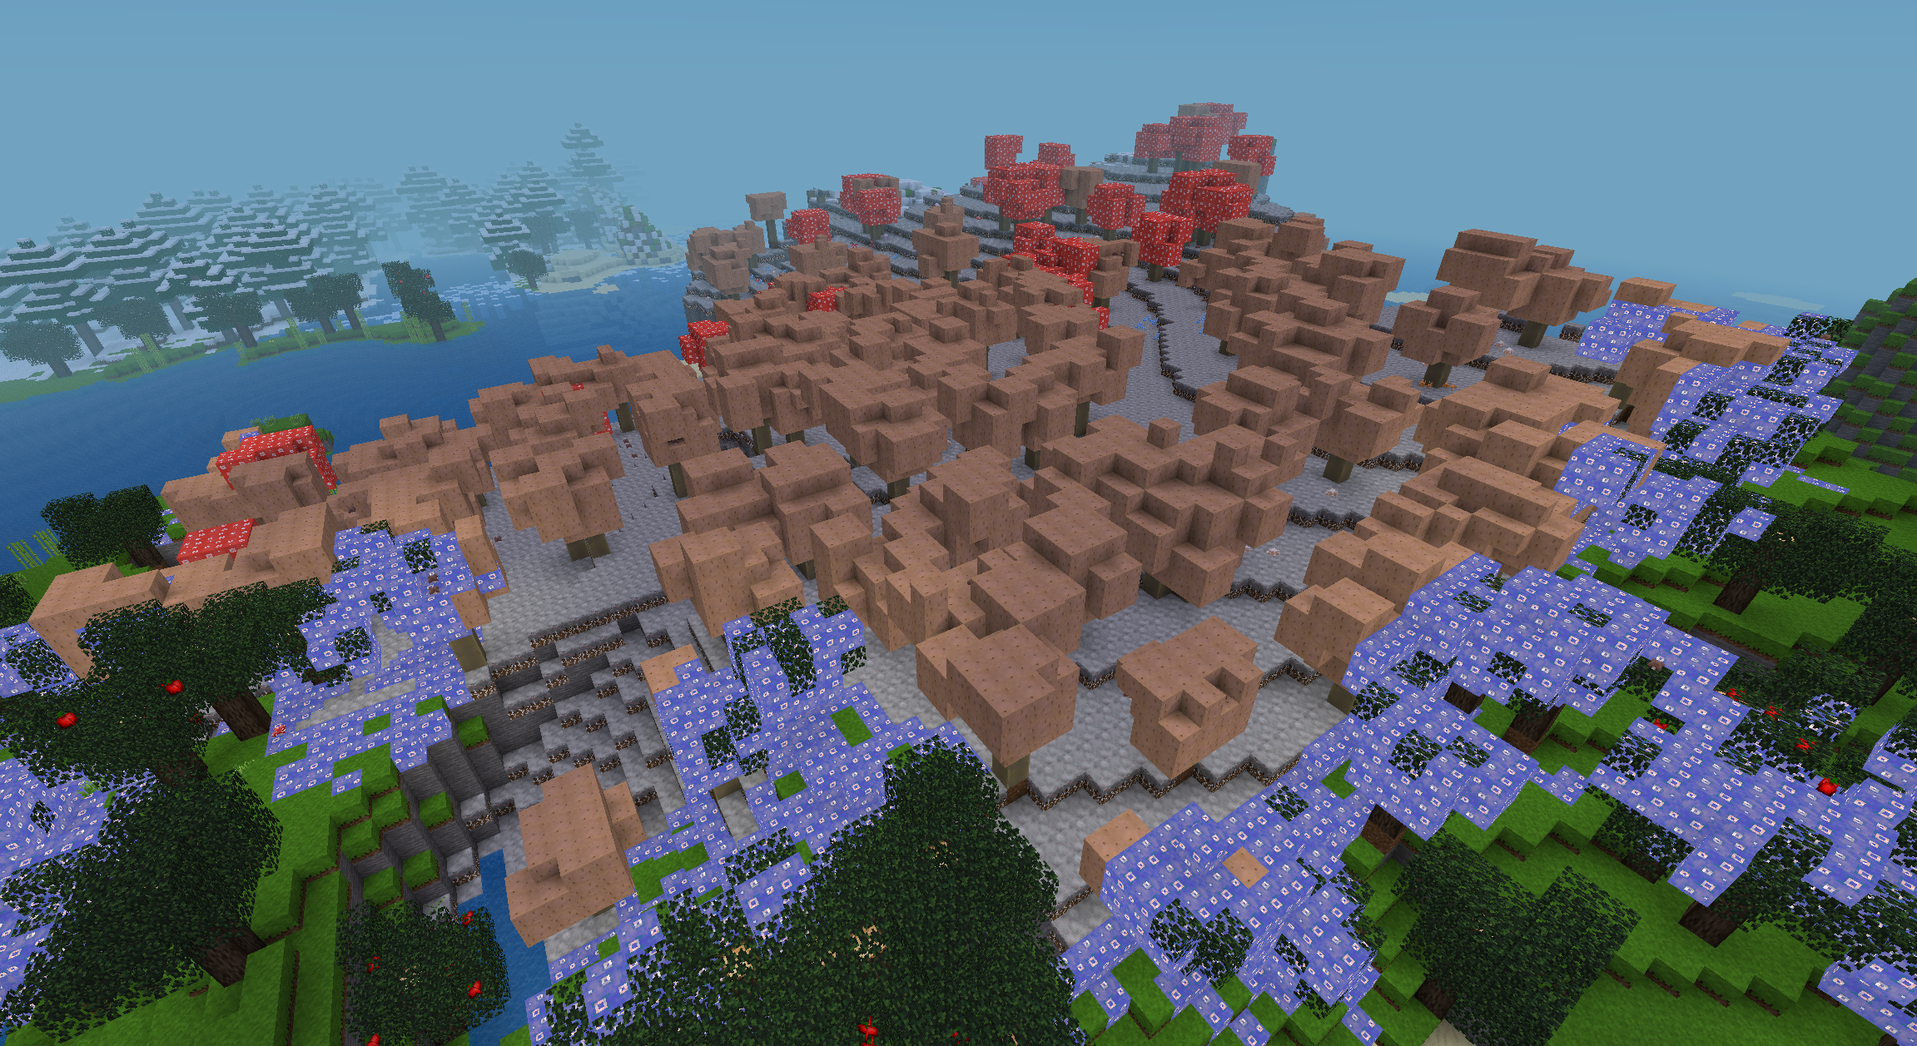
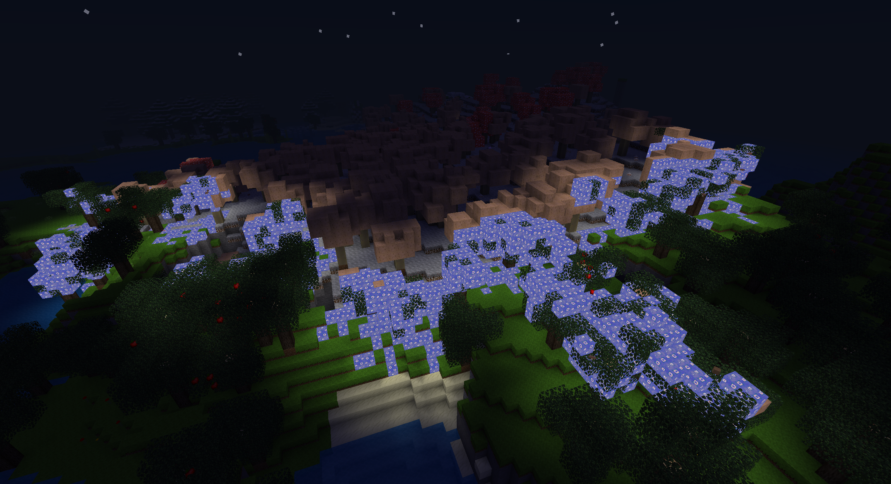
To stop a mushroom biome from growing, you must place an antidote block at its border, right between a myzelium-infested block and one that isn‘t infested yet. The antidote will quickly spread around the border, replacing every mushroomification-spreading block it reaches as long as said block is neighbor to an uninfected block it could infect. This way, the antidote blocks quickyl form a ring around the biome, through which the biome cannot spread, sealing off the biome from its growth. They also glow, making it even harder for the myzelium which only spreads at darkness!
A mushroom biome, its growth stopped by myzelium antidote spreading around its borders and sealing it. The antidote has already reached its max growth, so neither the antidote nor the myzelium will spread any further.

Stem Boss Movement Patterns & Behavior

Movement Patterns

After the mushroom boss gets spawned, it immediately rises up into the sky by 17 blocks and starts attacking the player – specifically the oen who punched the mushroom construct it arose from, even if there are multiple other players around. Mushroom bosses never divert their attention from the player they are attacking, unless the player leaves their view range of 150 blocks. If they have noone to attack they just wait until there comes a new player they can attack.

Whilst usually fighting with projectiles, mushroom bosses can also quickly rush into melee, which happens whenever a player gets closer than 8 blocks to them. They deal 6 HP of damage in melee, though punching them in melee scares them and causes them to fly up out of the players range, switching them back to their normal projectile-based attack pattern.

Apart from that, mushroom bosses never move, except for the following occasions (sorted from highest priority to lowest):
- Towards their spawn position, when they are more than 70 blocks away from where they spawned.
- Towards the player, if the player is more than 38 blocks lower (y-dir) than the boss is.
- Downwards, if the bosss spawn position is more than 50 blocks lower (y-dir) than the boss is.
The boss only moves into melee if none of these apply.

Resistances

Mushroom bosses are immune to sunlight-, lava/fire- and water-damage, don‘t get knockback when punched, don‘t get fall damage (since they can fly), can‘t be pushed away, can‘t be suffocated, and don‘t despawn after a certain time of being inactive like other mobs do.

Behavior towards other mobs

Mushroom bosses are technically passive, never attacking other mobs and never letting a mob distract them from who they are attacking even if the mob attacks them first. However, they bear some passive attacks to protect themselves, as every mob that hits them gets punched away with 4 HP of damage, causing the quick demise of any mob that dares attack them.

They also punch every mob that sits directly above their head, dealing only 1 HP of damage but knocking it back into the direction the boss is facing (rather than upwards like one might expect). This ensures that the boss doesn't get stuck under a flying non-attacking mushroom mime when it tries to rise out of the mimics of the mime tree it hid in, since getting stuck in this situation could lead to the boss being overwhelmed by agressive mimes.

Its presence also wakes up any sleeping mime in a radius of 4 blocks around it, which is how it ensures that it cannot get stuck under a sleeping mushroom mime, to avoid the situation described above.

Acknowledgements



This mod was made by a cute trans gal and if you don‘t like it you can die mad <3

(C) 2022 phseiff / Phii S.
(and partially other people whose code i used)

