Healthcare Analytics Platform
End-to-End Data Engineering — Build & Understand Guide
AWS S3 → Gatekeeper → Snowflake (Bronze / Silver / Gold) → dbt → Airflow → Cortex / BI
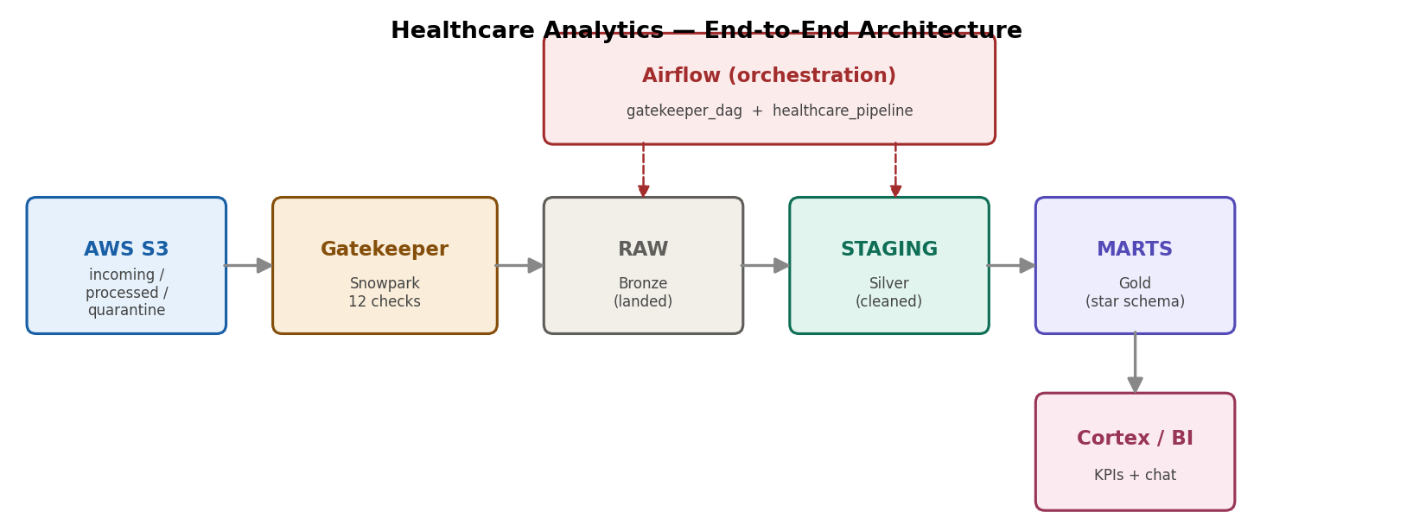
A complete, runnable pipeline anyone can rebuild by following the steps.

Contents
Contents 1
1. What this project is 1
1.1 The medallion layers 1
2. The big picture 1
3. Snowflake setup (run these first) 1
4. The audit (monitoring) tables 1
4.1 The FILE_RECONCILIATION view (an independent cross-check) 1
5. Error handling & alerting — the four files 1
5.1 Root-cause alerting — the email names the failing model 1
6. dbt — the Silver layer & incremental models 1
6.1 Silver is incremental TRANSIENT TABLES (not views) 1
6.2 What “incremental” means and why we use it 1
7. dbt — the Gold star schema 1
7.1 Star vs snowflake schema 1
8. Declared keys (PK / FK) for BI auto-relationships 1
9. Permanent Gold tables & 90-day Time Travel 1
10. Building the dbt project (VS Code) 1
10.1 Commands you’ll run day to day (with examples) 1
11. Snapshots — tracking change over time (SCD2) 1
11.1 The three SCD types (the difference) 1
11.2 Which table — and how dbt does it 1
11.3 FCT_ADMISSIONS_ENRICHED — SCD2 applied to admissions 1
12. Macros — reusable SQL functions 1
12.1 generate_schema_name — controls how schemas are named 1
12.2 money — consistent currency rounding 1
13. Seeds — version-controlled reference data 1
13.1 The seeds in this project 1
13.2 Seeds vs sources vs models 1
14. How the gatekeeper works 1
14.1 Simple view (data vs file) 1
14.2 Technical view (stages + tables) 1
14.3 One file does all of it 1
15. What dbt generates from your config 1
15.1 One config, two different generated commands 1
15.2 Where to see the generated SQL 1
16. Airflow — orchestration & setup 1
16.1 Setting up Airflow from scratch 1
16.2 How Airflow connects to Snowflake (no UI connection) 1
16.3 The two DAGs and how they chain 1
16.4 Everyday Airflow commands 1
17. Quick build checklist 1

1. What this project is
This platform ingests three related healthcare datasets — patient admissions, treatment records, and insurance claims — validates them, transforms them through a layered (medallion) architecture, and exposes business-ready tables for dashboards and AI chat. Everything is automated and monitored.
The whole system is built from two kinds of files:
- Snowflake SQL — run in the Snowsight web worksheet. Creates the warehouse, database, schemas, role, S3 link, tables, audit logs, and email alerts.
- VS Code / dbt project — runs from your computer. Builds the cleaned (Silver) and star-schema (Gold) layers, plus all data tests.
How to use this guide
Each step says exactly what to do and which file to use. Where you see “paste from file XX”, open that file from the project bundle and run it. Yellow dashed boxes are spots for you to paste your own screenshots.

1.1 The medallion layers
Layer | Snowflake schema | Built by | What it holds
Bronze | RAW | Gatekeeper (Snowpark) | Exact copies of source data
Silver | STAGING | dbt (incremental tables) | Cleaned, typed, decoded data
Gold | MARTS | dbt (tables) | Star schema: dimensions + facts
History | SNAPSHOTS | dbt (snapshot) | Slowly-changing history (SCD2)
Monitoring | AUDIT | Hand-built SQL | Logs of every file, check, error

2. The big picture
Files land in S3. A Python “gatekeeper” validates each file before loading — good files go into Snowflake’s RAW layer, bad files are quarantined and an alert email is sent. dbt then transforms RAW into the Silver and Gold layers. Apache Airflow runs the whole sequence on a schedule and emails you if anything breaks.
Why a single validated front door
Every file passes through one ingestion path: the gatekeeper runs 12 quality checks before any data can touch a real table. Good files load; bad files are quarantined and an alert is sent. One controlled path is easy to monitor, secure, and reason about.

3. Snowflake setup (run these first)
Run the numbered SQL files in the snowflake_setup folder, top to bottom, in a Snowsight worksheet. Each file has heavy beginner comments. Replace the placeholders first (see the folder’s README).
Step | File | What it creates
1 | 01_account_setup.sql | Warehouse, database, 5 schemas, role + grants
2 | 02_storage_integration.sql | Secure key-less link to S3 (+ AWS steps in comments)
3 | 03_file_formats_and_stages.sql | CSV recipes + 3 stages (incoming/processed/quarantine)
4 | 04_raw_tables.sql | The 3 Bronze landing tables
5 | 05_audit_tables.sql | The 4 monitoring/log tables
6 | 06_email_integration.sql | Email alerts + a test send
7 | 07_dbt_handoff_note.sql | (reading only) what dbt builds next
8 | 08_add_star_schema_keys.sql | Gold primary/foreign keys (after first dbt run)
Placeholders to replace before running:
- <YOUR_AWS_ACCOUNT_ID> — your 12-digit AWS account number
- <YOUR_BUCKET> — your S3 bucket name
- <YOUR_ALERT_EMAIL> — the inbox that receives alerts
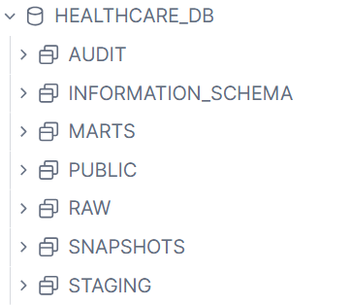

4. The audit (monitoring) tables
Real pipelines keep a “flight recorder”. These four tables record everything that happens, so you always know what ran, what passed, and what failed. They are created by 05_audit_tables.sql.
Table |  | Grain (one row per…) | What it tells you
FILE_PROCESSING_LOG |  | file | The “report card”: did this file load or get quarantined, and how many rows?
DQ_METRICS_LOG |  | quality check | The “answer sheet”: exactly which checks passed/failed for a file (for compliance)
PIPELINE_ERROR_LOG |  | DAG/task failure | Which Airflow task failed, when, and the error summary
EMAIL_RECIPIENT_LOG |  | recipient | Who receives alert emails (never truncate this one)
Report card vs answer sheet
FILE_PROCESSING_LOG is one line per file — quick health view. DQ_METRICS_LOG is one line per individual check — the detailed evidence. You want both: a summary and the proof behind it.

4.1 The FILE_RECONCILIATION view (an independent cross-check)
Alongside the four tables there is one view: FILE_RECONCILIATION. It summarises, per day and per RAW table, how many files and rows were loaded and how many rows were rejected. It works by reading Snowflake’s built-in COPY_HISTORY (the system’s own record of every COPY INTO), not the gatekeeper’s log.
Because it reads COPY_HISTORY rather than the gatekeeper’s own tables, it is an independent, system-level witness. It survives log resets (COPY_HISTORY can’t be truncated by you) and can be compared against FILE_PROCESSING_LOG — if the two ever disagree, that is a signal to investigate. It captures the gatekeeper’s COPY INTO loads because those run through COPY INTO too.
Two independent witnesses
FILE_PROCESSING_LOG = what the gatekeeper says it did (application-level). FILE_RECONCILIATION = what Snowflake’s engine recorded loading (system-level). Having both is good monitoring practice.
FILE_PROCESSING_LOG

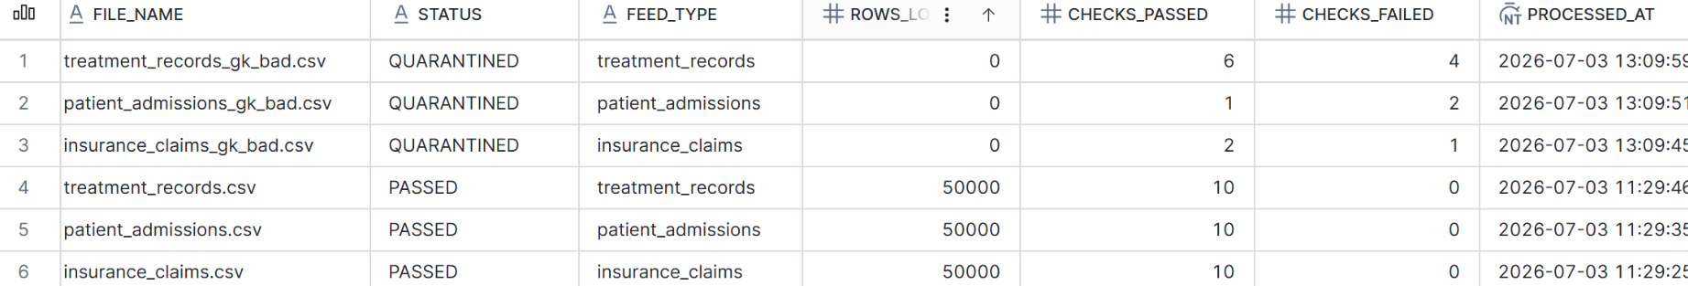

FILE_RECONCILIATION

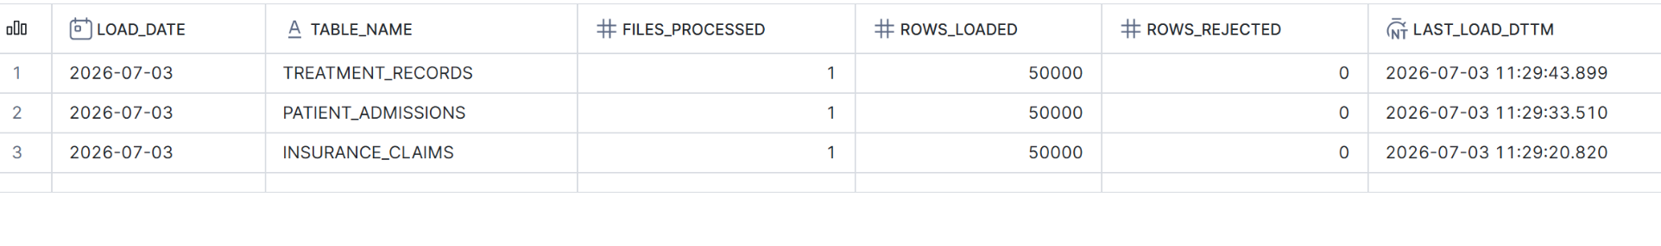5. Error handling & alerting — the four files
Failures are caught in two places: the gatekeeper (file problems) and Airflow (system / transform problems). Four files work together to validate, route, and alert. Each alert email is richly formatted and also logged.
File |  | Where it runs | Job | Sends email when…
gatekeeper.py |  | Snowpark (worker) | Validates each file (12 checks); loads good rows, quarantines bad ones | A file FAILS validation (quarantined) — the common case
quality_check.py |  | Snowpark (worker) | Optional read-only pre-flight check; loads nothing | Never — it only reports, does not email
gatekeeper_dag.py |  | Airflow (DAG) | Runs the gatekeeper every 10 min, then triggers the pipeline | The gatekeeper TASK itself crashes (e.g. Snowflake down) — rare
healthcare_pipeline.py |  | Airflow (DAG) | Runs dbt run → snapshot → test → reconciliation | A dbt task fails (e.g. a test or model error)
Simple rule to remember
File problem → email #1 from the gatekeeper. System problem → email #2 (gatekeeper task crash) or #3 (dbt failure) from Airflow. All three arrive from no-reply@snowflake.net; the SUBJECT line tells you which is which.
The three alert emails share the same rich format (file/feed, checks passed-vs-failed, plain-English explanation, action to take) and each writes a row to an audit table, so every alert leaves a permanent record.

5.1 Root-cause alerting — the email names the failing model
When a dbt task fails, a generic “dbt failed” message isn’t very helpful. The healthcare_pipeline DAG is upgraded so the failure email and the PIPELINE_ERROR_LOG row name the ACTUAL failing model — for example “Model failed to build: STAGING.stg_admissions” — instead of a generic sentence.
How it works: each dbt task tees its output to a log file; when a task fails, the failure handler reads that log, strips the colour codes, finds the real error line (ERROR creating model X, Compilation Error, Database Error, or a failing test) and puts that into both the email and the log row. If no known pattern matches, it falls back to the generic message.
What it can and can’t tell you
It reliably names the failing MODEL (so you know where to look). It does not include the exact SQL line — that full detail lives in the Airflow task logs. The alert’s job is to point you to the right model fast; the task logs give the line-level diagnosis.

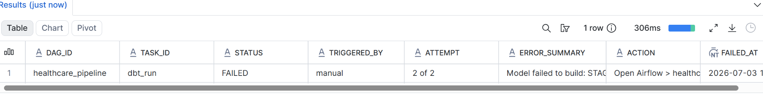

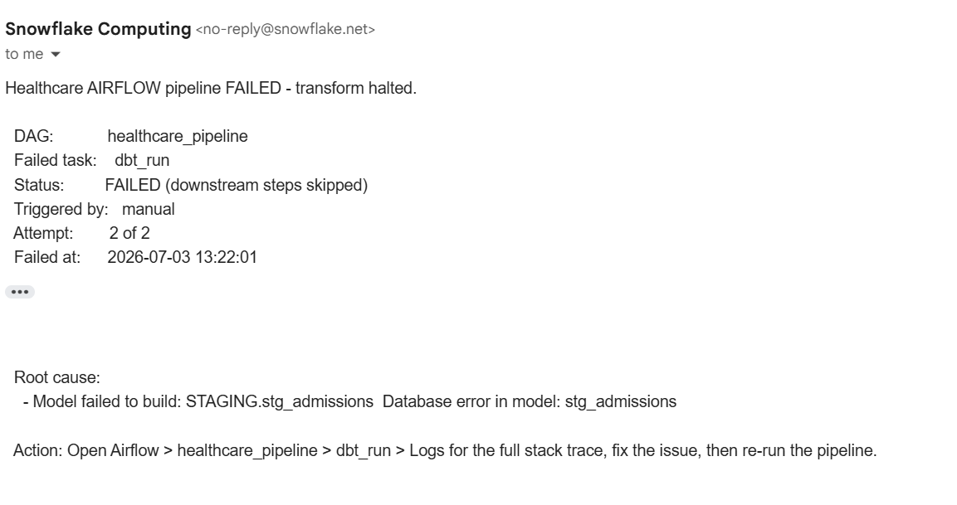

----------------------------------------------------------------------------------

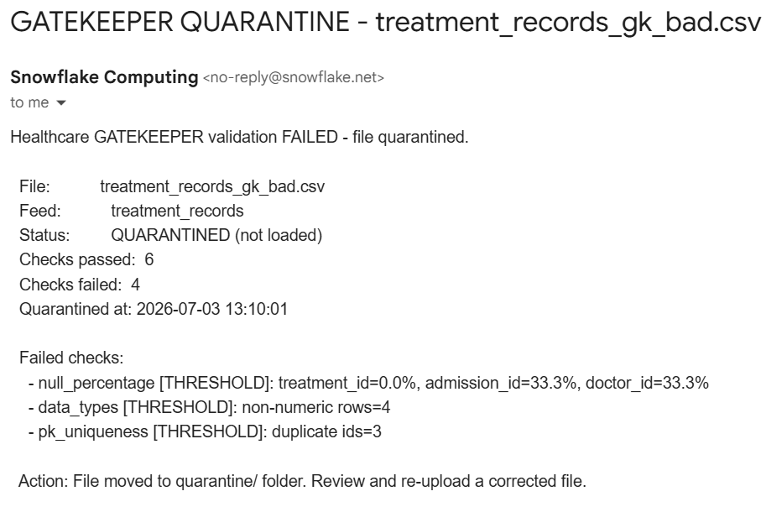 6. dbt — the Silver layer & incremental models
The Silver layer (STAGING schema) is built by dbt from the RAW tables. dbt models are just SELECT statements — dbt itself writes the create or replace DDL behind the scenes and builds the tables for you. You never hand-write the table structure in Snowflake.
Key idea: dbt owns the DDL
Because dbt generates the table-creation SQL at run time, the Silver, Gold and Snapshot tables must be built (and reset) by dbt — never created or truncated by hand. To reset them you use dbt’s --full-refresh, not a manual DROP/TRUNCATE.

6.1 Silver is incremental TRANSIENT TABLES (not views)
It is worth being precise about how Silver is materialized, because it is a common point of confusion. The staging models are NOT views — they are incremental transient tables. When you inspect stg_admissions in Snowflake, its definition begins with create or replace TRANSIENT TABLE, written automatically by dbt.
Why a table and not a view? Because the heavy transformation lives in Silver — readmission detection with LAG window functions over each patient’s full history, deduplication, and visit sequencing. A view stores nothing and re-runs its entire SELECT every single time it is read (by Gold, by tests, by BI). Putting heavy logic in a view means recomputing it constantly. An incremental table computes that expensive logic once, stores the result, and on later runs only processes new rows — far cheaper.
Why transient and not permanent? Because Silver is fully rebuildable from Bronze. If it were ever lost, dbt run recreates it. So it does not need fail-safe protection. Transient (no 7-day fail-safe, cheaper storage) is the correct, deliberate choice for a rebuildable intermediate layer. Only Gold — the final, trusted output — is made permanent (see section 9).
The rule: views for light work, stored tables for heavy work
Project-level config sets a default, but each model’s own config wins. The staging models set materialized='incremental' in their own header, which overrides the default and produces a transient table. Heavy transformation → store it. Light transformation → a view would be fine.

6.2 What “incremental” means and why we use it
A normal dbt model rebuilds the whole table every run. An incremental model only processes NEW or CHANGED rows after the first build — much faster and cheaper as data grows. dbt decides which mode to use via the is_incremental() flag.
In stg_admissions, readmission detection needs each patient’s FULL history (a LAG window over prior admissions). So the incremental logic is patient-scoped: when new admissions arrive, it reprocesses the complete history of just those patients — keeping the window calculations correct while still avoiding a full rebuild.
Key snippet (full code in the dbt project, models/silver/stg_admissions.sql):
{{
config(
materialized='incremental',
unique_key='admission_id',
incremental_strategy='merge',
on_schema_change='sync_all_columns'
)
}}
-- On incremental runs, reprocess the FULL history of any patient
-- who received a new/updated admission since the last run:
{% if is_incremental() %}
with affected_patients as (
select distinct patient_id
from {{ source('bronze', 'patient_admissions') }}
where load_dttm > (select max(load_dttm) from {{ this }})
)
{% endif %}
-- ... readmission LAG window then runs over each patient's full history ...
Why patient-scoped, not just “new rows”
If you only processed new rows, a readmission whose PRIOR visit is an old row would be missed (the window wouldn’t see it). Reprocessing the affected patients’ whole history fixes that, correctly and cheaply.
The same idea applies to the other staging models: stg_claims is a simple new-rows-only incremental (no cross-row windows), while stg_treatments reprocesses any procedure_code or admission_id that received new data (because of its cost z-score window).
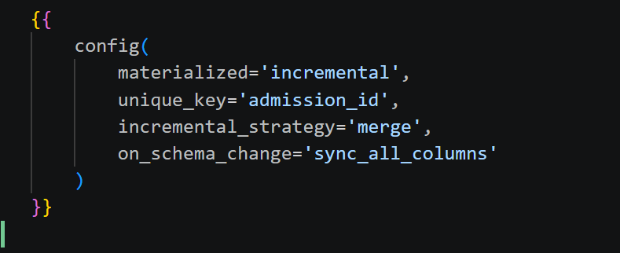

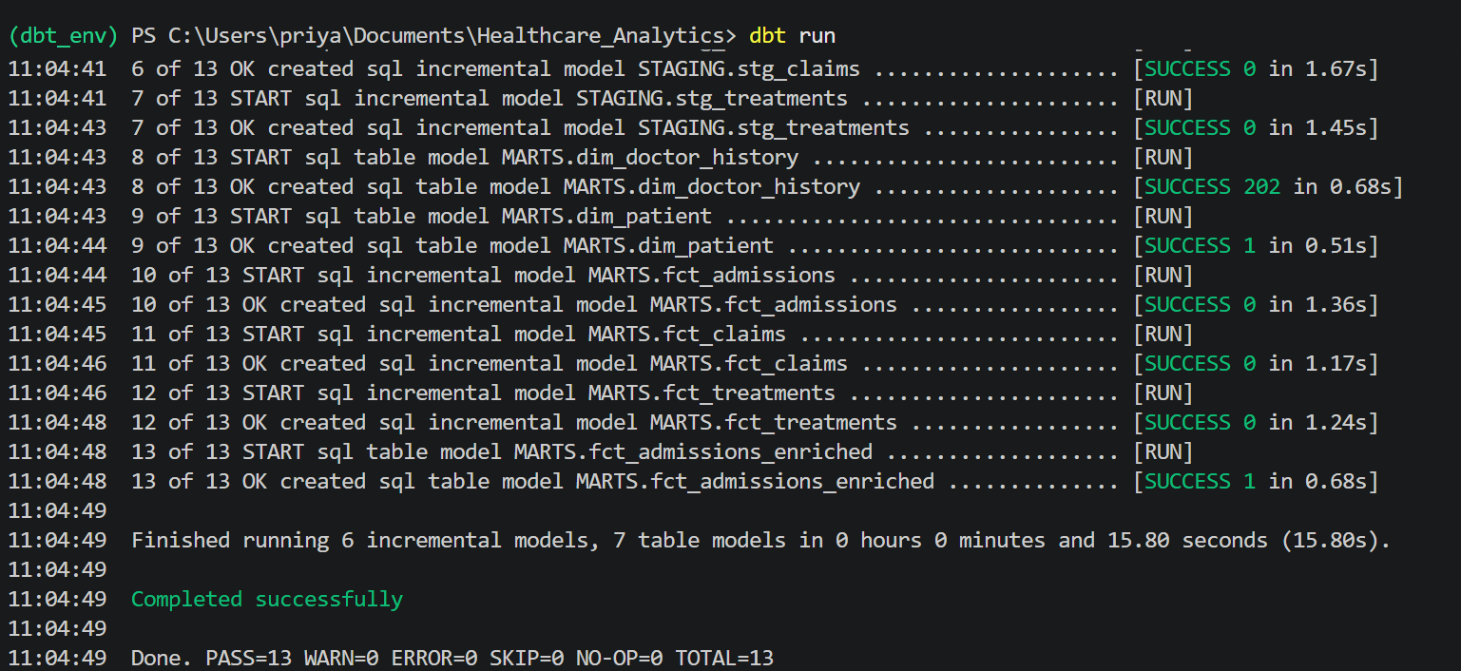

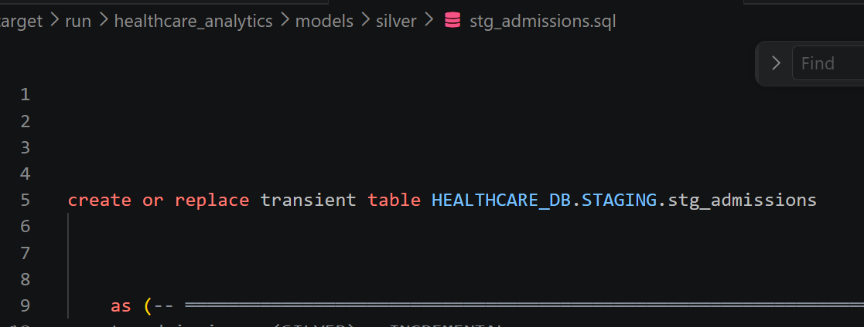

7. dbt — the Gold star schema
The Gold layer (MARTS schema) is the business-ready star schema: 5 dimension tables (the “who/what/when”) and 3 fact tables (the “events”). Facts connect to dimensions through surrogate keys (the _sk columns, generated with md5).
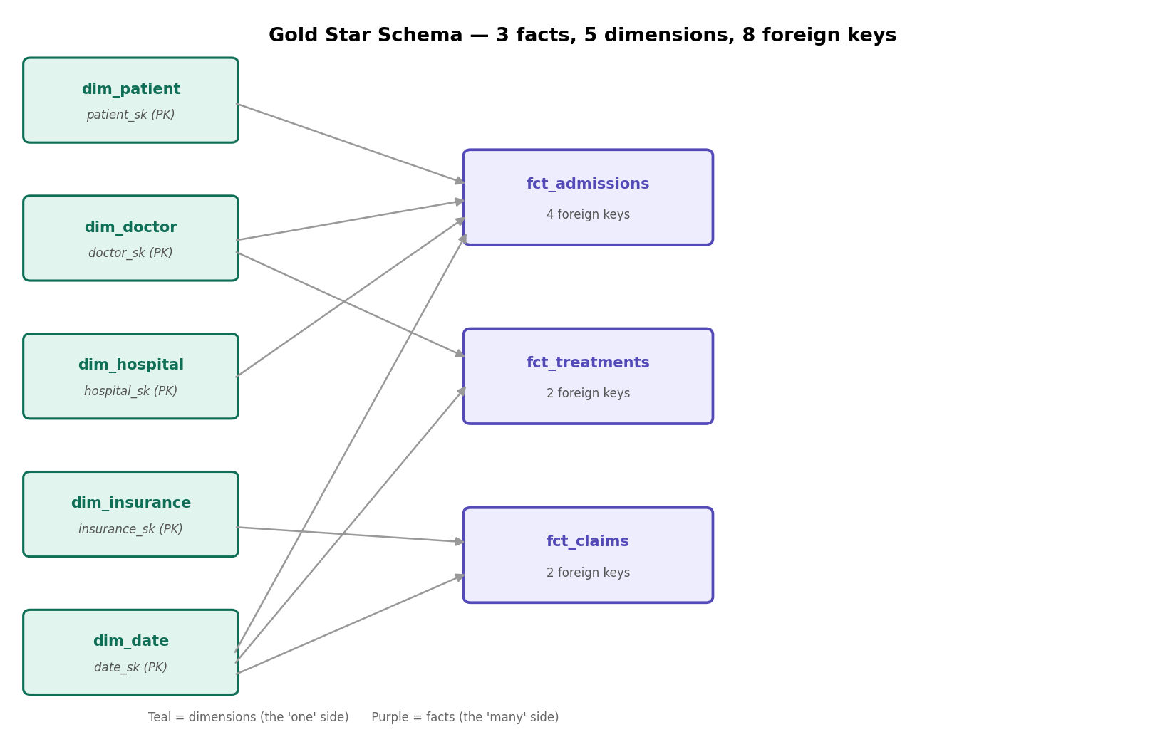
The eight relationships (fact foreign key → dimension primary key):
Fact | Foreign key | → Dimension
fct_admissions | patient_sk | dim_patient
fct_admissions | doctor_sk | dim_doctor
fct_admissions | hospital_sk | dim_hospital
fct_admissions | date_sk | dim_date
fct_treatments | doctor_sk | dim_doctor
fct_treatments | date_sk | dim_date
fct_claims | insurance_sk | dim_insurance
fct_claims | date_sk | dim_date

7.1 Star vs snowflake schema
This project uses a STAR schema — dimensions are flat (denormalized), and each fact joins directly to each dimension in one hop. A SNOWFLAKE schema would break dimensions into further sub-tables (more joins). Star is simpler and is what Power BI and Cortex prefer, so it is the right choice here.
The shape, in plain text — dimensions surround the facts, and DIM_DATE is shared by all three:
DIM_PATIENT DIM_DOCTOR DIM_HOSPITAL
\ | /
\ | /
-> FCT_ADMISSIONS <-
|
DIM_DATE <- (shared by all three facts)
|
FCT_TREATMENTS <- -> FCT_CLAIMS
| |
DIM_DOCTOR DIM_INSURANCE

8. Declared keys (PK / FK) for BI auto-relationships
Snowflake does not ENFORCE primary/foreign keys — they are informational. But Power BI and Cortex READ these declared keys and automatically build the table relationships for you. That is the real payoff, and it is what makes the model look “production-grade”.
Key snippet (full code in 08_add_star_schema_keys.sql):
-- 5 primary keys on the dimensions
ALTER TABLE DIM_DOCTOR DROP PRIMARY KEY;
ALTER TABLE DIM_DOCTOR ADD PRIMARY KEY (DOCTOR_SK) RELY;
-- 8 foreign keys on the facts (example)
ALTER TABLE FCT_ADMISSIONS DROP CONSTRAINT IF EXISTS FK_ADM_DOCTOR;
ALTER TABLE FCT_ADMISSIONS ADD CONSTRAINT FK_ADM_DOCTOR
FOREIGN KEY (DOCTOR_SK) REFERENCES DIM_DOCTOR (DOCTOR_SK) RELY;
Why DROP then ADD? (idempotency)
Each statement removes the key if present, then adds it fresh. This makes the script idempotent — safe to run any number of times with the same clean result and zero errors. That matters for a handoff script: whoever runs it does not need to know whether keys already exist.
RELY
RELY tells Snowflake and BI tools to TRUST these keys for query optimization and relationship-building, even though Snowflake doesn’t enforce them.
Order matters: run this script AFTER the first dbt run, and re-run it after any dbt run --full-refresh (a full-refresh rebuilds the tables and clears the keys). A normal dbt run keeps them.

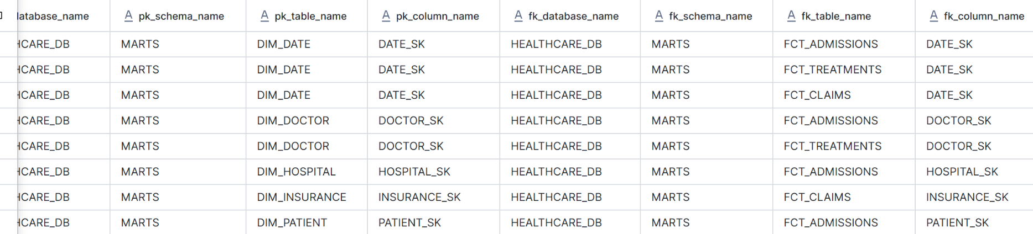9. Permanent Gold tables & 90-day Time Travel
By default dbt builds tables as TRANSIENT (cheaper, but no fail-safe recovery). For a production Gold layer we make them PERMANENT, which adds Time Travel plus Snowflake’s 7-day fail-safe — real protection for your trusted data.
We also set 90-day Time Travel (the maximum), so you can query or restore the tables as they were up to 90 days ago.
How it’s done — one config block in dbt_project.yml:
models:
healthcare_analytics:
gold:
+materialized: table
+schema: marts
+transient: false # makes tables PERMANENT
+data_retention_time_in_days: 90 # 90-day Time Travel
Why these two lines
+transient: false flips dbt's default so the Gold tables are permanent — they gain Snowflake's 7-day fail-safe, the safety net for your trusted, business-ready layer. +data_retention_time_in_days: 90 requests up to 90-day Time Travel; Snowflake grants as much as your edition allows.
Time Travel duration depends on your Snowflake edition. On Standard edition, Time Travel caps at 1 day — so even with the 90 requested, the tables run at 1-day Time Travel (this project runs on Standard). On Enterprise edition or higher, the same config gives the full 90 days. Either way the tables are permanent with fail-safe; only the Time Travel window changes.

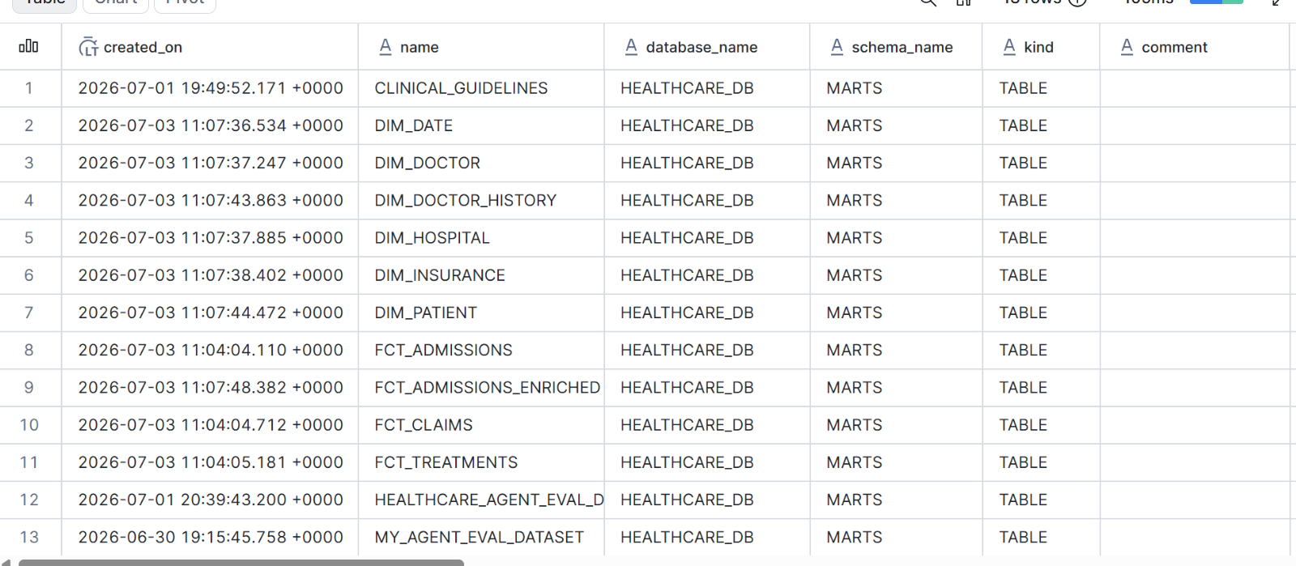

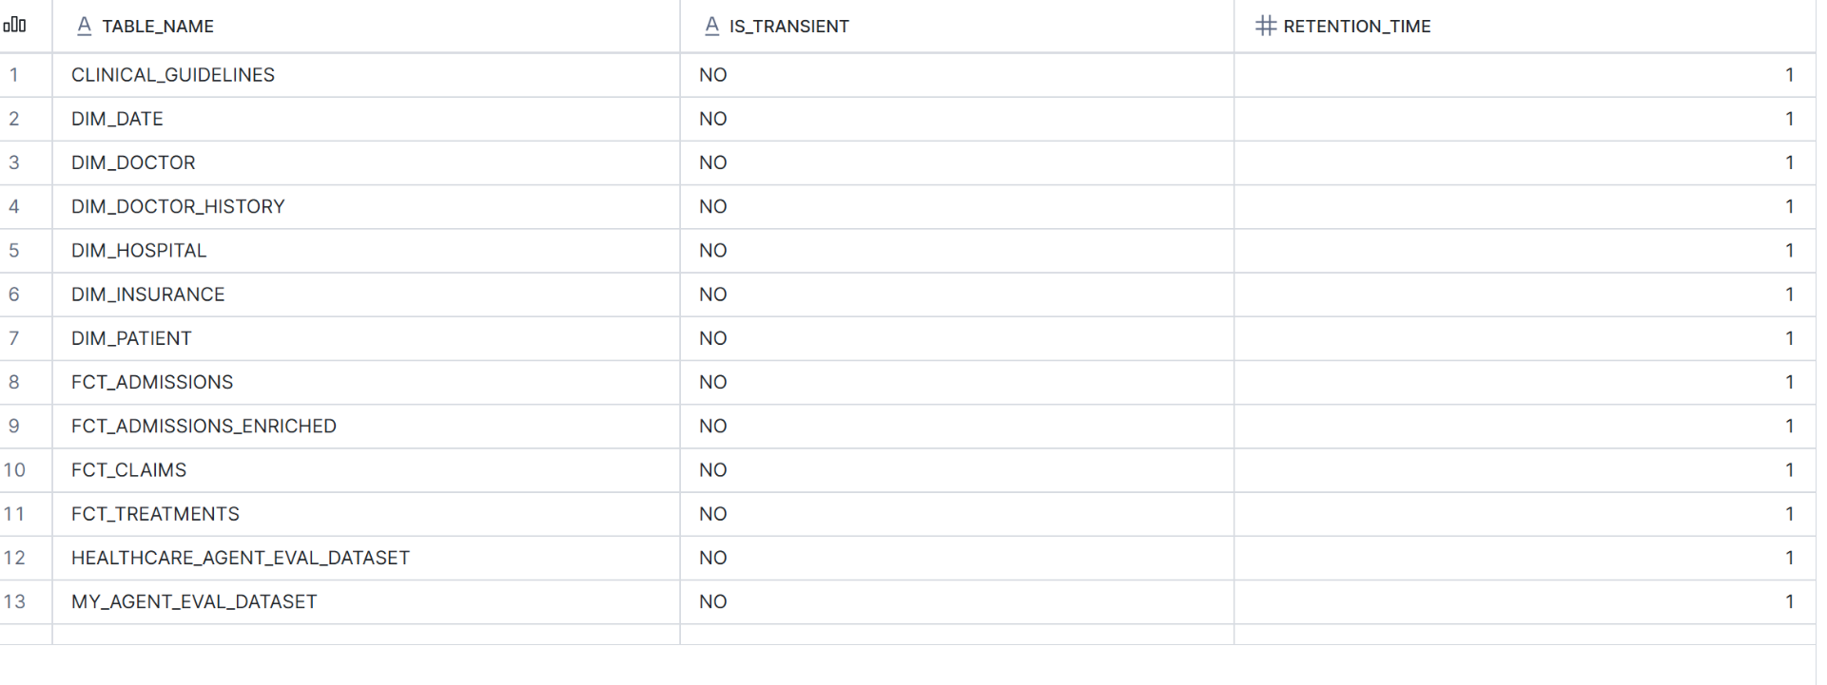

10. Building the dbt project (VS Code)

Once the Snowflake setup (section 3) is done, open the dbt project in VS Code. Every dbt command must run from the PROJECT ROOT with the virtual environment active — the prompt must show (dbt_env) at the front. First, activate it:
cd C:\Users\priya\Documents\Healthcare_Analytics
.\dbt_env\Scripts\Activate.ps1 # prompt should now show (dbt_env)
Two common gotchas
“dbt is not recognized” means one of two things: the environment isn’t active (no (dbt_env) in the prompt — run the Activate line), OR you’re in the airflow/ subfolder (dbt must run from the project root, where dbt_project.yml lives).
Then run these, in order:
dbt deps # install any packages
dbt seed # load doctors / hospitals / insurers into RAW
dbt run # build Silver (STAGING) -> Gold (MARTS) -> Snapshots
dbt test # run all data-quality tests
Then, back in Snowsight, run 08_add_star_schema_keys.sql to declare the Gold keys.

10.1 Commands you’ll run day to day (with examples)
Once built, here are the commands you reach for and WHEN you’d run each:
You added a column to stg_admissions.sql and want to rebuild just that model:
dbt run --select stg_admissions
Gold looks empty even though RAW has data (the incremental models think there’s nothing new) — force a full rebuild:
dbt run --full-refresh # then re-run 08_add_star_schema_keys.sql in Snowsight
You changed a DAG file and need Airflow to pick it up:
cd C:\Users\priya\Documents\Healthcare_Analytics\airflow
docker compose up -d # start Airflow
docker compose restart # reload DAGs after a code change
docker compose down # stop Airflow
You finished a change and want to save it to GitHub:
git status # see what changed (check no secrets are staged)
git add .
git commit -m "Add readmission column to stg_admissions"
git push origin main
Never commit secrets
Before git add, make sure profiles.yml, rsa_key.p8 (any .p8), and .env are in .gitignore and NOT in the staged list. Setup SQL should use placeholders (<YOUR_BUCKET> etc.), not real values.
Command |  | What it does
dbt seed |  | Loads the small reference CSVs (doctors, hospitals, insurers). Never truncate these by hand.
dbt run |  | Creates/updates all Silver views and Gold tables. dbt writes the DDL itself.
dbt test |  | Runs uniqueness, not-null, accepted-values and relationship tests across the models.
dbt run --full-refresh |  | Rebuilds tables from scratch (use after structural changes; re-apply Gold keys after).

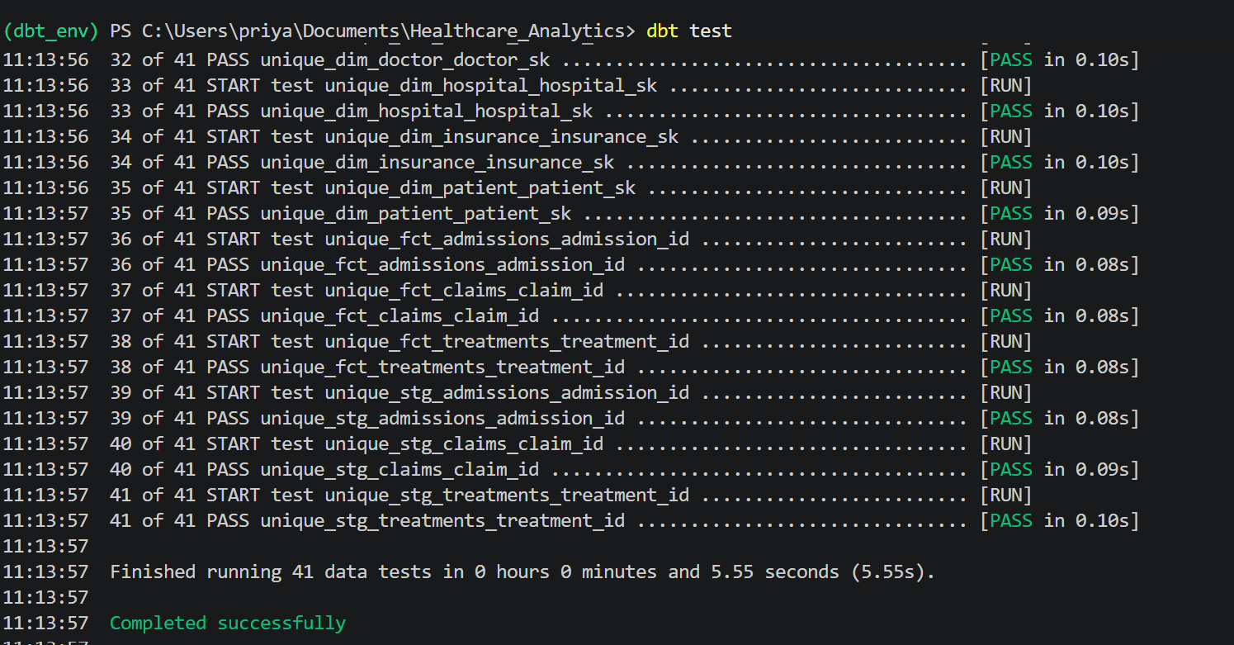

11. Snapshots — tracking change over time (SCD2)
Some dimension values change over time. A doctor gets promoted, changes specialty, or moves hospital. The question every data team must answer is: when a value changes, what happens to the old value? This is called Slowly Changing Dimension (SCD) handling, and dbt solves it with a feature called snapshots.

11.1 The three SCD types (the difference)
Type | What it does | Trade-off
Type 1 | Overwrite the old value — it is simply replaced | Simple, but history is lost
Type 2 | Keep the old row (expire it) and add a new version, each with valid-from/valid-to dates | Full history; more rows — THIS PROJECT USES THIS
Type 3 | Keep only the single previous value in an extra column | Remembers just one change back
Example — Dr. Olga Perez was Nephrology / Junior in 2023 and is Cardiology / Senior now. With Type 2, both versions are kept:
doctor_id | specialty | seniority | valid_from | valid_to | is_current
D001 | Nephrology | Junior | 2020-01-01 | 2025-03-15 | false
D001 | Cardiology | Senior | 2025-03-15 | (open) | true
An admission dated 2023 matches the first row → correctly shows Nephrology/Junior, even though she is senior now. That is point-in-time correctness, and it is why SCD2 matters for healthcare and compliance reporting.

11.2 Which table — and how dbt does it
This project applies SCD2 to the doctor dimension. The flow is: the seed_doctors reference data feeds a dbt snapshot, which produces the versioned history table dim_doctor_history (202 rows for 200 doctors — meaning 2 doctors currently have a second version).
You write a short snapshot file in the snapshots/ folder; dbt does all the version bookkeeping (valid-from / valid-to / current flag) automatically on every dbt snapshot run:
{% snapshot scd_doctors %}
{{
config(
target_schema='snapshots',
unique_key='doctor_id',
strategy='check',
check_cols=['specialty','years_experience']
)
}}
select doctor_id, doctor_name, specialty, years_experience
from {{ ref('seed_doctors') }}
{% endsnapshot %}
What the 'check' strategy does
On each run, dbt compares the listed check_cols against what it stored last time. If specialty or years_experience changed for a doctor, dbt closes the old row (sets valid_to = now) and inserts a new current row. If nothing changed, it leaves the row alone. You never write that logic — dbt manages dbt_valid_from / dbt_valid_to for you.
Why we used it: temporal correctness (admissions reflect the doctor’s attributes at the time, not now), auditability (prove what was true on any past date), and because SCD2 is the industry-standard way to track dimension change. The point-in-time values then flow into fct_admissions_enriched (specialty_at_admission vs current_specialty).

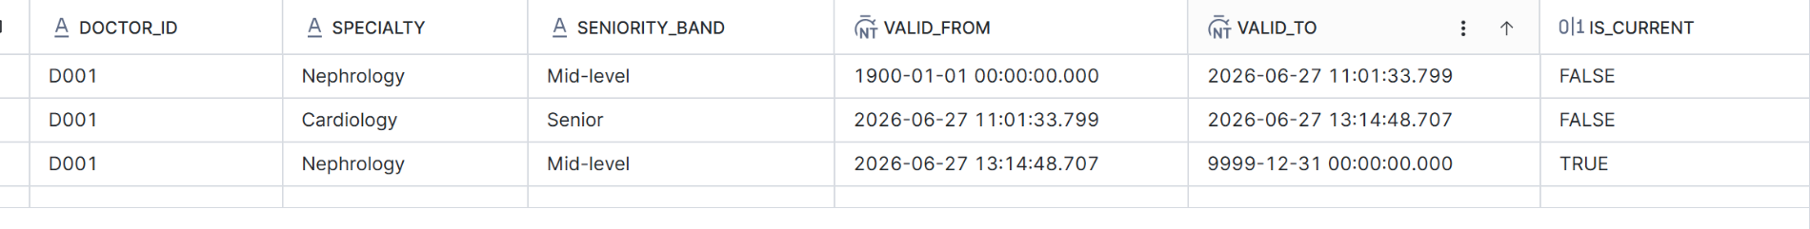

11.3 FCT_ADMISSIONS_ENRICHED — SCD2 applied to admissions
FCT_ADMISSIONS_ENRICHED is where the SCD2 history is put to work. It is the same admissions as FCT_ADMISSIONS, but pre-joined to the doctor’s history so each admission carries the doctor’s attributes AS THEY WERE on the admission date, next to their current values:
- specialty_at_admission / seniority_at_admission — what the doctor was at the time of that admission (looked up from DIM_DOCTOR_HISTORY using the valid_from/valid_to window).
- current_specialty — what the doctor is now.
- specialty_changed_since — a flag showing the two differ.
This answers questions a normal fact table cannot: “was the treating doctor junior at the time, even though they’re senior now?” A plain fact joined to DIM_DOCTOR would only ever show the doctor’s CURRENT attributes — rewriting history. The enriched table avoids that by carrying the point-in-time values.
How it fits the model
FCT_ADMISSIONS_ENRICHED is standalone — it carries DOCTOR_ID and its own dates, not surrogate keys, so in Power BI it needs no relationships; you build visuals straight from its columns. It’s used only for point-in-time doctor questions; everyday KPIs use the plain star (FCT_ADMISSIONS + dimensions).
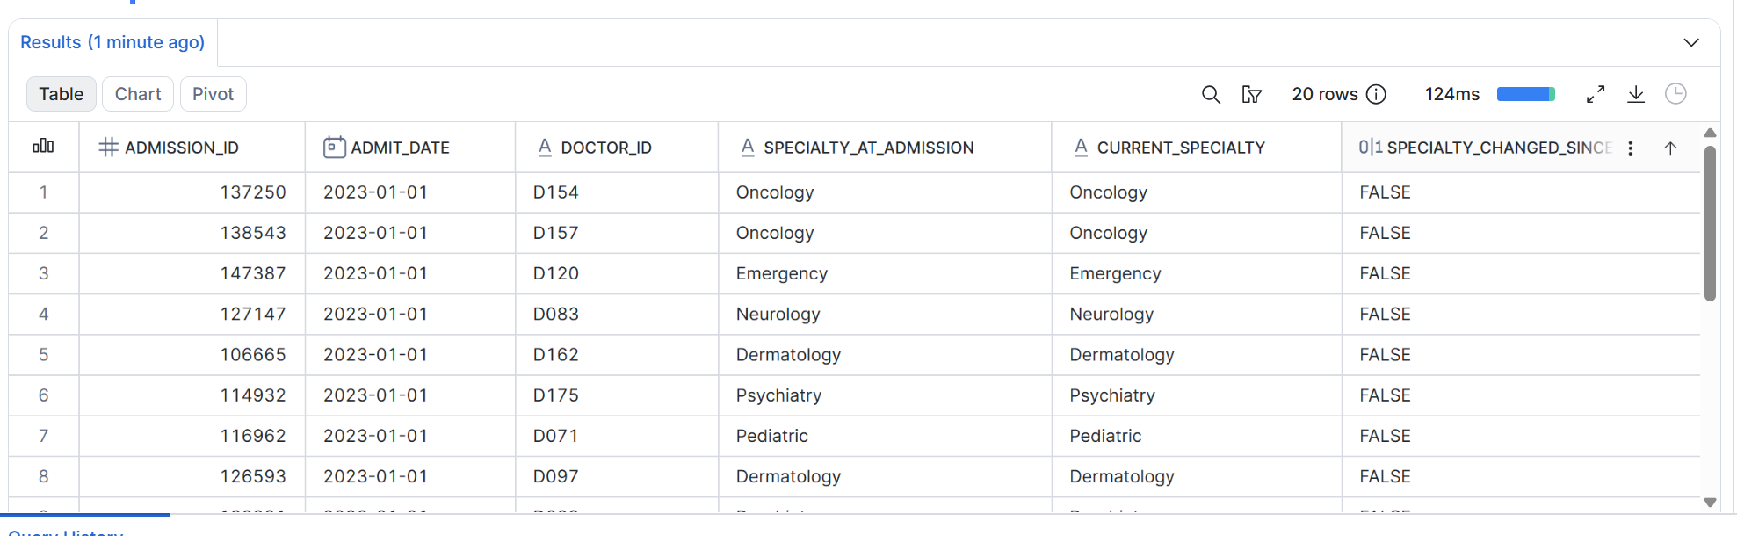

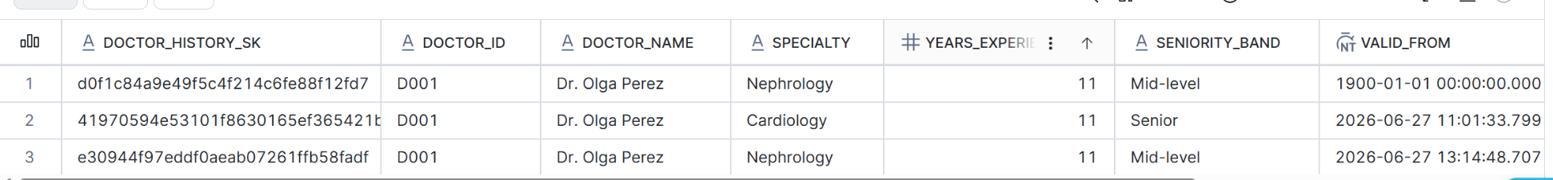12. Macros — reusable SQL functions
A dbt macro is a reusable piece of SQL logic — like a function in a programming language. You write it once and call it from many models, so logic stays consistent and you avoid copy-pasting. Macros live in the macros/ folder and are written in Jinja (the {% ... %} templating dbt uses).

12.1 generate_schema_name — controls how schemas are named
By default, dbt prefixes the target schema with your profile’s schema name (e.g. dbt_priya_marts). That is messy. This macro overrides that behaviour so a model lands in exactly the schema you name in config (marts, staging, etc.) — clean, predictable schema names.
{% macro generate_schema_name(custom_schema_name, node) -%}
{%- if custom_schema_name is none -%}
{{ target.schema }}
{%- else -%}
{{ custom_schema_name | trim | upper }}
{%- endif -%}
{%- endmacro %}
Why this matters
Without it, your Gold tables would build into something like DBT_PRIYA_MARTS instead of MARTS. This macro makes dbt use the schema name exactly as written (upper-cased), so STAGING, MARTS, SNAPSHOTS are clean. (This is also the file whose stale cache caused a parse error once — fixed with dbt run --no-partial-parse.)

12.2 money — consistent currency rounding
A tiny helper that rounds any money expression to 2 decimal places, so every cost/amount calculation is formatted identically across models — no repeated round(..., 2) everywhere.
{% macro money(column_name) %}
round({{ column_name }}, 2)
{% endmacro %}
Used like: {{ money('sum(cost)') }} inside a model, which dbt expands to round(sum(cost), 2). Change the rule once in the macro and every call updates.

13. Seeds — version-controlled reference data
A seed is a small CSV file stored in the project’s seeds/ folder that dbt loads into the warehouse as a table when you run dbt seed. Seeds are for small, static reference/lookup data that rarely changes and that you want versioned in Git alongside your code.

13.1 The seeds in this project
Seed | Loads into | Holds
seed_doctors | RAW | 200 doctors (D001–D200): id, name, specialty, years experience
seed_hospitals | RAW | 10 hospitals (H01–H10): id, name, city
seed_insurers | RAW | 15 insurers (I01–I15): id, name
These are the reference/lookup values the dimensions are built from — e.g. dim_doctor and the SCD2 doctor history both start from seed_doctors. Patients have no seed (there is no fixed patient master); dim_patient is derived from admission history instead.

13.2 Seeds vs sources vs models
Concept |  | What it is | Example here
Seed |  | Small CSV loaded by dbt into a table | doctors / hospitals / insurers
Source |  | Data already in the warehouse that dbt reads (not loaded by dbt) | the RAW admission/treatment/claim tables (loaded by the gatekeeper)
Model |  | A SELECT that dbt turns into a view/table | stg_admissions, dim_doctor, fct_claims
Why seeds (and one rule)
Reference data like the doctor and hospital lists is small and changes rarely — perfect for a version-controlled CSV. RULE: never truncate or hand-edit seed tables in Snowflake. To change them, edit the CSV and re-run dbt seed, so the file in Git stays the source of truth.
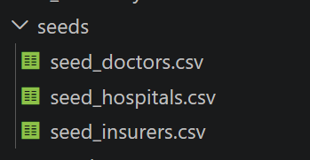

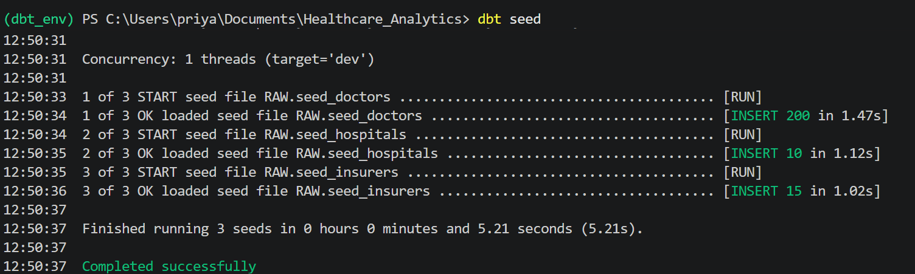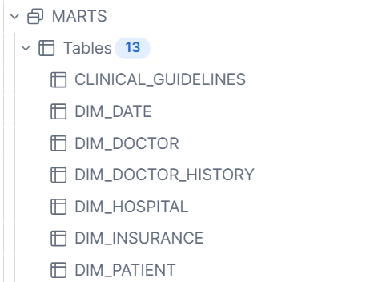

14. How the gatekeeper works
The gatekeeper is the single validated front door for all data. Before any file’s rows are allowed into the warehouse, it checks that the data is good. Bad data is stopped at the door. This section explains it two ways: a simple overview, then the technical version with the real stages and tables.

14.1 Simple view (data vs file)
The most important idea: the DATA (the rows) and the FILE (the .csv) are two different things that end up in two different places. When a file passes the checks, its rows are copied into the RAW table, and separately the file itself is moved to an archive folder. The data goes to a table; the file goes to a folder.
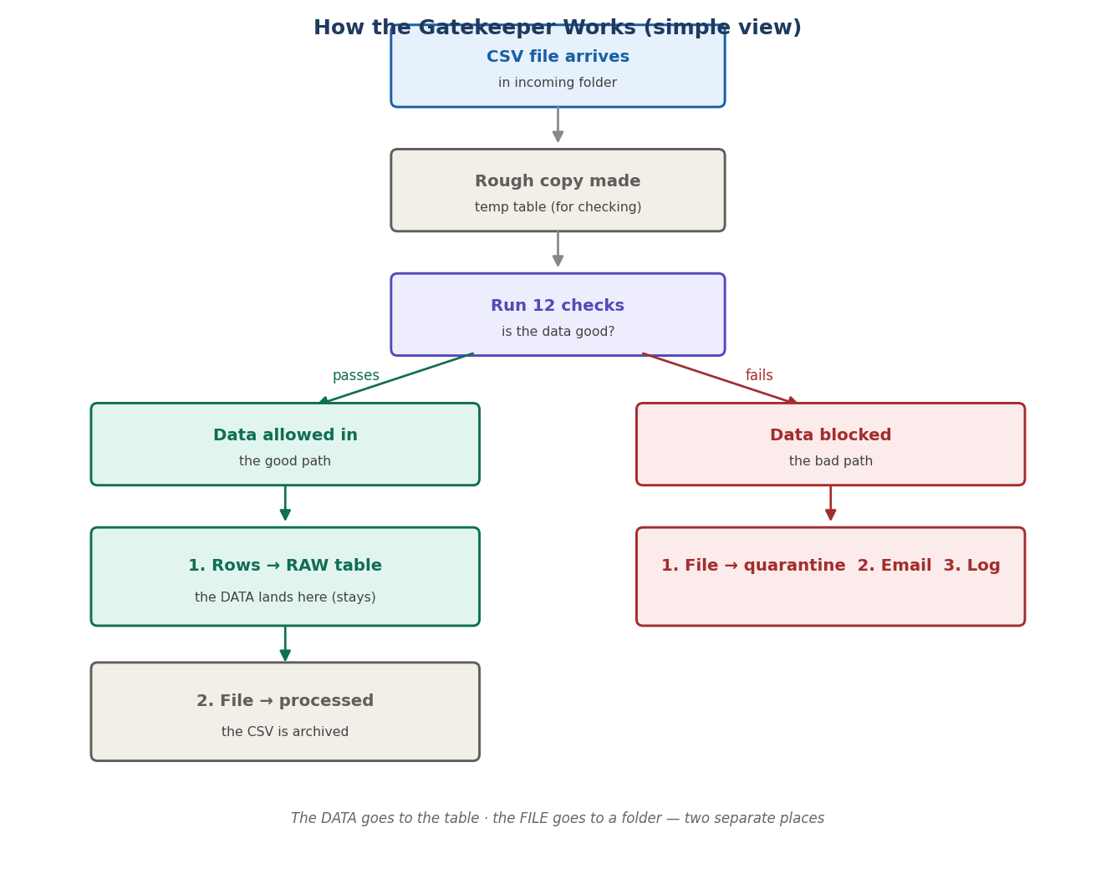
On the good (left) path two separate things happen: (1) the rows are loaded into the RAW table and stay there; (2) the file is moved to the processed folder as an archive. The processed folder is never a source — nothing is ever loaded from it. On the bad (right) path, the file is moved to quarantine, an email is sent, and nothing enters the table.

14.2 Technical view (stages + tables)
The same flow, now showing the actual S3 stages, Snowflake tables, and the function that does each step.
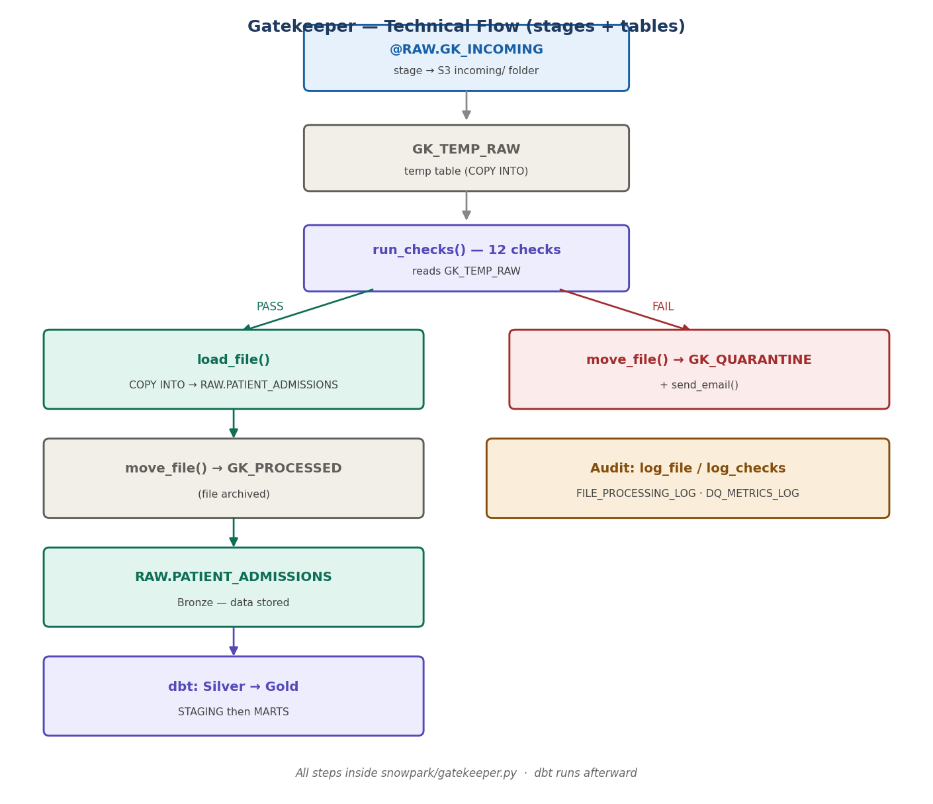

14.3 One file does all of it
Every step above lives in a single file: snowpark/gatekeeper.py. Each diagram step maps to a function inside it:
Step |  | Function in gatekeeper.py
Find & read the file’s columns from the incoming stage |  | list_incoming(), read_header()
Copy the file into the GK_TEMP_RAW temp table |  | load_to_temp()
Run the 12 quality checks |  | run_checks()
On pass: COPY INTO the real RAW table (stamps file_name / upload_dttm / load_dttm) |  | load_file()
Move the file to processed/ or quarantine/ |  | move_file()
Send the alert email on failure |  | send_email()
Write the report card + per-check detail to the audit tables |  | log_file(), log_checks()
Run all of the above in order for every file |  | main()
Where the gatekeeper ends and dbt begins
gatekeeper.py handles everything up to loading Bronze (RAW) and writing the audit logs. Transformation from RAW → Silver (STAGING) → Gold (MARTS) is done by dbt, run by the healthcare_pipeline DAG — a separate step. One file guards the door and loads Bronze; dbt builds the rest.
Note on the two file formats: the gatekeeper uses BOTH CSV formats deliberately — HEALTHCARE_CSV_NOHEADER in read_header() (to read the header row AS data and learn the column names) and HEALTHCARE_CSV in load_to_temp()/load_file() (which skips the header and loads the real rows). That’s why the setup keeps both formats.

15. What dbt generates from your config
You never hand-write the CREATE statements for Silver or Gold — dbt generates them from your model’s config and sends them to Snowflake to run. It’s worth seeing exactly what dbt produces, because it explains why a model configured as “incremental” shows up as a TRANSIENT TABLE in Snowflake.

15.1 One config, two different generated commands
A staging model’s config drives everything:
{{ config(
materialized=’incremental’,
unique_key=’admission_id’,
incremental_strategy=’merge’
) }}
From those few lines, dbt generates DIFFERENT SQL depending on the run:
Run type | What dbt generates | When it happens
First run / --full-refresh | create or replace TRANSIENT TABLE … as (select …) | Table doesn’t exist yet, or you force a rebuild
Normal (incremental) run | merge into … using (new rows) on admission_id | Table exists — only add new / update changed rows
So the incremental config produces a create-transient-table on the first build, then a merge on every run after. The merge matches on unique_key (admission_id) — “when matched, update; when not matched, insert.” That is the incremental behaviour: it never rebuilds the whole table, it merges in the changes.
Why it’s a transient table (not a view)
The project default in dbt_project.yml sets silver → view, but each staging model’s own config sets materialized=’incremental’, and a model’s own config always beats the project default. Incremental must store data, and dbt’s default table type is TRANSIENT. So the models are transient tables, and the view default is simply overridden.

15.2 Where to see the generated SQL
dbt authors the SQL but Snowflake runs it, so you can see it in three places:
- target/run/healthcare_analytics/models/silver/stg_admissions.sql — the exact statement dbt generated (create-table after a –full-refresh, or merge after a normal run).
- logs/dbt.log — dbt’s own run log; search for stg_admissions to see each statement with a timestamp.
- Snowflake → Snowsight → Monitoring → Query History — Snowflake’s complete record of every command it ran, including the create-transient-table, searchable by table name with time, rows and status.
To force the create-transient-table command (so you can see it), run a full refresh of just that model:
dbt run –select stg_admissions –full-refresh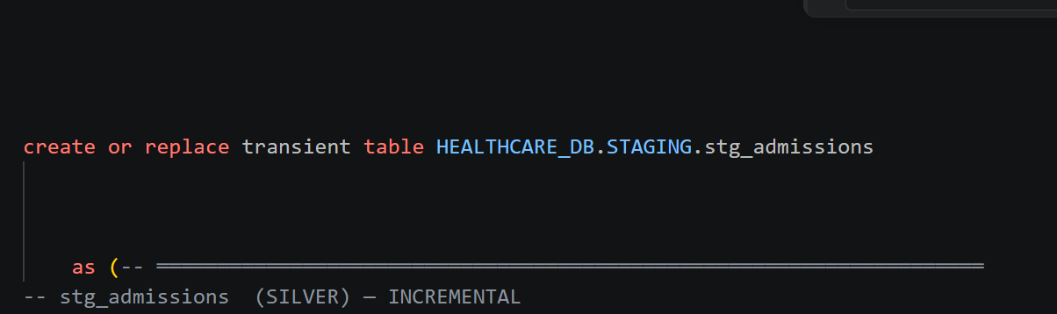
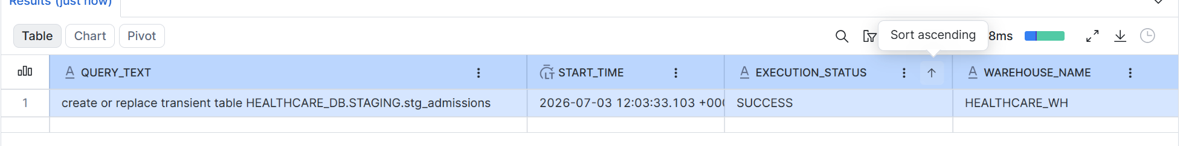

16. Airflow — orchestration & setup
Airflow is the scheduler that runs the whole pipeline automatically. It runs the gatekeeper, then triggers dbt — on a schedule and on demand. It runs inside Docker (on Windows, Docker uses WSL2/Ubuntu under the hood), so the whole environment is reproducible.

16.1 Setting up Airflow from scratch
These are the commands, in order. The important thing to understand: you only write a few files yourself — Airflow generates its own config automatically.
Step 1 — install WSL + Ubuntu (Windows only), then Docker Desktop:
wsl –install # in PowerShell (Admin), then restart the PC
# install Docker Desktop, keep “Use WSL 2” ticked, give it 4GB+ memory
docker –version # run inside Ubuntu to confirm Docker works
Step 2 — get Airflow’s official docker-compose file, then customise it:
curl -LfO ‘https://airflow.apache.org/docs/apache-airflow/stable/docker-compose.yaml’
The official file is then customised (this is the part you edit) by adding: the Snowflake environment variables, the extra pip packages (dbt-snowflake, snowflake-snowpark-python, cryptography), and volume mounts so the container can see your project, config, and keys folders.
Step 3 — create the folders and initialise Airflow:
mkdir -p ./dags ./logs ./plugins ./config ./keys
docker compose up airflow-init # AUTO-CREATES airflow.cfg, .user.yml, sets up the DB + login
docker compose up -d # start all services
# then open http://localhost:8080 (login: airflow / airflow)
Which files you create vs which Airflow auto-creates
You create: profiles.yml, the DAG files, and place your rsa_key.p8. You edit: docker-compose.yaml (add Snowflake env vars + mounts). Airflow AUTO-CREATES on `docker compose up airflow-init`: airflow.cfg, .user.yml, and the logs/plugins folders — you never write those.

16.2 How Airflow connects to Snowflake (no UI connection)
A common point of confusion: this project never sets up a Snowflake connection in the Airflow UI (Admin → Connections). Instead, the credentials flow from a .env file, through docker-compose, into the container — and the code connects directly.
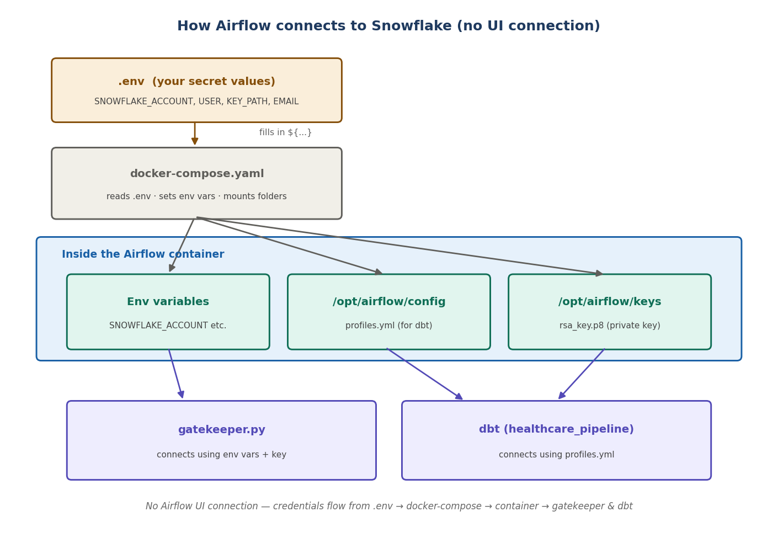
There are two connection paths, both avoiding the Airflow UI. The Python gatekeeper reads SNOWFLAKE_ACCOUNT, SNOWFLAKE_USER and the key path from environment variables (set by docker-compose from your .env file). Dbt reads its connection from profiles.yml, which lives in the mounted config/ folder — the DAG points to it with –profiles-dir /opt/airflow/config.
What connects |  | How it authenticates | Where the details live
gatekeeper.py (Snowpark) |  | env vars + private key file | docker-compose env vars (from .env) + keys/rsa_key.p8
dbt (healthcare_pipeline) |  | profiles.yml | config/profiles.yml (mounted into the container)
Never commit secrets
The real values live in airflow/.env and config/profiles.yml and keys/rsa_key.p8 — all of which must be in .gitignore. The docker-compose file only references them with ${…} placeholders, so it’s safe to commit.

16.3 The two DAGs and how they chain
There are two DAGs. Gatekeeper_pipeline runs the gatekeeper (validate + load), then automatically triggers healthcare_pipeline (the dbt transform). This chaining is done by a TriggerDagRunOperator inside gatekeeper_dag.py — so a successful load flows straight through to Gold with no manual step.
DAG | Tasks | What it does
gatekeeper_pipeline | gatekeeper_validate → trigger_healthcare_pipeline | Runs gatekeeper.py, then triggers the transform DAG
healthcare_pipeline | dbt_run → dbt_snapshot → dbt_test → reconciliation | Builds Silver + Gold, snapshots history, runs tests
The >> operator in each DAG sets the order: a task only runs if the one before it succeeded. Importantly, a file quarantine is NOT a task failure — the gatekeeper handles it gracefully and the pipeline continues, so good files still flow to Gold while bad files are set aside. Only a real crash (Snowflake unreachable, bad key) fails a task and stops the chain.

16.4 Everyday Airflow commands
cd C:\Users\priya\Documents\Healthcare_Analytics\airflow
docker compose up -d # start Airflow
docker compose restart # reload DAGs after editing a DAG file
docker compose down # stop Airflow
# UI: http://localhost:8080 (airflow / airflow) — trigger a DAG with the play button

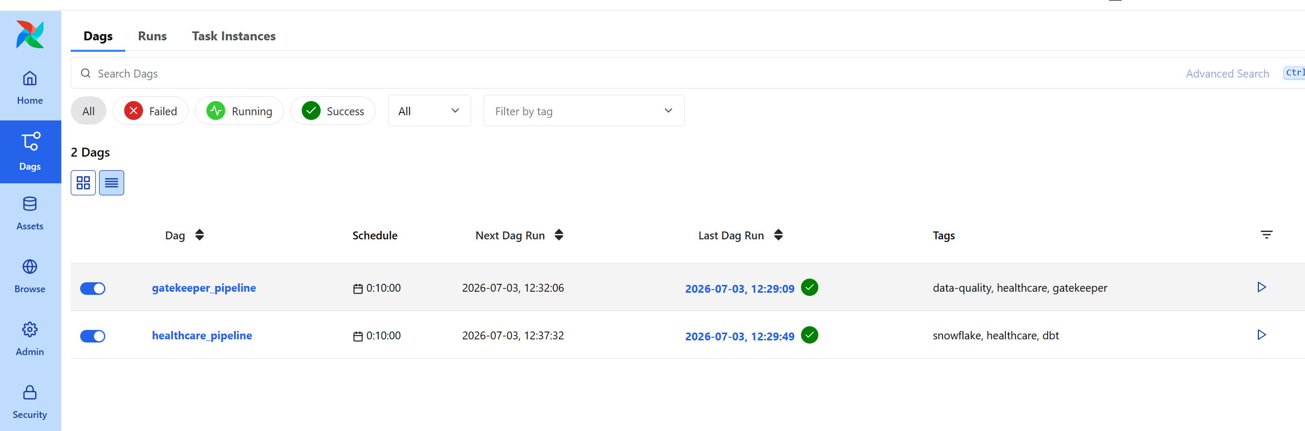

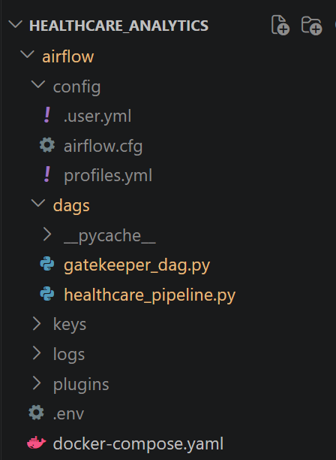

17. Quick build checklist
Follow this end to end to stand up the whole project from nothing:
- Create the S3 bucket + folders (incoming / processed / quarantine) and the IAM role (file 02 comments).
- Run Snowflake files 01 → 06 in Snowsight (replace placeholders first).
- Finish the S3 trust handshake using the DESC INTEGRATION output (file 02).
- Set up Airflow (section 16): install WSL/Docker, customise docker-compose, docker compose up airflow-init, then up -d.
- Deploy the gatekeeper + DAGs to Airflow; confirm the test email arrives.
- In VS Code: dbt deps → dbt seed → dbt run → dbt test.
- Run file 08 to declare the Gold PK/FK keys.
- Confirm: SHOW TABLES shows permanent + 90-day; SHOW IMPORTED KEYS shows 8 FKs.
- Connect Power BI / Cortex to the MARTS schema — relationships auto-build.
You’re done
At this point a file dropped into S3/incoming is validated, loaded, transformed, tested, and available to BI — fully automated, fully logged, with email alerts on any failure.

