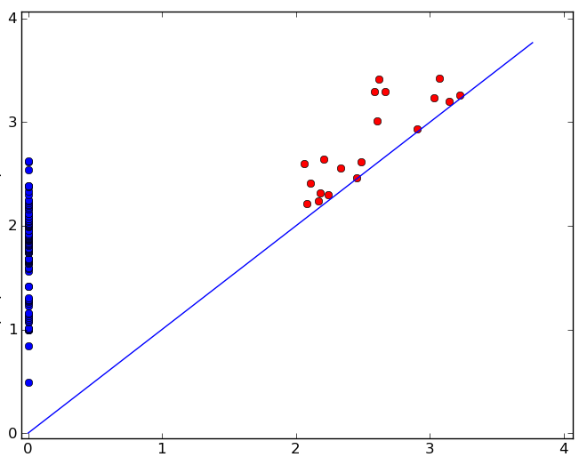

Topological
Data
Analysis
Version 0.1

User Guide
By John Harer and
Jürgen Sladeczek

Contents

Introduction 1
Getting Started 2
Requirements 2
Downloading the Files 2
Installation 3
Quick Start – Standalone Use 3
Quick Start – API Use (illustrated in Matlab) 4
Using Your Own Data 11
Sample Output and Screenshots 12
Using TDA 13
The TDA Application 13
The TDA Components 14
Input Data 14
Data Format: Point Cloud 14
Data Format: Distance Matrix 15
Data Format: “Sparse” Matrix 16
Tasks 17
Task: Rips Complex Analysis 17
RCA1 = M12 17
RCA2 = M23 17
RCA0 = Union Find 17
M01 17
Task: Compute Local Spherical Distance (LSD) 17
Using TDA in Matlab 18
Editing the TDA Java Source 20
Setting up the TDA Project in Eclipse 20
Running the Examples in Eclipse 23
Troubleshooting 27
When Little Things Don't Work As Expected 27
Missing or Invalid Parameter in the Settings File 27
Miscellaneous Errors and Warnings 27
Error During Program Execution 27
From the Api 27
Running Out of Memory 28
Data Affecting Memory Use 28
Crash With TDA “System” Error Message 29
Submitting an Error Report 29
Appendix A 31
File Formats 31
Example of a Minimal Settings File 31
Example of a Comprehensive Settings File 32
PointCloud File Example 33
Distance Matrix File Example 33
Sparse Matrix File Example 33
Appendix B 35
Settings File: Parameter Names and Values 35
Appendix C 40
API Calls 40
API Settings 42
Appendix D 43
References 43

Introduction
This guide focuses on using the core component of the TDA application, namely the jar file tda.jar, as a stand-alone application. This is in contrast to the separate user guide written by users of the Harer research group at the Duke University Mathematics Department. This group of users uses Matlab as the preferred front-end to tda.jar, and has developed a large amount of materials and examples for this approach. In this guide we will only briefly document how to access the methods in the tda.jar application from another application or programming language. For more extensive documentation on how to use the TDA API, the user is encouraged to examine the Matlab code that interfaces to tda.jar.

Getting Started

Requirements
The Topological Data Analysis (TDA) application is designed to work as a stand-alone application, without additional libraries or helper tools. However, since TDA is implemented in Java, the one prerequisite for using TDA on a particular computer or operating system is the availability of a Java virtual machine (JVM). The code has been written to comply with the 1.7 or later release of the Java SDK/JRE.

We have successfully tested TDA on PCs running Mac OS X, Scientific Linux, and Windows (XP, Windows 7), with available memory of at least 256 MB. If your system does not have a JVM installed, you can download one for free from http://www.java.com (the Java Runtime Environment) or http://www.oracle.com/technetwork/java/index.html (the Java SDK, needed only if you intend to make changes to the code).

Any Java development environment, from simple text editor to full-featured IDE, can be used to modify the code. We use the open source Eclipse IDE (http://www.eclipse.org) to develop TDA. The TDA Developer Guide features a brief tutorial on how to modify TDA within the Eclipse IDE.

Besides using TDA as a stand-alone tool, we have also implemented a ‘application programming interface’ (API) for accessing all of TDA’s functionality from another application (such as Matlab), or from any programming language that is capable of linking to Java code. Note that most languages have this capability, though the steps necessary can range from trivial to a little more involved.

Downloading the Files
Before downloading, please verify that your system has the required version of Java installed: open a console or command window, and type:

java -version

On a Windows machine you may see something similar as:

C:\>java -version
java version "1.7.0_55"
Java(TM) SE Runtime Environment (build 1.7.0_55-b13)
Java HotSpot(TM) Client VM (build 24.55-b03, mixed mode, sharing)

TDA is available for download as a Java Archive file (tda.jar) in a larger zip file (tda.zip). As long as you have the required version of Java installed, you will be able to run TDA from the command line without any need for compiling. The zip file also contains examples for computing the persistence, for several point clouds and distance matrices. We recommend that you extract tda.zip in a way that preserves the directory structure within the zip file. This way you can test TDA without any additional configuration. The following is a manifest of the files within tda.zip:

- README.txt - a welcome, containing a basic description of the files, as well as information on how to test whether your installation was successful
- Jars directory – Contains the main tda.jar of the Tda application.
- Data directory – Contains the default configuration/settings file tda.config.txt, as well as a number of example settings file with corresponding directories. All directories are named after an example, and contain subdirectories input and output. Each input directory contains the data file(s), and each output directory is set up for receiving the output produced by running the Tda application with the corresponding settings file.

Please note that this download is separate from the more extensive Matlab download that is also available from the TDA web pages on the Harer Group website.

Installation
Installing Tda is about as simple as it gets: simply download the tda.zip archive, and expand it to a location of your choice.

In the following we shall describe the two different usage modes that Tda supports. We call the first mode ‘standalone’, because it is not dependent on another application or host environment, and the second mode ‘api’, because it enables Tda to run within another environment such as Matlab, or any programming language/IDE that can ‘talk to’ (link) to a Java jar archive. Unfortunately, each environment has its own preferred syntax for linking to Java, and make the linking process more or less trivial – please refer to your favorite tools documentation for instructions, and the wealth of information available online.

Quick Start – Standalone Use
For the following, we assume that you have a working Java VM installed and the tda.zip downloaded and unzipped. Here are the steps for “test-driving” the TDA software:

- Open a command shell, and change directories to the directory where you expanded tda.zip (and that now contains the jars and data directories).
- To run the first test, type

java -jar tda.jar settingsFile=data/verifyInstall.settings.txt

in your command shell, and press Enter. If your environment is set up properly, the TDA application will start by printing out the results of the computation.

- To run the second test, and to demonstrate an alternate syntax for specifying the location of the settings file, type

java -jar tda.jar settingsFile=rca1.settings.txt settingsDirectory=data

- To use the TDA application with your own data, edit the settings template file called template.settings.txt. Unlike the settings files in the previous two tests, this template file does not contain enough information to run Tda on its own, so to make it work, appropriate values of the settings to describe your own data must be inserted.
You can eve save your settings file with the name tda.config.txt in the data directory [this is the name of the default settings file that Tda looks for when it can’t find another settings file], you can then run TDA with a shorter command line:

java -jar tda.jar

By the way, TDA lets you override any parameter from the settings file by appending it to the command line in the form item=value. A detailed description of all parameters used by Tda is available in Appendix A.

Quick Start – API Use (illustrated in Matlab)

In this section we will cover the basics of linking tda.jar to Matlab. Please note that we will use the most basic commands, and will not make use of the more sophisticated scripts that are available from the Harer research group also.

In this section we will outline the details of linking from an external environment to tda.jar. Although we will use Matlab as an example (in addition to describing the commands from the Java perspective), we don’t expect Matlab users to actually follow this path, because we encourage Matlab users to download our dedicated Matlab scripts collection, which further simplifies the end user experience.

Set-up:

>> javaclasspath('bin/tda.jar')
>> import tda.api.*;
>> tda=Tda()

tda =

TDA 0.0.10 (alpha->beta), 28 April 2014

The javaclasspath command tells Matlab where the tda.jar is located, and the import command links to the methods that the jar file makes available. The final line, ‘tda = Tda()’ , creates a Tda object. As part of our code we provide the version info for the tda.jar file that is being used.

Execution of some sample commands:

>> X = load('SwissRollSample.txt');
>> tda.RCA1( { 'taskchoice=m12', 'applicationmode=api', 'supplyDataAs=pointCloud', 'distanceBoundOnEdges=10' }, X)
-------------------------------------------------
TDA: Computing M12
-------------------------------------------------

Number of vertices = 500
Number of edges = 42876
Distance bound on edges = 10.0
Dimension of points = 3

Elapsed time: 4.9 s

ans =

Available Results:
0 0-dim. intervals
1 1-dim. intervals
2 Number of edges
3 Initial size (number of columns) of reduction matrix
4 Computation time (formatted) of matrix M12
5 Reduction time (formatted) of matrix M12
6 Computation time (raw) of matrix M12
7 Reduction time (raw) of matrix M12
8 Memory use at startup of M12 computation
- Memory use after computing matrix M12

Results:

>> tda.getResults( 0 )

ans =

0: ( 0.0, 0.044030444013205446 )
1: ( 0.0, 0.050734209366067685 )
2: ( 0.0, 0.051412550996814216 )
…
2313: ( 0.0, 1.5568759308628284 )
2524: ( 0.0, 1.6317097965018161 )
2906: ( 0.0, 1.7748525186335906 )
-1: ( 0.0, -1.0 )

>> tda.getResults( 1 )

ans =

285: ( 0.48061884232726454, 0.4962576915272951 )
340: ( 0.5279408323855997, 0.5464021450360532 )
352: ( 0.5049695326452871, 0.5586783421612116 )
…
18363: ( 6.258914694457817, 6.359643174149004 )
18595: ( 6.254209546705322, 6.382572061677016 )
19400: ( 6.382184484876631, 6.469363873836438 )
17012: ( 6.225702081339904, -1.0 )

>> tda.getResults( 2 )

ans =

42876

>> tda.getResults( 3 )

ans =

201

>> tda.getResults( 4 )

ans =

4.9 s

>> tda.getResults( 5 )

ans =

66.0 ms

>> tda.getResults( 8 )

ans =

At start-up of M12 computation, TDA is using 79 (out of an available 352) MB of memory

>> tda.getResults( 9 )

ans =

After computing M12 matrix, TDA is using 66 (out of an available 352) MB of memory

Elements of the TDA API:

Create a Tda object:

>> tda=Tda()

tda =

TDA 0.0.10 (alpha->beta), 28 April 2014

Optionally, it is possible to pass an argument to Tda() when creating the tda object:

>> tda=Tda({ 'settingsFile=data/my.settings.txt' });

tda =

TDA 0.0.10 (alpha->beta), 28 April 2014

You can pass along any argument, or combination of arguments, that are valid for the assignData method that follows in the next section.

Set a property of the object:

>> tda.assignData({ 'settingsFile=data/my.settings.txt' });
>> tda.assignData({ 'supplyDataAs=sparseMatrix', 'distanceBoundOnEdges=10' });

There can be as many assignData calls as needed. If the same property gets set repeatedly, the last value will be the one used.

Execute a task:

>> tda.RCA1();

or, with any settings specified the same way as in the assignData call:

>> tda.RCA1({ 'supplyDataAs=sparseMatrix', 'distanceBoundOnEdges=10' });

Choices of task at the time of writing this guide are RCA0, RCA1, RCA2 (currently being developed) and LSD.

Get info about the Tda object using the ‘getInfo’ method:

>> tda.getInfo

ans =

getInfo( i ) provides basic information about the state of your TDA instance:
use i =
1 for summary of results,
2 for error messages (if any),
3 for warning messages (if any).
4 for version number and date.
5 for complete listing of settings/configuration values.
6 for the setting values specified in the configuration file.
7 for a listing of available algorithms and tasks.

Get results from the Tda object using the getResults method:

>> tda.getResults

ans =

Available Results:
0 0-dim. intervals
1 1-dim. intervals
2 number of edges
3 initial size (number of columns) of reduction matrix
4 Computation time (formatted) of matrix M12
6 Computation time (raw) of matrix M12
5 Reduction time (formatted) of matrix M12
7 Reduction time (raw) of matrix M12
8 Memory use at startup of M12 computation
9 Memory use after computing matrix M12

The listing reflects the option available for the previously executed task, and thus will vary accordingly. The Tda object will simply tell you what it knows about the task, in our example from the execution of a task of type RCA1. Use the index of the result as the argument, e.g.:

>> tda.getResults(9)

ans =

After computing M12 matrix, TDA is using 67 (out of an available 352) MB of memory

>> tda.getResults(4)

ans =

1.1 s

Note if you simply type ‘tda’ at the Matlab prompt, you will see the version number of the tda.jar, the actual results, as well as the info associated with all the results options listed above (this may be a lot of information…).

>> tda

tda =

TDA 0.0.11-61 (alpha->beta), 18 Nov 2014
Results of the last program execution:

0 ):
0-dim. intervals:
0: ( 0.0, 0.044030444013205446 )
1: ( 0.0, 0.050734209366067685 )
… [lines omitted]
2524: ( 0.0, 1.6317097965018161 )
2906: ( 0.0, 1.7748525186335906 )
-1: ( 0.0, -1.0 )

1 ):
1-dim. intervals:
285: ( 0.48061884232726454, 0.4962576915272951 )
340: ( 0.5279408323855997, 0.5464021450360532 )
… [lines omitted]
19400: ( 6.382184484876631, 6.469363873836438 )
17012: ( 6.225702081339904, -1.0 )

2 ):
number of edges:
42876
3 ):
initial size (number of columns) of reduction matrix:
201
4 ):
Computation time (formatted) of matrix M12:
1.1 s
5 ):
Reduction time (formatted) of matrix M12:
3.0 ms
6 ):
Computation time (raw) of matrix M12:
1116
7 ):
Reduction time (raw) of matrix M12:
3
8 ):
Memory use at startup of M12 computation:
At start-up of M12 computation, TDA is using 49 (out of an available 352) MB of memory
9 ):
Memory use after computing matrix M12:
After computing M12 matrix, TDA is using 67 (out of an available 352) MB of memory

>>

For the following, we assume that you have working copies of Matlab and a Java VM installed, and tda.zip downloaded. Working with TDA in environments other than Matlab will be similar, but you will need to figure out how your environment lets you access Java jar files.

Here are the steps to get you started:

- First, let’s verify that you have a valid Java VM accessible within Matlab. Start your Matlab environment and type the following in the command window:

version -java

You should see something similar to:

ans =

Java 1.7.0_11-b21 with Oracle Corporation Java HotSpot(TM) 64-Bit Server VM …

- Next, expand tda.zip in a subdirectory of your Matlab workspace directory. After expanding, you will find several directories, including /jars, containing tda.jar, and /data, containing the settings files and the example directories. Please note that the tda.zip file creates the directory structure in exactly the way we use it in our examples below, so that following along lets you concentrate on the essentials. Experienced Matlab users can move the location of the directories any way they desire – there are no hard coded references in the TDA applications code. (you can rename the tda.jar file if you like, too). Be aware, though, that the application uses tda.config.txt as a config file for specifying various (default) settings: The location of this file, and any path values for settings need to be specified so that they point to valid files or directories in order for everything to work. Obviously, the various rules for correctly specifying relative and absolute paths apply.

- Let’s make sure that we have Tda set up as needed. Within Matlab, navigate to the directory that contains the README.txt file, and the jars and data directories. We want to have this directory set as our ‘working directory’. Please type the following commands into the Matlab’s Command Window.

>> javaclasspath('jars/tda.jar');
>> import tda/api.*;
>> tda=Tda()

tda =

TDA 0.0.10 (alpha->beta), 28 April 2014

In Matlab, all lines that end with a semi-colon will not provide any output. Note that we omitted the semi-colon on the tda=Tda() line, which resulted in a simple message about the version and the type of object that ‘tda’ was created as. Also note that within Matlab, the parenthesis for tda=Tda() are not required, as we don’t specify any arguments to Tda() in this call. If you are familiar to object-oriented programming, we simply made a call to the constructor of the Tda class that is part of tda.jar, i.e., the Tda application.
If you get an error message for any of these lines, you are likely not in the correct directory within Matlab. In the Matlab command window, you can type ‘pwd’ to see where you are located in your file system.

Important: Any time you start a Matlab session, or reset your workspace, you will need to enter the javaclasspath and the import command again, to tell Matlab how to access the Tda application via the tda.jar file.

- To run a first test, type the following commands into the Matlab Command Window.

>> tda=Tda()

tda =

TDA 0.0.10 (alpha->beta), 28 April 2014

>> tda.assignData( { settingsFile=data/verifyInstall.settings.txt, user=me, project=myProject } );

>> tda.RCA1();

>> tda.getResults(0)

ans =

0: ( 0.0, 1.0 )
1: ( 0.0, 1.0 )
2: ( 0.0, 1.0 )
3: ( 0.0, 1.0 )
4: ( 0.0, 1.0 )
5: ( 0.0, 1.0 )
6: ( 0.0, 1.0 )
8: ( 0.0, 1.0 )
9: ( 0.0, 1.118033988749895 )
0: ( 0.0, -1.0 )

>> intervalsDim1 = tda.getResults(1).getIntervals()

ans =

1.4142 -1.0000
1.4142 -1.0000
1.4142 -1.0000
1.4142 -1.0000
2.0000 -1.0000
2.2361 -1.0000
2.2361 -1.0000

Here is what happened in Matlab: first we used tda=Tda() to create our tda object. We then assigned several parameters to the tda object, namely the [location of] the settings file, the name of the user, and the name of the project. We then executed the RCA1 algorithm by calling tda.RCA1(). Our example data set was small, so the results were being returned very quickly. For larger data sets, one may have to wait a bit longer for the Matlab prompt to appear, indicating that the RCA1 computation has finished. For RCA1 we know that our results should be the 0-dimensional and the 1-dimensional persistence intervals. This explains why we call tda.getResults(0) and tda.getResults(1). For the 1-dimensional intervals results we appended ‘.getIntervals()’ to the getResults method, and we also assigned our result to a variable intervalsDim1. You may have noticed the slightly different format of the output between the 0 and 1-dimensional intervals: when we append ‘.getIntervals’, we actually get the results returned in the form of a Matlab array, instead of the simply text string otherwise. Having the return values in array form makes it much easier to continue processing them within Matlab.

- To run the second test, and to demonstrate an alternate syntax for specifying the location of the settings file, type

java -jar tda.jar settingsFile=sonar.settings.txt settingsDirectory=data/examples

- To use the TDA application with your own data, edit the settings template file called template.txt. Unlike the settings files in the previous two tests, this template file does not contain enough information to run TDA as such, so to make it work, appropriate values of the settings to describe your own data must be inserted. If you choose to save your settings file with the name tda.config.txt and place it in the same directory as tda.jar, you can then run TDA with a shorter command line:

java -jar tda.jar

By the way, TDA lets you override any parameter from the settings file by appending it to the command line in the form item=value. A detailed description and additional information about parameter use in the settings file and from the command line is provided below. Feel free to experiment with different parameter combinations to discover their effects on the runtime performance of a particular algorithm.

Using Your Own Data
After your successful test drive of TDA, you may want to try TDA with your own data. Here are the steps to accomplish just that.

To prepare your data, you'll need a settings file that describes your data and how you want the algorithm to proceed, e.g., the name of the point cloud file, your choice of algorithm or work flow, etc. You'll also need an observations file in a very basic format: Each row contains the coordinates of a single point, with one entry for the value of each coordinate delimited by a tab (actually, you can use arbitrary white-space) between the values. Let's say that you saved your settings in my.settings.txt and saved your point cloud data as my.pointCloud.txt; the pointCloudFile setting in my.settings.txt should list my.pointCloud.txt as its value (select values for the remaining settings as you desire).

You can then run TDA on your data with

java -jar tda.jar settingsFile=my.settings.txt

You may want to save your data and associated settings file in a custom directory structure that keeps your data sets organized for easy retrieval. Simply set the parameters for the file and directory information in the settings file to point to your structure.

You can also override any setting by specifying a key-value pair:

java -jar tda.jar settingsFile=my.settings.txt settingName1=value1
settingName 2=value2

Make sure that there are no ‘spaces’ anywhere around the ‘=’-signs, so that the key-value pairs are interpreted by Java as such.

Sample Output and Screenshots
In the examples below, the output was taken directly from the TDA application and can be viewed as simulated screenshots obtained by running TDA in a console or terminal window on a workstation.

Using TDA

The TDA Application

The TDA Components
*** Please note that the general design of the components, in particular their separation into tasks, algorithms, and postprocessors, will be simplified into a single type that we shall refer to as task. This will allow us to create a more flexible model of stringing together multiple tasks (see the pipelining section below).

So, currently the components are still divided into 3 categories, namely tasks, algorithms, and postprocessors.

Input Data
Depending on the availability and the properties of your data, you can use one of the three available input formats for TDA.

When your data is in the form of a set of points, given by their coordinates in n-dimensional space, you want to use the pointCloud format. Here you simply supply the coordinates of each point on a separate (white-space delimited) line of your input file, select the metric you want used for computing the distances between the points. TDA will then load the points, and compute a list of edges by comparing the length of each edge with the distance bound threshold (we don’t keep longer edges around past this stage).

When we use the edge information for executing, say, the RCA1 task, we have the option of specifying the internal representation of the “inverse lookup” of an edge (and its associated vertices as well as other internal info that we use during the computation) as either a distance matrix or a sparse matrix. The two representations represent the classic trade-off between speed and storage: For very large problems, storing a large distance matrix becomes intractable, so we forgo some speed by using a sparse storage technique: you can set the number of edges at which you want to switch between the two representation via the switchToSparseAt setting parameter. Of course you can experiment, since this value will be influenced by the amount of memory available in your machine.

The second format that you can use is the distanceMatix. Here you data file is a square array that lists the edge length between each two points in your point cloud.

The third and final format available if a sparse matrix-like format, that we named monotonicFunctionOnSimplicialComplexMatrix. Here the data is supplied as triples of numbers, representing the (indexes of the) vertices and the distance between those vertices.

We now examine each of the three data formats in greater detail.

Data Format: Point Cloud
When the data is provided as a point cloud, the input simply consists of the coordinates of the points that make up the point cloud. When supplied as a file, each input line is expected to hold the coordinates for a single point, with the coordinates separated by white space. Internally we refer to a point as a vertex.

Edges, i.e. connections between points, are computed as the distances between each two points, based on the user-specified metric (currently L₁, L₂, or L-inf). The code of the application can be extended easily to make use of additional metrics.

The list of edges that will be the basis for the algorithms is then compiled by applying a distance bound on the length of the edges. This list of edges is sorted based on increasing edge length. For each edge we store the two vertices that it is based on, its length, and several pieces of auxiliary information based on the needs of the algorithm.

Note that internally we use either a distance or a sparse matrix representation of the edge list for quick look up of edge length values.

Matlab example:

>> javaclasspath('jars/tda.jar');
>> import api.*;
>> tda=Tda();
>> pc =[ ];
>> tda2.RCA1( { 'settingsFile=data/tdaConfig.txt', 'supplyDataAs=pointCloud’, 'distanceBoundOnEdges=70'}, pc );

or???

>> javaclasspath('jars/tda.jar');
>> import api.*;
>> tda=Tda();
>> pc=[1,0;0,-1;-1,0;0,1];
>> tda.LSD( pc, 5, [0,0] )

ans =

4.0000 4.3507 5.0990 4.3507
0 4.0000 4.3507 5.0990
0 0 4.0000 4.3507
0 0 0 4.0000

Data Format: Distance Matrix
We can also compute the list of edges from a distance matrix. Given n vertices, the distance matrix would simply be a n-by-n matrix, where the (i,j)-th entry contains the value for the length of the edge connecting vertices i and j. By specifying a distance bound, we can prune down the number of edges used in the algorithm; alternatively, we could specify edges that either don’t exist or that we don’t want to have considered, by providing a ‘-1’ value in the matrix.

Matlab example:

>> javaclasspath('jars/tda.jar');
>> import api.*;
>> tda=Tda();
>> distanceMat =[ ];
>> tda2.RCA1( { 'settingsFile=data/tdaConfig.txt', 'supplyDataAs=distanceMatrix', 'distanceBoundOnEdges=70'}, distanceMat );

Data Format: “Sparse” Matrix
A third option for specifying an edge list is a “sparse” matrix format, where only the existing edges need to be specified, instead of every entry in the distance matrix. In the sparse case, the format for specifying an edge entry is simply ‘i j length’, where i and j are the indices of the two vertices that define the edge, and ‘length’ is the edge length. This format is supported so that we can tackle problems with a large number of vertices without quickly overrunning the available memory in a user’s machine: problems with hundreds of thousands or even millions of vertices become feasible with this format.

Matlab example:

>> javaclasspath('jars/tda.jar');
>> import api.*;
>> tda2=Tda();
>> sparseMat =[ … ];
>> tda2.RCA1( { 'settingsFile=data/tdaConfig.txt', 'supplyDataAs=sparseMatrix', 'distanceBoundOnEdges=70'}, sparseMat );

Tasks
These tasks are at the core of the Topological Data Analysis application.

Task: Rips Complex Analysis
This algorithm exists in several variations:

RCA1 = M12
Computes the 1-dimensional persistence. Output is a set of files containing the 0-dimensional and 1-dimensional intervals that are the results of the homology computation.

RCA2 = M23
Computes the 2-dimensional persistence. Output is a set of files containing the 0, 1, and 2-dimensional intervals that are the results of the homology computation.

RCA0 = Union Find
Computes the 0-dimensional persistence intervals.

[To be done] Has an option to output the components that were “encountered” during the union find algorithms, i.e., the subtrees before they disappear.

M01
[To be done] Adds the computation of the representatives (“generators”) to the M12 computations.

Task: Compute Local Spherical Distance (LSD)
The LocalSphericalDistance (LSD) task computes a distance matrix based on the local spherical distance computation for a point cloud and a specified center point. The input to this task is the point cloud, the special point, and the radius for the local neighborhood. As output the computation provides a file with the distance matrix for the vertices.

Using TDA in Matlab
When running the TDA application within Matlab, one probably wants set the “applicationMode” setting to “api”, so that any output from the application is turned off (i.e., no summary result file, and no files for the intervals are written to disk). In addition, the verbose level of the feedback is dialed way down. Please see the Appendix section on settings for turning off the output entirely.

Below is an example of an interactive Matlab session accessing TDA. The settings file for this example is supplied with the TDA distribution.

This assumes that the jar file for the application is located in the jars directory relative to our current ‘working directory’ (within Matlab).

>> javaclasspath('jars/tda.jar');
>> import api.*;
>> myTda = Tda();
>> sparseMat = [1 3 1;2 3 2; 0 1 3; 0 2 4; 1 2 5]

sparseMat =

1 3 1
2 3 2
0 1 3
0 2 4
1 2 5

>> I_0 = myTda.executeTda( { 'settingsFile=data/tda.settings.txt', 'supplyDataAs=sparseMatrix' }, sparseMat );

-------------------------------------------------
Tda: Computing M12
-------------------------------------------------

Number of vertices = 4
Number of edges = 5
Distance bound on edges = 10.0
Dimension of points: Unknown

Elapsed time: 2.0 ms

-------------------------------------------------
Completed M12 computation
-------------------------------------------------

Using the ‘javaclasspath’ method we make Matlab aware of the jar file that we want to connect to. We then use the ‘import’ command to specify the classes within the jar file that we want to access. In our case, ‘api.*’ will import all classes that are part of the jar file’s api package.

Having prepared Matlab to work with our jar file, we can now create objects: the line ‘myTda=Tda();’ creates an object called myTda that is of type ‘Tda’ – which is the object exported by the jar file’s api package.

Once we have our own object, we can execute the methods available for the object. Note that in Matlab the tab key will display a drop down of the available methods for myTda. In our example, we use the executeTda method with several arguments.

The fist argument of the executeTda() method is a list of “setting=value” pairs for setting up the TDA execution. The second argument is a 2-dimensional Matlab array (of doubles), for passing data that has been created programmatically in Matlab. This array can represent a point cloud, a distance matrix, or a sparse matrix. Clearly, the dimension of the array will be different in each case, based on the type of the data or the dimension of the data.

Note that in case of a sparse matrix, we don’t accept the Matlab sparse matrix format. Instead, TDA expects a simple 2-dimensional array containing the values, in the format ‘vertex1 vertex2 edgeLength’ each on a separate text line within the file.

Once the computation is finished, here is how one gets to the results into Matlab 2-dimesnional arrays (matrices):

>> I_0 = myTda.getResultsM12(0).getIntervals

I_0 =

0 1 0 3
0 2 1 2
0 3 2 1

>> I_1 = myTda.getResultsM12(1).getIntervals

I_1 =

4 5 4 -1

After Tda has finished its execution, the results are retrieved via the getResultsM12() call. In our case, the array I_0 contains the 0-dimensional intervals, and I_1 the 1-dimensional intervals obtained from the computation. The format for I_0 is “birth – death – edge – vertex”, and for I_1 it is “birth – death – edge”, so the last entry in all rows of I_1 is not associated with a result (hence the –1 value in our example). Note that there may not be a 1-dimensional interval, in which case the returned result is an empty (Matlab] matrix.

[TODO: get better names for the data that is being returned; column 4 for I_0 has special meaning for Paul, is likely redundant for most users]

[TODO: Paul mentioned a useful item for 4-th column in the 1-dim array, so we don’t return –1’s]

[TODO: Optionally return all results in a single matrix, and let user grab what they need in Matlab]

[TODO: the “assignData()” calls in the code for updating the Tda object do not seem to function as designed, so this is undocumented for now. It’s crucial that the user does a “clear all” before calling the execute function on the tda object again. Jose has his code wrapped in a Matlab function, which bypasses the issue with Java objects that are not updated within Matlab; Need to look into this, JavaPlex uses static method interface, possibly for this reason]

Useful links from the MathWorks Website:

How do I increase the heap space for the Java VM in MATLAB 6.0 (R12) and later versions?
http://www.mathworks.com/support/solutions/en/data/1-18I2C/
This is useful when your data is large, and you are getting an out-of-memory error message from the Java Virtual Machine.

Editing the TDA Java Source
The source code for the Tda is part of the available download. In the following we give a brief introduction how to set up the open source Eclipse IDE to view and edit the source code.

The Eclipse IDE is available as a free download from the eclipse.org website. There you will find several versions that you can download – for our purposes you can choose the smallest, most basic version for creating Java projects (note: as the Eclipse project has grown in popularity, all kinds of other programming languages, from PHP to C++, have been added to Eclipse’s capabilities, but for working with the TDA source code we don’t need anything besides the Java version). Btw, Eclipse is available for all the major platforms, and really works just about the same for all of them.

We now assume that you have downloaded and installed the Eclipse Java IDE. We also assume that you already have downloaded the tda.zip that includes the source code. Note that from the unzipped files will use the src and the data directories for setting up our Eclipse project, but first we need to do some general preparations.

Let’s launch the Eclipse IDE, by (double-) clicking on its icon. When you start Eclipse for the first time, you will get prompted for the location where you want to keep your workspace – the workspace will contain the directories for the projects that you create. Then, once the Eclipse application has fully launched you’ll see a welcome screen with various links to get you introduced to the environment. At this point we will jump straight in, and create a project for accessing the Tda code.

Setting up the TDA Project in Eclipse
From the File menu, select New, then Java Project:

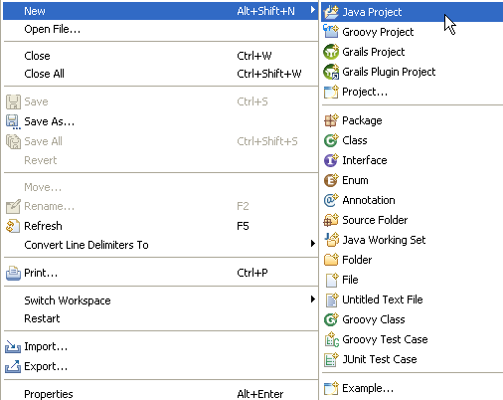

A window similar to the following will pop up, where we enter the name for our project, select the version of the desired Java runtime environment (we developed with version 1.7, so any earlier version would likely produce errors when trying to compile), and choose our project layout. We prefer to work with separate source and binary (class) files, which is reflected in the window:

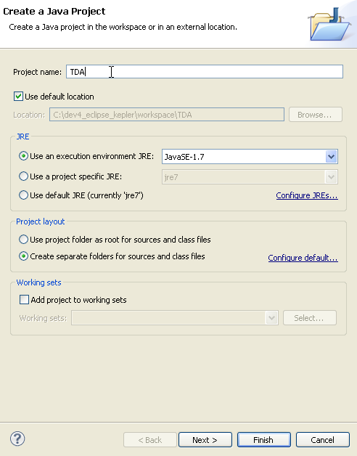

Click on Finish after you have entered your information.

Eclipse will be busy for a few moments, creating a new folder in your workspace with the name of your project (above we chose “TDA” in the “Create a Java Project” dialog), and separate src and bin subfolders within TDA, as you can verify by examining the directory structures on your machine.
Now that we have an empty project shell set up for our TDA project, we just need to add the source files: go to your unzipped Tda download location, and copy all directories from its src folder into the TDA’s src folder. When done, go to File → Refresh (short cut key F5):

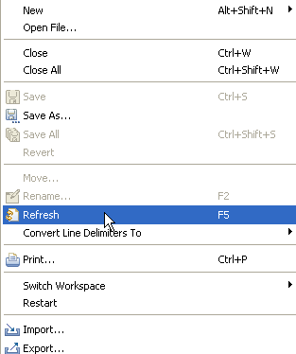

After a few moments Eclipse will have added all the Tda source files to your own project. You can now examine individual files, and make changes if you so desire.

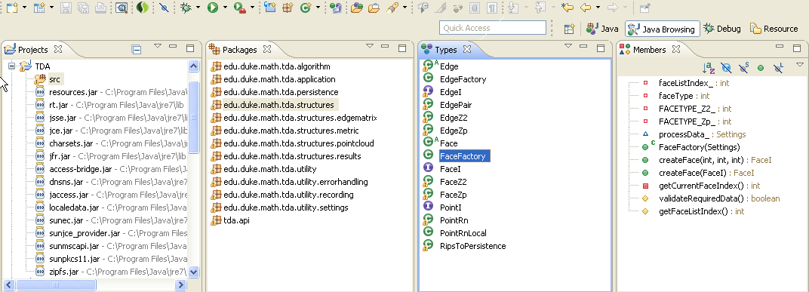

In the picture’s second panel from the left you can see the different Java packages that are part of TDA, and the classes (third panel from left) that are part of the (selected) edu.duke.math .tda.structures package. In the far right panel, the data members and methods of the (selected) FaceFactory class are listed. Double-clicking on any class will open the source editor panel with the source code for that class.

Don’t be alarmed if your Eclipse display looks slightly different from the picture above. To match you display with the picture, you may need to select the Java Browsing perspective from the Window → OpenPerspective menu, and you may even want to drag the different panels into the layout that works best for your computer display.

Running the Examples in Eclipse
Now that we have our TDA project ready to go, we only need to teach it how to run our examples. We do this by setting up what is called “runtime configurations”.

In the machine’s file system, the TDA project directory within your Eclipse workspace will look something like this:

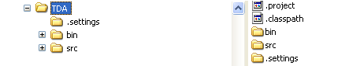

Let’s copy the data directory from the tda.zip download into the TDA directory:

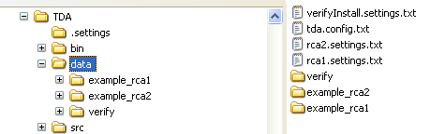

We will step through setting up the runtime configuration for the verify settings file. From the Run menu, select Run → RuntimeConfigurations to open the dialog for adding a new runtime configuration:

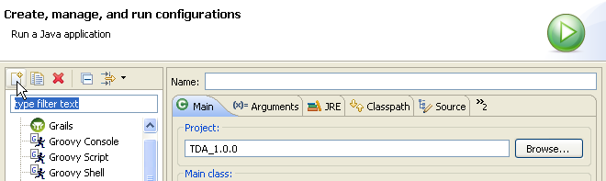

Click on the button for adding a new configuration (the icon for the button may look slightly different depending whether you are on a PC or on the Mac or Linux):
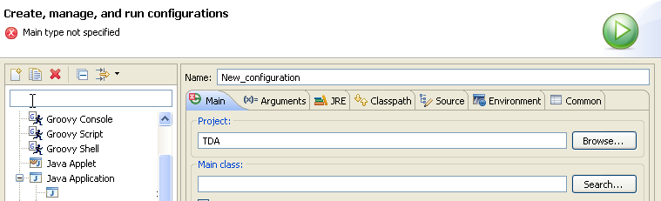

Edit the Name field for the new configuration, and then click on the Search button to the right of the (still empty) field for the Main class:

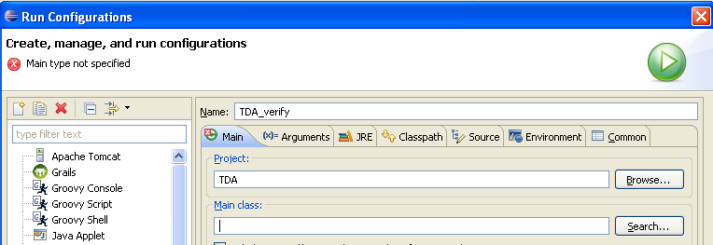

In the popup window, select the one available matching item, and click ‘ok’.

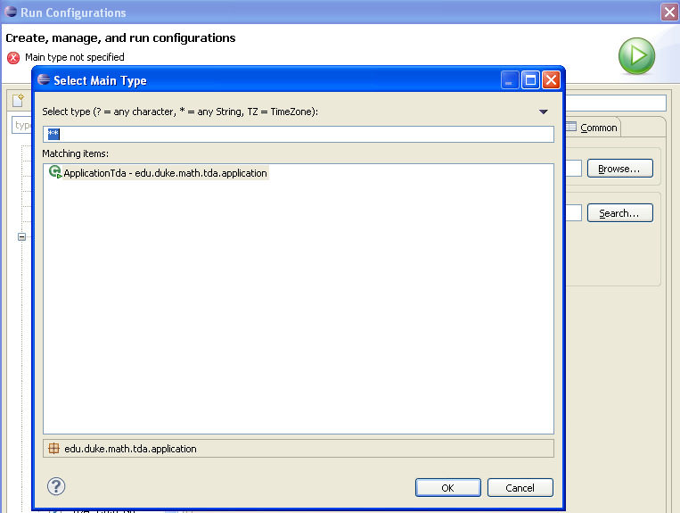

As a final step, we need to specify the settings file that TDA needs in order to run the verify example. In the dialog window, click on the Arguments tab, and enter the text “settingsFile=data/verifyInstall.settings.txt”:

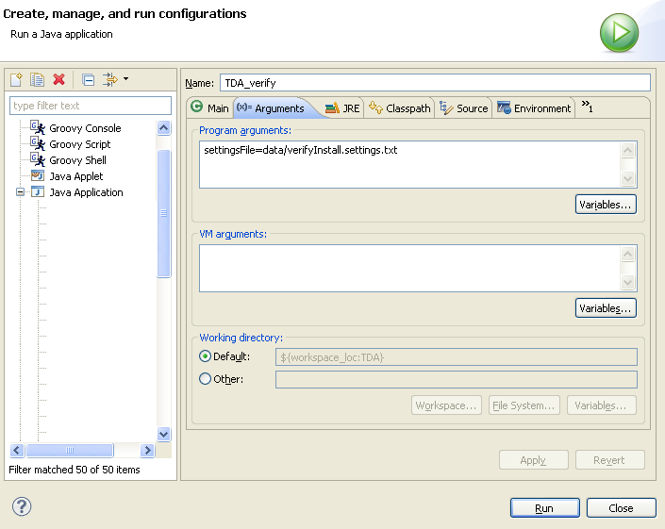

We are done – click on ‘Run’ and the results for the verify example will start to appear in the Eclipse Console panel:

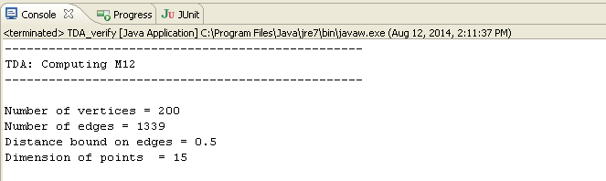

By default, the actual results will only be saved to the files in the data/verify/output directory, unless we explicitly tell Eclipse not to suppress them. We do this by adding the setting value ‘runningInEclipse=yes’ to the Program arguments of our runtime configuration:

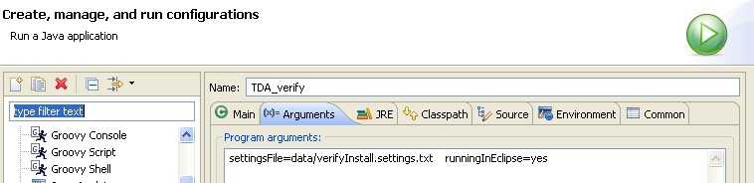

Troubleshooting
When working with a new software program it is important to know what to do when something doesn't work. In this section, we describe the main sources of problems that a user may encounter, and how to go about finding solutions. The problems themselves can be categorized into a number of different types, each described in detail below.

When Little Things Don't Work As Expected

Missing or Invalid Parameter in the Settings File

Miscellaneous Errors and Warnings

Error During Program Execution
From Standalone Application

From the Api
Here is an example of a mistake in specifying the input parameters. Note the missing ‘-symbols, so that two parameters are passed in as a single string to the application.

>> tda.RCA1( { 'taskchoice=m12', 'applicationmode=api', 'supplyDataAs=pointCloud', 'distanceBoundOnEdges=10, suppressAllOutput=yes' }, X)

This is the command with the error message in Matlab:

>> tda.RCA1( { 'taskchoice=m12', 'applicationmode=api', 'supplyDataAs=pointCloud', 'distanceBoundOnEdges=10, suppressAllOutput=yes' }, X)
[ERROR RCA1_args_dblArgs] Exception encountered: edu.duke.math.tda.utility.errorhandling.TdaException:
(Settings) Cannot recognize the input parameter 'distanceBoundOnEdges=10, suppressAllOutput=yes'. Please use the 'item=value' format.
at edu.duke.math.tda.application.ApplicationTda.parseStringSetting(ApplicationTda.java:239)
at edu.duke.math.tda.application.ApplicationTda.assignData(ApplicationTda.java:358)
at tda.api.Tda.RCA1(Tda.java:276)

Running Out of Memory
If your data consists of (very) large amounts of data, you may encounter a message from either Java, or your api-environment (such as Matlab), indicating that you don’t have enough memory to run the TDA application. If you have not yet used the options outlined in this section, you will likely be able to fix this problem quickly by simply instructing your environment to use a larger amount of memory. Modern hardware usually has a lot more memory available than the amount that the standard Java Virtual Machine (JVM) requests by default.

When running a Java application as stand-alone, the –Xms and –Xmx parameters are used for increasing the memory that the JVM requests from the operations system. In this example we instruct the Java Virtual Machine (JVM) to use a much higher amount of memory than its default setting (which is as low as only 64MB, depending on your OS):

java –Xms256m –Xmx900m -jar tda.jar settingsFile=…

The “-Xms256m” flag indicates to the JVM to set aside a minimum of 256 MB of memory for the execution of TDA, and “-Xmx900m” flag indicates to the JVM to set aside a maximum of 900 MB of memory. The default values are 2m and 64m respectively, so if you change “-Xms” to be greater than 64m, you must also specify “-Xmx” to be greater than 64m.

[Need to re-enable this via special setting] To help you find a useable value for the -Xmx setting, TDA displays a rough estimate of the memory used at several milestones during program execution, up to the respective point where the message was displayed. Keep in mind that memory use following the milestone may increase substantially.

When running TDA in api mode, e.g., within an environment such as Matlab, one needs to adhere to the way that the environment manages the use of libraries, such as the TDA Java code. Here is an excerpt from the Matlab online help pages:

How do I increase the heap space for the Java VM in MATLAB 6.0 (R12) and later versions?
http://www.mathworks.com/support/solutions/en/data/1-18I2C/
This is useful when your data is large, and you are getting an out-of-memory error message from the Java Virtual Machine

Please be aware that the way you supply the data may have a substantial effect on memory use as well as performance, as touched on in the next section.

Data Affecting Memory Use
Using a distance matrix will require the most memory when running the application, because we will store all n x n entries of the matrix, even though many of the entries may be zero (or –1, to indicate infinite edge length). This is in stark contrast to the sparse matrix approach, where the code will only use the supplied edges.
The advantage of the distance matrix over the sparse approach is the direct lookup of the edge information, which can lead to a much shorter execution time, especially for large problems.
For this reason, we use the following approach: When loading data from a point cloud, we internally use a distance matrix up to a threshold, after which we switch over to using the sparse representation. The switch-over point is user controllable via the ‘switchToSparseAt’ setting value.

Crash With TDA “System” Error Message
This can be a nightmare problem if you are not familiar with modifying Java code, and TDA quits on you unexpectedly: any error like this is what’s generally referred to as a software bug.

Here is a “typical” example (typical of bugs, but hopefully not typical for TDA): Suppose the application attempted a division by zero somewhere in its code, the error message would be forwarded by the error handling mechanism in this way:

-----------------------------------------------------------------------------
ERROR DETAILS
-----------------------------------------------------------------------------
- TDA Computational Topology: 1-dim. Persistence -
- Release 0.0.2 12 Feb 2013 -
- Licensed from Duke University -
- Copyright (c) 2012-2013 by John Harer -
- All rights reserved -
-----------------------------------------------------------------------------
- Project: computational topology sandbox
- User: test
- Dataset: one of the test data sets
- Notes: point cloud computed points in file
-----------------------------------------------------------------------------
…
-----------------------------------------------------------------------------

[ERROR: TDA 0.0.2, 3/8/13 2:29:12 PM]
Execution has stopped due to the following exception:
'java.lang.ArithmeticException: / by zero'

-----------------------------------------------------------------------------
End of error notification
-----------------------------------------------------------------------------

To get additional information about the location of the error, we can set the optional TDA setting “displayDebugInfo” to the value “stacktrace”:

[ERROR: TDA 0.0.2, 3/8/13 2:29:12 PM]
Execution has stopped due to the following exception:
'java.lang.ArithmeticException: / by zero'

Stack trace info:

edu.duke.math.tda.algorithm.AlgorithmM12.computeM12(AlgorithmM12.java:793)
edu.duke.math.tda.algorithm.AlgorithmM12.executeAlgorithm(AlgorithmM12.java:403)
edu.duke.math.tda.application.BasicTDA.main(BasicTDA.java:164)

Note that the message itself may be much more detailed, since most code sections in TDA are designed to trap possible exceptions, and supply some informative feedback. This feedback will hopefully enable the developer to locate and fix the problem more easily.

Submitting an Error Report
Hopefully you will never see the above message, or any other error message due to an internal problem with the TDA code. However, even the best coding practices and testing procedures sometimes let a “bug” slip through. If you encounter an error in the TDA code, we ask you to report it, and we will try to fix it as soon as possible. However, to do so we will need your help – most importantly, we need as much information about the issue as possible:

- We ask that you email us a copy of the error message along with a detailed description of the problem (see 2 below), your settings file, your data file(s), and your result file to our contact address (Jürgen Sladeczek, email: hjs(at)math.duke.edu). This information will (hopefully) enable us to recreate and quickly correct the bug.
- Please include any additional information that you may know about the problem: is it repeatable? Does it only show up with certain data or settings, and not with others – after what change did it first occur? Did it appear after you just upgraded to a new version of TDA, a new Java VM, etc? Did you run the jar file or did you execute the code from within an IDE? What version of Java are you using?

Appendix A

File Formats

Example of a Minimal Settings File
TDA implements truly optional settings, in the sense that settings that are not used, or that can default to internally specified values, don’t need to be part of the settings file. This leads to very compact setting files. The following is a sample settings file that contains only the minimal set of settings that need to be specified for executing TDA.

###-------------------------------------------------
### Mode(s) selection
###-------------------------------------------------

applicationMode = api

###-------------------------------------------------
### Algorithm selection
###-------------------------------------------------

algorithmChoice = M12

###-------------------------------------------------
### Algorithm component specifications
###-------------------------------------------------

supplyDataAs = sparseMatrix
pointCloudFile = examplePointCloud.txt
distanceBoundOnEdges = 100

###-------------------------------------------------
### Metric selection
###-------------------------------------------------

metricChoice = L2
p_valueForLpMetric = 2

###-------------------------------------------------
### Input and output locations
###-------------------------------------------------

inputDirectory = data/input

After removing all comments, the minimal settings file becomes:

applicationMode = api
algorithmChoice = M12
supplyDataAs = sparseMatrix
pointCloudFile = examplePointCloud.txt
distanceBoundOnEdges = 100
metricChoice = L2
p_valueForLpMetric = 2
inputDirectory = data/input

Example of a Comprehensive Settings File
The following setting file lists all available settings for TDA. Note that when settings don’t apply, they are simply ignored.

###-------------------------------------------------
### Input parameter settings file for
###
### Topological Data Analysis
###
### TDA is licensed from Duke University.
### Copyright (c) 2012-14 by John Harer.
### All rights reserved.
###
### Settings file consistent with version 1.0.0
###-------------------------------------------------

###-------------------------------------------------
### Project information
###-------------------------------------------------

project = computational topology examples
user = tester
dataset = test data
notes = settings are for stand-alone use

### settingsfile=data/tda.settings.txt

###-------------------------------------------------
### Mode(s) selection
###-------------------------------------------------

applicationMode = standAlone

###-------------------------------------------------
### Task and Algorithm selection
###-------------------------------------------------

algorithmChoice = M12

###-------------------------------------------------
### Algorithm component specifications
###-------------------------------------------------

supplyDataAs = distanceMatrix

distanceBoundOnEdges = 100
pointCloudFile = distanceMatrixExample.txt

convertDataToSparseMatrixFormat = yes
sparseMatrixOutputFile = sparseMatrix_@TS@.txt

###-------------------------------------------------
### Metric selection
###-------------------------------------------------

metricChoice = L2
p_valueForLpMetric =

###-------------------------------------------------
### Diagram related output
###-------------------------------------------------

0DintervalsFile = 0Dintervals.@TS@.txt
1DintervalsFile = 1Dintervals.@TS@.txt
1DdiagramFile = 1Dpic.@TS@.png

###-------------------------------------------------
### Input and output locations
###-------------------------------------------------

inputDirectory = data/input
outputDirectory = data/output
reportFile = results_@TS@.txt

Note that any @TS@ token in file names will be replaced by the current time stamp (as of starting the application).

PointCloud File Example
The following is a sample file of a point cloud…

#
# these lines describe the point cloud:
# …
#
1 3 2 2 3 3 3 0 1 1 3 2 3 3 2 3 2 1 2 2
0 3 1 1 2 1 1 2 3 2 3 2 2 1 3 3 2 3 3 3
3 0 0 3 0 1 3 2 2 2 1 2 2 1 3 1 2 2 1 2
2 3 3 3 3 0 1 3 2 2 3 3 3 1 0 0 3 2 3 3

(... some rows omitted)

3 3 1 2 3 2 1 3 2 3 2 1 2 2 3 3 3 3 3 1
3 3 3 3 3 2 0 1 3 1 3 3 3 3 1 2 3 2 1 2

Any line that starts with a #-symbol is being ignored by the data loading.

Distance Matrix File Example
The following is a sample file of a distance matrix, which always has the form of N rows with N (column) values each. Note that for standard problems, the values below the diagonal are being ignored for trivial reasons. However, the Harer group has found use of diagonal values for a special class of problems – please refer to the list of references for details.

#
# these lines describe the distance matrix:
# …
#

10 10 0 0 10
0 20 0 0 30
0 0 30 20 40
0 0 0 40 0
0 0 0 0 50

Any line that starts with a #-symbol is being ignored by the data loading.

Sparse Matrix File Example
The following is a sample file of a sparse matrix. The format of each line is “vertex1 vertex2 distanceBetweenVertex1AndVertex2”. The main advantage of using the sparse matrix input is the omission of all entries with distance 0, so the number of edges stored initially is far less than in the (N x N) distance matrix case.

#
# these lines describe the sparse matrix:
# vertexIndex vertexIndex edgeLength
#

0 1 0.5
1 2 1.0
2 5 4.0
3 4 2.0
4 5 3.0

Any line that starts with a #-symbol is being ignored by the data loading.

Appendix B

Settings File: Parameter Names and Values
Note that optional settings can either be omitted entirely from the settings file, or can have only their values omitted. The spelling of setting names and values in the settings file is case-independent.

Note that for any settings parameter that accepts a set of string values, and that has an associated default value, the string “default” can be specified in the settings file. The output by the application will record the actual value that was being used for program execution, prefixed by “defaulted to”.

Setting Name | Allowed Values |  | Explanation
Project information

project | Any string |  | Provided to users for organizing their data.  No restriction on user choice
dataset | Any string |  | Provided to users for organizing their data.  No restriction on user choice
user | Any string |  | Provided to users for organizing their data.  No restriction on user choice
notes | Any string |  | Provided to users for organizing their data.  No restriction on user choice
Application mode selections

applicationMode | Valid string specifying the mode of the application  - api  - standalone |  | The default mode is standalone mode, which means that all results from the application are saved to files (i.e., 0- and 1-dimensional intervals, general runtime results, etc).  In api mode, the output to files, as well as to the command line, is turned off. Instead, the user would use the return values from various methods to obtain the results computed by the application.
feedbackLevel | [To be implemented]  Valid string specifying the level of feedback provided by the application:  - verbose  - basic  - none |  | The feedbackLevel provides for overriding the default feedback from the application: in api mode, the default output is basic, whereas in standalone it is verbose.  However, depending on the personal preferences of the user, or the way the application is being run, e.g., in batch mode on a cluster, these settings can be changed.
suppressAllOutput | Does what it says, namely omit ALL output from the application. Valid values are  - yes  - no |  | Defaults to ‘no’.  Was introduced for use in the API mode, so any ‘front end’ code can get the output by calling back the tda object, while all output to the command line is being suppressed.
Task component specifications

taskChoice | Valid string specifying the task to be run:  - LSD (local spherical distance)  - M12  - M23  - RCA0  - M01 (to be implemented)  - skip
Selections for Algorithm ‘M12’, ‘M23’, and ‘M01’

distanceBoundOnEdges |  | Real number greater than 0
supplyDataAs |  | Valid string from:  - pointCloud  - distanceMatrix  - sparseMatrix  - object (to be implemented) | When ‘pointCloud’ is specified, the input needs to be provided as a valid file containing the listing of the points. The code will then compute the edges using the specified metric, and create the internal edgeList.  When ‘distanceMatrix’ is specified, the input file needs to specify the entire matrix of pair-wise distances between the points. Note that only values above the diagonal are being used (though the input needs to be a full matrix). Any value of 0 will be treated as “no edge” between the corresponding vertices.  When ‘sparseMatrix’ is specified, the format needs to be in form of triples on each input line (i.e., each edge], as follows:  ‘vertexIndex1 vertexIndex2 distanceBetweenTheVertices’.  Please note that each vertexIndex needs to be an integer. The order in which the vertexIndices are listed is not significant, though internally we always use the information in ascending order.  When the ‘object’ option is selected, we compute the point cloud from the specified object.  Currently, this is only used for internal testing.
pointCloudFile |  | File containing the supplied “point cloud” data, which can in fact be supplied as a point cloud, a distance matrix, a sparse matrix, or an object. | The content of the file needs to follow the format of the type of date (as specified via supplyDataAs), namely list of points, or distance matrix.
convertDataToSparseMatrixFormat |  | Valid string specifying whether to output the point cloud data in sparseMatrix format:  - yes  - no | This is a convenience option: when the input is in any of the other input formats (see ‘supplyDataAs’), the application outputs the edges in sparse matrix format to a file.  Note that the sparse matrix data that is being written to file is based on the list of edges after the distance bound is applied, i.e., it is not the entire set of points that was potentially provided via the original input!  Hint: if one wants to have the “complete” sparse matrix of all points in the original set, one needs to specify a large distance bound that “catches” all the points.
sparseMatrixOutputFile |  | Valid string for specifying the file for writing the sparse matrix to.
convertDataToDistanceMatrixFormat |  | Valid string specifying whether to output the point cloud data in distanceMatrix format:  - yes  - no | This is a convenience option: when the input is in any of the other input formats (see ‘supplyDataAs’), the application outputs the edges in distance matrix format to a file.
distanceMatrixOutputFile |  | Valid string for specifying the file for writing the distance matrix to.
0DintervalsFile |  | Any valid file name;  - May be specified using a time stamp token as part of the name. | The name of the file for the computed 0-dimensional intervals (as computed by the M12 algorithm).
1DintervalsFile |  | Any valid file name;  - May be specified using a time stamp token as part of the name. | The name of the file for the computed 1-dimensional intervals (as computed by the M12 algorithm).
1DintervalsAndRepsFile |  | Any valid file name;  - May be specified using a time stamp token as part of the name. | The name of the file for the computed intervals and representatives (as computed by the M01 algorithm).
Input and output locations

inputDirectory |  | Any valid directory path; can be specified as (valid) absolute or relative path | Specifies the directory where the input files for the current data run are located.
outputDirectory |  | Any valid directory path; can be specified as (valid) absolute or relative path | Specifies the directory where the output files for the current data run will be placed.
reportFile |  | Any valid file name;  - May be specified using a time stamp token as part of the name. | The name of the (detailed) report file.
intervalsFile |  | Any valid file name;  - May be specified using a time stamp token as part of the name. | The name of the file for the computed intervals (M12 algorithm).
intervalsAndGeneratorsFile |  | Any valid file name;  - May be specified using a time stamp token as part of the name. | The name of the file for the computed intervals and generators (M01 algorithm).
Used Metric

metricChoice | Valid string choices are:  - L1  - L2  - Lp  - Linf  If not specified, defaults to using the L2 metric. |  | L1, L2, L-p and L-inf metrics are implemented.
p_valueForLpMetric | Integer value greater than 0, when L-p metric is selected as the metric choice.
Z/Z_{p} computation

zp_value | Integer greater than 0.  When not specified, defaults to 2 (i.e. computations are done Z/Z₂) |  | Specifies the base p of the  Z_{p}-based computations.
Performance settings

switchToSparseAt | Integer greater than 0. |  | Specifies the switch-over point between using internal data representations of ‘distance matrix’ (below the threshold) and ‘sparse matrix’ (above the threshold)

Appendix C

API Calls

The methods exposed as part of the TDA API are located in the tda class, in the tda.api package, of the jar file.

Creating a Tda Object

Tda() |  | Simplest constructor, no options specified for initialization. Note that any new Tda object will start from a fresh slate (i.e., the reset() method will be applied as part of the internal code)
Tda( String ) | String contains a single “setting=value” pair as argument. | The supplied value will be applied to the setting.
Tda( String[] ) | Argument is an array of “setting=value” pairs. | Each specified setting is being set to its supplied value.
General Methods

reset() |  | Resets the internal properties of the Tda object.
applyData( String ) | String contains a single “setting=value” pair as argument. | Applies the supplied value to the setting.
applyData( String[] ) | Argument is an array of “setting=value” pairs. | Each specified setting is being set to its supplied value.
applyData( double[][] ) | Loading an array of data (use is determined by the algorithm – generally it is the set of points that make up the point cloud)
applyData( double[] ) | Loading an array of data (use is determined by the algorithm – generally it is the set of points that make up the point cloud) This is a special case of the 2-dimensional array, provided for environments like Matlab.
applyData(String[], double[][] ) | Combines the previous 2 calls (for convenience, and for preserving legacy code)
getResults() |  | Get a listing of the results that the Tda has available after executing. The listing depends on the algorithm.
getResults( int ) |  | Return the specific result as specified by int.
getData() |  | Get the set of assigned Data for the Tda object.
getParameters() |  | Get the entire set of parameters used by the Tda object.
Algorithms

RCA0() |  | Computes the 0-dimensional persistent homology.
RCA0( String[] ) | Argument is an array of “setting=value” pairs. | Computes RCA0, with the additional argument(s).
RCA0( double[] ) | 2-dimensional array specifies the coordinates for the points in the point cloud. | Computes RCA0, with the additional argument.
RCA0( String[], double[] ) | Combines the previous 2 calls (for convenience, and for preserving legacy code) | Computes RCA0, with the additional arguments.
RCA1() |  | Computes the 1-dimensional persistent homology.
RCA1( String[] ) | Argument is an array of “setting=value” pairs. | Computes RCA1, with the additional argument(s).
RCA1( double[][] ) | 2-dimensional array specifies the coordinates for the points in the point cloud. | Computes RCA1, with the additional argument.
RCA1( String[], double[] ) | Combines the previous 2 calls (for convenience, and for preserving legacy code) | Computes RCA1, with the additional arguments.
RCA2() |  | Computes the 2-dimensional persistent homology.
RCA2( String[] ) | Argument is an array of “setting=value” pairs. | Computes RCA2, with the additional argument(s).
RCA2( double[] ) | 2-dimensional array specifies the coordinates for the points in the point cloud. | Computes RCA2, with the additional argument.
RCA2( String[], double[] ) | Combines the previous 2 calls (for convenience, and for preserving legacy code) | Computes RCA2, with the additional arguments.
LSD() |  | Computes the least spherical distance matrix.
LSD( double[][], double, double[] ) | Arguments are the point cloud, distance, and center point. In n-dimensions. | Executes LSD with the specified data.
LSD( double[], double, double ) | Arguments are the point cloud, distance, and center point. In 1 dimension – this is obviously a special case of the n-dimensional data, but needed for environments like Matlab. | Executes LSD with the specified data.

API Settings
The following settings are useful when accessing TDA via its API calls.

applicationMode | Select value ‘api’. | The ‘api’ value will restrict the output from TDA to a bare minimum. In particular, no output to file will be attempted.
suppressAllOutput | Optional value, set to ‘yes’. | When set to ‘yes’, all (command line) output from TDA is omitted.

Appendix D

References

For more information about TDA and its background, please refer to John Harer and Paul Bendich’s web pages at the Duke Mathematics Department:

http://fds.duke.edu/db/aas/math/faculty/john.harer
http://fds.duke.edu/db/aas/math/faculty/bendich

