I have been tasked with analyzing and improving the decision science behind bidding on contracts consisting of $3.00, $35.00, $50.00, and $75.00,

Using the Expected Revenue, Expected (loan) Conversions, and Winning or Losing Bids… here is my analysis.

As you can see this is a general summation of revenue increase with respect to the Successful Bid Price. At first glance the $35 fixed price is the most lucrative.

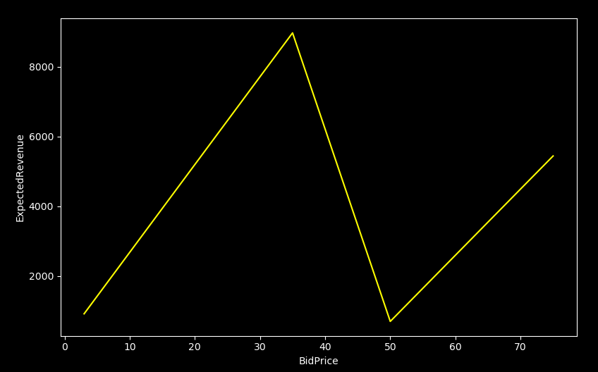

Now that we are only looking at bids that were successful. We still have 16,026 total bids to analyze in one set. So let’s group them into BidPrice buckets and try and take a closer look into what’s happening.
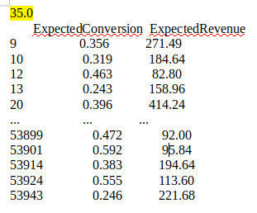
3.0
ExpectedConversion ExpectedRevenue
290 0.168 196.40
816 0.109 270.61
1083 0.137 235.76
2384 0.190 340.58
3073 0.140 234.48
... ... ...
53729 0.236 126.08
53770 0.203 179.28
53812 0.346 95.36
53920 0.202 107.68
53926 0.360 88.24
[913 rows x 2 columns] [8975 rows x 2 columns]

50.0
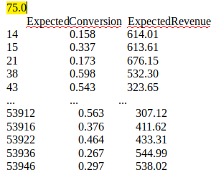
ExpectedConversion ExpectedRevenue
349 0.206 474.43
396 0.238 456.97
442 0.313 385.91
549 0.279 408.15
566 0.370 365.06
... ... ...
53461 0.422 352.12
53485 0.349 374.14
53511 0.169 572.05
53835 0.276 414.24
53911 0.433 313.45

[695 rows x 2 columns] [5443 rows x 2 columns]

Note*

Now we have a nice sampling that shows we are far more successful bidding at the $35 and $75 price marker. Or at least in this sample. Let’s look closer by taking the mean() of each outcome, then using that to find the profit margin with a fixed size of 20

At $3.0
ExpectedConversion 0.301
ExpectedRevenue $153.089
NetRevenue(20leads): $861
** 93.5% profit margin

At $35.0
ExpectedConversion 0.349
ExpectedRevenue $261.681
NetRevenue(20leads): $1,126
** 61.7% profit margin

At $50.0
ExpectedConversion 0.286
ExpectedRevenue $447.308
NetRevenue(20leads): $1,236
** 60.9% profit margin

At $75.0
ExpectedConversion 0.374
ExpectedRevenue $545.888
NetRevenue(20leads): $2,583
** 63.2% profit margin

Here again we have some very telling leads into which way we should go given a finite try at bidding these contacts. One thing we can see clearly is that we are spending the most at the $35.00 bid price which actually has the lowest reward (profit) at the current ExpectedConversion rates!
This quick chart allows us to take into account a reshuffling and prioritize at the slightly higher margins. Furthermore, because of the negligible cost of the $3.00 price, we probably not ever pass it up if the opportunity arises. In this case net revenue is not the correct benchmark but rather the profit margin
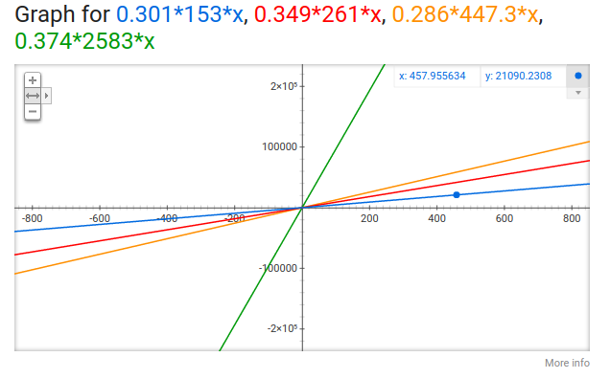
No hard and fast rules here as there is much more variability in this universe to account for, but the priority of bidding should be $75, $3 , $50, $35

(quick google graph shows just how close the margins are for at least a few thousand winning bids.)

Of course this leaves out a large amount of variables in this universe that need exploring.

So let’s see what happens we attempt regression analysis on only successful bids, first this needs organized into a sample dataframe. Here is an example of a random sampled dataframe with n=30.
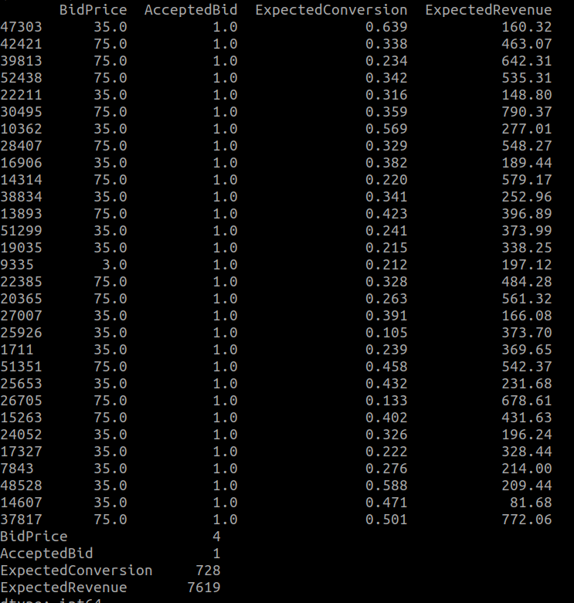

Now we can split the dataframe into a test set and a training set. Adding in some columns for purview and potential training features.
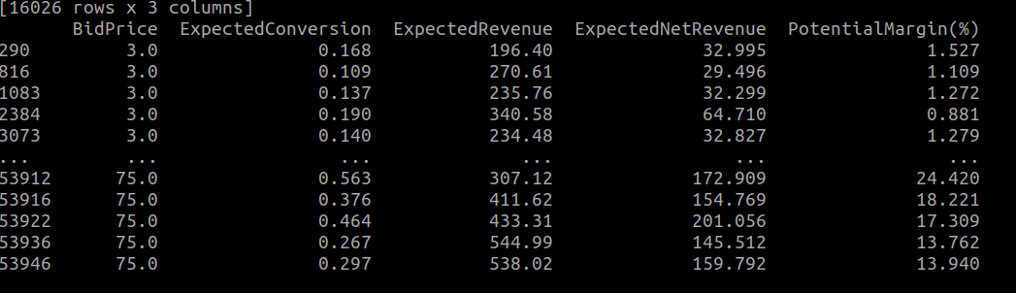
Now with our nicely organized dataset that assumes all bids were successful we can train a linear regression model and make a prediction. Here’s one that is training with one of the main coefficients being PotentialMargin.
Hypothesis: Potential Margin percentage affects the Total Expected Revenue
Result:

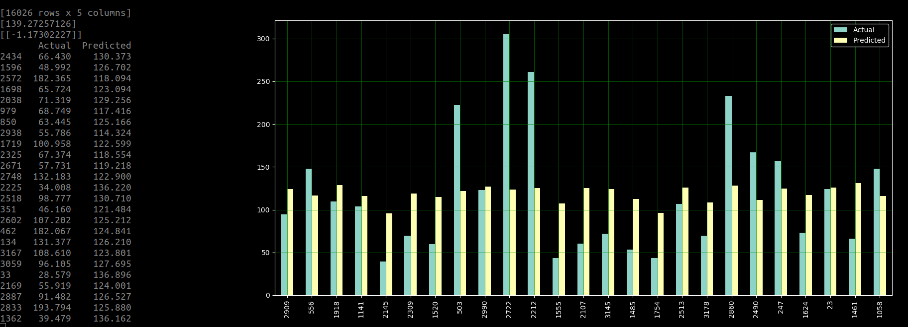
Not so great…. It appears that we are regularly missing by 50% much of the time.

Hypothesis: Bid Price is greater factor in Total Expected Revenue
Result:

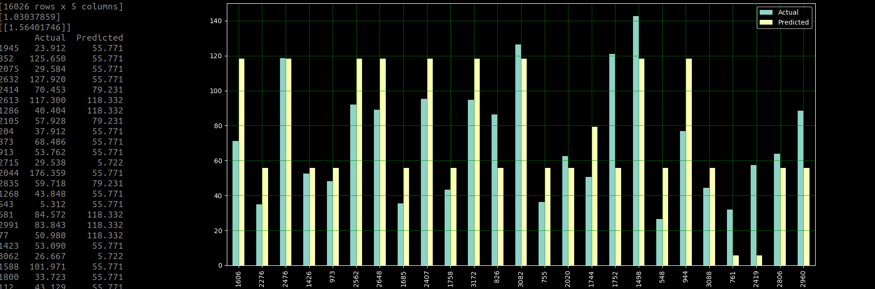
This seems like it’s moving quicker into the right direction even with the overfitting problem (notice the 55.771 repeats etc.)

One thing is very clear, more work is needed because of the abundance of missing features, not even considering the failed bids as missed potential revenue. However, this leads me to believe that BidPrice is actually a very important indicator of long-term growth in bottom line.

Thanks for the opportunity to work on this and I look forward to continuing it!

Respectfully,

Ted Morrison
theodorejmorrison@gmail.com
708-490-9553

