**Existing functions:**

Data Converter

* Shapefile to xml and xml to shapefile
* 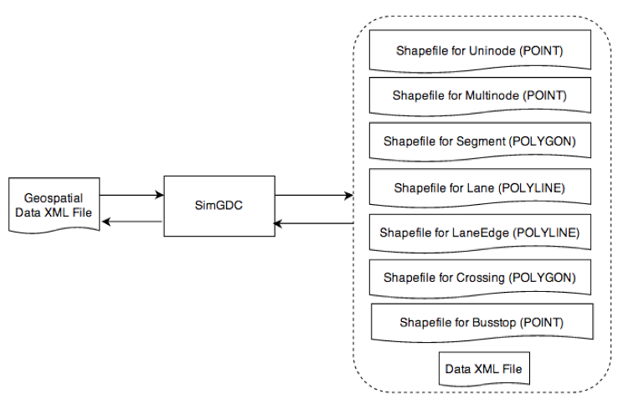

Add/Edit/Delete following features:

* Segment
* Bus Stop
* Crossing
* Lane
* Lane Edge
* Uninode
* Multinode
* Link Manager

Generate lane edges for lanes

**Feature attributes :**

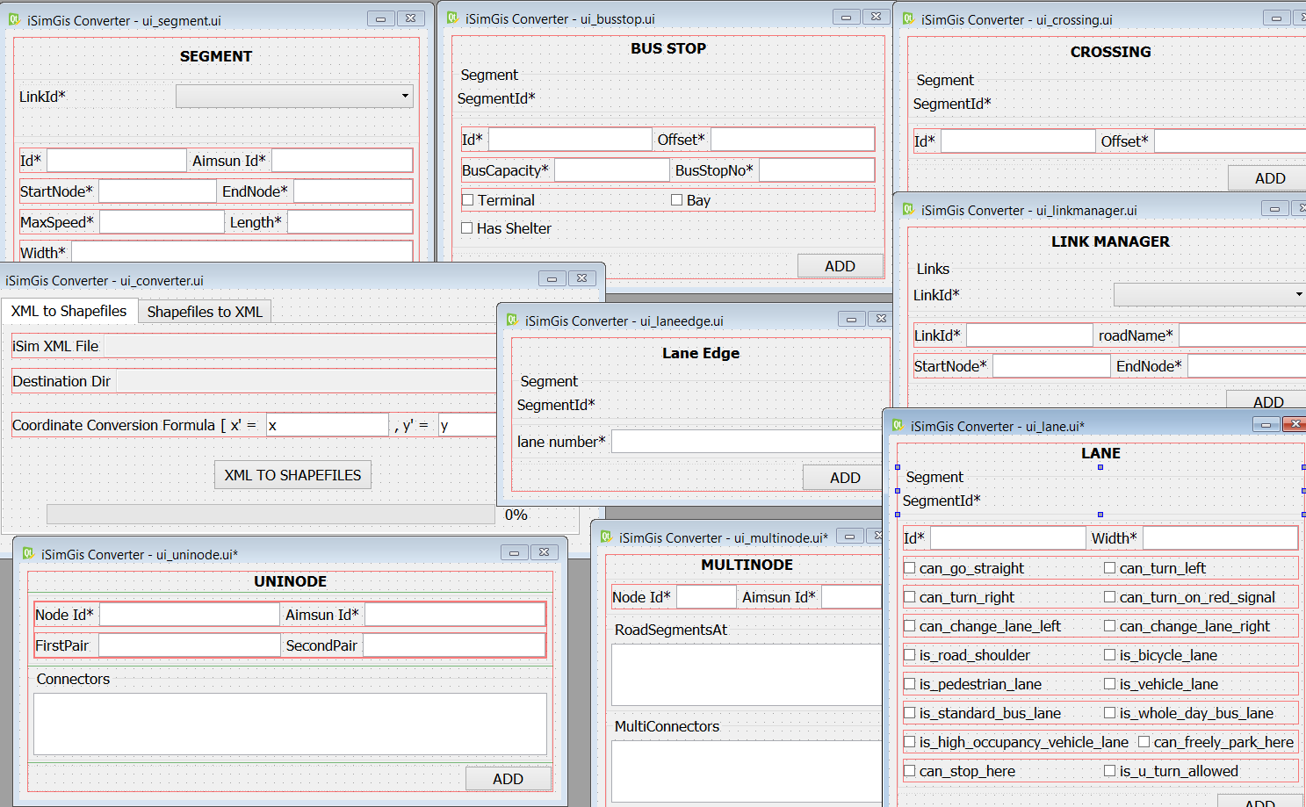

**Consistency Checks:**

1. S : Duplicate section IDs - ok but sort issue for editing existing segment
2. S : Duplicate ‘’from node-to node’ pair for different segments - “”
3. S : If either From Node or To Node for Segments is unknown(not in Nodes layer)/NULL/0 - ok
4. S : If From Node equals To Node for same segment - ok
5. N : Duplicate Node IDs - ok but editing existing issue
6. N : Nodes unallocated as FromNode or ToNode - missing link with Segments layer
7. N : Checking correctness of Node coordinates derived from Turnings and Segments - By checking the averages of attributes of the segment layer(from/to coordinates) with the attributes of the turning layer - and if it differs by >10m
8. N : Start and end coordinates of turnings belonging to same node have large deviation, (xmax-xmin) or (ymax-ymin) > 200m
9. N : Node which is not at dead ends, but do not have any turnings (not letting vehicle to go anywhere as no turning)
10. **N : Traffic Light ID is not in network - some traffic light info not included in network**
11. T : Duplicate Turning IDs
12. T : Duplicate ‘from segment -to segment’ pair for different turnings
13. T : If From Segment equals To Segment
14. T : If NodeID is unknown(not in Nodes layer)/NULL/0 (Turning ids have a relation to node, eg. Turning 10001-10004 are in node 1000)
15. T : Phases in turnings are missing/not specified although traffic light ID is specified in node (Phase A,B,C according to turning’s traffic light, could be 2 phases)
16. T : ToNode of FromSegment and FromNode of ToSegment are not the same
17. T : Either FLANEB<FLANEA or TLANEB<TLANEA (they should not because FLANEA: FLANEB is a range)
18. T : Either (FLaneB+1)>NumlaneFromSegment or (TLaneB+1)>NumlaneToSegment (FLaneB and TLaneB are upper limits of the ranges)
19. B : Duplicate bus stop IDs
20. B : Bus stop pairs are linked to segments with different driving directions (Bus Stop pairs have only last digit different in their IDs, cannot be more than 2 bus stops as a pair)
21. B : SegmentID for bus stop does not exist in ID of Segment layer. -Resolved
22. B : Distance between coordinates of Bus stops vs midpoint of Segment polyline is more than 500m (Bus Stop linked to a segment -> Bus Stop linked to nearest segment using GRASS GIS - Then routing the bus lines may *check correctness of links*)
23. **Removing turnings and extend segments - Ping Ping**

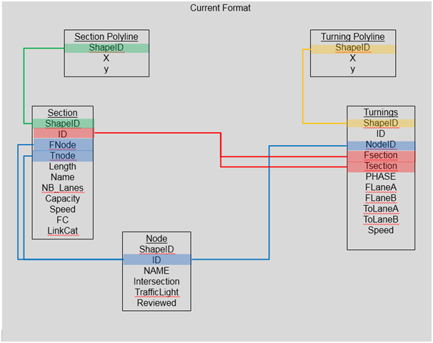

***Plan of Action***

- Two functionalities : Editing and consistency checks on a database

- Editing : Can modify Tuan’s plugin with Simmobility 2.0 Network Format for editing to comply with all consistency checks, main problems with older plugin :

none of the consistency checks are verified

allows adding shapefiles only in a specific format (DBF, PRJ, QPJ, SHP, SHX, CPG + data.xml),

make it to work with postgis

Add new network format, some attributes are missing(eg traffic light ids)

- Database Checks : View/Edit/Delete layer tables, whereas checks – stored SQL queries using either Query Builder or DB Manager

***Useful QGIS tools***

* Topology Checker - Performs validation checks for chosen layers and displays the errors highlighted on the map (duplicacy)
* XyTools - Editing database directly, but the entire layer at once
* DBManager - Editing tables, viewing area of a map and corresponding entries
* PostGIS Query Builder - Run predefined PostGIS functions for the network

Viewing/Editing/Deleting layer tables in database - DB Manager

Perform consistency checks on imported data - Using SQL queries, QueryBuilder

Remove turnings and extend segments - P2

Adding features to network - Keeping in mind consistency checks and dependencies