**Ton Duc Thang University** 

**Faculty of Information Technology**

**WEB PROGRAMMING AND APPLICATIONS**

**(503073)**

**WEEK 2**

**Prepared by Mai Van Manh**

**Objective:** In this week, you will be given some html files that contain only HTML code and by default, they are not styled. You are required to write css code to style the pages and make them look better as the illustrative images. You are not allowed to modify html code except by changing the class attirbute values. Your css code should be placed in a separate file e.g. style.css and it will be referenced from html pages with the <link> tag.

Please watch the corresponding tutorial videos before doing the exercises. **Exercise 1: Student Schedule Table**

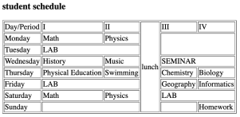

***Figure 1****. Plain HTML Table*

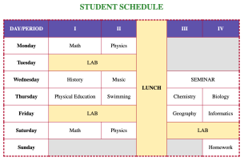

***Figure 2.****. HTML Table with CSS applied*

Web Programming and Applications - Week 02 – Page 1

**Ton Duc Thang University** 

**Faculty of Information Technology**

**Exercise 2: Registration Form**

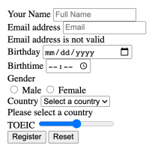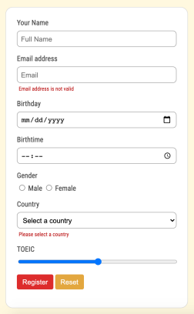

***Figure 1****. HTML Form without CSS*

***Figure 2****. HTML Form with CSS*

**Exercise 3: Responsive Website**

**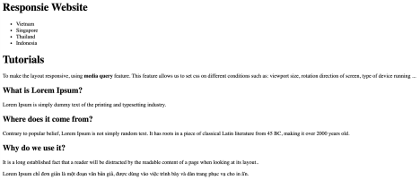*Figure 1****. Plain HTML page*

Web Programming and Applications - Week 02 – Page 2

**Ton Duc Thang University** 

**Faculty of Information Technology**

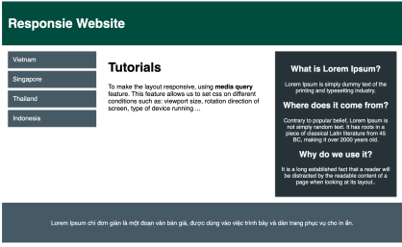

***Figure 2****. HTML page with CSS applied when running on PC*

*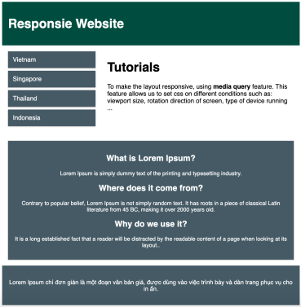****Figure 3****. HTML page with CSS applied when running on tablet devices*

Web Programming and Applications - Week 02 – Page 3

**Ton Duc Thang University** 

**Faculty of Information Technology**

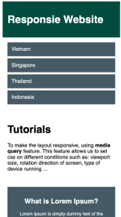

***Figure 4****. HTML with CSS applied when running on mobile devices*

**Exercise 4: Chat Conversation**

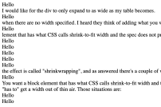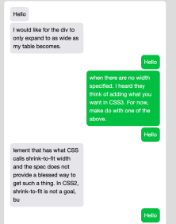

***Figure 1****. HTML only*

***Figure 2****. HTML with CSS applied*

Web Programming and Applications - Week 02 – Page 4