Lab 07 –

Continuous Probability Distribution

Trần Lương Quốc Đại  
tlqdai@it.tdt.edu.vn

Nguyễn Quốc Bình  
[nqbinh@it.tdt.edu.vn](mailto:nqbinh@it.tdt.edu.vn)

Required libs: math, numpy, matplotlib.



Provide the *generator_data* function as follows:

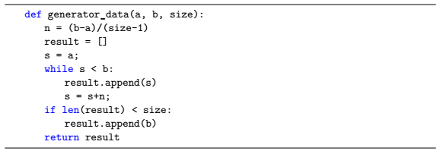

Let X be a continuous random variable in [4, 6]. Create an array of 100 continuous real numbers in [4, 6] and save to variable X.



# 1 Uniform distribution

The random variable X that has a constant even distribution will receive values on [a, b]. The probability that X receives any value of the range (a, b) is equal to . The notation X is evenly distributed on (a, b) is X ∼ U (a, b).

The probability density function of a continuous uniform distribution is determined by the formula:



Write the probability density function of continuous distribution:



Using the above pmf_uniform_cont function to graph the relationship between the random variable X and the corresponding probability. The horizontal axis represents the value of the random variable X, the vertical axis represents the corresponding probability p (x).

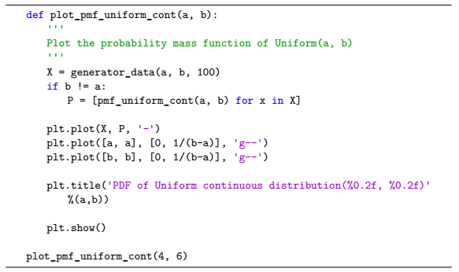

Implementation results are as follows:

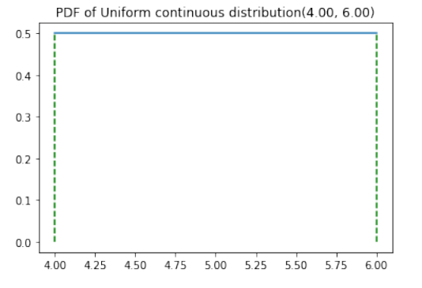

# 2 Normal distribution

Normal distribution (also known as Gaussian distribution) is an important probability distribution, with applications in many areas.

The probability density function of the normal distribution is determined by the formula:



The cumulative distribution function of the normal distribution is determined by the formula:

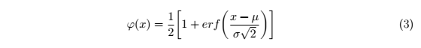

Where µ is the mean (expected) and σ is the standard deviation.

Write the probability density function and the cumulative distribution function of the normal distribution:

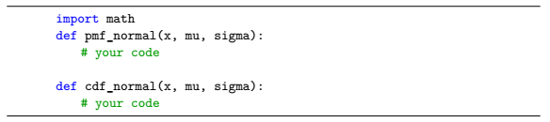

Use the pmf_normal above function to plot a graph representing the relationship between random variable X (following the normal distribution with two parameters µ and σ) and the corresponding probability.

The horizontal axis represents the value of the random variable X, the vertical axis represents the corresponding probability p (x).

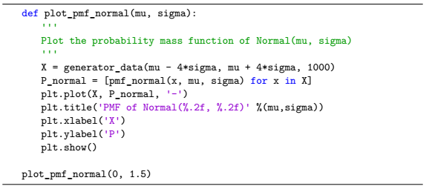

The result is:

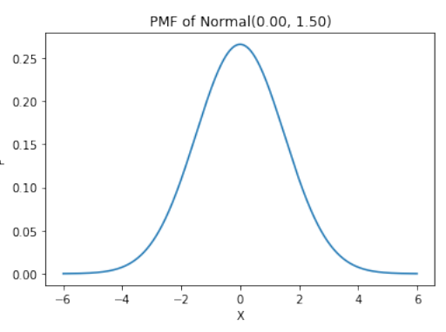

# 3 Exercises

1. Use the cdf_normal function above to plot a graph representing the relationship between random variable X (following the normal distribution with two parameters µ and σ) and the probability of cumulative distribution. The horizontal axis represents the value of the random variable X, the vertical axis represents the probability φ(x), respectively.

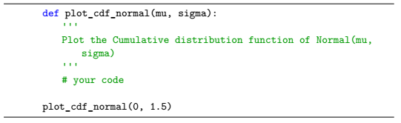

Reference answers:

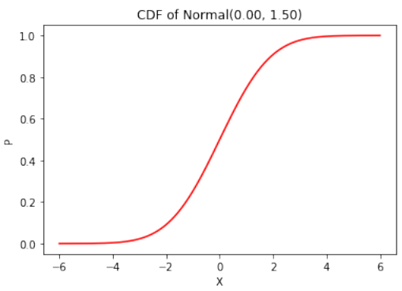

2. The time to produce a product of workshop A is a random variable that follows the normal distribution with parameters µ = 10 and σ = 1 (minute units). Use the functions in the exercise to calculate the probability that the product will be generated in the period from 9 minutes to 12 minutes. (Answer: 0.8185)