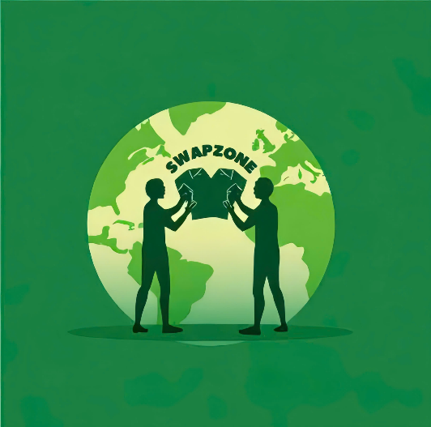

SwapZone

Application To Connect & Share Unused Items

**January 15th**

Document Status: **Draft** | In Review | Approved

**Executive Summary:**

**Our app enables users to share unused items, promoting sustainability, resource efficiency, and environmental conservation. It also supports donations to charitable organizations, turning unused goods into meaningful contributions.**

|  |
| --- |
| **Project Goal** |
| ***SMART: S****pecific,* ***M****easurable,* ***A****ttainable,* ***R****elevant, and* ***T****ime-bound*   * Develop and deploy a connection platform that allows users to share items. * 80% of posted items are connected to recipients within 30 days. * Use a team of experts to build effective communication systems and strategies to ensure the ability to achieve set goals. * Support communities in reducing waste and promoting sustainable consumption habits. * Complete the foundation and achieve these goals within 6 months of project launch. |

|  |
| --- |
| **Deliverables** |
| 1. Develop a plan to ensure 95% of shared items are delivered on time within one month of launch. 2. Choose and implement software to ensure items are prepared and ready for sharing within two business days of the request being made. Maintain the software to ensure continuous efficiency and reliability. 3. Create and launch a comprehensive training program to ensure 90% of employees are trained and ready before the official launch of the service. The training will cover the operation of the sharing platform, customer service protocols, and software usage. |

|  |
| --- |
| **Business Case / Background** |
| **Why are we doing this?**   * The **Unused Item Sharing App** is developed to create a platform that allows users to donate, share, and pass on items they no longer use. The app aims to reduce waste, save costs, and build a mutually supportive community. By repurposing these items, we not only minimize environmental impact but also provide economic benefits to users.Ensuring the app operates smoothly and efficiently will provide a high-quality user experience, supporting the broader project goal of increasing community revenue by 5%. |

|  |
| --- |
| **Benefits, Costs, and Budget** |
| **Benefits:**   * Promote sustainable consumption and reduce waste by exchanging, donating and reusing items. * Provide an effective platform to connect users with individuals and organizations in need of items. * Build an environmentally conscious community working towards a sustainable future.   **Costs:**   * Development and maintenance of the platform. * Costs associated with user training sessions and materials.   **Budget needed:**   * $100,000 |

|  |
| --- |
| **Scope and Exclusion** |
| **In-Scope:**   * Develop features for donating, exchanging, and sharing pre-owned items. * Organize educational programs, provide application usage guidance, and foster community connections to promote the spirit of sharing. * Other scope items include: integrating multiple payment methods, assessing item conditions, ensuring a user-friendly interface, and optimizing performance.   **Out-of-Scope:**   * Developing features that are not directly aligned with the core objectives of the application. * Engaging in commercial partnerships or recycling activities for business purposes. |

|  |
| --- |
| **Project Team** |
| **Project Sponsor:** Director of Operations -  **Project Lead:** Project Manager (You!)  **Project Team:** Fulfillment Director, Quality Assurance Tester, Inventory Manager, Financial Analyst, Human Resources Specialist, Training Manager  **Additional Stakeholders:** VP of Customer Success, Account Manager, Receptionist, Sales Director, Sales Team, Marketing Director, Investors |

|  |
| --- |
| **Measuring Success** |
| **What is acceptable:**   1. Facilitate the successful donation or exchange of 80% of listed items within the first two months of launch. 2. Reduce the estimated waste volumn by 500kg through the reuse of items within the list six months. |