Peer Testing Report — Live Bilingual Translator
Image: phthienan99/bilingual-translator:v72-web · Peer trial period: September 2026 · Final retests included

1. Summary
- Peers tested: 3 of 3. On the first attempt, Lisbeth reached a working session; Lucy was blocked by CPU architecture and Yuqing did not receive a working Safari session. After the multi-architecture update and peer retests, all 3 of 3 peers reached a working session on the current published v72-web image.
- Peer 1 (Lucy, Biology), attempt 1: the Docker image would not run on her Intel-based MacBook Air (2020) because the original release did not include an Intel/AMD build. Attempt 2, after the group’s fix: installation was smooth and English captions were understandable. Lucy reported about 3 seconds from speech to caption and considered that slower than Google Translate for a fast-paced lecture.
- Peer 2 (Lisbeth, Business) installed easily on her M-series Mac (Chrome). She found the speed fast enough for a live lecture and reported that the translation was about 90% understandable, while also noting that the app can have difficulty selecting the meaning of words with multiple senses.
- Her saved caption history (Appendix A) provides additional evidence of terminology problems in a data-modeling passage, including both speech-recognition errors and everyday-sense translations of technical terms. These examples should be considered alongside her overall assessment.
- Peer 3 (Yuqing, BMS) initially installed the image on an M-series Mac and opened the app in Safari, but her first session produced no captions and the page became unresponsive after Stop. After retesting the current published v72-web build, Yuqing reported that it “work[s] ok.” The group also reproduced a successful Safari flow on the developer Mac: microphone permission appeared, Listening started, and Stop returned the page to a normal usable state.
- Three findings emerged: (1) the original single-architecture image blocked the Intel-based peer, which was fixed by publishing linux/amd64 and linux/arm64 variants; (2) Yuqing’s initial Safari failure was not reproduced on the developer Mac and was resolved in her retest, so the evidence does not establish a general Safari incompatibility; and (3) for technical lectures, terminology accuracy remains the clearest limitation reported by peers.

2. Peer Overview
Peer | Program | Device | Setup | Reached app? | Consent
Lucy | Biology | MacBook Air 2020 (Intel) | Attempt 1: failed. Attempt 2: smooth | Yes (attempt 2) | Agreed to be named
Lisbeth | Business | M-series Mac, Chrome | Easy | Yes | Agreed to be named
Yuqing | BMS | M-series Mac, Safari | Easy | Opened, but no captions; froze | Agreed to be named

3. Peer 1 — Lucy (Biology)
- Device: MacBook Air (Retina, 13-inch, 2020), 1.2 GHz Quad-Core Intel Core i7, 16 GB RAM, macOS Sequoia 15.7.9
- Group assistance: Group observed; Lucy followed the Docker Desktop steps herself.
- Attempt 1 — setup: Image could be located in Docker Desktop, but it would not run on her machine because the original published image did not include an Intel/AMD (linux/amd64) build.
- Attempt 2 — setup: Smooth, on the same laptop after the group published the multi-architecture v72-web image with linux/amd64 and linux/arm64 variants.
- Transcription (English captions): Understandable.
- Translation: Not reported.
- Speed: About 3 seconds from speech to caption, according to Lucy. She described this as slower than Google Translate and potentially difficult to keep up with in a fast-paced lecture.
- Would use in a real lecture?: Yes, in classes where the lecturer speaks clearly and relatively slowly.
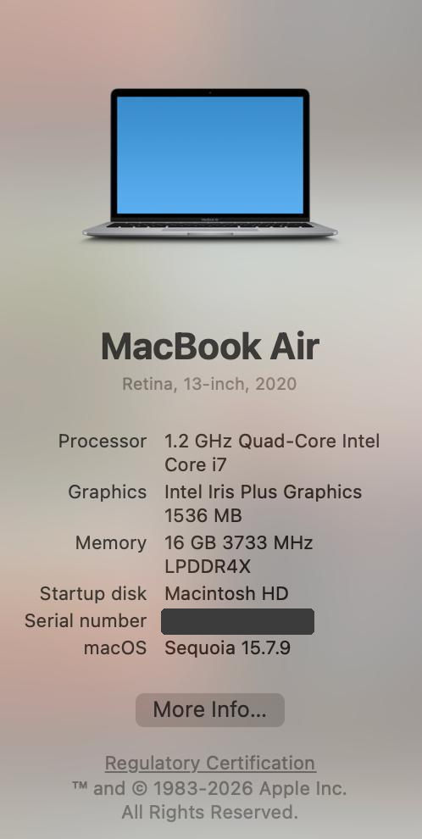
Figure 1. Lucy’s laptop: Intel-based MacBook Air (2020). Serial number redacted.
Peer comment: “This time installation went smoothly. The English captions were understandable, but it was fairly slow — about 3 seconds per response, a bit slower than Google Translate. At that speed it might not keep up with the lecturer in a real class. I would use it in classes where the teacher speaks clearly and slowly.” (Translated and condensed from her responses.)
What the group changed between attempts: The release was rebuilt and published as a multi-architecture v72-web image supporting linux/amd64 and linux/arm64. Lucy then repeated the Docker Desktop installation on the same Intel MacBook Air and reached a working session.
Consent: Lucy was told her name, program, and comment will be submitted as coursework and may be reviewed by the instructor, and agreed to be identified by name.

4. Peer 2 — Lisbeth (Business)
- Device / browser: M-series Mac, Chrome
- Setup: Easy.
- Transcription (English captions): Understandable, but some words are not accurate.
- Translation: About 90% understandable.
- Speed: Fast enough for a live lecture.
- Friction: When a word has multiple meanings, the app cannot select the one that fits the current context.
- Would use in a real lecture?: Yes for literature or art lectures; probably not for data science, for the same reason (ambiguous/technical words).
Peer comment (her words): “When a word has multiple meanings, it cannot itself select the one best suited to the current context. That certainly applies to lectures on literature or art; however, for data science, probably not.”
Group observation: The caption history provides additional evidence of terminology errors in the data-modeling passage. These examples should be considered alongside Lisbeth's overall assessment of approximately 90% understandable translation; the report does not infer a different accuracy percentage from the log.
Consent: Lisbeth was told her name, program, comment, and caption history will be submitted as coursework and may be reviewed by the instructor, and agreed to be identified by name.

5. Peer 3 — Yuqing (BMS)
- Device / browser: M-series Mac, Safari
- Setup: Easy — image pulled and ran; the page opened at localhost:8005.
- Initial result: Yuqing followed the steps and clicked Start listening. No microphone permission prompt appeared, no English captions or translation were produced, and after clicking Stop the buttons stopped responding. She waited several minutes and refreshed the page, but that initial session still did not work. Retest result: Yuqing tested the current published v72-web build again and reported that it “work[s] ok.”
- Accuracy: Not recorded in the latest short retest; the current session was reported working.
- Speed: Not recorded in the latest short retest.
- Would use in a real lecture?: Not assessed in the latest retest.
Peer comment: Latest peer response: “work ok.” No longer claim that Safari generally fails; the initial failure was machine/session-specific and was not reproduced on the developer Mac.
Consent: Yuqing was told her name, program, and comment will be submitted as coursework and may be reviewed by the instructor, and agreed to be identified by name.

6. Key Finding 1 — CPU architecture blocked Intel-based computers (fixed, re-tested)
- The original release was single-architecture and did not include linux/amd64, which blocked Lucy's Intel Mac. The current v72-web release is a multi-architecture image with both linux/amd64 and linux/arm64 manifests.
- Implication: the original release did not meet cross-platform CPU compatibility for Intel-based Macs. The current multi-architecture release addresses that specific blocker; Lucy's successful re-test on the same Intel Mac provides direct evidence that the architecture mismatch was the cause of her first failure.
- Why it matters for the product: Docker packaging needs to match the user's CPU architecture before any application feature can be tested.
- After the fix: Lucy's re-test on the same laptop succeeded, confirming that the missing linux/amd64 image was the blocker in her first attempt.
- New observation: once the image ran, Lucy reported about 3 seconds from speech to caption, while Lisbeth found speed fast enough for a live lecture. These are individual peer observations from different machines and are not a controlled latency comparison.

7. Key Finding 2 — Terminology errors compound across two stages
- Stage 1, speech recognition: technical words are mis-heard as common words (Chen → “chain”, ellipse → “Palips”, non-key → “canceric”, multiplicities → “multiplicitus”).
- Stage 2, translation: even correct English terms get the everyday sense instead of the database sense (key → 关键 (“crucial”) instead of the database term; foreign key → 外国密钥 (“foreign-country secret key”); associative entity → 协会实体 (“society/club entity”); parent/child table → 父母/孩子 (“mother and father / kid”)). This is exactly the ambiguity Lisbeth reported.
- Errors from stage 1 cannot be fixed by stage 2, so they compound: “non-key attributes” → “canceric attributes” → 癌症特征 (“cancer features”).
- Why it matters: a student who needs translation is the least able to spot these errors. Fluent-looking wrong output is worse than visibly broken output, because it is trusted.
- Counterpoint: speed and general sentence structure held up well, and Lisbeth’s point stands that for non-technical lectures the tool may already be useful. The weakness is domain-specific, not general.

8. Key Finding 3 — Safari issue observed on one peer machine, then resolved on retest
- Initial symptom in Yuqing’s test: no microphone permission prompt, no captions, and a frozen UI after Stop. Because no permission prompt appeared, the initial test did not produce usable audio for transcription.
- Evidence and limitation: Lisbeth used Chrome on an M-series Mac and got captions and translation. Yuqing initially used Safari on an M-series Mac and did not. The group later tested Safari on the developer Mac with the same published image: Safari requested microphone permission, the session entered Listening, and Stop returned the page to a normal usable state. Yuqing then retested the current published build and reported that it “work[s] ok.” The available evidence therefore supports a machine/session-specific initial failure, not a general Safari incompatibility.
- Likely explanation: the initial difference may involve browser permissions, browser environment, or another machine-specific condition. The current evidence is not sufficient to isolate the original cause.
- Why it matters: Yuqing initially received no usable feedback during her failed attempt, but the later retest reached a working session. The developer Safari test also confirms that the published app can request microphone permission and recover normally from Stop in Safari.
- Current status: no Safari-specific code change is required based on the available evidence. Keep Chrome/Edge as the recommended browser for microphone capture and retain Safari as a tested compatibility path.

9. Next Steps
- Document the compatibility fix and keep the multi-architecture v72-web image (linux/amd64 + linux/arm64) as the default release.
- Measure latency on Intel vs M-series machines with the same audio clip if a controlled performance comparison is needed; current peer timings are observations, not a controlled benchmark.
- Add a course glossary / domain hint (for example, a term list for speech recognition and a fixed technical-term dictionary for translation) if the project is extended to improve performance on technical lectures.
- Keep Chrome/Edge as the recommended browser for microphone capture. If another Safari failure occurs, collect the browser permission/error details from that machine before changing the audio-capture implementation.
- Keep the visible microphone error handling and bounded Stop recovery. The developer Safari test and Yuqing’s successful retest show that the current published build can return to a usable state.
- The current peer instructions already document the computer-type check and multi-architecture release; keep that guidance in the final package.

Appendix A — Caption history excerpt (Lisbeth’s session, ER-modeling passage)
Likely intended | App heard (EN) | App translated (literal meaning) | Error type
weak entity / key | weak entity … key | 弱小的实体 … 关键 (“feeble entity … crucial”) | Translation: everyday sense
same owner | same order | 同一顺序 (“same sequence”) | ASR
Chen notation | chain notation | 链形符号 (“chain-shaped symbol”) | ASR → translation
ellipse | Palips | 剪贴纸 (“sticker paper”) | ASR → translation
in its own right | in its market | 在其市场中 (“in its market”) | ASR
non-key attributes | canceric attributes | 癌症特征 (“cancer features”) | ASR → translation
arrow-based cardinality conventions | Variable based cardinality cognitions | 基于变量的基点… (“variable-based base points…”) | ASR
candidate key / primary key | candidate keys / primary key | 候选人键 / 主要关键键 (“election-candidate key / main crucial key”) | Translation
foreign key | foreign key | 外国密钥 (“foreign-country secret key”) | Translation: everyday sense
referenced table / reference direction | reference table / preference direction | 父母 … 偏向方向 (“parents … bias direction”) | ASR + translation
Note: “Likely intended” is the group’s reconstruction from context. One segment was translated to Vietnamese, and prior live-session testing confirmed that target-language switching can occur during a session.

