|  |  |  |
| --- | --- | --- |
| Documents > Outputs > | taxbase > | Using > |

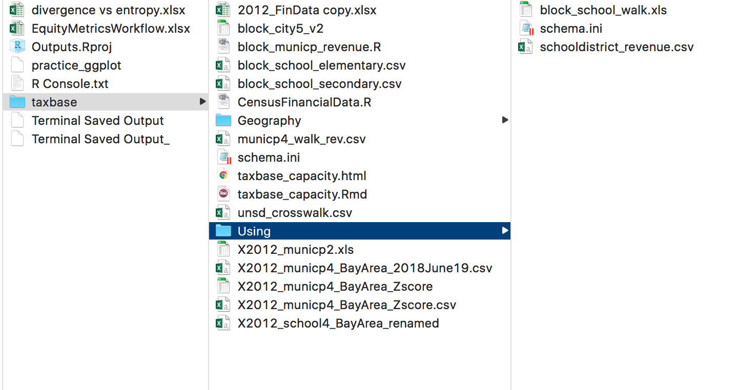

|  |  |  |
| --- | --- | --- |
| Root folder | Sub-root1 | Description |
|  | * **2012_FinData copy.xlsx** | is the copy of Heather’s original financial data that she pulled from Census |
|  | **block_city5_v2** is an excel file that has the metadata of all the outputs of R’s block municipal revenue |  |
|  | **block_municp_revenue.R** is an R-script that analyses the block municipal revenue |  |
|  | * **block_school_elementary.csv** has elementary records of block to school-district * **block_school_secondary.csv** has secondary records of block to school-district * **municp4_walk_rev.csv** * **taxbase_capacity.Rmd** * **unsd_crosswalk.csv** * **X2012_municp2.xls –** this file has the * **X2012_municp4_BayArea_2018June19.csv –** this file has the raw and processed data of revenueitems_final * **X2012_municp4_BayArea_Zscore (xls) –** this file has the same info as the file above but it also has zscores of the revenueitems_final and a metadata * **X2012_school4_BayArea_renamed** – this file has the same info as the two files above but it has the school-district revenue instead and it also has 7 concatenated fields that attempted to rename the school-district school names since it was inconsistent. May not need. |  |

This README contains information of all files in the taxbase folder.