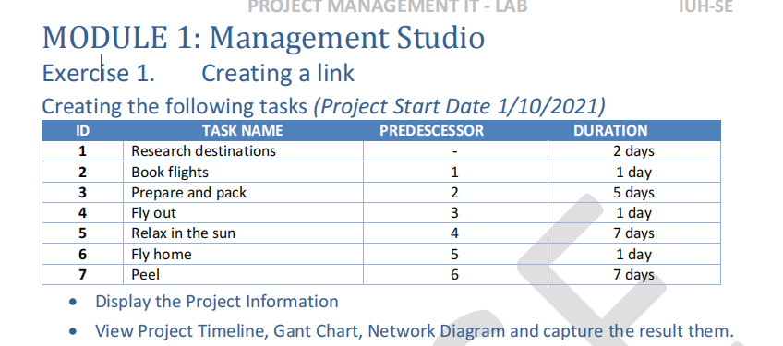

Display the Project Information

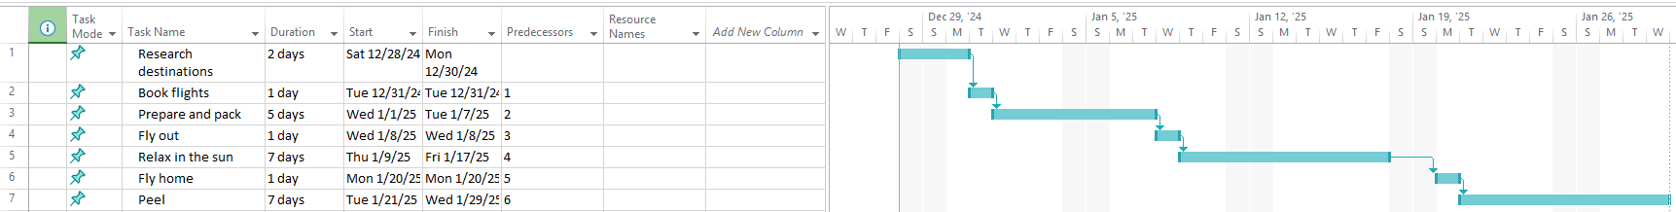

View Project Timeline :   
  
Gant chart :   
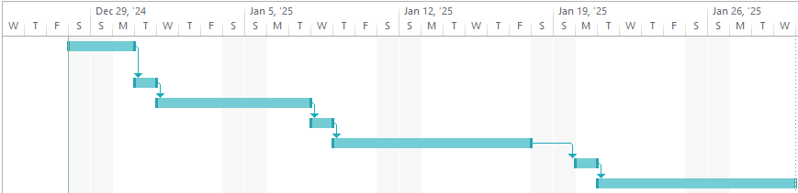

Network Diagram :  


