Schedule the project from a Project Start Date of 1 June 2022;

Chon file->option

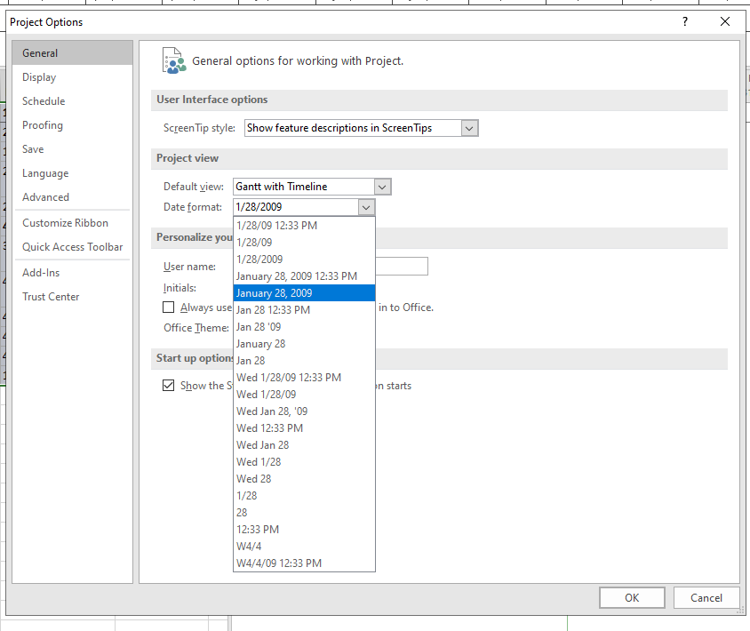

Choose an overall project calendar of Standard

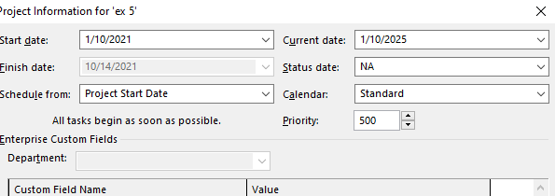

The office will shut down for 2 weeks in the summer. Use the Change Working Time dialog

box to create an Exception called "Summer Shutdown" and make the first 14 days of August

nonworking time

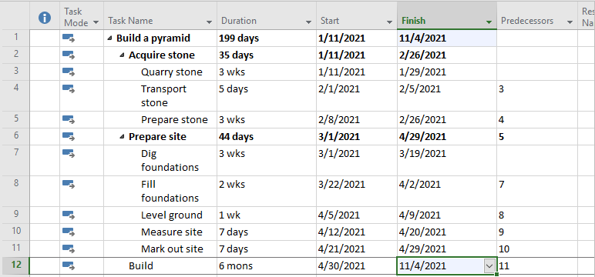

Display the information

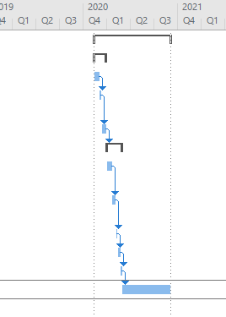

Exercise 2. Changing Working Time

Open project file Ex4 (Module 1) Use the Project Information dialog box to:

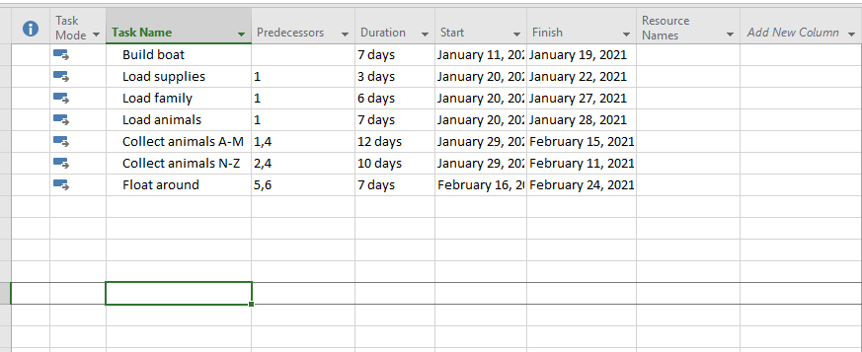

Schedule it to start on 1 Dec 2021. The project will be based upon the Standard calendar.

Project Information :

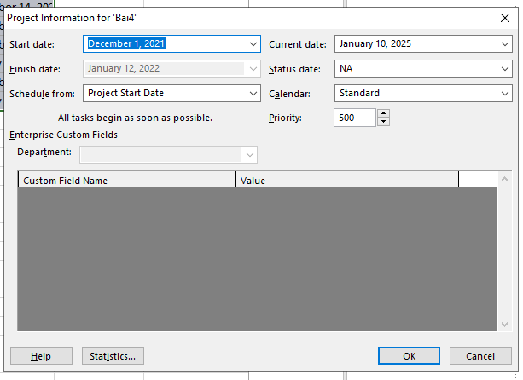

Chon file->Option

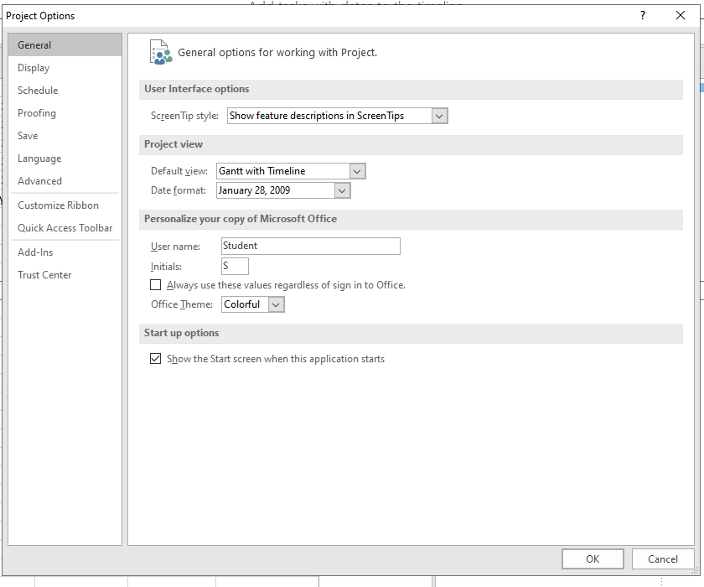

Ket qua :

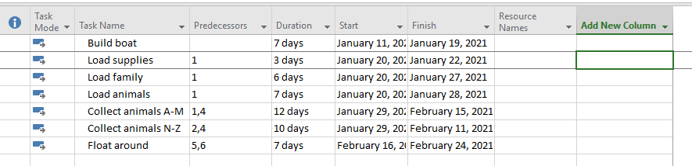

Go to the Change Working Time dialog box and create an Exception to the Standard calendar

called "Xmas Bank Holidays". This needs to make 25 and 26 December 2021 into nonworking

time.

Chon working time

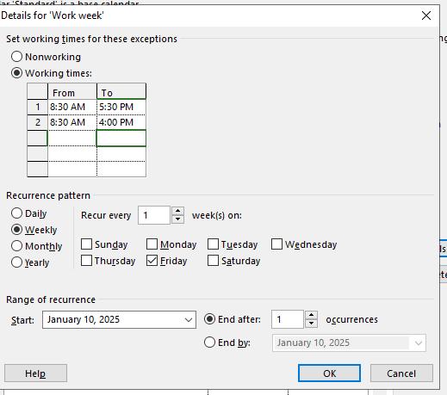

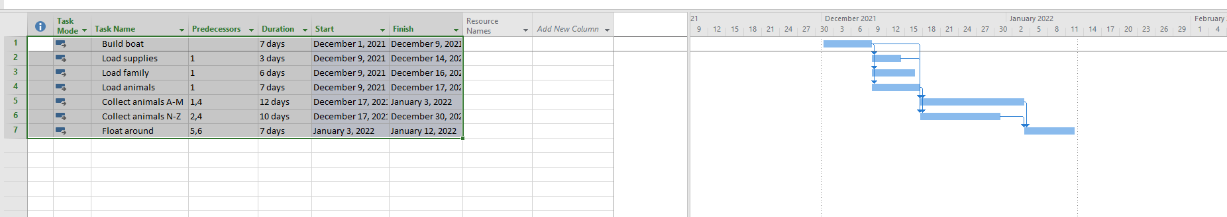

Chuot phai chon nonworking-time

Chon mau

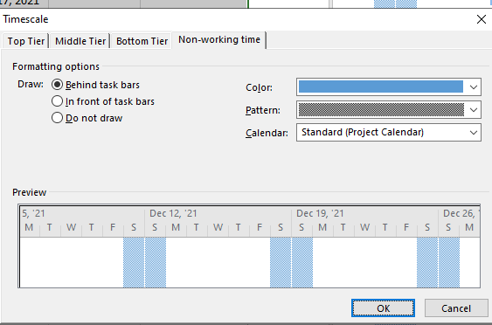

Ketqua :

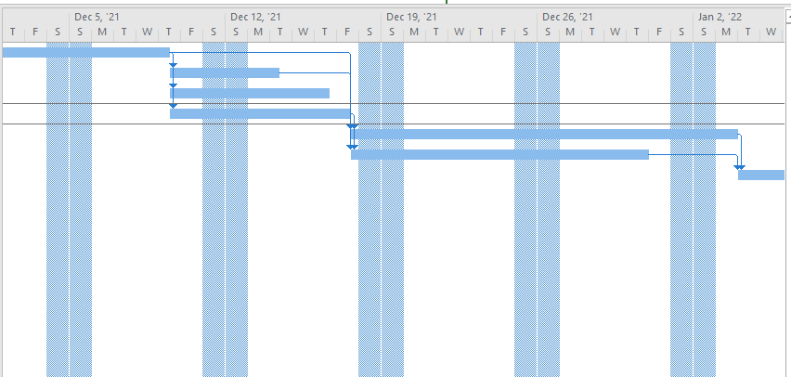

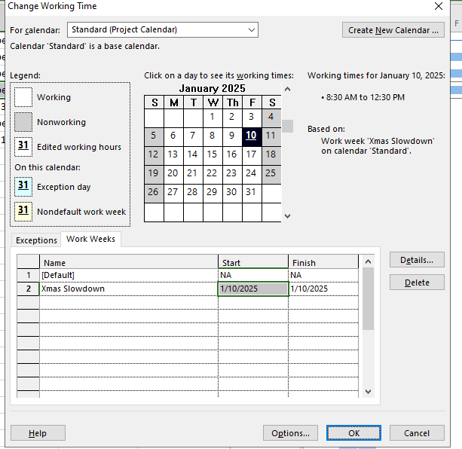

Ket qua

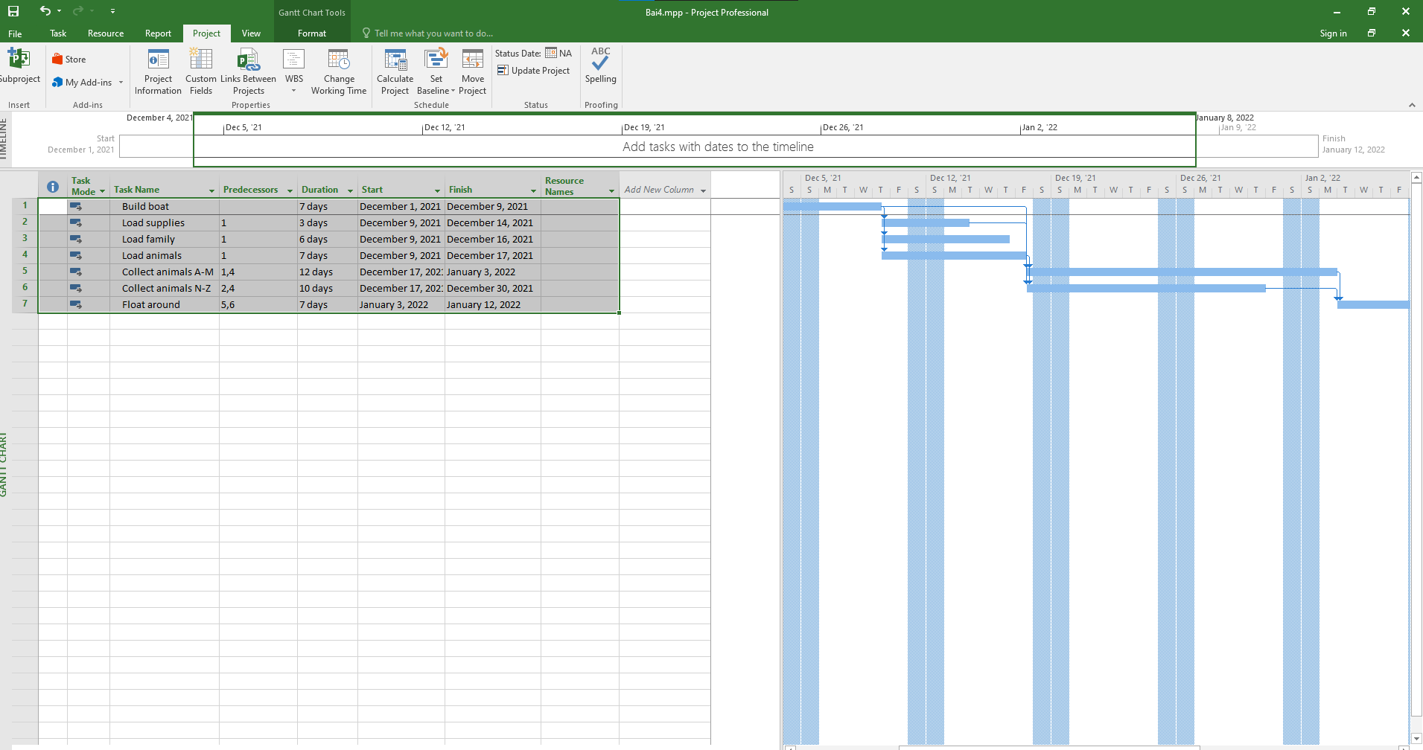

Ex3 : Part Time - creating new calendar

Open project file Ex2 (Module 1), Use the Project Information dialog box to:

Schedule it to start on 11 March 2022. This project should be based upon the Standard

calendar.

Chuyen ngay

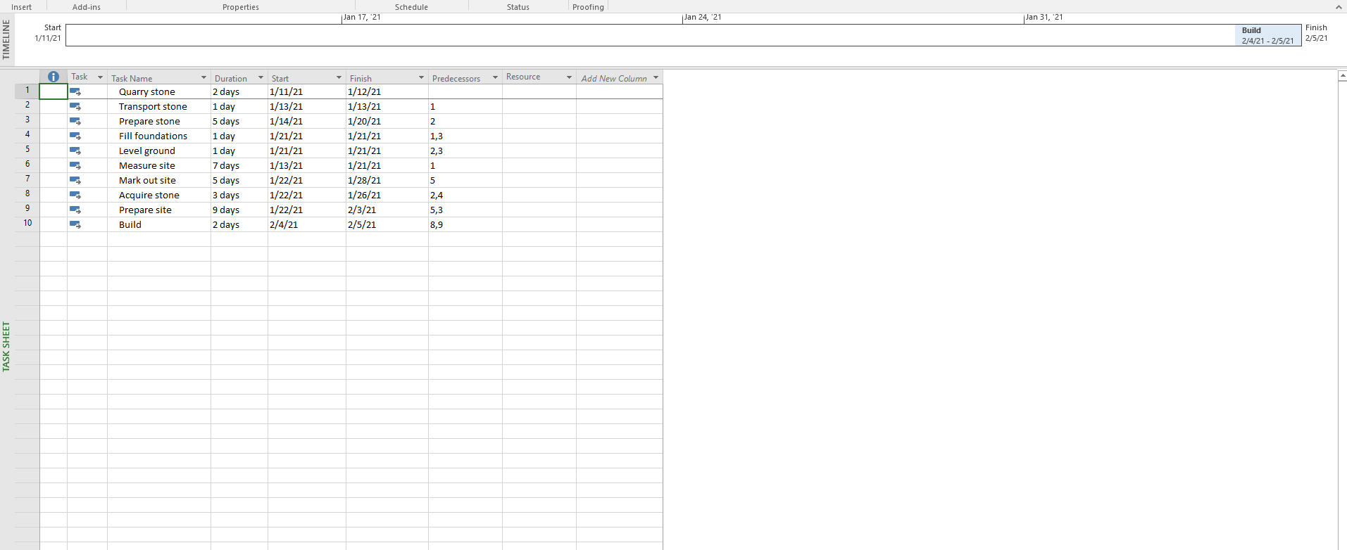

A part-time worker will be used on this project. Go to the Change Working Time dialog box

and create a new copy of the Standard calendar, calling it "Part Timer".

Chon create new calendar :

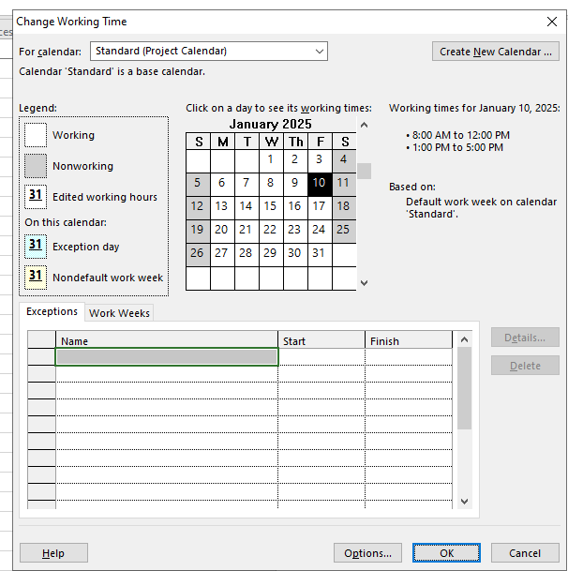

Chon working week -> Set Sunday + Saturday -> go vao start : 10 am to 3 pm

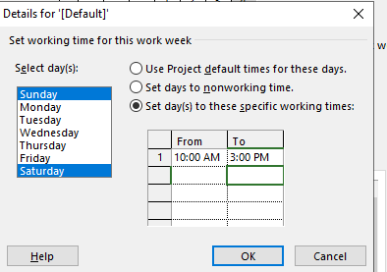

Hien thi bieu do gantt chart

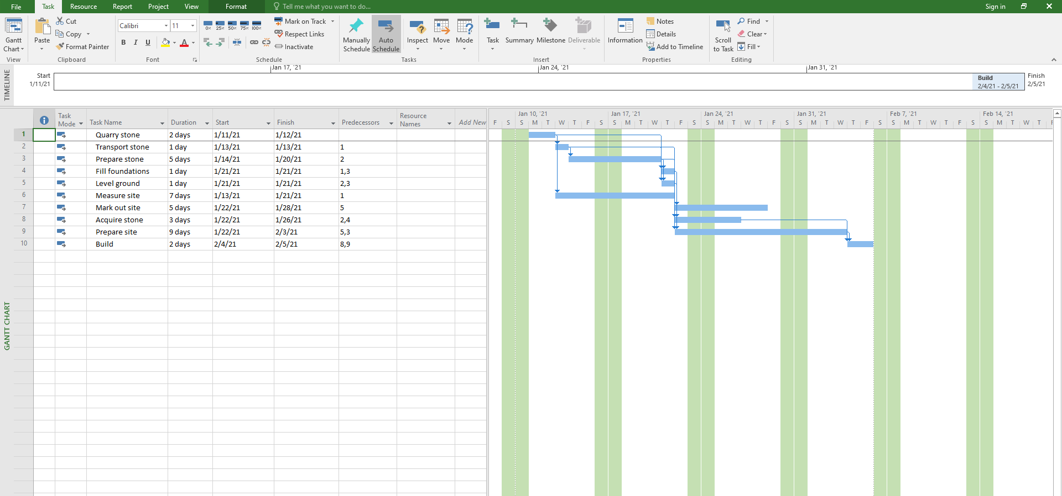

Va display project

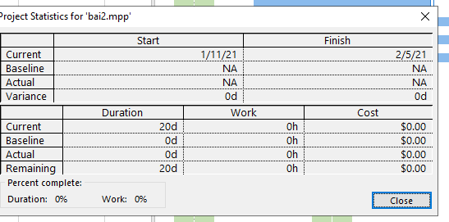

Bai 4 Changing Working Time

Open project file Ex6 (Module 1), Use the Project Information dialog box to schedule it to start

on Nov 1st of next year

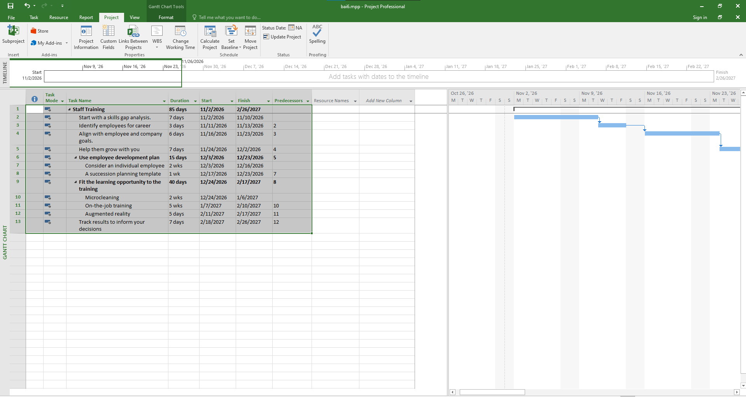

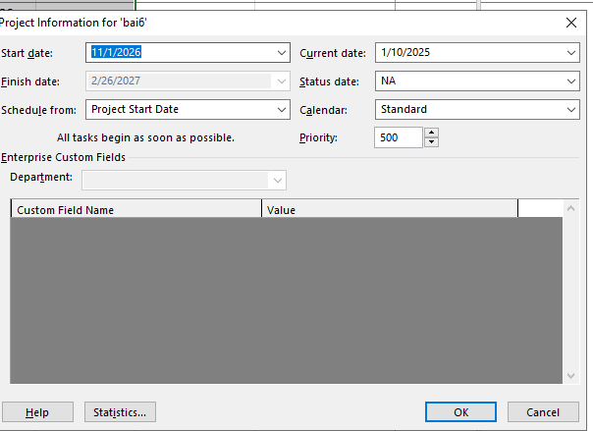

Modify the Standard calendar and change the [Default] work week to use the hours shown

below:

Chon changing work time :

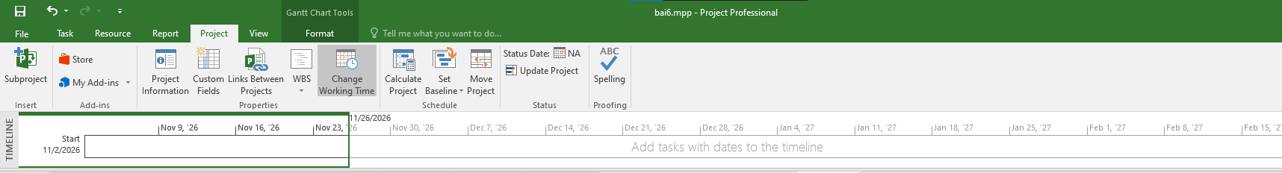

Ket qua :

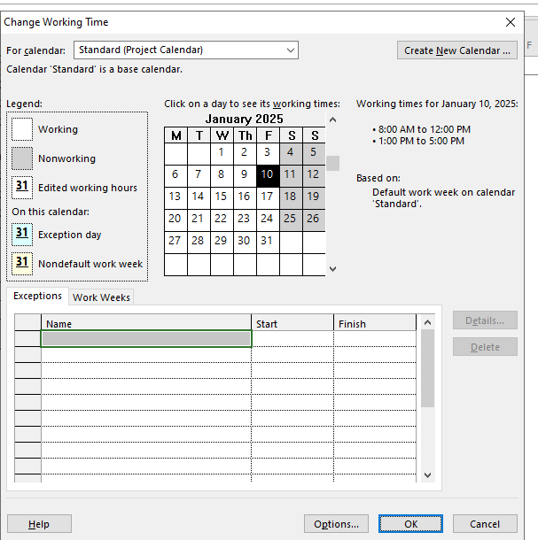

Chon work week -> Default-> Details

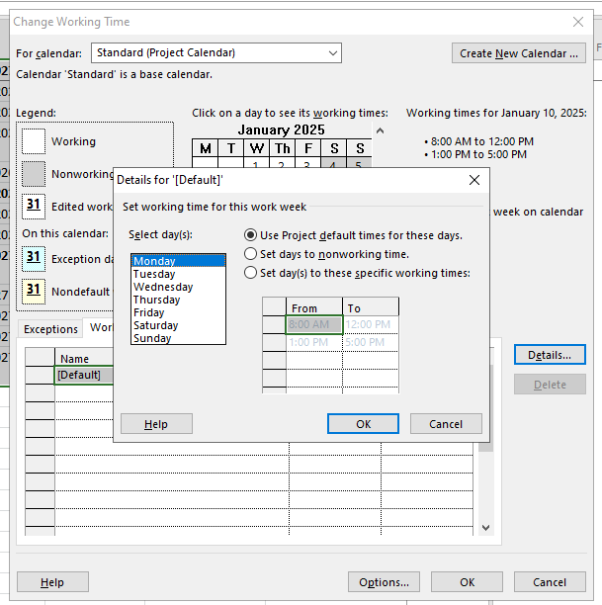

Ket qua :

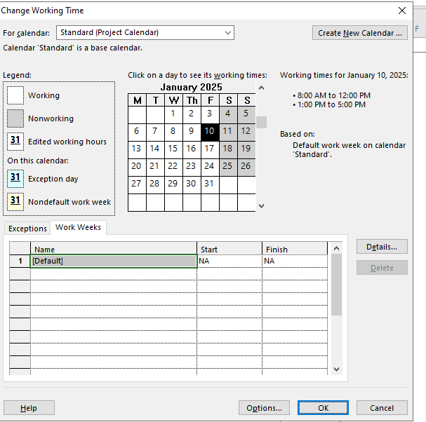

Them ngoai le

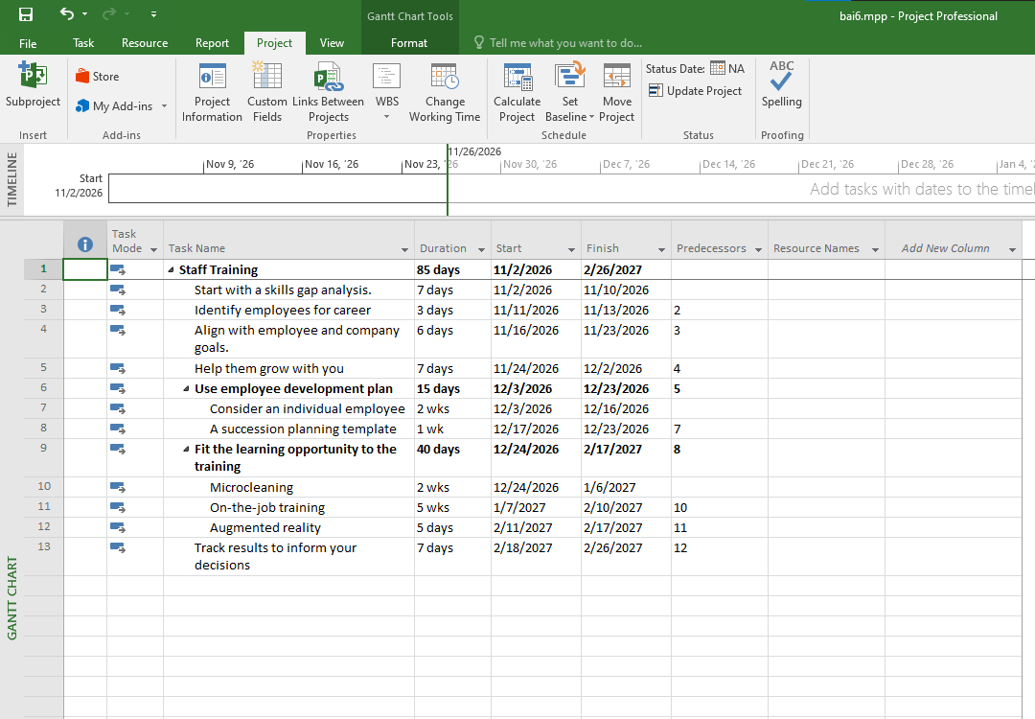

Va ket qua

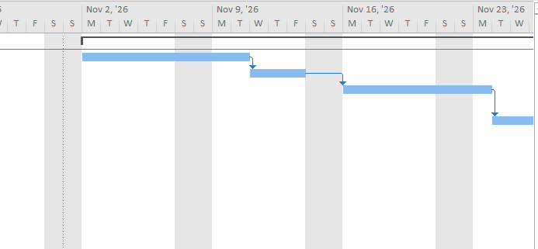

Exercise 5. Create the private Time for a project

Open project file Ex7 (Module 1), Use the Project Information dialog box to:

Schedule this project to begin on January 1st of next year.

Create the new Time Work for your project. [NameTimeProject]

{Name: Your Name - Ex: MinhTimeProject}

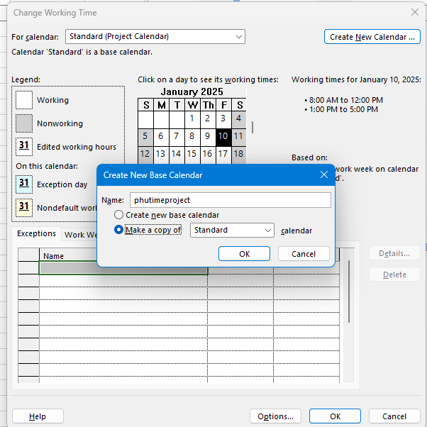\

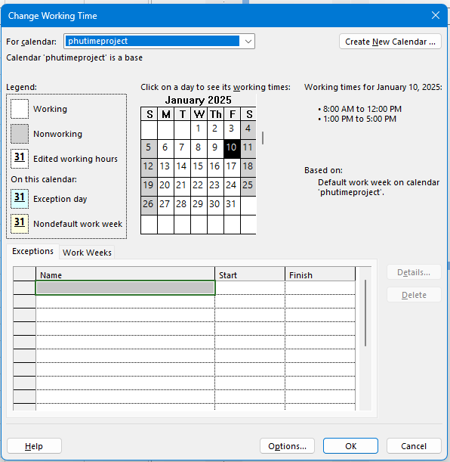

NameTimeProject have Work Time form Monday to Saturday as the following:

Monday to Friday: 7:30-11:30, 13:30-16:30

Saturday: 7:30-11:30

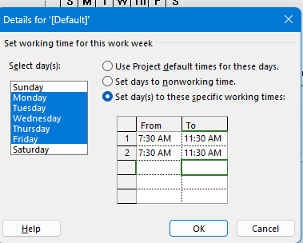

NameTimeProject have two important religious holidays when they don't work (Exception)

Calendar 1 - on the last Monday (off 13:00-16:00) of every month.

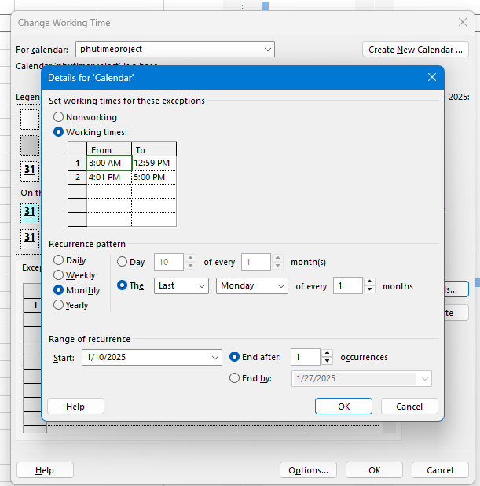

Holiday Day - on April 30th, and May 1st in this year.Assign the NameTimeProject to your Project and display the Project Information.

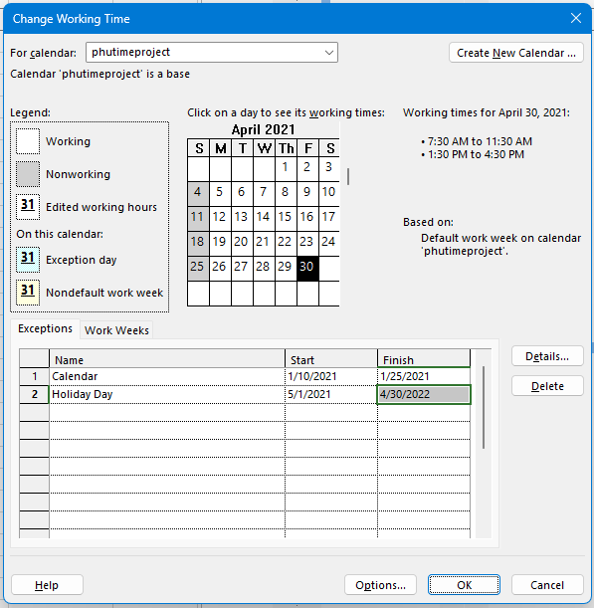

Ket qua

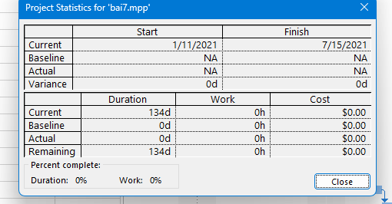

Exercise 6.

Your project

• Create your plan from Monday to Sunday. It will list all of your activities, your time you spend

and resources joining in each task.

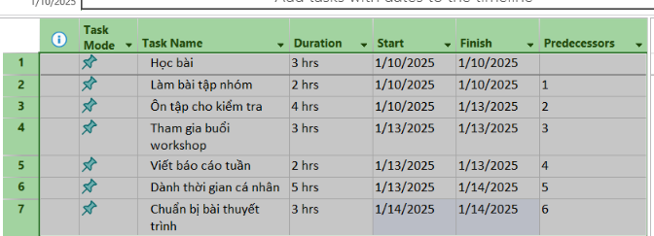

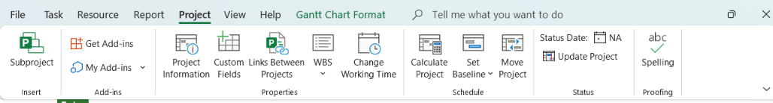

• Create a new calendar called **Student** based on the **Standard** calendar.

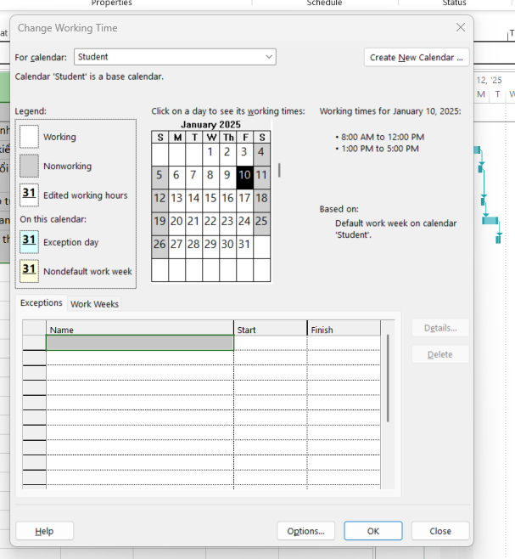

• Change the **[Default]** work week so that the hours match to your calendar everyday

• Using Note function in MP 2010 to take note for important tasks in your plan

