Did we tune this strategy to the past?
Settings review of the four-book ETF rotation strategy — plain-language summary
Friday, 3 July 2026 · summary of the review conducted on 2 July 2026

The question | The strategy was built by trial and error on 2018-2026 data. Are any of its settings fitted to the past rather than genuinely robust?
The answer | No setting was changed. Every setting sits in a broad stable range, and all ~139 tested 'improvements' did worse on data the models had never seen.
How it was tested | Fixed 7.6-year window, realistic costs (re-tested at double), and everything after September 2022 held out as an honest exam.

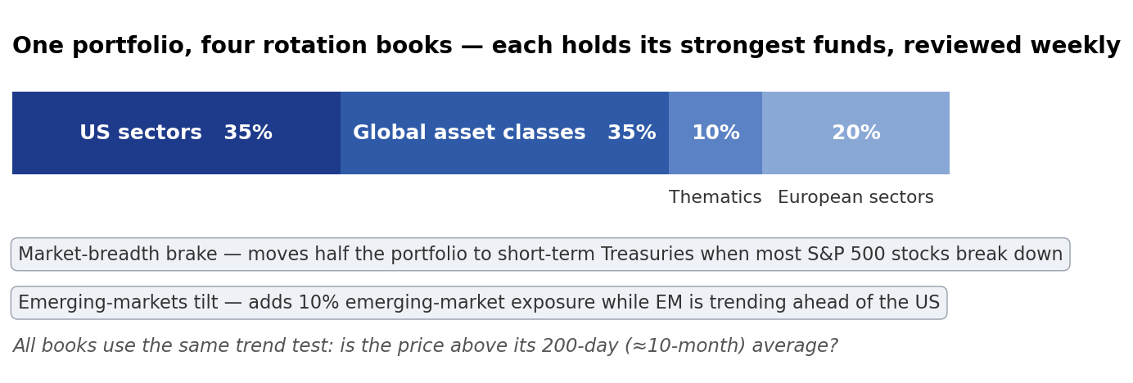
1. The ten-month trend measure is the right speed — and it is not a lucky number.
Thirteen speeds were tested from one month to fifteen months: fast settings were whipsawed in the choppy 2022 market, and everything from ten months up performs within a hair's breadth.
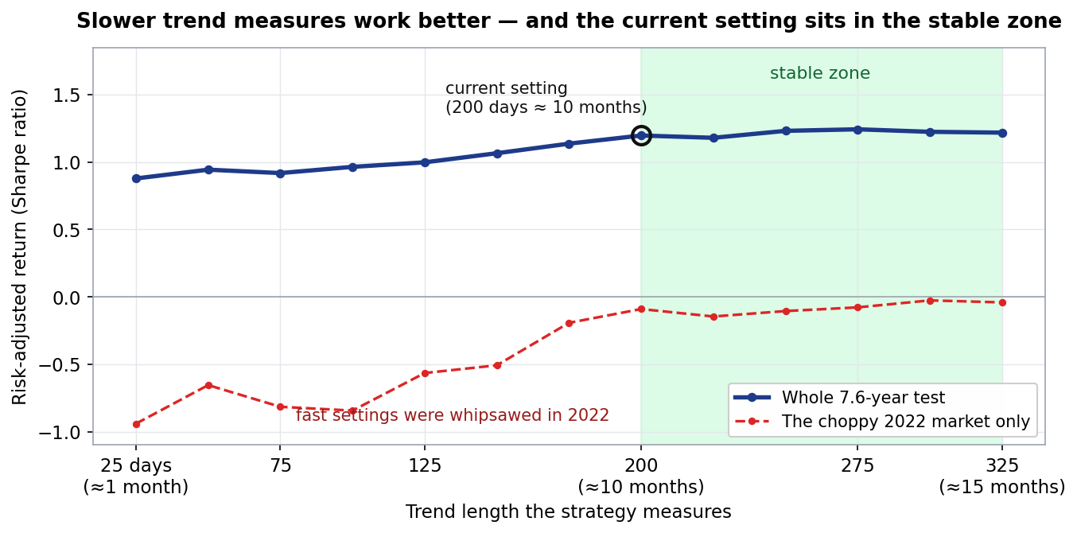
Risk-adjusted return = Sharpe ratio (return per unit of volatility; higher is better). On 7.6 years of data, differences under about 0.4 are statistical noise.
2. Leaving the setting alone beats re-tuning it.
A manager who re-tunes the trend speed every January — using only information available at the time — finishes behind the one who never touches it. Discipline beats optimisation.
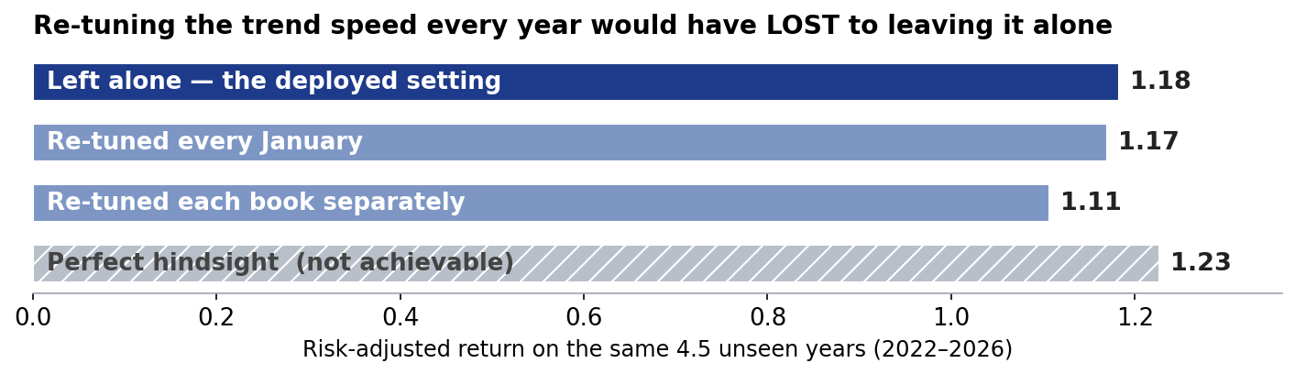
3. Cleverer signal mathematics did not help.
Sixteen of seventeen more sophisticated variants — volatility-adjusted signals, blends of several trend speeds — were worse on unseen data; the simple version is the strong version.
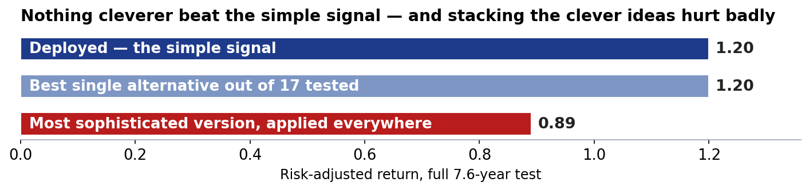
4. The safety brake is robust, not lucky — a long-standing caveat is retired.
Its trigger levels came from a small search, which fairly raised an overfitting concern: all 25 sensible combinations were tested and every one improved both return and worst loss.
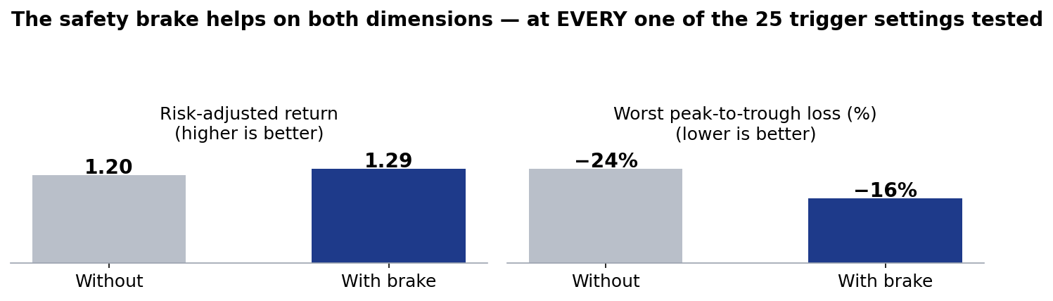
5. The one tempting change was declined.
Removing the thematic book's +5% entry hurdle lifts returns on unseen data but deepens that book's worst loss, all of it in 2022. The hurdle stays; the thematic book is on formal watch.
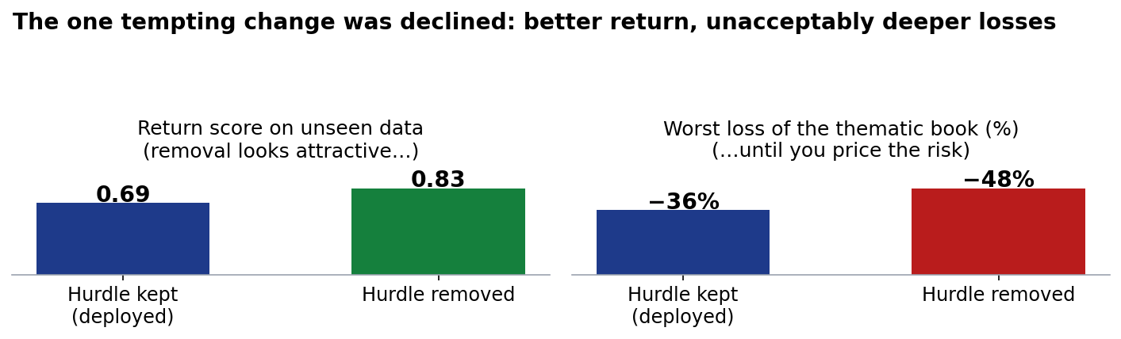

What an allocator should take away
- Performance nowhere depends on a finely-tuned number — the review actively tried to find one and failed.
- Every attempt to be cleverer than the deployed version lost on unseen data; the strategy has earned its simplicity.
- The honest remaining risks are not settings: the thematic book is the weakest component (on watch), the history is only 7.6 years, and every figure is a backtest, not a live track record.

Document of record: reviews/2026-07-02_ws0-ws1_ma-robustness.docx (full methodology, tables and audit trail). Personal research artefact; all figures are simulated backtests in USD, net of stated costs; nothing here is investment advice.

