Strategy review record
breadth-thrust-etf — Workstream 0 (orientation) and Workstream 1 (moving-average robustness)
Thursday, 2 July 2026

Field | Value
Project | breadth-thrust-etf (personal research artefact; all returns simulated)
Review scope | Per REVIEW_PROMPT.md: Workstream 0 (code-verified signal map) and Workstream 1 (MA robustness, vol-normalisation, threshold surfaces)
Evaluation window | 2018-11-08 to 2026-06-16; split-half at 2022-09-08; walk-forward OOS 2022-01-03 to 2026-06-16
Data basis | Committed parquet caches through 2026-06-16 (EU) / 2026-07-01 (US); weekly refresh of 2026-07-02
Method basis | Deployed engines imported unchanged; fixed common window; deployed per-sleeve costs (A 2 / B 2 / C 5 / D 9 bps) plus 2x stress
Repository commits | d98903b, 5d5f151, dc1b332, 893e7b5 (branch main)
Running memo | RESEARCH_MEMO.md (repository root)
Outcome | REVIEWED — no changes to deployed parameters; one flagged trade-off carried to Workstream 3

1. Executive summary
- The deployed single-horizon 200d formulation (binary constituent breadth for sleeves A and D, raw MA-distance momentum for B and C) survives an adversarial calibration review without a single economically meaningful out-of-sample improvement appearing across roughly 120 evaluated configurations.
- The lookback surface is a one-sided plateau: fast lookbacks (25-150d) are uniformly worse; 200-325d is flat (blend spread 0.06 Sharpe against a Sharpe standard error of about 0.4). The 2022 inflation shock is the discriminating regime.
- Walk-forward horizon re-selection LOSES to the fixed deployed value: annually re-fitting the common lookback earns +1.170 OOS versus +1.183 for never touching 200d; per-sleeve re-fitting is worse (+1.107). The hindsight optimum (275d, +1.227) is not capturable by any process restricted to information available at the time.
- Every vol-normalised and multi-horizon ensemble variant fails the cheap-reflex OOS bar; applied to all four sleeves the preferred formulation drops the blend Sharpe from +1.20 to +0.89. Vol-targeted sleeve sizing also fails; the slope gate on B passes formally but its effect (+0.006 blend) is negligible and is not deployed.
- The Phase 19 regime gate thresholds sit on a genuine plateau: all 25 hysteresis pairs land Sharpe +1.22 to +1.33 versus +1.20 ungated, every pair better on both Sharpe and drawdown. The long-standing in-sample-tuning caveat is materially defused. Keep 20%/50%.
- One candidate is carried to the Workstream 3 heavy gate: removing Sleeve C's +5% signal floor (OOS test Sharpe +0.83 vs +0.69, one knob fewer, lower turnover — but max drawdown -48% vs -36%, concentrated in the 2022 grind). Flagged as a stated trade-off, not a change.

2. Workstream 0 — verified architecture and drift
The deployed system was mapped from code, not documentation. Key corrections to the prior written record (README stops at Phase 24; code is at Phase 28.7):
- Sleeves A and D select on 200d constituent breadth, not 50d; the 50d breadth series drives only the Phase 19 regime gate. The architecture deliberately runs two horizons: slow selection, fast de-risking.
- Sleeve A ranks sector-RELATIVE breadth (cross-sectional demean); Sleeve D ranks ABSOLUTE breadth.
- Sleeve C runs K=5 equal-weight (Phase 27) on 25 thematics with a +5% signal floor and a 30% sleeve-breadth gate; the README's K=4 on 23 names is stale.
- Sleeve A's tradeable universe is 13 lines (IUIT pruned for 0.97 correlation with CNDX) and includes broad-cap and small-cap slices alongside sectors.
- The pre-existing robustness harness covers the legacy single-ETF 50/150 strategy; no parameter surface existed for the deployed top-K sleeves before this review.
Deployed headline (committed track, 2018-11-08 to 2026-06-18): ungated 35/35/10/20 blend Sharpe +1.20 (CAGR +15.8%, max DD -23.8%); with Phase 19 gate +1.29 (-16.4%); with the Phase 22 EEM tilt +1.29 (-16.3%). The EEM tilt has had 11 switches ever (29% of days ON) — its bet-count audit is a Workstream 3 item.

3. Workstream 1 findings

3.1 Lookback parameter surface (13 points, 25d steps)
Sharpe | 25 | 50 | 75 | 100 | 125 | 150 | 175 | 200 | 225 | 250 | 275 | 300 | 325
blend | +0.88 | +0.94 | +0.92 | +0.96 | +1.00 | +1.06 | +1.14 | +1.20 | +1.18 | +1.23 | +1.24 | +1.22 | +1.22
A | +0.72 | +0.81 | +0.77 | +0.81 | +0.85 | +0.91 | +0.97 | +0.99 | +1.00 | +1.02 | +1.00 | +1.02 | +1.03
B | +0.63 | +0.81 | +0.83 | +0.78 | +0.88 | +0.84 | +0.95 | +1.01 | +0.99 | +1.07 | +1.10 | +1.09 | +1.04
C | +0.72 | +0.63 | +0.63 | +0.64 | +0.52 | +0.72 | +0.72 | +0.73 | +0.75 | +0.72 | +0.79 | +0.77 | +0.75
D | +0.62 | +0.55 | +0.52 | +0.67 | +0.69 | +0.74 | +0.74 | +0.87 | +0.80 | +0.89 | +0.89 | +0.82 | +0.84

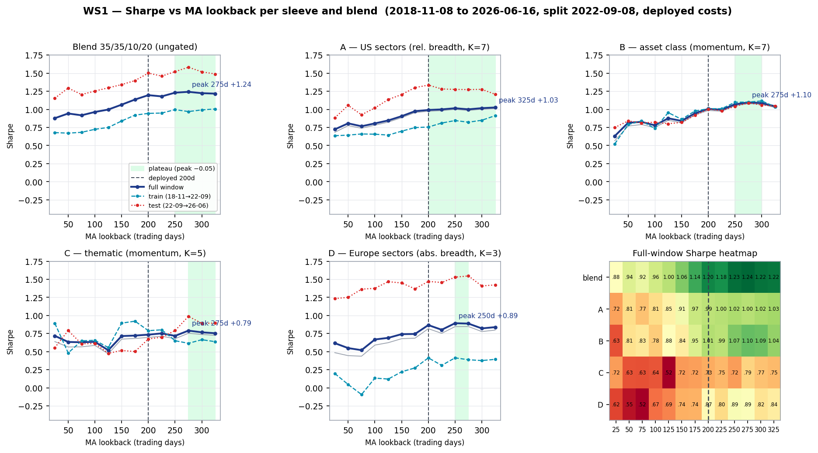
Figure 1 — Sharpe vs lookback per sleeve and blend; full/train/test lines, plateau band (within 0.05 of peak), deployed 200d marked. Both halves prefer slow lookbacks; train/test rank correlation: blend +0.88, B +0.88, A +0.67, D +0.67, C -0.41 (noise).
- Fast lookbacks fail in the 2022 inflation shock (blend sub-period Sharpe -0.51 to -0.84 at 50-150d versus -0.03 to -0.11 at 200-300d).
- 2x costs move full-window Sharpe by 0.03 or less at weekly cadence for lookbacks of 150d and above; slow is also the low-turnover direction.
- Sleeve C's horizon preference is statistically noise (rank correlation flips sign on the denser grid); C stays on the common horizon by parsimony.

3.2 Drawdown surface
Blend metric | W=50 | W=100 | W=150 | W=200 | W=250 | W=300
Max drawdown | -22.5% | -23.0% | -24.3% | -23.8% | -23.8% | -24.3%
Worst rolling 12m return | -14.8% | -16.6% | -13.0% | -11.9% | -10.1% | -10.0%
Drawdown within 2022 | -17.3% | -20.2% | -17.0% | -14.2% | -13.2% | -13.8%
Longest underwater (days) | 427 | 431 | 425 | 163 | 395 | 298

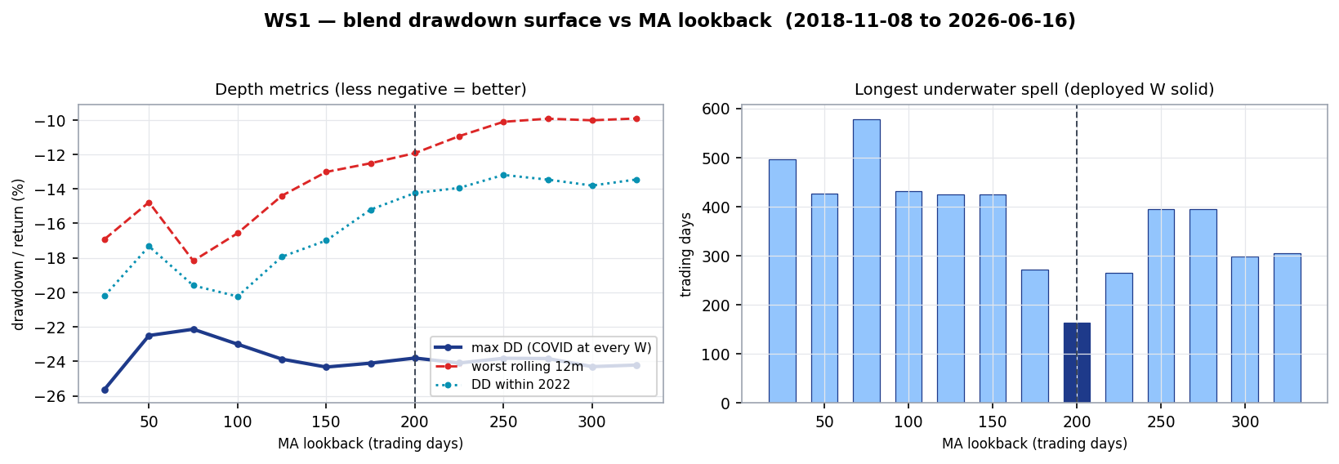
Figure 2 — blend drawdown surface. Max drawdown is horizon-invariant (COVID 2020 binds at every lookback — a crash faster than any MA in the grid); every conditionable metric prefers slow. The fast-vs-slow underwater contrast (400-580 days vs 270-300) is robust; the 163-day reading at exactly 200d is path-specific.
The one genuine trade-off: fast lookbacks did protect the momentum sleeves in the COVID crash specifically (C at W=50: -19.3% versus -32.5% at 200d) and paid for it in every choppy grind. This asymmetry is the division of labour the architecture already encodes — slow selection horizons, fast 50d gate.

3.3 Walk-forward horizon selection
Annual expanding re-fits (year-ends 2021-2025) choosing the lookback from the 13-point grid on train data only; 100% one-way turnover charged per sleeve on every change; all protocols scored on the identical OOS window.
Protocol | OOS Sharpe | Lookbacks used
Fixed 200d (deployed) | +1.183 | 200
Fixed 250d | +1.181 | 250
Fixed 275d | +1.227 | 275
Walk-forward, common horizon (annual re-fit) | +1.170 | 275 to 325
Walk-forward, per-sleeve horizons (annual re-fit) | +1.107 | 25 to 325
Oracle fixed (hindsight upper bound) | +1.227 | 275

The plateau's gradient is smaller than the selection variance of any honest re-fit process. Recalibration of the horizon demonstrably loses out of sample; the parameter is closed rather than deferred.

3.4 Vol-normalised and ensemble variants
Variant (sleeve-level full Sharpe) | A | B | C | D
V0 deployed (binary breadth / raw distance, 200d) | +0.99 | +1.01 | +0.73 | +0.87
Graded raw distance, 200d (grading alone) | +0.88 | n/a | n/a | +0.65
Vol-normalised z, 200d (item 3a) | +0.82 | +0.96 | +0.69 | +0.56
Ensemble 50/100/150/200, raw (item 2a) | +0.88 | +0.84 | +0.65 | +0.67
Vol-normalised ensemble (2a + 3a joint) | +0.75 | +0.78 | +0.72 | +0.43

Sixteen of seventeen sleeve-level variants fail the cheap-reflex bar (OOS test delta >= 0; at least 4 of 6 regimes not worse; survives 2x cost). Attribution is clean: grading the breadth count, vol-normalising, and multi-horizon ensembling each hurt independently; composed, the all-variant blend is +0.89 versus +1.20 deployed. The bucketed-horizon fallback was skipped on evidence: fair cross-bucket ranking requires the vol-normalisation that failed, and sleeve B — the genuinely cross-asset sleeve — prefers slow horizons for the whole basket while C's preference is noise. Vol-targeted sleeve sizing fails (blend -0.015 full, consistency 2/6). The slope gate on B is the sole formal survivor (+0.006 blend full, +0.021 test, 4/6) — an economically negligible effect, not deployed, logged for the Workstream 3 shortlist.

3.5 Threshold surfaces
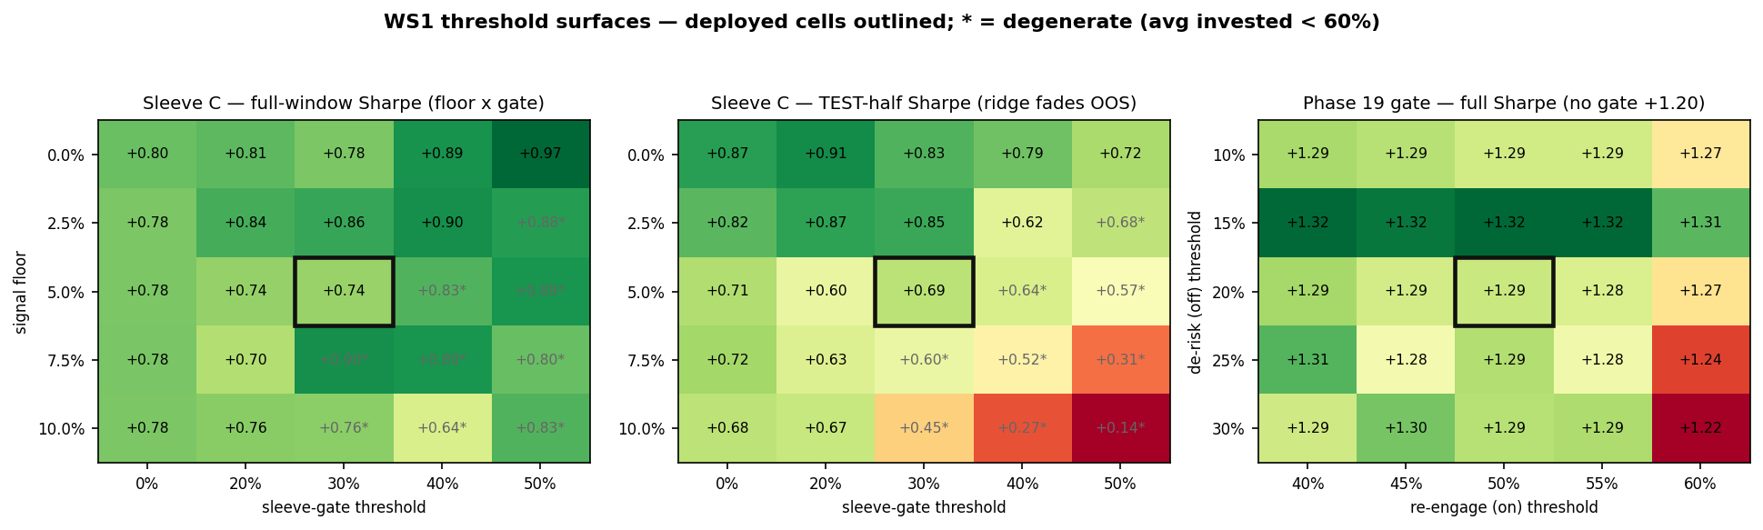
Figure 3 — threshold surfaces; deployed cells outlined; * marks degenerate cells (average invested share below 60%). The C ridge that looks attractive full-window fades out of sample (middle panel).
- Phase 19 gate (off x on hysteresis): FLAT. All 25 valid pairs Sharpe +1.22 to +1.33 versus +1.20 ungated; every pair improves both Sharpe and max drawdown; deployed 20%/50% sits mid-plateau (+1.287). The gate's value is structural, not parameter luck. Keep.
- Sleeve C floor x gate: bumpy, with the high-gate ridge earning its full-window Sharpe in the train half (floor 0%/gate 50%: train +1.23, test +0.72) — independent confirmation of the Phase 27 bake-off that rejected the 50% gate. The high-floor/high-gate corner is degenerate (invested share down to 24%).
- Pre-registered candidate — remove the +5% floor, keep the 30% gate: full +0.78 vs +0.74, test +0.83 vs +0.69, 5/6 regimes, survives 2x cost, one knob fewer, lower turnover; BUT max drawdown -48% vs -36%, the floor's entire value sitting in the 2022 grind (sub-period Sharpe -2.49 vs -0.94). Sharpe says remove; drawdown says keep. Carried to Workstream 3 as a stated trade-off.

4. Decisions
Component | Decision | Basis
Sleeve lookbacks (200d, all four sleeves) | KEEP — closed | Flat slow plateau; walk-forward re-fit loses OOS (3.1, 3.3)
Signal formulation (binary breadth / raw distance) | KEEP — closed | All vol/ensemble variants fail OOS (3.4)
Vol-targeted sleeve sizing | REJECT | No OOS payoff, adds a knob (3.4)
Slope gate on B | NOT DEPLOYED | Passes bar, effect negligible; WS3 shortlist (3.4)
Phase 19 gate thresholds (20%/50%) | KEEP — caveat defused | Flat surface, every cell beats ungated (3.5)
Sleeve C +5% floor | KEEP, FLAGGED | OOS Sharpe favours removal, drawdown opposes; WS3 shortlist (3.5)
C sleeve-gate 30% | KEEP | OOS-robust vs 40-50% alternatives (3.5, Phase 27)

Trial register for the Workstream 3 deflated-Sharpe audit: 65 lookback-surface evaluations (13 x 5 including blend), 17 signal variants, 2 overlays, 5 walk-forward protocols, 25 C threshold cells, 25 gate cells — approximately 139 configurations evaluated this review, none selected for deployment.

5. Artefact register
- Scripts (new, deployed engines untouched): ws1_common.py, run_ws1_ma_surface.py, run_ws1_vol_variants.py, run_ws1_wf_horizon.py, run_ws1_threshold_surface.py, plot_ws1_surface.py, plot_ws1_thresholds.py
- Data: ws1_ma_surface.json, ws1_vol_variants.json, ws1_wf_horizon.json, ws1_threshold_surface.json
- Charts: ws1_ma_surface.png, ws1_ma_dd_surface.png, ws1_threshold_surface.png
- Memo: RESEARCH_MEMO.md (Workstream 0 map, ranked plan, findings 1-4)
- Commits: d98903b (WS0+WS1 deliverables), 5d5f151 (drawdown addendum), dc1b332 (dense grid + charts), 893e7b5 (walk-forward + thresholds)

6. Next phase
Per the staged plan, the next session is Workstream 2 (universe): EEM coherence, correlation-cluster overlap control, trend-opportunity map, country-momentum sleeve evaluation against the EEM+EFA hurdle, and data-integrity gates for any addition. Workstream 3 (heavy robustness gate) runs once, on the frozen shortlist, and inherits this review's trial register, the C-floor trade-off, and the slope-gate re-check.

Sign-off
Prepared by | Claude Code research session (Fable 5), under direction of Zhenghao Phua
Reviewed and approved by
Date
Next review | Workstream 2 — universe (session 2 of the staged review)

Personal research artefact. All performance figures are simulated backtests in USD, net of stated costs; nothing in this document is investment advice.

