Strategy review record
breadth-thrust-etf — Workstream 2 (universe)
Thursday, 2 July 2026
Project | breadth-thrust-etf (personal research artefact; all returns simulated)
Review scope | Per REVIEW_PROMPT.md: Workstream 2 — trend-opportunity map, EEM coherence, overlap control, country-sleeve evaluation, the in-flight commodity-spot thread, and data-integrity gates on every addition
Evaluation window | 2018-11-08 to 2026-06-16; split-half at 2022-09-08; commodity re-run ends 2026-06-12 (cache bound)
Data basis | Committed caches plus a fresh 16-line candidate panel (data/ws2_prices_cache.parquet, fetched 2026-07-02); every candidate ticker verified against two or more sources
Method basis | WS1 harness inherited unchanged; deployed baselines rebuilt and regression-checked (ungated blend +1.196, identical to WS1); every add/drop pre-registered before results were seen; cheap reflex, kill on contact; blend-level decision numbers
Repository commits | 903749c, 6747aae (branch main)
Running memo | RESEARCH_MEMO.md (repository root)
Outcome | REVIEWED — zero additions survive; both pre-registered prunes rejected; one architectural change proposed for approval (EEM to overlay-only)

1. Executive summary
- The deployed universe survives a full overlap audit with zero forced changes: both pre-registered within-sleeve prunes fail the keep bar, and every proposed widening — country momentum sleeve, commodity-spot additions, factor lines — is killed or deferred on out-of-sample evidence rather than taste.
- Overlap rule adopted: cluster at pairwise weekly correlation of 0.80 or above (full window, connected components); keep the most liquid line per cluster; reject any CANDIDATE above 0.90 to an incumbent (the IUIT/CNDX 0.97 prune generalised). Auto-rejected candidates: IEMG (0.998 to EEM), EWG and EWU (0.93-0.97 to VGK/EFA), DBE and GSG (0.94-0.96 to DBC).
- The blend's true US-beta concentration is now quantified: the 28 blend lines that link into one correlation cluster average 46.8% of NAV with an 83.5% peak; QQQ alone peaks at 24.1% look-through, held by Sleeves A and B simultaneously in 43% of weeks. Cross-sleeve same-beta duplication is retained as deliberate dual-signal coverage; the concentration number goes to Workstream 3 as context.
- Country momentum sleeve KILLED on the pre-registered bar: 3 of 6 sub-periods against the 50/50 EEM+EFA benchmark, with the train half negative (-0.04 vs +0.18) — the ranking flips across the split and the whole edge sits in the 2022+ half. Long-window reconciliation confirms the earlier Idea 3 rejection: country momentum wins only in EM-favoured regimes; the Phase 22 overlay already expresses that bet with fewer knobs.
- Commodity-spot thread KILLED on the fixed window: blend test-half delta -0.124 at 2 of 6 consistency with both sleeves widened; the widened B earns its improvement in the train half only (+1.15 train vs +0.66 test) — a backward-looking bet on the 2021-22 commodity bull. The kill stands even at zero add-cost, and DBE/GSG duplicate incumbent DBC at 0.94-0.96.
- EEM coherence DECIDED: overlay-only. All four ablation cells sit within 0.009 full-window Sharpe, so the choice is architectural: removing EEM from Sleeve B ends a real double-count (peak look-through 15.0% of NAV; both roles held EEM on 26% of days), leaves B no worse standalone (+1.02 without vs +1.01 with), and preserves the validated Phase 22 EM-turn expression. Approval required before any deployed script changes.
- Data-integrity catch: FM (frontier) is a dead fund — liquidated January 2025 — caught by two-source ticker verification and excluded; frontier is currently uninvestable via clean US-listed ETFs. Session trials: 32 (21 new + 11 retro-logged from the commodity thread); cumulative register ~171 configurations for the Workstream 3 deflated-Sharpe audit.

2. Method and data integrity
All experiments run in new scripts (scripts/ws2_common.py, scripts/run_ws2_*.py) against the WS1 harness: fixed window, split-half at 2022-09-08, deployed per-sleeve costs (A 2 / B 2 / C 5 / D 9 bps) with a 2x stress, and the six-regime sub-period grid. The deployed baselines were rebuilt at W=200 and regression-checked against the WS1 result before any experiment (ungated blend Sharpe +1.196, exact match). Every script states its three silent-failure modes (look-ahead, window inconsistency, cost/FX realism) and defends each in code; every configuration was pre-registered before its performance was seen.
- Ticker verification (two or more sources — yfinance metadata, data/ishares_catalogue.csv, BlackRock/aggregator pages): all sixteen panel lines verified. EWW (iShares MSCI Mexico) and EWS (iShares MSCI Singapore) confirmed via BlackRock product pages. FM returned a stub name from yfinance; web sources confirm the iShares Frontier and Select EM ETF was wound down with a last price of 2025-01-08 — EXCLUDED, and the survivorship gate is recorded as having caught a dead fund in the candidate list itself.
- Erratum to the WS0+WS1 record: it stated Sleeve A's tradeable universe as 13 lines. A recount of UNIVERSE_ETFS confirms 14 (15 registered minus IUIT); the README was correct. RESEARCH_MEMO.md carries the correction.

3. Workstream 2 findings

3.1 Overlap control — rule, matrix, look-through
Seventy-two lines (all sleeve members, Sleeve D converted EUR to USD with the deployed FX series, plus all candidates), weekly Friday returns, 397 observations full window plus a trailing year. Eighteen pairs exceed 0.90; the load-bearing ones:
Pair | Corr | Reading
EEM / IEMG | 0.998 | candidate IEMG auto-rejected
XLRE (A) / VNQ (B) | 0.990 | cross-sleeve dual-signal REIT — deliberate, quantified
EFA / VGK (both B) | 0.984 | within-B duplicate — prune tested (P1)
VGK-EWG / EFA-EWG / VGK-EWU | 0.93-0.97 | candidates EWG, EWU auto-rejected
DBC / GSG and DBC / DBE | 0.94-0.96 | commodity adds duplicate incumbent DBC
XLI (A) / PAVE (C) | 0.954 | thematic behaving as A's industrials beta — prune tested (P2)
SPY (A,B) / QQQ (A,B) | 0.930 | deployed dual-coverage core
ICLN / TAN and CIBR / SKYY (C) | 0.93 / 0.90 | within-C duplicates — prune tested (P2)
TLT / IEF (B) | 0.918 | deliberate duration ladder — keep
Blend look-through (ungated 35/35/10/20, sleeve weight panels): the US-beta cluster averages 46.8% of NAV and peaks at 83.5%; QQQ 6.8% mean / 24.1% peak (jointly held by A and B in 43% of weeks); SPY 4.0% / 10.4%; IJR 2.1% / 13.7%. Trailing-year additions change no decision but add context: EEM-EWT 0.908 and EEM-EWY 0.906 (Taiwan and Korea have converged onto broad EM — EM is currently a semiconductor trade), IEF-SHY 0.901.
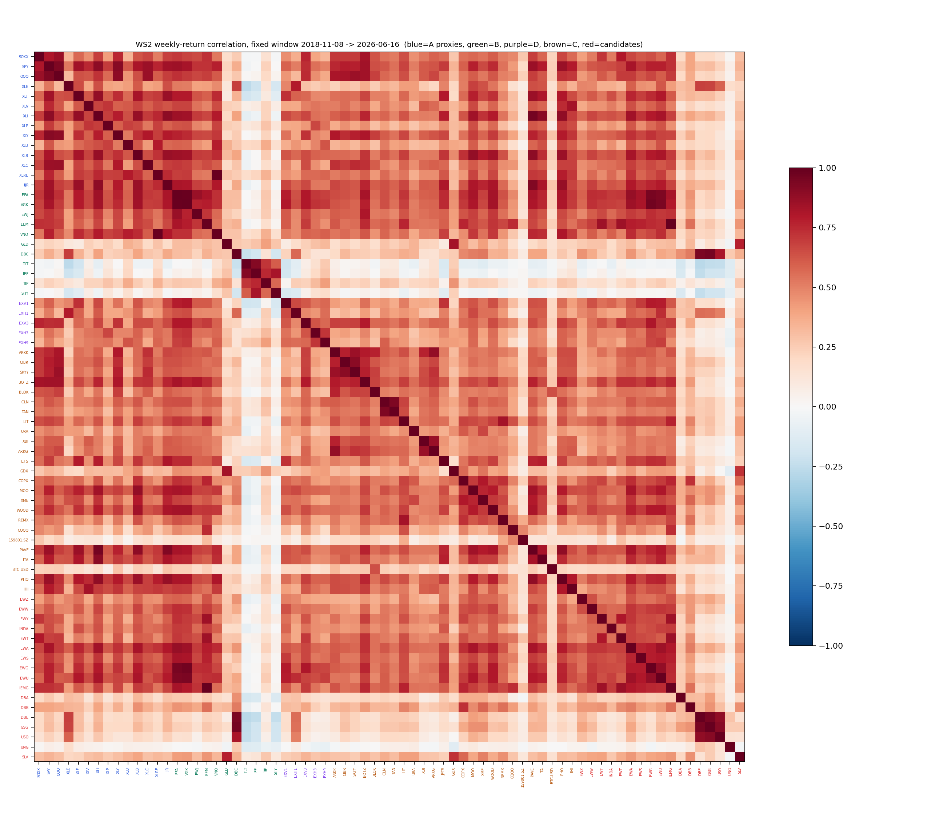
Figure 1 — weekly-return correlation matrix, fixed window 2018-11-08 to 2026-06-16 (labels coloured by bucket: A proxies, B, D, C, candidates). Full matrix in data/ws2_correlation.json.

3.2 Pre-registered within-sleeve prunes — both rejected
Bundle | Sleeve dFull / dTest | Blend dFull / dTest | Consistency | Verdict
P1: B drop VGK (0.984 to EFA) | +0.007 / -0.029 | +0.004 / -0.003 | 3/6 | REJECT — a wash; incumbent wins ties
P2: C drop TAN, SKYY, PAVE | -0.111 / +0.006 | -0.021 / +0.001 | 1/6 | REJECT — actively harmful; DD -40.7% vs -36.1%
The dropped C names carried the sleeve's train half (2020 solar, 2021 infrastructure). Corollary recorded: correlation redundancy alone is not sufficient grounds to REMOVE an incumbent, mirroring the Phase 16 SLV lesson that a passed correlation gate is not sufficient grounds to ADD one.

3.3 Country momentum sleeve — killed on the pre-registered bar
Design (pre-registered): the deployed B formulation — graded (close-MA200)/MA200, top-K by signal share among positive names, SHY deficit floor, which IS the own-200d risk gate — on ten country lines (EWZ EWW EWY INDA EWT EWA EWS EWG EWU EWJ), headline K=3 at 5 bps one-way including cash legs; K in {2,4} and a +EEM variant reported, not selected. Bar: beat the 50/50 EEM+EFA benchmark on full window AND test half AND 4 of 6 sub-periods AND at 2x cost.
Configuration | Full | Train | Test | 2x cost | Max DD
50/50 EEM+EFA benchmark | +0.60 | +0.18 | +1.16 | — | -33.8%
U10 K=2 | +0.74 | +0.03 | +1.30 | +0.70 | -38.6%
U10 K=3 (headline) | +0.70 | -0.04 | +1.27 | +0.65 | -35.3%
U10 K=4 | +0.66 | -0.09 | +1.23 | +0.61 | -31.4%
U11 (+EEM) K=3 | +0.66 | -0.10 | +1.25 | +0.61 | -35.3%
Bar result: full PASS, test PASS, 2x PASS, sub-periods 3/6 FAIL — KILL (no blend variant run). The train half is negative against a positive benchmark: the ranking flips across the split and the edge is entirely post-2022. Long-window context (2004 start): the sleeve beats the benchmark 2004-2010 (0.91 vs 0.50) and 2022-now (0.74 vs 0.61) but loses 2011-2013 and 2014-2021 — country momentum is a regime bet on EM leadership, which the architecture already expresses through the Phase 22 overlay at 10% with 11 switches. Adding EEM inside the sleeve universe is strictly worse everywhere. FM excluded (liquidated); frontier uninvestable.

3.4 Commodity-spot thread — killed on the fixed window
The in-flight thread (scripts/run_commodity_expansion.py, 2026-07-01) proposed adding DBA/DBB/DBE to Sleeve B and DBC/DBA/DBB/DBE to Sleeve C. Method review: the engine is faithful (validated to 1e-9 against the deployed engine, re-asserted this session) and roll cost is correctly inside the ETF NAV, but the original inner-join truncated the C comparison to 2020-11, used MAR on its own windows, and had no split, sub-period or blend-level view. Its own numbers were already uniformly negative (dMAR negative at every start year 2008-2023, negative even at zero add-cost). Fixed-window re-run:
Variant | dFull | dTest | Consistency | Max DD
B + DBA/DBB/DBE (sleeve) | -0.093 | -0.343 | 2/6 | -16.2% vs -13.3%
C + DBC/DBA/DBB/DBE (sleeve) | -0.015 | -0.142 | 2/6 | -46.7% vs -36.1%
Blend, B widened | -0.007 | -0.095 | 3/6 | —
Blend, C widened | +0.005 | -0.016 | 3/6 | —
Blend, both widened | -0.008 | -0.124 | 2/6 | —
KILL. The widened B's train half (+1.15) exceeds its test half (+0.66): the additions are a backward-looking bet on the 2021-22 commodity bull — the in-sample-only improvement pattern the cheap reflex exists to catch. GLD + DBC remain Sleeve B's commodity expression. The thread's script is filed in the repository as reviewed-and-rejected.

3.5 EEM coherence — decision: overlay-only
EEM appeared twice: as a Sleeve B rotation member AND as the Phase 22 overlay (EEM/SPY 50/200 golden cross tilting 10pp of NAV out of B). The 2x2 ablation isolates each role on the fixed window, ungated (Phase 19 gate applied afterwards as context; the gate reimplementation validated at +1.286 vs the committed +1.287). The third prompt option — decompose EM into a country sleeve — was killed in 3.3, so no fifth variant was run.
Variant | Full | Train | Test | Max DD | Gated
V0 status quo (EEM in B + tilt) | +1.202 | +0.920 | +1.540 | -23.6% | +1.279
V1 overlay-only (B w/o EEM + tilt) | +1.210 | +0.933 | +1.544 | -23.6% | +1.289
V2 B-member-only (no tilt) | +1.201 | +0.947 | +1.509 | -23.6% | +1.286
V3 neither | +1.207 | +0.964 | +1.506 | -23.6% | +1.295
All four cells sit within 0.009 full-window Sharpe — statistically indistinguishable — so the decision is architectural. ADOPT V1 (overlay-only): remove EEM from Sleeve B's rotation universe (B becomes 12 rotation lines + SHY); the Phase 22 tilt becomes the system's one designated EM expression. It ends a real double-count (mean look-through EEM 4.5% of NAV, peak 15.0%, both roles holding simultaneously on 26% of days), is weakly dominant ungated, leaves B no worse standalone (+1.02 vs +1.01), and preserves the EM-turn expression whose walk-forward validation is on file. Choosing V3 on its +0.006 gated edge would be sequential tuning on noise. The tilt's own keep/kill (11 switches — few distinct bets) is reserved for the Workstream 3 overlay audit, deliberately not decided here.

3.6 Trend-opportunity map
The exposure space is either covered, deliberately not covered, or was evaluated and killed this session. Named gaps with status: frontier (uninvestable — FM liquidated); non-US rates (no clean USD-listed liquid vehicle set; low priority); styles/factors (marginal by construction — QUAL 0.985 to SPY auto-rejects, USMV/MTUM/VLUE at 0.889-0.896 sit ON the 0.9 flag boundary, and a factor sleeve adds a factor-timing knob with a weak prior; deferred behind a written distinct-exposure bar); ex-US DM sectors beyond D's five (requires point-in-time EU constituents — the expensive data bucket; deferred); credit (deliberate, HYG removal documented at Phase 24). Redundancies are quantified in 3.1 and are either deliberate (dual-signal core, duration ladder) or resolved (EEM double-count; candidate auto-rejects; prune bundles tested and rejected).
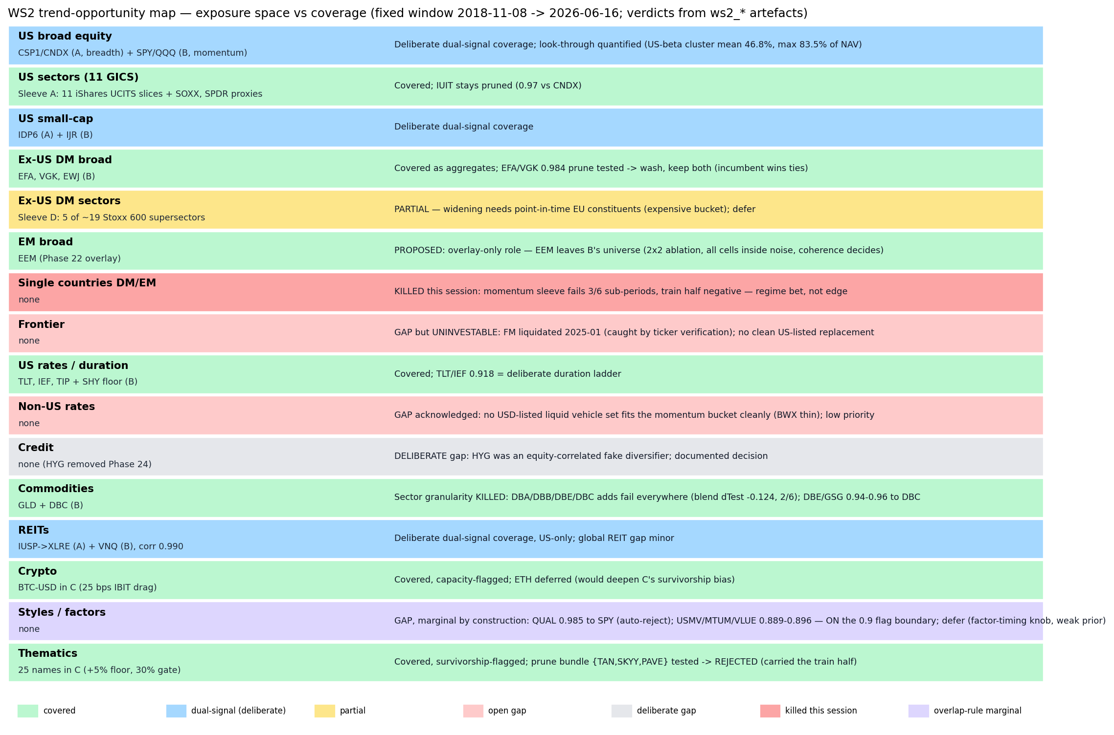
Figure 2 — trend-opportunity map: exposure buckets vs coverage, with per-bucket WS2 verdicts and their artefact basis.

4. Decisions
Component | Decision | Basis
Overlap rule (cluster 0.80; reject candidates >0.90 to incumbents) | ADOPT | IUIT/CNDX precedent generalised (3.1)
Sleeve A universe (14 lines) | KEEP | untouched by candidates or prunes; erratum corrected (2)
Sleeve B: EEM membership | PROPOSE REMOVE — approval required | overlay-only role ends the double-count (3.5)
Sleeve B: VGK | KEEP | prune is a wash; incumbent wins ties (3.2)
Sleeve B: TLT/IEF pair | KEEP | deliberate duration ladder (3.1)
Sleeve C universe (25 names) | KEEP | prune bundle actively harmful (3.2)
Sleeve D universe (5 sectors) | KEEP | widening blocked on point-in-time constituent cost (3.6)
Country momentum sleeve | REJECT | fails pre-registered bar 3/6; regime bet duplicating Phase 22 (3.3)
Commodity-spot additions (B and C) | REJECT | fails cheap reflex at sleeve and blend level (3.4)
Candidates IEMG, EWG, EWU, DBE, GSG | REJECT | above 0.90 to incumbents (3.1)
Factor sleeve (USMV/MTUM/QUAL/VLUE) | DEFER | 0.889-0.985 to SPY — marginal by construction (3.6)
Phase 22 EEM tilt | KEEP — WS3 audit | the one EM expression; bet-count audit reserved (3.5)
Trial register for the Workstream 3 deflated-Sharpe audit (each evaluated configuration counted once; 2x cost is a stress report of the same configuration): country sleeve 6 + benchmark 1; commodity fixed-window re-run 5; commodity thread of 2026-07-01 retro-logged 11; prunes 4; EEM coherence 5. Session total 32; cumulative across the review ~171 configurations.

4.1 Proposed change awaiting approval
Remove “EEM” from the UNIVERSE dictionary in scripts/run_asset_class_rotation.py (Sleeve B becomes 12 rotation lines + SHY cash floor); leave the Phase 22 overlay untouched as the sole EEM expression; re-run the pipeline and refresh committed JSONs. NOT applied this session — review-and-propose only. If approved, the change should land before the Workstream 3 heavy gate so the frozen shortlist reflects the final architecture.

5. Artefact register
- Scripts (new; deployed engines untouched): ws2_common.py, run_ws2_fetch_panel.py, run_ws2_correlation.py, run_ws2_country_sleeve.py, run_ws2_commodity_fixed.py, run_ws2_prune_tests.py, run_ws2_eem_coherence.py, run_ws2_trend_map.py; run_commodity_expansion.py filed as reviewed-and-rejected.
- Data: ws2_correlation.json, ws2_country_sleeve.json, ws2_commodity_fixed.json, ws2_prune_tests.json, ws2_eem_coherence.json, ws2_ticker_verification.json, ws2_baselines_meta.json; caches ws2_prices_cache.parquet, ws2_baseline_*.parquet, ws1_fx_eurusd_cache.parquet (WS1 leftover, now committed).
- Charts: ws2_correlation.png (Figure 1), ws2_trend_map.png (Figure 2).
- Memo: RESEARCH_MEMO.md — Workstream 2 section, proposed target universe, trial register, WS0 erratum.
- Commits: 903749c (harness + panel + verification), 6747aae (experiments + results + memo).

6. Next phase
Per the staged plan, the next session is Workstream 3 — the heavy robustness gate, run once on the frozen shortlist: deflated/haircut Sharpe across the ~171-configuration register, full-system walk-forward (weights, K, gate thresholds, tilt windows), 1x/2x/3x cost stress, the EEM-tilt bet-count audit (11 switches), the Sleeve C floor trade-off carried from WS1, and entry-point discipline checks. The shortlist freezes before that gate; nothing is re-optimised after seeing the haircut.
Sign-off
Prepared by | Claude Code research session (Fable 5), under direction of Zhenghao Phua
Reviewed and approved by
Date
Next review | Workstream 3 — heavy robustness gate (session 3 of the staged review)

Personal research artefact. All performance figures are simulated backtests in USD, net of stated costs; nothing in this document is investment advice.

